The Importance and Trending of IT Project Management

Group 6

Industrial Talk 2 – Commerce Dot Com Sdn Bhd (CDC).
1st semester, Group 6, Technology Information System, MJIIT UTMKl.

Salah.mohammed-2001@graduate.utm.my

Abstract_ Rarely any area in the management sciences developed as much as project management in the last years. It grew into a holistic, contextual, behavioral, and industrial competence-based management discipline from tools and a methods-oriented way. Is this revolution coming to an end, or will project management further improve in the next decades? There are many singular hypotheses concerning future phases of project management. Nevertheless, a summary of the different trends and the compelling end is still missing. Consequently, this paper aims to bridge this gap.

- Introduction

This report aims to understand the importance of IT Project Management trending to provide a brief overview of the approach that underpins the most formal projects. Many companies may not have full-time Project Managers, and it is normal for a project team to work together to meet a particular need. Although most people are not professionally trained in project methodology, taking part in a project team can be an excellent learning experience and improve a person's career profile.

- The importance of IT project management

A project tends to be only half a portfolio at intervals within the exchange. A project may be a mission assigned to the achievement of a specific purpose, which is exclusive on its own. Many places will contribute to the broader overall purpose of Associate in Nursing, referred to as a program. Similarly, a few allocated services will contribute to the largest of all: a portfolio. The tasks will break down to be a lot of smaller and manageable individual tasks by splitting an oversized portfolio into several programs that come into being. Many entirely distinct organizations can handle their own allocated goods or programs while not conflicting with alternate businesses. Companies would be able to emphasize one target, thereby raising the resulting level.
In the speech, the example of breaking down an out-sized portfolio into individuals is seen as follows.

Figure 1: Example of the breakdown of Portfolio into projects.

Project Management can be a system used by the area unit of data, expertise, techniques, and tools specific to project activities to confirm project needs' fulfillment. Blue blood, a pair of the United Kingdom, is one of the highly stressed project management methodologies within the conference. There is a joint methodology of PMP project management applied first to construction industries in the North American region. Project management is especially stressed in 2 sectors: construction and IT, and it is mainly due to the following importance:

1) Early product delivery may not be preferred since surprising losses and risks may be added. One such example is the downside of storage and corrosion hazards resulting from the suppliers' previous cement supply during a building project.

2) To prevent the conventional flow of current activities in a sector from being interrupted. For example, IT systems used in financial systems require the measurement of interests and risks involving an oversized sum of cash and cannot afford non-continuous operations.

3) Healthcare IT systems include human life, so a comprehensive project is required to prevent accidents and miscalculations.
To put it concisely, the most objective is to confirm that the vi keys (Time, Efficiency, Scope, Risk, Gain, Cost) square measure impacted in the execution of the project and stop the fortuitous performance and unexpected results.

The system of the project can be summarized into the following sequence of stages, which are flow-lined and many followed and managed:
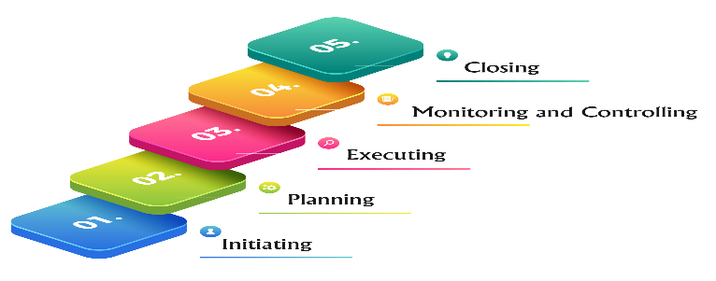
Figure 2 Summarized Project Management Process

However, the project procedures should be customized or specialized to accommodate and conform to the project's dimensions or design. It enables the system to be reduced to a vacant minimum, to the related degree that the price problem is reduced while the outcome standard continues to be guaranteed. It is not appropriate to incorporate anything compatible with the applied project method because it contributes to a greater price thanks to additional documentation work and time usage.

- The arising Trends in Project Management

1) Shifting, Globalized Gig Economy_

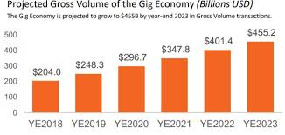
For quite a long time, the standard for an occupation has been full or low maintenance work. In any case, as of late, an ever-increasing number of individuals are starting to take on a variety of short positions, additionally knows as GIGS. These incorporate things like freelancing, Temp Jobs, and Jobs in the offered economy, which is just the beginning. The entirety of these various positions structures something many refer to as THE GIG ECONOMY. The gig economy has been dramatically expanding from that point forward. What's more, it is well known among the occupation. This is halfway because of the advancement of innovation in digital technologies. Organizations are presently ready to recruit any laborer on the planet who can then effectively telecommunicate utilizing different famous portable applications like Cisco Web and Google Meet. Mobile apps have allowed businesses like UBER, Airbnb, Talabat to grow an enormous number of contract workers. Social media has given people the ability to market themselves and sell their products and services at a much lower price than traditional advertising. Sometimes it is either B2C or C2C. Nevertheless, usually among the business seen on social media are not among the big stock markets. It is hard to say how the rise of the gig economy will affect and change the job market's future, but we know that both companies and workers will need to continue adapting to it.

2) Greater focus on Data (Big Data) _
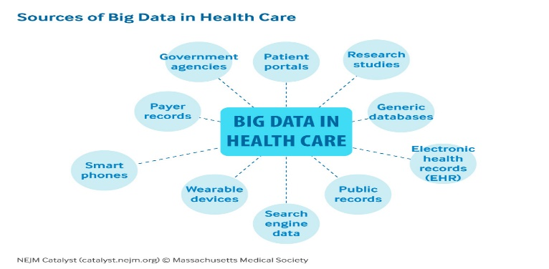
Big Data is the way toward gathering and examining huge informational collections from conventional and advanced sources to recognize patterns that can be utilized in dynamic decision making. {Big data is getting an exponential growth, and the main reasons are:
• Retail e-commerce databases.
• Interactions with websites and mobile device apps.
• Use of logistics, transportation systems.
• Social media interaction.
• Location data (e.g. GPS-generated).
• Internet of Things (IoT)}
Big data refers to the tremendous volumes and kinds of data that organizations would now be able to gather and deal with overgrowing high-tech tools. This comes from both inside sources inside your organization and outer ones. It is both structures. For example, clients buy information from retail locations and unstructured, for example, web list items; however, all information must be placed into organized arrangements to be investigated. Analytics is utilizing math and statistics to get significance from information to settle on better business choices. There are three sorts of analytics. Some are distinct, for instance, dashboards, scorecards, and cautions. They mention to you what occurred in the past yet not why it occurred or what may change. The predictive investigation is more valuable. They use past information to display future results, showing how clients will react to an advertising advancement or how certain economic situations would influence deals. Far superior is a prescriptive investigation that uses methods to encourage supervisors and laborers to take care of their responsibilities.

3) Automation and Artificial Intelligence_ Artificial intelligence is a development of computer science where a software system applies techniques that mimic the brain's structure and function to interpret data, support automated decision-making, and take preventive and correct actions. Artificial intelligence has been adopted by many banks for:
• Conversational AI (Chabots).
• Compliance.
• Customer service.
• Wealth management.
Most CIOs feel AI and Machine learning will be the game changer for their organizations.

- Relevant IT careers

You are lucky to enjoy technology and are searching for a position with a high salary and a strong job prospect. In the next ten years, the technology sector is rising, and IT employment growth is expected. These positions often pay much higher for all jobs than the median salary.

1) Computer Network Specialists_ Computer network experts and analysts identify, plan, develop, and manage a wide range of data transmission networks and systems. They currently have a bachelor's degree in computer science or a similar field. Some also have a Masters’ degree in Business Administration (MBA) with an emphasis on information management. Computer network architects can receive particularly high salaries: the median salary is $109,020.

2) Database Administrator_ Database managers help to store and organize data for businesses and/or clients. They protect the data from unauthorized users. Some of them work for organizations offering computer design services. Others work for companies with broad database networks, such as educational institutions, financial firms, etc. These jobs are growing at a faster-than-average pace, with jobs projected to rise by 9% between 2018 and 28.

3) Information Technology Leadership_ IT leadership draws on candidates with deep experience in technology and superior management skills. They have expertise in developing and implementing policies and systems to achieve IT goals and the capacity to budget the time and funds needed.

4) Information Security Specialist_ The increased occurrence of security breaches and the related risk of identity theft has heightened the value of securing data on commercial and government sites. Information security experts are helping to protect the data network and computer infrastructure of the enterprise. They prepare and implement a range of security steps, such as installing and using software and the simulation of cyber-attacks on test systems. Information security jobs are projected to rise much faster than normal, with 32% between 2018 and 2028.

Ⅴ. Software/Application Developer_ Software developers design, run, and test a range of computer programs and applications. Software Developers are developing new applications and technology solutions. They typically have a degree in computer science or a related field. They have good programming skills, too. Software developer jobs are projected to rise by about 21 percent between 2018 and 28. The median wage for a software developer is $105,590.

- Acknowledgment

First and foremost, our cluster would like to specify our sincere and deep feeling to Dr. Haswadi bin Hassan, our Technology and information system lecturer, for providing the possibility to attend the ennobling and informational speak. The report would not be possible to be completed while not the foremost speaker of this speech, Mr. Mohd Khairul Reeza Ruslan, still due to the moderator, Dr. Goh Eg Su, that along delivered valuable info and insights through the speakers. We are grateful to our people for their love, support, and sacrifices in shaping our future.

- Reflection

• Sourav Ahmed_ As a profession, I chose software engineering to become an online developer and help with technology events. I took up this subject because I was curious about computers and their applications. I heard about the management of IT projects from the business talk-2 video. There are several phases in which problems are solved, and better solutions are obtained. Project management is the practice required to accomplish a specific aim and accomplishment after a specific duration of a defined period in several phases.

• Alaa Salah_ My dream is to be a successful entrepreneur in computer science and use technology to take our life to the next level. What I learned from this talk are two things. First, how IT project management is so essential in lives. Second, the enormous and fascinating future trend for IT project management.

• Emran- My dream is to be a good developer to help improve programs, repair mistakes and holes, be one of the simplest people in the programming field, and benefit my fatherland. I learned from this talk about how necessary project management is intended to fail certain projects, and then the other is intended to succeed. If we stick and work hard and work hard to be a successful project manager and our study trip is a project in the end, but it is clarified that constructing yourself annotated to work in it and to prepare for each move you take is one of the most important, if not the most important, projects you will ever run.

•Ashraf_ As a CS student, personally, I am more curious about technological instruments/objects. I have the curiosity to learn the fundamentals and advanced parts of CS. However, after watching Industrial Talk, where Mohd Kahirul Reeza was the speaker, I understood that learning and how to imply those learnings in the real fields are important.

References

1) https://www.researchgate.net/publication/303375998_Future_Trends_in_Project_Management

2) https://www.projectsmart.co.uk/introduction-project-management.php

3) Ruslan, Mohd Khairul Reeza, interview by Dr Goh Eg Su. 2020. The Importance and Trending of IT Project Management https://utm.webex.com/recordingservice/sites/utm/recording/playback/1f7c1229a78448648c63a11cd72bd8ba. 4) https://www.tutor2u.net/business/reference/big-data-explained 5) Source: https://www.thebalancecareers.com/list-of-information-technology-it-job-titles-2061498

