

Session 2020/2021
Malaysian Japanese international
Institute technology

Lectures: | Dr. Halinawati, Dr. Nor Shahida.
Section: | 15
Group.no: | 6
Members: | - Alaa Salah Mohammed Nasser Badr (A20MJ4002)  - Mohammed Ashraful Islam (A20MJ0160)  - Sorva Ahmad (A20MJ4007)  - Al Emran (A20MJ4003)

Part A: (tools needed to construct a PC):

- Anti-Static Equipment:

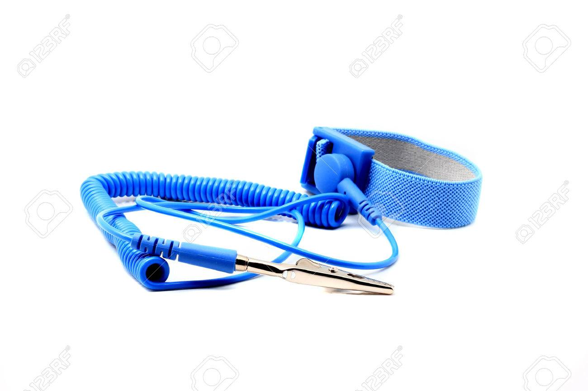

The function of Anti-Static Equipment:
They reduce the most hazard of electrostatic discharge, ESD, the buildup or discharge of static electricity.
Anti-Static Devices’ importance:
Those tools also guarantee that you and your computer devices stay defended from Electrostatic discharge.

- Screwdriver:
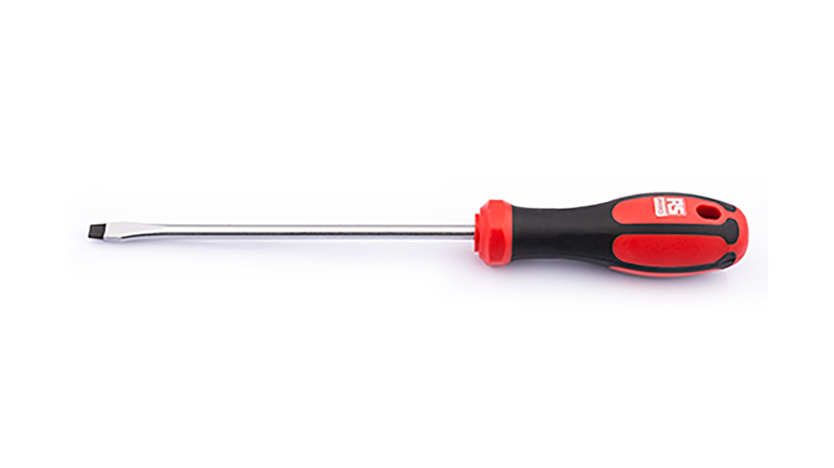
Screwdriver’ role:
They were designed for turning screws with slotted heads.

The value of Screwdriver:
Computers are attached with screws and, fortunately, almost all sorts of screws used in computers are Phillips-head. The number-one most essential gadget for PC building is a Phillips-head screwdriver with a long bit, which it is important to avoid stripping the head.

- Pliers:
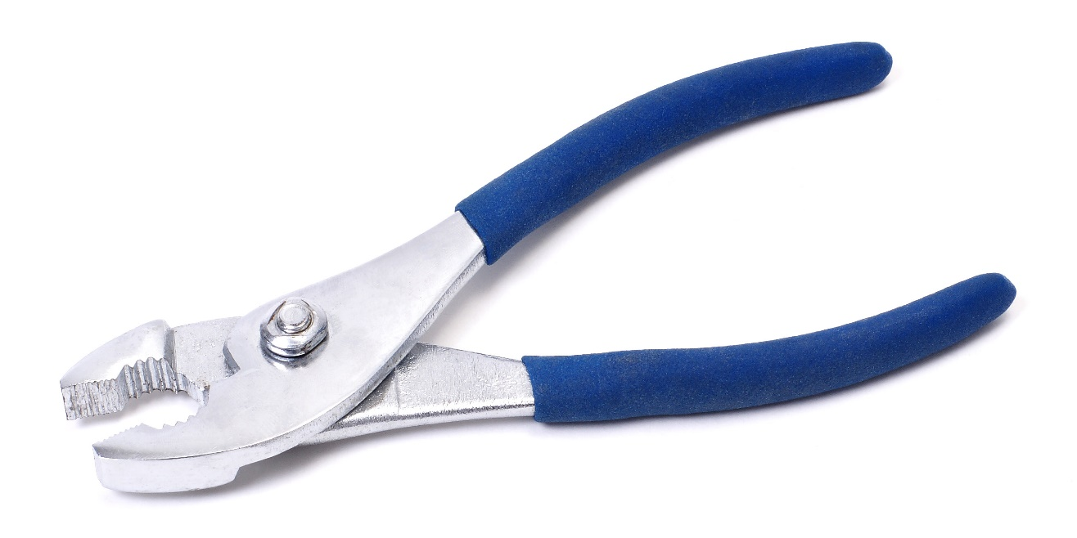

The use of pliers:
They are hand-operated equipment made for catching and lifting small items or for twisting and cutting wires.

Plier's importance:
Sadly, sometimes the heads of poor screws get torn. When that occurs, sometimes the only choice we have is to use a pair of pliers nicely.

- Zip or Twist Ties:
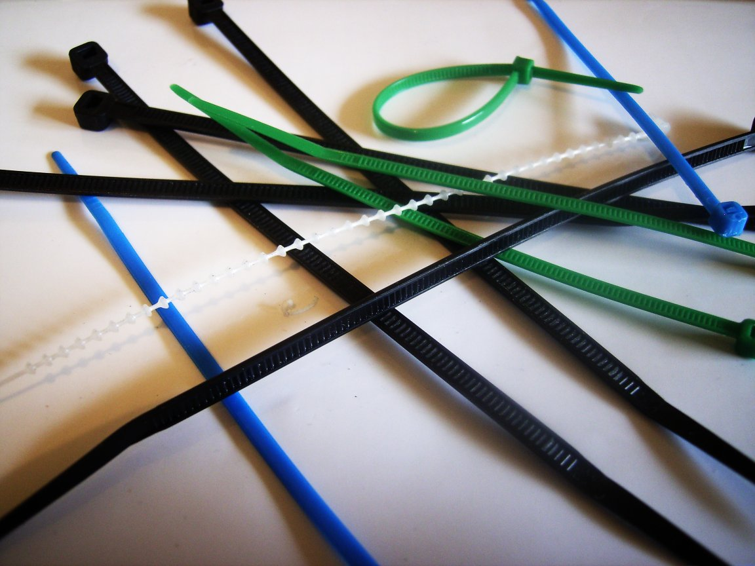
Function of Twist Ties:
They are used to tie up any loose cables lying throughout your case, giving your finished build looks more orderly.

Twist Ties and its importance:
Zip ties are the most excellent idea to hold cables in place. Cables that might be moved throughout in the future could be tidied-up with zip twist ties, which are almost hidden, nearly as safe, and far easier to remove.

PART B – Sketch of a mother board layout:

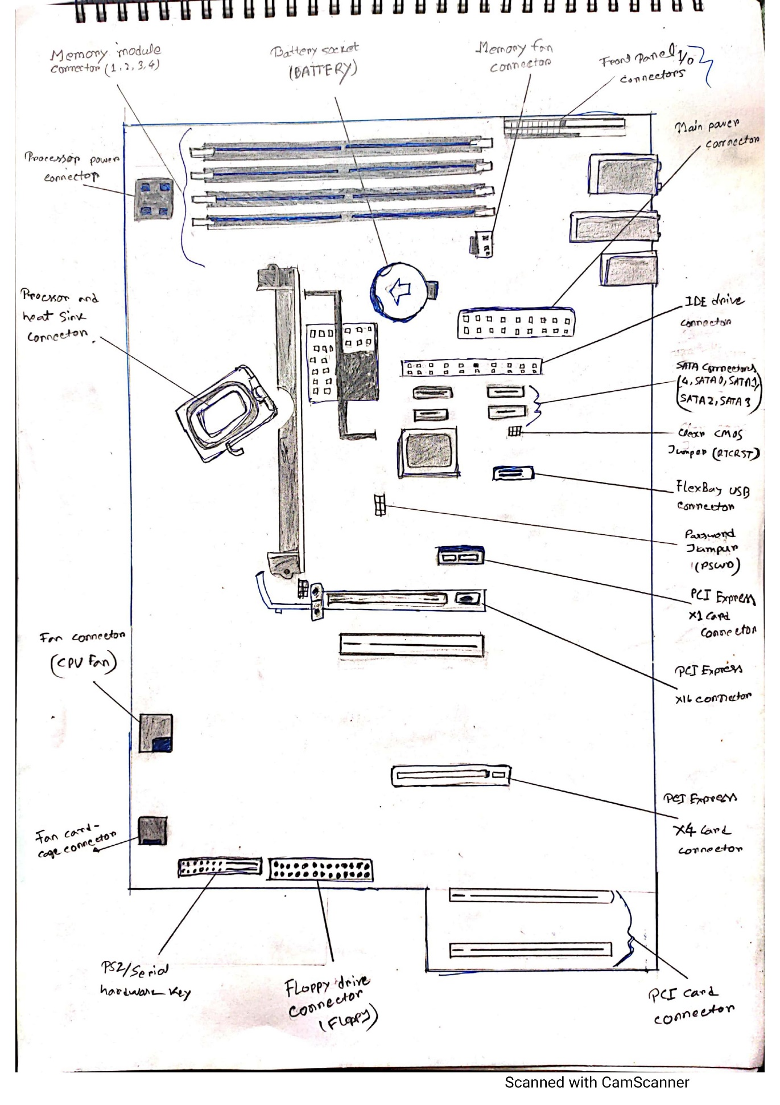
- Graphics Card
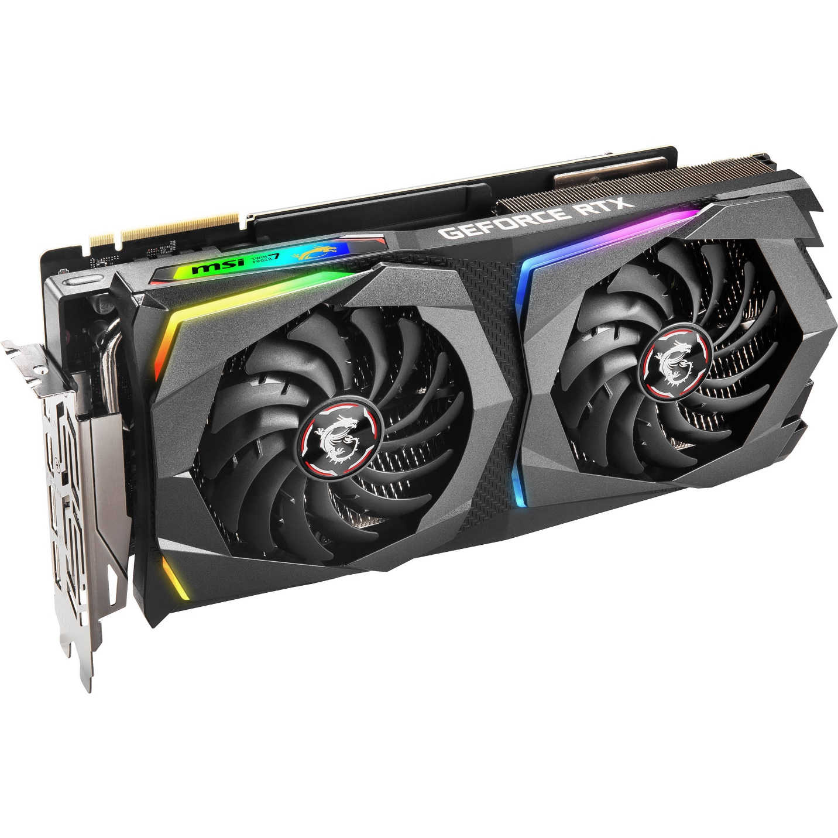
Model: MSI GeForce RTX 2070
A graphics card is primarily designed to remove the graphical processing tasks from the processor or RAM. It includes a dedicated graphical processing unit (GPU) and a dedicated RAM that help it to process graphical data quickly. Like most processors, a graphics card also has a dedicated heat sink to keep the heat out of the GPU. A graphics card enables the display of 3-D images, image rasterization, higher pixel ration, a broader range of colors and more. Moreover, a graphics card includes various expansion ports such as AGP, HDMI, TV and multiple monitor connectivity. A graphics card can be integrated within the motherboard or be added on as an extension card.
2.CPU/Processor
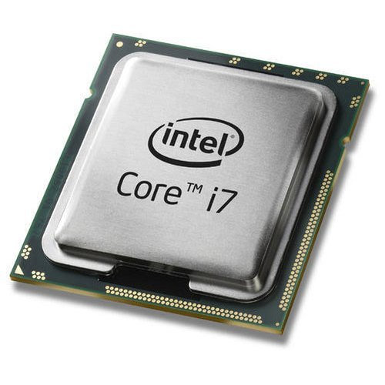
Model: Intel Core i7
A processor (CPU) is the logic circuitry that responds to and processes the basic instructions that drive a computer. The CPU is seen as the main and most crucial integrated circuitry (IC) chip in a computer, as it is responsible for interpreting most of computers commands. CPUs will perform most basic arithmetic, logic and I/O operations, as well as allocate commands for other chips and components running in a computer.
The term processor is used interchangeably with the term central processing unit (CPU), although strictly speaking, the CPU is not the only processor in a computer. The GPU (graphics processing unit) is the most notable example, but the hard drive and other devices within a computer also perform some processing independently. Nevertheless, the term processor is generally understood to mean the CPU.
3.Heat Sink
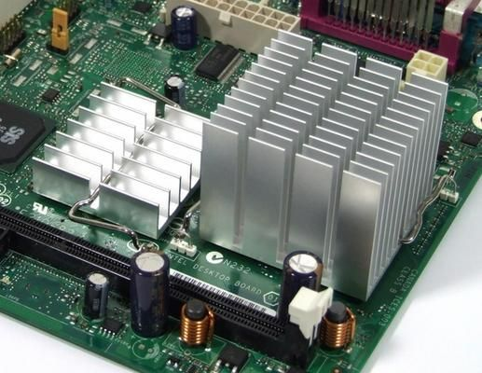
BGA Heat Sink

A heatsink is a piece of metal that sits on top of a computer chip such as a CPU and draws power away from components by letting it rise through a set of fins. By themselves, heatsinks are passive; they have no moving parts. However, in most cases--especially with desktop CPUs and GPUs the heatsink is combined with a fan that blows the hot air away or a that carries the heat away through pipes.
4. CD ROM
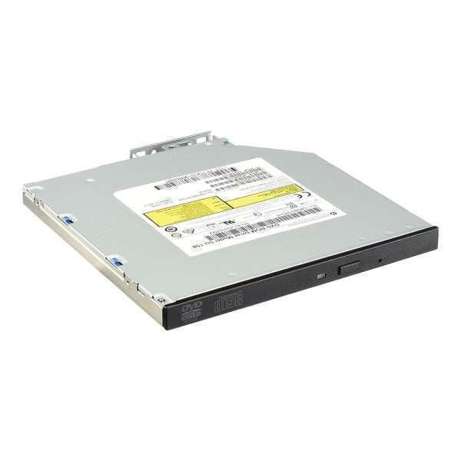

HPE 9.5mm SATA DVD-RW Optical Drive 726537-B21
A CD-ROM is a CD that can be read by a computer with an optical drive. The "ROM" part of the term means the data on the disc is "read-only," or cannot be altered or erased. Because of this feature and their large capacity, CD-ROMs are a great media format for retail software. The first CD-ROMs could hold about 600 MB of data, but now they can hold up to 700 MB. CD-ROMs share the same technology as audio CDs, but they are formatted differently, allowing them to store many types of data.

5. USB cable
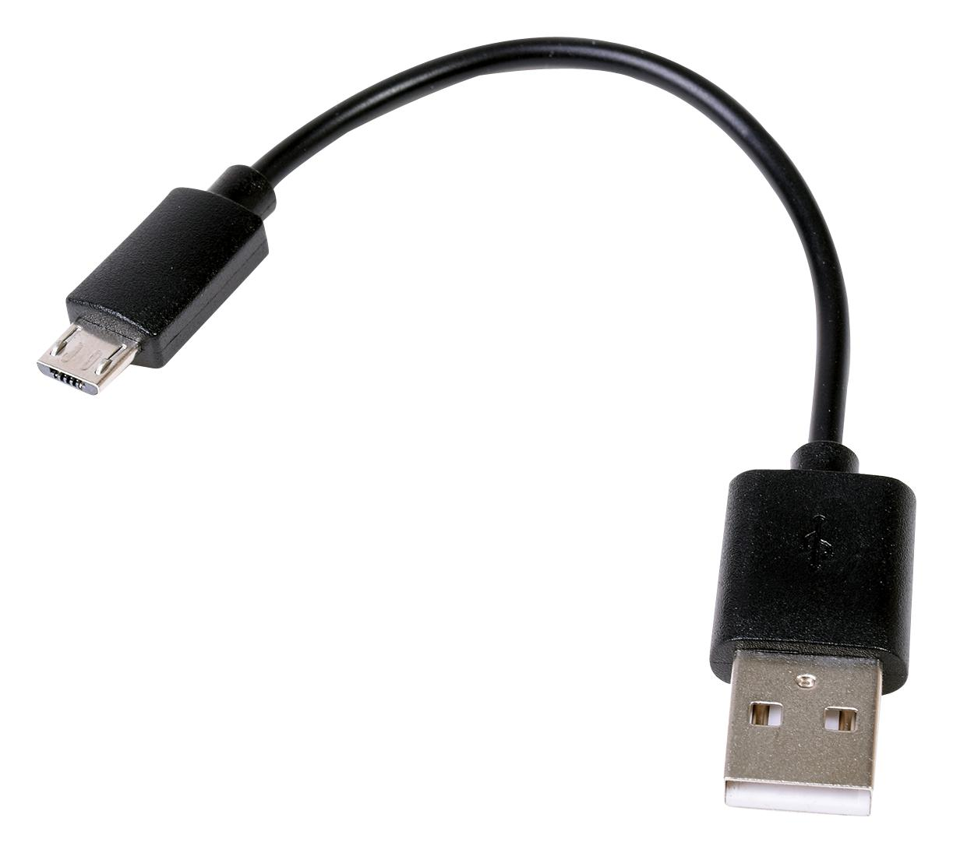
GLJ-C4-1506 USB Cable
USB cables, also known as USB leads, provide connection from computers to peripherals such as keyboards, printers, portable media players, network adaptors and pointing devices. They are also used to provide electrical power to portable devices via a wall adaptor or computer. “USB” stands for Universal Serial Bus.

6.Slots (IDE,PC)
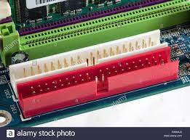
Model: SH87R6
SLOT-IDE allows you to generate the mathematics of slot games from a description of the game rules. No knowledge of slot mathematics is needed, a complete PAR-sheet is generated within seconds along with a playable prototype of your game and an engine that implements the game logic.
7. RAM
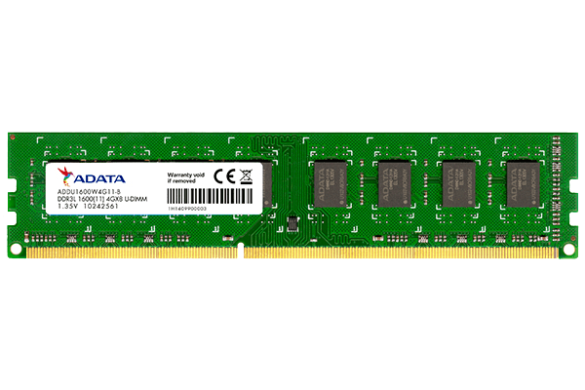
MODEL: ADATA 8GB DDR4
RAM is temporary storage that goes away when the power turns off. So what is RAM used for, then? It’s very fast, which makes it ideal for things the computer is actively working on, such as applications that are currently running, for example, the web browser in which you’re reading this article and the data those applications work on or with.
8.SATA cable
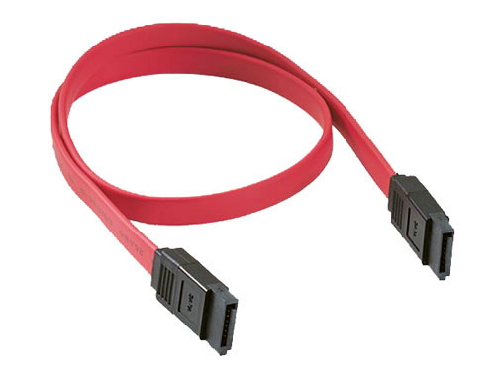
MODEL : SATA CABLE 45CM
Serial Advanced Technology Attachment (SATA) or Serial ATA cables are used to connect devices in computer cable assemblies, such as storage devices, for example The SATA technology itself is a connecter interface primarily used for computer bus connections in storage applications. In this application, the cables are used to connect a mass storage device (e.g. hard disk drives, optical drives, solid-state memory drives) to a host bus adapter such as a motherboard.

9.POWER SUPPLY
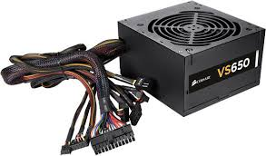
MODEL: VS650
A power supply unit (PSU) converts mains AC to low-voltage regulated DC power for the internal components of a computer. Modern personal computers universally use switched-mode power supplies. Some power supplies have a manual switch for selecting input voltage, while others automatically adapt to the mains voltage.
10. Hard Disk master
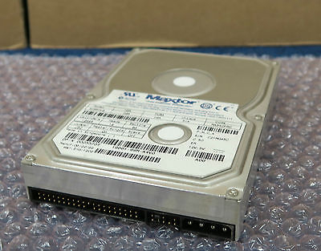
Model: Maxtor 90650U2 - 3.5" 6.5GB, 5.4K IDE
A hard disk is part of a unit often called a disk drive, hard drive or hard disk drive -- that stores and provides relatively quick access to large amounts of data on an electromagnetically charged surface or set of surfaces. Today's computers typically come with a hard disk that can contain anywhere from billions to trillions of bytes of storage. A hard disk is actually a set of stacked disks, like phonograph records. Each disk has data recorded electromagnetically in concentric circles, or tracks, on the disk. A head, similar to a phonograph arm but in a relatively fixed position, writes or reads the information on the tracks. Two heads, one on each side of a disk, read or write the data as the disk spins. Each read or write operation requires that data be located, an operation called a seek. Data already in a disk cache, however, will be located more quickly
PART C - “Step by Step PC Assembly”:
It is true that computer is one of the important device which plays a vital role in our daily life activities. It makes our activity too easier. So, in this report we will discuss about the assemble of a PC.
If we build up a CP 1st of all we need some common elements these are given below.

1.Processor /CPU.
2. Heat sink.
3.RAM.
4.Power supplier.
5.Hard disk.
6. CD Rom/ DVD drive.
7. SATA cable.
8. IDE cable.
9.USB port.
10. Graphic card.
11.Slots (IDE, PC)
By using these basic and fundamental elements, step by step we are going to assemble a PC.

- CPU Installation:
1st of all we have to take a motherboard. After taking it, we need to open the CPU slot which included in the motherboard

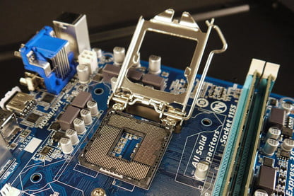
Opening CPU Slot

Now we need to install the CPU carefully in the CPU slot. Make sure that all CPU edge match with the slot.

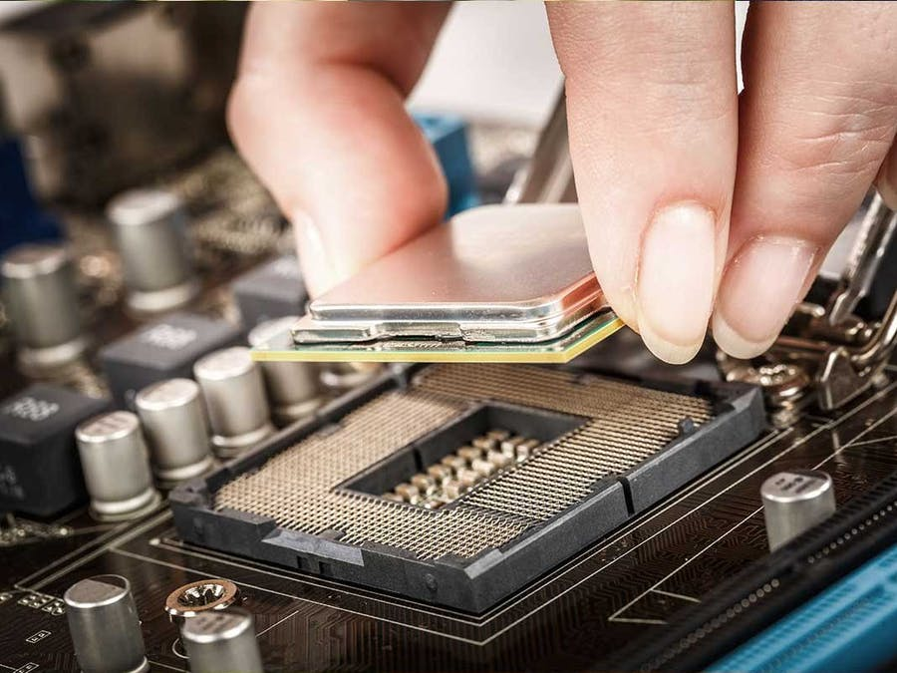
Installing CPU

After installed the CPU perfectly, then we have to close the slot slowly and carefully otherwise it can be break down or don’t attach properly.

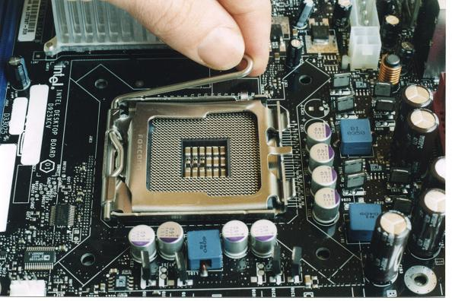
Closing CPU Slot

- Heat Sink Installation:
Place the CPU heatsink according to the diagram print on the motherboard.
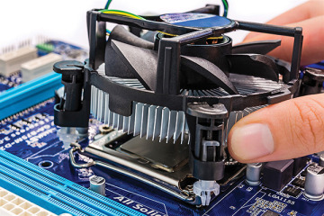
Heat sink Installation

After attach the heatsink we Place the mounting ring at the back of the motherboard and align it with the CPU heatsink.

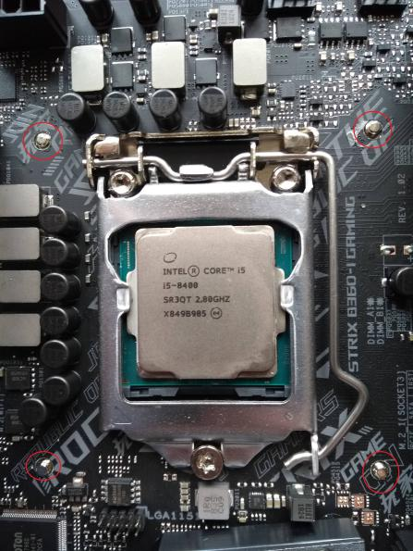
Attach Mounting Ring

Then we screw the CPU heat sink by following X-formation on the 4 screws. After that we attach the motherboard in CPU cabinet.
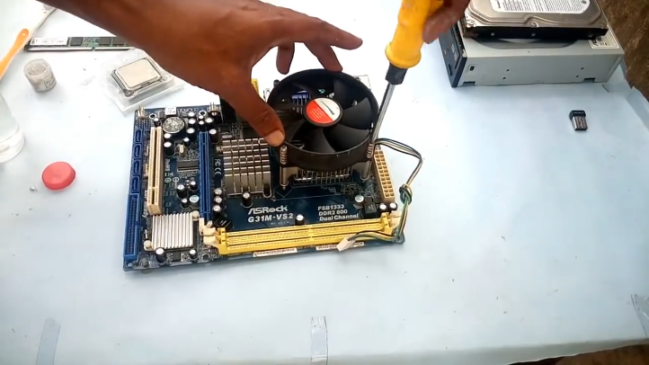

Heat sink attach by using screw

- RAM Installation:
In the next step we open the ram clip at the both side of RAM slot by slowly pulling it outward before install the RAM.
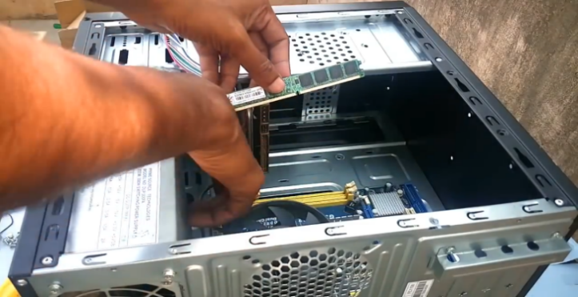

Opening RAM Slot

Press the RAM stick into the RAM slot gently until hear the click sound of the RAM slot clip. We have to ensure the RAM stick position is the same with the RAM slot.
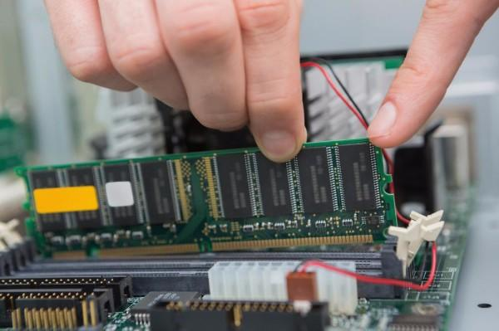
RAM Installing

- Power Supply Installation:
After that install the power supply in CPU cabinet then attach the power supply with CPU cabinet using screw.
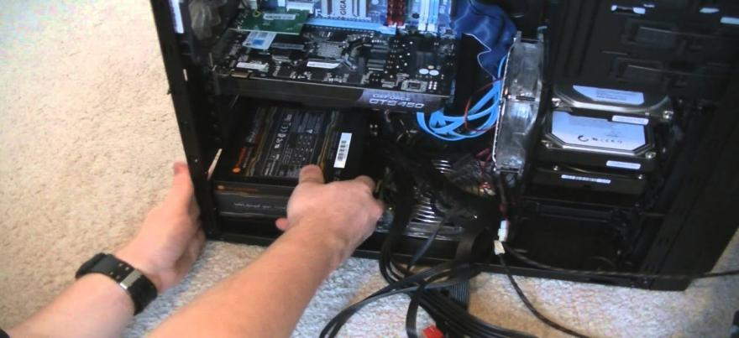
Power Supply Installation

5.Hard disk installation:

The next step is hard disk install. According to install firstly we place it into the CPU cabinet.

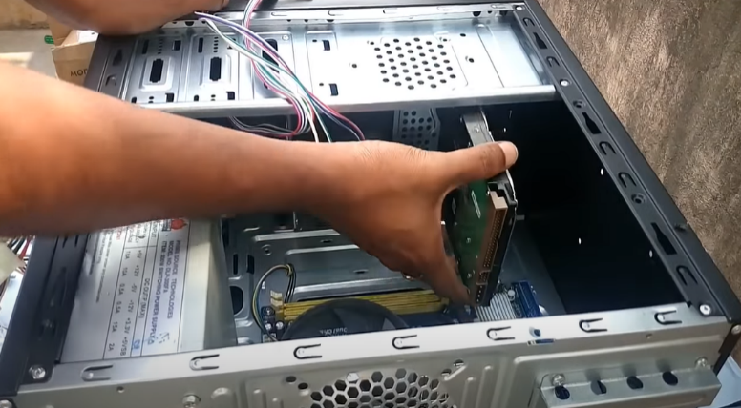

After place it into the CPU cabinet bay and screw the hard disk tightly. And ensure the hard disk is tightly screwed on the CPU cabinet hard disk bay.
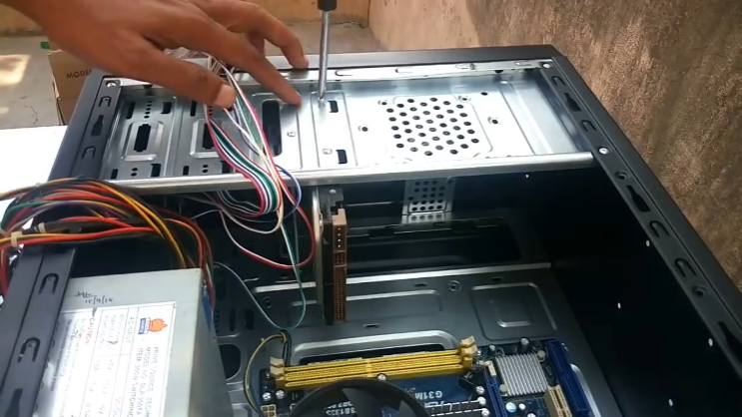

Attach by using screw

If the storage drive is configured as a master, plug in the black IDE cable connector into the IDE connector on the hard disk.
If the storage drive is configured as a slave, plug in the grey IDE cable connector into the IDE connector on the hard disk.

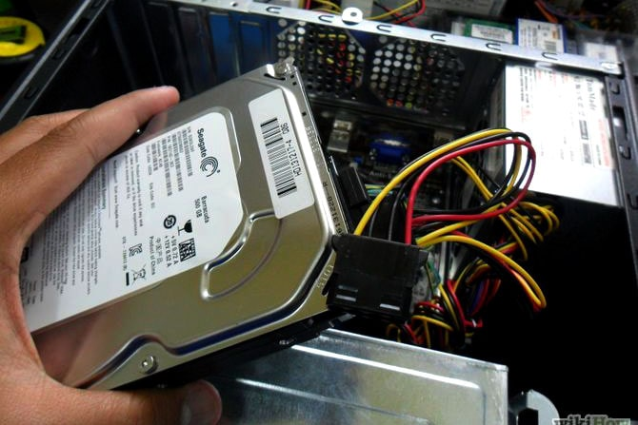

Installation Hard Disk

- CD Rom/ DVD drive installation:

Complete to installed the hard disk we again Place the new drive, DVD drive in the CPU cabinet as like as the hard disk.

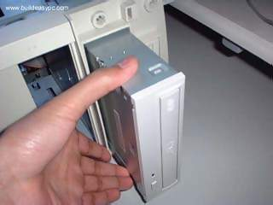
DVD drive installing

Then screw the DVD drive tightly by using the screwdriver. And ensure that DVD drive is tightly screwed on the CPU cabinet DVD drive bay.

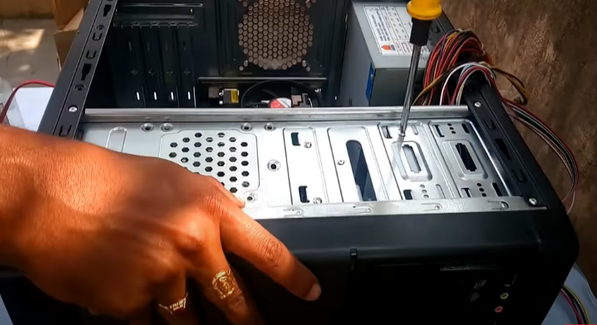

7. SATA & IDE cable installation:
Now we have to connect the CD ROM with the motherboard via SATA Cable. For that 1st we have to take the SATA cable and connect with CD ROM and another port we connect with the motherboard.
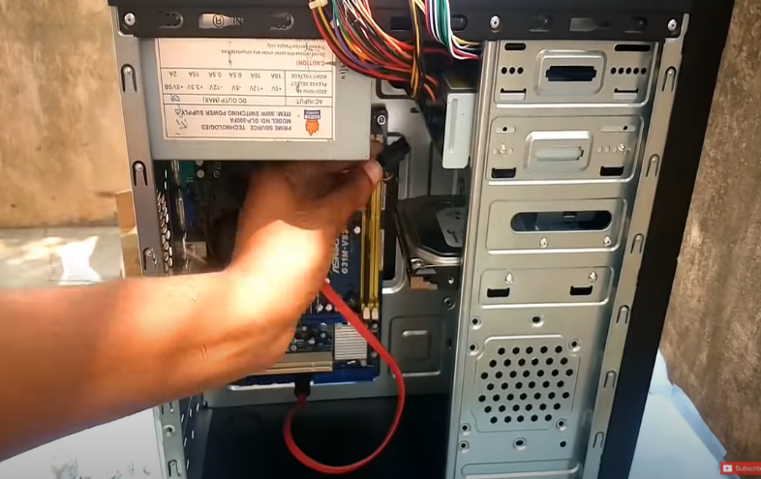

Connect the CD ROM with the motherboard
Now we have to connect the Hard Drive with the motherboard via IDE cable. If the storage drive is configured as a master, plug in the black IDE cable connector into the IDE connector on the hard disk. If the storage drive is configured as a slave, plug in the grey IDE cable.
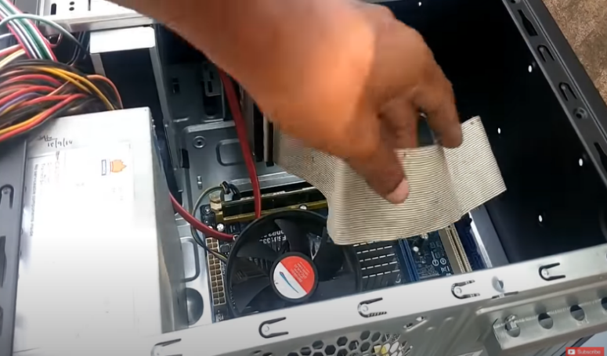

IDE Cable connection

8.USB port installation:
After installed the SATA and IDE cable we have install the USB port in front side and connect the cable with the motherboard. And surely we have to install it very carefully.
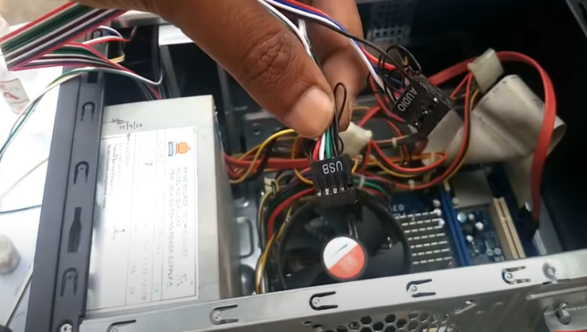

USB Port Installing

9. Graphic card installation:
For graphics card section we have to use PCI express 16x slot. We have to put carefully the graphics card like RAM installation. Make sure we need to use PCI express 16x slot for installing otherwise it doesn’t be work.
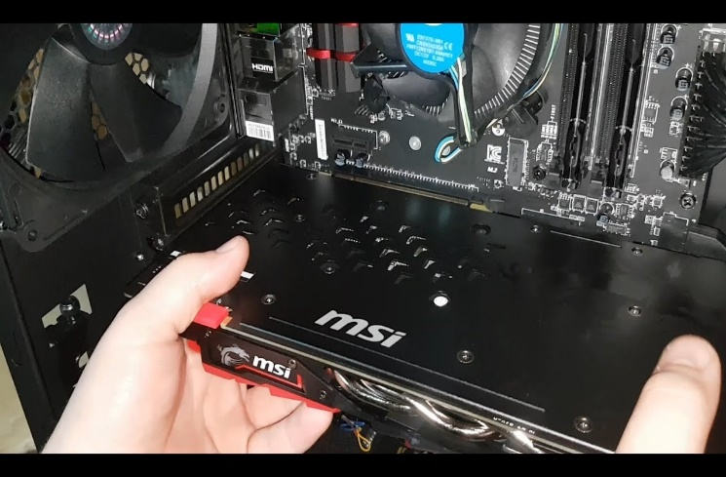

Graphics card installing

10. Power supply port Connection:
Now we need to connect the power supply port with Motherboard, CD ROM, Hard Drive, and graphics card. For motherboard connection we have to use Power SW, Reset SW, Power LED, H.D.D LED port to connect with motherboard.

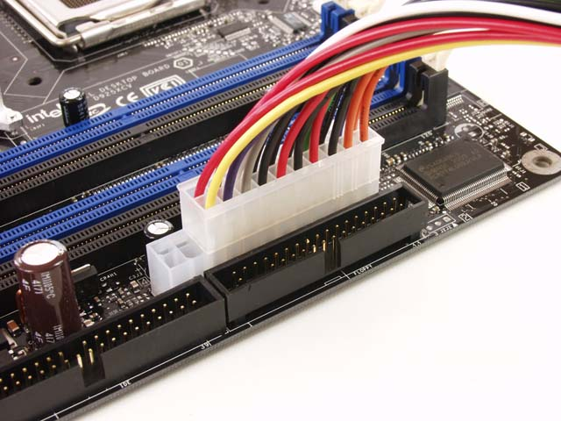
Power Supply Port Connection

we have to connect ATX power supply pin with Hard Drive. We need to do it more carefully.
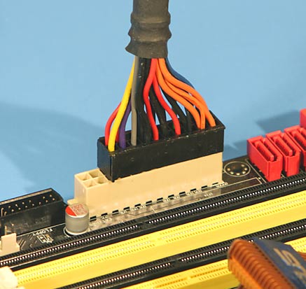
Connecting ATX Pin

For graphics card, use via 6 pin F to M port which supply the power on graphics card.
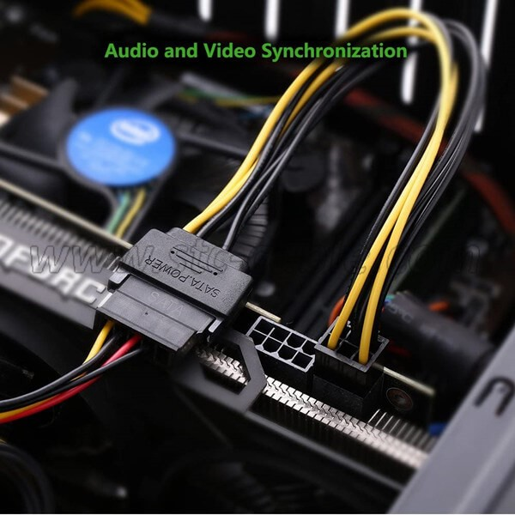

Connect pin with graphics card

And lastly, we have to connect 4 pin peripheral port with CD ROM.
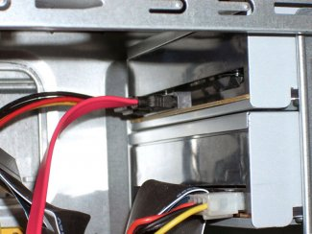

Connect peripheral port

11. Closing the CPU case:
After finishing to installed all of the ports we have to close the CPU case using by screw. once it’s finished, simply plug it into our new system. Go back into our BIOS for tailing our system to boot from the USB stick first. From there we have to go through the prompts to install the operating system onto our new rig.

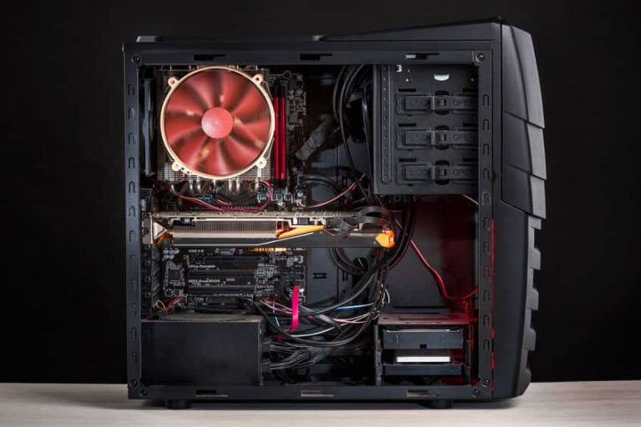
After closing CPU Case.

Reference:
1.https://www.youtube.com/watch?v=m_-G9Cacx2U&ab_channel=TechnologyGuide.
2.https://www.build-computers.com/how-to-assemble-a-pc.html.

