

BY: AL -EMRAN [A20MJ4003]

Introduction

Many of the existing car parks actually do not have a formal scheme. Most of them are operated manually and are a little inefficient. In looking for the available parking spaces,the dilemma that often happens at the car park is time spent. Users can continue to circle the parking area until they locate an empty parking slot. This issue typically arises in urban areas, where, relative to the availability of parking spaces, the number of vehicles is greater.These unsuccessful circumstances have arisen owing to the lack of adoption of the technologies available on the market today.Many nearby car parks are now constructed inside a shopping mall or multipurpose building to provide the car driver with a parking lot.
In several shopping centres, parking inside a building is becoming common because it is user-friendly and can prevent cars from exposing themselves to sunlight.
Normally, this type of car park has a parking guidance system focused mainly on the use of message signs to provide drivers with details on the availability of parking within the car park. In general, the availability of parking spaces within the car park is obtained from sensors that count the number of cars entering and leaving or in other situations, by comparing the number of tickets issued by the machines.This information on the capacity of the parking lot inside the car park is normally expressed in full or empty terms on the display board at the entrance of the car park. The actual number of parking availability inside car park is rarely provided. Hundreds of cars enter the car park every day and search for vacant parking spaces inside the car park.Therefore, it is difficult to find out an empty

parking slot. Inside most local car park, car drivers still need to find out empty parking slot themselves. They will definitely waste a slot time for searching an empty parking slots if they do not know where they are, especially when there are only a few of empty parking slot available at each row of parking slot.Therefore, it is important to have an effective empty parking slot tracking system to display empty parking available at each row of parking slot and guide car driver to there.The development of this project prototype will serve as a way-finder to direct the car driver inside the car park to the available parking space inside the car park and guide the car driver to go there. It is a project focused on an Arduino microcontroller. The infrared sensor is used to classify the vacancy of each parking slot at the parking level, send a wireless signal to the microcontroller to process and view the total available parking slot on 16x2 LCD displays.Therefore all businesses that own a large building, or even a small one, must provide a decent parking for travellers. The Smart Parking System helps to minimise the time usage from the driver's point of view, as the travel time is minimised due to the information provided. Drivers may avoid looking for a vacant parking space that is already completely occupied, based on the details given.This project is being developed based on research into the existing parking system at the parking facility.
A crowded parking area, such as a mall or shopping complex. Understanding that there is some parking. An available parking lots are difficult to find areas, this project is purposely built to solve The issue. The focus of this project is to find the best way to guide drivers and vehicles.
Users can get a free parking space in no time.The Smart Parking System can notify drivers of the available parking zones and the number of free parking spaces in order to inform them.
They can make good decisions about where they want to park, so they can find free parking without any difficulty.

Step of design thinking.

1)Empathy.
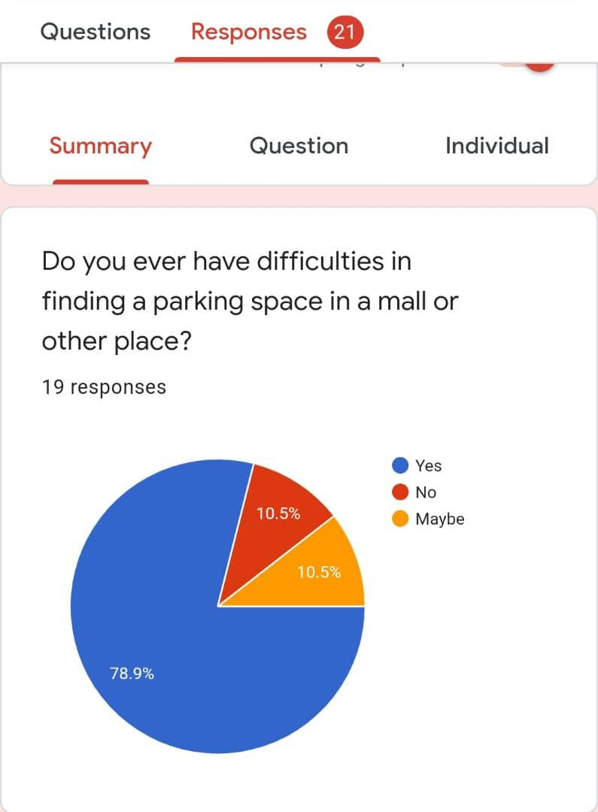
In this first step of design thinking progress, we have done some kind of online survey (using google survey) that we need to know what the users think about these difficulties in finding the problem of parking space. There are data that we are already collecting from the survey. Based on the data we received, most users have difficulty finding a parking space (78.9%) of the total response.
2)Define.
In this second stage, we have some votes and users' opinions on this subject. Here are the results.
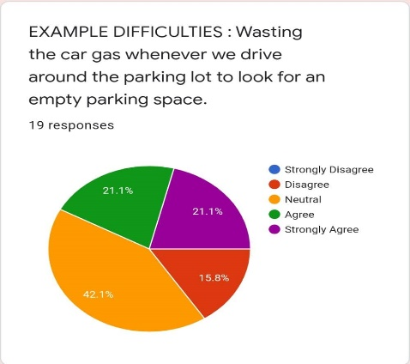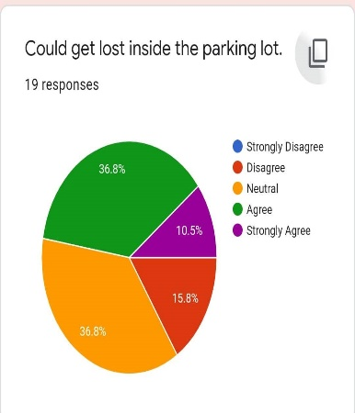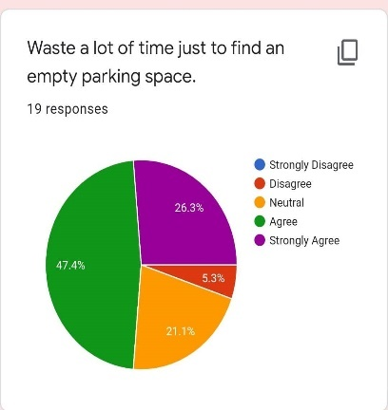
In every case most of the users vote neutral ,42.1% responses of the wasting car gas , 36.8% get lost inside parking lot and 47.4% vote shows of wasting time to search space for parking.
Here also some response that we get
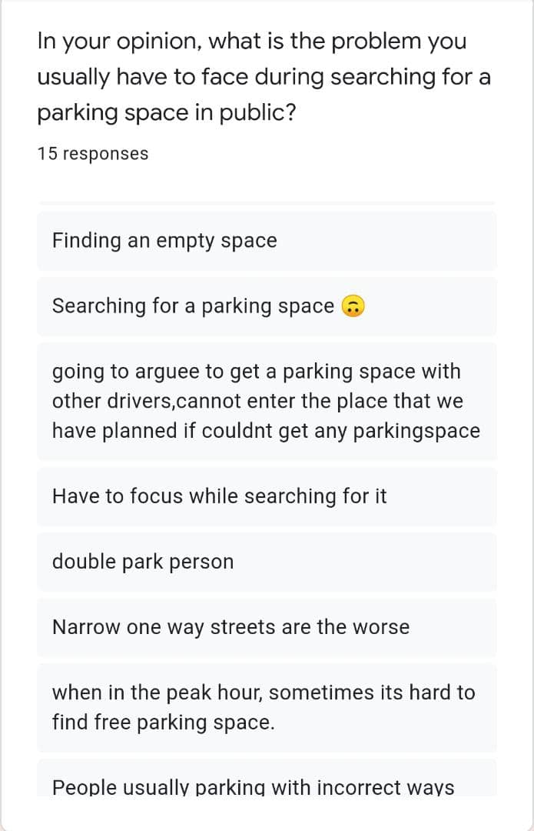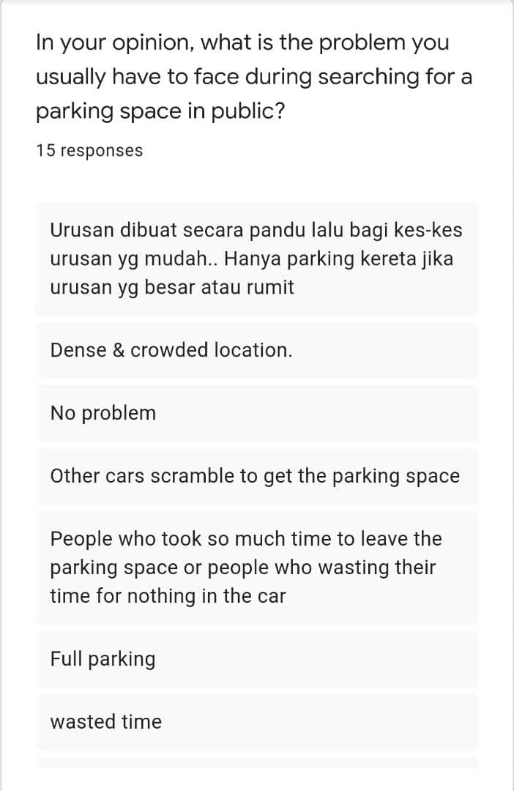
3)Ideate:
After taking all opinions we make discussion and note some possible solutions those can solve this problem.our listed idea is making an app that can help to navigate nearest parking space with booking and payment system.

4)Prototype:
After finding solutions we combine all idea for creating prototype.here are some of those:
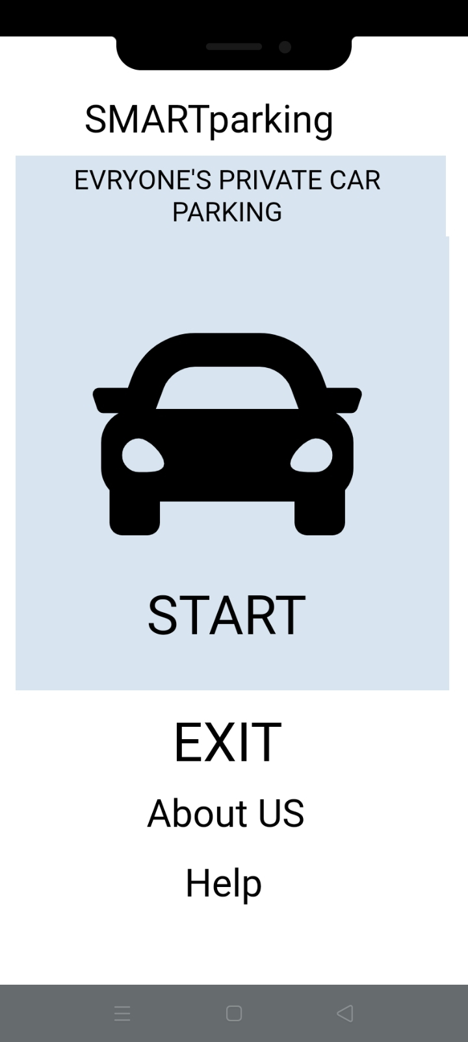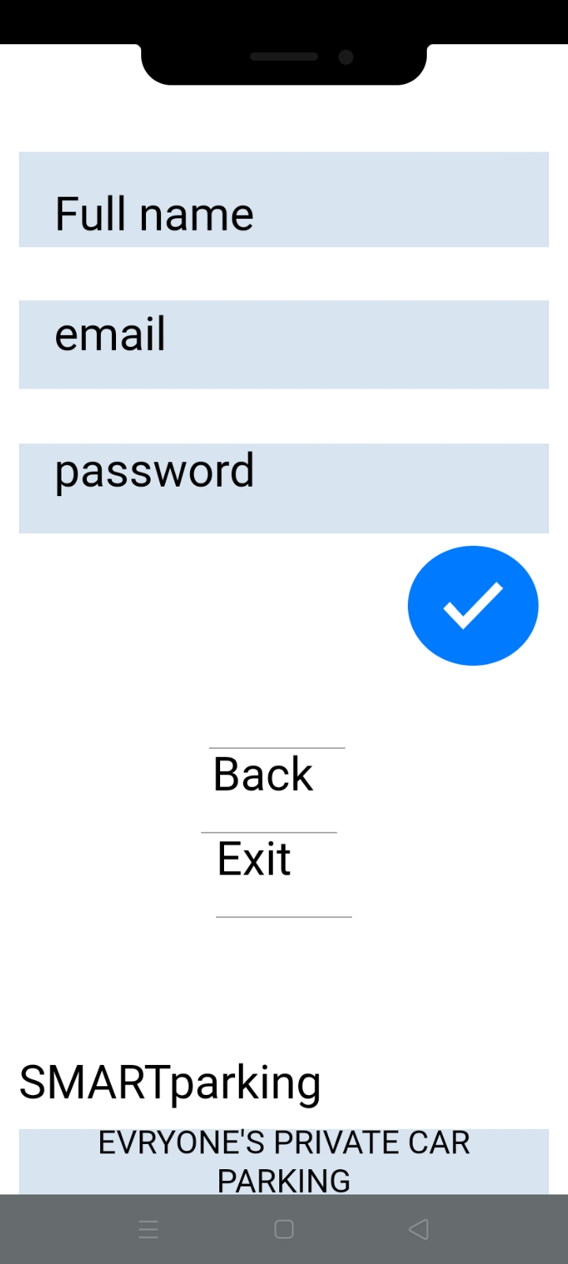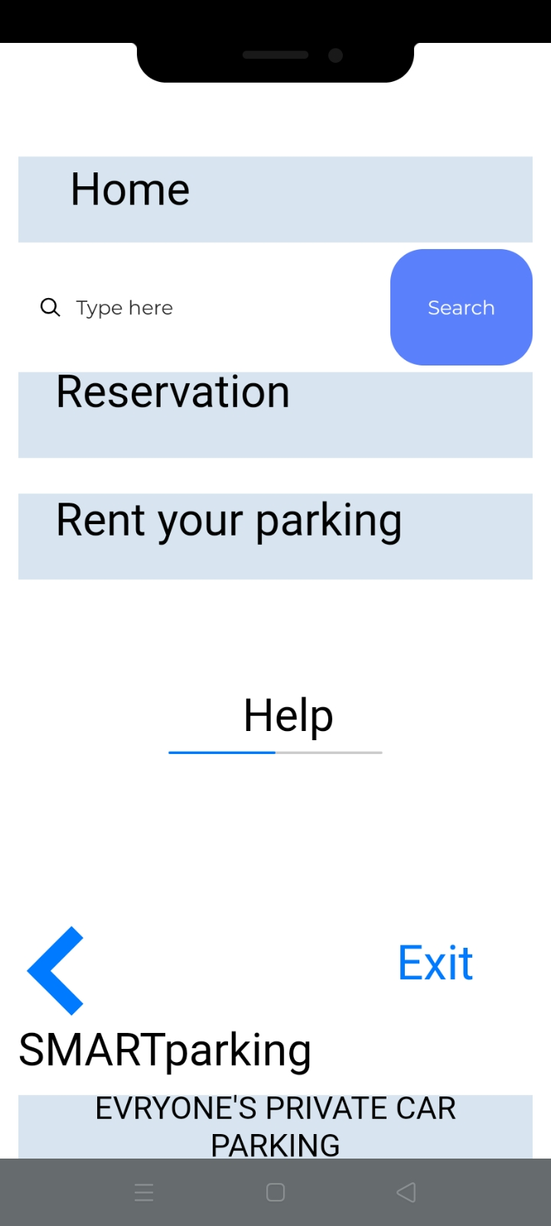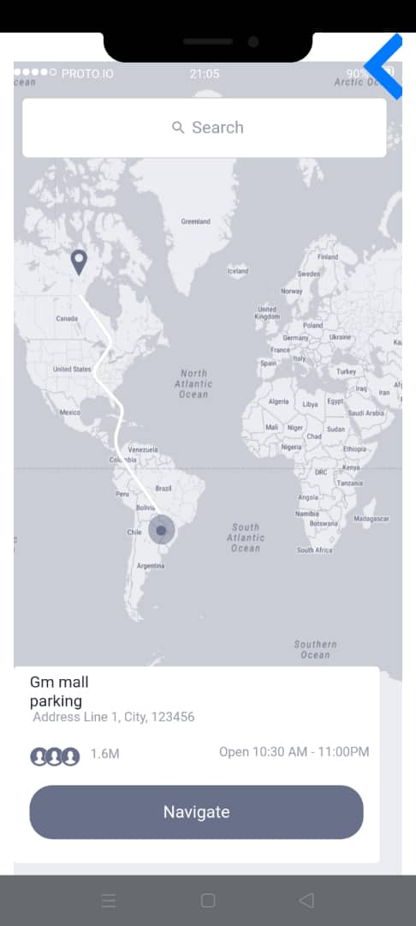

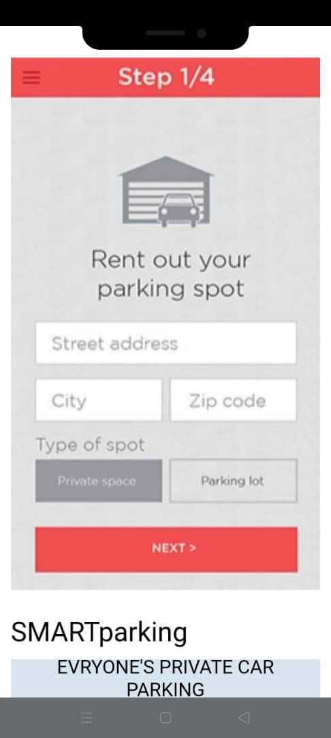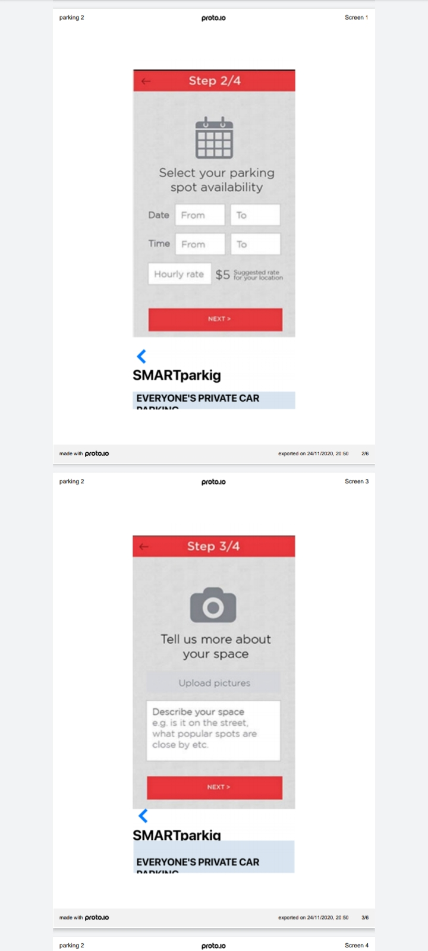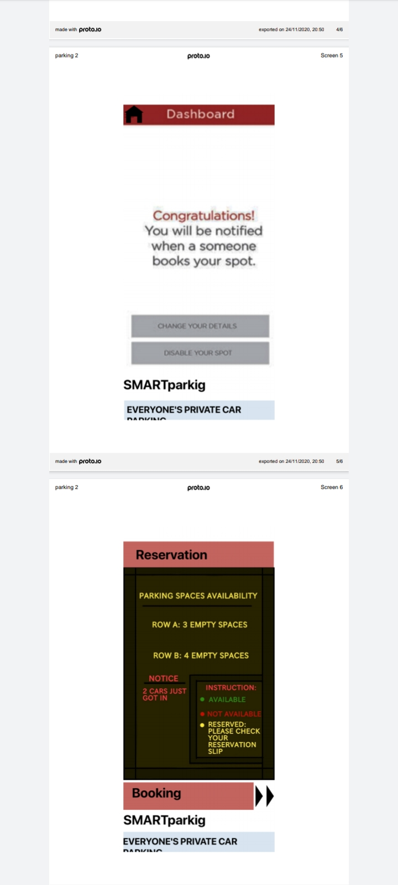
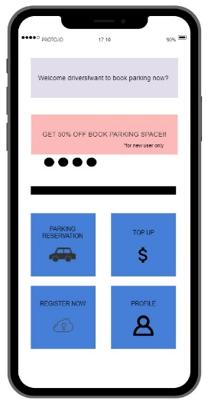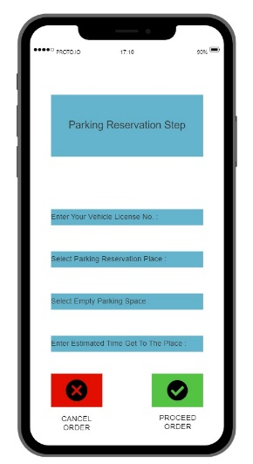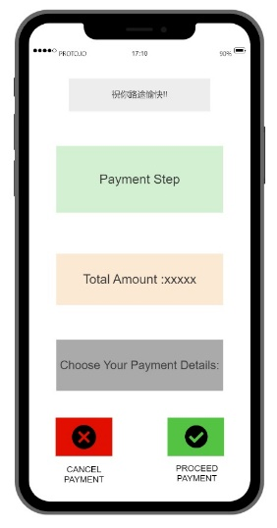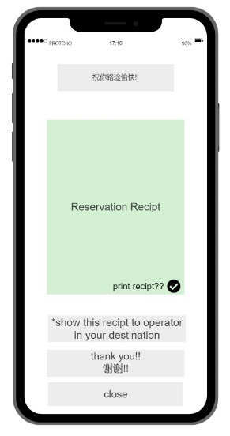
5)Testing:
After creating prototype who have to testing it that will show how it works.
- here we can see its 1st page with some option although every page have lot of option and by this way we make solution.
- If you go on start before going other step it will tell you to register.
- after register it will show you other option such as parking lot rent and reservation ,parking navigate etc.
- here it will also show of nearest available car parking lot by using AI navigation system.
- this also have a step for those who want to rent their empty parking space.
- here also can find booking option that also shows how many parking are still available here.
- in every parking lot slot can give some color sign.this colour can inform to the motive force the parking lot handiness.here is a few color sign information:
-green:will inform to the motive force if there’s an empty parking lot slot.
-red:will inform to the motive force if the parking lot slot already fill by another driver.
-yellow:will inform to the motive force if the parking house slot already reserved by another driver through the reservation app.
- After the users completed the payment step,the will incline the reservation receipt.this receipt are show to the operator if the users already get in to the parking lot.
6)Finality:
we hope from this result that we offer during this DT it'd be serving to the users whereas facing this sort of downside

Problem statement
Due to the proliferation in the number of vehicles on the road, traffic problems are bound to exist. This is due to the fact that the current transportation infrastructure and car park facility developed are unable to cope with the influx of vehicles on the road. To alleviate the aforementioned problems, the smart parking system has been developed. With the implementation of the smart parking system, patrons can easily locate and secure a vacant parking space at any car park deemed convenient to them. Vehicle ingress and egress are also made more convenient with the implementation of hassle free payment mechanism. With vehicle detection sensors aplenty on the market, the choices made may defer due to the different requirements in addition to the its pros and cons. Subsequently, the various sensor systems used in developing the systems in addition to the recent research and commercial system on the market are examined as vehicle detection plays a crucial role in the smart parking system.
Car parking system is a system that is used to help managing cars in parking area in other to avoid congestion and arrange cars in an allocated position. The system also helps to track how many cars pass through the gate and the duration taken by each, and then it will calculate the amount of money a car should pay when exiting. Car parking system is being used in many congested area or location where there are many meeting point of people like where there are more than one shopping complex near to each other or where there is mega mall or stadium. For example like Sunway pyramid, LowYat and TimeSqure, and Mid-valley megamall all in Malaysia.

Reflection

Software engineering education has evolved over the past ten years as understanding of the issues related to the practice of developing software systems has increased. A part of that evolution is an increased appreciation that learning software development requires more than participating in a design project. The design project provides a context in which the social and technical aspects of software engineering can become visible, but students often fail to learn the intended lessons. We, like other academics, believe that active reflection on experiences during these activities promotes the acquisition of more meaningful and persistent learning. We further believe that writing can and should play a critical role in promoting that reflective learning when the writing assignments require students to explore connections that arise during project activity. This will occur, however, only if the learning environment supports students in the construction and management of the writing activity, and supports faculty in providing the necessary feedback to students regarding their ideas. In this paper, we describe how our incorporation of writing activities in software project courses has evolved over the past five years, and a formative evaluation of our current efforts in software engineering.

References
- Design Thinking TIS Slide
- https://www.digiteum.com/iot-smart-parking-solutions
- https://www.elsevier.es/es-revista-journal-applied-research-technology-jart-81- articulo-a-survey-intelligent-car-parking-S1665642313715803
- Smart Parking:(2019) A Literature Review from the Technological Perspective by:Jhonattan J. Barriga 1,2 , Juan Sulca 1,2 , José Luis León 1,2 , Alejandro Ulloa 1,2 , Diego Portero 1,2 , Roberto Andrade 1 and Sang Guun Yoo 1,2,*

Task Distribution
- Emran- make dt video, create prototype, write report
- Dafa- making prototype, write report
- Islam - make chapter video, write report
- Jonaed- make dt video, write report
- Khaleeda - make chapter video, create prototype, write report

