
Semester I 2020/2021
Subject | : Technology and Information Systems (SECP1513)
Section | : 01/02/03/04/05/06/07/08/09/10/11
Task | : Step by step Basic PC Assembly
Due | : 1/12/2020 (Report);

Submission Instruction
- submit softcopy (.docx) via e-learning & a copy in your e-portfolio
- One ONE submission for each group
- Name your file as RptPCAsmbly_GroupNumber.doc (eg for Group 1: RptPCAsmbly_01.doc)

_____________________________________________________________________________________

Objectives:
Upon completion of this assignment, students should be able to:
- Identify and distinguish basic components of CPU
- Understand functions of the CPU basic components
- Understand the process to assemble a PC
- Demonstrate the assembly of a PC
This assignment will be 4% of the course assessment

Instruction:
In this assignment, students are required to write a group report on Basic PC Assembly. The report consists of 3 parts as follows:
PART A – Tools needed
PART B – Sketch of a mother board layout
PART C – Step by Step PC Assembly
Details of each part are described in page 4.

For part C, you MAY REFER to the following videos:
- https://www.youtube.com/watch?v=ctK58A71DTs (Asas pemasangan Sistem Komputer)
- https://www.youtube.com/watch?v=m_-G9Cacx2U (How to Make or Assemble Desktop CPU Step by Step)

For part B and C, your report must include keywords, listed in Table 1.0 below.

Table 1.0 – Keywords for Part B and C
Graphic card | USB cable | IDE cable
CPU /  Processor | Slots (IDE, PC | Power supply
heat sink | RAM | hard disk (jumper setting either  master/slave)
CD ROM | SATA cable

Semester I 2020/2021

Subject : Technology and Information Systems (SECP1513) Section : 15
1 |  | Name : Dachiyani Mogan  Matric Number : A20EC5020  Phone Number:0146196719  E-mail : perseusj12@gmail.com
2 |  | Name : SIDDAREDDY USHA SREE  Matric Number : A19MJ4002  Phone Number: 0182653785  E-mail : siddareddyushasree@graduate.utm.my
3 |  | Name : MD MEHEDI HASAN  Matric Number : A20MJ4005  Phone Number : +60182832433  E-mail : md.hasan@graduate.utm.my
4 |  | Name : Nafi Ahmed  Matric Number : A19MJ3073  Phone Number: 01139738165  E-mail : nafia@graduate.utm.my
Assignment : Step by step PC Assembly

GROUP NAME / NUMBER : 1

FORMAT OF REPORT
PART A – List at least FOUR tools needed to assemble a PC. For each tool, Provide picture(s), explanations of its functions and its importance.

- SCREWDRIVERS:
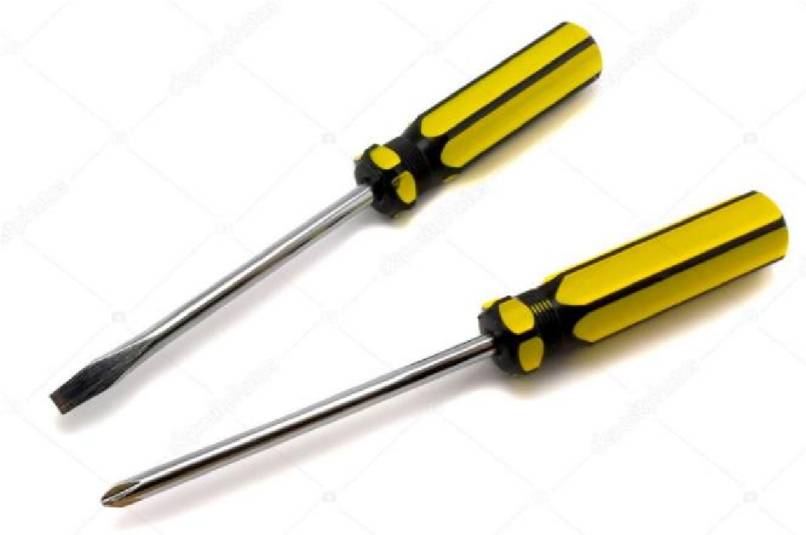
The screwdrivers are used to unscrewing all the screws attached to the inside of the pc. Screwdrivers are important to get leverage, tighten or to unscrew things or to prying things apart.

2) ANTI STATIC EQUIPMENT:

Anti-static equipment are used to discharge the electrostatic discharge while assembling a pc. The importance of an anti-static equipment is to avoid minor or major electric shocks.

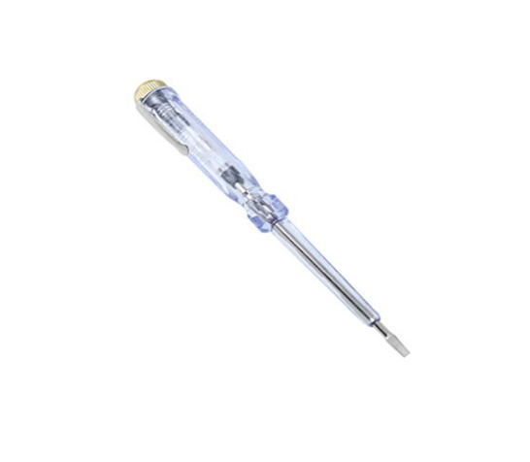
3) TEST PEN:

A test pen is used to check the presence of electricity flowing either in the cable, in the equipment or in the circuit board of the pc itself. The importance of a test pen is to test if any equipment is malfunctioning or not functioning at all.

4) PILER:

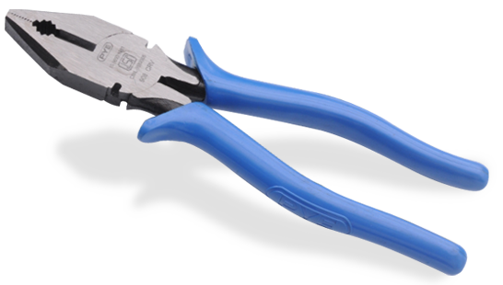
This Photo by Unknown Author is licensed under CC BY-NC

A Plier is used when the heads of cheap screws get stripped. When this happens, sometimes the only option is to use a pair of pliers. And also, pliers have a wide variety of uses, and they often include a wire cutter, which can be used to snip(cut) the excess off of cable ties.

5) SCREWS:

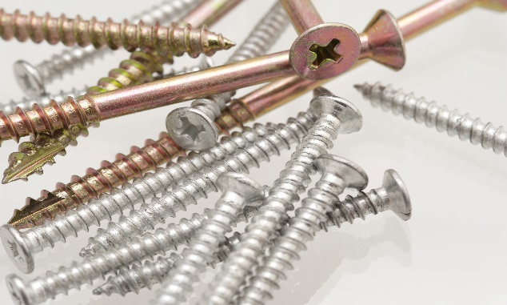

Generally, for PC, we will two types of screws, they are low and high thread-count. Low thread-count used to keep side panels in place, attach graphics cards to the back of the case, and hold together any internal case pieces. And High thread-count screws are used to secure any internal drives, like HDDs, SSDs, and optical drives.

PART B – Sketch of a mother board layout
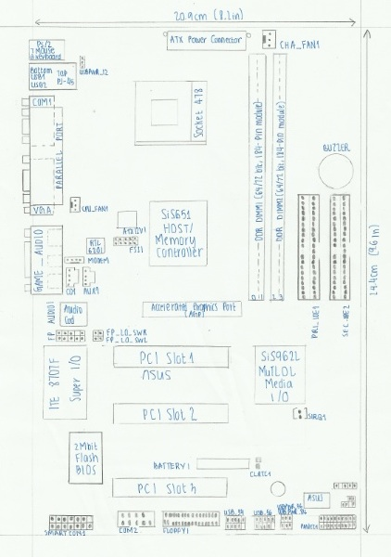

PART C - “Step by Step PC Assembly”
Based on the given video and keywords in Table 1.0, prepare a report on “Step by Step PC Assembly” that provide guided instructions on how to Assemble a PC. Assumed that in front of you is an opened computer case (without the side panels). Number of steps should not exceed the number of keywords.
1.CPU installation:
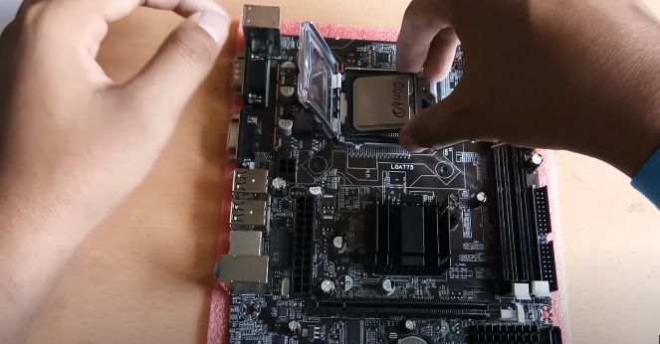
First of all, we have to take the motherboard and need to open the processor slot which included in the motherboard.

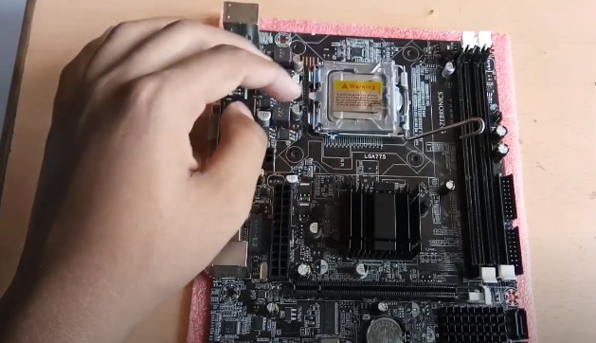
Now need to install the processor carefully in the processor slot. Make sure that all processor edge match with the slot.

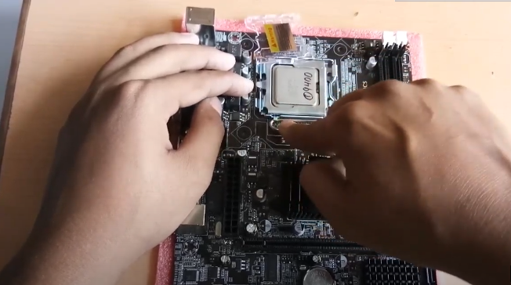
After installed the processor perfectly. Close the processor slot lock
Preauction: Close the lock carefully. It can be damaging the processor.

2. Heat sink installation:
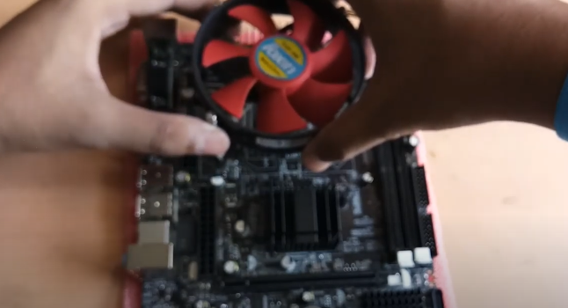
Place the CPU heatsink on the motherboard according to the diagram. After attach the heatsink, Place the mounting ring at the back of the motherboard and align it with the CPU heatsink

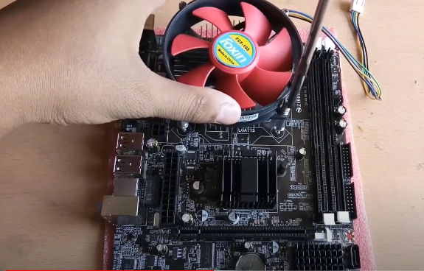
Then we screw the CPU heat sink by following X(cross)-formation on the 4 screws. After that we attach the motherboard in CPU case.

3.RAM installation:
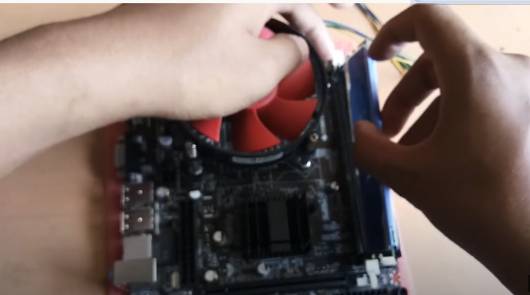
Now in this step open the ram clip at the both side of RAM slot by slowly pulling it outward before install the RAM.

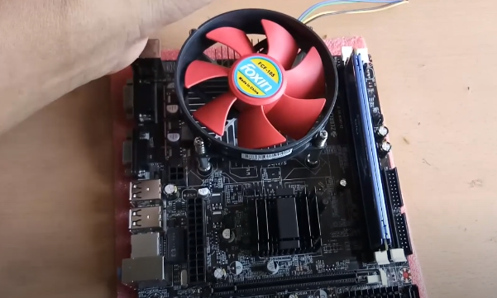
Press the RAM stick into the RAM slot slowly until hear the click sound of the RAM slot clip. Precaution: Ensure the RAM stick position is the same with the RAM slot. Read the motherboard RAM installation manual to figure out which slot need to be occupied first.

4.Power supply installation:

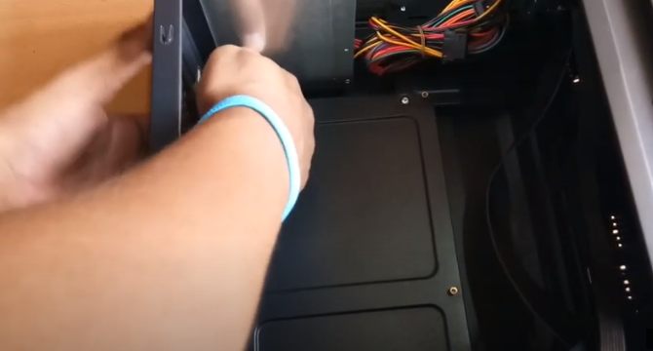
Now install the power supply in CPU case then attach the power supply using screw.

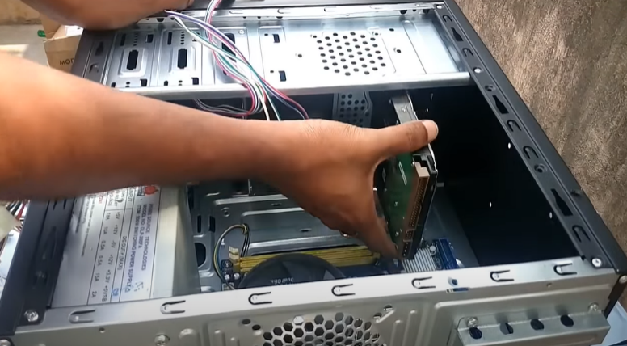
5.Hard disk installation:

After that install the hard disk. For that, place the hard disk on CPU case.

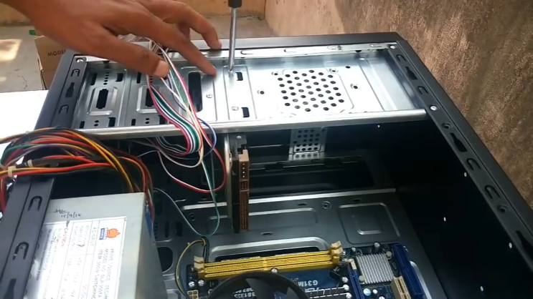
After place it into the CPU case bay and screw the hard disk tightly.
Precaution: Ensure the hard disk is tightly screwed on the CPU case hard disk bay.

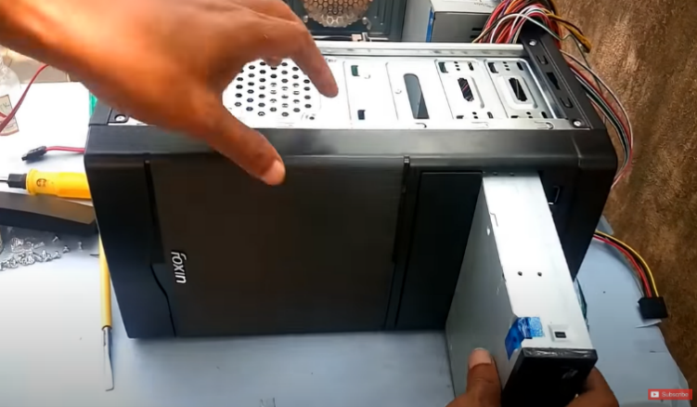
6. CD Rom/ DVD drive installation:

In this step Place the DVD drive / CD ROM in the CPU case as like as the hard disk.

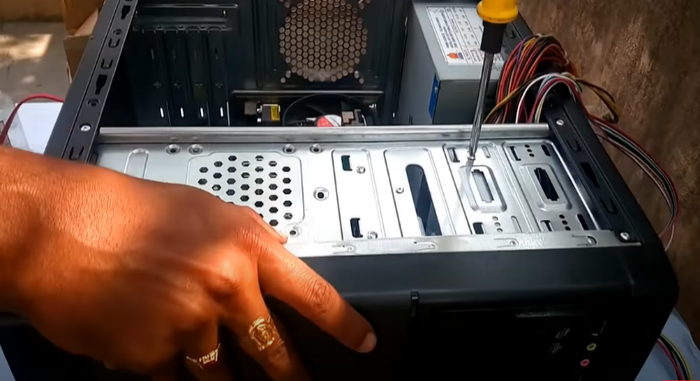
Then screw the DVD drive / CD ROM tightly by using the screwdriver.
Precaution: Ensure the DVD drive is tightly screwed on the CPU case DVD drive / CD ROM bay.

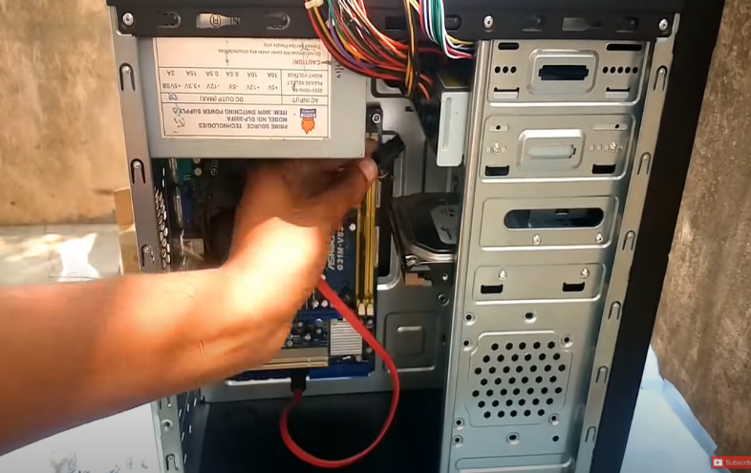
7. SATA& IDE cable installation:
Now we have to connect the CD ROM with the motherboard via SATA Cable. For that first take the SATA cable and connect one port with CD ROM and another port connect with the motherboard.
Precaution: Make sure that put the cable on right slot.

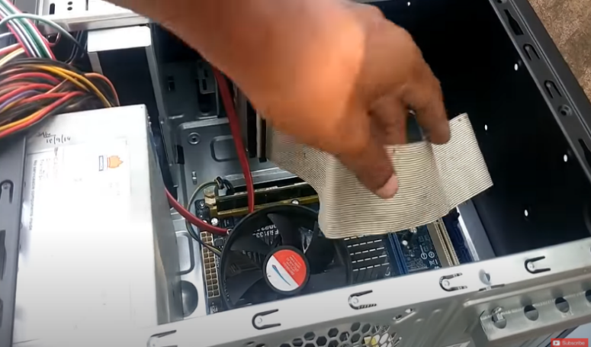
Now we have to connect the Hard Drive with the motherboard via IDE cable. If the storage drive is configured as a master, plug in the black IDE cable connector into the IDE connector on the hard disk.
If the storage drive is configured as a slave, plug in the grey IDE cable.
Precaution: Make sure that need to install it carefully.
Precaution: Make sure you put the cable on IDE slot.

8.USB port installation:
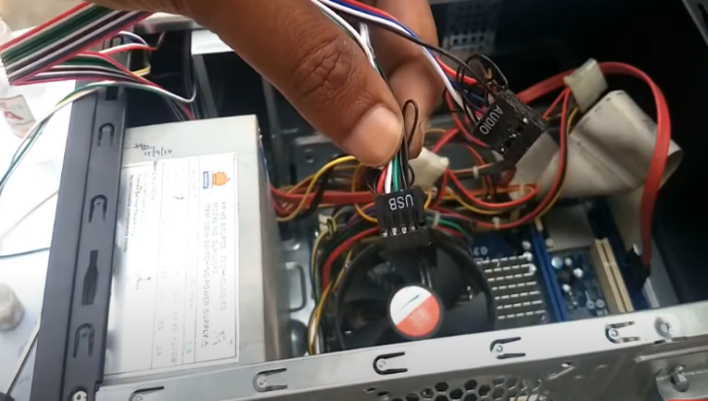
After installed the SATA and IDE cable we have install the USB port in front side and connect the cable with the motherboard.

9. Graphis card installation:

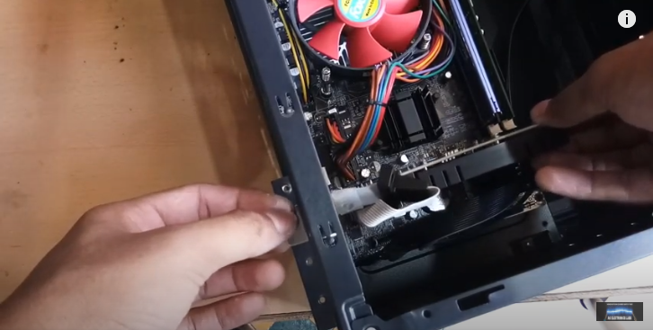
For install the graphics card, use PCI express 16x slot. Put the graphics card carefully like RAM installation on PCI slot.
Precaution: Make sure we need to use PCI express 16x slot.

10. Power supply Connection:
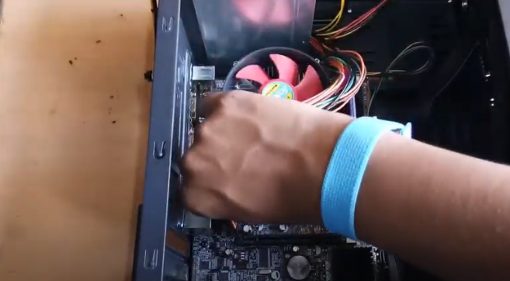
Now connect the power supply port with Motherboard, CD ROM, and Hard Drive. For motherboard connection use Power SW, Reset SW, Power LED, H.D.D LED ports

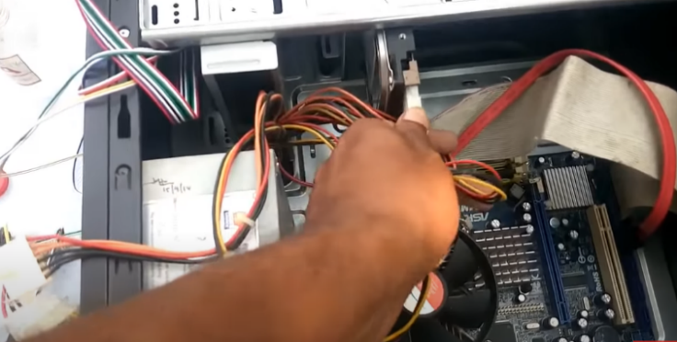

Then connect ATX power supply pin with the Hard Drive.

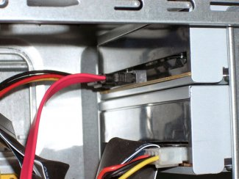

And lastly, connect 4 pin peripheral port with CD ROM

11.Closing the case:
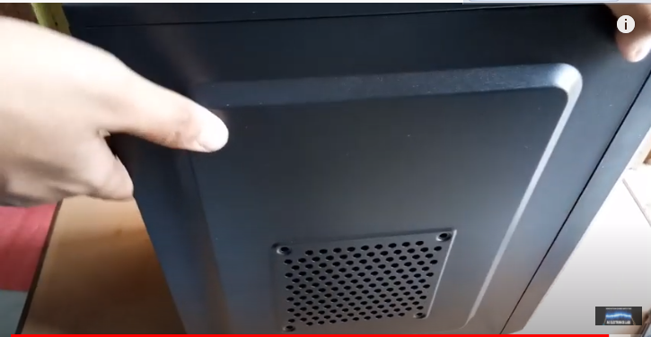
After finishing to installed all of the ports close the CPU back panel case using by screw. Now the system is ready for the OS installation.

