
SCHOOL OF COMPUTING
SESSION 2020/2021 SEMESTER 1
SECP 1513 -07
TECHNOLOGY AND INFORMATION SYSTEMS
ASSIGNMENT
STEP BY STEP BASIC PC ASSEMBLY

GROUP MEMBERS :
1. SAVERO FAJRI SUTIONO (A19EC3016)
2. ABDULRAHMAN AHMED RAFAT ABDELHAMID (A20EC0523)
3. MUHAMMAD HAFIZZUL BIN ABDUL MANAP (A20EC0211)
4. IBTESHAM AHMED PROMIT (A20EC4027)
LECTURER : DR. HASWADI BIN HASSAN

Semester I 2020/2021
Subject : Technology and Information Systems (SECP1513)
Section : Section 07
Assignment : Step by step PC Assembly
GROUP NAME / NUMBER : GROUP 6
1 |  | Name : Savero Fajri Sutiono  Matric Number :A19EC3016  Phone Number :+60 19-748 3976  E-mail :saverosutiono@graduate.utm.my
2 |  | Name : Abdulrahman Ahmed Rafat Abdelhamid  Matric Number : A20EC0253  Phone Number : +201126693008  E-mail : rafat@graduate.utm.my
3 |  | Name : Muhammad Hafizzul bin Abdul Manap  Matric Number : A20EC0211  Phone Number : +60 17-5637749  E-mail : muhammadhafizzul@graduate.utm.my
4 |  | Name :Ibtesham Ahmed Promit  Matric Number :A20EC4027  Phone Number :+601156226504  E-mail :promit.i@graduate.utm.my

PART A
1.0 Screwdrivers
The screwdriver Phillips head number 2 it’s better a longer length and also a magnetic tip. The function of a screwdriver is to screw bolts and bolts in PC building are usually phillips bolts. It’s very important to have the screwdriver, it's actually the main tool of building a PC. Without a screwdriver your PC cannot be assembled. Maybe carry a different variance of screwdriver just in case but number 2 phillips will be enough
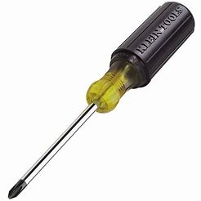
2.0 Zip Ties
Zip ties, regular zip ties are used to tie the cable together just to make them tidier. It’s very important to use zip ties because if the cables are messy it will be hard to work on and we don’t want to misinput the cables.
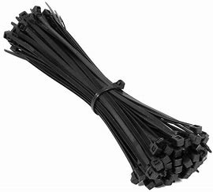
3.0 Wire Cutter
Wire cutter, an usual wire cutter will do, the purpose of a wire cutter is to cut the zip ties. Why is It important to use wire cutters? It's because wire cutters have shorter blades than any other cutters it will be easier to cut the zip ties and not accidently cut the wires.


4.0 Torch
Torch or any other light source, is used to see in case the bolts roll over into a dark place on your PC. It's very important not to lose a bolt inside your pc if you lost 1 inside your pc it's better to find it, you don’t want a bolt to break your work.

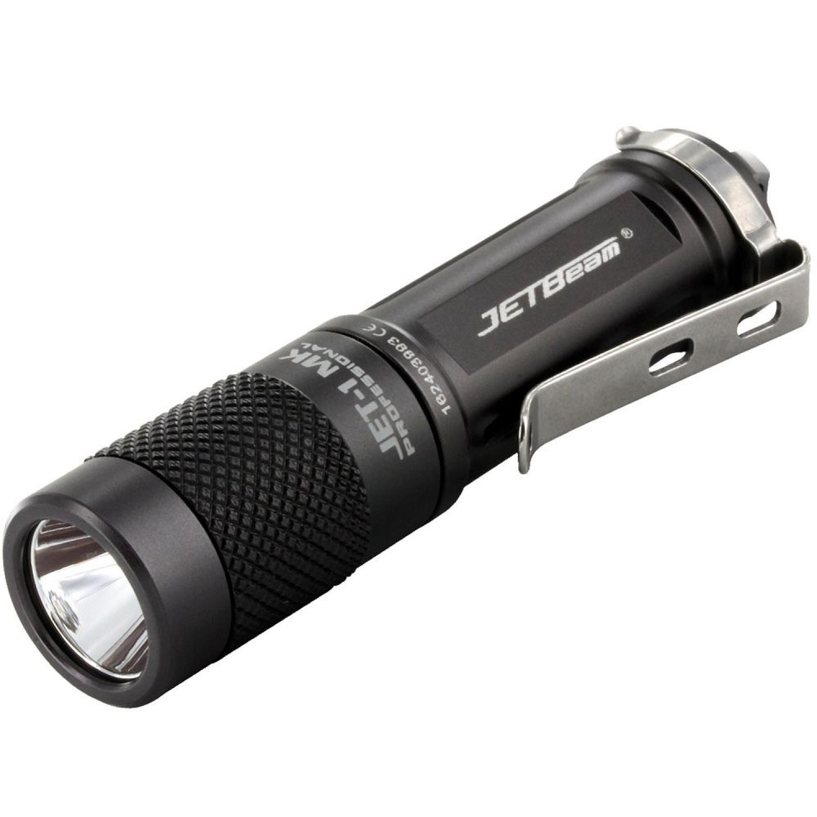
5.0 Anti-Static Equipment
Anti-static equipment, used to eliminate most risk of electrostatic discharge, is very important to not get electrocuted so it's better to have this thing around.
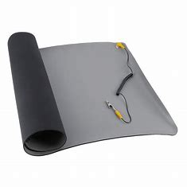

PART B
Motherboard Sketch:

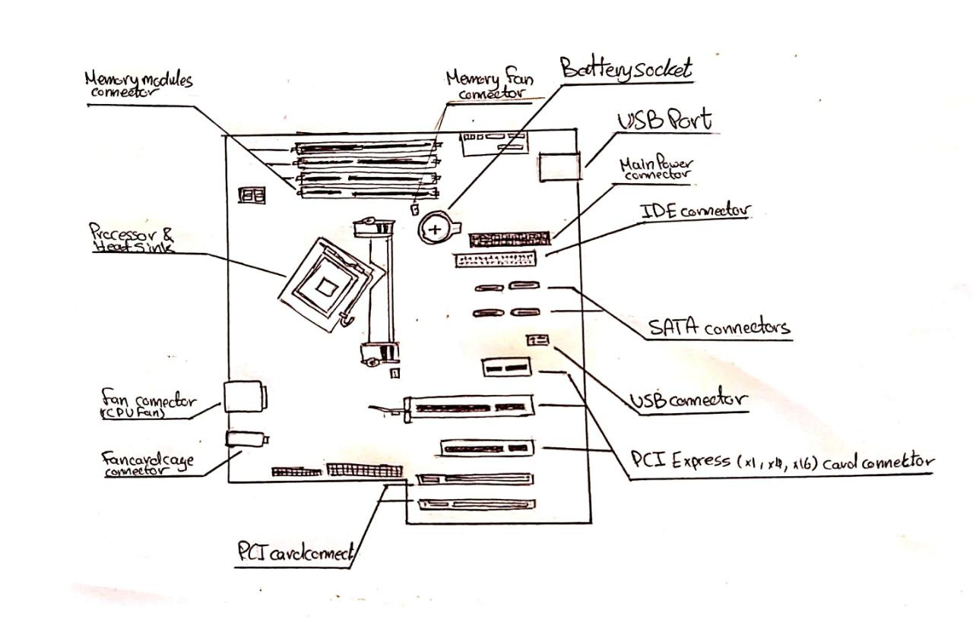

1. Graphics Card:
A video card (also called a graphics card, display card, graphics adapter, or display adapter) is an expansion card which generates a feed of output images to a display device (such as a computer monitor). Most video cards are not limited to simple display output. Their integrated graphics processor can perform additional processing, like removing a task from the central processor of the computer. There are two types of graphics cards which are integrated and dedicated. An integrated graphics card, usually by Intel to use in their computers, is bound to the motherboard and shares RAM(Random Access Memory) with the CPU, reducing the total amount of RAM available.
Intel Chipset Manufacturer And Integrated Graphics Card:
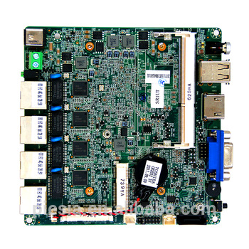
MSI RTX 2080 Ti integrated graphics card:
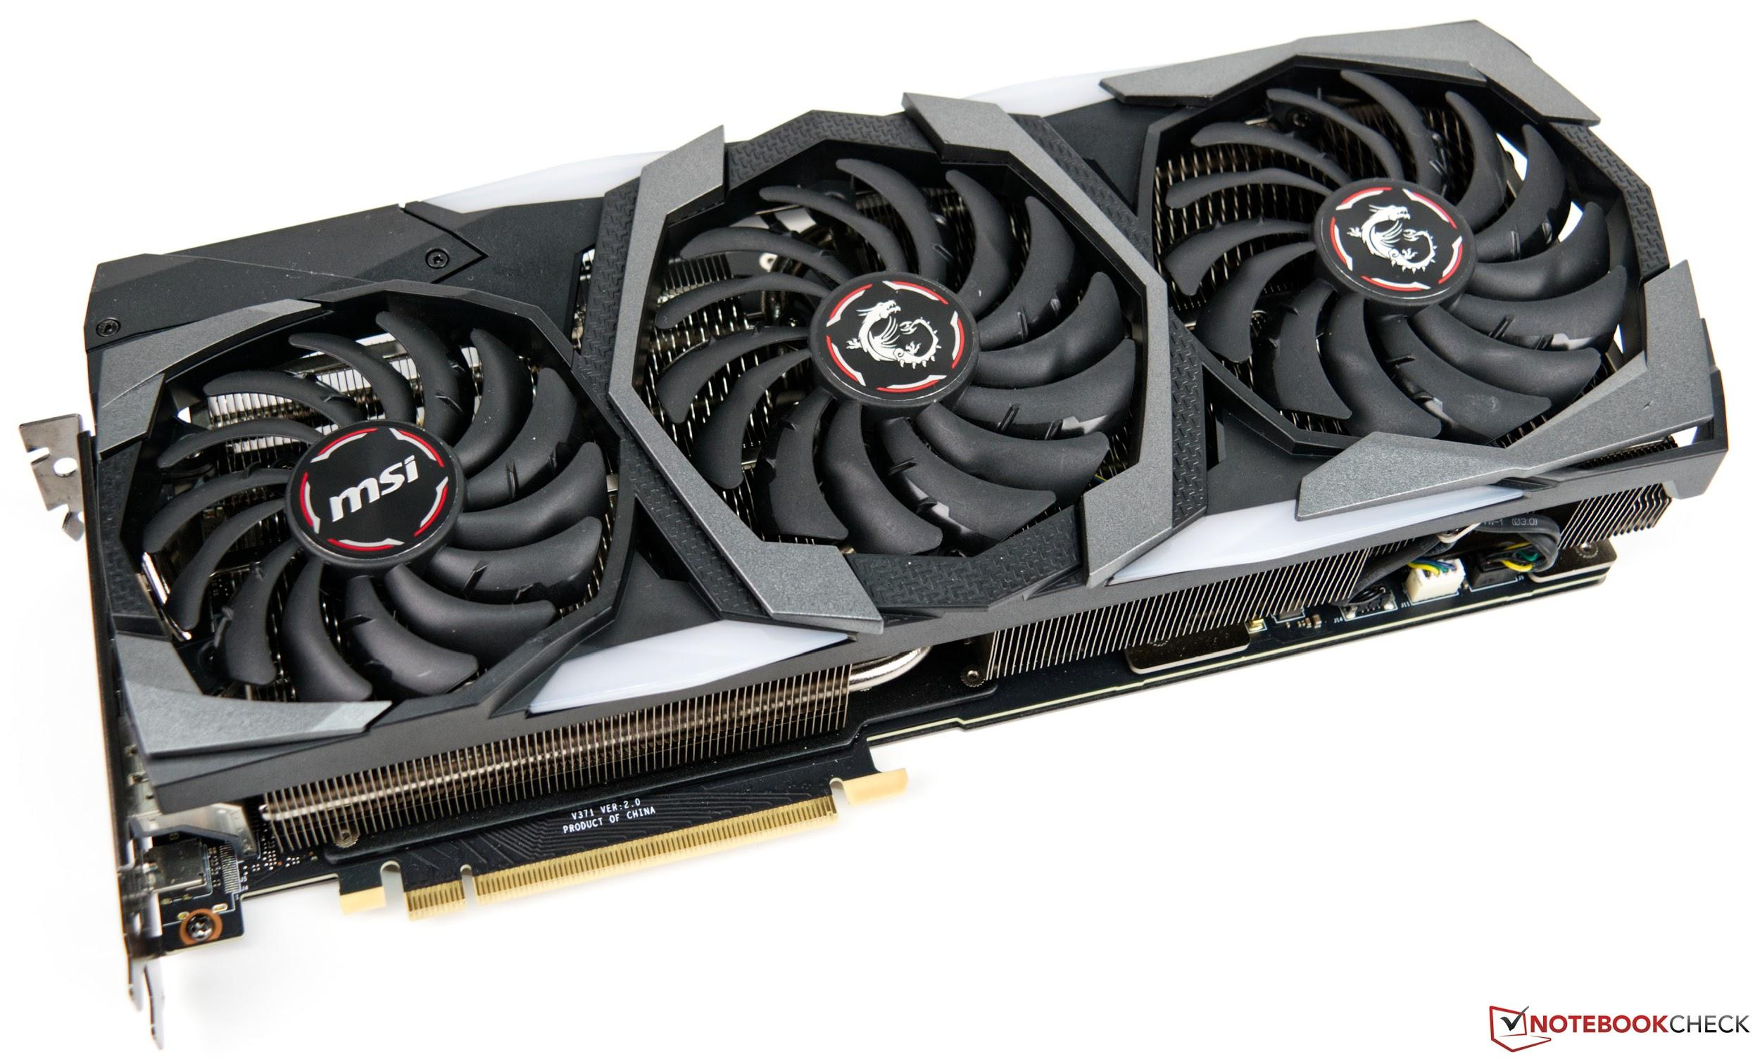
2. USB cable:
Universal serial bus (or USB for short) is a standard industry connector/cable that is widely used across multiple systems and platforms. USB cables are connected to computer units directly to peripheral devices like mobile phones, cameras, camcorders and printers/scanners. The main function of these cables is to effectively, quickly and properly gather or transfer data from one device to another. There are 11 different types of USB connectors, including USB-A and USB-C. There have been four generations of USB specifications, going from USB 1.x until the recent USB 4.
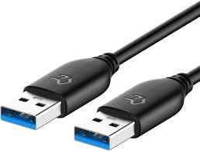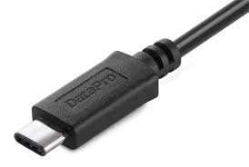
USB-A 3.0. USB-C.
3. IDE cable:
Integrated Drive Electronics (IDE) is a standard type of connection for computer storage devices. Generally, IDE refers to the types of cables and ports used to connect certain hard drives and optical drives to each other and to the motherboard.

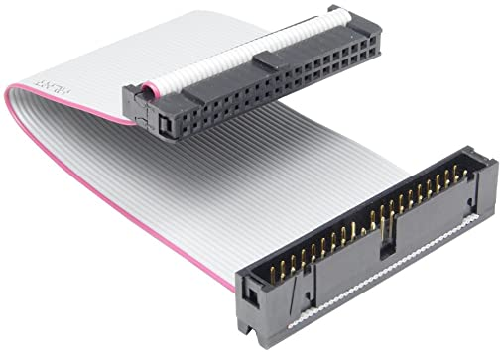
4. CPU / Processor:
Processor(CPU) is considered as the brain of the computer. A computer's CPU handles all instructions it receives from hardware and software running on the computer. It performs all types of data processing operations. It can store data, intermediate results, and instructions (program). The CPU controls the operation of all parts of the computer. The main function is to take input from the peripheral or the computer program and interpret it. Then it will send the output information to the monitor or perform the task. CPU consists of three components which are Memory or Storage Unit, Control Unit, and Arithmetic Logic Unit(ALU).
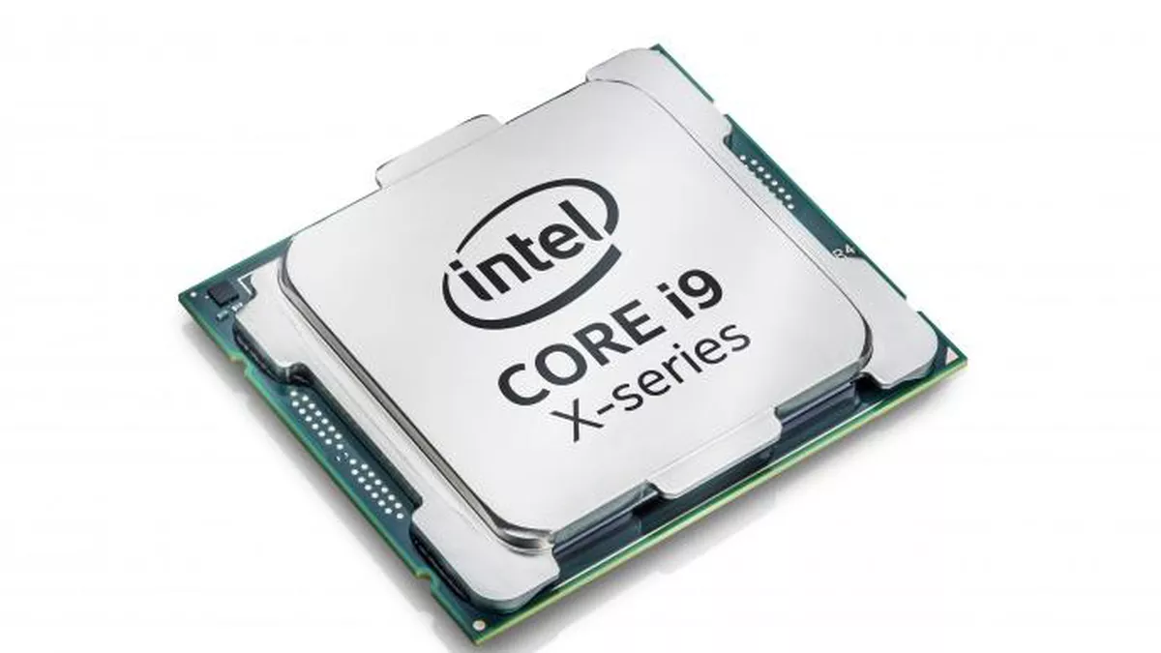
Intel Processor Core i9
5. Slots:
A slot consists of an operation issue and a data path machine surrounding a set of one or more execution units. For this purpose, the term slot is common in very long instruction word (VLIW) computers, where the relationship between the operation in the instruction and the pipeline to be executed is explicit. In dynamically scheduled machines, the concept is more commonly referred to as pipeline execution. There are several types of slots on a motherboard, like CPU Slot, RAM Slot, PCI Slot, and PCI Express Slot.
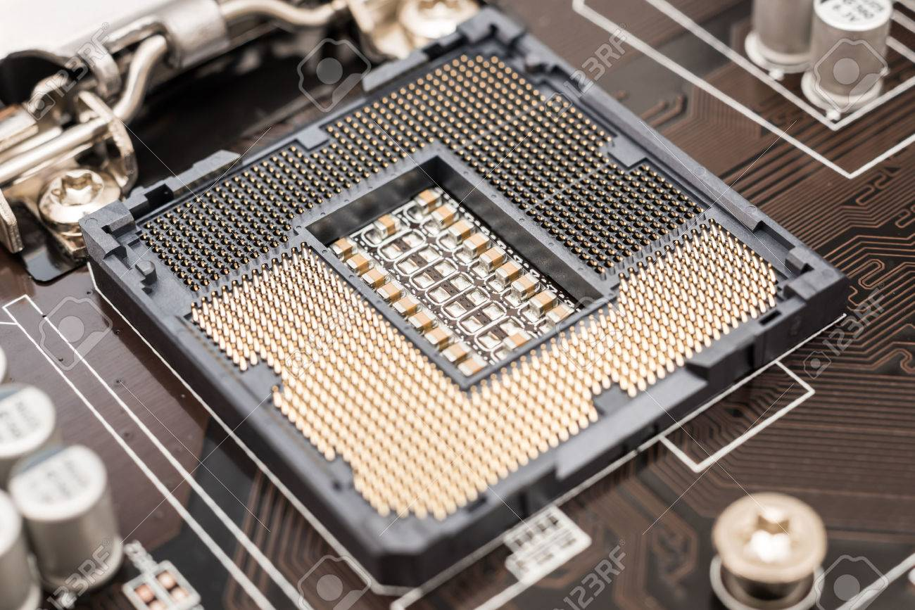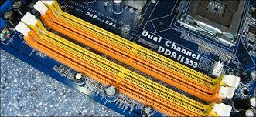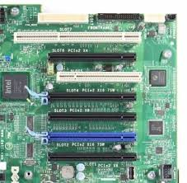

6. Power supply:
A power supply unit converts mains AC to low-voltage regulated DC power for the internal components of a computer. Modern personal computers universally use switched-mode power supplies. Some power supplies have a manual switch for selecting input voltage, while others automatically adapt to the mains voltage.
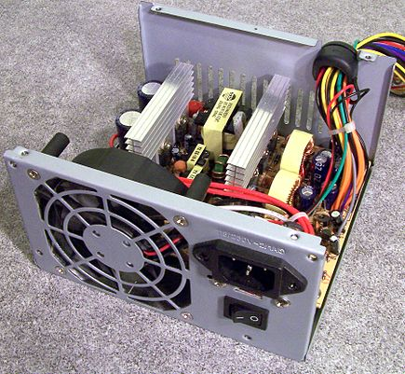
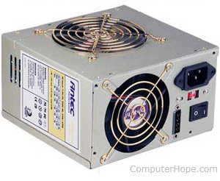
Example: Antec True 330 W Power Supply
7. Heat Sink:
A heat sink is a device that incorporates a fan or another mechanism to reduce the temperature of a hardware component such as the processor. There are two types of heat sink which are active and passive. It works by increasing the heat flow away from a hot device. The heat sink has a thermal conductor that carries heat away from the CPU into fins that provide a large surface area for the heat to dissipate throughout the rest of the computer, thus cooling both the heat sink and processor.
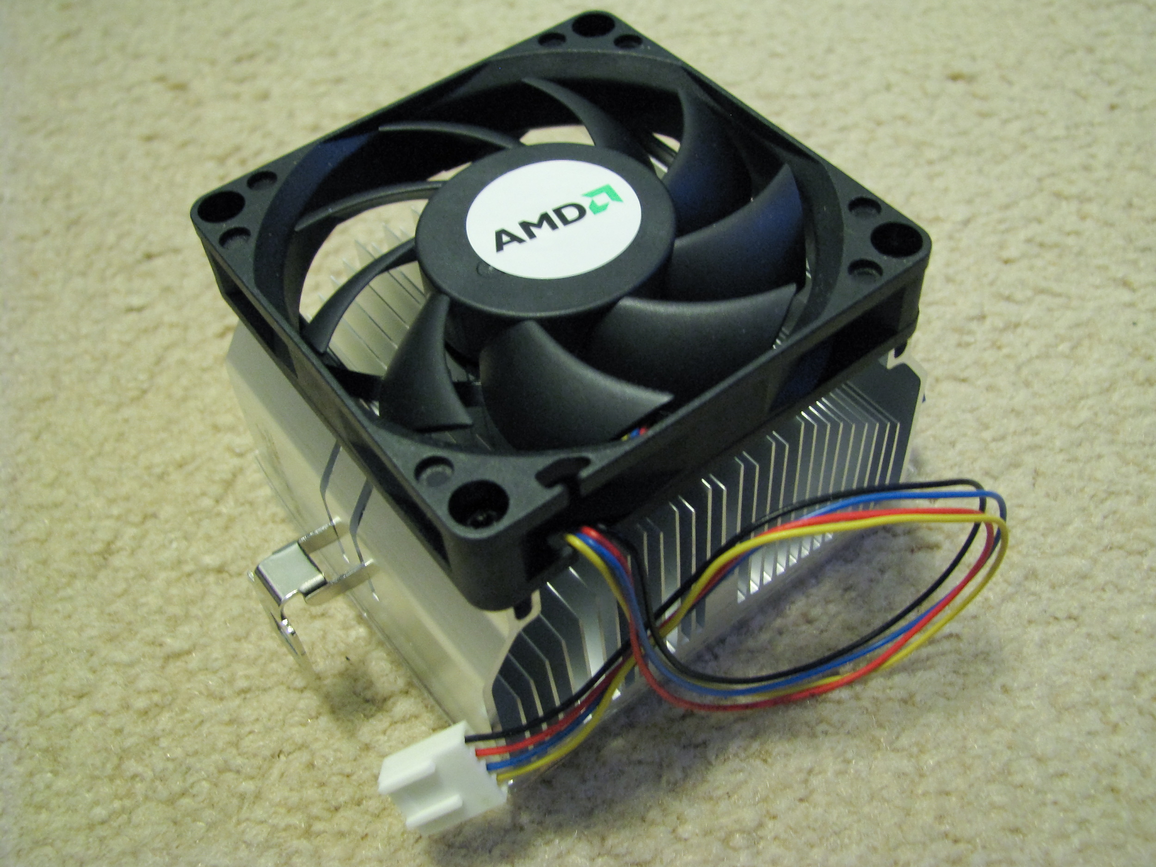
Example: AMD CPU heatsink
8. RAM:
Random-access memory (or RAM) is a volatile type of memory device, meaning that the stored information will be lost once power is cut/ removed. RAM gives applications a place to store and access data on a short-term basis. It stores the information your computer is actively using so that it can be accessed quickly. RAM devices can read and change data in almost the same amount of time with no respect to the physical location of data in the memory.
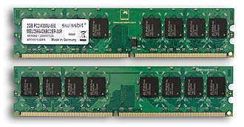
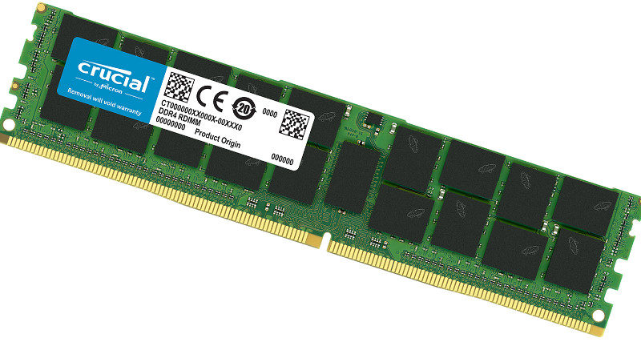
Example: DDR5 RAM
9. Hard Disk:
Hard disk drive or HDD is an electro-mechanical data storage device. It stores and receives (digital) data using magnetic storage and one or more rigid rapidly rotating platters coated with magnetic material. HDDs are one example of non-volatile storage devices, meaning the data stored won’t be lost when power is cut.

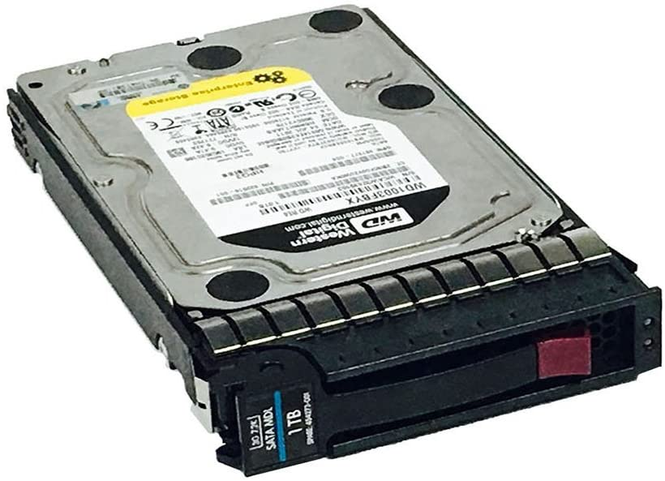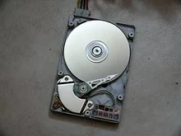

Example: HP 1 TB 3.5" Internal Hard Drive 454273-001

10. CD ROM:
Compact Disc Read-Only Memory (CD ROM) is a CD that can be read by a computer with a CD ROM drive. The “ROM” part of the term means that the data on the disc is “read-only”, or cannot be changed or erased. CD-ROM drives can open documents on data CDs, such as music files, pictures, word documents and other files.

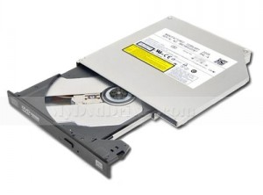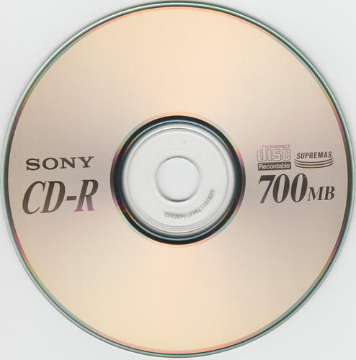
Example: HP 520 CD ROM Drive
11. SATA cable:
Serial Advanced Technology Attachment (SATA or Serial ATA cables) is used for connecting devices in computer cable assemblies, such as storage devices. SATA technology itself is a connector interface primarily used for computer bus connections in storage applications.
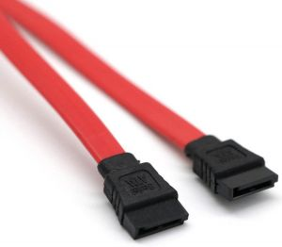
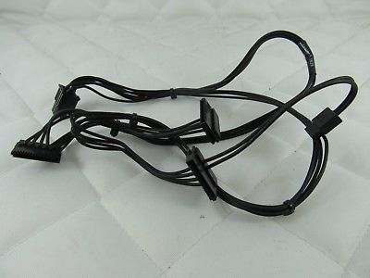
Example : HP Z240 SFF SATA Cable

PART C - “Step by Step PC Assembly”
Based on the given video and keywords in Table 1.0, prepare a report on “Step by Step PC Assembly” that provides guided instructions on how to Assemble a PC. Assumed that in front of you is an opened computer case (without the side panels). Number of steps should not exceed the number of keywords.
STEP 1 – Mounting Processor/CPU into Motherboard
- Locate the CPU socket holder on the motherboard and lift up the latch lever to release and hinge open the CPU socket cover.
- Gently place the CPU straight down into the motherboard socket to seat the CPU
- Make sure the CPU is placed on the socket properly lower the CPU socket cover and the latch lever closed again to secure the CPU socket holder closed
- Apply a little amount of thermal paste on top of the CPU
- TIP - Don’t apply force to seat the CPU. Avoid touching or pressing down on the back of the CPU with fingers, as any residue from hands can destroy the heat transfer surface for the cooler which will be mounted next.
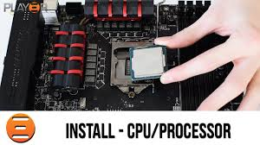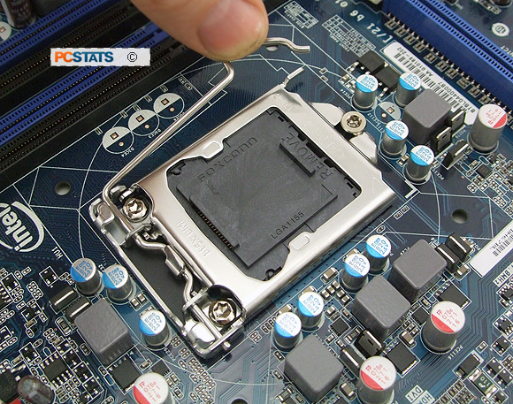
Hold the CPU by its sides, and line up the triangle on the corner of the CPU to the triangle marked on the motherboard.
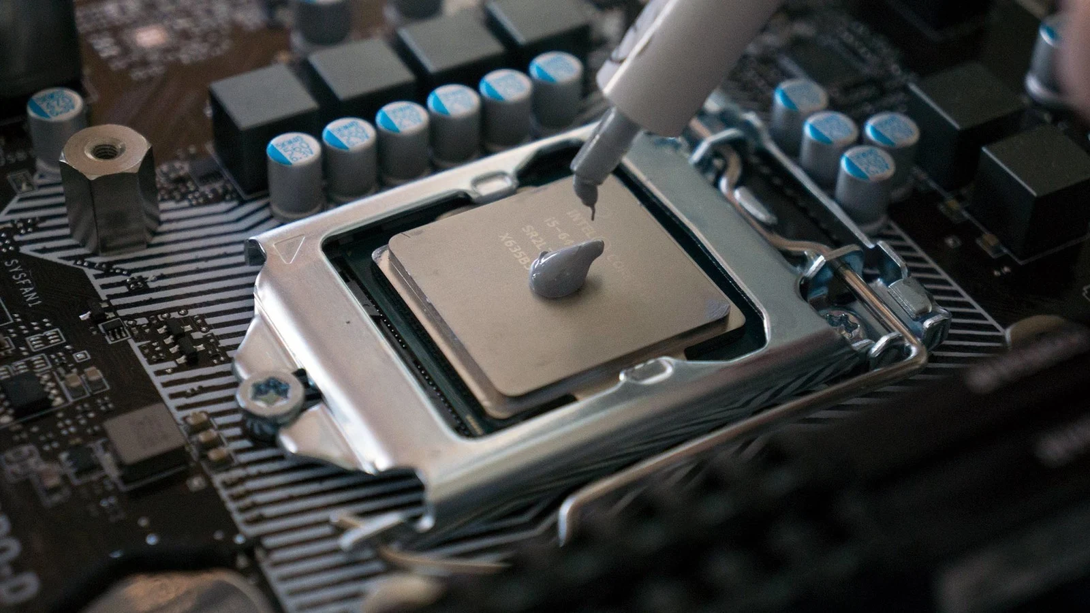
Applying thermal paste on the CPU
STEP 2 – Installing Heat Sink/CPU Cooler
- Install heat sink/CPU cooler neatly and properly and fix in position on top of the CPU
- Make sure the heat sink is clipped tightly
- Plug the power cable attached to the cooler fan into the motherboard connector
- CAUTION : thermal paste should be applied or else it will cause in insufficient cooling and will damaged the CPU or motherboard
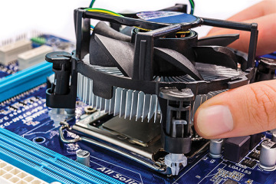
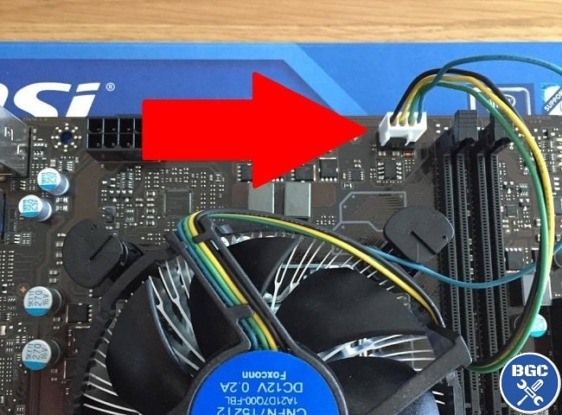
STEP 3 – Installing RAM
- Line up the notch on the RAM with the mounting slots.
- Install RAM into the RAM slot and make sure it is installed correctly by pressing it firmly down into the slot.
- CAUTION: The RAM boards or the motherboard could be damaged if the board is pressed when the tab is not aligned.
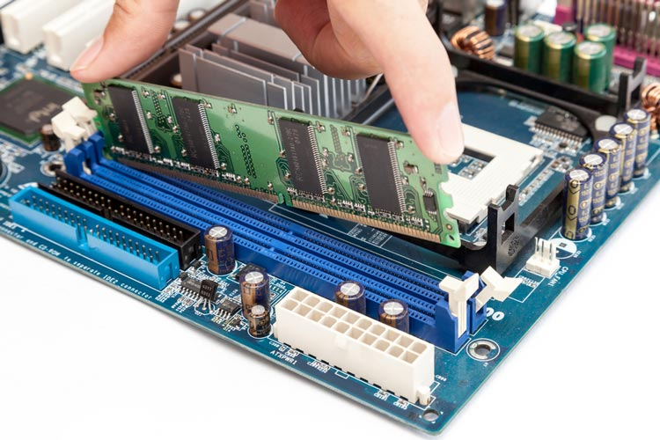
STEP 4 – Installing Power Supply in Computer Case
- Install Power Supply in Computer Case
- Mount the power supply and tighten the screws on each part
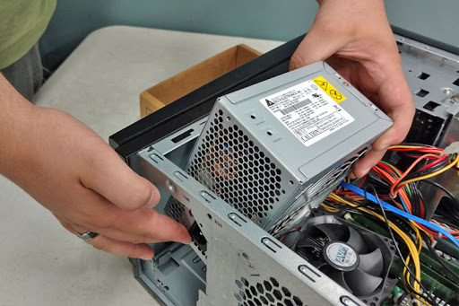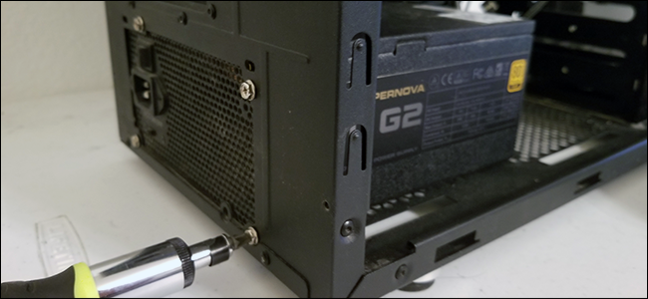
STEP 5 – Mounting Motherboard into Computer Case
- Screw motherboard into the case neatly
- Punch out rear I/O plate from the case and replace it with the motherboard I/O
- Fasten the motherboard in place on top of the mounting standoffs
- TIP: Install the mounting standoffs in the case positions that match the screw mounting holes on the motherboard to prevent any damages.
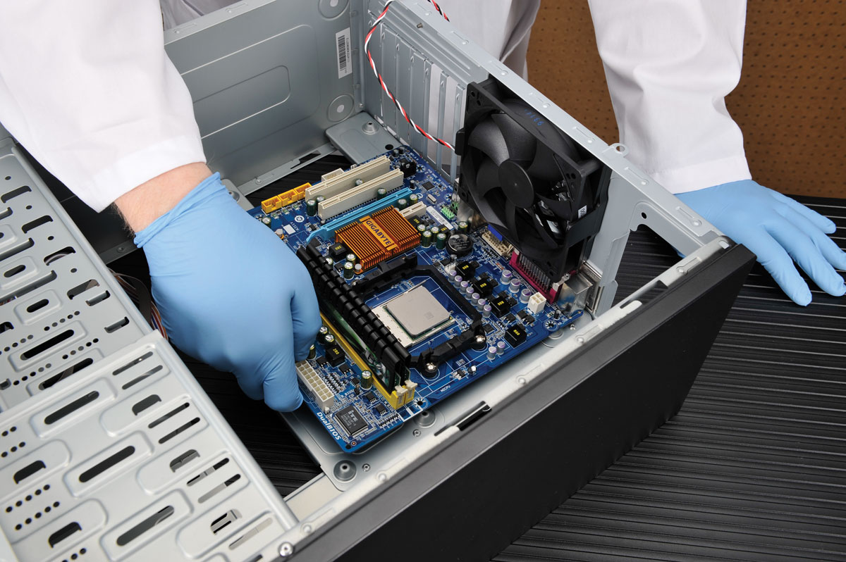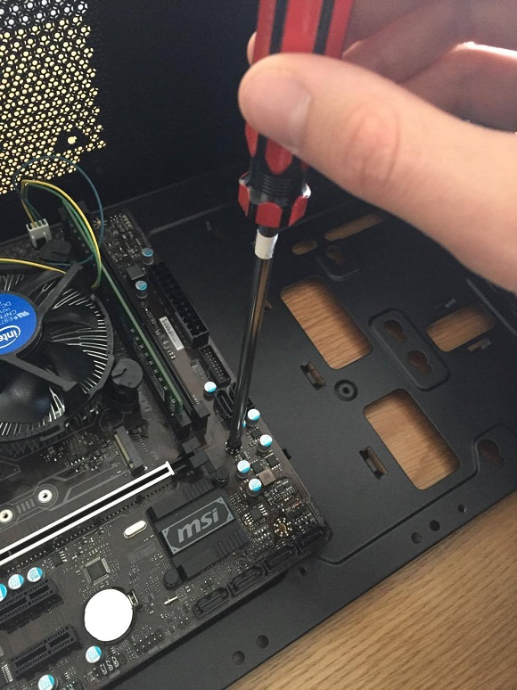
STEP 6 – Installing Graphics Card into PC slot
- Remove the expansion slot covers from the rear of the case where the graphics card will sit
- Install the graphic card in the PCIe slot. Line it up and press down firmly to install the card
- Screw on the graphic card holder so that it is neat and not easily moved
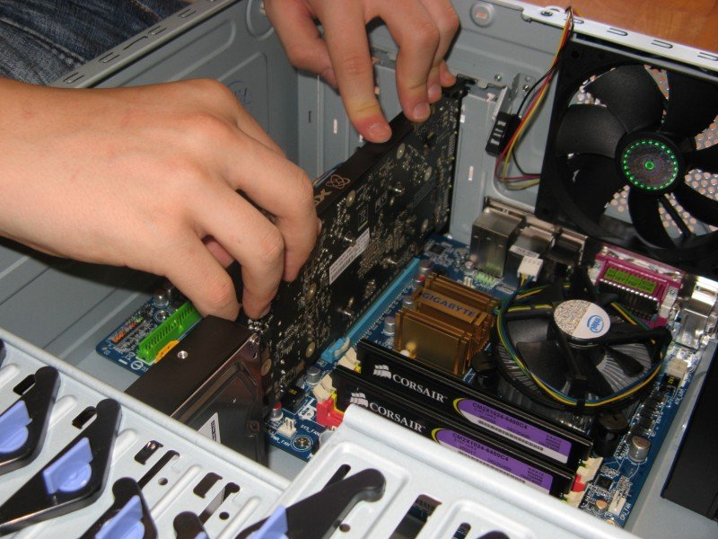
STEP 7 – Mounting CD ROM Drive
- Remove the front panel from the case where the CD ROM drive will sit
- Make sure it is oriented correctly before installing the screw
- Mount the CD ROM drive into the case by fixing with screws through the case frame into the case mounting holes located on the CD ROM drive.
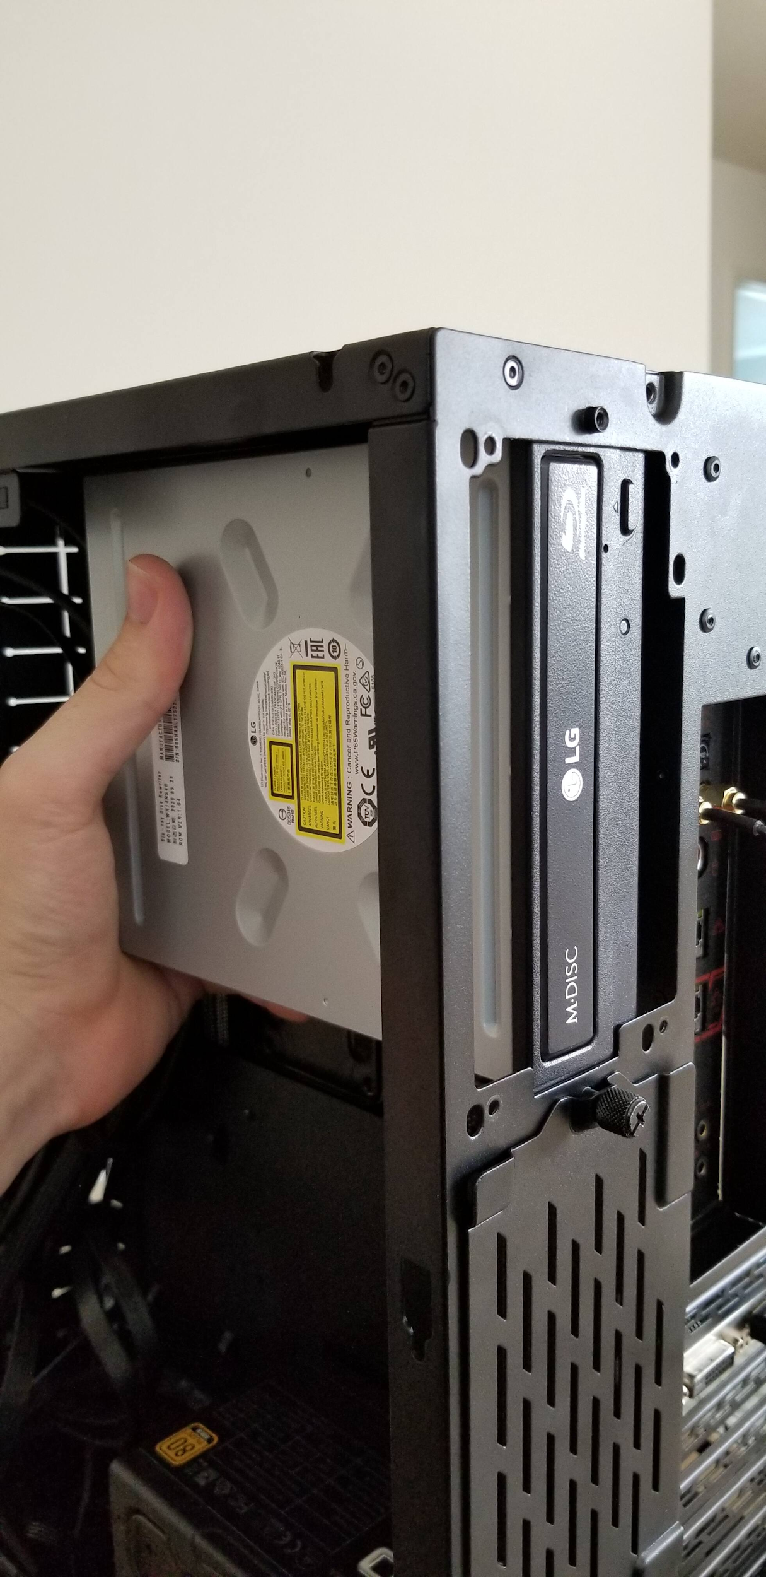
STEP 8 – Mounting the Hard Disk
- Mount the hard disk in the case drive bays
- Fix it in place with screws through the case frame into the case mounting holes located on the storage device
- Make sure the CD ROM drive and Hard Disk not easy to sway or loose to ensure it is not easily damaged
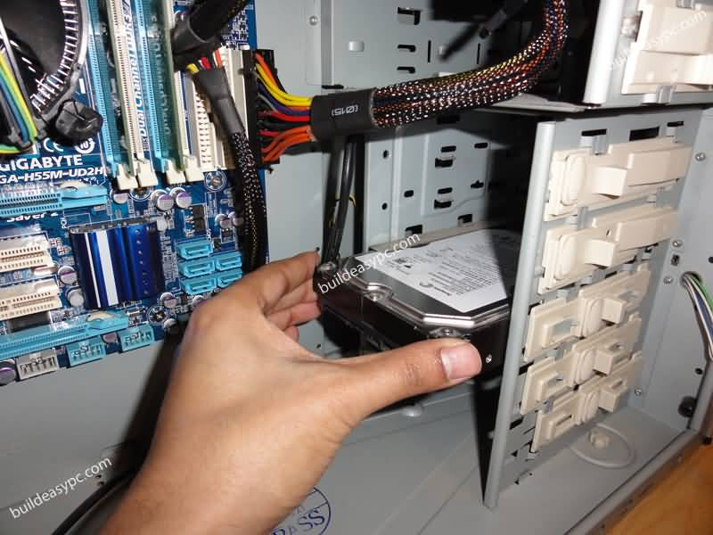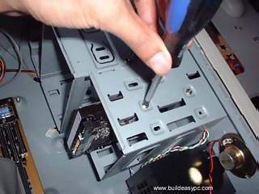
STEP 9 – Connecting IDE, SATA and Power Supply Cables
- Connect the IDE cable for the CD ROM drive to the motherboard
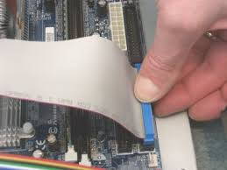
- Connect the SATA cable for Hard Disk to the motherboard
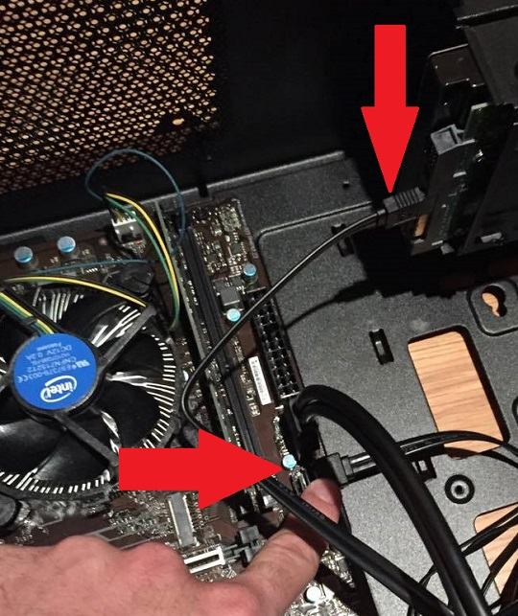
- Connect the Power Supply to each drives
- Tidy up the connection of the IDE and Power Supply cables neatly to use less space and avoid heat accumulation in the case. Zip ties can be used to tie the cables and wires.
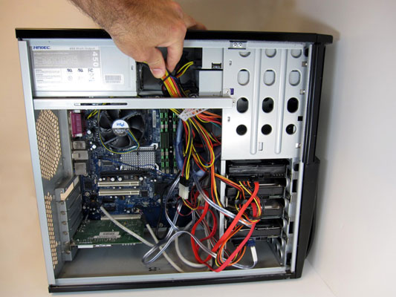
- CAUTION: Make sure all connections are correct because incorrect connections can cause damage to the components.
STEP 10 – Connecting Switch Wire and USB Cable on the Motherboard
- Connect the switch wire and USB cable which located in the case to the motherboard
- Refer to the Motherboard Installation Manual to ensure the connection is performed correctly and precisely
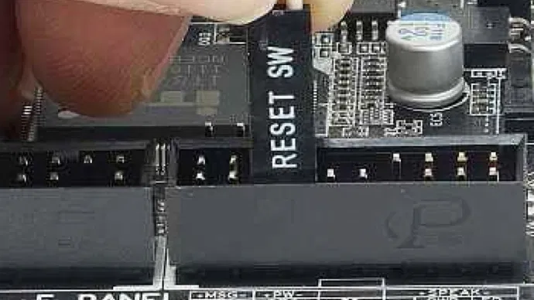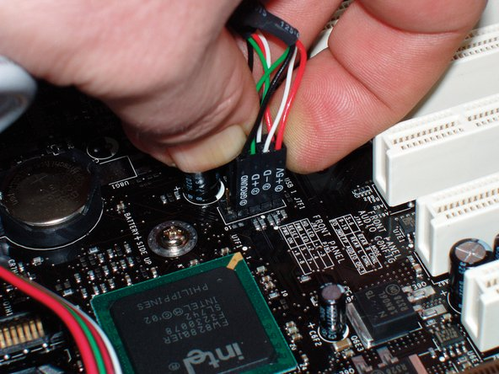
STEP 11 – Closing the Case and Connecting the Peripherals
- Place the side cover back on and secure the side panels with case screws
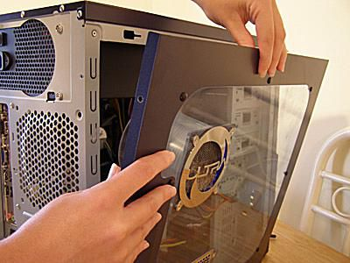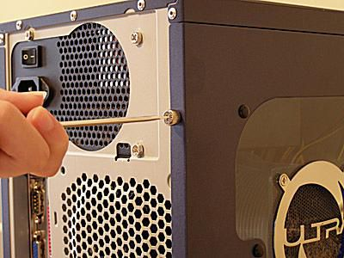
- Connect peripheral devices which include keyboard, mouse, wireless network dongle, printer, and webcams with your CPU by plugging into USB port.
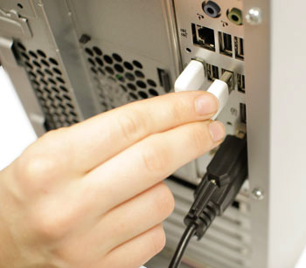
- Then, connect speakers and microphone into 2.5 mm sockets.
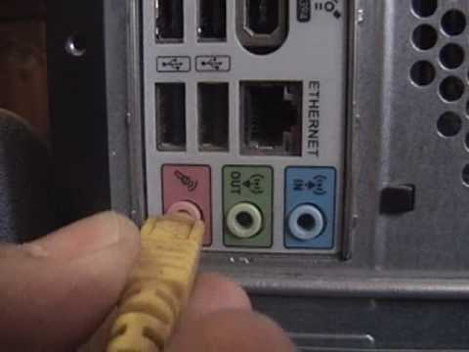
- Finally connect the CPU with the monitor by plugging into display ports.
