Report
Our topic is about the world in the view of Islam. we have discussed about the problems ,solutions ,metaphors etc in the presentation .
Our group members of this project:
1.MD TAWFIQUZZAMAN
2.MD SIRAJUM MUNEER
3.HASAN ADITTIYA
4.MAHI ANAN
5.MASQURUL HASAN
Summary of the project : Our main intension was to upload the view of Islam to everyone by this project as people from various background think Islam differently .Maybe some people think this is not a religion of peace as we want to change the view of them through this. Then we make video, poster and presented in the class. As ISLAM is the 2nd large religion in the world ,different people has different views about ISLAM. It is a matter of sorrow that some people think Islam is a religion that support terrorism and criminalism but terrorism is totally barred in Islam. Let’s see what THE HOLY QURAN tells about this:
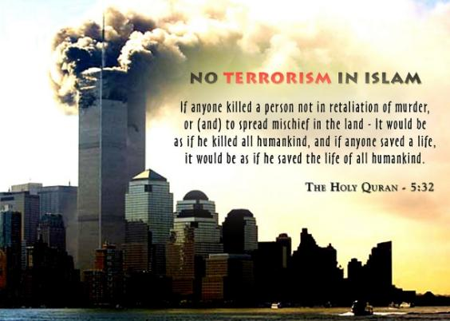
QURAN’S SAYING ABOUT TERRORISM
Another thing is just because of one person you can’t blame the whole religion as there could be a lot of good persons . Our prophet told us to invite mankind to Islam (who are not muslim) but we can’t force them .We have to convince them through love and affection .Islam also doesn’t support any criminal activities .Yes, we were told to stand against any kind of wrong activity but we are not told to commit ant criminal activity . Let’s see what Quran tells about criminals :
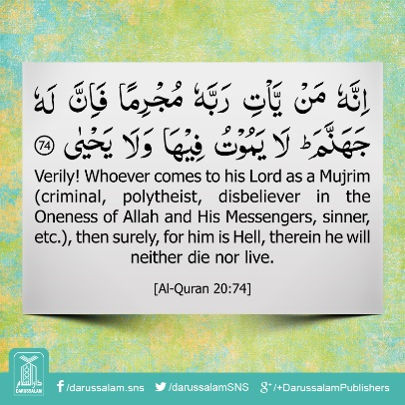
Quran’ saying about CRIMINALS
Methods of preparing video: For making this video we use Animaker app. The duration of the video is 3min58 sec. It takes two hours to make this video. We have to watch some videos on YouTube first then we discuss among ourselves and make a script in notepads. After this we make this video.

OUTCOMES OF THE SURVEY CONDUCTED: Our survey outcomes is to reach the thinking level of the common people and their complications about Islam. By this we found out that 13% people think that Islam is a complicated religion, 5% think that Islam supports the terrorism and criminal activities ,2% people think that Islam always creates unnecessary wars etc. So, our motive has to be strong that we can change thinking the little percentage of people.
CONCLUSION: Islam means peace. The philosophy of Islam is to spread love, peace and brotherhood. We cannot blame a community by judging on a few people. There are always some people in this country whom always wanted to gain their individual interest. This kind of people always waiting to get the frustrated and bad people to use them for their interest. We have to find out who are they, what is their religion and root. Islam teach us that everyone is our brother and sister, we have made good relationship with them. We should respect other religion and culture. So, it is clear that a true Muslim can never become a terrorist. We have to change our way of thinking and society.

References:
- https://en.wikipedia.org/wiki/Islamic_terrorism.
- https://americanhumanist.org/what-is-humanism/islam-terrorism-humanist-view/.
- https://www.tandfonline.com/doi/abs/10.1080/10576100600781612?queryID=%24%7BresultBean.queryID%7D.
- https://www.tandfonline.com/doi/pdf/10.1080/15205436.2017.1342131.
- https://www.researchgate.net/publication/228162087_'I'M_a_Muslim_But_I'm_Not_a_Terrorist'_Victimization_Risky_Identities_and_the_Performance_of_Safety.
- https://www.unafei.or.jp/publications/pdf/RS_No71/No71_09VE_Praja1.pdf.

