
Semester I 2020/2021
SECP 1513
Technology Information System
Faculty of Engineering
School of Computing

Group: 10
Group member: 1. Kheng Ming Jie (A20EC0197)
2. Ariq Ghazi Rabbani (A20EC0262)
3. Hasin Araf (A20EC4024)
4. Hasan Adittya (A20EC4023)

PART A
1.0 Screwdriver
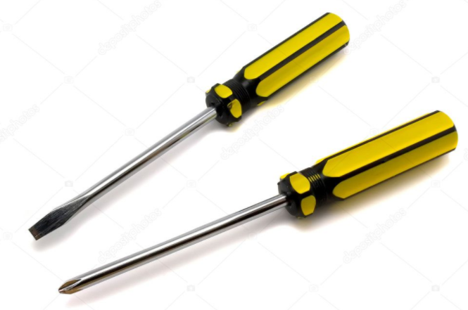
The Screwdrivers function is for turning screws with slotted heads in PC hardware during assembly, they are also used to tighten screws within each part. It’s Importance when it comes to PC assembly is that they are the most used tools in PC assembly, screwdrivers have many types, the two most important types of screwdrivers are standard and the Philips screwdrivers. These two types of screwdrivers are the most commonly used screwdrivers. Standard and the Philips screwdrivers are made in a variety of sizes and in several styles. The mostly commonly designs are straight, shank, and offset. For the safety measures, it is always recommended that use the right width blade when installing or removing screws. The most important tool for PC building is a Phillips-head screwdriver with a big bit, helpful to avoid stripping the head; a long shaft also aids in keeping the handle out of the way when working in tight spaces—it’s a good idea to keep a short screwdriver around as well, for the same reason.

2.0 Anti-Static Kit
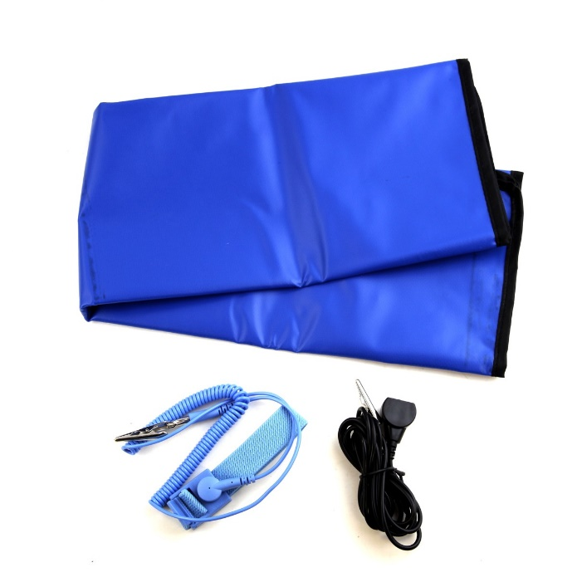
Anti-static equipment should be used for any serious PC assembly. This Tool protects the equipment from static damage and protects your tabletop from scratches. Touching a grounded case or another grounded, metal object occasionally will eliminate most risk of electrostatic discharge, but better safe than sorry. The anti-static mat and service kit is essential when you're repairing or building electronic equipment containing components sensitive to electrostatic electricity. Electrostatic electricity can destroy computer processor and memory chips used in a wide variety of equipment.

3.0 Thermal-interface material
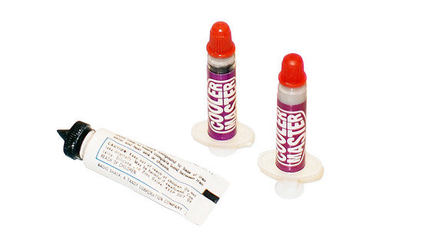
The main role of thermal paste is to eliminate air gaps or spaces (which act as thermal insulation) from the interface area in order to maximize heat transfer and dissipation. It allows for an efficient transfer of heat from the IHS of the processor to the base plate or water block of the CPU cooler that is designed to dissipate that heat. Thermal paste is important for CPUs because both metal surfaces are not completely flat. so, there will not be enough contact to transfer heat without the paste. especially if the heatsink is not machined well. Metal on metal is never sealed enough. It is the reason why gaskets were invented in cars. to seal the metal-metal contact of parts of the engine.

4.0 Pliers
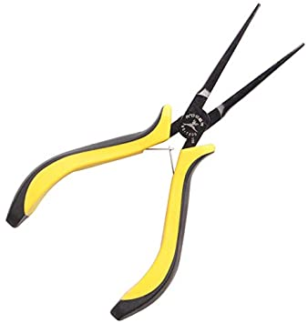
The primary purpose of the tool known as pliers is to grip objects firmly. The objects can then be turned, bent, or otherwise manipulated. Pliers are very handy for removing and inserting jumpers on motherboards and hard drives. Cable Ties. Plastic cable ties are useful for neatly bundling wires and cables away from fans and other components inside the computer.
5.0 PSU Tester
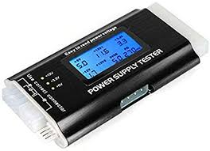
A power supply tester is an electronic device used to test how well a computer power supply is functioning. This type of testing is often performed as part of maintenance on a computer, and can be used to try to determine the source of a computer problem. The PSU tester is often used during computer diagnostics to establish whether the power supply is failing, to better narrow down the cause of computer issues.

PART B
1.0 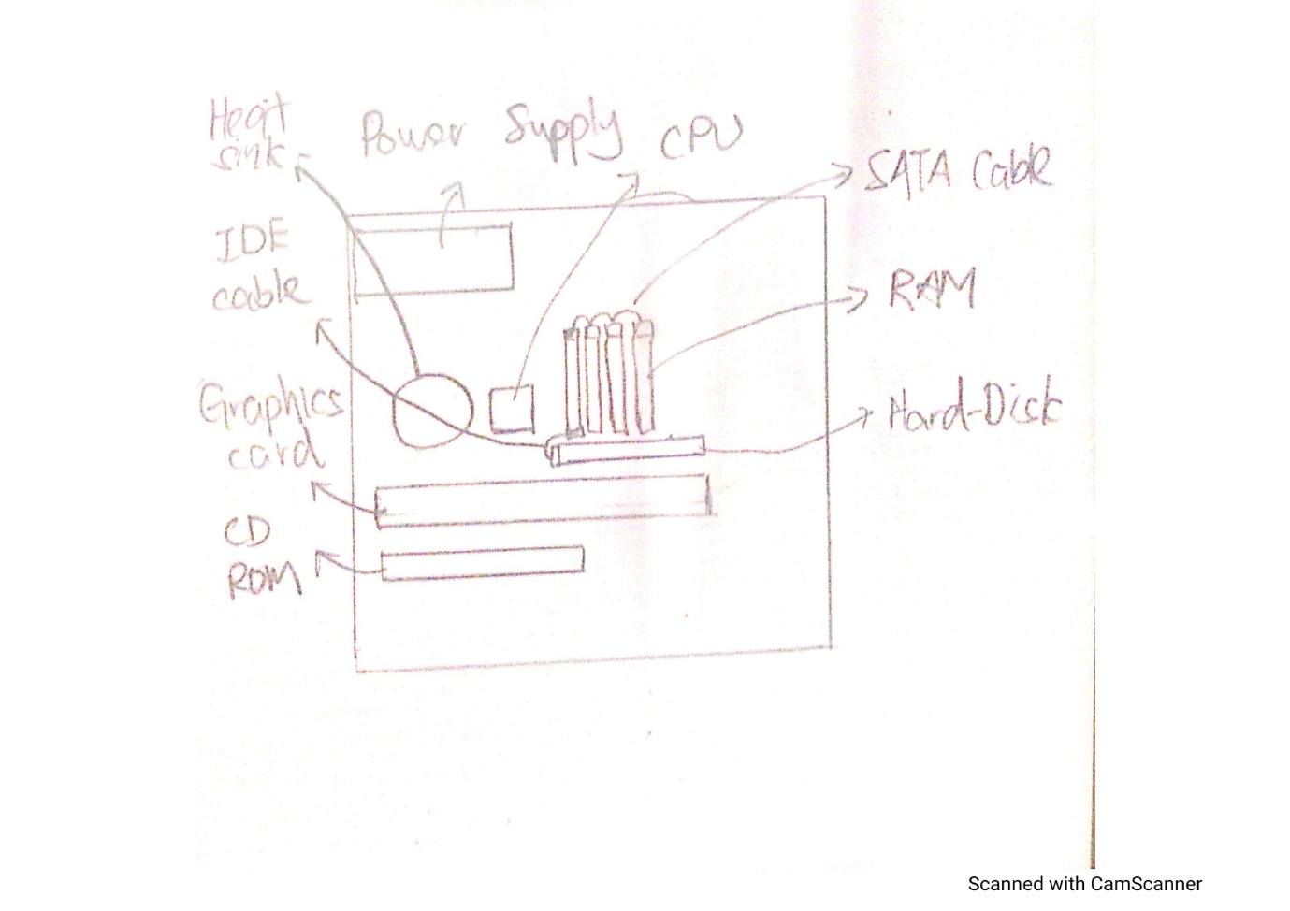

This diagram shown the motherboard sketching.
2.0
GRAPHIC CARD
A Design Card may be a piece of computer equipment that produces the picture you see on a screen. The Illustrations Card is dependable for rendering an picture to your screen, it does this by changing over information into a flag your screen can get it.
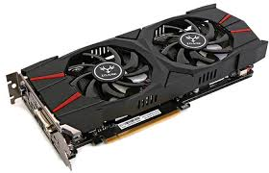

USB CABLE
Micro-USB. Usually a modest connector that's well known on all sorts of versatile gadgets. Everything from Android phones to outside battery packs to Bluetooth earphones employments a micro-USB port.
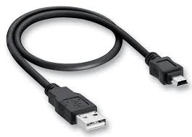
IDE CABLE
IDE, an acronym for Coordinates Drive Gadgets, may be a standard sort of association for capacity gadgets in a computer. By and large, IDE alludes to the types of cables and ports utilized to associate a few difficult drives and optical drives to each other and to the motherboard.
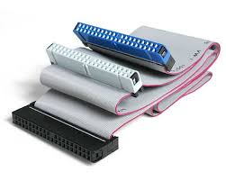

CPU
The CPU (Central Handling Unit) is the portion of a computer framework that's commonly alluded to as the "brains" of a computer. The CPU is additionally known as the processor or chip. The CPU is capable for executing a grouping of put away informational called a program .
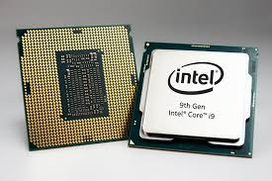

SLOTS
In computers, a space, or extension space , is an designed method for including capability to a computer within the frame of connection pinholes (ordinarily, within the run of 16 to 64 closely-spaced gaps) and a put to fit an extension card containing the circuitry that gives a few specialized capability, such as video , photo.
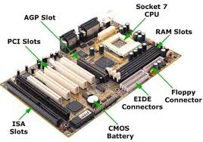

POWER SUPPLY
A control supply unit (PSU) changes over mains AC to low-voltage directed DC control for the inner components of a computer. Advanced individual computers all around utilize switched-mode control supplies. A few control supplies have a manual switch for selecting input voltage, whereas others consequently adjust to the mains voltage.
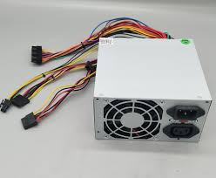

HEAT SINK
A warm sink could be a component that increments the warm stream absent from a hot gadget. It finishes this errand by expanding the device's working surface range and the sum of low-temperature liquid that moves over its broadened surface zone.
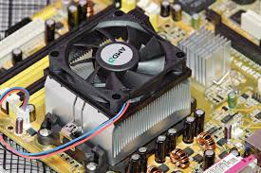

RAM
Smash permits your computer to perform numerous of its regular errands, such as stacking applications, browsing the web, altering a spreadsheet, or encountering the most recent diversion. Memory moreover permits you to switch rapidly among these errands, recollecting where you're in one errand once you switch to another assignment.
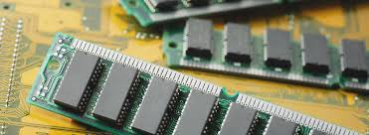

HARD DISK
Difficult disk, Attractive capacity medium for a microcomputer. Difficult disks are level, circular plates made of aluminum or glass and coated with a attractive fabric. Difficult disks for individual computers can store up to a few gigabytes (billions of bytes) of data. Information are put away on their surfaces in concentric tracks.
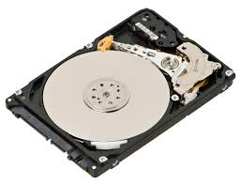

CD ROM
Utilized to store programs and information records, a CD-ROM holds 650MB or 700MB of information and utilizes a distinctive recording organize than the sound CD (CD-DA), from which it advanced. Within the 1990s, the CD-ROM quickly supplanted the floppy disk for program conveyance.
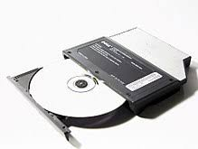

SATA CABLE
The Serial Progressed Innovation Connection (moreover known as Serial ATA and SATA) cable is an Coordinates Drive Gadgets standard computer transport interface. A SATA cable interfaces a have transport connector like a motherboard to mass capacity gadgets like optical drives, difficult disk drives, and solid-state drives.
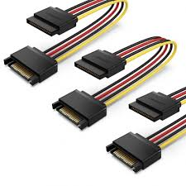

PART C
It is true that computer is one of the important device which plays a vital role in our daily life activities. It makes our activity too easier. So, in this report we will discuss about the assemble of a PC.
If we build up a CP 1st of all we need some common elements these are given below.

1.Processor /CPU.
2. Heat sink.
3.RAM.
4.Power supplier.
5.Hard disk.
6. CD Rom/ DVD drive.
7. SATA cable.
8. IDE cable.
9.USB port.
10. Graphis card.
11.Slots (IDE, PC)
By using these basic and fundamental elements, step by step we are going to assemble a PC.

- CPU Installation:
1st of all we have to take a motherboard. After taking it, we need to open the CPU slot which included in the motherboard.

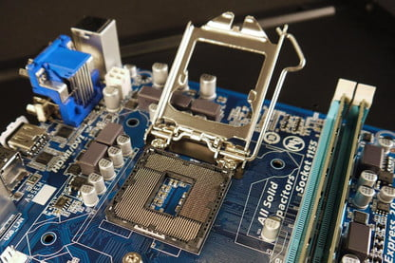
Opening CPU Slot
Now we need to install the CPU carefully in the CPU slot. Make sure that all CPU edge match with the slot.
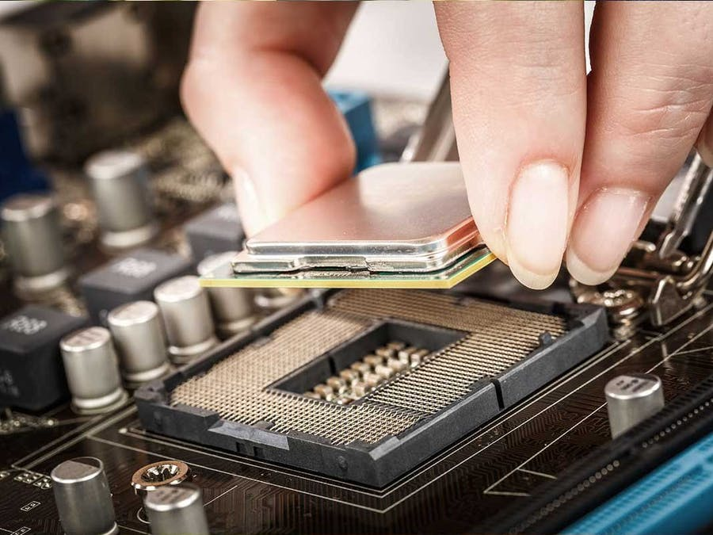
Installing CPU

After installed the CPU perfectly, then we have to close the slot slowly and carefully otherwise it can be break down or don’t attach properly.

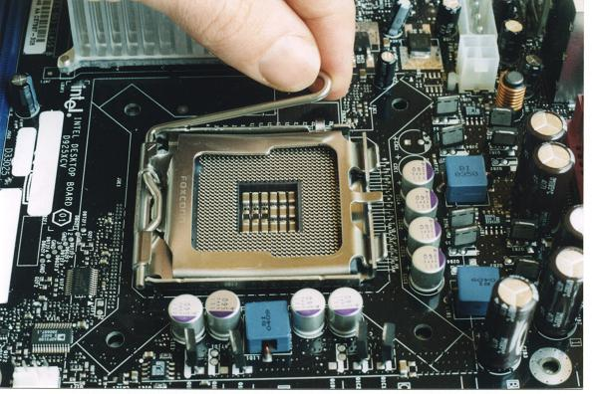
Closing CPU Slot

- Heat Sink Installation:
Place the CPU heatsink according to the diagram print on the motherboard.
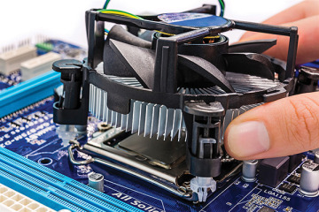
Heat sink Installation

After attach the heatsink we Place the mounting ring at the back of the motherboard and align it with the CPU heatsink.
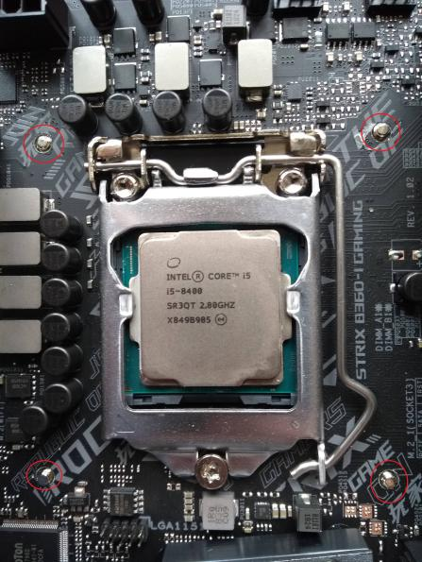
Attach Mounting Ring
\
Then we screw the CPU heat sink by following X-formation on the 4 screws. After that we attach the motherboard in CPU cabinet.
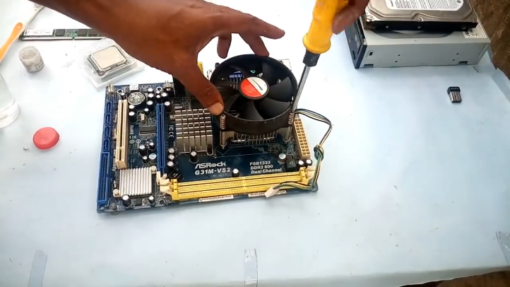

Heat sink attach by using screw

- RAM Installation:
In the next step we open the ram clip at the both side of RAM slot by slowly pulling it outward before install the RAM.
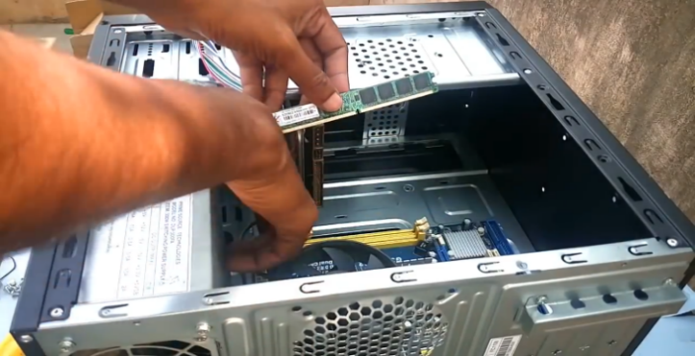

Opening RAM Slot

Press the RAM stick into the RAM slot gently until hear the click sound of the RAM slot clip. We have to ensure the RAM stick position is the same with the RAM slot.
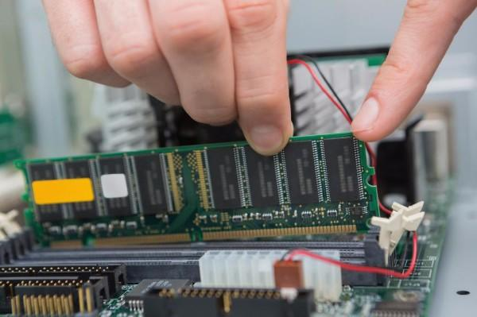
RAM Installing

- Power Supply Installation:
After that install the power supply in CPU cabinet then attach the power supply with CPU cabinet using screw.
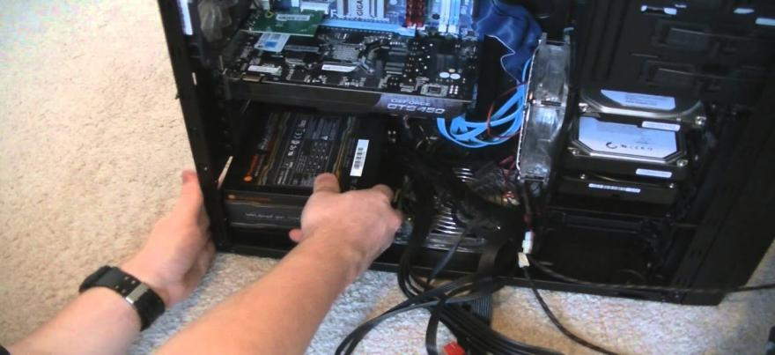
Power Supply Installation

5.Hard disk installation:

The next step is hard disk install. According to install firstly we place it into the CPU cabinet.
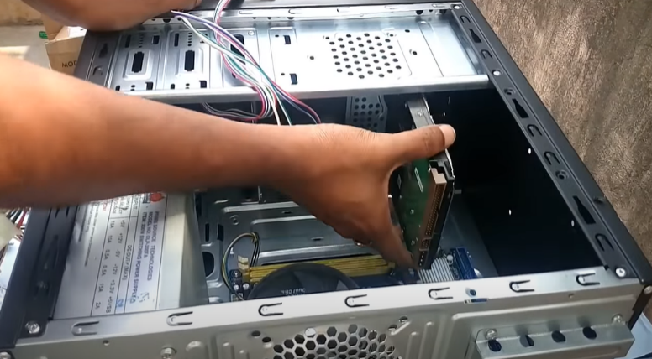

After place it into the CPU cabinet bay and screw the hard disk tightly. And ensure the hard disk is tightly screwed on the CPU cabinet hard disk bay.

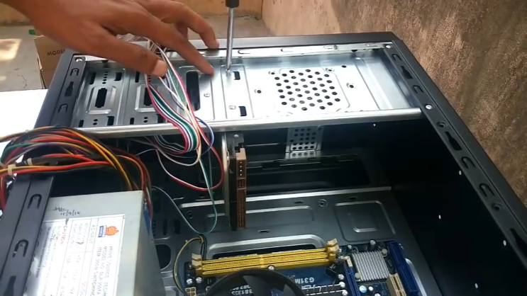

Attach by using screw

If the storage drive is configured as a master, plug in the black IDE cable connector into the IDE connector on the hard disk.
If the storage drive is configured as a slave, plug in the grey IDE cable connector into the IDE connector on the hard disk.

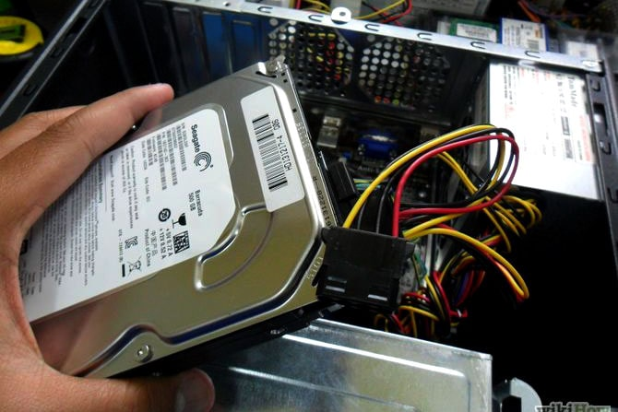

Installation Hard Disk

- CD Rom/ DVD drive installation:

Complete to installed the hard disk we again Place the new drive, DVD drive in the CPU cabinet as like as the hard disk.

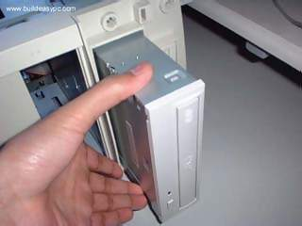
DVD drive installing

Then screw the DVD drive tightly by using the screwdriver. And ensure that DVD drive is tightly screwed on the CPU cabinet DVD drive bay.

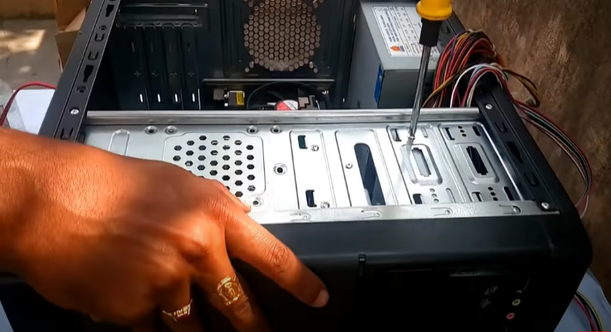

7. SATA & IDE cable installation:
Now we have to connect the CD ROM with the motherboard via SATA Cable. For that 1st we have to take the SATA cable and connect with CD ROM and another port we connect with the motherboard.
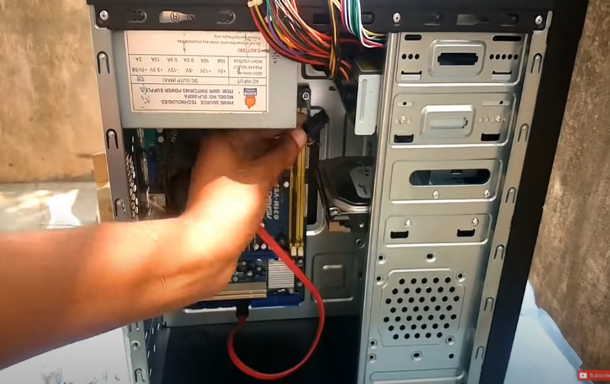

Connect the CD ROM with the motherboard

Now we have to connect the Hard Drive with the motherboard via IDE cable. If the storage drive is configured as a master, plug in the black IDE cable connector into the IDE connector on the hard disk. If the storage drive is configured as a slave, plug in the grey IDE cable.
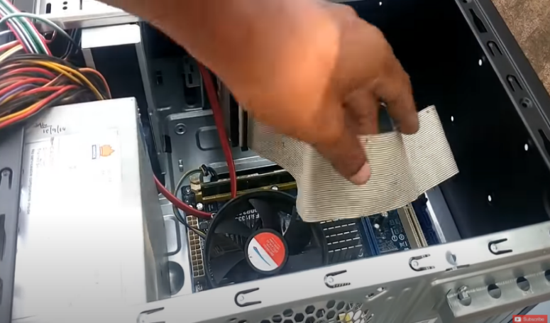

IDE Cabble connection

8.USB port installation:
After installed the SATA and IDE cable we have install the USB port in front side and connect the cable with the motherboard. And surely we have to install it very carefully.
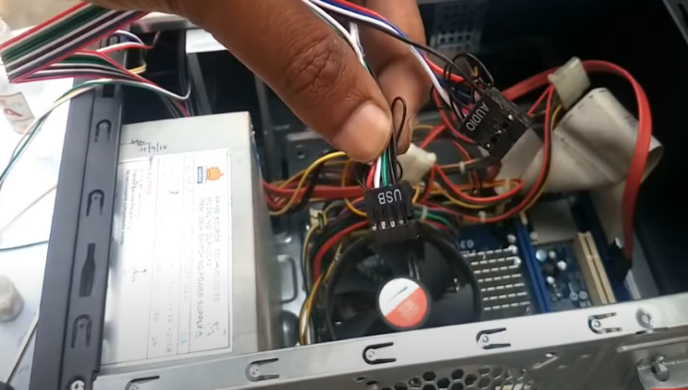

USB Port Installing

9. Graphis card installation:
For graphics card section we have to use PCI express 16x slot. We have to put carefully the graphics card like RAM installation. Make sure we need to use PCI express 16x slot for installing otherwise it doesn’t be work.
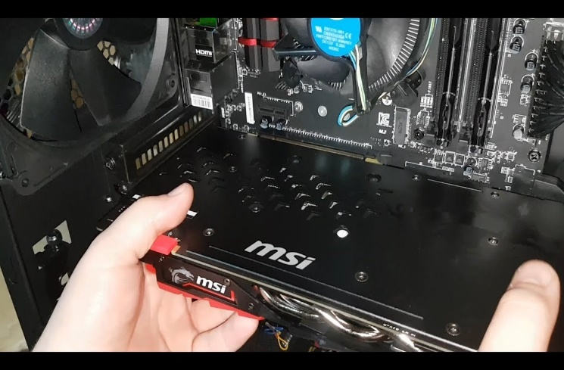

Graphics card installing

10. Power supply port Connection:
Now we need to connect the power supply port with Motherboard, CD ROM, Hard Drive, and graphics card. For motherboard connection we have to use Power SW, Reset SW, Power LED, H.D.D LED port to connect with motherboard.

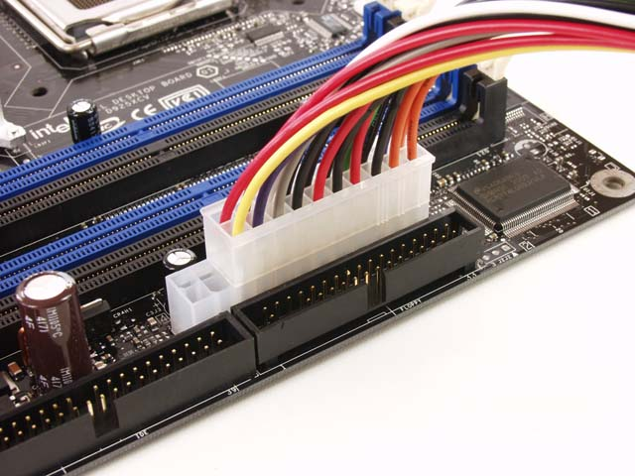
Power Supply Port Connection

we have to connect ATX power supply pin with Hard Drive. We need to do it more carefully.
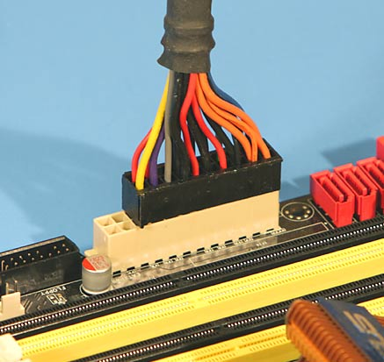
Connecting ATX Pin

For graphics card, use via 6 pin F to M port which supply the power on graphics card.
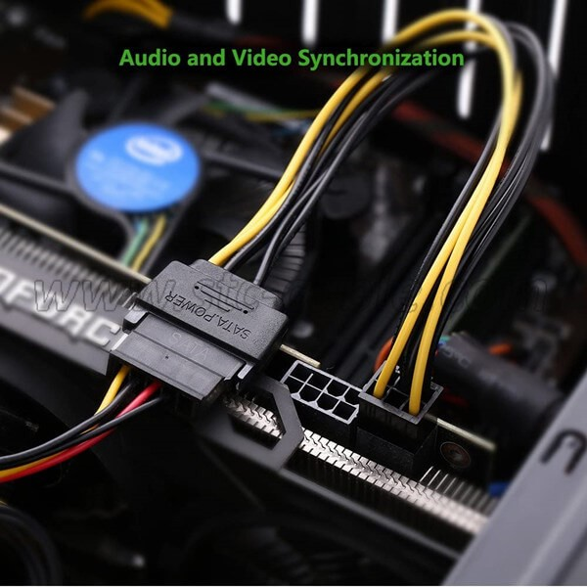

Connect pin with graphics card

And lastly, we have to connect 4 pin peripheral port with CD ROM.
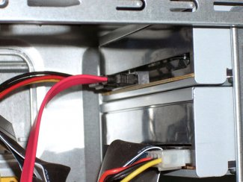

Connect peripheral port

11. Closing the CPU case:
After finishing to installed all of the ports we have to close the CPU case using by screw. once it’s finished, simply plug it into our new system. Go back into our BIOS for tailing our system to boot from the USB stick first. From there we have to go through the prompts to install the operating system onto our new rig.

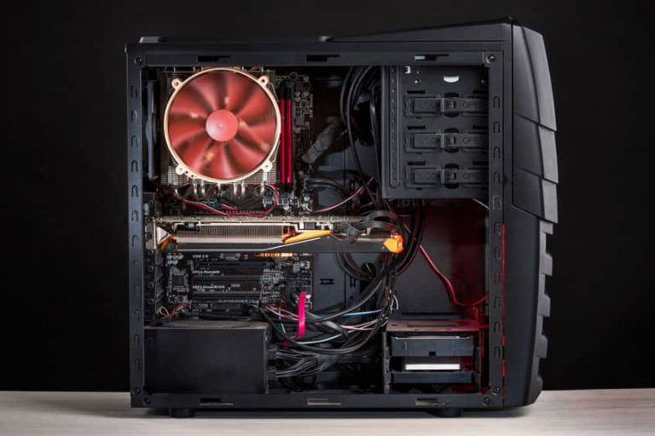
After Closing CPU Case

Reference:
1.https://www.youtube.com/watch?v=m_-G9Cacx2U&ab_channel=TechnologyGuide.
2. https://www.build-computers.com/how-to-assemble-a-pc.html.

