
Semester I 2020/2021

Subject : Technology and Information System (SECP1513)
Section : 09
Assignment : Step by step PC Assembly

GROUP NAME / NUMBER : 08

1 |  | Name : ANATASYA HUMAIRA  Matric Number : A20EC0261  Phone Number : 62 82287218207  E-mail : anatasyah35@gmail.com
2 |  | Name : HARESH NAIDU A/L S MURUGAYAH  Matric Number : A20EC0042  Phone Number : 60 165805998  E-mail : hareshnaidu@graduate.utm.my
3 |  | Name : NUR AISYAH BINTI AZMI  Matric Number : A20EC0111  Phone Number : 60 1155091567  E-mail : aisyah-01@graduate.utm.my

PART A- TOOLS TO ASSEMBLE PC

- Screwdrivers
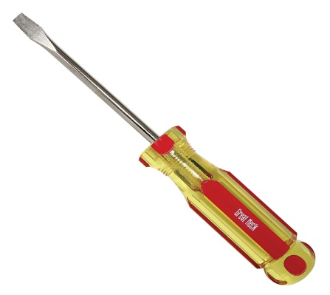

The screwdrivers are used to secure the screws on components so that it will not loosen. Screwdrivers come in different types and functions. The recommended screwdriver for assembling PC would be a Philips-head screwdriver Number 2. The importance of screwdrivers is we mostly used screwdrivers to assemble the PC. This is because PC parts are held together using screws.

- Anti-static wraps
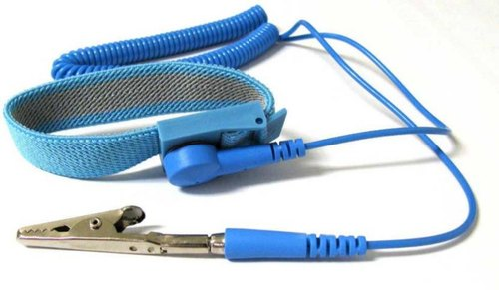
The anti-static wraps is used to eliminate electro-static discharge (ESD).The importance of this tool is to prevent us from damaging component with ESD. Sometimes, we cannot feel ESD so anti-static wraps can be used as precaution before anything happens.

- Pliers
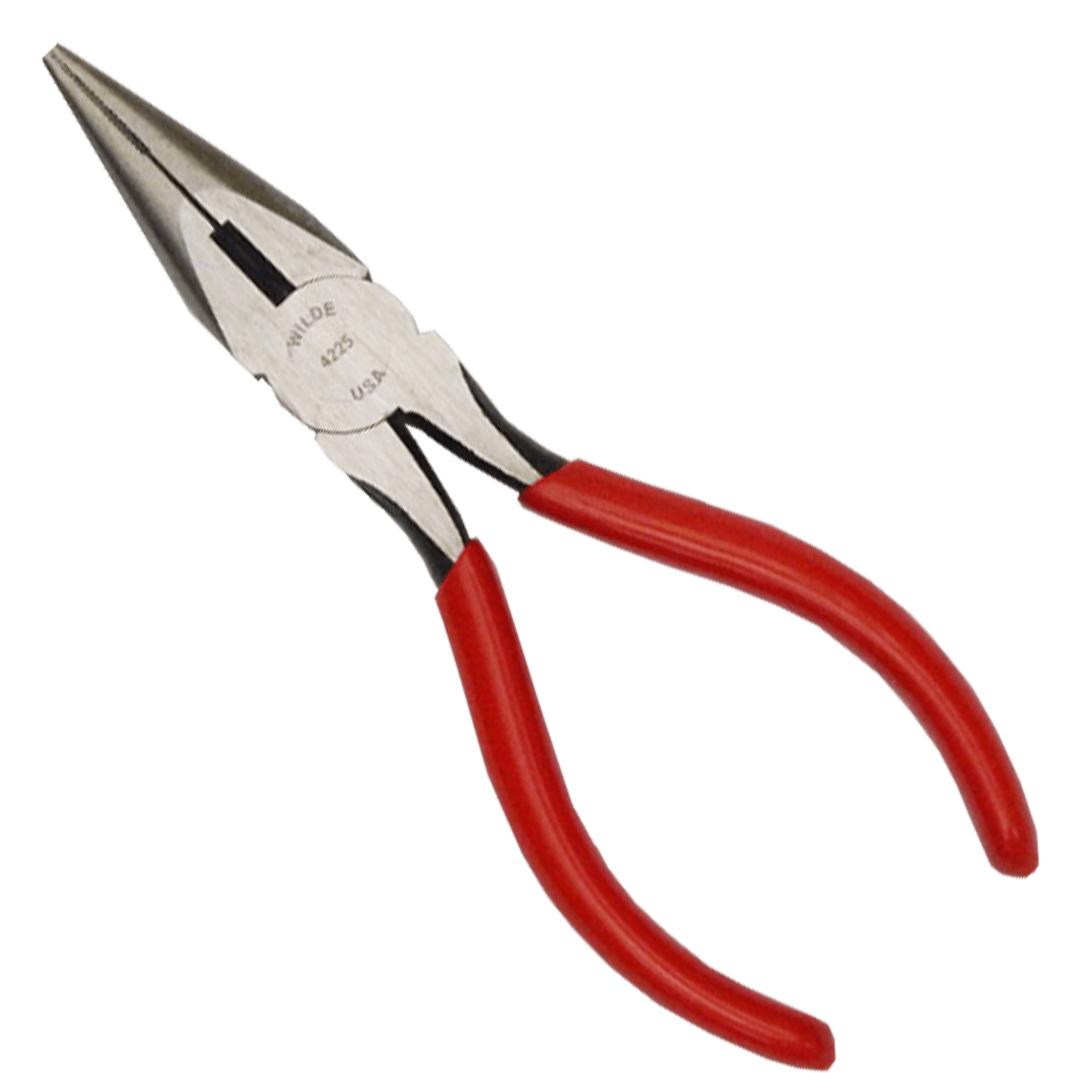
The pliers are used when we want to remove or insert small components. The importance of pliers is we can use it in various situations. As example, we can use pliers to pick up small screws that fall in the case, remove or insert jumper on hard drive and cut the excess zip ties.

- Lamp or light source

Lamp works as extra light source in case the main light source is not enough. The importance of lamp is to make sure we can exactly see what we are doing when assemble the PC. This is because PC cases blocked most of the light so many components in PC are hidden in dark.

- Zip or twist ties
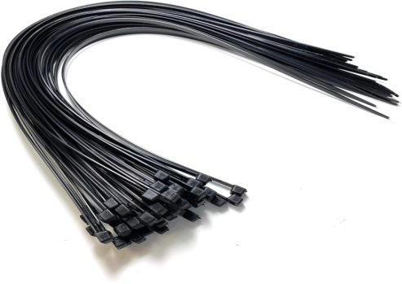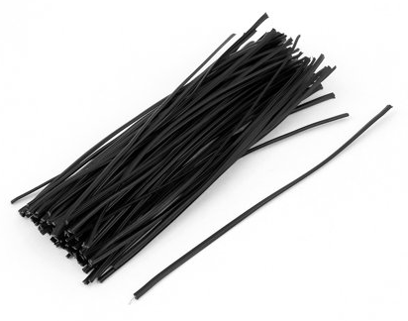
The zip ties and twist ties are used to tie any cables in a place. Zip ties, normally made of nylon are strong and single-use. Twist ties are secure and easy to remove but it have potential to scratch the cable because it made of metal wire. The importance of this tool is we can manage the cables well and keep better airflow in PC case. The cables also will look neat in term of cable management.

PART B – Sketch of a mother board layout
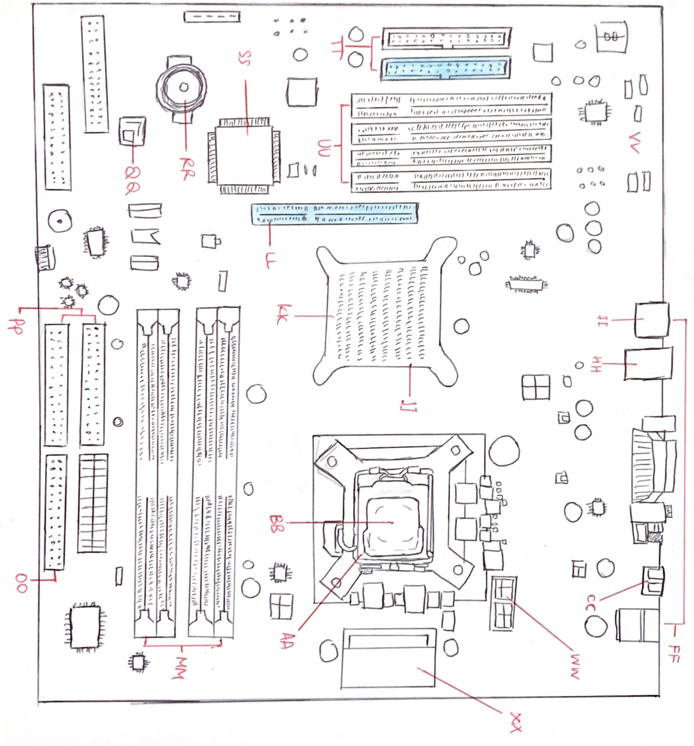

No/  Key Words | Pictures of Model | Name | Function
1  BB | 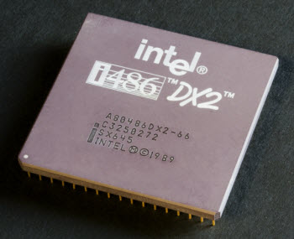 | CPU/Processor | A piece of hardware that carries out the instructions of a computer program.
2 | 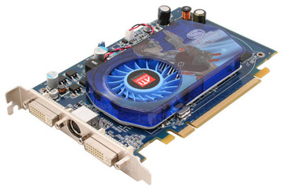 | Graphic card | A piece of computer hardware that produces the image you see on a monitor.
3 | 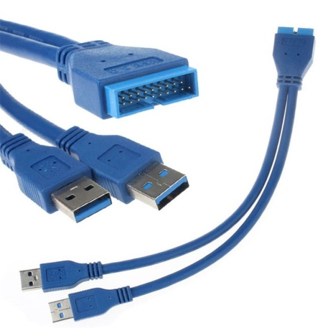 | USB cable | USB (Universal Serial Bus),  used mostly to connect computers to peripheral devices such as cameras, camcorders, printers, scanners, and more.
4  TT | 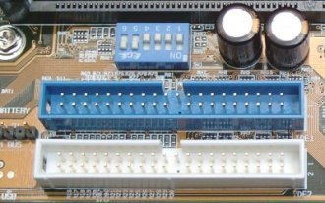 | IDE Slot/Connector | A standard interface for connecting a motherboard to storage devices such as hard drives and CD-ROM/DVD drives.
5 | 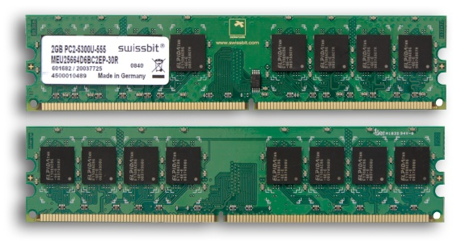 | RAM | Random Access Memory is a high-speed type of computer memory which temporarily stores all the information your PC needs at the moment.
6 | 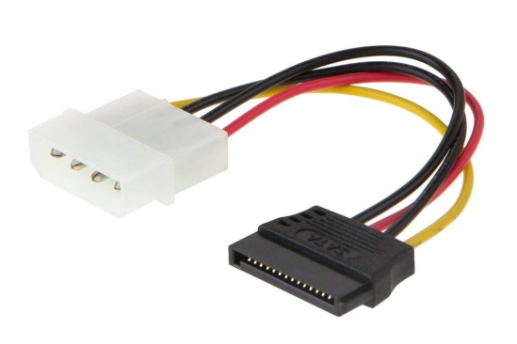 | SATA cable | Used to connect the hard disk to the motherboard. Serial Advanced Technology Attachment cable is also responsible for supplying power to the hard disk so additional hard drive power cables may not be required.
7 | 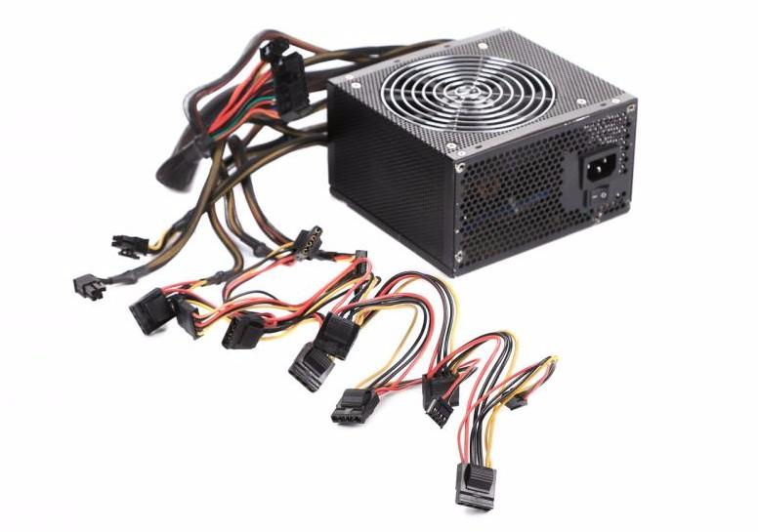 | Power supply | Converts the electricity from your wall socket into a low-voltage, direct-current (DC) form that can be used by all the components that make up your computer.
8 | 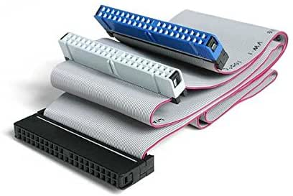 | IDE cable | Integrated Drive Electronics, is a standard type of connection for storage devices in a computer. IDE refers to the types of cables and ports used to connect some hard drives and optical drives to each other and to the motherboard.
9  XX | 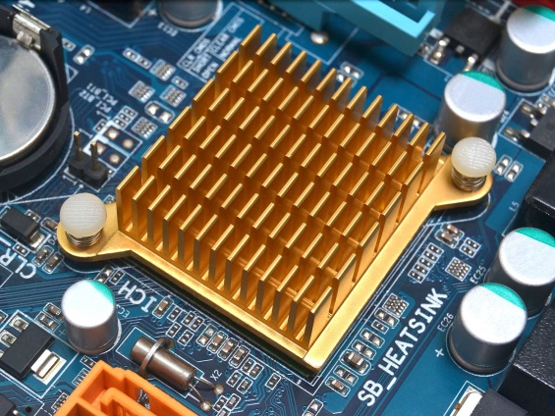 | Heat sink | A passive heat exchanger that transfers the heat generated by an electronic or a mechanical device to a fluid medium, often air or a liquid coolant, where it is dissipated away from the device, thereby allowing regulation of the device's temperature.
10 | 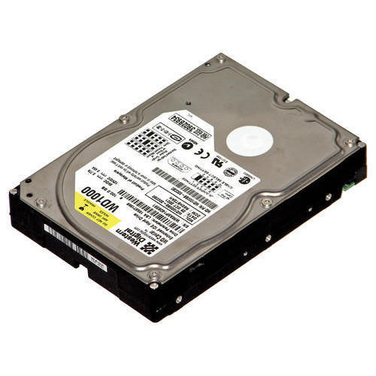 | Hard disk (jumper setting either master/slave) | A hard disk drive (HDD) is an electro-mechanical data storage device that stores and retrieves digital data using magnetic storage and one or more rigid rapidly rotating platters coated with magnetic material.
11 | 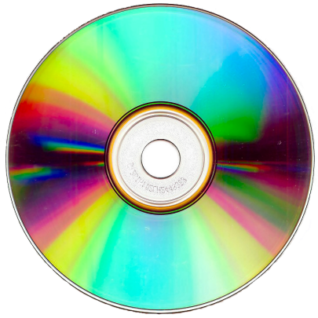 | CD ROM | (Compact Disc-Read Only Memory) A type of CD disc that can only be read, but not recorded. Used to store programs and data files, a CD-ROM holds 650MB or 700MB of data and employs a different recording format than the audio CD (CD-DA), from which it evolved.
12  AA | 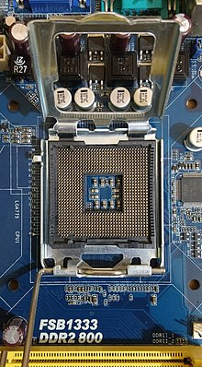 | Processor Slot | a CPU socket or CPU slot contains one or more mechanical components providing mechanical and electrical connections between a microprocessor and a printed circuit board (PCB). This allows for placing and replacing the central processing unit (CPU) without soldering.
13  CC,II | 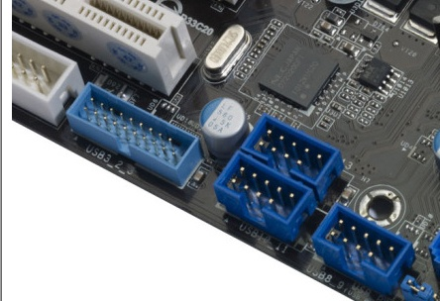 | USB Slot | Used for connecting pen drives and external hard drives, like Ipods or Mp3 players.
14  FF | 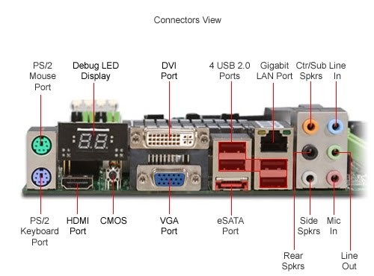 | Back Panel Connectors | The panel at the rear of certain equipment, which serves to connect to other devices. For example, a computer’s back panel allows to connect the computer to peripherals such as monitor, speakers, keyboard, and mouse as well as to a power source.
15  HH | 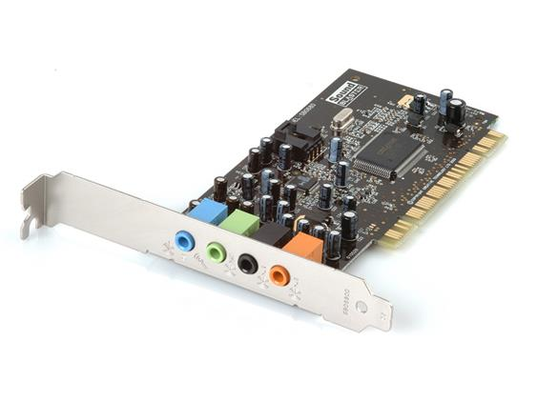 | Audio Slot | A computer's audio ports link the computer's sound hardware with your speakers, microphone, headsets or other audio equipment. Every computer motherboard has at least a few basic audio ports built in, allowing you to connect stereo speakers and a microphone.
16  JJ, QQ | 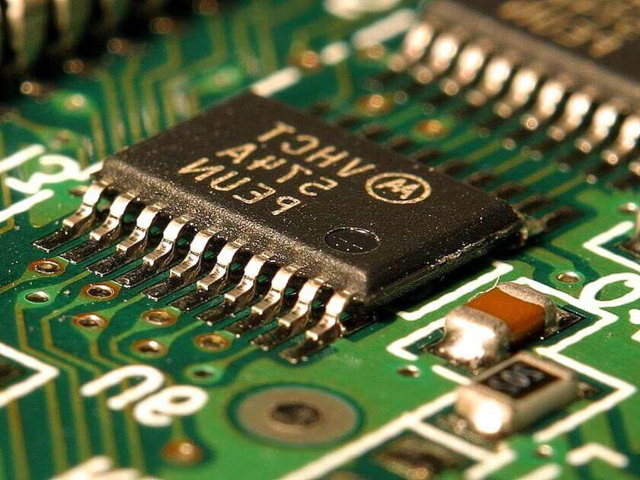 | Chipset | A group of interdependent motherboard chips or integrated circuits that control the flow of data and instructions between the central processing unit (CPU) or microprocessor and external devices.
17  LL | 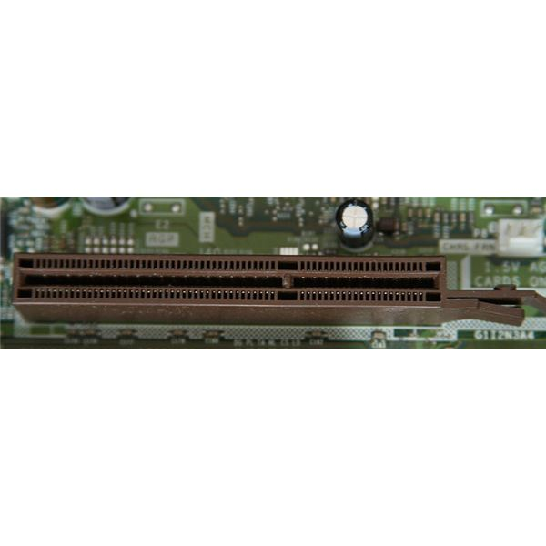 | AGP Slot | An accelerated graphics port (AGP) is a point to point channel that is used for high speed video output. This port is used to connect graphic cards to a computer's motherboard. The primary purpose of an AGP is to accelerate 3D graphics output for high definition video.
18  MM | 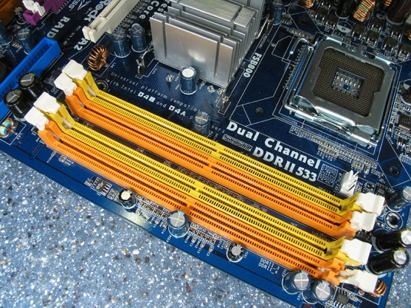 | RAM Slot | A memory slot or RAM slot is what allows computer memory (RAM) chip/stick to be inserted into the computer. Depending on the motherboard, there will usually be 2 to 4 memory slots (sometimes more on high-end motherboards) and are what determine the type of RAM used with the computer.
19  OO | 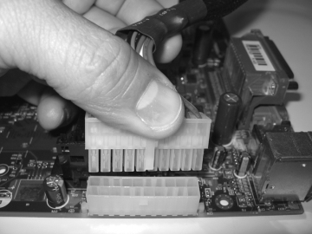 | Power Supply  Slot | One purpose of a power supply is to convert AC to DC so the computer has proper power to run its components.
20  PP | 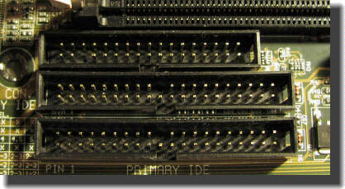 | HDD Slot | Hard Drive Slots  Connect solid-state drives to the high-speed SATA slots and mechanical disk drives to the lower-speed slots.
21  KK | 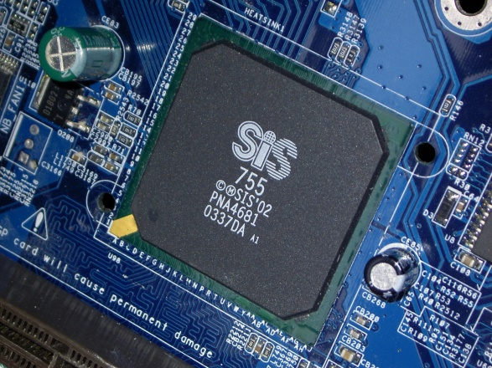 | North Bridge (Chipset) | also known as Memory Controller Hub, is usually paired with a southbridge. In systems where they are included, these two chips manage communications between the CPU and other parts of the motherboard, and constitute the core logic chipset of the PC motherboard.
22  SS | 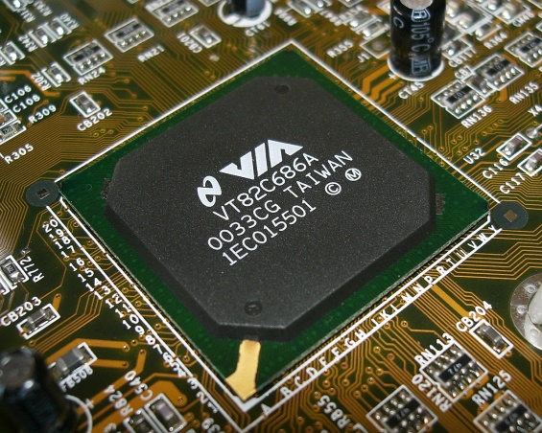 | Southbridge (Chipset) | A southbridge chipset handled the many of a computer's I/O functions, such as USB, audio, the system BIOS, the ISA bus or the LPC bus, the low speed PCI/PCIe bus, the IOAPIC interrupt controller, the PATA/SATA storage, and the NVMe storage.
23  RR | 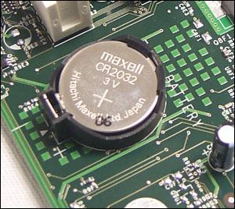 | CMOS Battery | Stands for “Complementary Metal Oxide Semiconductor.” The CMOS battery powers the BIOS firmware in your laptop. If the CMOS battery dies, settings will be lost when the computer is powered down.
24  UU | 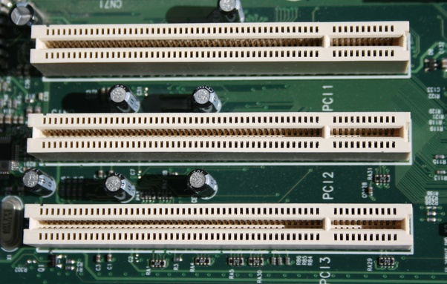 | PCI Slot | Peripheral Component Interconnect, is a hardware bus used for adding internal components to a desktop computer. PCI card can be inserted into a PCI slot on a motherboard, providing additional I/O ports on the back of a computer.
25  VV | 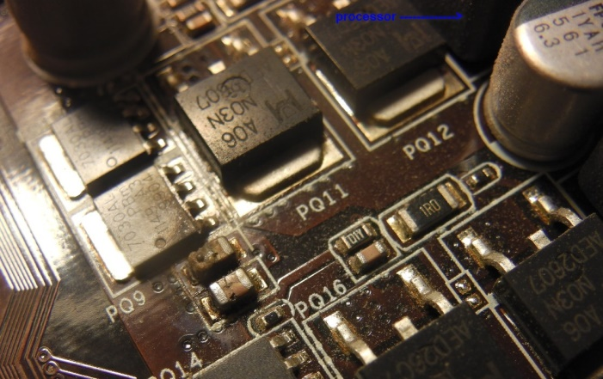 | Resistor | Resistors help restrict and impede a current flow.
26  WW | 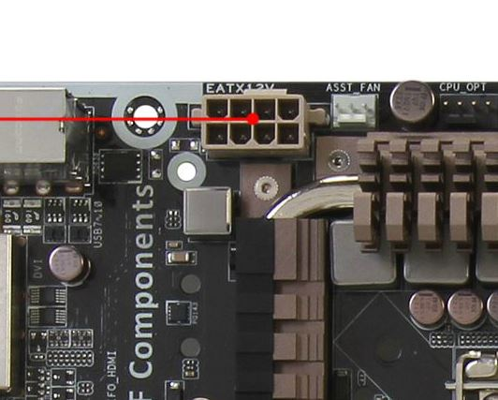 | Processor Power  Suppy Connector. | ATX12V 4-pin power connector (also called the P4 power connector). A second connector that goes to the motherboard (in addition to the 24-pin ATX motherboard connector) to supply dedicated power for the processor.

PART C - “Step by Step PC Assembly”
STEP 1- INSTALLATION OF CENTRAL PROCESSING UNIT(CPU)
- Find the CPU socket on the motherboard open the CPU it by lifting the retention arm ( the small metal lever on the side of the socket) and unlock the retention arm by pulling it away from the socket.
- Look for a matching indicator on the corner of your CPU and the socket.The indicators are there to ensure the installation of CPU in a correct position.
- NOTE: It's best practice to only touch the sides when holding your CPU. Touching the underside or the metal lid can get undesirable residue on them that may affect performance.
- Ensure that your CPU is correctly lined up with your socket to avoid damaging pins while installing.
- Gently place CPU in the socket.
- Make sure your CPU is installed.
- Lock the socket cover by pushing down the retention arm
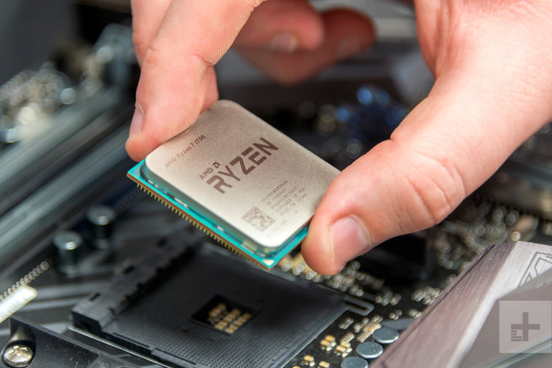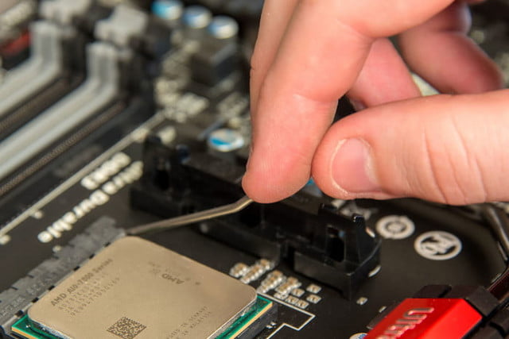
STEP 2- USE THERMAL PASTE
- Place a tiny drop of thermal paste on the center of CPU.
- It should be in the size of a grain of rice.
- NOTE: Make sure do not place excessive amount of thermal paste otherwise you will end up with paste on motherboard.
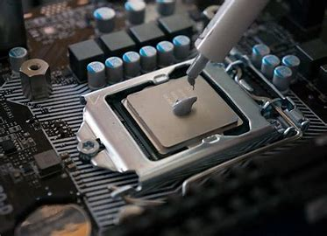

STEP 3- INSTALLATION OF HEAT SINK
- Align the heatsink or cooling solution above the processor so that the clamps are in line with the mounting points around the processor.
- Clamp the heatsink in place using a screwdriver.
- NOTE: At this stage as a lot of pressure will be placed on the board. A slip of a screwdriver can cause a lot of damage to the motherboard.
- Locate the power lead for the cooling solution's fan and the CPU fan header on the motherboard. Connect the heatsink power cable to the header on the motherboard.
- Make sure the installation is secure.

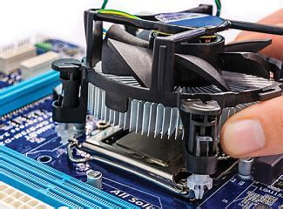

STEP 4- INSTALLATION OF RANDOM ACCESS MEMORY(RAM)

- Locate RAM sockets
- Take your RAM by gripping it from the sides to avoid touching the contacts on the bottom or the circuitry on the board.
- Insert the RAM into the RAM slot by lining up the notch in the stick of RAM to the break in the slot.
- Apply equal pressure onto the stick until the clamps on the side click and lock the RAM in. You may have to apply a fair amount of pressure, but never force it in.
- Make sure matching pairs are inserted into their matching sockets.
- Repeat the process for each stick of RAM you want to install.

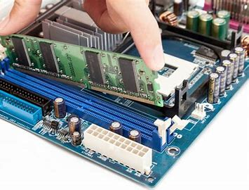

STEP 5- INSTALLATION OF POWER SUPPLY
- Find the power supply's intended location
- Insert the power supply.
- The "back" should face the back of the case, while the "bottom" should face the internal part of the case.
- Screw the power supply in place.
- Make sure the power supply is screwed tight enough.

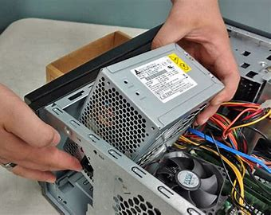

STEP 6- INSTALLATION OF MOTHERBOARD

- Find and install standoffs to keep the motherboard above the case. This prevents it from shorting out and helps cooling.
- Place motherboard on the standoffs secure it with screws.
- NOTE: Don’t overtighten the screws
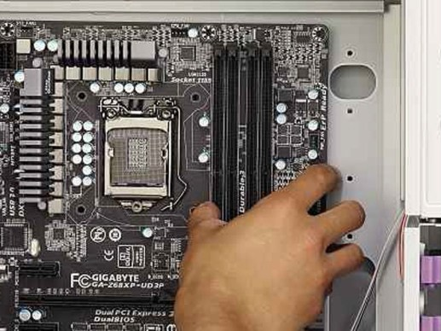
STEP 7- INSTALLATION OF GRAPHICS CARD

- Locate the peripheral component interconnect express (PCIe) slot dedicated for the graphic card on your motherboard
- Insert the graphic card straight into the empty PCI-e slot and apply even pressure to the top until it is fully seated.
- NOTE: Avoid touching any of the circuitry of the graphic card.
- Make sure the graphic card is inserted completely.
- Secure the card by screwing the holder.
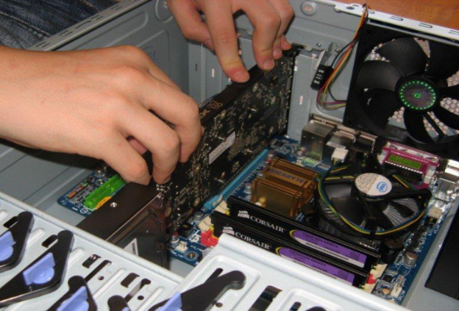

STEP 8- INSTALLATION OF CD-ROM DRIVE

- Adjust the jumpers on the back of the drive.
- Slide the CD/DVD drive into the drive bay on the computer.
- Connect the data and power cables to the CD/DVD drive. For IDE drives, align pin 1 (the red edge) to the connector on the CD/DVD drive. Then connect the 4-pin power connector to the drive. For SATA drives, align the notch to the connector on the drive. Then connect the SATA power connector (the long one) to the drive.
- Connect the audio cable to the drive.
- Screw the CD Rom
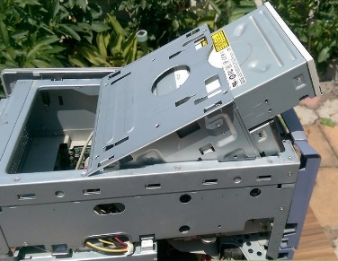
STEP 9- INSTALLATION OF HARD DISK DRIVE

- Locate the slot to place the hard disk drive

- Place the hard disk drive in the slot

- Secure the hard disk drive by screwing it.

- NOTE: Make sure the hard disk is secured in place to avoid any damage to the hard disk.

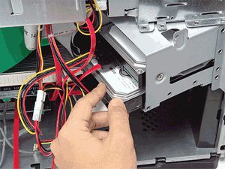

STEP 10- INSTALLATION OF IDE, SATA and POWER SUPPLY CABLES
- Locate the SATA slot at the motherboard, CD-ROM, and power supply.
- Connect the SATA cable to the CD-ROM drive.
- Connect the other end of the SATA cable to the motherboard.
- Connect another SATA cable to the CD-ROM drive.
- Connect the other end of SATA cable to the power supply.
- Locate the IDE slot.
- Connect the IDE cable to the hard drive.
- Connect the other end of IDE to the motherboard.
- Take power supply cable and connect to its place.
- NOTE: Make sure to do it carefully to avoid damage to the cable. Make sure that the cable is managed tidily to save room and decrease the heat accumulation inside the PC

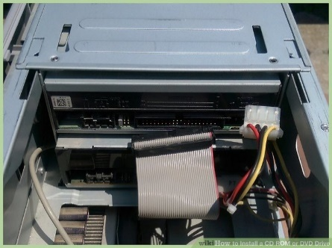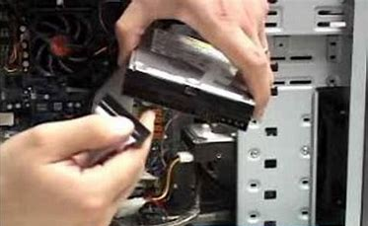

STEP 11- INSTALLATION OF SWITCH CABLES AND USB CABLES
- Find switch cables and USB cables at PC.
- Connect the switch cable to the motherboard
- Connect the USB cable to the motherboard.
- Make sure the cables are connected tightly.

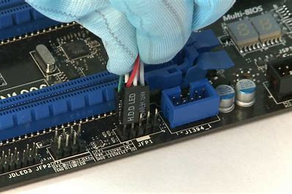

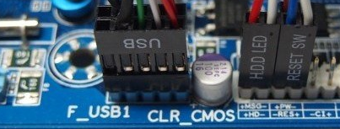

Last STEP - CLOSING THE CASE AND CONNECTING THE PERIPHERALS

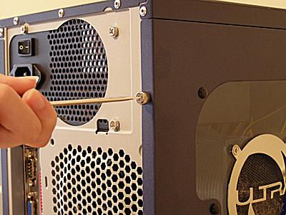
Place the side cover back on and secure the side panels with case screws.

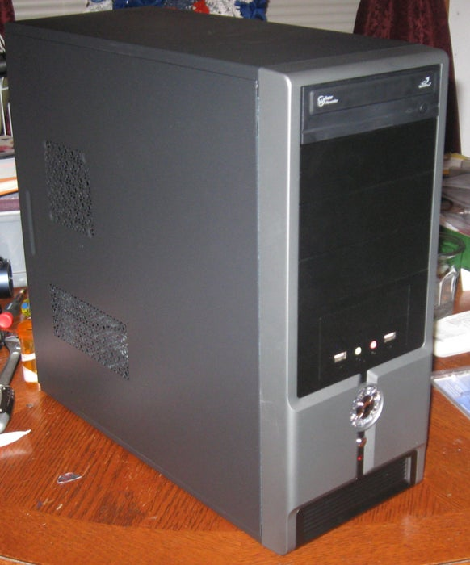

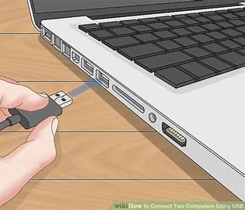
Connect peripheral devices which include keyboard, mouse, wireless network dongle, printer and webcams with your CPU by plugging into USB port.
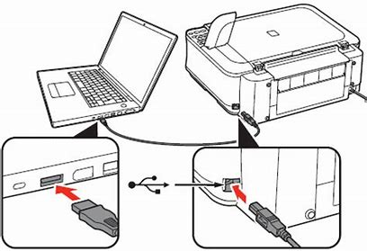

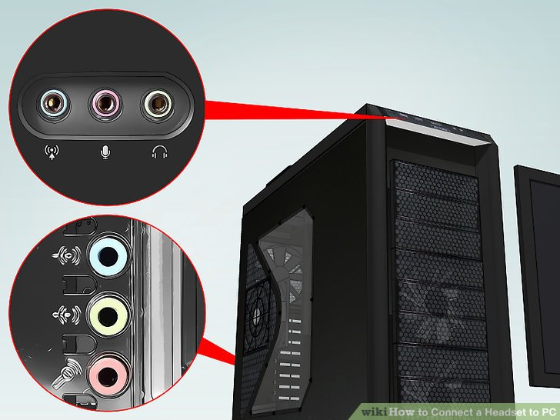
Then, connect speakers and microphone into 2.5 mm sockets.
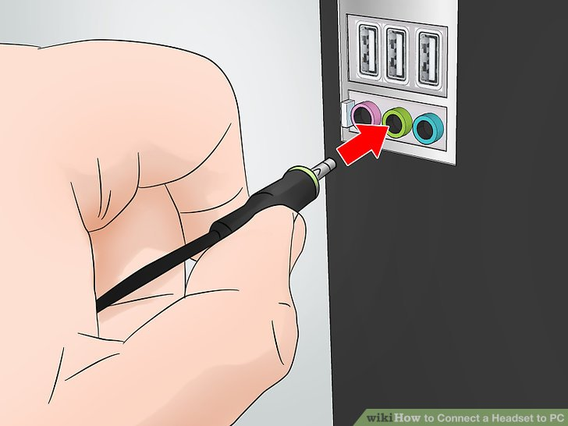

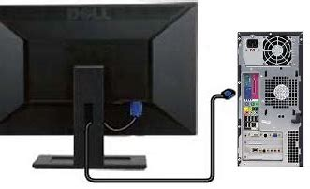
Finally connect the CPU with monitor by plugging into display ports.

