

TECHNOLOGY AND INFORMATION SYSTEM
SECP1513-09

DESIGN THINKING
CHAPTER 10: INFORMATION SYSTEMS

LECTURER:
DR SARINA BINTI SULAIMAN
NAME OF GROUP MEMBERS:
ANATASYA HUMAIRA (A20EC0261) - LEADER
HARESH NAIDU A/L S MURUGAYAH (A20EC0042) – GROUP MEMBER
NUR AISYAH BINTI AZMI (A20EC0111) – GROUP MEMBER

TABLE OF CONTENT
INDEX | CONTENT | PAGE
1.0 | INTRODUCTION | 3
2.0 | DETAILED STEPS IN DESIGN THINKING | 4
3.0 | DETAILED DESCRIPTIONS | 5- 7
4.0 | DESIGN THINKING ASSESSMENT | 8-12
5.0 | REFLECTIONS | 13
6.0 | TASK FOR GROUP MEMBERS | 14

1.0 INTRODUCTION

Design thinking is one of innovative way to solve a problem and has been widely used in various sectors including business and service organization. It is considered as powerful framework for innovation and product improvement because it used “human-centered” approach. With this approach as the base, design thinking emphasizing us to be creative to create a solution. It is basically can be concluded as different way to view a problem than we normally do. Advancing technology day by day caused changes in society where different problems occur every day. Rather than work to break down the problems which only fit for certain problems, design thinking can be used because it flexibility to fit with any types of problem. Design thinking involves some phase like ideate, prototype and test.

5 PHASE IN
DESIGN THINKING

EMPHATIZE
TESTING

DEFINE
IDEATE
PROTOTYPE

Information systems are a collection of people, procedures, software, hardware, and data. It also can be view as a set of components that collect, create, store, process and distribute information. Information systems are made to support operations, management and for making decision whether in business, organization and many more.

- DETAILED STEPS IN DESIGN THINKING

DATES | ACTIVITY
2 November 2020 | - Make Whatsapp group for discussion.  - Discuss on Information Systems  - Brainstorm to get question to ask to the interviewer.
3 November 2020 | - Interview with Mr. Aris bin Arifin from Department of Digital Services UTM.  - Asking question related to Information Systems
4 November 2020 | - Conduct survey on online shopping
5 November 2020 | - Find information about online shopping
6 November 2020 | - Gather information from previous survey  - Start to make slide for presentation
7 November 2020 | - Make the prototype  - Start editing video
8 November 2020 | - Test the prototype with users  - Starting the report work.
9 November 2020 | - Make final touch up with report, video and presentation.
10 November 2020 | - Final check  - Ready to be submit

- DETAILED DESCRIPTIONS
The topic given to our group is Information Systems. An interview was conducted to get more understanding in this topic. We decided to interview Mr. Aris bin Arifin from Department of Digital UTM through Webex.
QUESTION | ANSWER
How Information Systems impacts on organization and society? | Information Systems help us to manage our information become much easier. As an example, if you use system compared when you use manual processing, the system will be faster than the manual one. If you used manual transactions, you have to make sure that the transaction capped securely but in Information Systems, that has been considered. So, of course the Information Systems will help us better than manual one.
What are the roles of databases to Information Systems? | To get the data that has been received from the transaction systems and to capture every update that information system received from user. Databases also make sure that data are stored secure and can be reached by the user anytime and anywhere without any problem.
How do you usually handle the problem if there is lack of communication among the management staff or if sometimes the information needed is not provided well? | Firstly, the user or the management staff that needed information or data must clearly state their requirement. They have to give details about what information they need. Then, the receiver of the requirement must understand clearly about the requirement. If it is clear enough, I think we will have no problem about the lack of information given to the users. So, you have to be clear what information you need, you have to state clearly and with that, I think that problem will never arise.

From the interview, we decided to focus on online shopping problem. To continue with, we conducted a survey on online shopping problem from customer view.

PROBLEMS | EXPLANATION
Seller took time to respond | Some issues on communication management with staff may cause this problem.
Too much process to sign up or complete purchase | Some websites or application requires customer to go through some stages before sign up or complete their purchase. People may find this is quite a troublesome and new users find it is hard to use.
Product description are not clear | Some seller did not put detailed description on their items, resulting their customer hesitate to buy.

After making analysis and discussing, we find out that our first survey is hardly related to our topic. Hence, we change our survey by focusing on problem faced by online seller in term of information management. Since information systems also involved people, we want to know what kind of problem they faced when managing online selling.

PROBLEMS | EXPLANATION
Misinformation | The data received is manually transferred to next process. Some problem like error from human mistake can occur this time.
Have to check manually the stock updates | Seller has to check the number of stock in the system one by one and make sure it is tally with the one they have.
Limited place to fill in product variation | The system is limiting how many variation the seller can have in one product.
Ads took time to be taken up | The seller needs to wait for their old ads to be taken down before taken up the new one. This is because sometimes they do wrong in entering the keywords for ads target.

After we get the results from survey, we define the problem faced by the users. In this project, we focus on problems faced by online seller in managing their information. We make a meeting to help each other get clear understanding before move to next phase. Then, we proceed to brainstorming idea to solve the problem. Each of us has given solution and at the end, the best solution is chosen. We choose to design an application that take concept from existing online shopping application where our solution will be added as new features. So, we create a prototype to show how our solution will help the users. Feedback also has been noted for us to make some improvement.
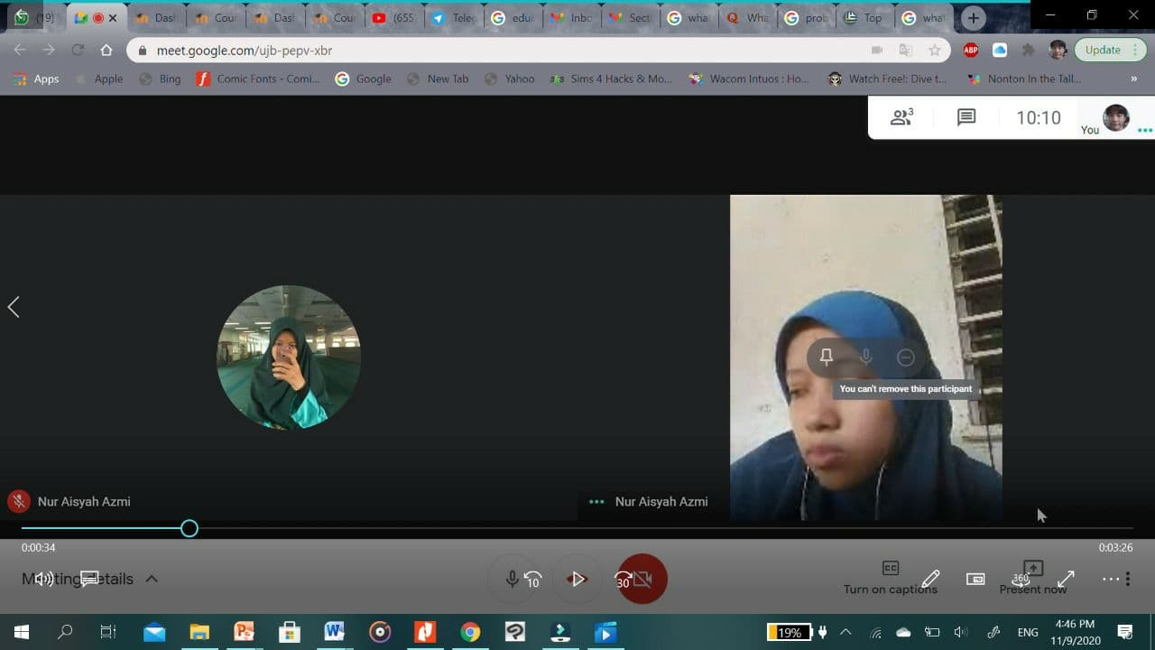
One of our discussions in Google Meet
For our working team, we in group of three decided to divide our work by the one that we most familiar with. We also involve together in discussion to get idea. If one of us do not know how to do or did not understand, our another group member will help that person to make sure we can do this project smoothly.

- DESIGN THINKING ASSESSMENT
4.1 ASSESSMENT POINT
On the first step of design thinking which is empathize, we conducted interview with Mr. Aris Bin Arifin who has been using Information Systems in his work. After that, we conducted a survey on online shopping seller. They know more about how the system work and have the experience using it.
From empathize phase, we managed to analysis the problem from users’ view. Firstly, we tried to understand what kind of problem they faced and define them one by one. At this phase, we point out what actually they need to solve their problem.
Using the information that was gathered from previous phase, we make research on Internet on online shopping application. We all give our opinion on how to solve the problem by brainstorming ideas. By choosing the best idea, we finalized the solution.
We did the prototype that can satisfy user needs and at the same time maintaining its original functions. Doing discussions and stay in contact has improved our prototype quality to be more users friendly.
4.2 DESIGN THINKING EVIDENCES
Phase 1: Emphatize
During this phase, we interviewed Mr. Aris bin Arifin from Department of Digital UTM. Picture below shows group members, Nur Aisyah and Anatasya Humaira asking the interviewee questions.
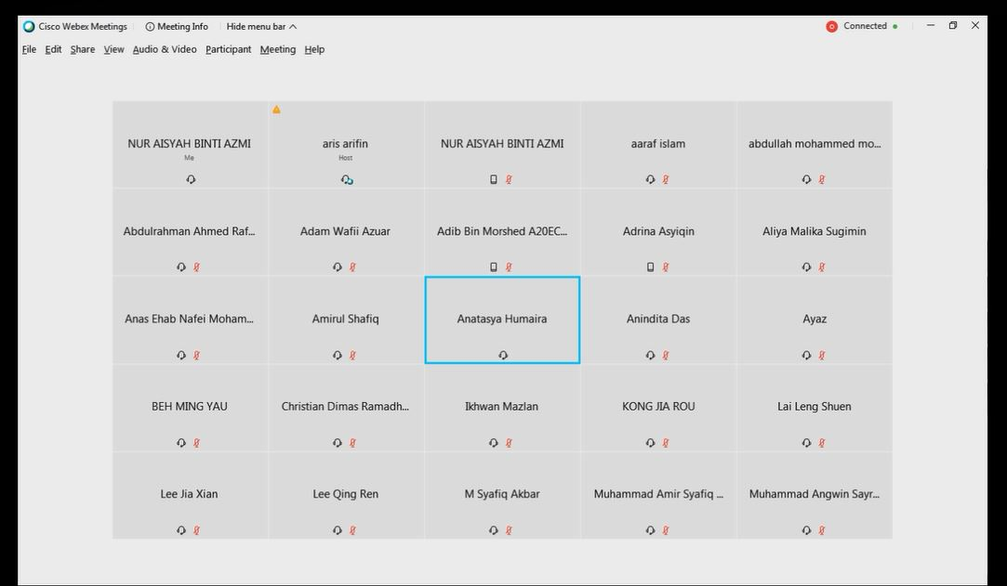
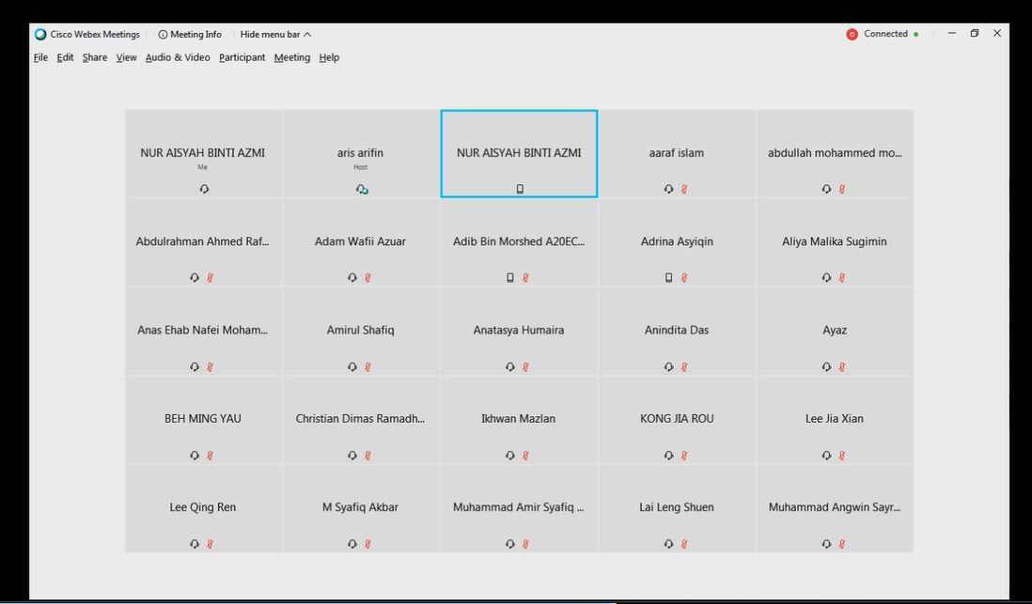

We also conducted a survey through Google form to know people opinion and problem. The form can be accessed here: https://forms.gle/QkQpo1myiHvD5Gmx9

Respondents | Respondent 1 | Respondent 2 | Respondent 3
Gender | Female | Female | Female
Age | 19 | 19 | 19
What medium you used to sell online? | Manual replying | Application and manual replying | Application and manual replying
If you use application to sell online, what kind of problem you always faced in term of information management? | - | I accidentally sent my customer’s parcel using wrong courier because it was my first time using it. | We have to alert in updating stock. If there is a problem with stock, we have to notify the customers. It also has limited place for product variations resulting the customers cannot get fully information about our product.
If you sell online by manual replying, what kind of problem you always faced in term of information management? | Misinformation | Sometimes when my customers are too many, I got confused easily. So I need to jot down all information | Our customer is not that much than usi informatng application one.
What features you, as a seller wish to exist in online shopping application? ( Related to information management ) | Has various choice for delivery courier | It is great already | The ads system that we can easily take up and take down, the current one take a long time to be taken down.
Phase 2: Define
From the survey, we identified the problem that most online seller faced when managing their online shop.
- Misinformation. Majority error happened is from the seller itself since human ability is limited compare to system.
- Have to check manually for stock updates. Even in system, seller has to check one by one each number of items before proceeds to confirm customer purchase.
- Limited place to fill in variation of items. Some of the seller has many item variations but the system does not provide enough places to show to the customer. Customer can mistakenly choose the wrong type because the information is not full.
- Ads took time to be taken up. Each ad that has been taken up by seller will stay for quite a long time. If they realized that they actually done mistake entering the keywords for targeted customers, they need to wait until it done before entering new keyword.
Phase 3: Ideate
A meeting was conducted to find solution for our problems. After doing some research on Internet, we come up with idea on taking concept from one of popular online shopping application, Shopee and adding our solution as it new function.
PROBLEM | SOLUTION
Misinformation | A system where the buyers’ information is already saved.
Have to check manually for stock updates | Auto notifications update for the stock.
Limited place to fill in variation of items | Make the unlimited place to fill in variation of items
New ads took time to be taken up, not good if the existing one does not work | Ads function to reach user by data and interest from visitors.

Below is the new design sketch that we come up from brainstorming idea.
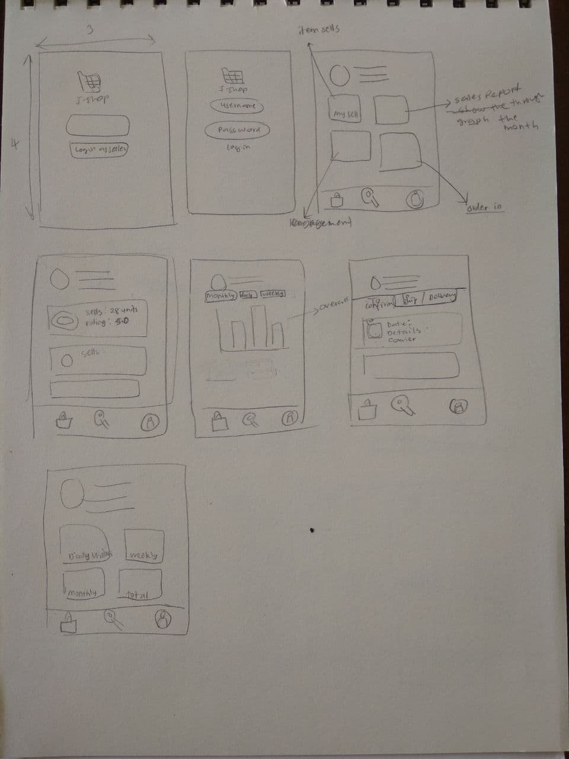
Phase 4: Prototype
According to the solution we get from ideate phase, we proceed to do a prototype. We created the prototype using paper and used boxes. We take the design from our ideate phase and do some editing before print it out.
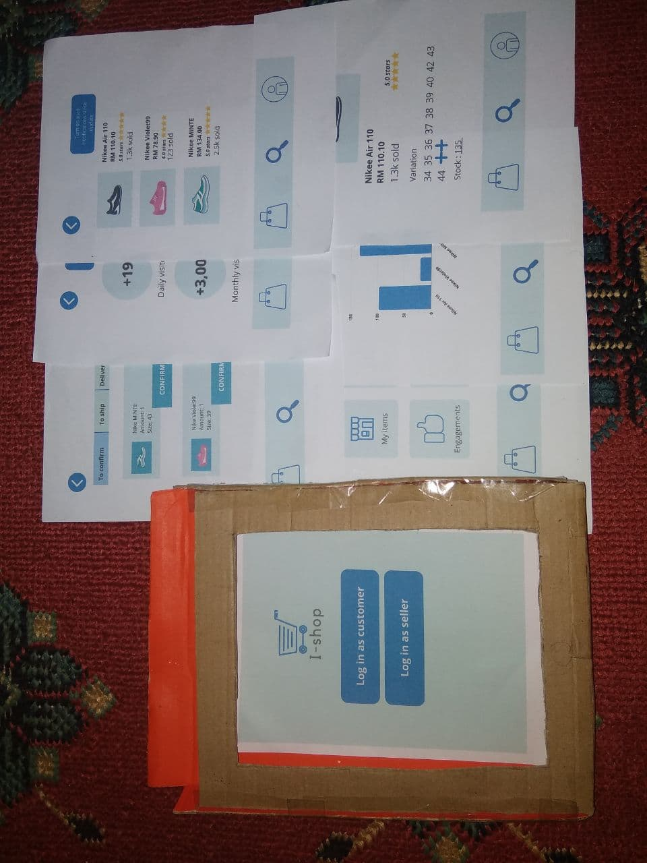
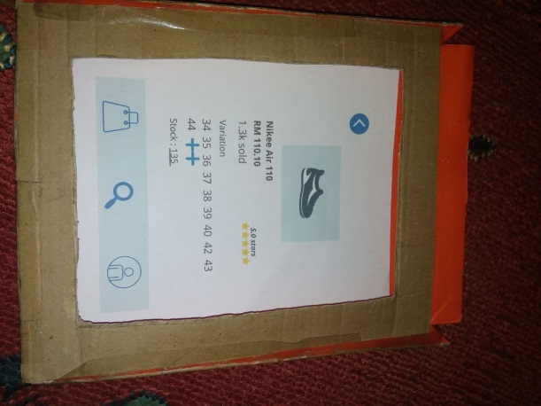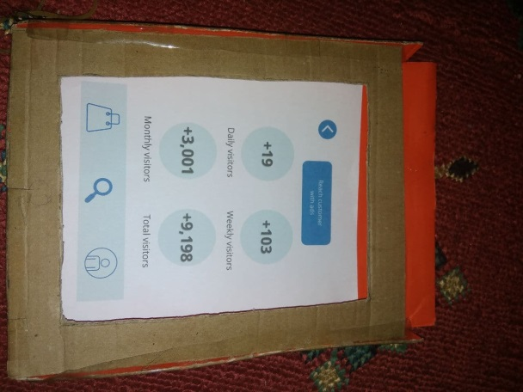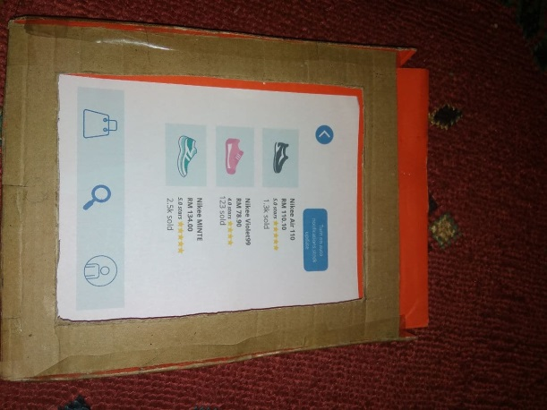

Phase 5: Testing
A testing with our prototype was conducted by showing it to one of our respondents. We explain how our new improving systems work and it functions. The feedback we receive is this prototype is much better than the existing one. There is also some improvement we need to do in term of the color design.

- REFLECTIONS
Our goal with regard to this course is to be a flexible person who can survive in any situation. We know how fast technology changes during this time, so we have to keep in track with the changing trends. As a Computer Science student, this factor plays a big role in our daily task. We need to be creative and have good management information in order to adjust with the change. We also need to make effort to learn new skills, parallel to how problem can diverse in many ways. Only by that, we can handle unexpected problems or tasks effectively.
This design thinking has impact on our goal by changing us to be an open-minded person. We found that it is easier to understand the situation if we takes also other people perspective. One of the benefits is we gain greater insight into new ideas and topics we never think of. Before this, we all know the problem but we cannot solve it since we lack of understanding. During this project, we realized that in order to create a better product and experience, we need to focus on the people which are the user, not us.
The improvement that necessary to us improve our potential is our personal management. This skill is important because we need to be able to independently plan, organize, create and execute. With more commitment and distraction as we grow up, we have to sort our work effectively. In addition, we also have to improve our motivation to learn new things. We realized that we need to increase our productivity in order to perform a good result.

- TASK FOR GROUP MEMBER

NAME | TASK
Anatasya Humaira | - Be interviewer  - Edit video
Haresh Naidu A/L S Murugayah | - Make slide for chapter presentation  - Edit video for chapter presentation
Nur Aisyah Binti Azmi | - Be interviewer  - Make report  - Make prototype

