International Economic downturn-2020

DATE: 23/12/2020 REPORTED BY-
JOHOR BAHRU, MALAYSIA NABIL RAYHAN-A20EC9107
FARIHA TABASSUM-A20EC4017
NAZMUS SAKIB-A20ec4046
TASMIAH SARIF NAYNA-A20EC9109
SHAHARIAR SHOWMIK-A20EC9108

Introduction:
The economy is an interconnected mass of production, consumption and exchange activities that helps to determine how scarce resources are allocated. The production, consumption and distribution of goods and services are used to meet the needs of those who live and operate in the economy, which is also called the economic system.
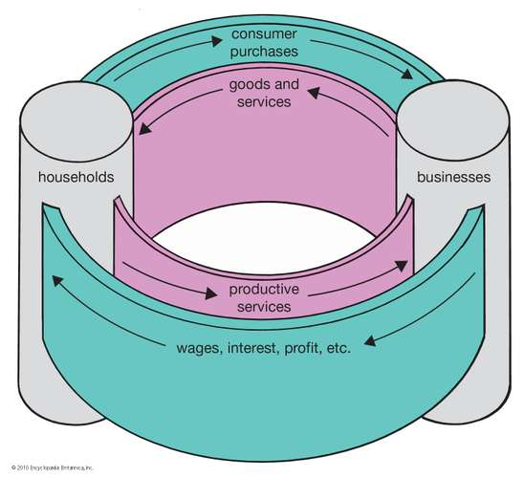

The word economy is Greek, meaning "family management". In ancient Greece, especially Aristotle, philosophers began to use economics as a research field, but modern economics research began in Europe in the 18th century, especially in Scotland and France.
Economic indicators show the economic performance of a country in a specific area. These reports are usually issued by government agencies or private organizations on a regular basis, and when they are released, they usually have a significant impact on the stock, fixed income and foreign exchange markets. They are also very useful for investors to assess how economic conditions will affect the market and guide investment decisions.
Philosophy connects economy with economics. Economics is the study of how people make decisions in the face of scarcity. These can be personal decisions, family decisions, business decisions or social decisions. If you look around carefully, you will find that scarcity is a fact. Scarcity means that human demand for goods, services and resources exceeds what is available. Resources such as labor, tools, land, and raw materials are essential for producing the goods and services we want, but their supply is limited. Of course, the ultimate scarce resource is time-no matter rich or poor, everyone has only 24 hours a day to try to obtain the goods they need. Limited resources can be used at any time.

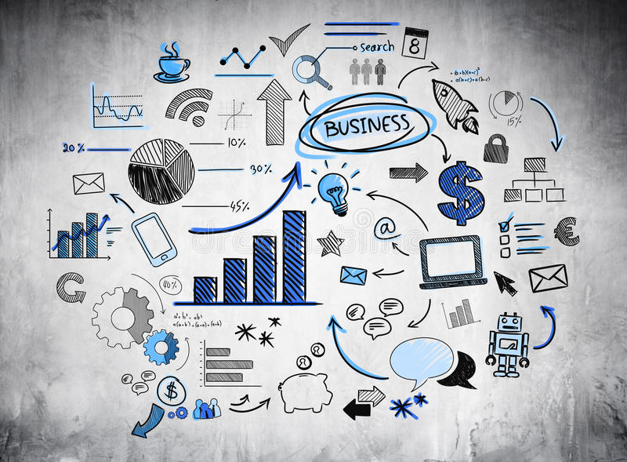
In an economy, the production and consumption of goods and services are used to meet the needs of life and operators in it.

Problem:
Economic growth: Steady economic growth Nowadays, the GDP of a country is becoming increasingly imbalanced. In the last few months since we updated the World Economic Outlook in January, the world has changed dramatically. A rare disaster, the coronavirus pandemic, caused a large number of deaths. As countries adopt necessary isolation and social isolation measures to contain the pandemic, the world has fallen into confinement. The scale and speed of the ensuing collapse of activity is different from everything we have experienced in life.

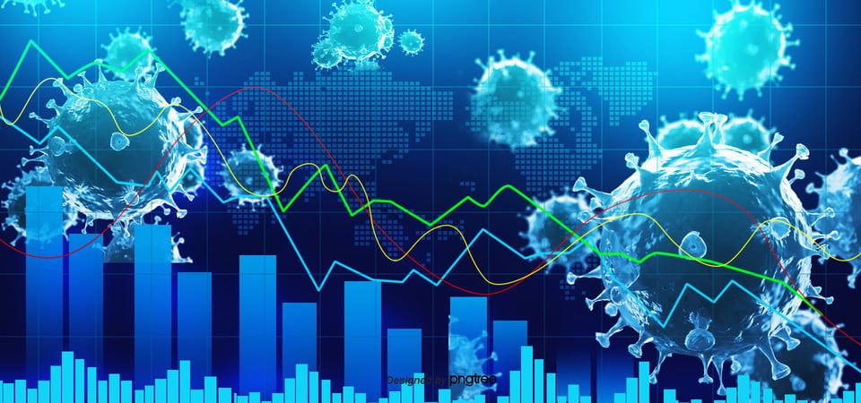

Unemployment: Unemployment is a term that refers to individuals who are available and are looking for work but cannot find a job. In addition, those who do not have suitable jobs in the labor force or group of people. It is usually measured by the unemployment rate, that is, the number of unemployed divided by the total labor force. The unemployment rate is one of the indicators of economic conditions. Unemployment exposes workers to financial difficulties, which can lead to emotional damage. When this happens, consumer spending, one of the key drivers of economic growth, will fall.

Problem of face-to-face Trading: The fact that COVID-19 is affecting international trade patterns should not surprise anyone. Due to the communication gap, the company cannot maintain its classic transaction. In today's global business climate, COVID-19 affects the way companies operate. Efforts to control and mitigate the spread of the virus include temporary restrictions on travel and at borders. These efforts could have further ramifications for international business activities. Global trade has collapsed.

Overseas shipment: With the economic downturn, tariffs and trade affect the supply chain, many discussions have focused on imports of goods and services. Customs declaration, unforeseen tariffs, compliance with local laws and regulations, these are just some of the problems that may arise before the goods even enter the market. Recently, the import and export system cannot operate as it did in previous years.

Inequality/ Poverty: Poverty is a problem. Recognizing that we should work to reduce the amount of poverty is also a problem. Many people will admit the need to reduce overall poverty, whether this is a good idea. 10% of the world’s population still live on less than $1.90 a day-although this number has fallen in the past three decades. It is expected that the number of countries already struggling with high levels of poverty will further increase, but more than four-fifths of countries have been forced into poverty during the pandemic.

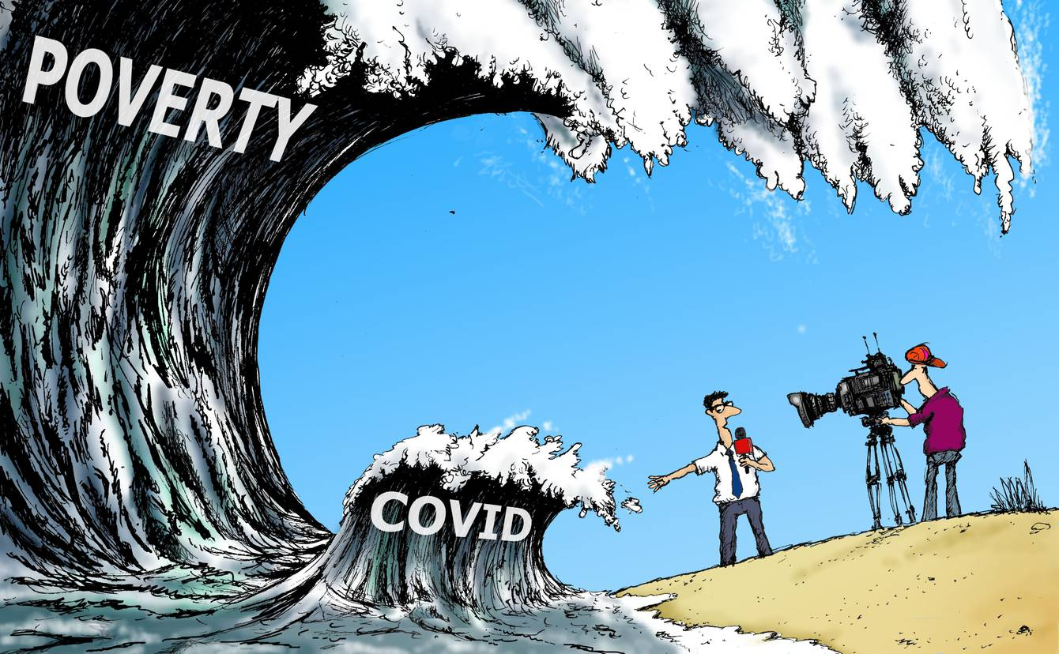
Poverty is the biggest indicator of Economy that can describe a country's whole situation.

Covid-19 effect on economic imbalance:
Nowadays, the effect of Covid is spreading in all ways. Economy is not different from it. Before this economic system was not this much unstable. Covid took place in everyone’s life and people couldn’t maintain their health condition like before. Dying rate touched a high level and government couldn’t maintain the rate. They tried to give the best treatment but as still there is no vaccine they failed. The poor countries couldn’t maintain their economical balance and they felled from their previous. The developing countries also couldn’t maintain their place in world rank on economic status.
Many companies and business faced a lot of troubles and issue related to their savings. Lastly, they couldn’t continue that business. International student universities couldn’t sure the education due to Covid so the education systems are also getting unstable. Countries tried to made a mutual relationship by providing jobs and education to poor countries. But right now, no country is able to continue this relationship anymore.as their own country situation is worst. Only the online business and marketing got the highest priority in this situation. They developed themselves from their previous situation.

This is a graph of the economic status during Covid time of some countries:

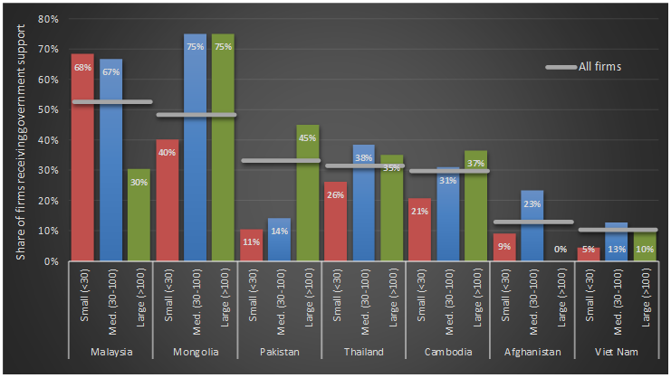

Trade impact of the Coronavirus of some countries:

Here is a graph which shows the trade impact of the coronavirus pandemic.
The graph is taken from the source of UNCTAD

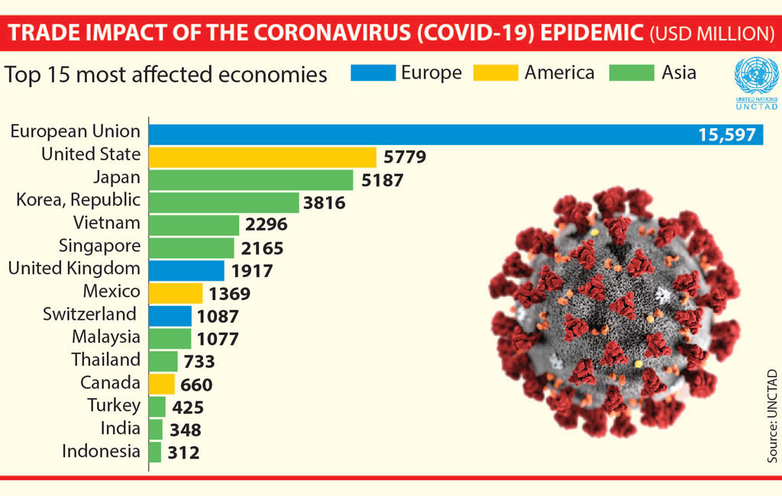

From the picture it is clear that corona is affecting highly in economies. Moreover, it is an international problem. Top 15 countries faced the most effect of covid. Such as United States, Japan, Korea, Singapore, United Kingdom. Countries that was little affect is Malaysia, Turkey, Indonesia. By blue color it showed countries of Europe and by yellow and green it showed America and Asia trade impact on this pandemic.

A country GDP rate in lockdown situation:
Here is a graph related to the total GDP of a country as an example.
This graph is taken from the source social accounting matrix (Sam)model.

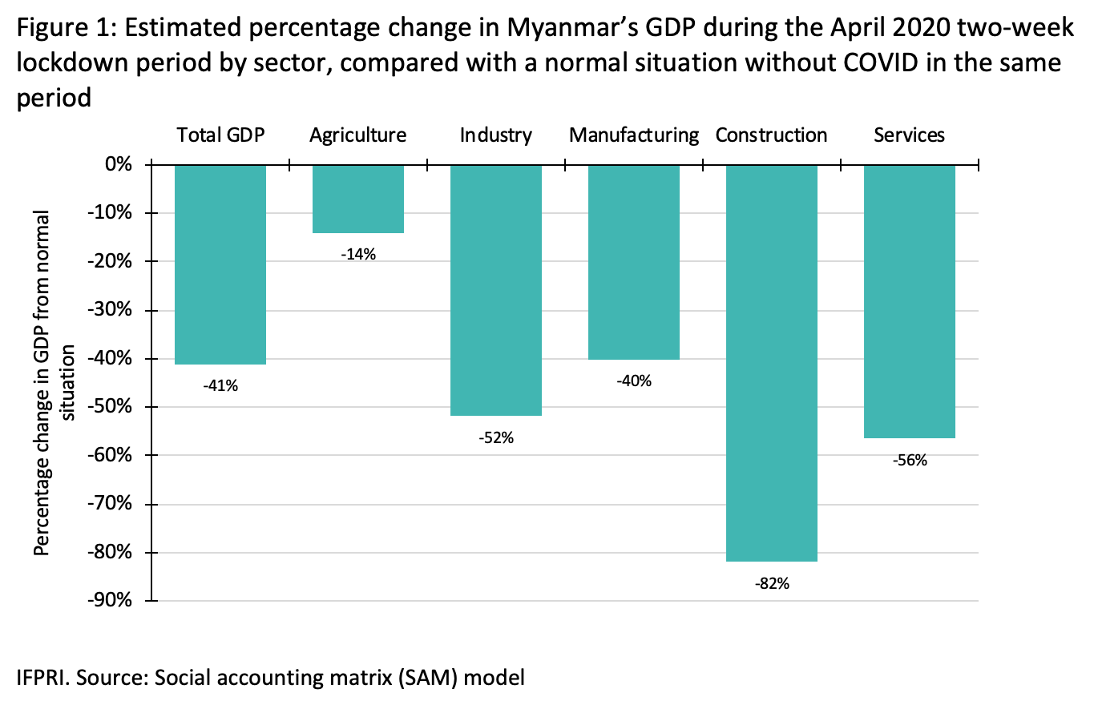

If we have a look on this chart though this chart is of Myanmar’s GDP still every country is facing the same GDP situation on percentage because of this pandemic. Starting with agriculture, Industry, manufacturing, construction every part has shown a downfall than the previous. Total GDP is also changed. Like this way every country is having their total GDP less than previous years which shows an effective downfall in world rank.

Impact of corona virus on stock market:
If we turn to stock market we can follow that it started with the rate of 0% and then it is falling down decreasing its rate into -5% to -40% which is a big loss that cannot even been thought. Furthermore, it tried to overcome its rate and then it reached a level of -13.3%. still they are trying to get their place back to 0%This is a graph related to stock market shows the impact of coronavirus.

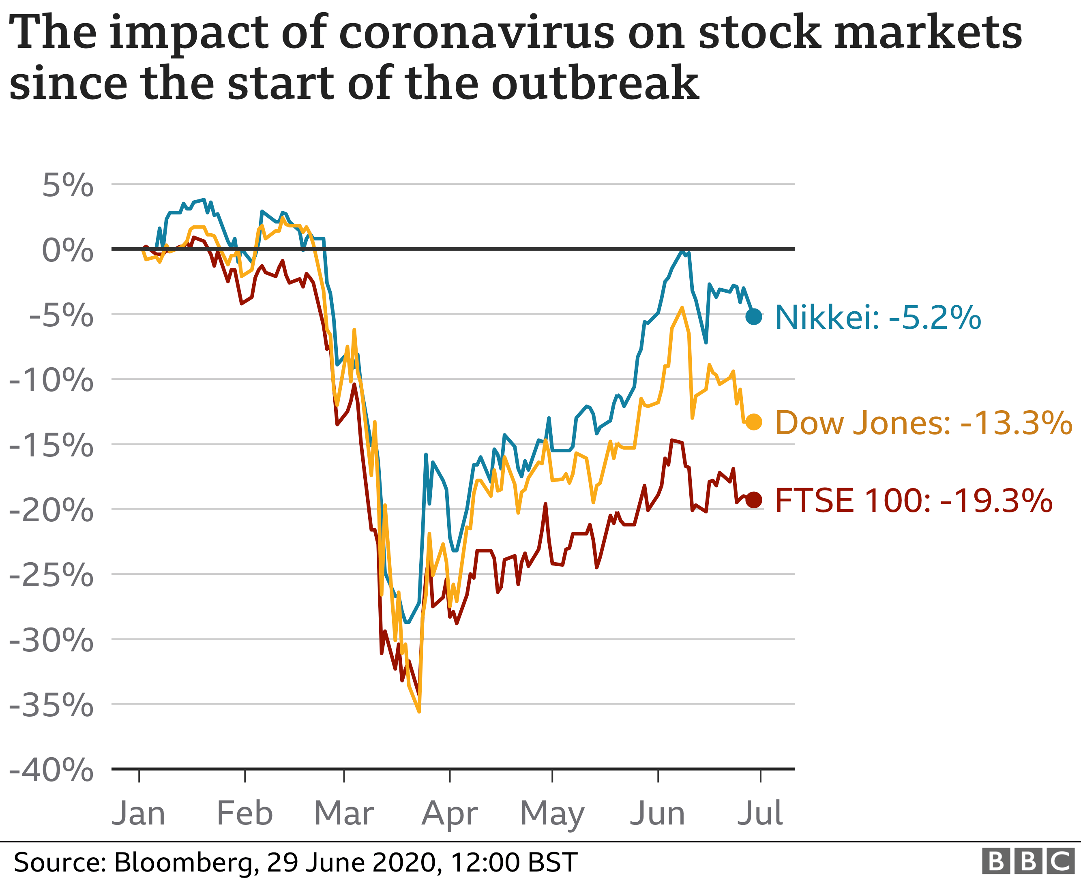

An economical survey:
A survey was done on 11.01,2020 between international students on this matter of economy to know their current situation in their respective countries. Some responses are given below:
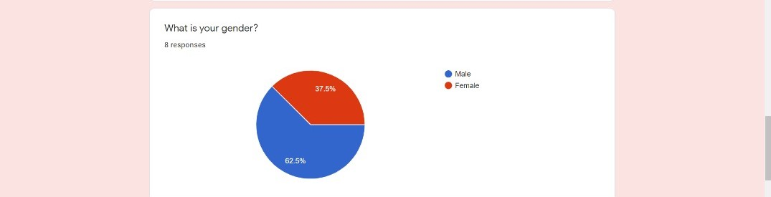

Mainly male and female both took part on this survey. There were 37.5% female responses and 62.5% male responses according to the survey. And they gave their opinion on it.



As they were all students. Their age was between 16 to 30. Therefore, 100% was of this age. They tried to inform us about their current place also.

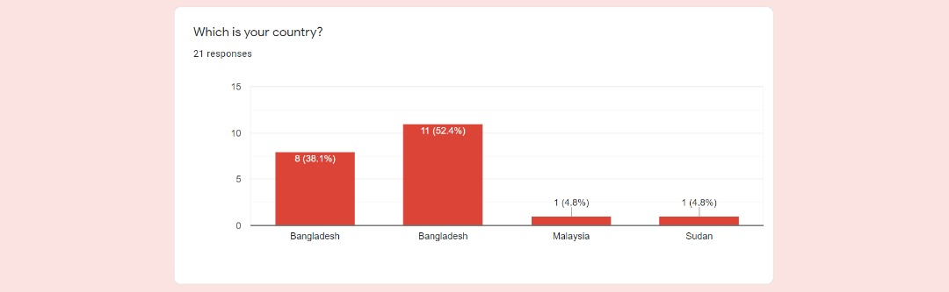

Many international students of Bangladesh, Malaysia, and Sudan filled this survey. Therefore, their rate was nearly 38.1% and 54.4% from Bangladesh, 4.8% from Malaysia and 4.8% from Sudan.


The survey got 62.5% responses as not good. So, the international students reviewed that this pandemic affected their countries highly.37.5% responses was stable. On this pandemic some of the countries could managed the situation smartly which was rare. They didn’t fall down from their economic status or they had a fall down and then they tried to overcome and stick in the point on stable. But no one response came as good. From this survey it is very clear that no country economic system is facing good effect on this situation. This is a great economic fall down of 2020.histry will mark it.



Focusing on the effect the reason for this sudden fall down was Covid-19, unemployment and poverty. According students 71.4% students agreed with the reason of covid-19, 14.3% agreed with unemployment and 14.3% with poverty. Mainly, by the percentages it can be said that covid-19 is the main reason of this sudden economical fall down. Also, it can be related with unemployment and poverty. After this pandemic many people lost their respective jobs and now shifting to business which is also not getting profit as expected. Therefore, Unemployment and poverty both is connected with this pandemic though it was a previous problem which was not only because of 2020 but now all problems got mixed and it viewed as fall down of economy. This fall down will create mark on history of world economic fall down of 2020.


Methodology:
To overcome the economical fall-down occurred in the Covid-19 in the year of 2020, we all are supposed to play important role. All individuals, start-up & small companies, enterprises should implement some techniques. Since the developing and undeveloped country’s developments totally dependent on their economy so they must overcome this current economic fall down. To overcome this situation, traders should resume trading by understanding the market demand. They need to understand the demand of products in current market. They need to produce and prepare their products as customers want. If the product demand is high then the Companies and industries should arrange part-time job slots for the unemployment people in the holiday or after the working hours. It can be helpful for 2 ways, one is for more production within the short time and another one is it’s a blessing for unemployment people. While the unemployment ratio will reduce then the GDP will grow automatically. Companies should notice on the pricing, so that it can be fixed by considering the customer’s affordability. Because after passing this Covid-19 pandemic, the people have almost empty pocket nowadays. The Government as well as the administrators must keep an eye on the market and business sectors, so that any syndicate can’t be made or carrying on such like this unethical work. Product should be promoted and the advertisement must be spread more in the same ratio of the market demand. It also can be helpful slightly for preventing the market syndicate. Preventing market syndicate is helpful for customers, companies, manufacturers, wholesalers.

During this Covid-19 pandemic, most of the start-up companies, small enterprises been closed because they couldn’t run their business. Lockdown, order close, shipment problem and more problems had to face to them. That’s why many employees lost their job. Even many big companies and industries also fired their employees because of that circumstance. Now, many companies and industries started running their business though in short range but they need to refill their empty job positions by the unemployed people. It can be reduce a nation’s unemployment rate. On the other hand, the freelancing and outsourcing began to being popular all over the world. Many IT firms, IT companies, software solutions companies providing their work, project to the freelancers in this pandemic. In this pandemic, many IT students, newly trained IT employees can do their job by staying their home by getting paid. They can make or fix websites, applications, software and so on without exiting own house. So, the educated unemployed people must learn these kinds of IT work then do freelancing. It will help a nation’s economy a lot to grow.
The food delivery & parcel services also got popularity in this pandemic as we already have seen. These services helping the citizen a lot. People can order food by mobile applications then they get their food easily by staying home. So, young unemployed people should do these kinds of work by getting paid. This can be helping a person to prevent poverty by earning money.
Though the lockdown situation gone out but still everyone didn’t come out of home properly. So, entrepreneurship can play a big role to overcome this economical fall down even in a short range. It can make at least few job opportunities for some unemployed people. If 100 entrepreneurs start their business one by one and they make at least 5 job opportunities then the total job opportunities will be create almost 500. Entrepreneurs will be benefited from it also some unemployed persons will get work. This is how the unemployment problem will be gone. Government, banks, big trusties should help the new entrepreneurs by giving advice, loan and help what they need to start-up and run their business.
Education is considered as the backbone of a nation. So, schools, colleges and universities should carry on the schooling, taking examinations and educational activities through the online medium so that students don’t fall behind with their study. We already have seen that many universities taking their classes, assessments etc. through online. It must be keeping up until the situation gets well.

The industries shouldn’t produce more against the market demand. If a product’s market demand is 100 pieces of quantity but the factory produced 150 pieces of that product then it will be counted as a wastage amount. Because the shipping process is still non-smooth all over the world. That’s why they need to balance the production and sell rate. Also the pricing must be set with maintain the flow of market value as following the classical economic theory. Pricing definitely be set balancing between production cost and the customer’s affordability.
To overcome this economic fall down can be done by reducing poverty. Poverty can be reduced or erased by creating job opportunities and working sectors, starting up mini business, entrepreneurship and so on. Once the poverty is erased or reduced only then the sustainable development of a nation will automatically rise up.

Development Goals and Objectives:
The development strategy is not done overnight. There are some steps to restore the global economy to its previous position and get improvement.
To reduce unemployment, we have to maintain a broad community consensus on the direction of economic development hard work. Promote the diversification of the business/industrial base. Encourage access to economic incentives to create high-quality jobs. Continue to use a unified economic development team with public/private sectors Participate to achieve the economic development goals of the region. While acknowledging the function of supervision, reduce obstacles to economic growth. Identify other resources to help economic development. We need to build a o build a highly skilled workforce.
The primary goal of economic planning is to increase national output. Due to poor national output, most backward economies will fall into poverty. Compared with the population and the needs of the people, the per capita output will be very low.
The key to economic development is the industrialization of the country. An economy can have the potential to produce a large amount of goods. But in the absence of industrialization, the powers of the economy will remain dormant and the economy will be condemned as backward.
Reduction of Inequalities of Income and Wealth is one of the most important objectives of economic planning. Many development plans can generate inequality problems, and effective planning will have to reduce them.
Investments in education, health, slum clearance, medical facilities, social insurance, etc. are aimed at improving the living standards of the poor. The private sector does not spend social expenses to improve the quality of workers, and this can only be achieved through planned public investment. Stabilization of the finance is the only solution to overcome the problem of poverty and make the world better.

A Poster was made on 18/12/2020 by Group-02

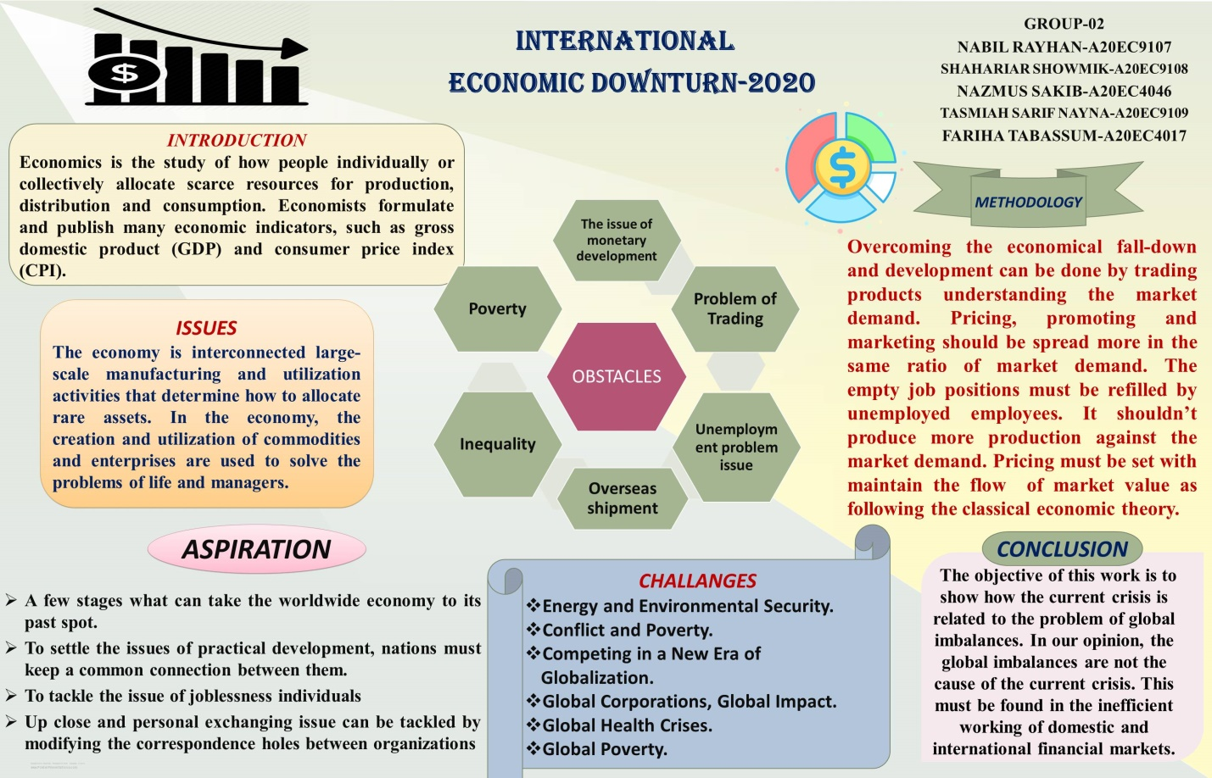

A PROPOSAL WAS CREATED BY GROUP 02 ON 14/11/2020

HERE IS THE LINK: (https://drive.google.com/file/d/1gj2ciWnXtVyr8u5apUoyDEeUUYTzQkYi/view?usp=sharing)

A video was created by Group 02 on 20/12/2020
Here is the Video Link: (https://youtu.be/cY7x_znbZeY)

Review:
A social problem of economy was selected by us. A survey was arranged to observe the issues among general people. However we have came up with some solutions. To overcome this economy problem companies should arrange more slots for unemployment people. trading problems can be solved by communicating more and more. On the other hand as everything is going through online communications can be build more easily. Poverty can not be erased in one day day by day it will cross a line which is better that previous. Because of Covid-19 the economy lost it's balance moreover we hope and pray that we can get the economy status like previous years. Once poverty is erased sustainable development of a nation will automatically raise up.

Conclusion:
The COVID-19 pandemic has, with alarming speed, dealt a heavy blow to an already-weak global economy, which is expected to slide into its deepest recession since the second world war, despite unprecedented policy support. The global recession would be deeper if countries take longer to bring the pandemic under control, if financial stress triggers defaults, or if there are protracted effects on households and firms. Economic disruptions are likely to be more severe and protracted in emerging market and developing economies with larger domestic outbreaks and weaker medical care systems; greater exposure to international spillovers through trade, tourism, and commodity and financial markets; weaker macroeconomic frameworks; and more pervasive informality and poverty and also our education. Education is considered as the foundation of a country. In this way, schools, schools and colleges should carry on the tutoring, taking assessments and instructive exercises through the online medium so understudies don't fall behind with their investigation. We as of now have seen that numerous colleges taking their classes, evaluations and so on through on the web. It should keep up until the circumstance recovers. Beyond the current steep economic contraction, the pandemic is likely to leave lasting scars on the global economy by undermining consumer and investor confidence, human capital, and global value chains. Being mostly a reflection of the recent plunge in global energy demand, low oil prices are unlikely to provide much of a boost to global growth in the near term. While policymakers’ immediate priorities are to address the health crisis and moderate the short-term economic losses, the likely long-term consequences of the pandemic highlight the need to forcefully undertake comprehensive reform programs to improve the fundamental drivers of economic growth, once the crisis abates. Subsequently, this issue can't be addressed or executed for the time being. Be that as it may, nations are attempting to survive and arrive at a standard level.

References:
1.Bardhan, P.K. (1970): Economic Growth: Development and Foreign Trade (New York, Wiley)
2. Anand, S. (1975): ‘Aspects of Poverty in Malaysia’ (St Catherine’s College, Oxford; mimeographed).
3. Alamgir, M. (1976): ‘Poverty, Inequality and Development Strategy in the Third World’ (First Congress of Third World Economists, Algiers, February).
4. Milagron, P. R., & Roberts, J. (1992). Economics, organization & management. Englewood Cliffs, NJ: Prentice Hall.
5. Rivera- Batiz, 2018. "Economic Integration and Endogenous Growth," World Scientific Book Chapters, in: Francisco L Rivera- Batiz & Luis A Rivera- Batiz (ed.),International Trade, Capital Flows and Economic Development.
6. Four steps towards a more sustainable global economy, Department of Economic and Social Affairs,
10 January 2018, New York.
7. John P. Own, Methodology in Economic Development: A Comparative Analysis, Southern, Economic Journal.Vol. 23, No. 2, p. 126-133

