

Subject | : Digital logic
Section | : 05
Task | : Lab 3

Group member
Tasmiah Sarif Nayna
A20EC9109
Afifa Jumana
A20EC4009

D. Preliminary Works :
1.

Table 1
Desired result | PRE’ | CLR’ | J | K | CLK | Q
Set initial value Q = 1 | 0 | 1 | X | X | -- | 1
Output Q stays the same | 1 | 1 | 0 | 0 | ⇓ | 1
Output Q become 0, no change in asynchronous input | 1 | 1 | 1 | 1 | ⇓ | 0
Output Q is not the previous Q | 1 | 1 | 1 | 1 | ⇓ | 1
RESET Q | 1 | 1 | 0 | 1 | ⇓ | 0
SET Q | 1 | 1 | 1 | 0 | ⇓ | 1

2. a) JK toggles when J is active (HIGH) and K is also active (HIGH)

b) Negative edge triggered

E. Lab Activities :

1.
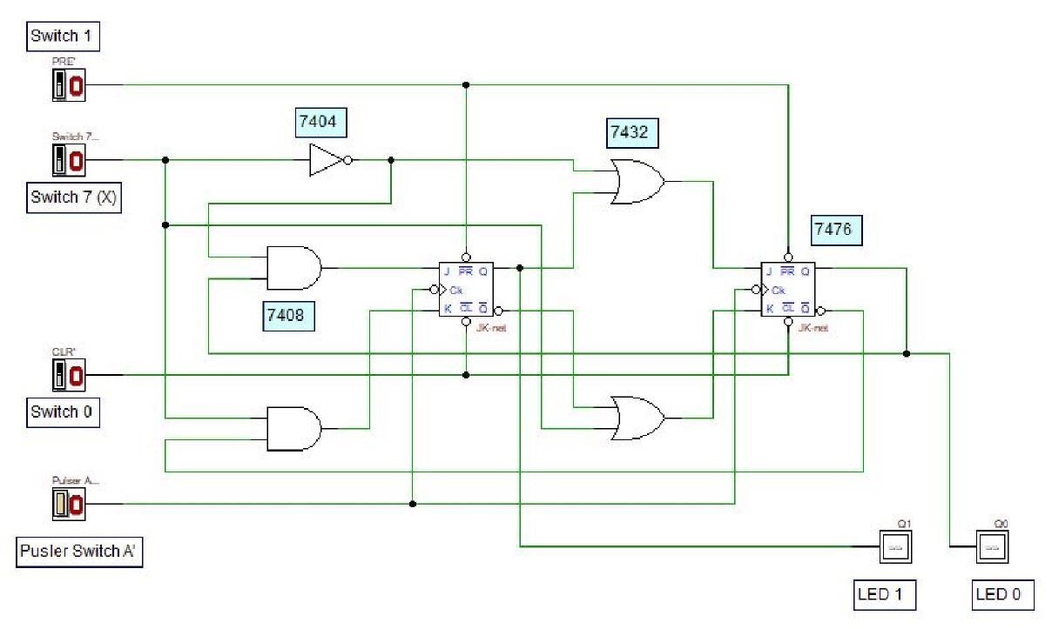
Figure 4: A Synchronous Counter Circuit

2.
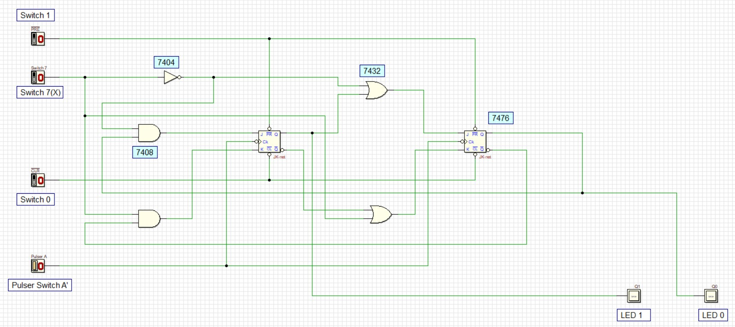
Figure 5: A Synchronous Counter Circuit

3.

Table 2
Switch 7 | Present State |  | Next State
X | Q1 LED 1 | Q0 LED 0 | Q1 LED 1 | Q0 LED 0
0 | 0 | 0 | 0 | 1
0 | 0 | 1 | 1 | 0
0 | 1 | 0 | 1 | 1
0 | 1 | 1 | 1 | 1
1 | 0 | 0 | 0 | 0
1 | 0 | 1 | 0 | 0
1 | 1 | 0 | 0 | 1
1 | 1 | 1 | 1 | 0

4. State diagram :
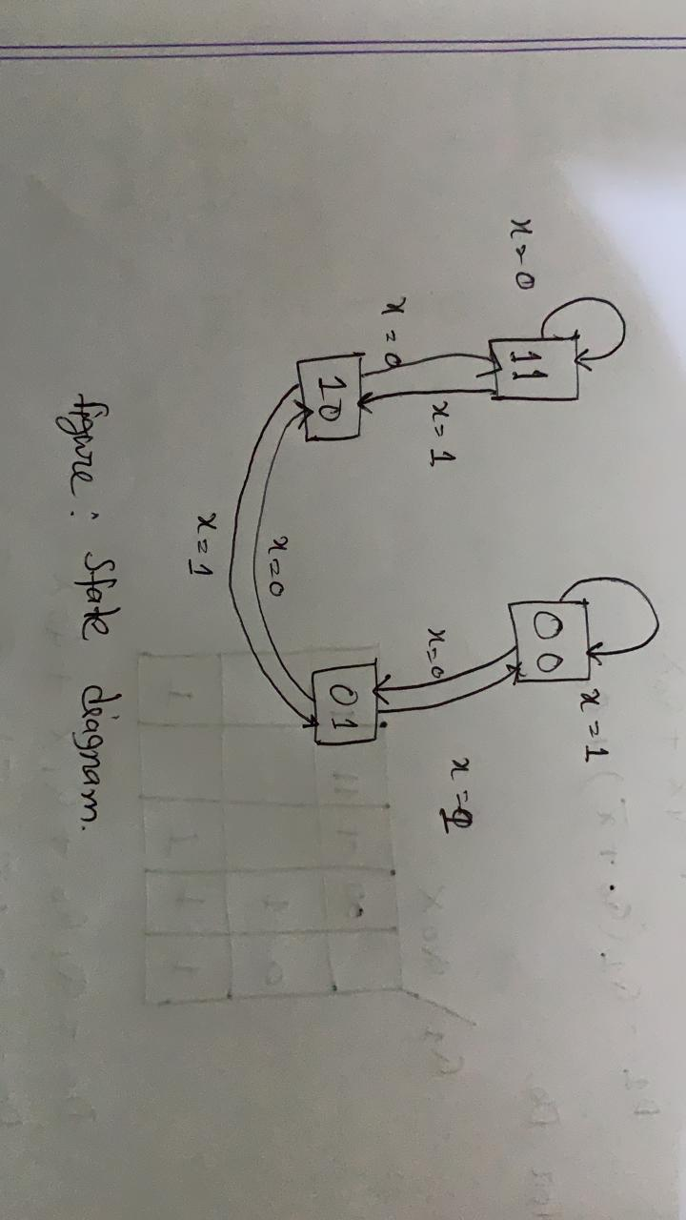

5. a) Both flip-flop are triggered with same clock simultaneously .
Synchronaus counter:
In the Synchronaus counter at the clock input to the flip flop state are changed.
So, main inclicatior for synchronaus counter is sate should change with reipeat to clock and input only when clock occure.

- There are 4 states: 00,01,10,11.

- Switch 7 is count direction, it will determine if counter will go up or down. X=1(count down) and X=0 (count up).

- There are asynchronous inputs, if both set to 1, JK can work synchronously. Switch 1 is active (HIGH), it presets output to 1 and when switch 0 is active, it clears the output to 0.

e) Yes, it is saturated counter. Because a saturated counter is counter which count from minimum 00 to maximum value 11.

6. a)

Table 3
Input X | Present | state | JK FF | input | Next | State | D FF | Input
 | Q₁ | Q₀ | J₁ K₁ | J₀ K₀ | Q₁⁺ | Q₀⁺ | D₁ | D₀
0  1 | 0  0 | 0  0 | 0 0  0 1 | 1 1  0 1 | 0  0 | 1  0 | 0  0 | 1  0
0  1 | 0  0 | 1  1 | 1 0  0 0 | 1 1  0 1 | 1  0 | 0  0 | 1  0 | 0  1
0  1 | 1  1 | 0  0 | 0 0  0 1 | 1 0  1 1 | 1  0 | 1  1 | 1  0 | 1  1
0  1 | 1  1 | 1  1 | 1 0  0 0 | 1 0  1 1 | 1  1 | 1  0 | 1  1 | 1  0

J K | clk | Q⁺
0 0  0 1  1 0  1 1 |  | Q  0  1  Q̅
D | Q⁺
0  1 | 0  1

b)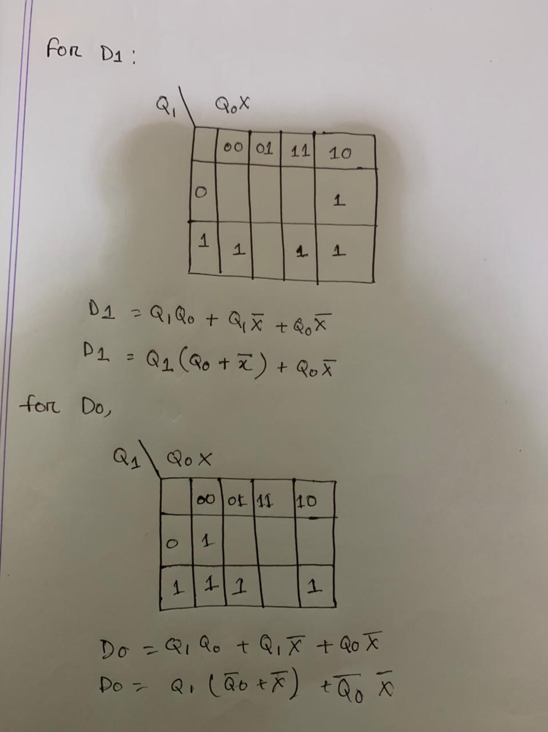

Circuit design for D FF

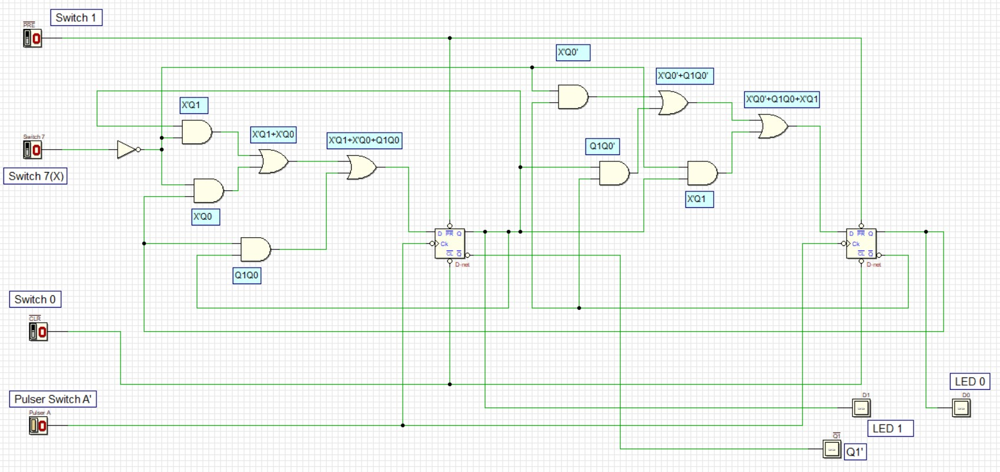

c) Count up

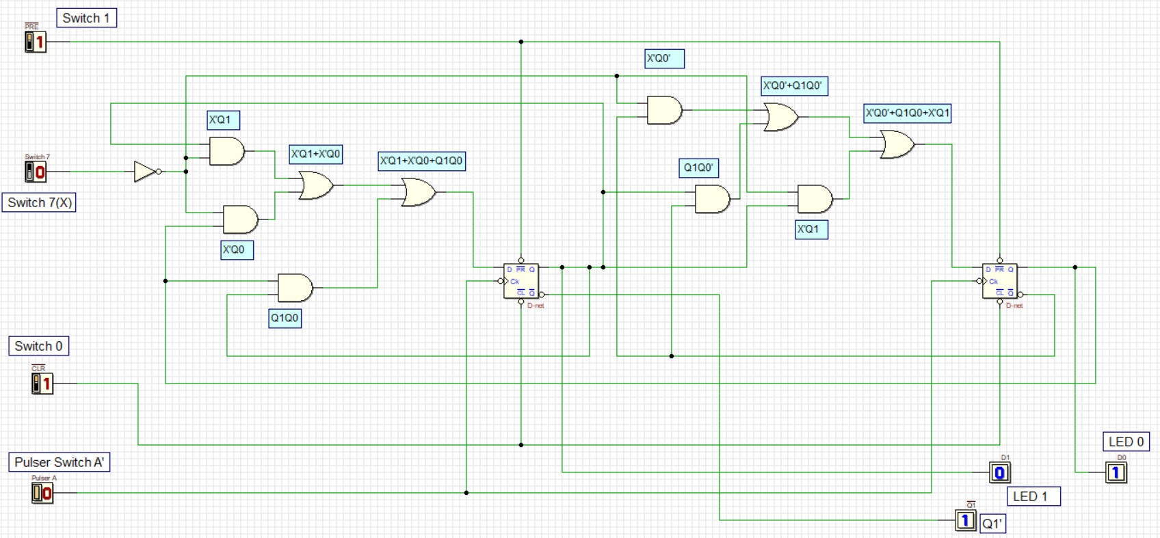

Count down

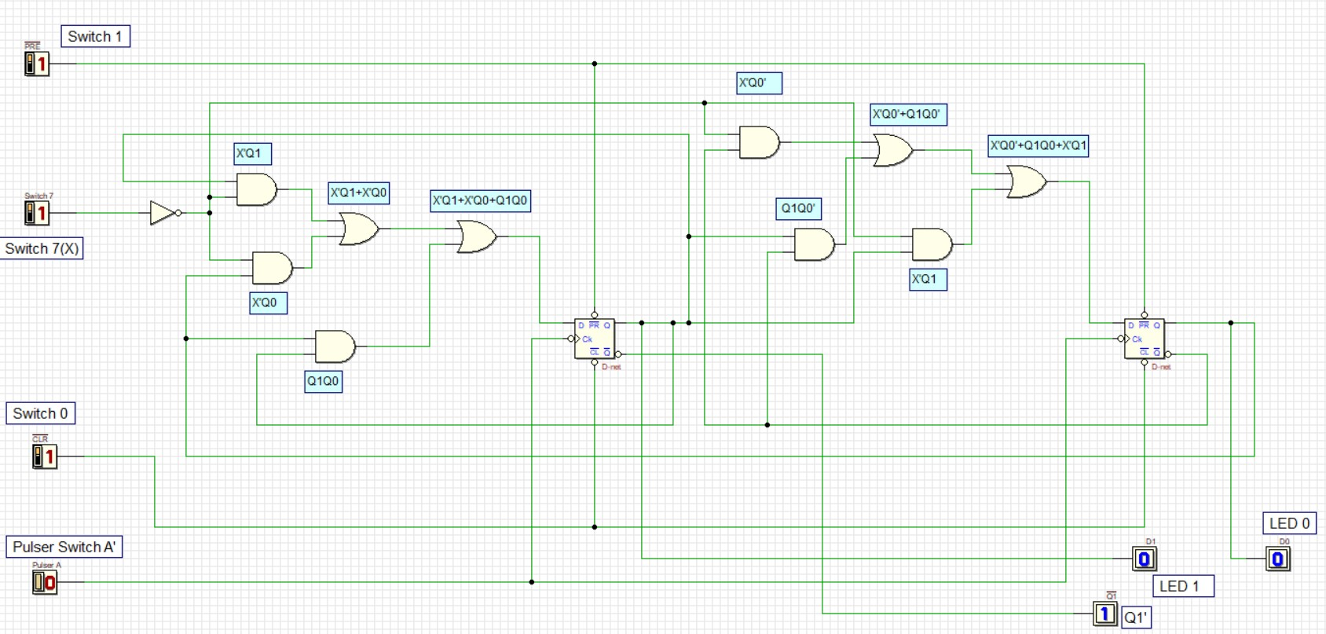

7. a) Table 4
Switch 7 | Present State |  | Next State |  | D FF Transition
X | Q1 LED 1 | Q0 LED 0 | Q1 LED 1 | Q0 LED 0 | T1 | T0
0 | 0 | 0 | 0 | 1 | 0 | 1
0 | 0 | 1 | 1 | 0 | 1 | 1
0 | 1 | 0 | 1 | 1 | 0 | 1
0 | 1 | 1 | 1 | 1 | 0 | 0
1 | 0 | 0 | 0 | 0 | 0 | 0
1 | 0 | 1 | 0 | 0 | 0 | 1
1 | 1 | 0 | 0 | 1 | 1 | 1
1 | 1 | 1 | 1 | 0 | 0 | 1

k-map for T flip-flop :
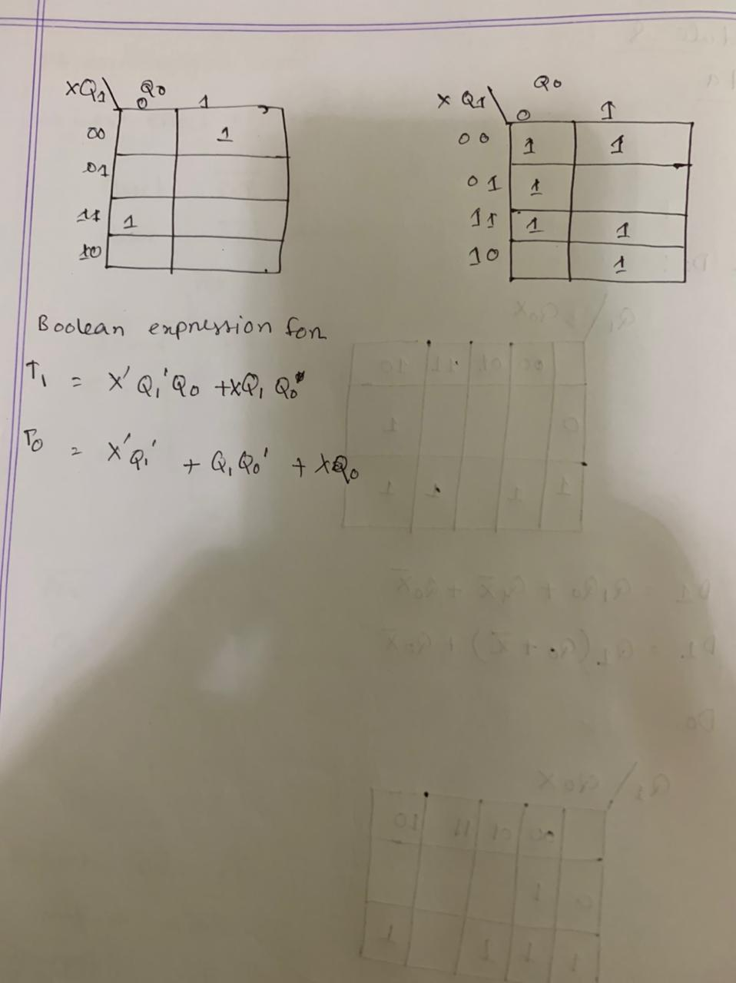

Circuit design for T FF
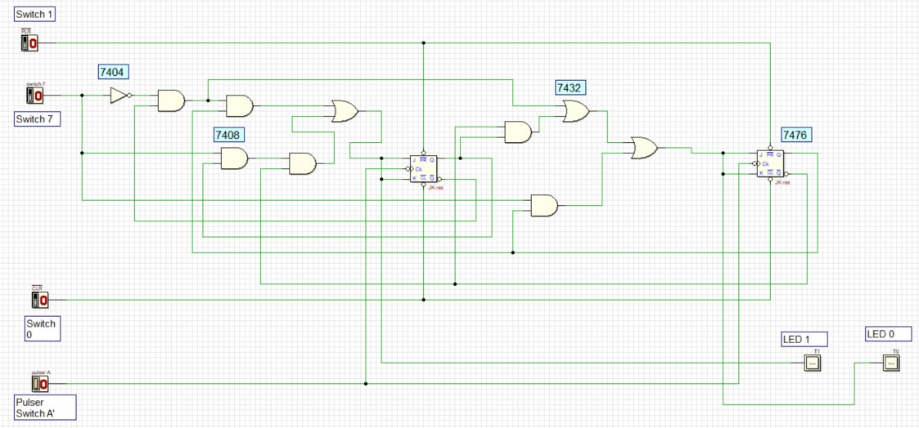

Simulation

Count up
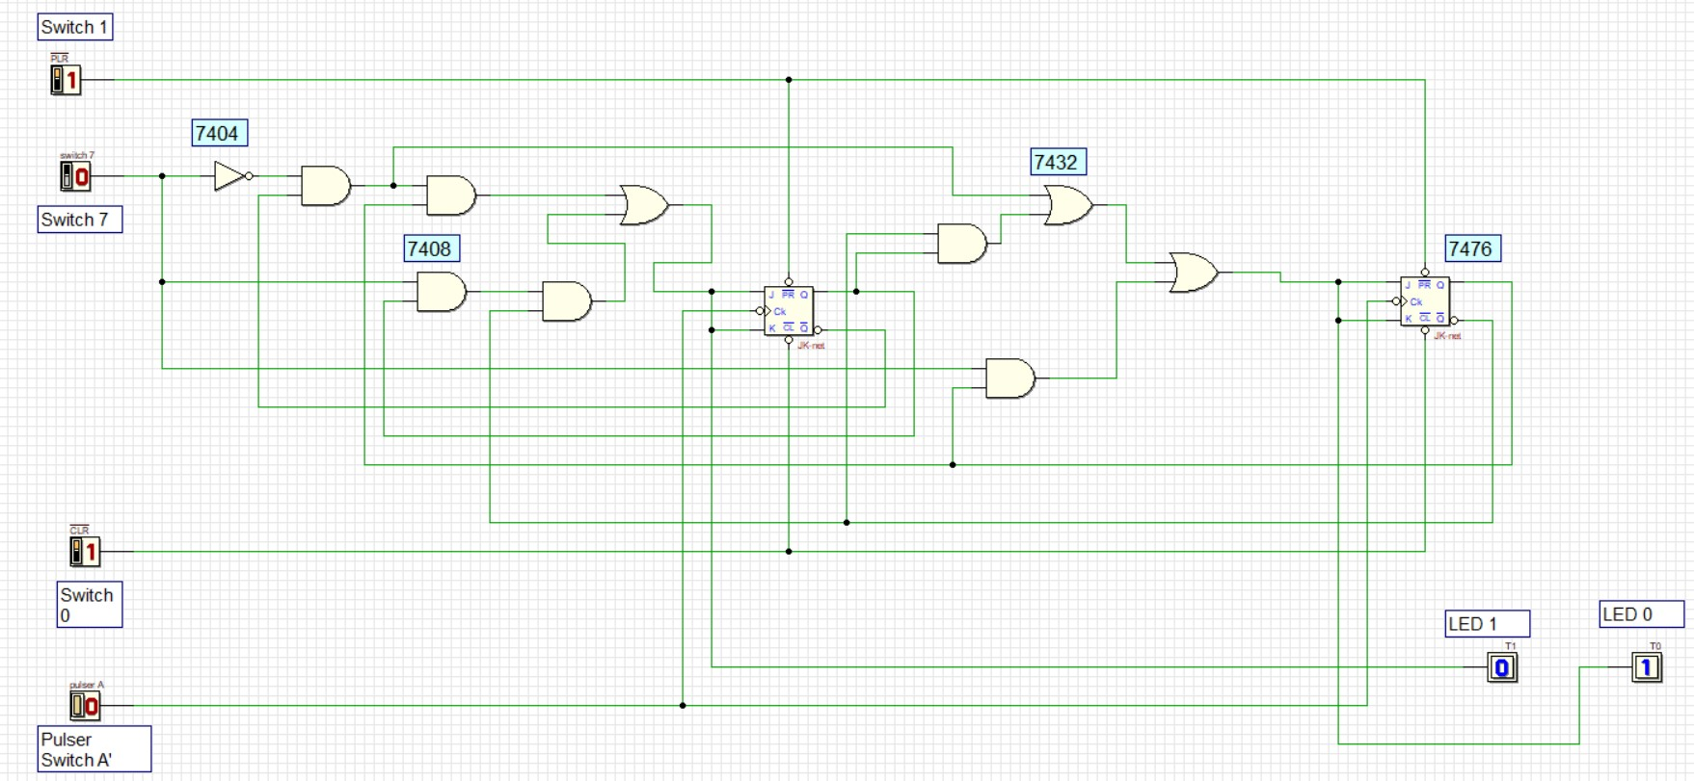
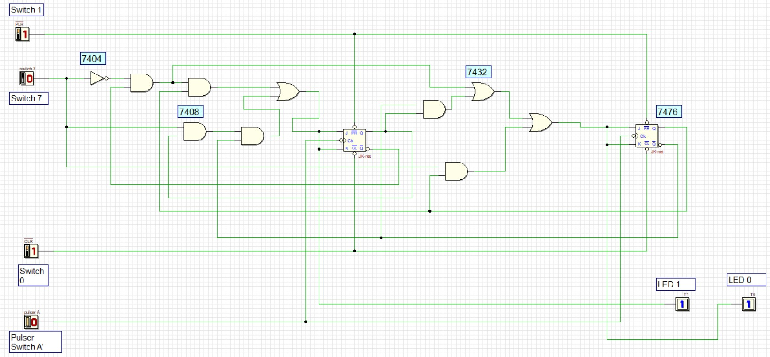

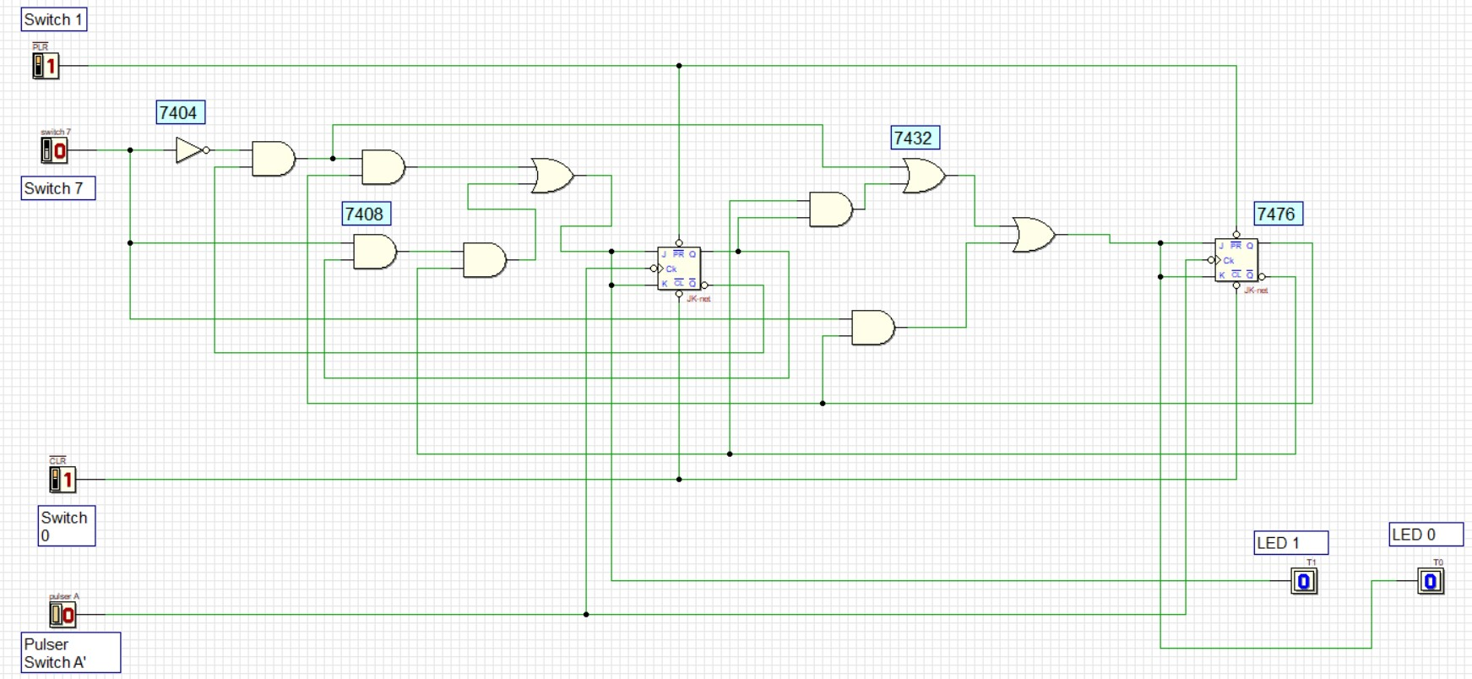

Count down
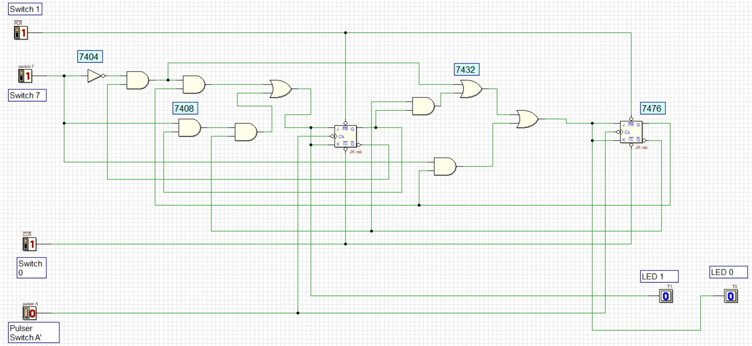

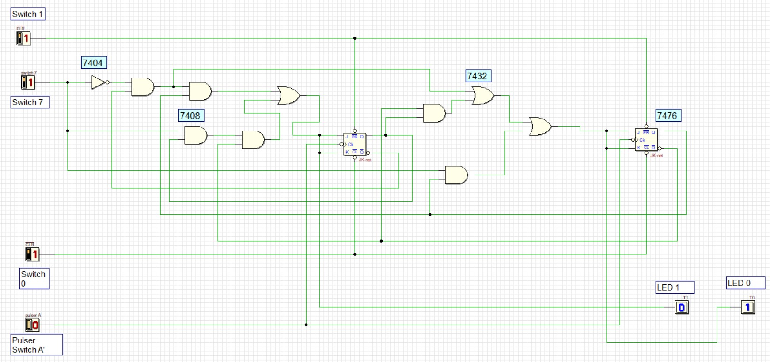

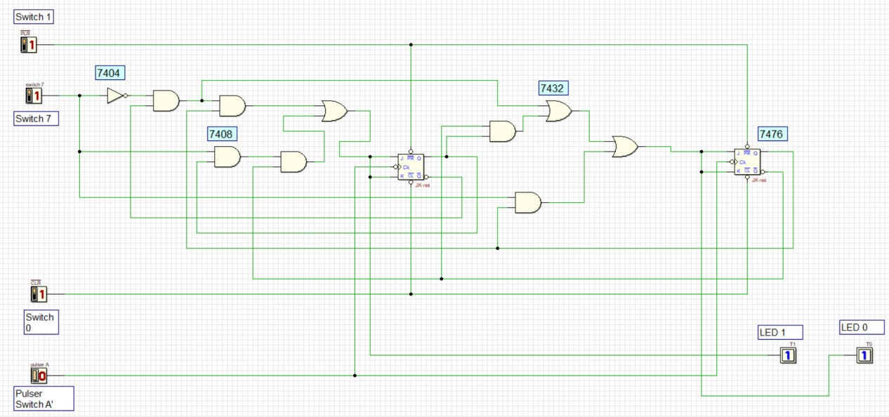

Here is our video link:
https://drive.google.com/drive/folders/1--tIWaPO08epyp7ZLsH5bdAh12zzM9bx

