DIGITAL LOGIC- LAB 2
Afifa JumanaA20EC4009
Tasmiah Sarif(A20EC9109)

PART 1:

Simulating logic circuit, construct truth table and timing diagram with Deeds.
Given Boolean expression as follow:

Y = AB + BC + AC

1. Convert the non-standard Boolean expression into standard form.
Answer:
Y=AB(C+C’)+BC(A+A’)+AC(B+B’)
=ABC+ABC’+ABC+A’BC+ABC+AB’C.

2. Based on standard form expression, complete the following truth table.

TRUTH TABLE-1

INPUT |  |  | OUTPUT
A | B | C | Y
0 | 0 | 0 | 0
0 | 0 | 1 | 0
0 | 1 | 0 | 0
0 | 1 | 1 | 1
1 | 0 | 0 | 0
1 | 0 | 1 | 1
1 | 1 | 0 | 1
1 | 1 | 1 | 1

3. Using Deeds Simulator, draw the following circuits:

a) Circuit (i) for non-standard form (based on the given expression).

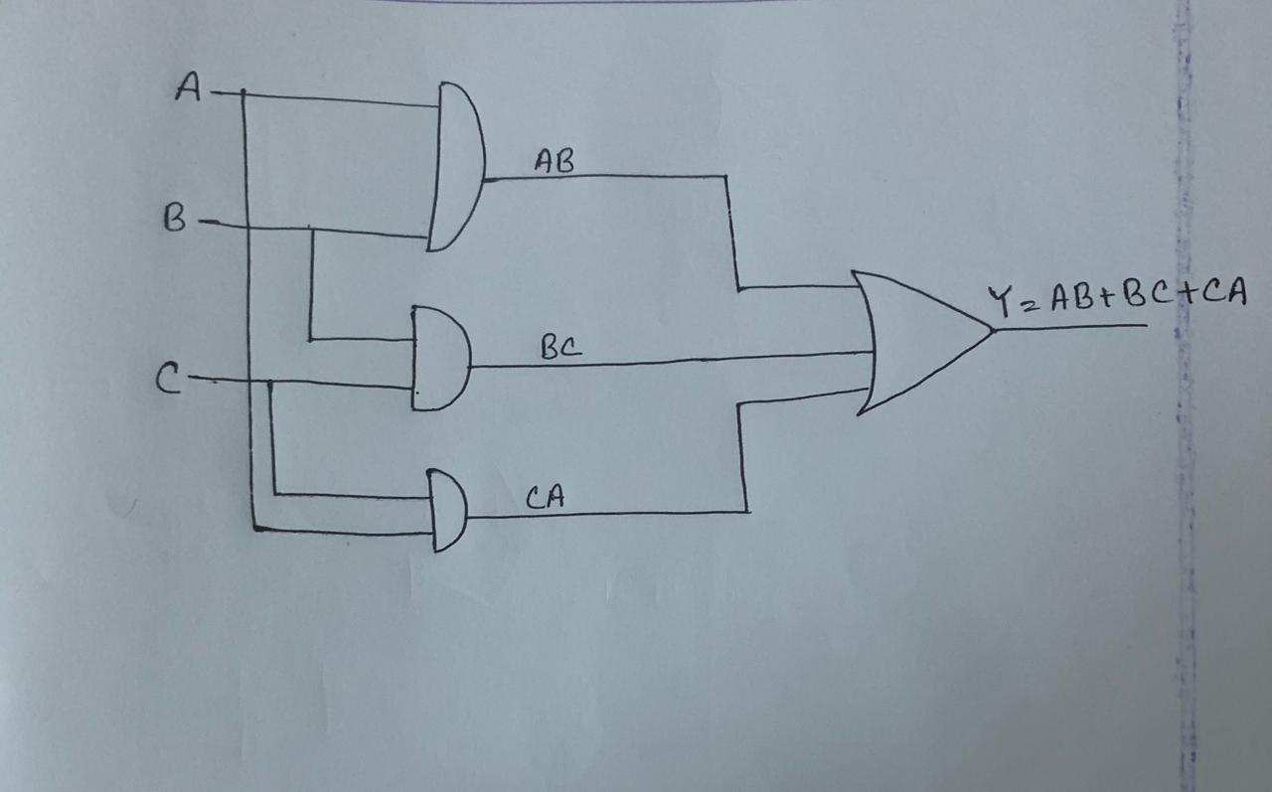

b) Circuit (ii) for standard form (from your answer in question (1)).

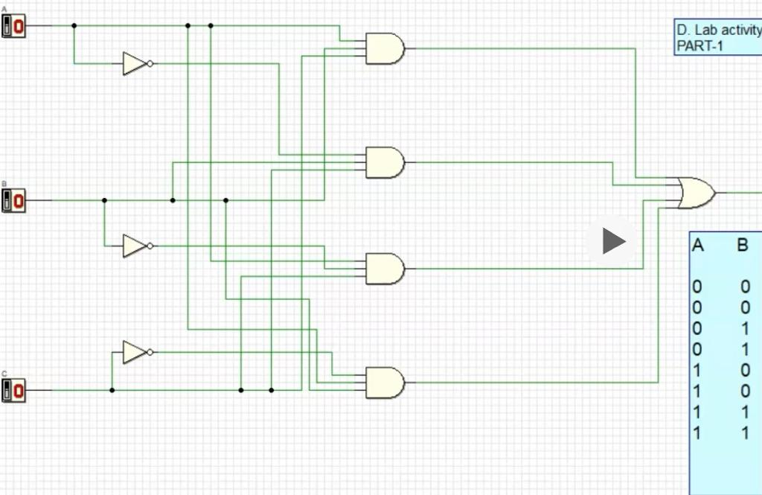

4.
Circuit 1:

INPUT |  |  | OUTPUT
A | B | C | Y
0 | 0 | 0 | 0
0 | 0 | 1 | 0
0 | 1 | 0 | 0
0 | 1 | 1 | 1
1 | 0 | 0 | 0
1 | 0 | 1 | 1
1 | 1 | 0 | 1
1 | 1 | 1 | 1

Circuit 2

INPUT |  |  | OUTPUT
A | B | C | Y
0 | 0 | 0 | 0
0 | 0 | 1 | 0
0 | 1 | 0 | 0
0 | 1 | 1 | 1
1 | 0 | 0 | 0
1 | 0 | 1 | 1
1 | 1 | 0 | 1
1 | 1 | 1 | 1

Conclusion: We can see that the 2 outputs of the circuits are the same and circuit 1 is in the reduced form and circuit 2 is in the standard form.

TABLE-1(TRUTH TABLE)

input | input | input | input | output | output | output | output
A | B | C | D | E1 | E2 | E3 | E4
0 | 0 | 0 | 0 | invalid
0 | 0 | 0 | 1 | 1 | 0 | 0 | 0
0 | 0 | 1 | 0 | 0 | 1 | 0 | 0
0 | 0 | 1 | 1 | 0 | 0 | 0 | 0
0 | 1 | 0 | 0 | 0 | 1 | 0 | 0
0 | 1 | 0 | 1 | 0 | 0 | 0 | 0
0 | 1 | 1 | 0 | 0 | 0 | 0 | 0
0 | 1 | 1 | 1 | 0 | 0 | 0 | 0
1 | 0 | 0 | 0 | 0 | 0 | 0 | 0
1 | 0 | 0 | 1 | 0 | 0 | 0 | 0
1 | 0 | 1 | 0 | 0 | 0 | 0 | 0
1 | 0 | 1 | 1 | 0 | 1 | 1 | 0
1 | 1 | 0 | 0 | 0 | 0 | 0 | 0
1 | 1 | 0 | 1 | 0 | 1 | 1 | 0
1 | 1 | 1 | 0 | 0 | 0 | 0 | 1
1 | 1 | 1 | 1 | invalid

2.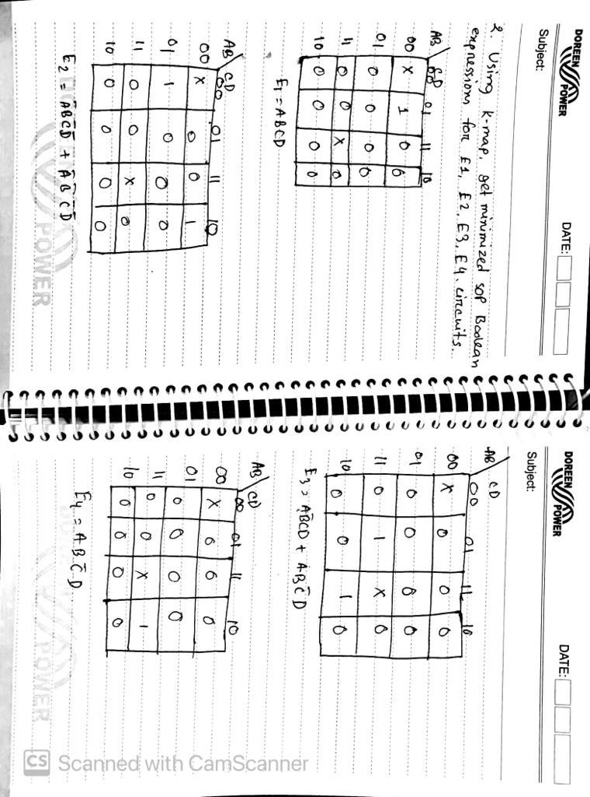

TABLE-2(TRUTH TABLE)

input | input | input | input | output | output | output | output
A | B | C | D | E1 | E2 | E3 | E4
0 | 0 | 0 | 0 | invalid
0 | 0 | 0 | 1 | 1 | 0 | 0 | 0
0 | 0 | 1 | 0 | 0 | 0 | 0 | 0
0 | 0 | 1 | 1 | 0 | 0 | 0 | 0
0 | 1 | 0 | 0 | 0 | 0 | 0 | 0
0 | 1 | 0 | 1 | 0 | 0 | 0 | 0
0 | 1 | 1 | 0 | 0 | 0 | 0 | 0
0 | 1 | 1 | 1 | 0 | 0 | 0 | 0
1 | 0 | 0 | 0 | 0 | 0 | 0 | 0
1 | 0 | 0 | 1 | 0 | 0 | 0 | 0
1 | 0 | 1 | 0 | 0 | 0 | 0 | 0
1 | 0 | 1 | 1 | 0 | 1 | 1 | 0
1 | 1 | 0 | 0 | 0 | 0 | 0 | 0
1 | 1 | 0 | 1 | 0 | 1 | 1 | 0
1 | 1 | 1 | 0 | 0 | 0 | 0 | 1
1 | 1 | 1 | 1 | invalid

From here we can see that both truth tables are giving the same outputs.

TRUTH TABLE-3

input | input | input | input | output | output | output | output
A | B | C | D | E1 | E2 | E3 | E4
0 | 0 | 0 | 0 | invalid
0 | 0 | 0 | 1 | 1 | 0 | 0 | 0
0 | 0 | 1 | 0 | 0 | 1 | 0 | 0
0 | 0 | 1 | 1 | 0 | 0 | 0 | 0
0 | 1 | 0 | 0 | 0 | 1 | 0 | 0
0 | 1 | 0 | 1 | 0 | 0 | 0 | 0
0 | 1 | 1 | 0 | 0 | 0 | 0 | 0
0 | 1 | 1 | 1 | 0 | 0 | 0 | 0
1 | 0 | 0 | 0 | 0 | 0 | 0 | 0
1 | 0 | 0 | 1 | 0 | 0 | 0 | 0
1 | 0 | 1 | 0 | 0 | 0 | 0 | 0
1 | 0 | 1 | 1 | 0 | 0 | 1 | 0
1 | 1 | 0 | 0 | 0 | 0 | 0 | 0
1 | 1 | 0 | 1 | 0 | 0 | 1 | 0
1 | 1 | 1 | 0 | 0 | 0 | 0 | 1
1 | 1 | 1 | 1 | invalid

From here we can see that both truth tables are giving the same outputs.

Click here for video:
https://drive.google.com/drive/folders/1tl-6gNQ3prbVciEGhYlRaetrCvDBt4Jt

