

______________________________________________________________________________
SECP 1513
TECHNOLOGY AND INFORMATION SYSTEM
______________________________________________________________________________

DESIGN THINKING:
SMART FRESH DIFFUSER

LECTURER:
Dr Azurah binti A Samah

SUBMITTED BY:
Chang Min Xuan (A20EC0024)
Nur Haznirah binti Hazman (A20EC0114)
Saidah Binti Saiful Bahari (A20EC0141)
Navinthra Rao A/L Venkatakumar (A20EC0104)

Semester 1 2020/2021

SMART FRESH DIFFUSER
Team members’ name: Chang Min Xuan, Nur Haznirah binti Hazman, Saidah Binti Saiful Bahari, Navinthra Rao A/L Venkatakumar
School of Computing, Faculty of Engineering
Universiti Teknologi Malaysia, 81310 Skudai,
Johor Bahru, Malaysia
______________________________________________________________________________

ABSTRACT
This report is about designing a model, Smart Fresh Diffuser, which provide solutions for us not only to always keep our room smell nice, but also relieve our stress and improve our sleep quality at the same time with the scents and fragrances provided by this Smart Fresh Diffuser. Moreover, the small speaker installed in this Smart Fresh Diffuser will enable us to display music according to our needs especially during our bedtime. In order to proof that our designed model is suitable to be used, we had carried out some researches and interviews and we had got the responses and feedback from the users. The analysis of this model will be displayed in this report and discussed further.

INTRODUCTION
Nowadays, many people suffer from the problem of insufficient sleeping hours and bad sleep quality at night. This is probably because they always feel stressed out and tension due to their daytime work. Besides, some of them have no choice but to be forced to sleep at late night just to finish all their assignments, work, reports and so on which are going to be finished and submitted as soon as possible. Hence, these are all the possible reasons which cause them lack of concentration and focus in their work and studies on the next day.
As a matter of fact, studies shown that scents and fragrances can promote us better sleep, trigger our memories and emotions while different scents play important roles to bring physiological effects. For example, scent of lavender can cure insomnia; smell of coffee can refreshing and relaxing our mind; fragrance of orange can eliminate tension and improve work efficiency. Thus, sense of smell is actually has a strong relationship with our sleep quality whereas music provided in this Smart Fresh Diffuser as an additional aid to promote better sleep. Nature sound and relaxing piano music build a conducive environment enable us to sleep comfortably at night.

PROBLEM BACKGROUND
In this era of globalization, stress is a common problem that frequently faced by anyone, be it stress from work, stress from studies, stress from community, or even stress from our own.
We have no way to escape from stress because stress is usually surrounding us. If we could not cope with stress, it will definitely affect our academic performances, our work efficiency, our mood and emotions and so on. Even worse, it will continuously affect us until we lack of motivation and being depressed. However, instead of escaping from stress, we can relieve our stress and tension by another way. Smart Fresh Dispenser would be a good choice to us.

METHODOLOGY
The Design Thinking Process:
Emphatize
Nowadays, most of the people, ranging from students to office workers, tend to sleep at late night because of busying with their studies and work. This can be observed through their state and condition on the next day. We found out most of these people are always not in a good state and they could not focus and concentrate in their studies and work. However, they are still wandering in this vicious cycle as long as they haven’t find out the solutions to deal with it.
Hence, we take actions to find out their requirements and problems by conducting interviews. Based on the interviews conducted, we realize that there are some parts that we need to do improvements and we had told to do so. For example, we have considered some parts which are slightly immature and improve it to become better.
With that, we experience what our user experiences. We set ourselves a goal that we should sleep before 12o’clock and we will test our condition on the next day. Then, we found out that it was quite difficult to do so. This is because we have load of homework and assignments to finish every single day. We are stressed out and we need to complete the assigned tasks until we burn the midnight oil. Even if we are able to sleep before 12, we still cannot increase our spirituality on the next day.

Define
After knowing the problems faced by everyone, we had come out with an actionable idea of designing a model which can overcome this problem. Our point of views are always surrounding with and focusing on users so that we may have deep understanding on our users’ needs. We discuss among each other in our group and decide what type of design is suitable to be used and will be proposed.

Ideate
After that, we undergo brainstorming process, which enable us to come out with any wild ideas that came across our minds. Each of our group members suggest their ideas and point of views as more as possible and give brief explanation about their designs. Later, we chose and voted for which design we like the most until all of us have no objection to the idea and everyone agreed with it. Finally, we decide to do a Smart Fresh Diffuser which fulfil our users’ needs.

Prototype
In this mode, we convert our creative and innovative idea into reality. We try our best and able to write our own application software. Moreover, we also make a Smart Fresh Diffuser using cardboards.

Test
Through this process, we introduce our designed model to every users and ask for their responses. If there exists problems that we need to improve, we will do so to refine our model and make it better.

Tasks Assignment:
To ensure our tasks conducted properly, we often make discussions and meetings through WhatsApp group. Furthermore, we always post up our status of tasks in WhatsApp Group to ensure all of us keep on track and no one lags behind. For task assignment, we have divided into 4 parts, which are report, video, prototype and interview.

THE PROPOSED SOLUTION
Acknowledgement of Similar Product
From what we had studied, there are aroma diffuser products in the markets but our designed aroma diffuser had add on some features which so far do not exists. Our designed aroma diffuser, Smart Fresh Diffuser is special with variety scents and fragrances stored in it and we can choose any of scents by just clicking it in application software installed in our mobile phones. Additionally, we can even choose music and nature sounds in that same application software as well.

Features of Proposed Solution
The Smart Fresh Diffuser designed by our group has up to 24 spaces which are slightly slanted for where we store the oil essence. Every different type of oil essences are separated into 2 rows and 12 columns. Each of them have a valve (gate valve), which control the amount of oil essence flow out to the water stored at the base of Smart Fresh Diffuser. Besides, each of those spaces where we store the oil essence also have their own tiny holes where for us to inject and refill oil essence. The Smart Fresh Diffuser have physical consideration in design as it has a heavy base so that it would not topple down. There is also a speaker installed in it so that music and songs can be displayed. On top of that, Smart Fresh Diffuser is connected to an application software. In the software, we can adjust the time limit, choose the scents and fragrances as well as music.

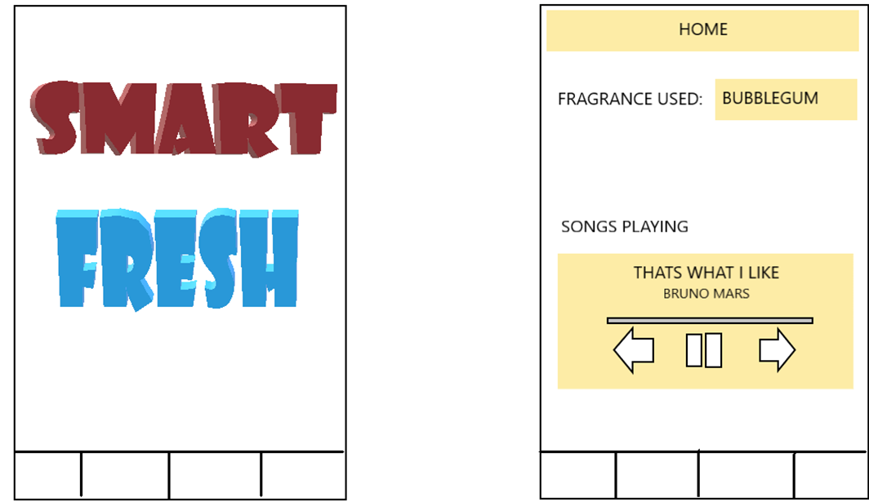
Features in Smart Fresh Diffuser Application
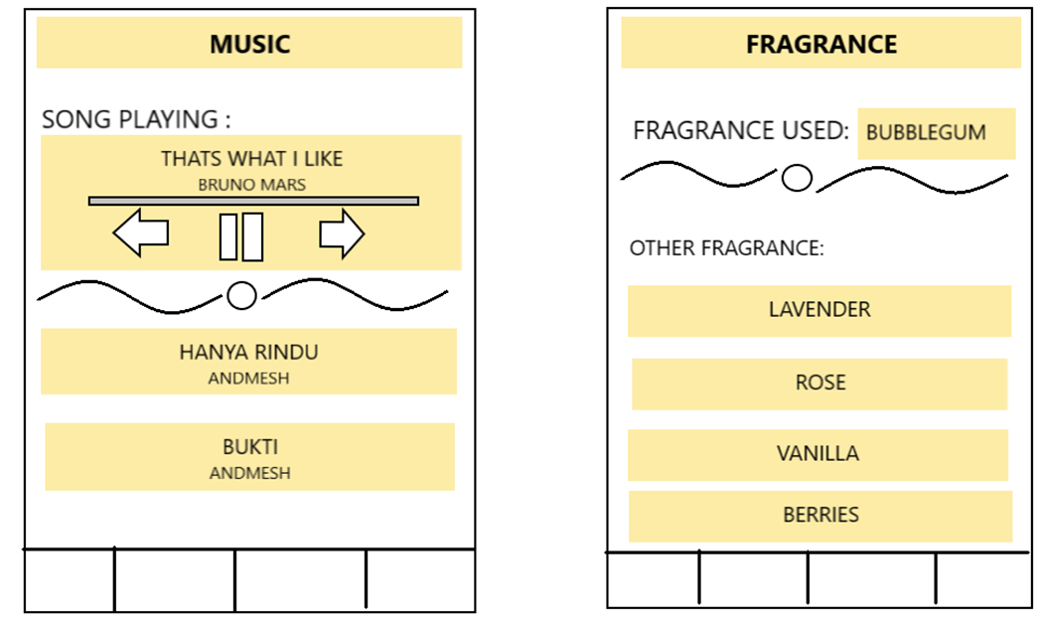

Feature in Smart Fresh Diffuser Application
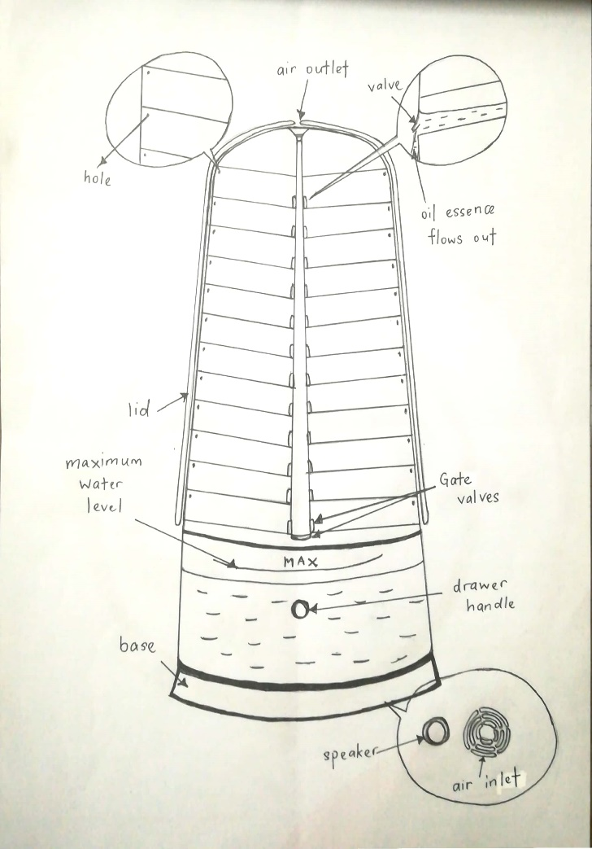
Design of Smart Fresh Diffuser
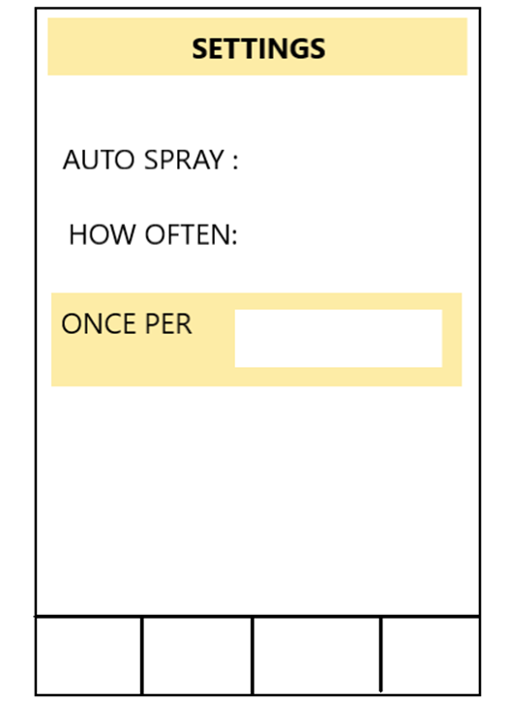

Design of Smart Fresh Dispenser
Type of Oil Essence:
- Lavender
- Eucalyptus
- Ylang
- Petitgrain
- Rosemary
- Geranium
- Peppermint
- Pine
- Tea tree
- Grapefruit
- Apple
- Bergamot
- Sandal Wood
- Rose
- Ginger
- Muguet
- Lily of Valley
- Melatti
- Sweet Osmanthus
- Phytoncide
- Jasmine
- Neroli
- Orange
- Orchid

Users Feedback
According to user feedback, most of the users (34.20%) vote ‘reduce stress and tension’ as the main advantages of Smart Fresh Diffuser. Next, they think Smart Fresh Diffuser is effective for eliminating odour (28.90%) and improving sleep quality (23.60%). Then, 11.10% of users vote ‘relax body and mind’ as one of the advantages of Smart Fresh Diffusion and the rest vote for others (2.20%).

Business Analysis using SWOT
We analyse our business analysis using SWOT:
Strengths:
- Release stress
- Improve sleep quality
- Build conducive environment

Weaknesses:
High cost to buy essence oil available in Aroma Diffuser

SWOT

Opportunities:
- Find replacement for essence oil to be commercialized
- Reduce cost of products
Threats:
Misuse of essence oil may cause poisoning

Future Works/Improvement
Improvements have to be made to our prototype to be commercialized. To further illustrates, we ought to reduce the costs for Smart Fresh Diffuser so that it would be more affordable. We need to find alternatives for speakers and essence oil that are more likely to be found in markets.

REFLECTIONS AND CONCLUSIONS
The lessons that we learnt from this project are we are able to conduct activities in group and we know about teamwork is the most important element that we should have in conducting group activity. All of us show our great commitment and perseverance in conducting activity. Apart from that, we have a deep understanding about the process of design thinking and we would know how to do it and show improvements in our future.
It is undeniable that we had faced a great deal of problems in this project but we manage to overcome with the problems at last. At first, we found out that it was hard to decide which idea was the most suitable ones. Then, the process of designing our models which meet users’ requirements had become a big problem to us as well. Besides, we had to keep improving our design when we found out any insufficient or inappropriate. Nevertheless, we never lose our passions towards the project until we make a success to complete it.
It is believed that Smart Fresh Diffuser bring convenient to people from all walks of life not only to ensure good sleep quality, but also relieve stress and pressure of them after a hustle and bustle day. All the inappropriate ideas have taken into consideration so that the proposed solution is safe to be used.

