

REPORT ON DESIGN THINKING

GROUP 5
Name | Matric No.
Nazmus Sakib | A20EC4046
Tasmiah Sarif Nayna | A20EC9109
Abu Sakib Bin Lutful Hassan | A20EC4007
Fariha Tabassum | A20EC4017

Smart Matric Card
Malaysia
Date: 16.11.2020
Reported by: Group-5
Nazmus Sakib
Tasmiah Sarif Nayna
Abu Sakib Bin Lutful Hassan
Fariha Tabassum

INTRODUCTION:
The project was envisioned to mitigate the analogue system to digital system. This project is a part of Information Systems. Four members of group 5 tried to invent an idea for the execution of this project together on 14.11.2020 in Johor Bahru, Malaysia. They tried to solve the issue with their own design thinking. It is important to advert that design thinking is a design methodology that provides a solution to break out the problems which is extremely useful.

MAIN CONTENT:

How the project work was started?
As the project was done during Covid-19 pandemic 2020, we decided to take interview of students whom were facing the problem and opinion from the insiders of UTM. Half of our group members were present in Malaysia they took the interview and the work of cinematography, the rest tried to go for the execution and editing.

Design Thinking Steps:

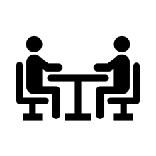
Empathy: Researching users need
First step is empathy, the foundation of any design process. To complete the empathize mode we need to focus on three points they are: observe, engage, and emerge.
Each team member of this project tried to observe their surroundings to find the latest problem. They came out with the problem of Student Movement Card. As all of them were students so they used to carry the card always to go outside and to come back. This was a problem that they experienced with the users.


Define: Users needs and problems

We put together the information we have created and gathered during the Empathise stage. This is where we analysed and tried to arrange them in order to define the core problem of carrying the movement card.
In this stage, we started to progress to the Ideate, by asking questions. Mainly this step is the preparation for the third step.

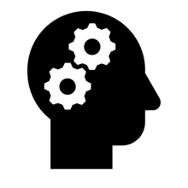
Ideate: Creating own ideas
This step is the most important in design thinking as it forces to think out of the box. We identified the problems and tried to find a digital system to fix up the analogue system with providing a better solution.Brainstorming is mostly useful in this phase.


Prototype: creating solution
The problem and the solution both are related to Information Systems. We tried to investigate the idea which generated in this phase. A QR code was created by us where our general data can be stored from our UTM Portal. By scanning the QR code with an authorized scanning device, it will read the information and the system will record the time as well as the information provided in the QR code.


Test: testing the solution
At last this is the final step of design thinking. On this stage we tried to execute the solution with the scanner by scanning the QR code which we attached on our Matric Card. We tried to solve the user’s problems that occurred these days and tried to find alternative solutions. Finally, we can say it worked.

Detailed descriptions of the project:

Problem:
Right now, in Malaysia due to Covid-19 UTM has provided a student movement card which is needed to show whenever students go out and come in.
The problems of using this movement card are given below:
- Firstly, point to be noted that this movement card is a paper-based card, which is large and inconvenient to carry it around.
- On the other hand, there are only few rows on the back of the card which fills up easily then users need to collect the form again from the Office.
- Users need to collect a new card from the office each and every time when the card is filled-up.
- Sometime it occurs traffic jam in road and kills valuable time.
- Mostly it is time consuming.
- Also, Data can be lost.
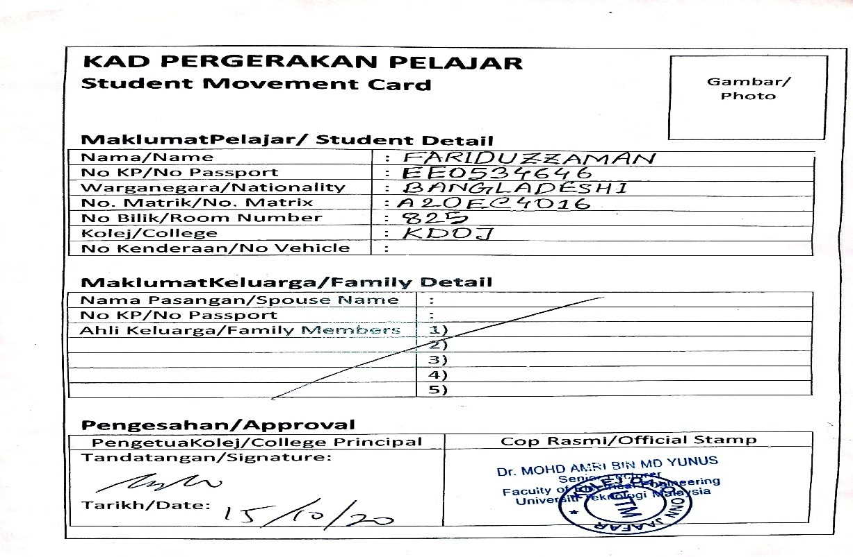
Solution:
After investigating problems, we tried to find a solution using Information Systems. A QR code was created by using Mid-Level Language and all the information has been given as input. By using the Mid-Level Language, we had set the program. The QR code will provide the information given in the picture:
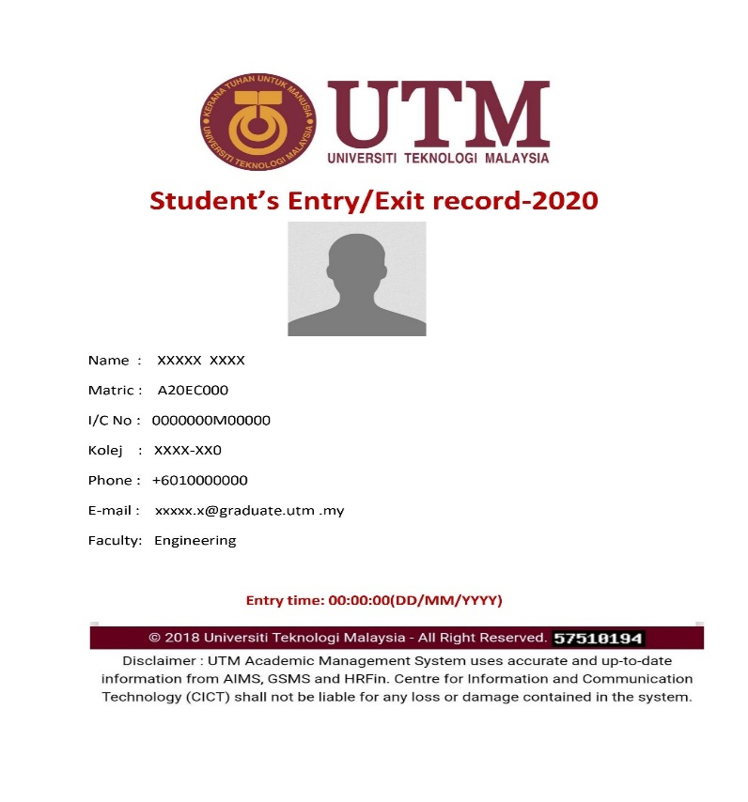

This information will be stored in UTM Official Database. There will be some authorized scanning devices only that can detect the QR code. This QR code will be attached on the back of our Matric Card. So, those students can always carry it anywhere.

Highlights of the project:
- Firstly, it is a new thought with digital system.
- There is no data storage limitation like papers it will take only a few bites to record.
- It will record the exact time.
- Data spoil ratio is reduced.
- It will have secured data changes.
- The information can be changed only by the authority.
- It can be used in security purpose.
- This idea is not only for this pandemic but also it can be further used for our class attendance and can save time in exams.

Team work:
We tried to communicate with each other how much it was possible during this pandemic. The work was divided into two parts. The work of cinematography was done by the members who were present in Malaysia the rest tried to complete the writing section and the editing part. We had done the work like four in one. Also we had a discussion with our respective professor.
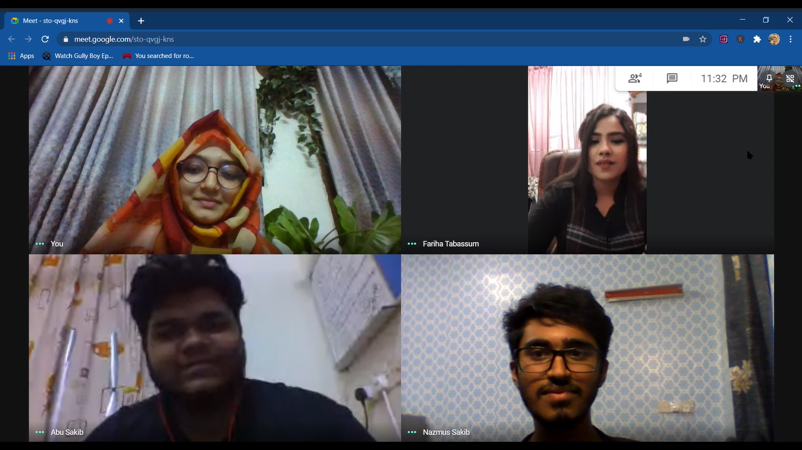
Design thinking evidence:
Here is the sample work done by us to solve the design challenge;
A video that we made based on our project:
Visit-https://youtu.be/xb-QZT0z-D0

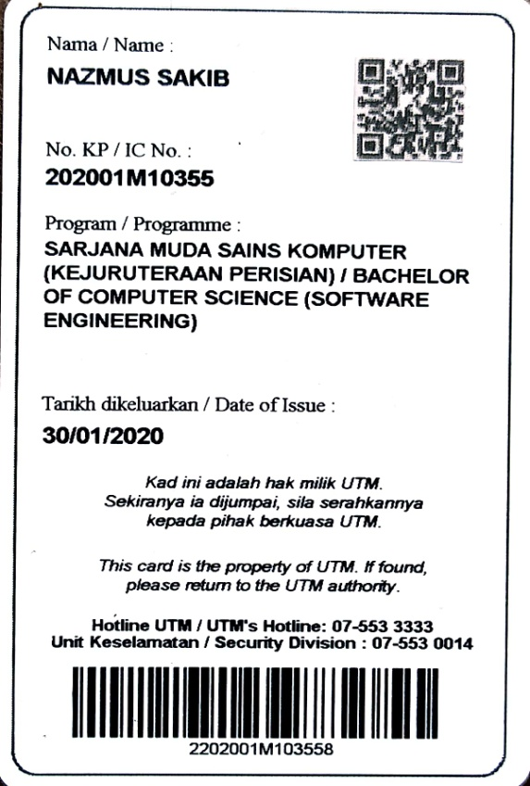

Each phase related to design thinking:
Empathy:
The group 5 worked to invert a digital system instead of an analogue and inconvenient data recording system.
The possible questions that can be asked by users are given below with the answers and a picture of taking interview has been shown below:
1. Why the bar code of Matric Card is not being used?
ANSWER: Because it can only carry real numbers or digits. It cannot give an output of proper information.
2. Will it charge a huge storage on server?
ANSWER: No, maybe it will take only few bytes to store one student’s entry/exit record.

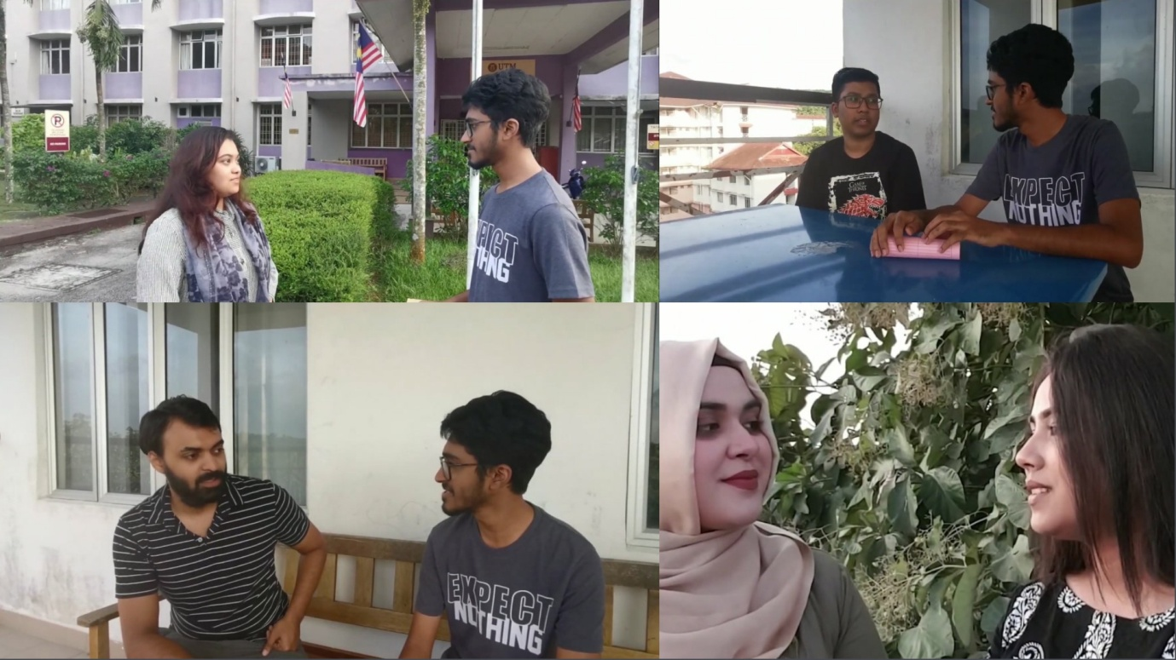

Define:
A convenient and storage friendly digital system executed through the Smart matric card. It would be helpful for both authority and employee. Using this system, an authority can keep the record accurately, and the student can be benefited by saving time. A sample picture given below.
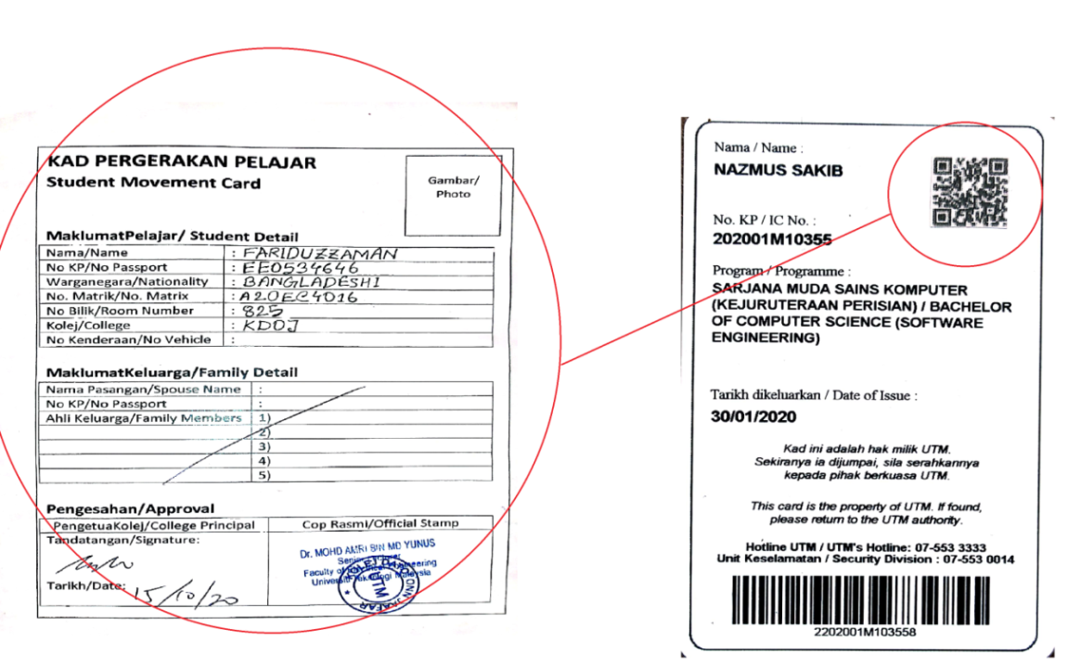
Ideate:
Converted into a digital system from an analogue system. Few problems were found on student’s movement card from UTM residential students. The group 5 thought to convert this time consuming system to a secure and accurate digital system. They discussed together. Also, they had a discussion with their respective professor. Here is a picture of their discussion,
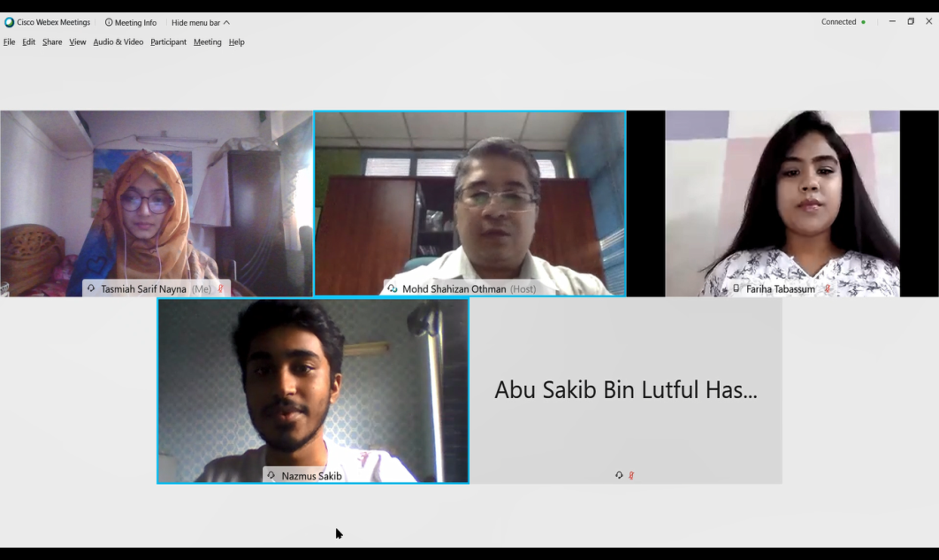
Prototype:
A QR code has been inserted at the back of matric card with specific and basic information. While the code will be scanned with authorized scanning devices, only it can be read and saved on the server. The QR code was generated by Mid-Level Language.
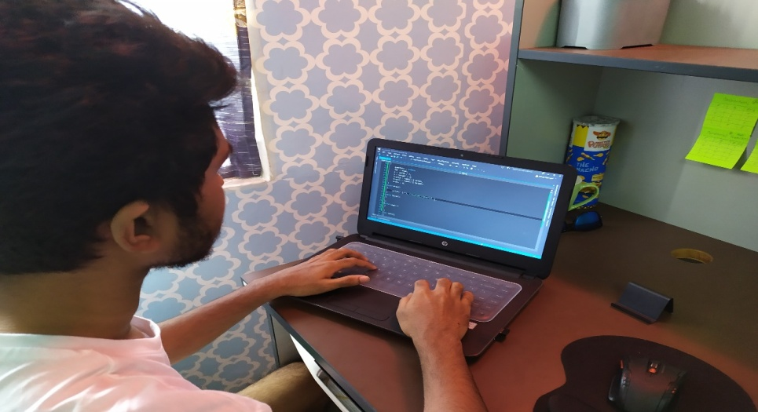

Test:
After executing the solution, the system was tested whether it worked or not. The new invented Smart Matric Card was used on authorized scanning device and it was ensured that the system worked. A sample picture given below.
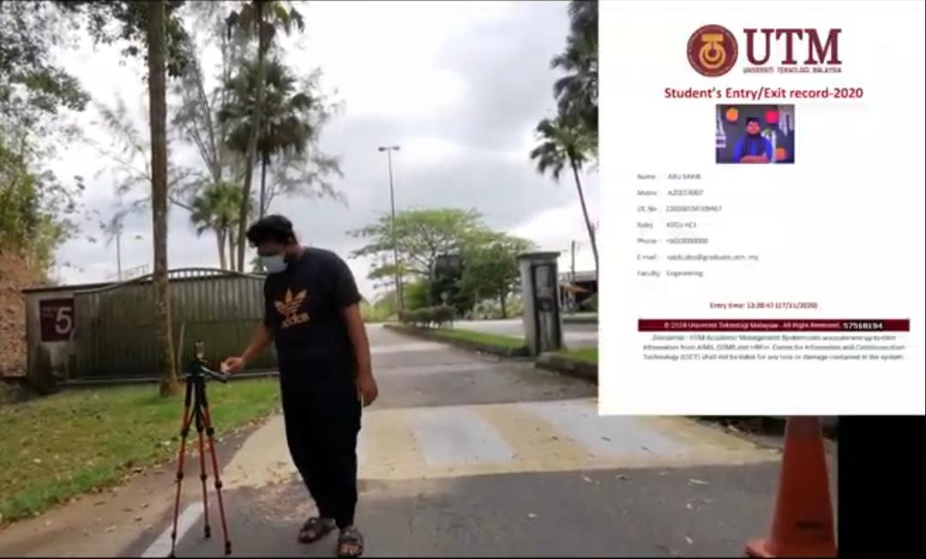

REFLECTIONS:

- The goal is very clear, as a Software Engineering student we are interested in IT sector and want to be a part of it and gather vast knowledge by experiencing different work and projects. Our main goal is to contribute for countries and to invent new ideas according to the problems.

- This is our first design thinking; a fresh start with ambitions. The step we’ve taken for university students. This idea will help the students and the professors both. It is related to our subject and goal. And it can be a small contribution to the invention of new big idea.

- As a Software Engineering student, our goal is to build a career in the highly extensive field of Computer Systems and Technology albeit it being a competitive one. This project was a glimpse into the vast world of Information Systems and the approach that we need to take in innovating and implementing new ideas. We understand that this project encapsulated only a tiny aspect of the huge sector. We have plenty of room to improve our ideas and the path forward to implementation. The academic works and associated projects that we will partake in the course of our degree will be the most useful tool in the future. Furthermore, the innovative ideas that we may ideate in that period or later will help us overcome the shortfalls and realize the true potential in ourselves.

Task for each member:

Team members | Matric numbers | Tasks
Nasmus Sakib | A20EC4046 | Interview (asking questions), video making, video editing, prototype
Tasmiah Sarif Nayna | A20EC9109 | Interviews(professor),  discussion, Report writing
Abu Sakib Bin Lutful Hassan | A20EC4007 | Video making, interview(experts),  Collecting information, testing
Fariha Tabassum | A20EC4017 | Interview (asking questions), Discussion.

