Lee Jia Xian A20EC0200

Preiminary Work

- Draw a symbol, determine the IC number and produce a truth table for the following gate.
Truth Table 2
IC Number: ………7400…………..
Symbol:
NAND
Truth Table 1
IC Number: ………7408…………..
Symbol:
AND

Input |  | Output
A | B | F
0 | 0 | 0
0 | 1 | 0
1 | 0 | 0
1 | 1 | 1

Input |  | Output
A | B | F
0 | 0 | 1
0 | 1 | 1
1 | 0 | 1
1 | 1 | 0

- Complete the truth table for the following circuit.

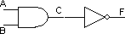

Truth Table 3

A | B | C | F
0 | 0 | 0 | 1
0 | 1 | 0 | 1
1 | 0 | 0 | 1
1 | 1 | 1 | 0

- Write the Boolean expression for output C, D and F the following circuit.

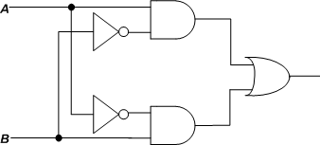
F F
C
D

C = $A • \overline{B}$

D = $\overline{A} •B$

F = ($A • \overline{B})$ + ($\overline{A} •B$)

- Complete the truth table for the circuit in (3) based on the Boolean expression produced for C, D and F.

Truth Table 4

A | B | C | D | F
0 | 0 | 0 | 0 | 0
1 | 0 | 1 | 0 | 1
0 | 1 | 0 | 1 | 1
1 | 1 | 0 | 0 | 0

