
Semester I 2020/2021

Subject : Technology and Information Systems (SECP1513) Section : 2
Assignment : Step by step PC Assembly

GROUP NAME / NUMBER : Group 1

1 |  | Name : Lee Jia Xian  Matric Number : A20EC0200  Phone Number : 011-20621573  E-mail : xian_123@hotmail.com
2 |  | Name : Kong Jia Rou  Matric Number : A20EC0198  Phone Number : 011-10870488  E-mail : jrkong2001@graduate.utm.my
3 |  | Name : Luqman Ariff Bin Noor Azhar  Matric Number : A20EC0202  Phone Number : 013-6683008  E-mail : luqmanariff2001@gmail.com
4 |  | Name : Adam Wafii Bin Azuar  Matric Number : A20EC0003  Phone Number : 019-2612066  E-mail : adamydee@gmail.com
5 |  | Name : Adrina Asyiqin Md Adha  Matric Number : A20EC0174  Phone Number : 011-13033218  E-mail : adrinaasyiqin38@gmail.com

Part A - List of tools needed
1.0 Screwdrivers
1.1 Philips screwdriver

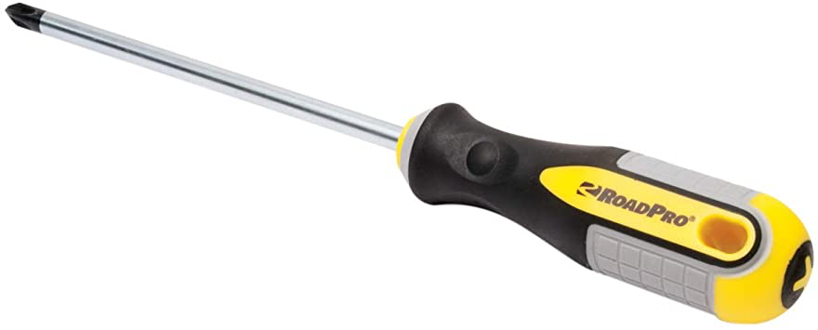

Philips screwdriver is used to tighten or loosen cross-headed screws. Phillips-head screwdriver with a big bit, helpful to avoid stripping the head.

1.2 Flat-head screwdriver

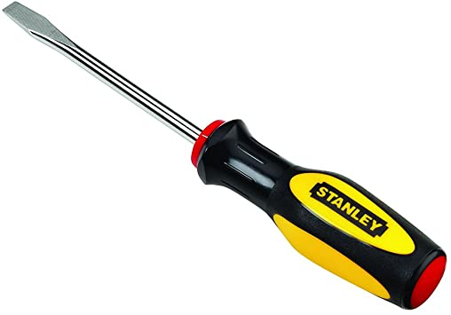

Flat-head screwdriver is used to tighten or loosen slotted screws.

2.0 Grounding Straps
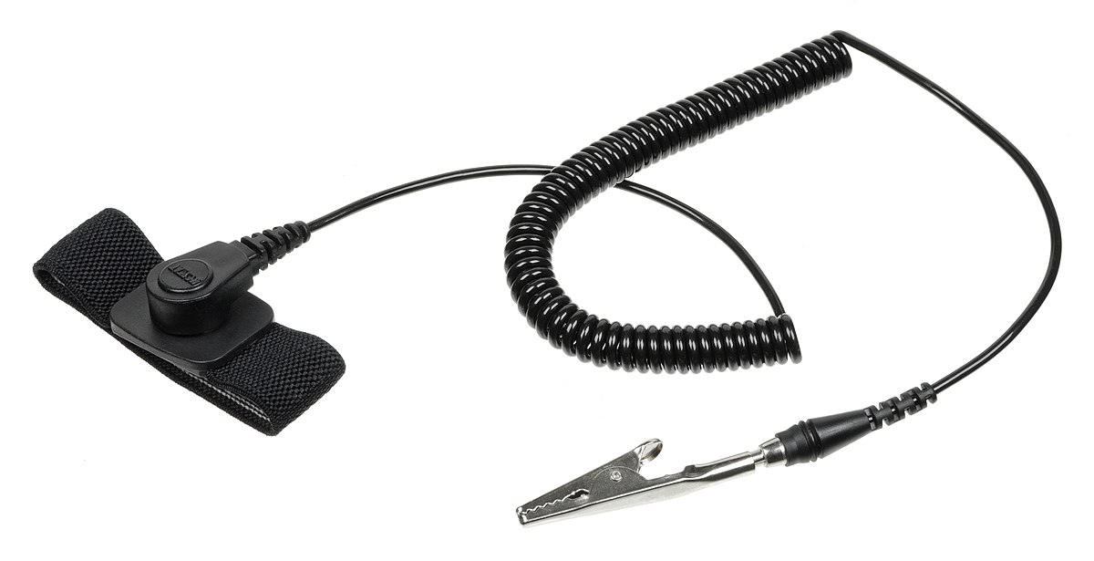

Grounding straps are anti-static devices that are used to protect people and electronic equipment from electrostatic discharges (ESD) by routing the electric current to a safe ground. It is important to prevent the static electricity from damaging the computer components.

3.0 Wire cutters and strippers
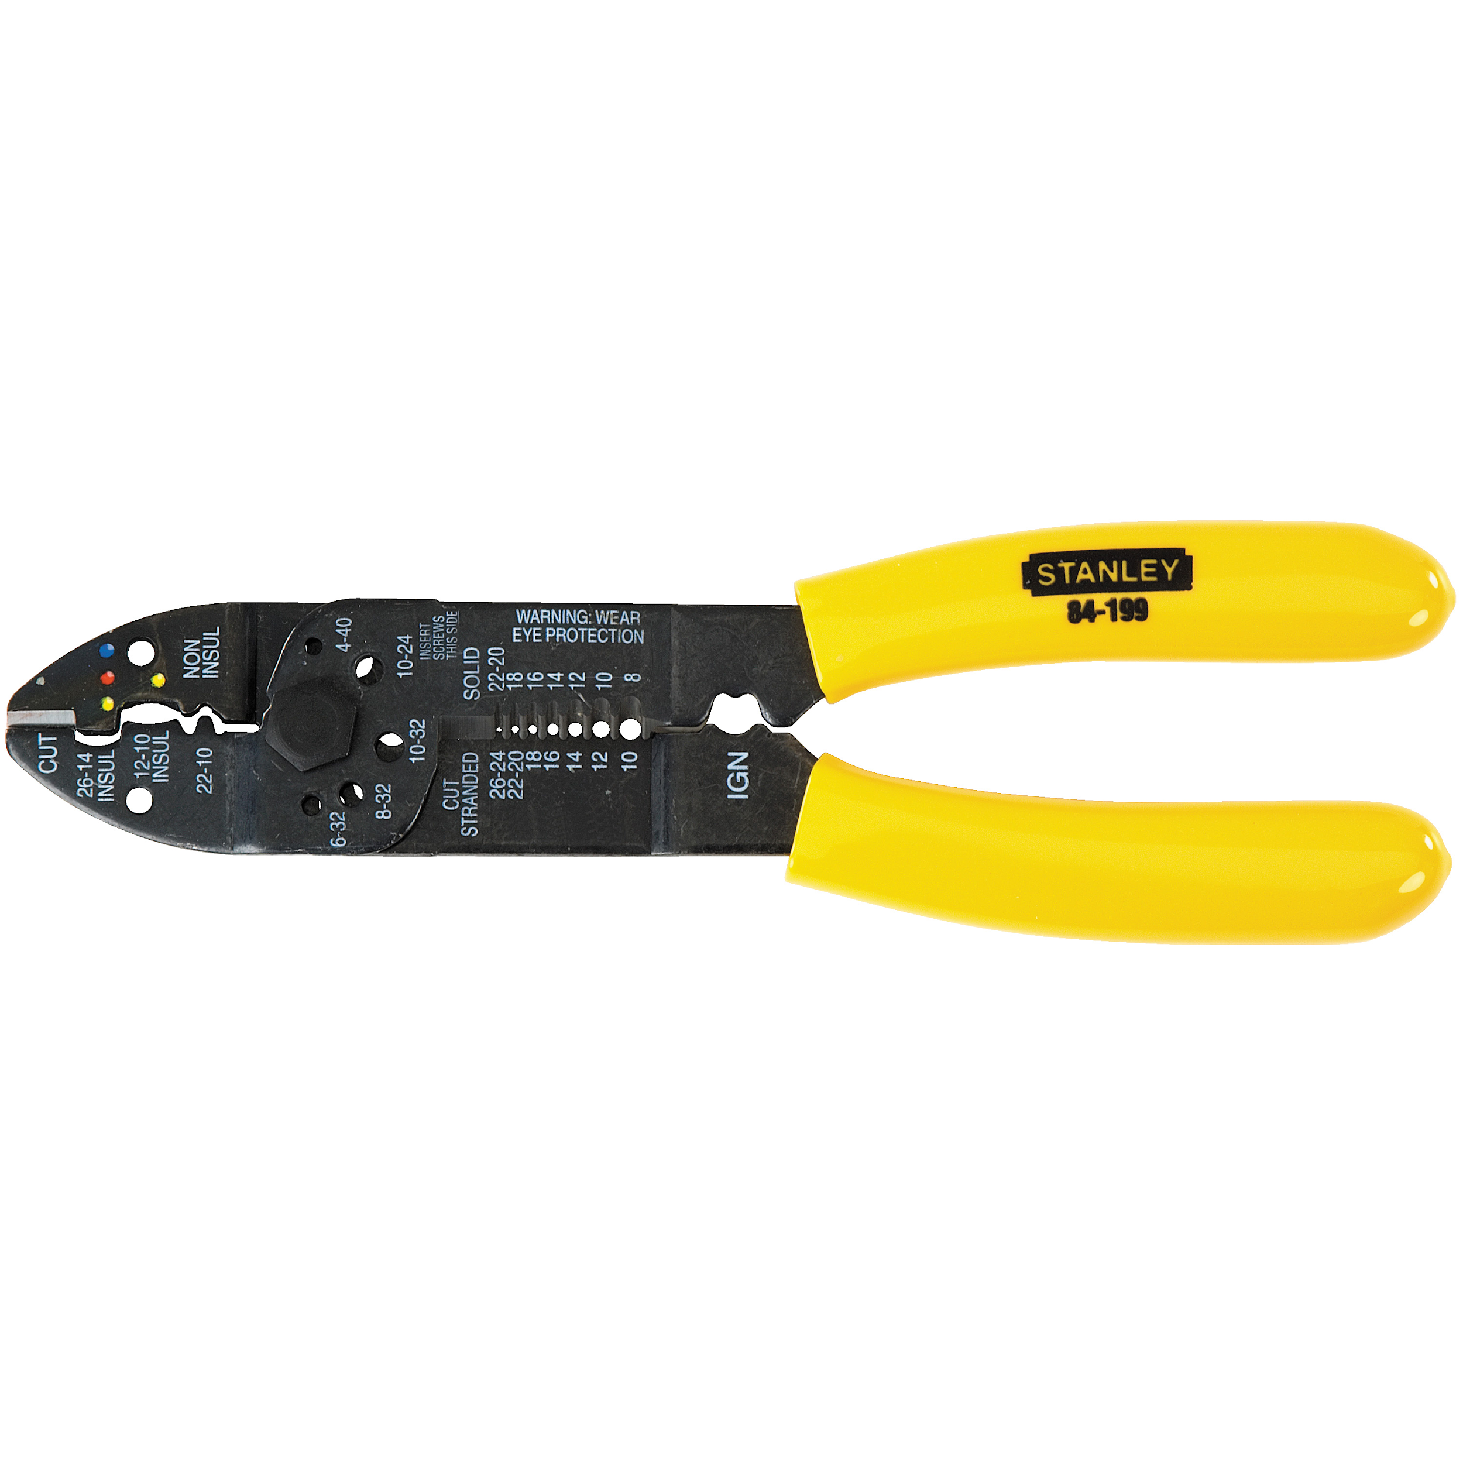
Wire cutters are commonly used to cut copper, brass, iron, aluminum, and steel wire. Some wire cutters have insulated handles which ensure that you will not get shocked from the wires you’re working with.Wire strippers are used to remove the insulation from electric wires in order to make contact.

4.0 Needle-nosed pliers
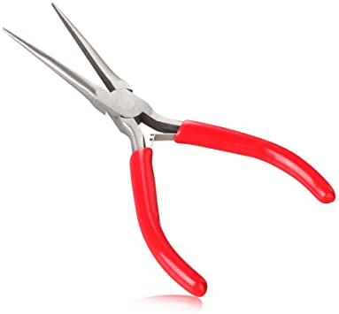
Commonly used to cut and bend small wires and electrical wiring, needle-nose pliers have other uses, as well. They can bend, cut and grip where fingers and other tools are too big or clumsy. Needle-nose pliers are good for reaching into tight spots where regular pliers are unwieldy.

5.0 Soft cloth
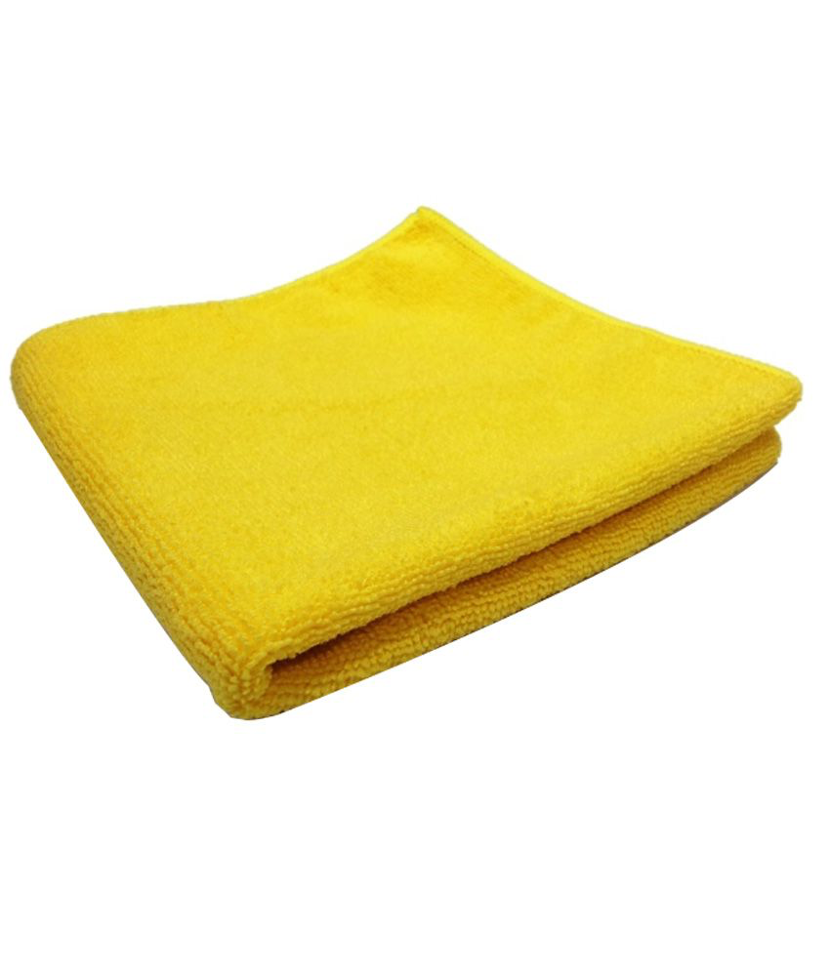
Having the appropriate cleaning tools is essential when maintaining and repairing computers. Using the soft cloth helps ensure that computer components is cleaned without scratching or leaving debris

6.0 Small flashlight
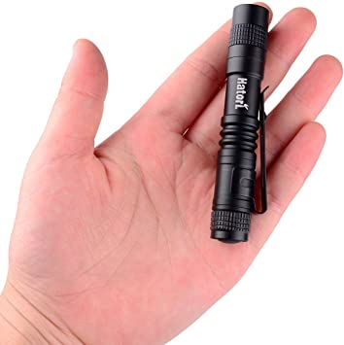

PC cases are full of shadows. It's difficult to see in small spaces inside the computer case. A flashlight will help to get visibility into the dark, narrow corners of your build.

7.0 Heat sink compound
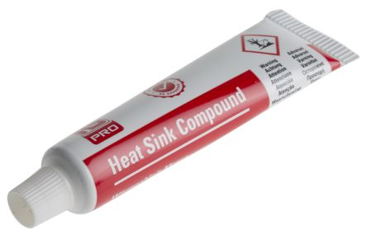
Heat sink compound (also called thermal grease or CPU grease) is a sticky paste that is used as an interface between CPU heat sinks and heat sources. It is important to fill the gap between the CPU or other heat generating components and the mechanical heat sink to dissipate the excess heat.

Part B - Sketch of a motherboard layout

- Sketch

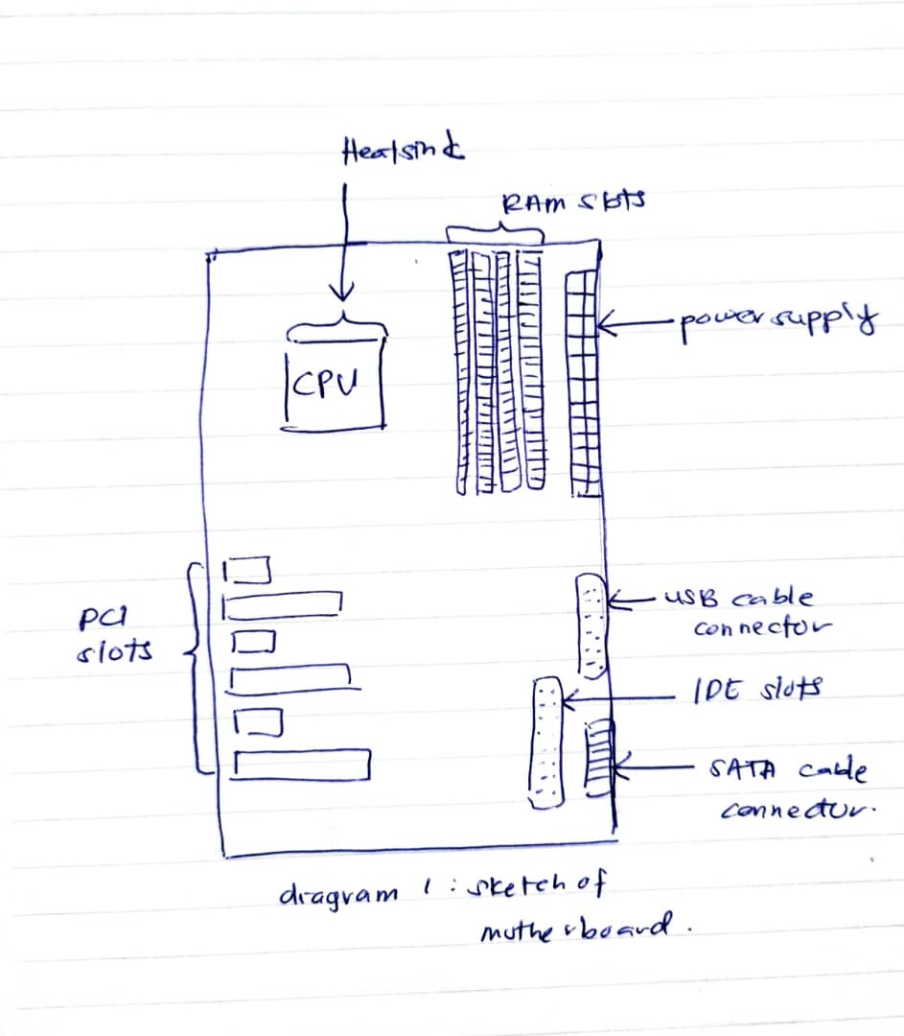
Diagram 1: motherboard sketch

- For each keyword in Table 1.0. Provide picture(s), explanations of its functions and example of models.

Name | Picture | Function | Examples
Graphics Card | 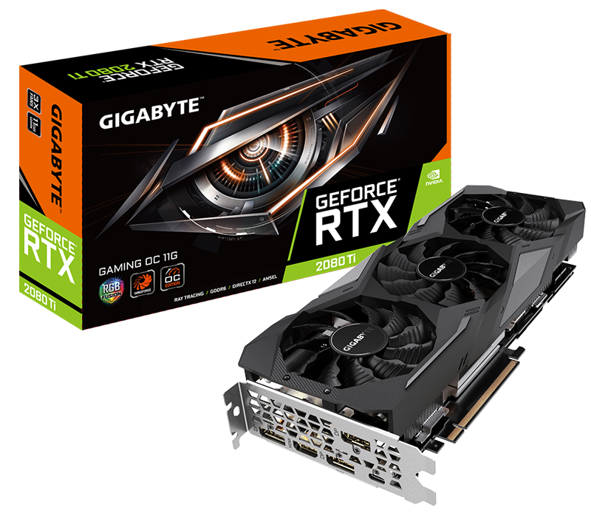 | Renders image by converting data into signal a computer can understand | PCI, AGP, PIC - Express
USB Cable | 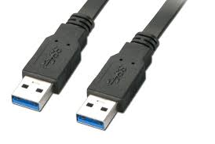 | Carries power as well as signals | USB 3.0 Type A Plug
IDE Cable | 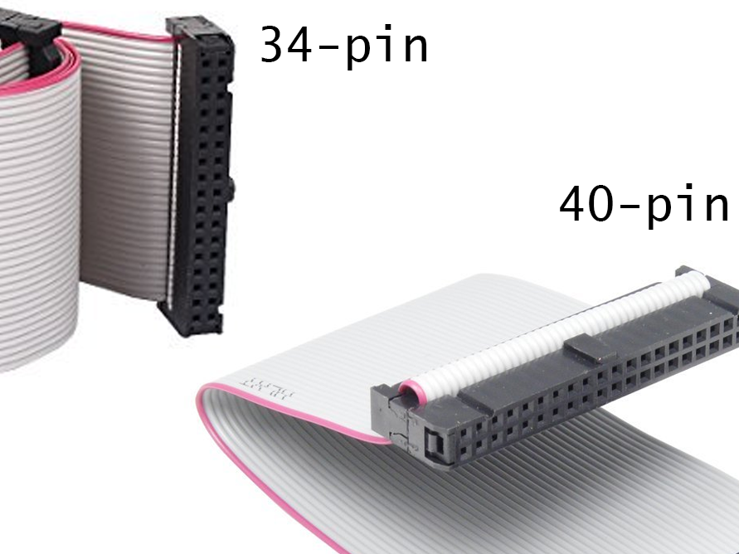 | Connect some hard drives and optical drivers to each other and to the motherboard | 34 - pin and 40 – pin
CPU / Processor | 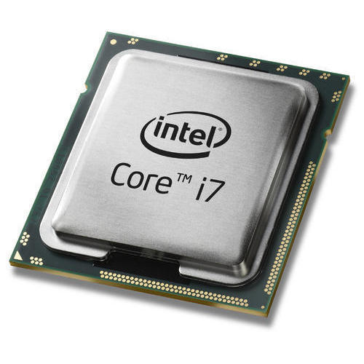 | Performs all types of data processing operations. Stores data, intermediate results and instructions | Single-core, Dual-core, Quad-core
Slots | 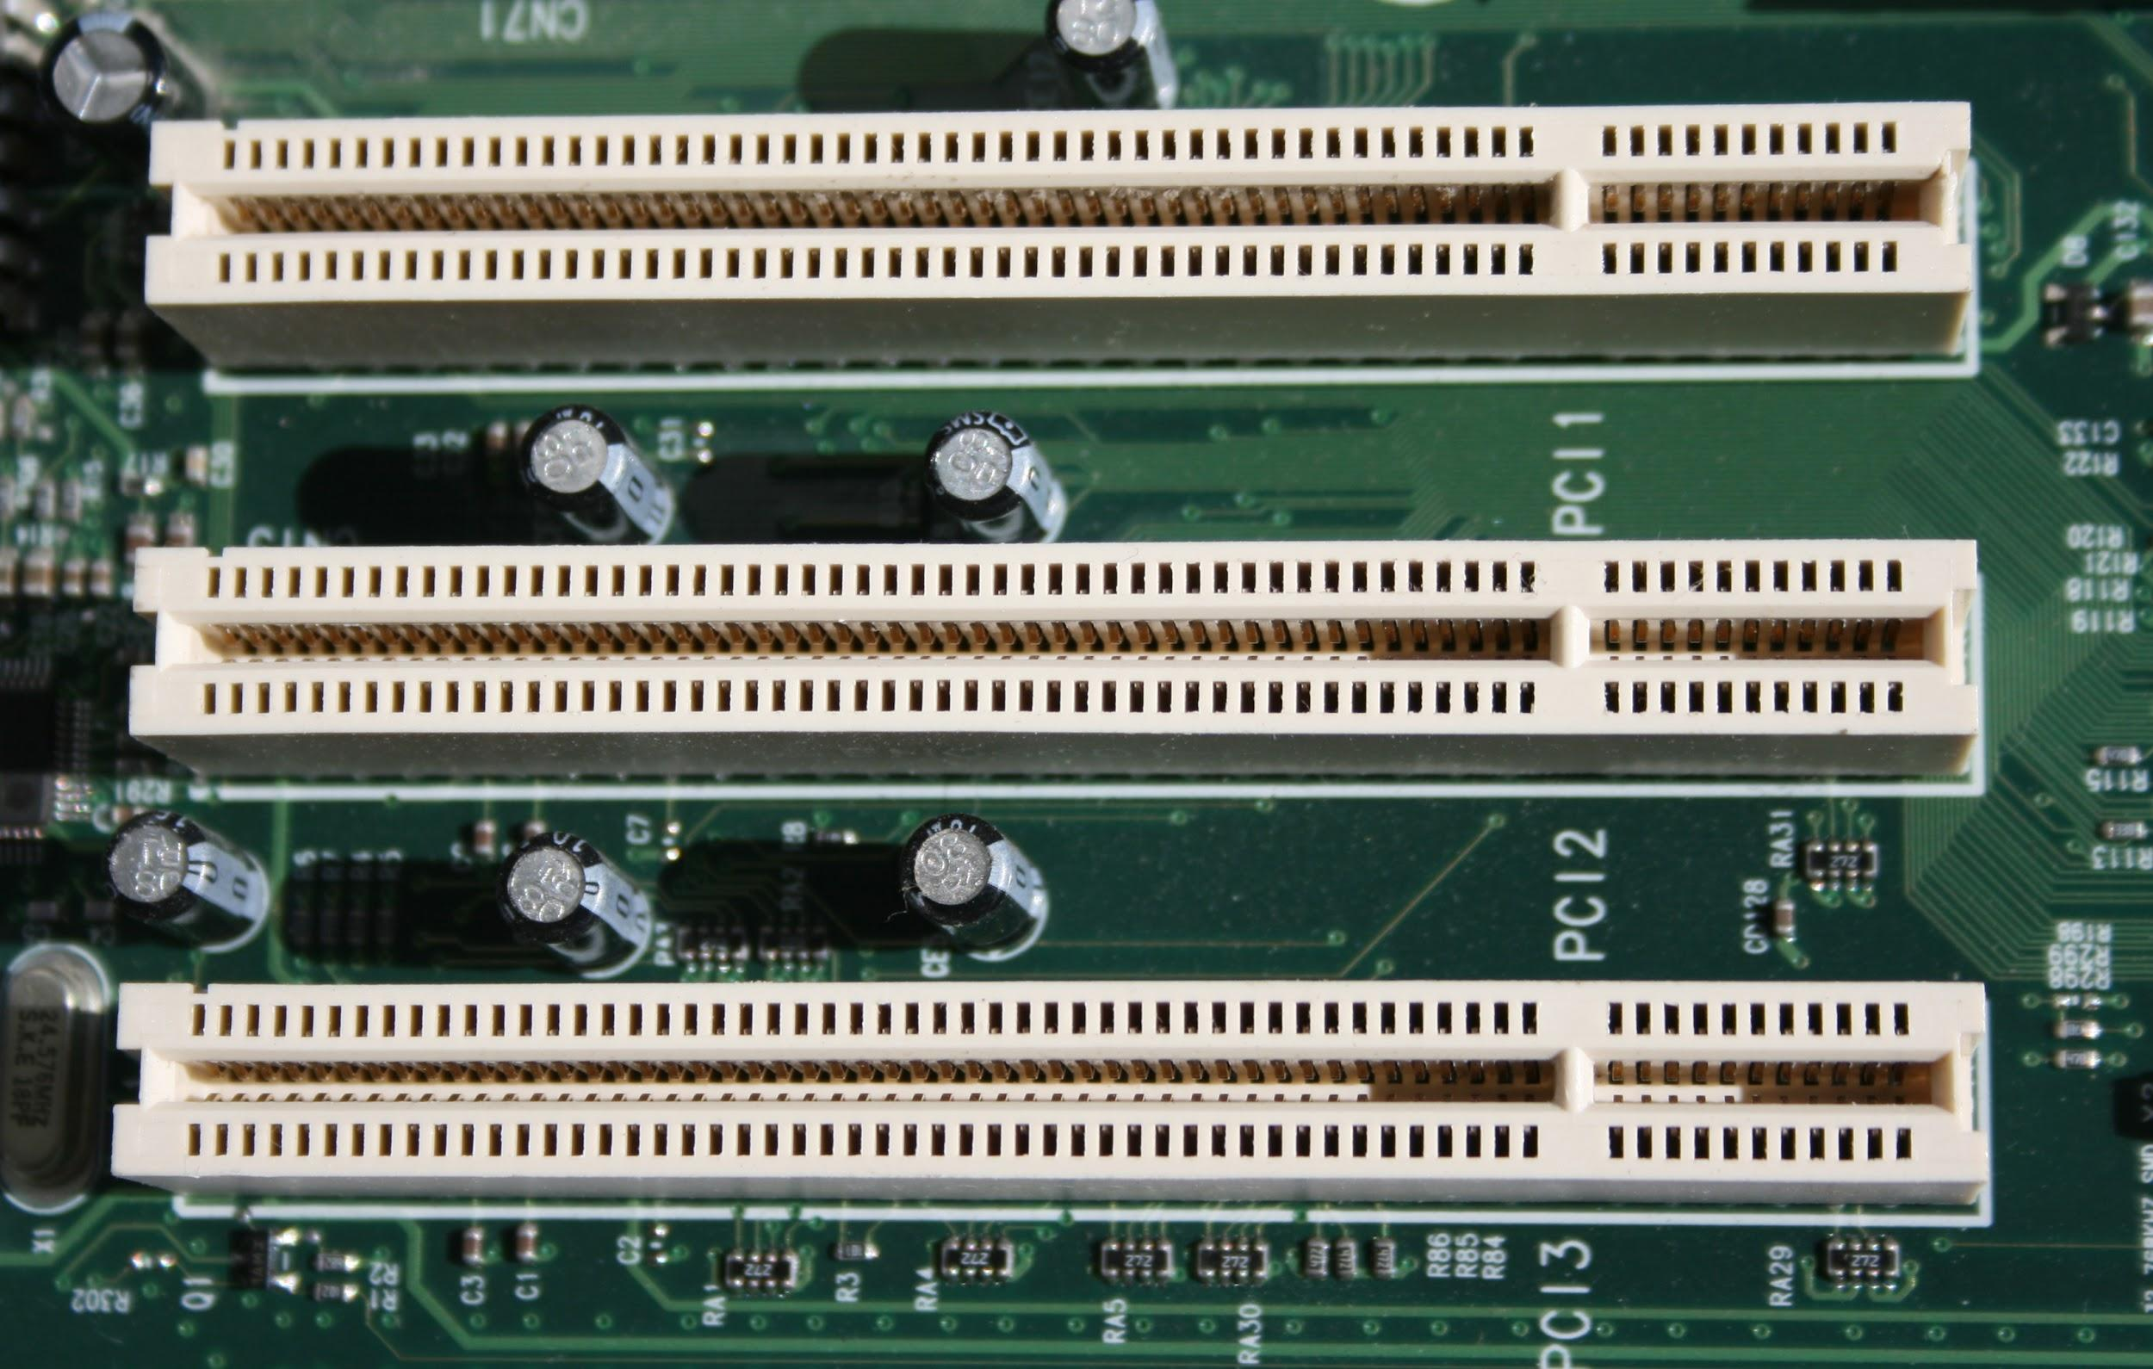 | A local computer bus for connecting hardware to a computer. It supports all the functions of a processor bus | PCIe
Power Supply | 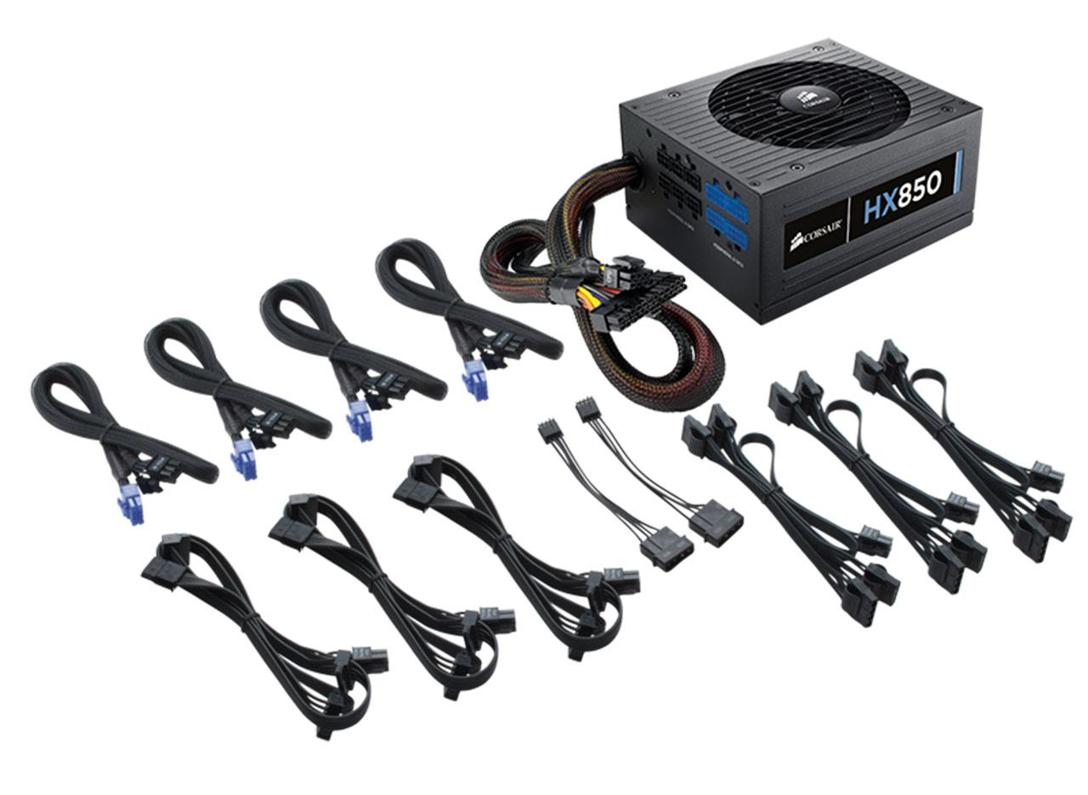 | Provides the necessary electrical power to let the computer to work | AT, ATX, ATX-2
Heat Sink | 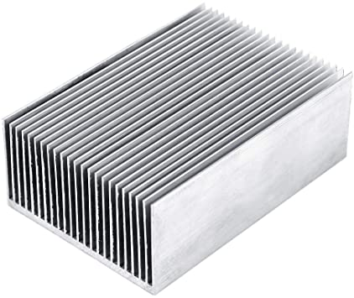 | A heat sink is a passive heat exchanger that transfers the heat generated by parts of the motherboard into a fluid medium like liquid or air. | Aluminium Heat Sink
RAM | 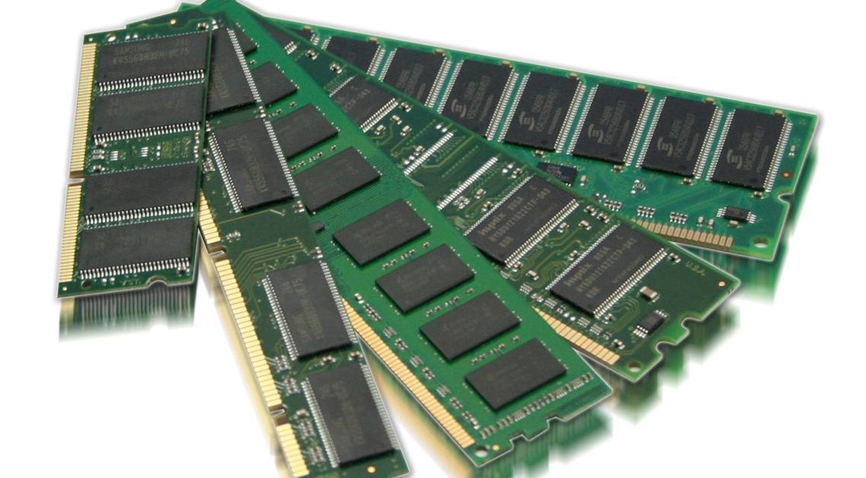 | Save data and machine code | DRAM, SRAM
Hard Disk | 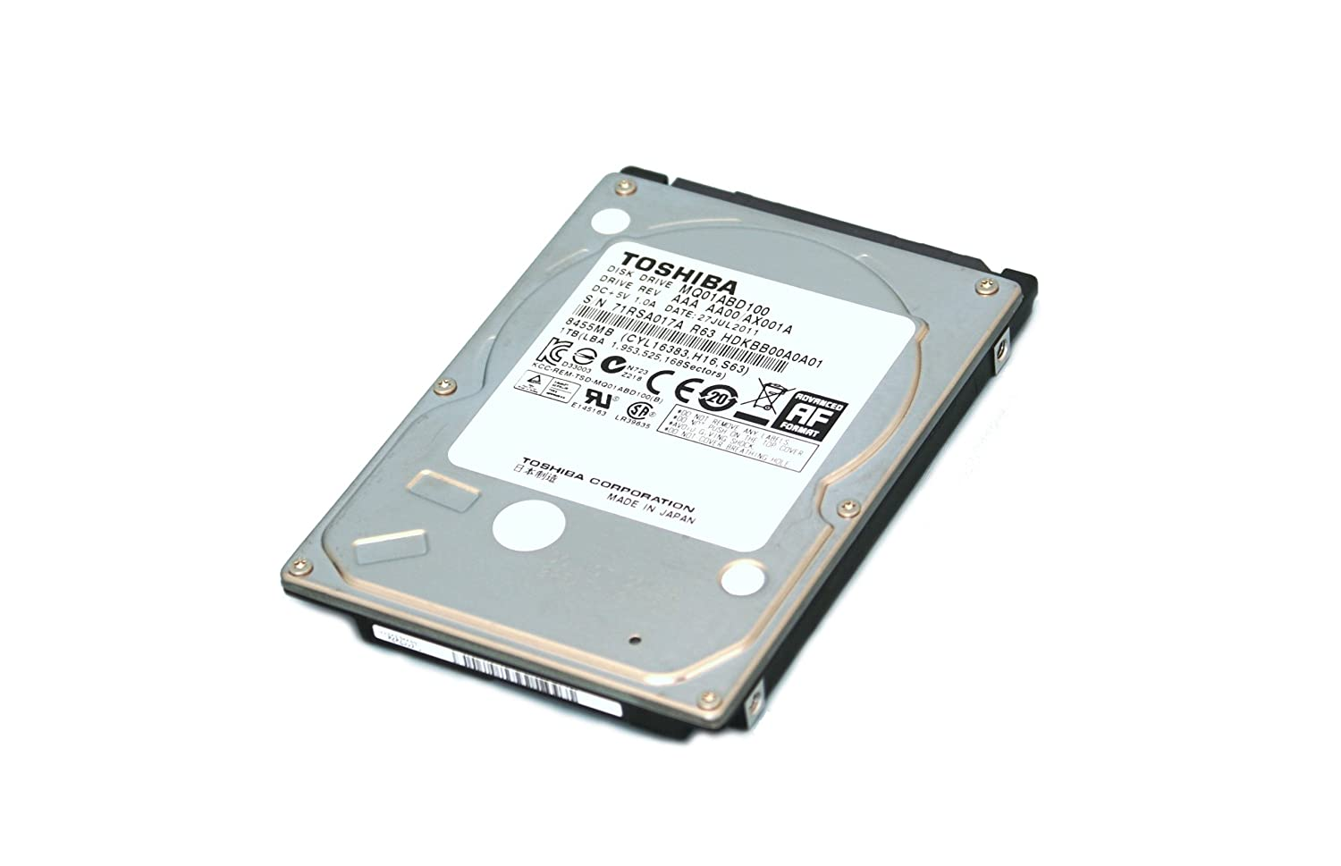 | Stores and retrieves digital data using magnetic storage and one or more rigid rapidly rotating platters coated with magnetic material | SSD, HDD
CD ROM | 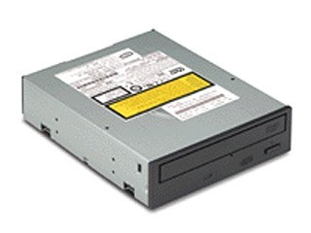 | Store programs and data files | CD-R, CD-RW
SATA Cable | 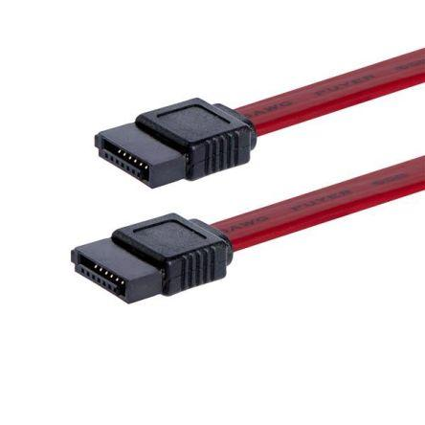 | Used to connect devices in computer cable assemblies, such as storage devices | eSATA, SATA

Part C - “Step by Step PCAssembly”
Step 1 - Ground yourself

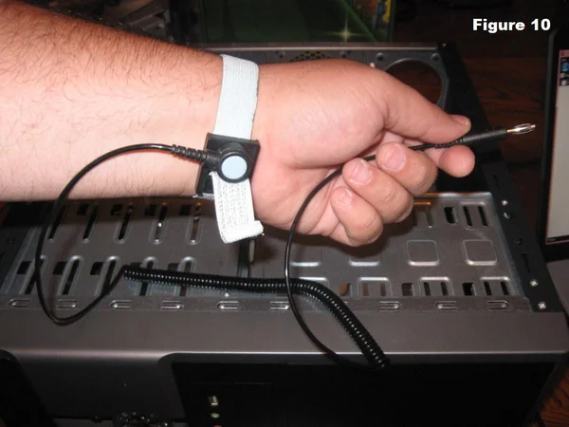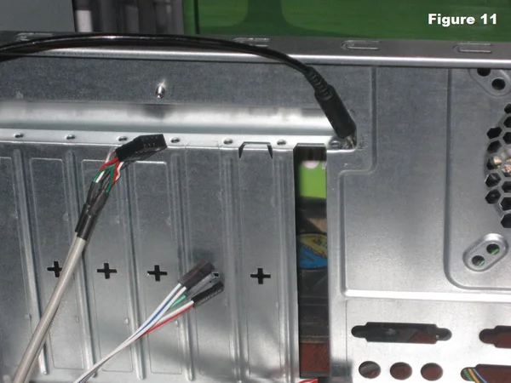

- Put the grounding strap on your wrist as shown.
- Connect the other end of the grounding strap to the computer case.
- This to prevent any buildup of static electricity on our body from damaging the computer components.
Caution : computer components can be ruined by static electricity. Always wear a grounding strap before handling the computer components.
Step 2 - Install The Motherboard
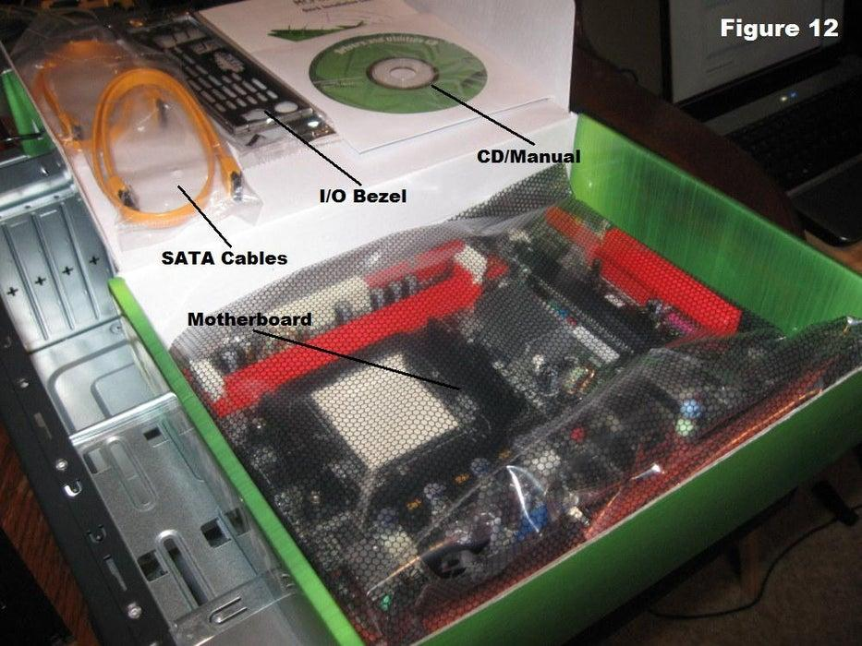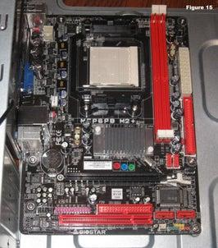
- Open the back of the case and install the I/O bezel plate
- Install standoffs in the case and make sure the screw hole is in the exact location.
- Put the motherboard in the case and align it with the I/O bezel.
- Install screws in the screw holes.

Step 3 - Install the Hard Drive and Optical Drive (CD ROM)
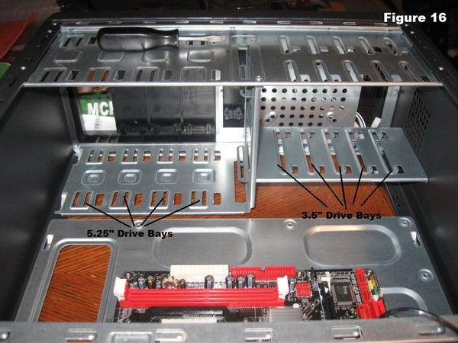
- Slide the hard drive into the 3.5” drive bay until the drive is lined up with the screw holes.
- Slide the optical drive (CD ROM) into the 5.25” drive bay until the drive is lined up with the screw holes.
- Install all the screws.

Step 4 - Install the CPU and RAM
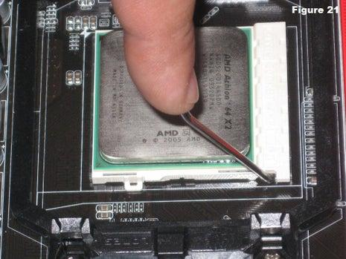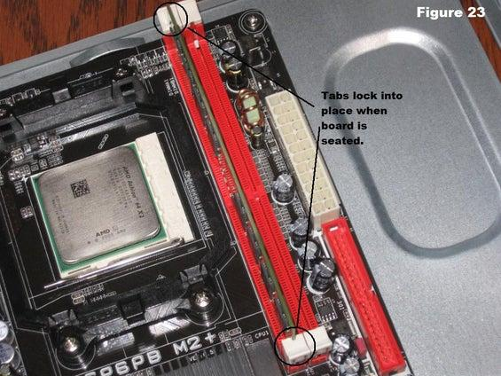
- The CPU is installed on the motherboard in a socket. Lift a small metal rod next to the socket.
- Lined up the orientation mark on the CPU socket and inserted it.
- Push down the metal rod to lock the processor.
- Press the RAM board into the socket and make sure the tabs are aligned.

Step 5 - Install the Fans ( CPU fans and Case fans)
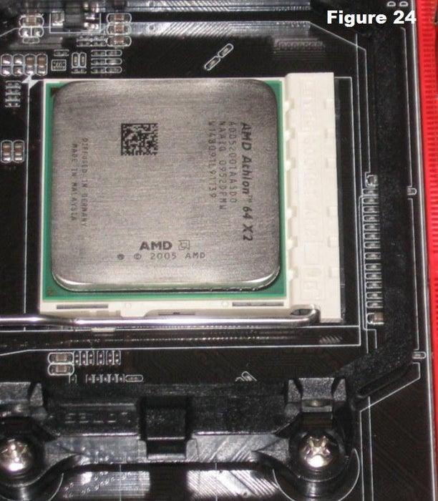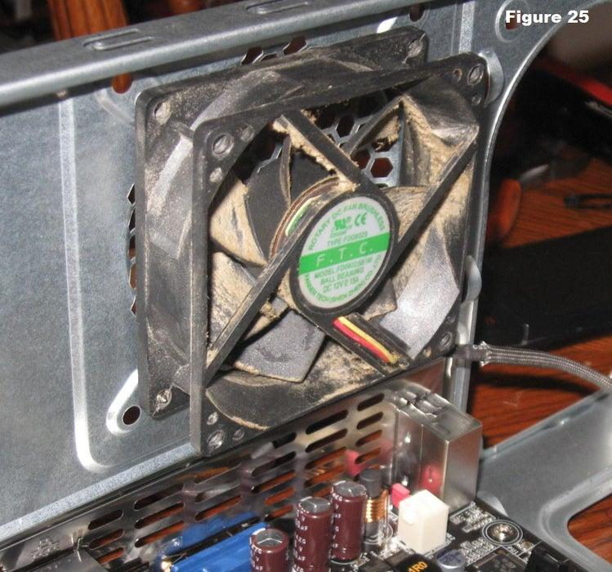
- Put thermal compound and set a fan assembly into the CPU. CPU fan is a combination of heat sink and fan.
- Pull down the locking rod to lock the fan assembly.
- Connect fan assembly to motherboard.
- Align the case fan with the mounting pad on the case.
- Install some screws to tighten the fan.

Step 6 - Install power supply
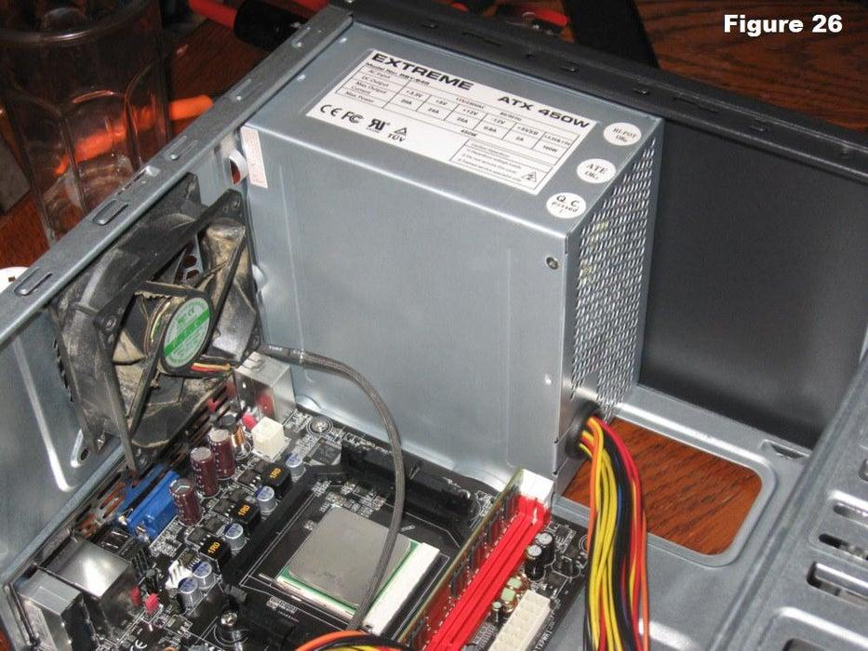
- Align the power supply with the screw holes on the case.
- Install screws to tighten the power supply

Step 7 - Closing the case and connecting the peripherals.
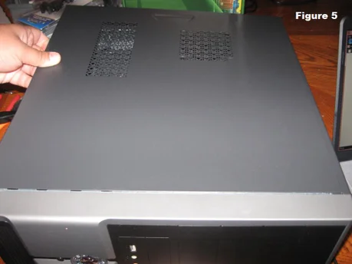
- After all the components are installed, reinstall back the side of the case.
- If the computer has any problems turning on, recheck all the components and make sure everything is correct.
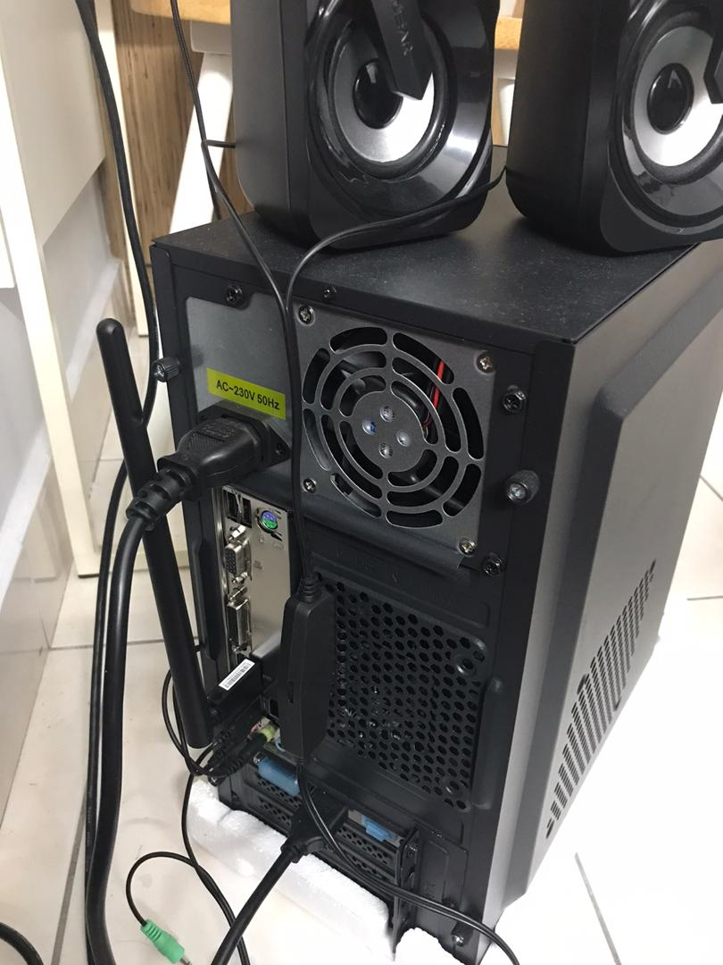
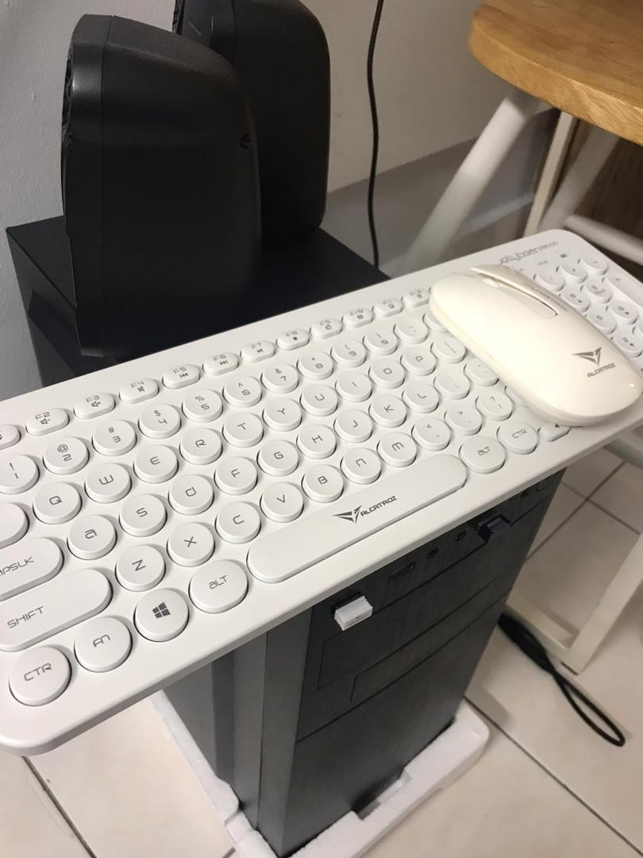
- Consult specialists for particular troubleshooting information.
- Connect peripherals devices such as keyboard, mouse, speaker, microphone etc into USB port.
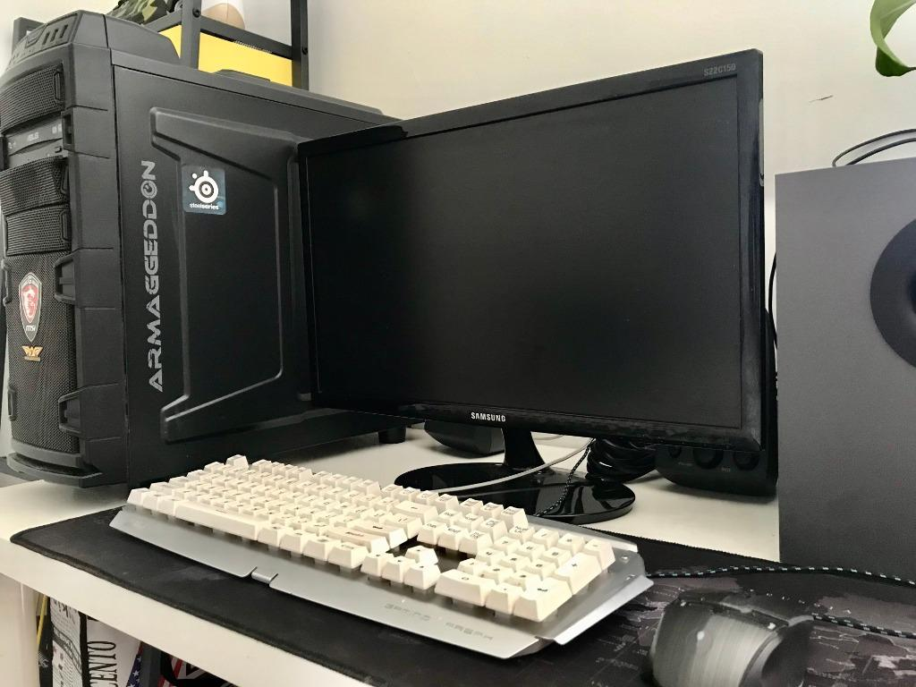
- Finally connect the CPU with the monitor by plugging into display ports.

