

SECP1513-02 TECHNOLOGY AND INFORMATION SYSTEM
SEMESTER 1, 2020/2021
TOPIC:
Database & Design Thinking
LECTURER’S NAME:
DR ARYATI BAKRI

NAME | MATRIC NO.
Lee Jia Xian | A20EC0200
Luqman Ariff Bin Noor Azhar | A20EC0202
Adam Wafii Bin Azuar | A20EC0003
Adrina Asyiqin Binti Md Adha | A20EC0174
Kong Jia Rou | A20EC0198

TABLE OF CONTENTS

INTRODUCTION 3
DETAILED STEP AND DESCRIPTIONS 5
EMPHATISE 5
DEFINE 5
IDEATE 5
PROTOTYPE 5
TEST 6
PROBLEMS 6
PROBLEM STATEMENT 6
SOLUTION 7
OBJECTIVE 7
DESIGN THINKING EVIDENCE 8
EMPHATISE 8
DEFINE 10
IDEATE 11
PROTOTYPE 12
TEST 13
REFLECTION 15
Lee Jia Xian 15
Luqman Ariff Bin Noor Azhar 16
Adam Wafii Bin Azuar 17
Adrina Asyiqin Md Adha 18
Kong Jia Rou 19
TEAMWORKING 20
REFERENCES 21

INTRODUCTION

Design Thinking is a process we try to find out and understand the problems and challenges that are faced by the user in an attempt to identify alternative solutions and strategies that might be beyond our level or standard. This process can be applied in any field and focuses on satisfying the user’s needs. This process involves five stages :

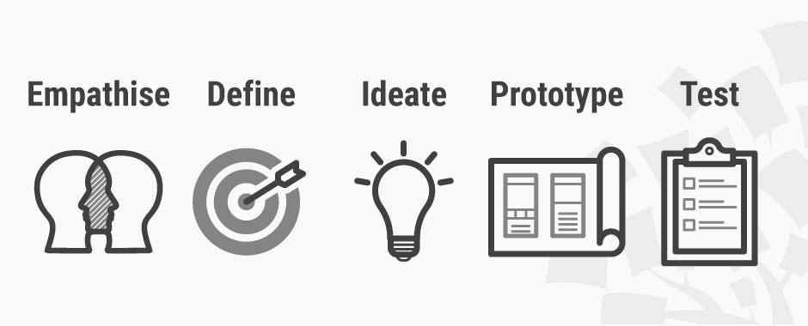
Empathise
Empathy is the first stage of Design Thinking that allows developers to investigate the user’s needs and gain and empathic understanding of the problem that we are trying to solve. This involves consulting experts to find out more about the area of interest through observing, engaging and immersing with people. Hence in this stage an interview will be conducted to collect all the information that helps to create a solution.
Define
During the Define stage, we will gather all the information that was collected from the Empathise stage. We will analyse our observations and synthesis them to define core problems: you point of view. So in this stage a clear problem statement will be defined and listed.
Ideate
Ideate stage is where we start to “think outside the box” to find the solutions for problem statements that are defined. It is a stage of “flaring” rather than “focus”. With Brainstorming, we explore alternative ways of viewing the problem to find the best way to solve the problem.

Prototype
Prototype stage is where all the ideas and explorations in our minds turn into physical form. We will now produce a number and versions of inexpensive products. This is an experimental phase and the goal is to identify the best possible solution for the problems we defined. So at the end of this stage we will know how our product works.

Test
Testing is the final stage of Design thinking and it is an iterative process to refine our solutions to make them better. We will put our prototype in front of people to get feedback on whether it solves their problems or not. During this phase, even the alterations and refinements are made in order to finalise a perfect end product.

What is a Database ?
A database is an organized collection of data that is generally stored and accessed from a computer system. A database is usually controlled by a database management system (DBMS). The DBMS is a software that interacts with end users, applications and the database itself to capture and analyze the data. Data within the most common types of databases in operation today is typically modeled in rows and columns in a series of tables to make processing and data querying efficient. So, the data can then be easily accessed, managed, updated, controlled and organized. Most databases use structured query language (SQL) for writing and querying data.

In this design thinking, we will interview experts to investigate and research DBMS software from different aspects, such as advantages, disadvantages, limits, etc as our empathise stage. Then, we will find out the method used by the small business grocery stores to collect and store their data and the risk of using this method. After determining the problem, we will search for solutions in order to overcome the problem by creating a simple DBMS for small business grocery stores. Next, a prototype regarding DBMS designed by our team is created. A number of versions of DBMS are made to get the best versions of the system to overcome all the problems Finally, we will put our prototype in front of people to get feedback on whether it solves problems or not. During this stage, even the alterations and refinements are made in order to finalise a perfect end product.

DETAILED STEP AND DESCRIPTIONS
On 25/10/2001, we learned about Design Thinking during the class in Google Meet. Then a task is given for each group to create a prototype based on topic picked. After some discussion our group decided to pick the topic Database. Then we started to make a research on Database to have more understanding of it.

EMPHATISE
In the first step we have to collect and investigate problems that are faced by users in Database. So, we are going to have an interview with an experienced DBA staff in UTM. The interview was held online on the 3rd of November at 3pm sharp with Dr Aris Bin Arifin by using Webex as a platform. This is because we couldn't hold the interview session face to face due to the pandemic COVID-19. In this interview, we managed to ask the questions that we prepared and gather the information we can get from the answers and replies of Dr Aris Bin Arifin. Very thankful to Dr Aris Bin Arifin, the information that we gained from this interview helped us a lot.

DEFINE
In the Define stage, we have a discussion on the information we collected from the interview session in our WhatsApp group. During the discussion, we decided to help the small business grocery stores to improve their database system. From our research, we managed to find out 3 main problems of the database system of the local grocery stores.

IDEATE
In this stage, we wanted to find the solution for the problem statement that is clearly listed in the previous stage. So, we first think about the objectives of our solution. After that we had our brainstorming process, we shared our ideas on Google Docs to find the best way to solve the problems. Then, we narrowed down the ideas and finally got one best way to overcome the problems

PROTOTYPE
In this stage, we gathered our ideas and solutions and created a software named “Grocery Stocker”. By using Google slide as a platform, we designed our software’s interfaces and listed the details for each interface clearly. We worked together to decide the functions and features of our software that meet the objectives. For example we got an auto tracking system for the grocery stores to track their products easily in our software.

TEST
Testing and demo is done by distributing google forms to receive feedback. We gathered questions to confirm the effectiveness of the prototype. The google form will also include the link to the prototype slides to ease the respondents to browse through our prototype.

PROBLEMS
Grocery stores are a place where we always visited to buy our daily supplies. This experience gives us a basic understanding on how grocery stores operate and manage their data. This includes employees, customers, suppliers, inventory, orders, etc. They usually used a proper Data Management System (DBMS) software such as MySQL, Oracle, SQLserver, RDBMS, etc. However, these software. Moreover, with the existence of big data nowadays, grocery stores are able to collect data with every transaction made by the customers. This not only benefits the grocery store to easily collect and access data, it also can help the customers to receive promotions or vouchers by tracking customers’ shopping habits.

However, these software are only widely used in grocery stores which own a great business like TESCO, AEON ECONSAVE, 7-eleven. For those who only own a small business, they have difficulties using the software, because some of them have no idea how to use them and they need to afford them in order to use them. Therefore, they choose to store their data manually which is very inconvenient, lacks security and takes longer time.This design thinking will aim to design a prototype database system for those who own a small business.

PROBLEM STATEMENT
- Some of the small business grocery stores are still manually collecting and storing data.
- The owners of small business grocery stores do not know how to use existing DBMS.
- The existing DBMS is unaffordable for small business grocery stores due to limited budget.

SOLUTION

OBJECTIVE
- To ease the collecting and storing data of small business grocery stores.
- To design an easy understanding DBMS for small business grocery shops.
- To create a free platform for small business grocery shops to collect and store their data.

When starting a business it is important for the business owners to evaluate their business on a regular basis in order to ensure that the business is on track. One of the major parts of business is inventory management. Inventory management is part of business that always needs to keep in check so that the right products are in the right quantity and ready to sell. This process needs to be done effectively so that business owners can minimize the costs of having excessive inventory. By doing so, owners will have the specific products in the correct quantity on hand and avoid products being out of stock or being stuck with excessive stock. Owners also can avoid spoilage of products by making sure the products are being sold in time.

We created a software called Grocery Stocker to ensure all the business owners can easily keep their business on track in real time. A software that surely reduces the cost of expenses for the business owners by downloading the software on their mobile devices. The software is free to use by anyone and it is also easy to access due to the user-friendly features. Grocery Stocker also helps the business owners to prevent product shortages or excessive products. It also allows for easy inventory analysis using their mobile devices and also optimizes the employee times. Employees can save their time from counting the stock manually and they can focus on the production to boost the business’s bottom line.

DESIGN THINKING EVIDENCE

Record for each phase:

EMPHATISE

Here is the list of questions we asked and the responses from Dr Aris Bin Arifin during the interview session.

- What are your challenges in managing data in UTM ?
The main challenge is that technology rapidly evolves. We have to adapt to the changes, study and find the solution to solve the problem due to the evolving of technology. When I started doing my job in DBA, we use Oracle as our DBMS, the evolving of the system itself is quite fast, for every version they have upgrades that we need to learn. Everytime it upgrades from one version to another, we have to update ourselves. Second is the limited budget. We need to make use of what we have now to accomplish our job.

- How does UTM store and process data ?
We store the data on premise because the data is confidential according to the policy of Malaysian government. We do not store data in the cloud. We have our own data centre. We have quite a number of servers and storage. To handle them, we need to be knowledgeable and skillful .We have to make sure all the storage and server is managed properly.

- In your opinion, what are the disadvantages of storing data in the cloud?
Cost, we need to invest in another proper server to make sure data is safe and secure. Besides, the staff must be knowledgeable about the status of the data.

- How u do to ensure your data is safe
We have a policy on how to manage data, how to manage users and passwords. For every password we give to the user, the user has to ensure the password is not shared to others, or we will have to take actions on them.

- What if the system is affected by a virus ?
The system is operated by the app server. So basically, we do not have a problem with that. The problem usually comes from the end user laptop. The virus attack on the end user computer. In this case, we provide the end user with an antivirus application so they can install in their computer as a protection.

- What is the daily task for DBA ?
We need to ensure the backup is properly running daily and the security of the database is taken care of.

- Do you ever have any thought of "if we have (something useful eg system)" so you can get your job done easier ?
Yes, if we have more advanced software, it will help us more. But, as I said earlier, we have a limited budget, so we have to make use of what we currently have.

- How do you ensure there will always be a backup of data ?
We have daily backup. We ensure the backup does not fail. If there are problems occurring on the data like the data is accidentally deleted, the data is lost, we will recover the data because we have a data recovery centre in UTMKL. We will transfer all the daily backup data in UTMJB to UTMKL . So we have two copies of backup daily.

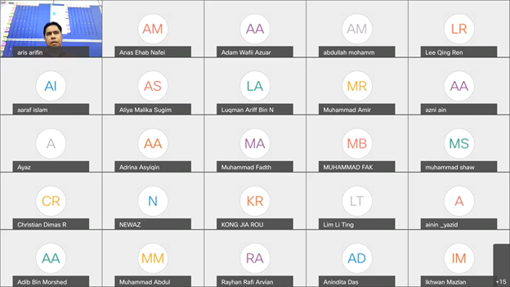

Diagram 1: Interview session in Webex meeting room

DEFINE

After the interview session, we have our discussion in the WhatsApp group. We decided to help the grocery stores to improve their database system. After our research on the grocery stores, we discuss the problems that the grocery stores faced. We found out that the small grocery stores still manually collect and store their products data (like records in the books). At the end of this phase, we finalized 3 clear problem statements.

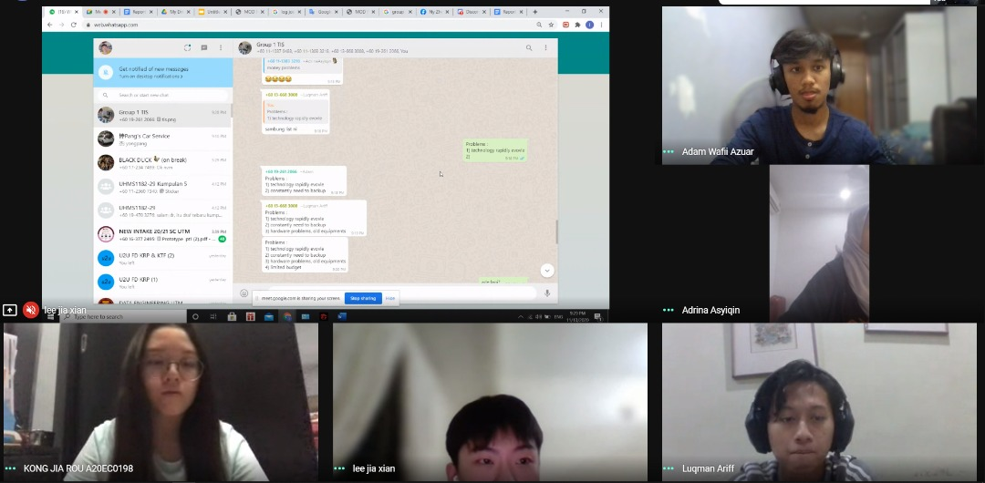

Diagram 2 : We discuss the problems faced by small grocery stores on WhatsApp.

IDEATE

We have come up with a brilliant idea which solves all the problems. The solution is to set up a system in an application that keeps track of all the items in the store. Most small business owners still update their entire stock with a pen and paper, so by switching to a virtual alternative not only would it be better for them to operate with but also environmentally friendly. How this would work is by the system would continuously update the stock every time a purchase is made. It will notify the employees once an item about to run out so they can immediately restock it. This would ease the worker’s job as they do not have to check each item whether it should be restocked or not.
Indeed, a technology like this is available but it might be too complicated for small business owners to implement it themselves. That is where we come in with our idea here as we will be the one doing the hard work for them. The app will set up on its own and it also comes with instructions or a user's manual along with it. Unlike the existing technology, ours is much more low – cost. Therefore, small business owners can utilize our service as they could afford it with much money left to spare and don’t have to worry if it will take up all their budget.
Initially we had some other ideas such as portable barcode reader or to replace barcodes to QR codes instead as it can be used or read through a phone because mobile phones are much more common compared to a bar code reader itself, so the small business owners can make use of the items they already own. Though both of the ideas were good candidates but unfortunately it does not satisfy our issue as the problem was more about recording the stock.
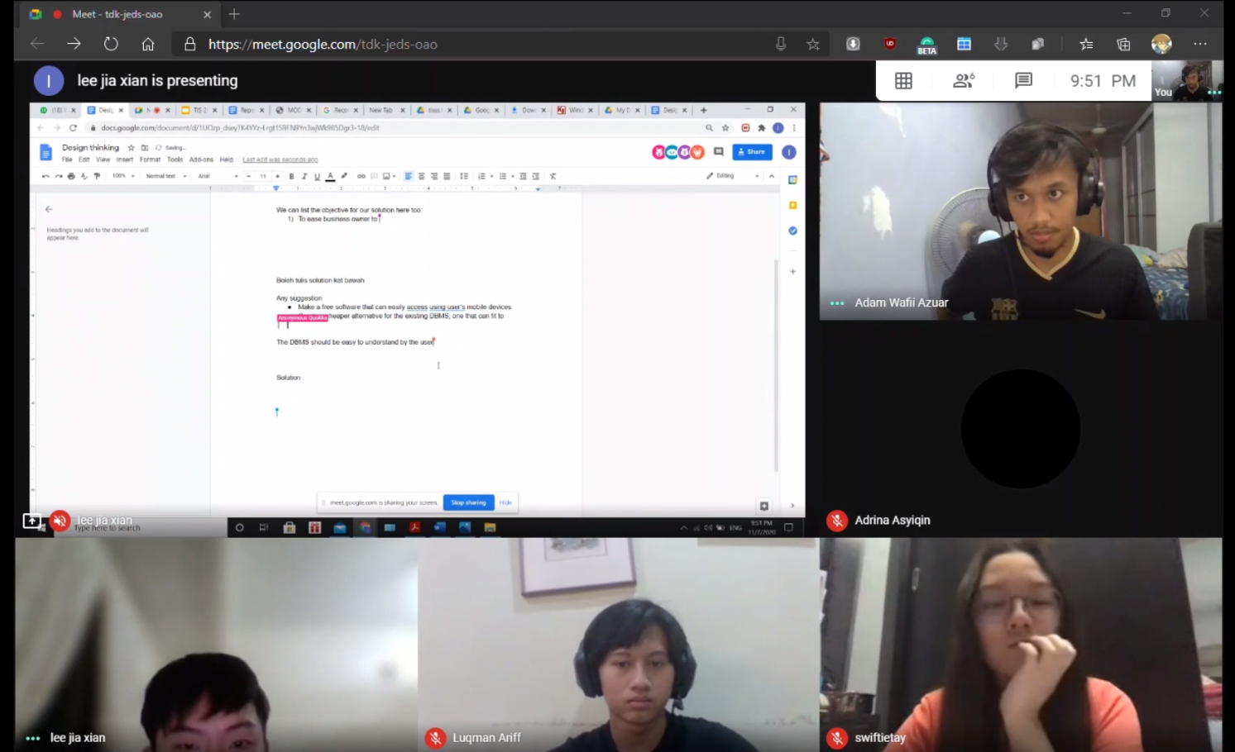
Diagram 3 : Brainstorming for solution on Google Docs

PROTOTYPE

Due to the current pandemic right now, many people lost their jobs because of the company financial crisis and many of them started to find a new income in order to survive by starting a small business. Little that they know, starting a business is not that easy especially when it comes to stocktaking. To help all the new and small business owners, we developed a software that can be easily accessed by using the user's mobile devices. This application is called Grocery Stocker. Users just need to sign up and fill in their details to start using the application. Users can register as many items as they want into the system and it will help users keep track with their particular product by simply scanning the product barcodes. The software also helps the users to know how many of their products are being sold for the specific month and even for a specific year.

Example of the application interface:
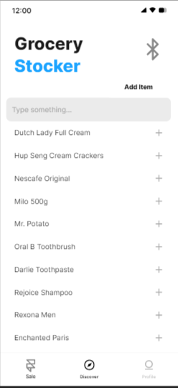
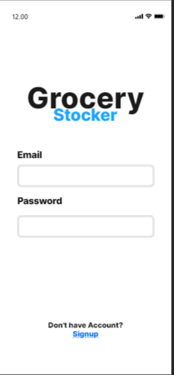

Diagram 4 : Login phase Diagram 5 : Main Menu

TEST

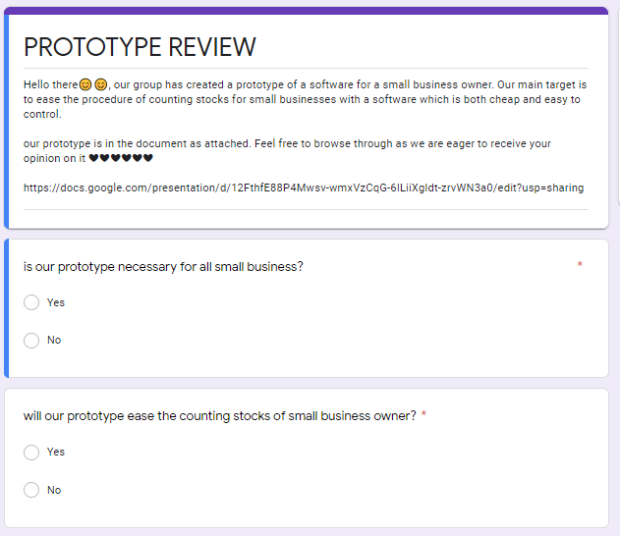
The reviews are collected by google forms. The survey consists of 4 questions to determine the effectiveness of the prototype.

Diagram 6 : Google Form

Based on the result and answers from 46 respondents, almost 90% agree that our prototype is convenient for small businesses to count and update their stocks. There are certain aspects that we receive comments to improve further our prototype such as; making use of fingerprints to access the database, using QR codes, and suggest incorporating the screen where the Small and Medium Enterprise (SME) can see the amount defected goods.
An average of 97.5% respondents also state that overall it is user friendly for business owners as it is easy and effortless to operate.
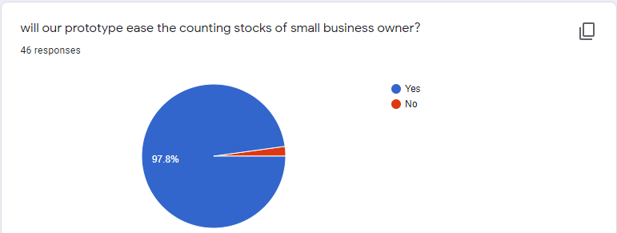
Diagram 7 : Pie chart on feedback from user

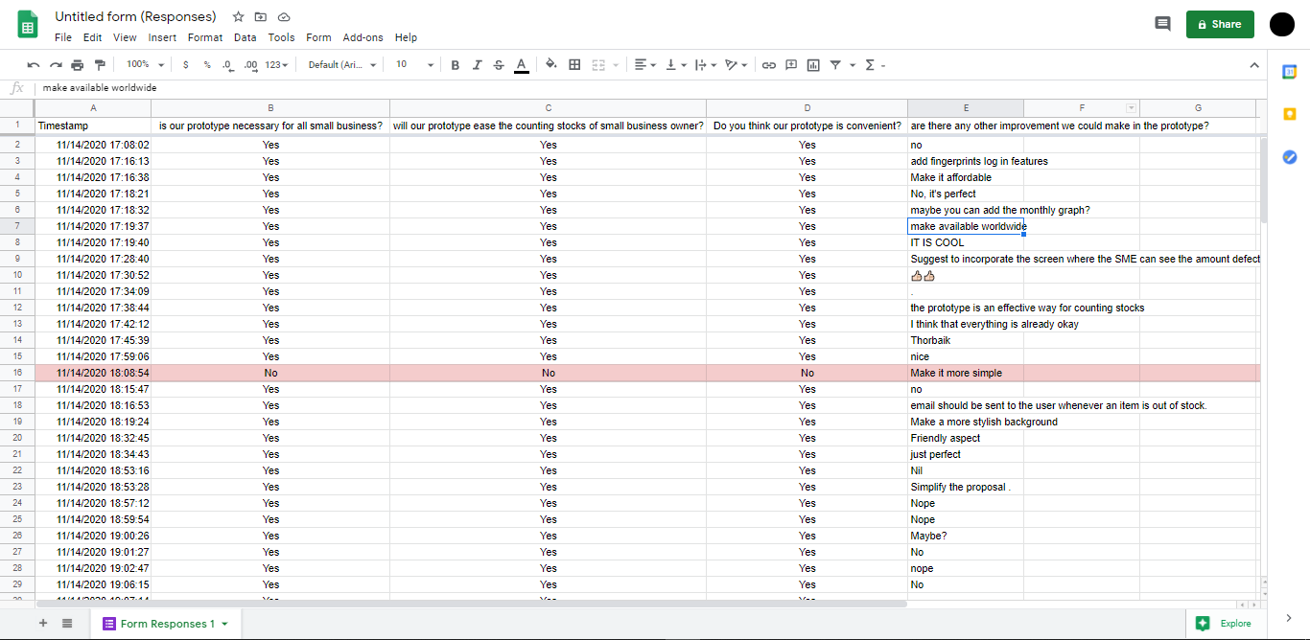

Diagram 8 : Detailed feedback from users

REFLECTION

Lee Jia Xian
I would like to start my reflection report by saying that I am extremely grateful for being given this opportunity to take part in this assignment because it was completely different from all of my other assignments. Not only that, it provided a new, exciting and practical approach to learning which really helped me a lot. I major in data engineering, which is responsible for design, construct, install, test and maintain data management systems. My goal is to design a DBA system which can automatically take large volumes of complex data, extract insights and also help solve problems.
In this Design thinking assignment, I learned about the concept on how to handle the problems which will be really helpful in my future. Design thinking gives me the opportunity to view a problem from a different perspective. I learned that how we put ourselves in the view of the users to determine the problems they are facing thus we can remedy the problems by creating an effective solution. Furthermore, in this assignment we carried out the brainstorming process together and shared our ideas. Although we faced a lot of challenges and troubles during the assignment work as a team can always keep us to stick with it. And finally, with our hard work, we have a surprising outcome. From this, I realized the importance of team working from Design Thinking.
To improve the potential in the industry, I believe that having the right mindset is crucial. In addition to achieving my goals, I must keep myself motivated even if I experience hardness or setbacks. I will keep improving my skill sets nonstop to make myself more valuable. Data engineering is not an easy career, it's new but still keeps evolving year by year. So, I have to keep myself always updated and master the programming skills such as SQL, Python, C++, etc.

Luqman Ariff Bin Noor Azhar
The goal I had in mind when I chose this program was to come up with a system that is easy and accessible so it could help anyone regardless of their position in terms of data handling. This would be done manually which is why it is very inefficient especially in these times. Those ancient ways of organizing data could no longer be considered suitable as the world is now stepping into Industrial Revolution 4.0, therefore to ensure our country matches the other first world countries, this is where I come in by contributing as much as possible to help those that lack modern technological aid.
This is because I myself have been in that situation where I had to manage all the data in my part – time job with pen and paper as well as the help of Microsoft Excel. Though I was using the help of a quite common technology, it was still a hassle as I had to associate with a number of data. Through this design thinking we came up with a solution to overcome just that. It was spectacular to hear some of the innovations my team came up with as it is the exact thing I needed back then during my part – time job. Indeed it may not be the most groundbreaking idea that anyone has ever came up with but it is a very good start or a stepping stone for me in my journey to fulfil my dream and I would have never thought of it if it was not for this design thinking thus I am very grateful to ever come across this opportunity.
Needless to say, I do require some improvements or betterment to make myself a more valuable asset in this industry especially in the years to come. Some of it are possessing the ability to execute such a system instead of just proposing the idea and that calls for gaining more knowledge as I have only scratched the surface in this field which can be obtained through my program here. Apart from that, I personally think I would require some enhancement especially in terms of soft skills which could also be obtained here by working together in groups.

Adam Wafii Bin Azuar

To be honest, at first, I never thought that I would enroll myself in this program called Data Engineering. But one day, while I was searching for a movie to watch on Netflix, suddenly a documentary pops out and I feel amazed with the trailer. So, I decided to watch the show called The Great Hack. The documentary shows how powerful a set data can influence the whole country election’s results. For this case, the country is the United States of America. After finishing the show, I feel very excited to learn about data and then I decided to pursue my studies in Data Engineering. My goal in pursuing this program is to help people in business to make the best use of computer technology to provide the information needed to achieve their goals. I want to make every business owners’ dreams come true. A company without good data strategies will never be successful.
The design thinking task helped me to enhance my decision-making skills. Putting myself in an unfamiliar situation and trying to complete new challenges makes me feel enthusiastic to learn more. It also helps me to adapt to the new environment by doing so and expand my critical thinking ability.
In order to improve my potential in the industry, I need to keep improving and updating my skill sets. The most important thing is to focus on the big picture. There are too many distractions in our daily life. By focusing on the big picture, I will know the purpose and I will feel motivated to live each day to achieve my fullest potential. It is not enough just by focusing on the purpose without the right mindset. In order to have a productive day, all I need is a positive attitude. With positivity, I will be able to accomplish what I want in the future. It is all about the right perspective and mindset. Surely, my dreams will come true.

Adrina Asyiqin Md Adha

My goal for this program is to recognise every skill that will be used in the future. That also includes attitude, time management and creative thinking. Data engineering can be considered quite new to the industry. I am going to absorb everything my lecturer gave to me in terms of knowledge. These skills can help me determine my path in the fore future that is still blurry for me.
Technology and Information System programs teaches me to tackle a problem creatively. In every group there would always be many ideas from each member. Some may see it in a way that it is troublesome, but for me it is rather convenient because every idea consists of both the pros and cons. We could take certain aspects from each idea or suggestion to make the perfect item or product.
The design thinking assignment made me realise that team working is a necessary need in every group or team anywhere you go. It also made me rethink my mind set of working together is troublesome when in reality every human needs help from others. In data engineering, students are mostly expected to handle big data in the industry after we graduate. Handling it alone will not make work any easier even if you are a genius or an introvert.
For now, I would like to sharpen my team working skill and leadership skill so I will not be a burden to my teammates. This would mean I will have to participate in every discussion so I will not be left behind. I would also contribute in giving ideas and suggestions even though it is most likely to be rejected due to insufficient advantages. Speaking out is the most important factor for every team. Throwing out ideas and speaking out your mind may be helpful because in the industry, everyone is expected to contribute in every meeting or project held.

Kong Jia Rou
As a data engineering major, my goal is to design my own software and own a business myself.
The design thinking gives me a great illusion on starting my own development of software. Design thinking is the very first step before starting to plan on creating a project. Besides, design thinking also teaches me working as a team makes work done easier. By having discussion together, we can gain more creative, effective ideas to solve existing problems. It not only teaches me how to work as a team, it also teaches me how to cope with this current pandemic in order to have good communication in a team.
To improve my potential in the industry, I should improve my critical thinking by being more active in class or group projects. I should involve myself more in team working activities. In this way, I can improve my communication and leadership skills.This is because technology evolves rapidly, more critical thinking is very important to solve problems, make good decisions and understand the consequences of our actions.

TEAMWORKING

Organised strategy is crucial when working as a team. A successful teamwork promotes a positive atmosphere which will motivate every individual in the group to work harder, cooperate and be supportive of one another. Therefore, a responsible leader is needed in order to reach the goals. We discussed and voted Lee Jia Xian as our group leader.

Under the leadership of him, we started our design thinking project with doing simple research on what is a database. To have a better understanding on our topic, we prepared questions and interviewed an experienced UTM DBA staff, Dr Aris bin Arifin. We had learned what his daily tasks, how he processed data and how he cope with the challenges.

We then excavated deeply the demand nowadays to gather some ideas for our project. We discussed our ideas and solutions on Whatsapps and recorded them in Google Docs. Next, we divided the report writing into several parts, which are introduction, detailed steps and descriptions, design thinking evidence, team working and references. Lee Jia Xian was in charge in the introduction part and references part; Luqman Ariff was in charge in the detailed step and descriptions part; Adam Wafii was in charge in the problems and solutions part and lastly Kong Jia Rou was in charge in the teamworking part.

Next, we had a meeting on Google Meet. We discussed and built our prototype on an application called Grocery Stocker. Adrina Asyiqin was in charge of making Powerpoint slides for the prototype. After that, she did a test to get feedback from the user to check whether the problem is solved efficiently or not by using Google Form. Other group members helped to distribute the form. Every group member had shown their commitment throughout the project. This made the team work to be successful.

REFERENCES

- Thoring, K., & Müller, R. M. (2011). Understanding design thinking: A process model based on method engineering. In DS 69: Proceedings of E&PDE 2011, the 13th International Conference on Engineering and Product Design Education, London, UK, 08.-09.09. 2011 (pp. 493-498).

- Piateski, G., & Frawley, W. (1991). Knowledge discovery in databases. MIT press.

