
SCHOOL OF COMPUTING
Faculty of Engineering

Semester I 2020/2021

Subject: Technology and Information Systems (SECP1513)
Section: 02
Assignment: Step by step PC Assembly

GROUP NAME / NUMBER: GROUP 2

1. |  | Name: Low Junyi  Matric Number: A20EC0071  Phone Number: 018-2858291  E-mail: Low.junyi2001@gmail.com
2. |  | Name: Muhammad Imran Hakimi bin Mohd Shukri  Matric Number: A20EC0213  Phone Number: 011-36584107  E-mail: muhdimran190@gmail.com
3. |  | Name: Madina Suraya Binti Zharin  Matric Number: A20EC0203  Phone Number: 012-3136850  E-mail: madinasuraya@graduate.utm.my
4. |  | Name: Nur Syamalia Faiqah binti Mohd Kamal  Matric Number: A20EC0118  Phone Number: 011-63360800  E-mail: nursyamaliafaiqah@graduate.utm.my
5. |  | Name: Sakinah Al’izzah binti Mohd Asri  Matric Number: A20EC0142  Phone Number: 011-23607340  E-mail: sakinahalizzah@gmail.com
PART A - List of tools

1.0 Screwdrivers
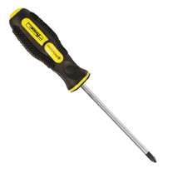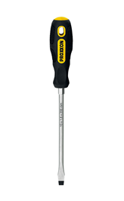
The screwdrivers are the most important tool for PC assembly. It is used to tighten the screw to the components so that it will securely in place. Screwdrivers are important as they have a long shaft that can help people working on a small or tight space. The type of screwdrivers that are commonly being used are Phillips-head size screwdrivers and flat-bladed screwdrivers. Moreover, magnetic screwdrivers are also one of the best options as it is very handy.

2.0 Anti-Static Equipment
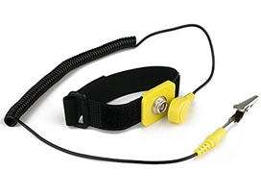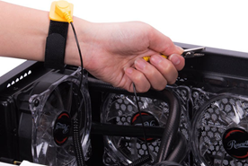
The anti-static equipment is a device that is usually worn on the wrist. The function of this tool is to eliminate the risk caused by the electrostatic charge. It is important as it could avoid the static-charge from entering the human body and components. There are also some possibilities that the spark could produce and damage the parts of components.

3.0 Cable ties
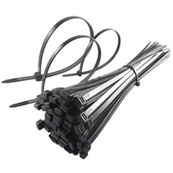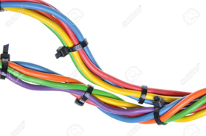
The cable ties are being used to tie up the loose cables that spread around the case. It is important as it makes the wire inside the system unit neater and provides a better air flow within the case. However, we should not make it too tight as it could damage the cables. After applying the ties, we can also cut the end of it using needle-nose pliers or scissors.

4.0 Pliers
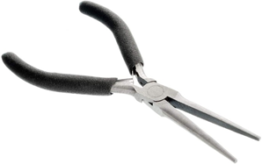
Plier is being used to untighten the screws or bolts that are very tight. It is important as we could pick up screws that were dropped inside the case as it is long and thin. Moreover, a plier such as needle-nose pliers could also be used to cut the end of the cable or zip ties.

5.0 Flashlight (Optional)
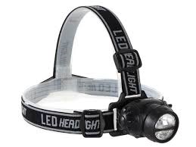
Flashlight such as head flashlight is being used to provide more sources of light. The importance of this is we could easily see what we are working on. The PC cases, shadows or dark surrounding could block the light from entering the PC which makes people hard to see the small components.

6.0 Thermal paste
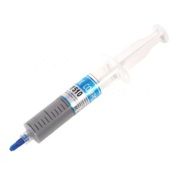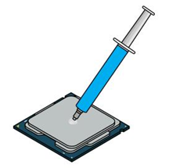
Thermal paste is a silvery-grey substance that is applied to the processor before installing a cooling solution. The function of this is to eliminate air gaps or spaces within the area. It is important as it could ensure the efficiency of heat transfer from processor to water block of CPU cooler.

PART B – Sketch of a mother board layout

1.0 Sketch of a motherboard layout

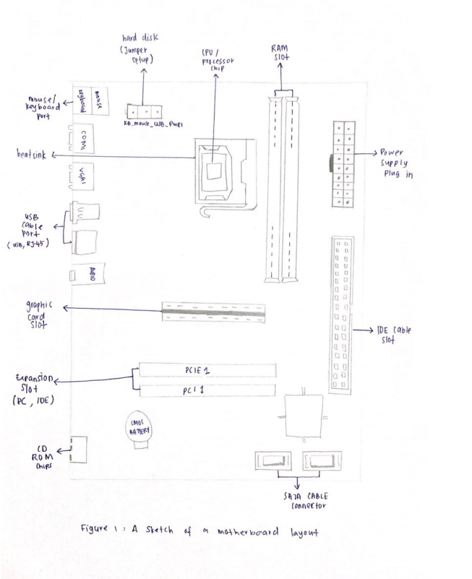
Diagram 1.0

2.0 For each keyword in Table 1.0. Provide picture(s), explanations of its functions and example of models.

Keywords/Hardware | Picture | Function | Example of Models
Graphic Card | 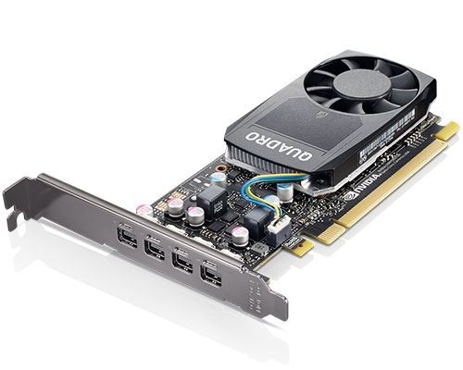 | Controls the visual output of a computer by processing graphical data. Also takes place in rendering video or photos. | Nvidia Geforce RTX 3090 GDDR6X, AMD Radeon R9 GDDR5.
CPU/Processor | 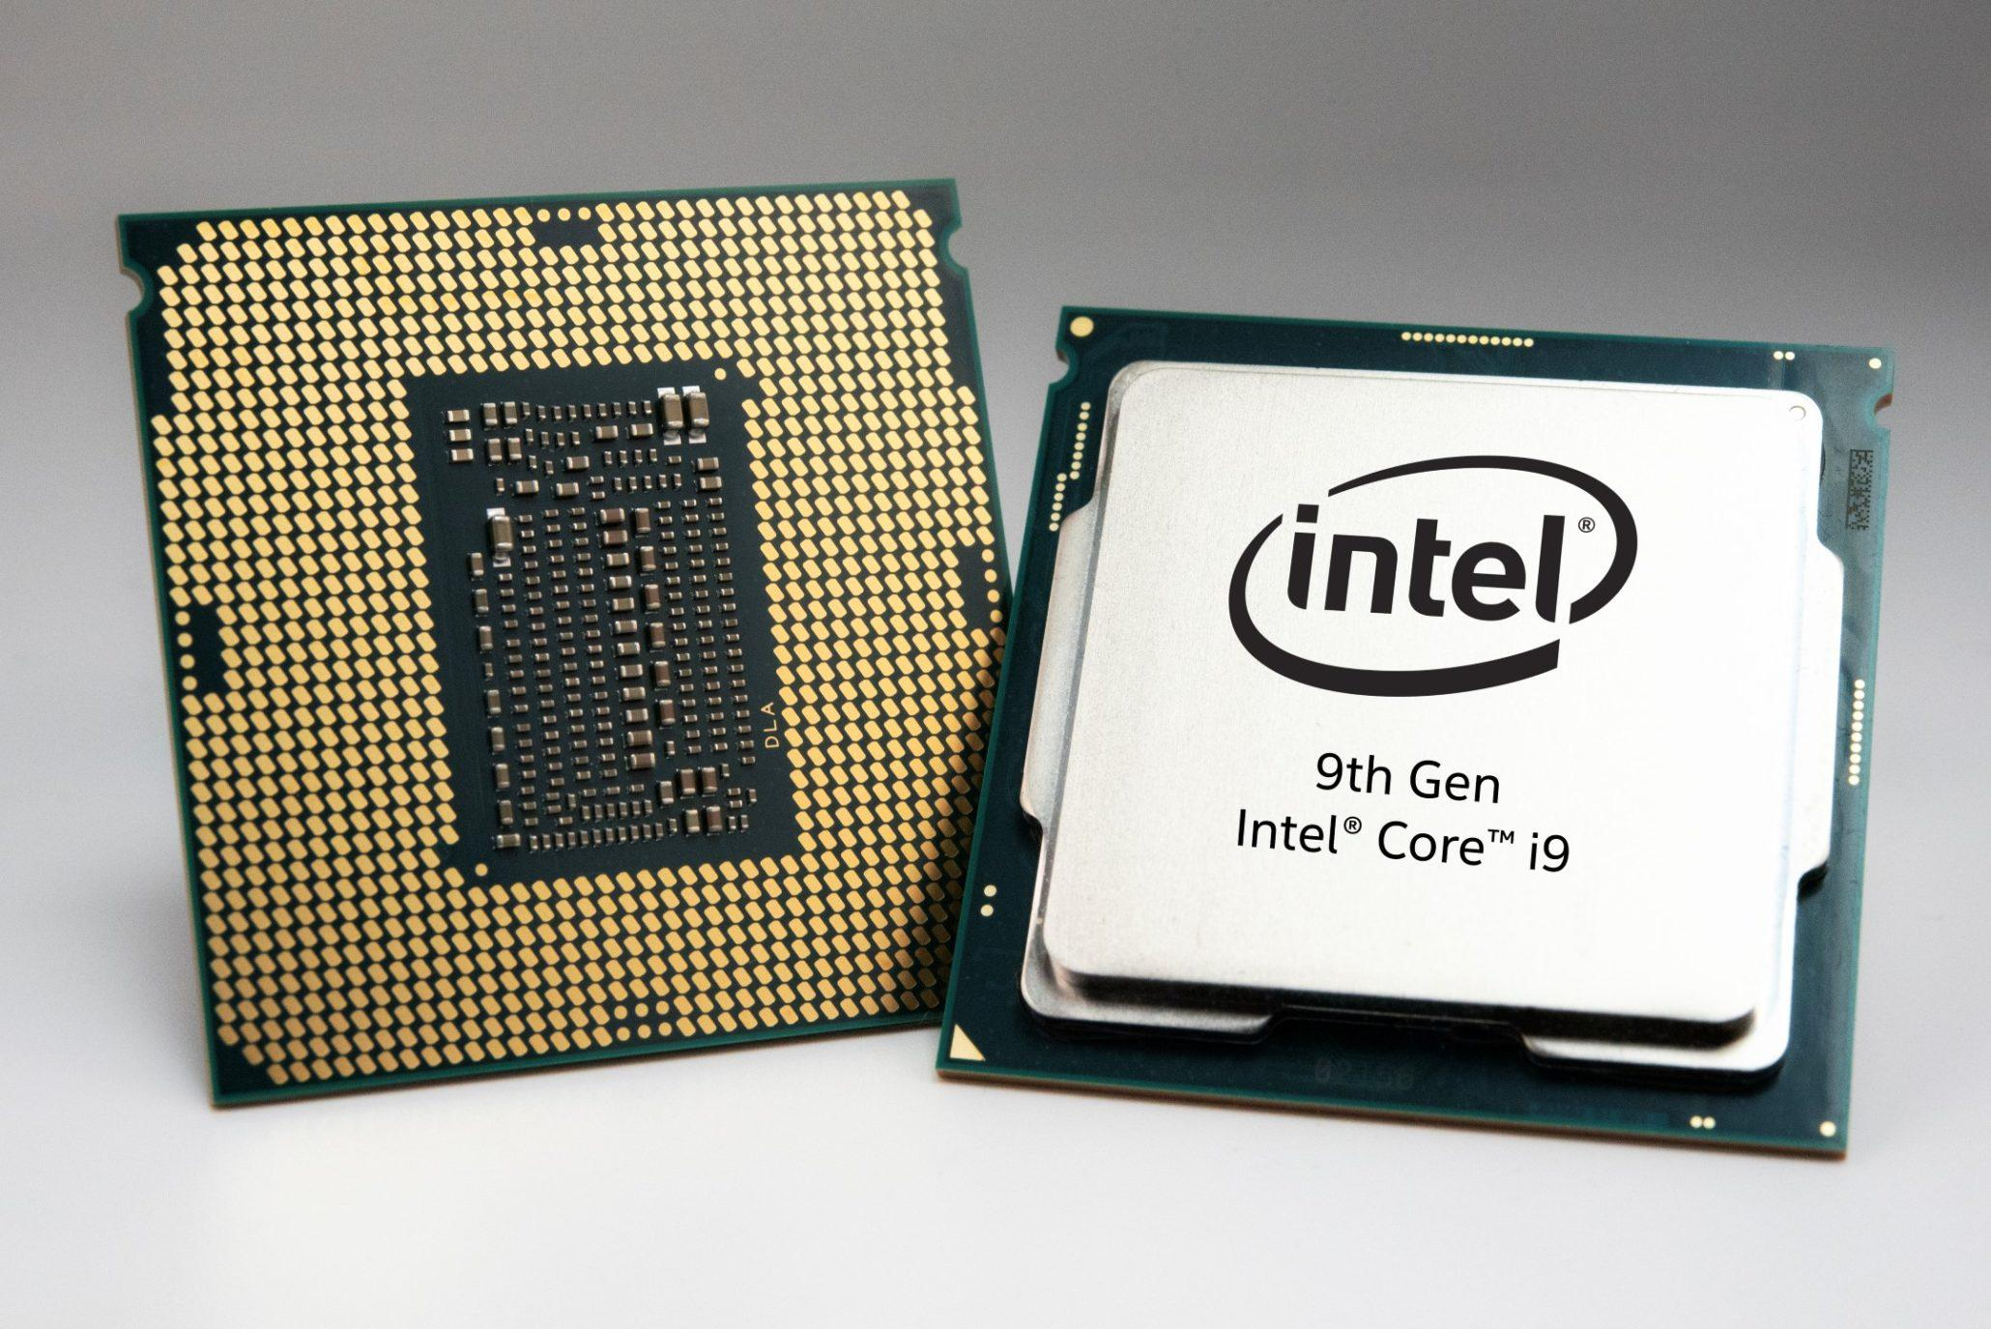 | Acts as brain of a computer that carries out instructions and tasks by solving and processing mathematical problems such as arithmetic data | Intel Core-i9 10900k (deca-core), AMD Ryzen 7 5800x (octa-core), Intel Core 2 Duo (dual-core), AMD Athlon (single-core)
Heat sink | 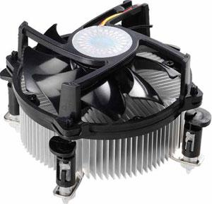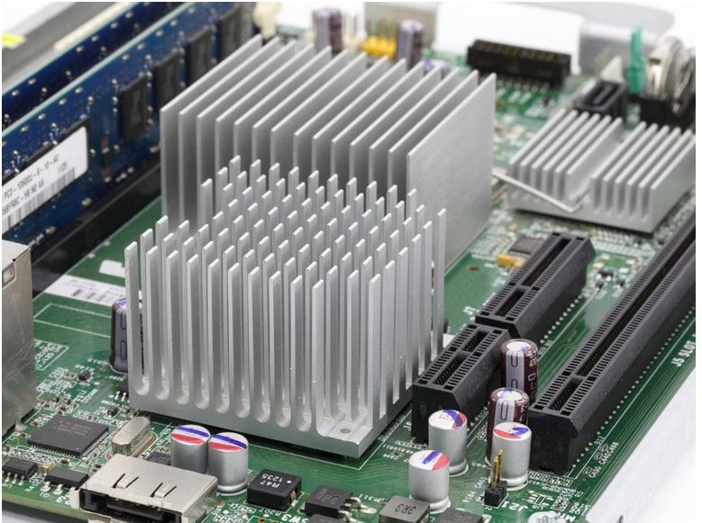 | Used to exchange the flow of heat generated by computer components such as chips, CPU, and graphic card passively. Usually connected to a fan that cools down the heat conducted by heat sink. | Aluminium heat sink, Copper heat sink, Active heat sink, Passive heat sink.
CD ROM | 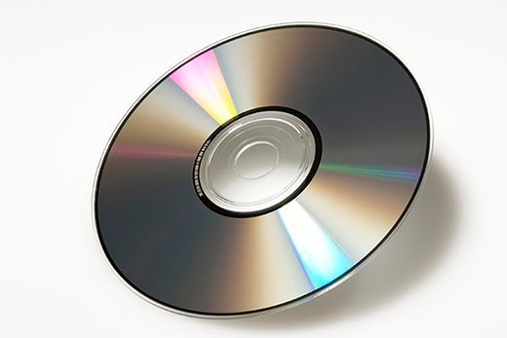 | Optical compact disc (CD) that is pre-pressed by manufacturer. Data in this disc can only be read and not to be erased nor altered. | Software CD ROM, Games CD ROM.
USB cable | 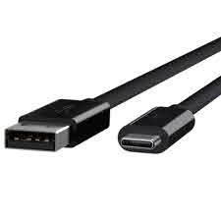 | Used to transfer data between devices, and to deliver power for charging purposes. | Type A to Type C, Type C to Type C, Type A to Micro USB.
IDE slot | 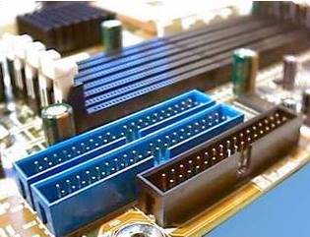 | Interface for a motherboard to connect to storage devices such as hard drives and CD-ROM. | 40 pin IDE slot, 34 pin IDE slot.
Peripheral Computer Interconnect (PCI) slot | 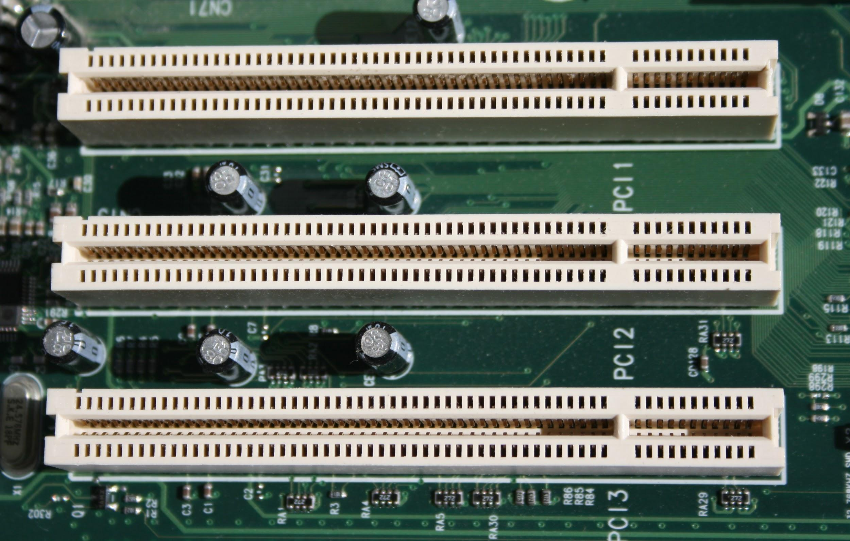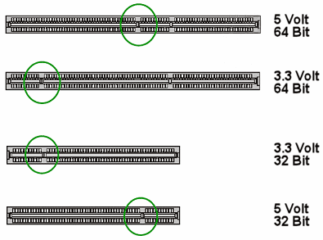 | Built-in slot on electronic board that allows user to attach components such as sound cards, modems, and network cards. | 5 Volt 64 Bit PCI, 3.3 Volt 64 Bit PCI, 3.3 Volt 32 Bit PCI, 5 Volt 32 Bit PCI.
RAM | 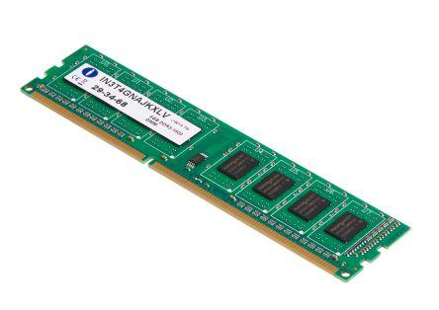 | Acts as a short term or temporary storage space of data that a computer processor is using. | Samsung DDR2, HyperX DDR3, HyperX DDR3L, HyperX DDR4.
SATA Cable | 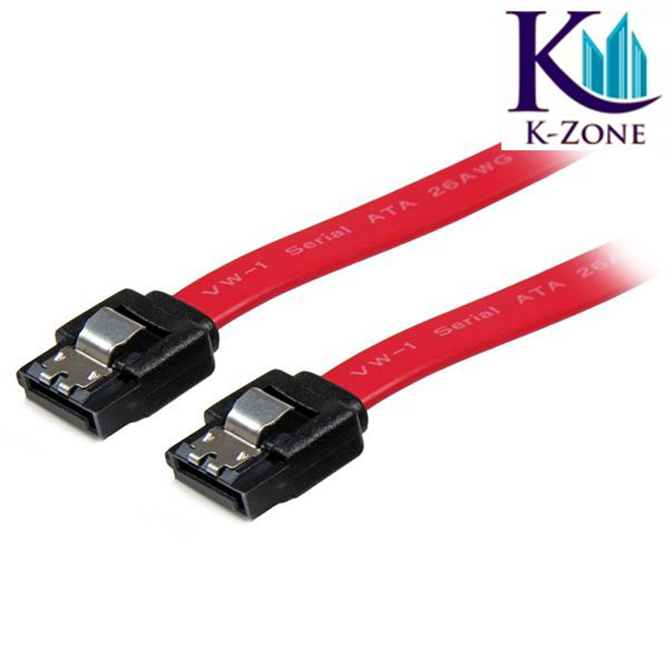 | Connects internal hard drive, solid state drive, CD-ROM drive that uses SATA interface to the motherboard. | Two-connection SATA cable, Three-connection SATA cable, eSATA cable.
IDE cable | 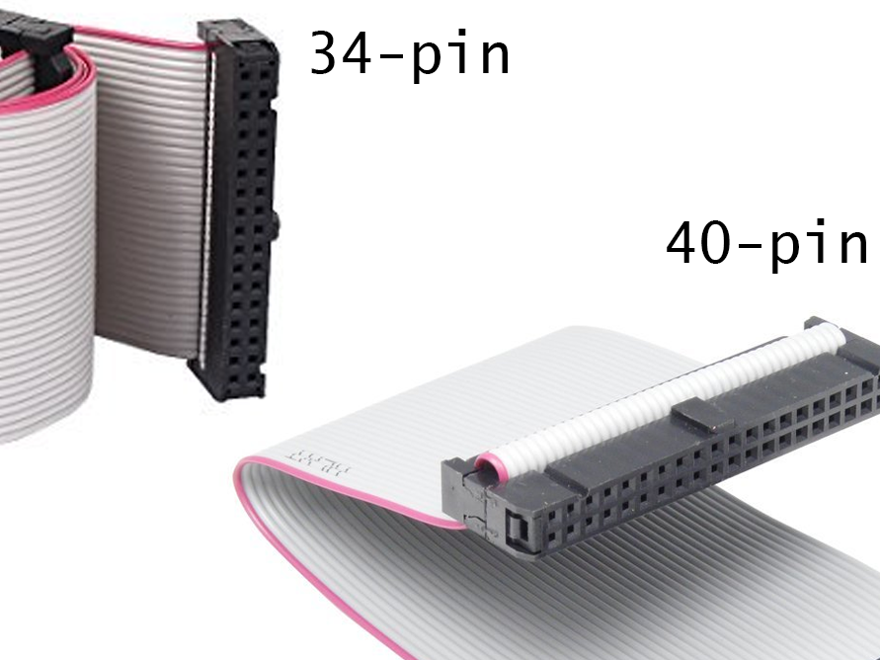 | Used to connect motherboard to storage devices. | 34 Pin IDE cable, 40 pin IDE cable.
Power supply | 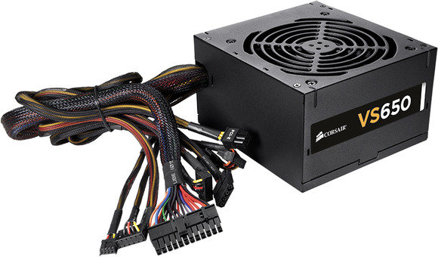 | To supply power to all the computer components through motherboard. | AT power supply, Corsair VS650 650-Watt ATX power supply, ATX-2 power supply.
Hard disk | 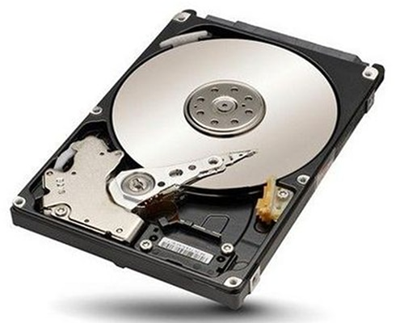 | Non-volatile and stores digital content of a computer permanently unlike RAM. | Toshiba 500GB 5400rpm, Seagate 1TB 7200rpm, LaCie 1TB Rugged External Hard Disk.

PART C - “Step by Step PC Assembly”

STEP 1 - INSTALLATION OF CENTRAL PROCESSING UNIT (CPU)
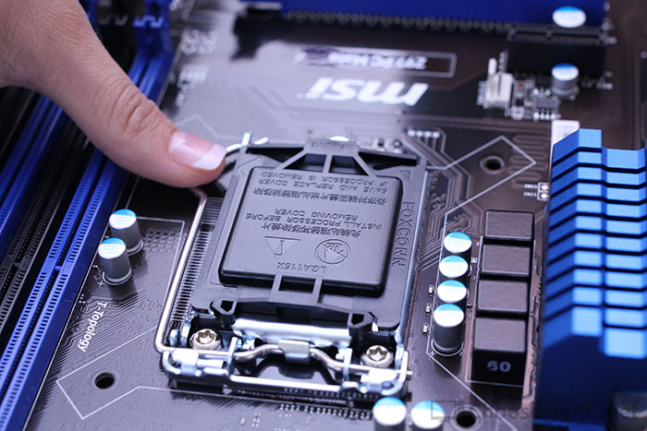
By pressing down and out of the processor socket, raise the CPU retention bracket lever from under its latch. Bear in mind that this can differ slightly depending on the socket of your motherboard and it is best to refer to the manual that came with the motherboard.

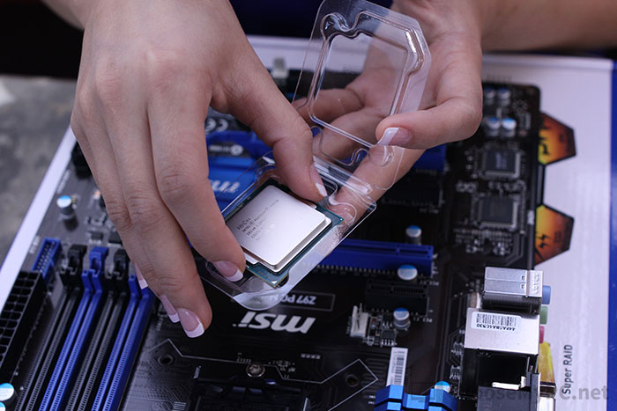
To show the socket and its pins, remove the CPU retention bracket lever. These are extremely sensitive and simple to bend, so when working around the socket carefully.

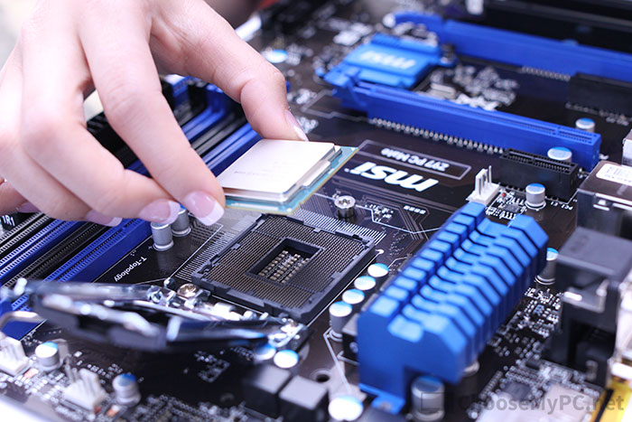

On the CPU socket, locate the corresponding marking and insert the CPU so that the markings are lined up.

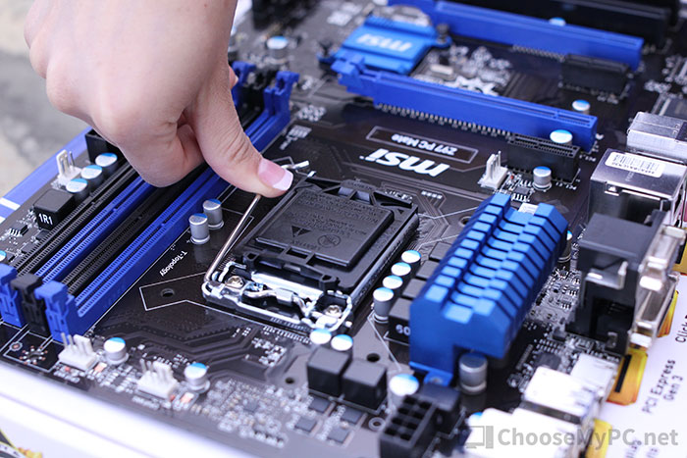

Finally, push down the CPU retention bracket lever to lock the processor in place.

STEP 2 - INSTALLATION OF HEAT SINK
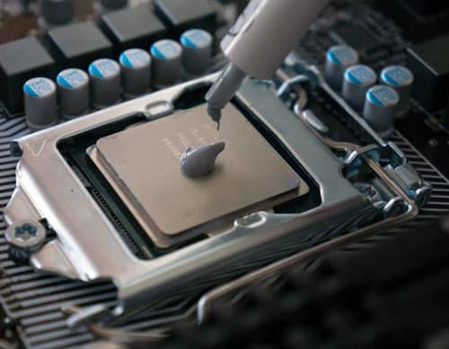
Apply a little bit of thermal paste on top of the CPU or processor. Make sure the chip is clean before doing this process.

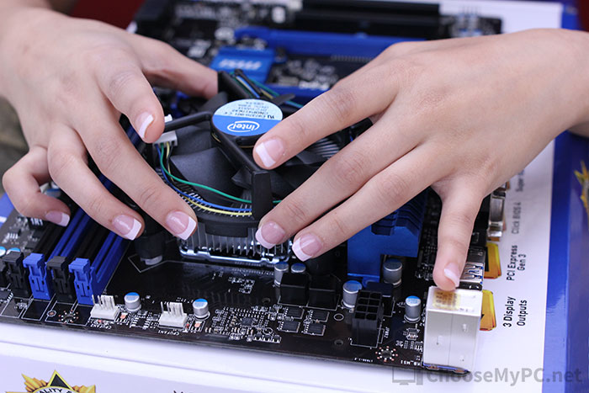
Then, install the heat sink neatly on the processor.

STEP 3 - INSTALLATION OF RANDOM-ACCESS MEMORY (RAM)
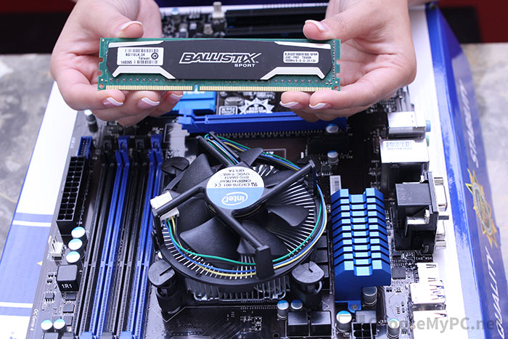

On either side of the RAM slots that you will use, pull back the clips.

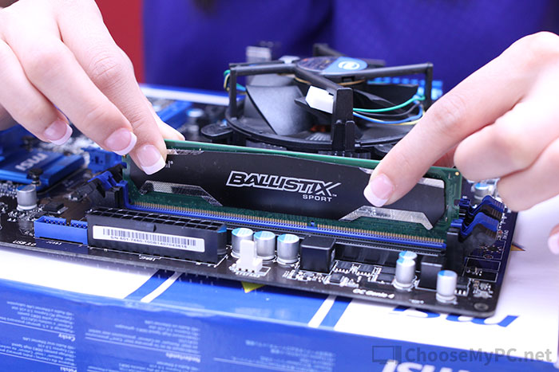

Place each RAM stick in a slot and force it down on both sides equally before the clips interact.

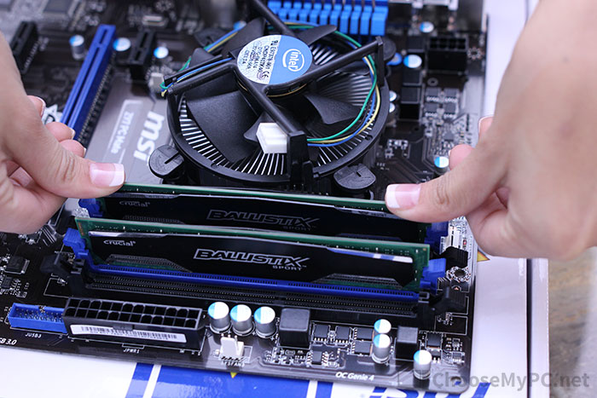

Ensure the tabs are locked into place by clipping down each side of RAM.

STEP 4 - INSTALLATION OF POWER SUPPLY
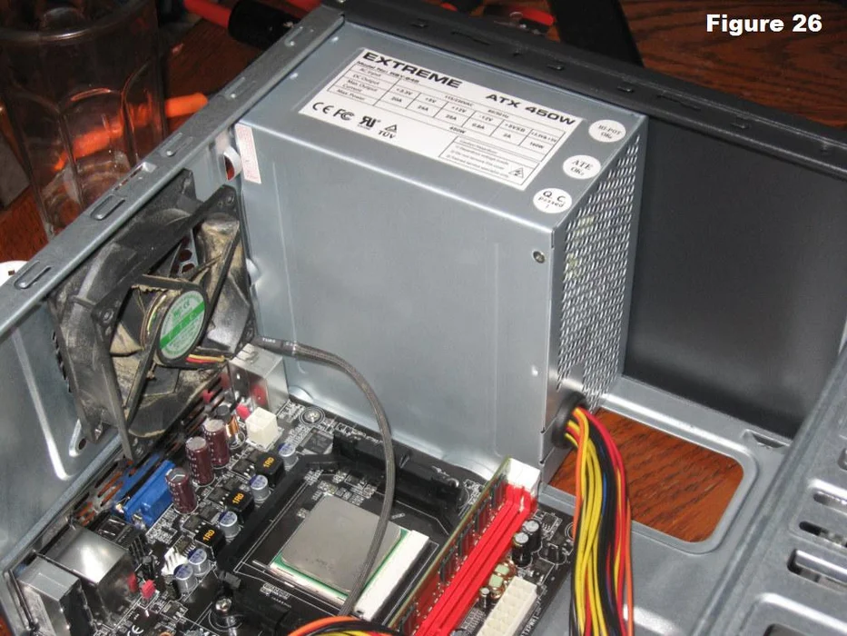

Attach the power supply to the mounting holes in the case.

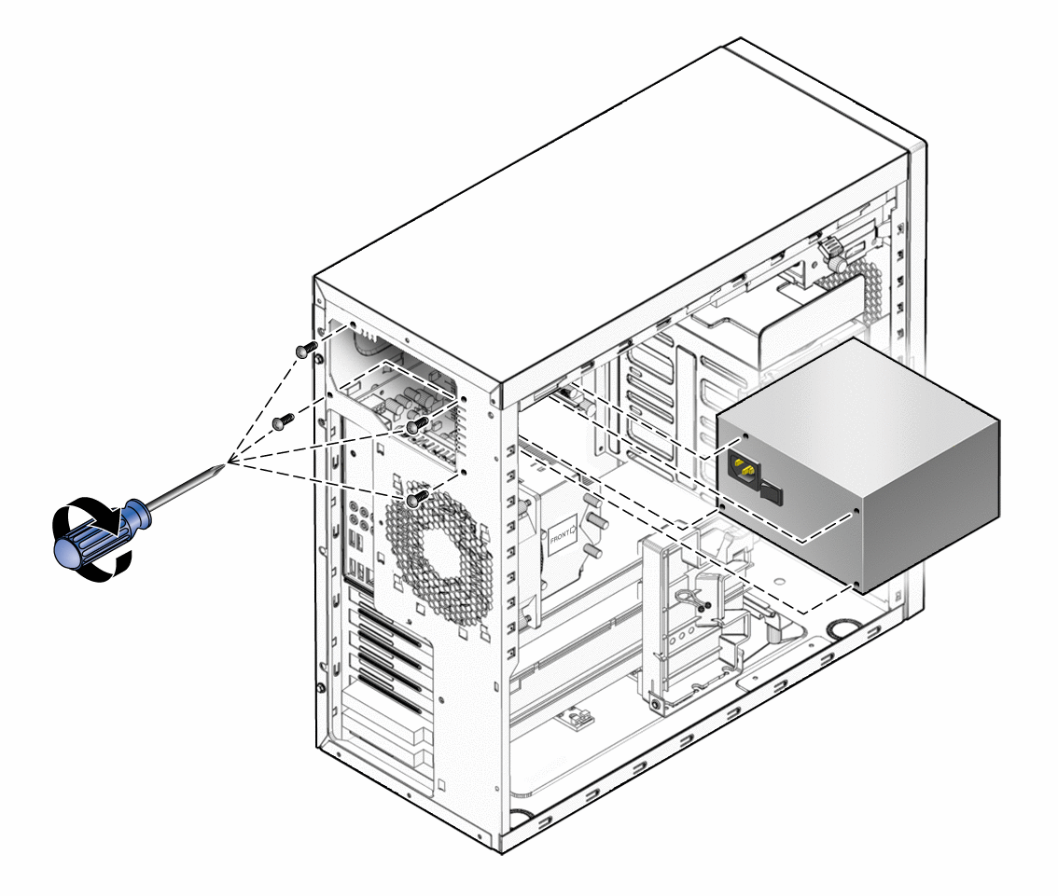

Tighten it by screwing each side of the power supply using a screwdriver.

STEP 5 - INSTALLATION OF THE MOTHERBOARD IN THE CASE

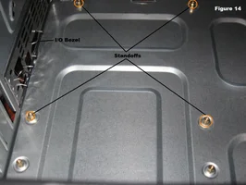
Place in the rear of the case the I/O bezel plate into the opening and instal standoffs in the case. The standoffs screw into the mounting holes of the motherboard. For correct positioning, check the screw hole positions on the motherboard.

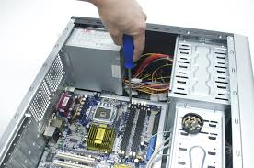

After aligning the motherboard to its place, use a screwdriver to tighten the screws.

STEP 6 - ADDING GRAPHIC CARD

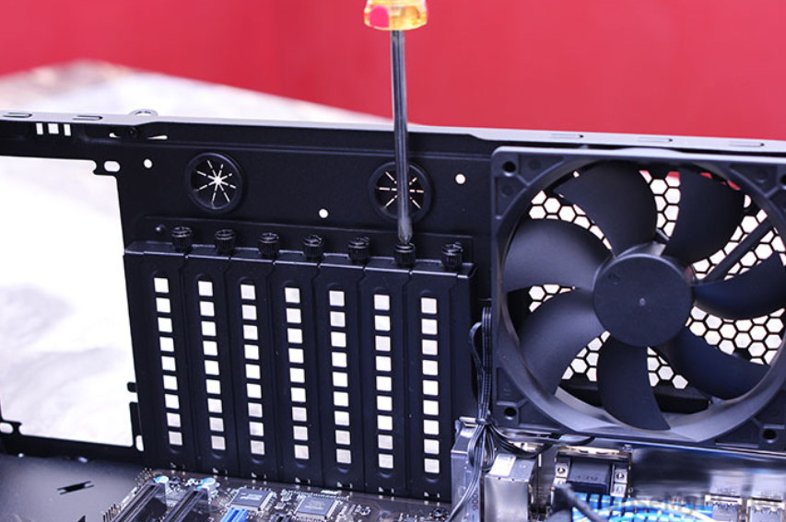
For the installation of graphics card, PCIe blanking plates need to be removed to insert the graphics card in.

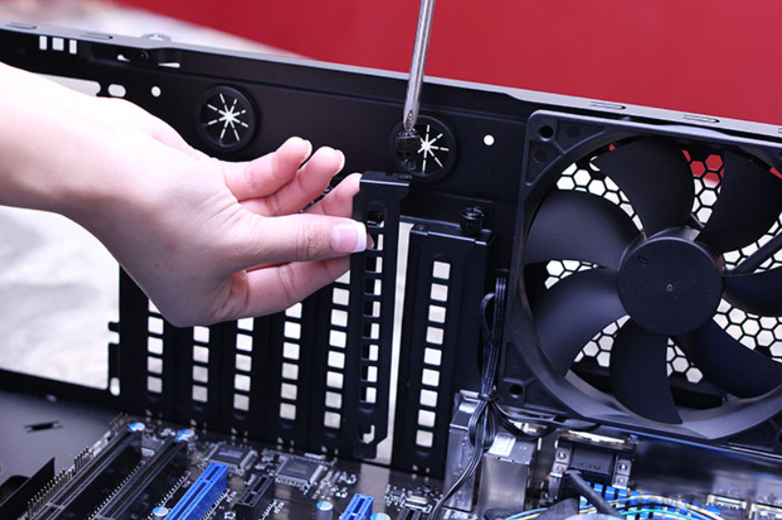
For graphics card, it is usually placed at the topmost PCIe x16 and for the second PCIe blanking plate is for the 2nd graphics card if using dual slot graphics card.

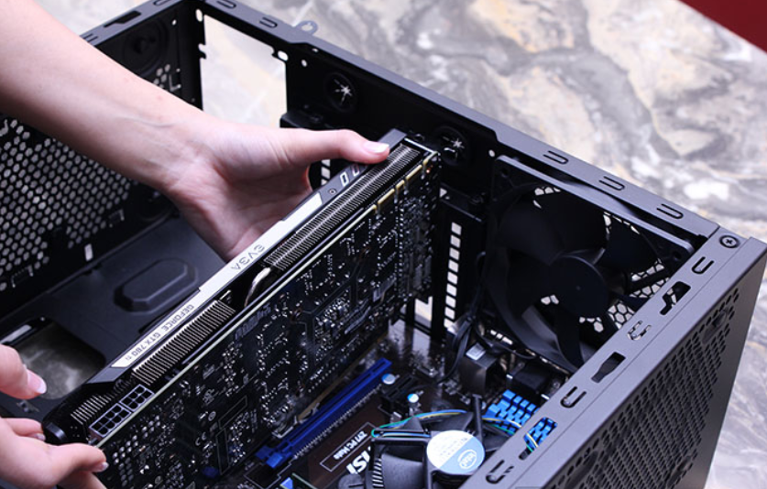

Lower the card into position and push down evenly at both ends until the clip engages.

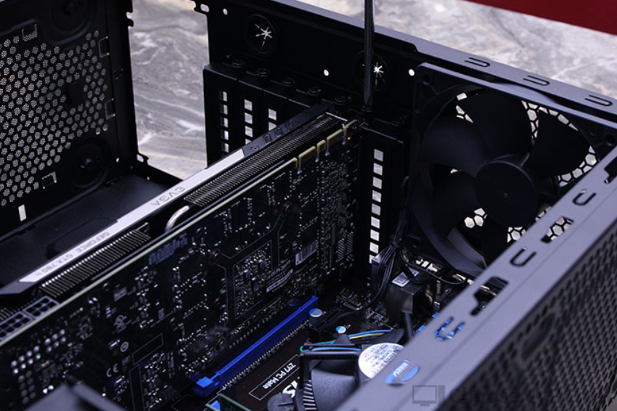
Screw the graphics card tightly with the holes originally provided from the graphics card which have the same diameter holes as blanking plates.

STEP 7 - INSTALLATION OF CD ROM

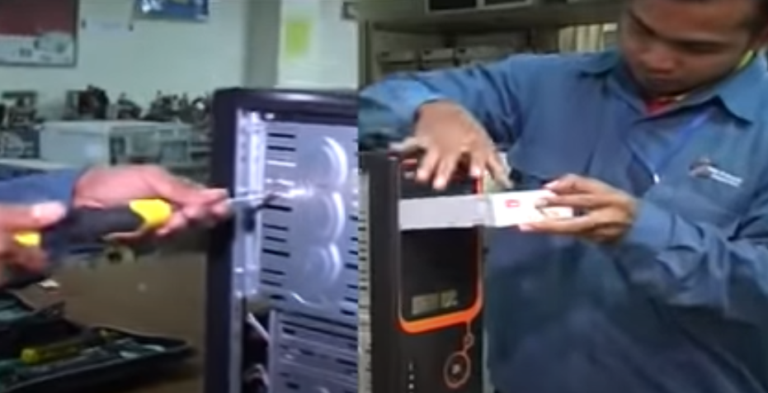
As all the CPU have the CD ROM, the CD ROM will be inserted once after the installation of the graphics card because the graphics card is placed in a deeper position compared to CD ROM. For this task, we need at least two people, one of the persons holding the CD ROM and the other one will be in charge of screwing it.

STEP 8 - HARD-DISK DRIVER INSTALLATION

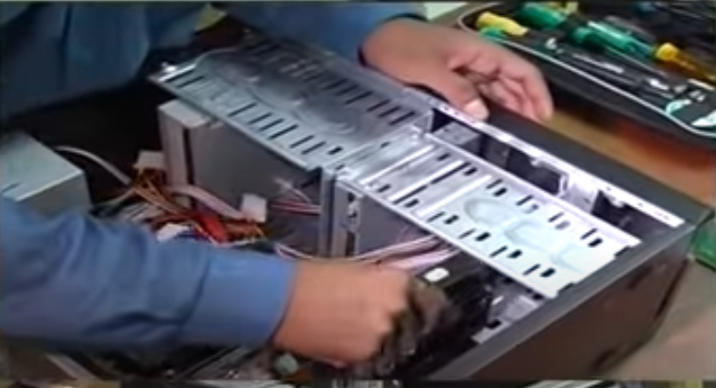
Hard- Disk is a must for every CPU. The CPU will be placed down by side so that it will be easier to place and screw the hard-disk driver inside the CPU.

STEP 9 - Installation of SATA cable/ IDE CABLE/POWER SUPPLY
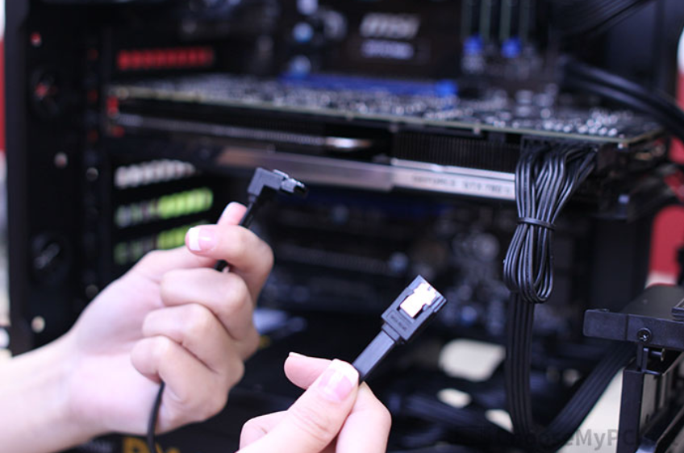
SATA cable actually have two connectors which is SATA data and SATA power and both connectors is in “L” shape

SATA power cable will be connected to the hard drive while the SATA data cable will be connected to the motherboard.

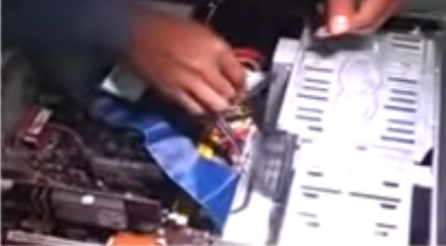
So as the IDE cables with 40 pin (may have 80 also) connectors are connected from drive to motherboard.

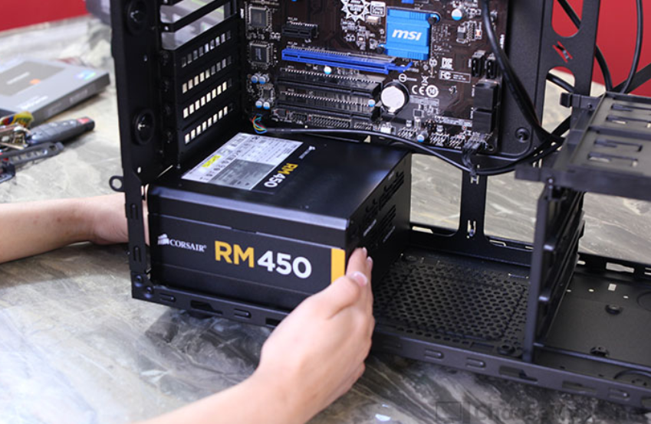
The power supply is placed under the motherboard and sits against the back of the case. After placing well, the power supply can be screwed tight.

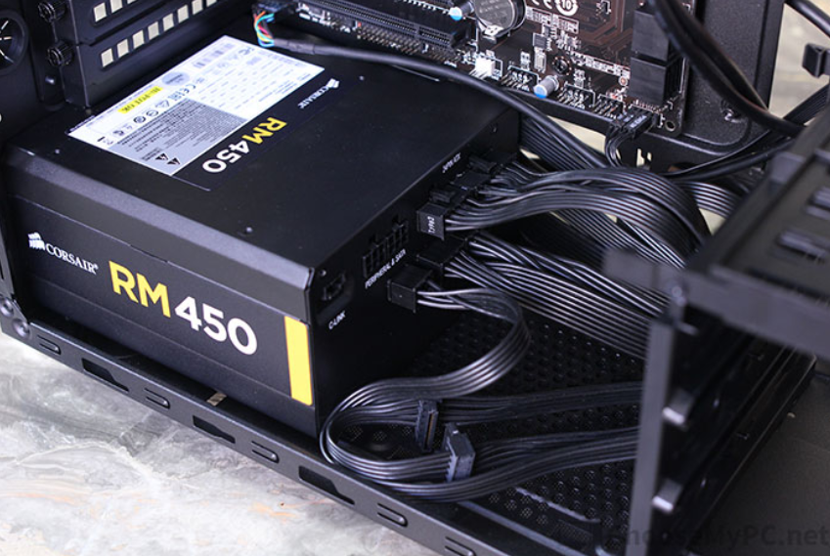
The power cabling is important for our CPU also as it connects directly to our motherboard and if we placed the cable wrongly, the motherboard might spoil 20/24 pin ATX power cable and the 4/8 pin EPS power cable will be connected to the motherboard but in a different position.

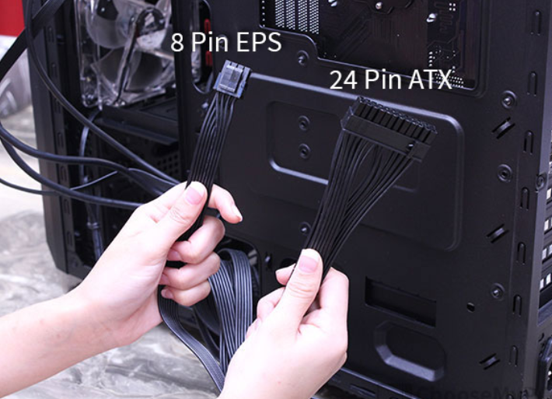
EPS power connector will be placed on top of the motherboard and the ATX is connected to the edge of the motherboard.

Last STEP - CLOSING THE CASE AND CONNECTING THE PERIPHERALS

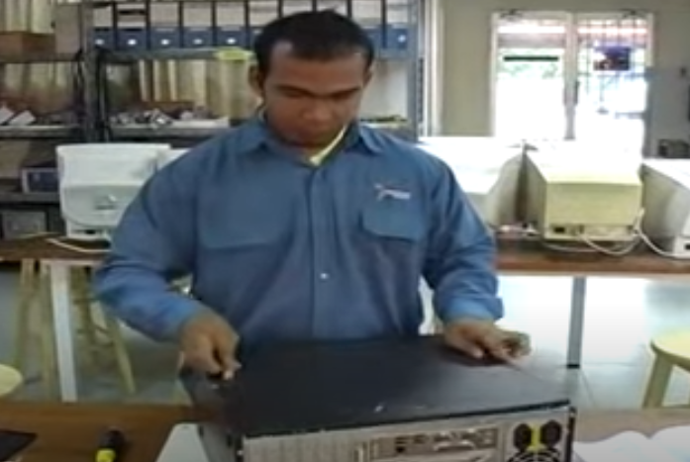
Lastly the case will be screwed to close the internal part of the CPU to prevent any further damage from the outside force and to avoid the accumulation of dust too.

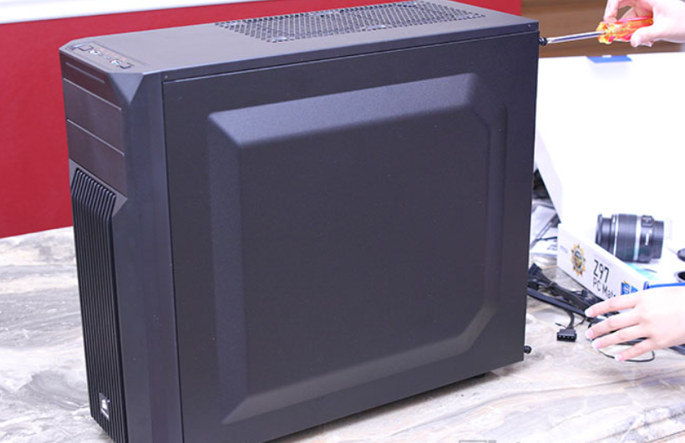
Make sure all the cables connect properly and the screw is screwed well. CPU is ready to use.

