
Semester I 2020/2021

Subject : Technology and Information Systems (SECP1513)
Section : 01/02/03/04/05/06/07/08/09/10/11
Task : Step by step Basic PC Assembly

Due : 1 December 2020, Tuesday (Report);

Submission Instruction
- submit softcopy (.docx) via e-learning & a copy in your e-portfolio
- you will do it in your group (same group with your chapter) and submit it individually
- Name your file as RptPCAsmbly_GroupNumber.doc (eg for Group 1: RptPCAsmbly_01.doc)

_____________________________________________________________________________________

Objectives:
Upon completion of this assignment, students should be able to:
- Identify and distinguish basic components of CPU
- Understand functions of the CPU basic components
- Understand the process to assemble a PC
- Demonstrate the assembly of a PC

This assignment will be 4% of the course assessment

Instruction:
In this assignment, students are required to write a group report on Basic PC Assembly. The report consists of 3 parts as follows:
PART A – Tools needed
PART B – Sketch of a mother board layout
PART C – Step by Step PC Assembly
Details of each part are described in page 4.

For part C, you MAY REFER to the following videos:
- https://www.youtube.com/watch?v=ctK58A71DTs (Asas pemasangan Sistem Komputer)
- https://www.youtube.com/watch?v=m_-G9Cacx2U (How to Make or Assemble Desktop CPU Step by Step)

For parts B and C, your report must include keywords, listed in Table 1.0 below:

Table 1.0 – Keywords for Part B and C
Graphic card | USB cable | IDE cable
CPU / Processor | Slots (IDE, PC | Power supply
heat sink | RAM | hard disk (jumper setting either master/slave)
CD ROM | SATA cable

Semester I 2020/2021

Subject : Technology and Information System (SECP1513)
Section : 09
Assignment : Step by step PC Assembly

GROUP NAME / NUMBER : 1

1 |  | Name : Azni Ain Sabrina Binti Mohamad Nazri  Matric Number : A20EC0019  Phone Number : 013-9105944  E-mail : aznisabrina@gmail.com
2 |  | Name : Low Jia Ying  Matric Number : A20EC0070  Phone Number : 016-8222913  E-mail : ljying2001@gmail.com
3 |  | Name : Abraham Loh Tze Lung  Matric Number : A20EC0001  Phone Number : 01121879700  E-mail : dannychung443@yahoo.com

FORMAT OF REPORT
PART A – List at least FOUR tools needed to assemble a PC. For each tool, Provide picture(s), explanations of its functions and its importance.

- Screwdrivers
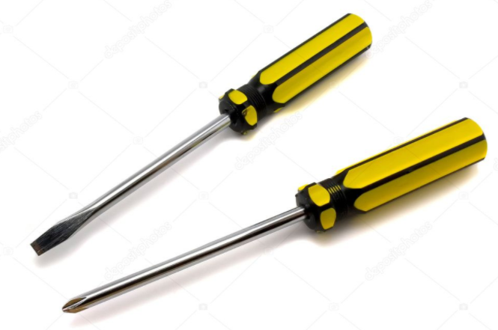

The screwdrivers is used to tighten the screws on the components to make sure the components are secure in their places. Phillips-head size number #2 would be ideal.

- Anti-static wrist strap
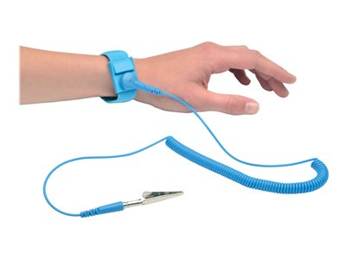

The anti-static wrist strap is a device that you wear on your wrist, which is connect to an electric socket. It is used to avoid spark and electrostatic discharge by dispel the electrical charge through to the socket.

- Cable ties
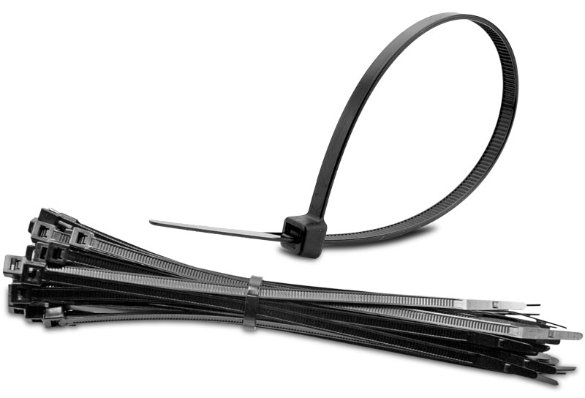

The cable ties are used to tie up any loose cables and keep the cables in place neatly. It is important for better airflow within the case and keep dust accumulation low.

- Flashlight
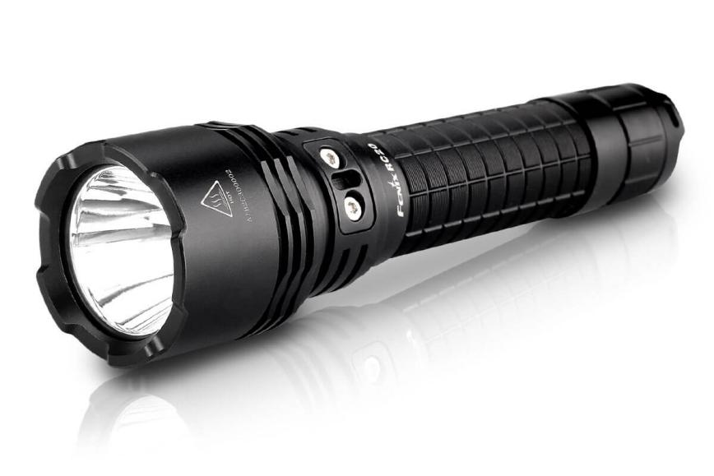

The flashlight will help you to see better when you are assembling the PC because the PC cases are full of shadows or if the screws accidentally roll into the darkest corner.

- Needle-nose pliers



The needle-nose pliers are very handy in assembling a PC. You can use it for removing and inserting jumpers on the motherboard, removing broken screws, and cutting cable ties. It is important to remove the screws if you dropped them inside your build because it may cause an electrical shortage.

- Extra screws
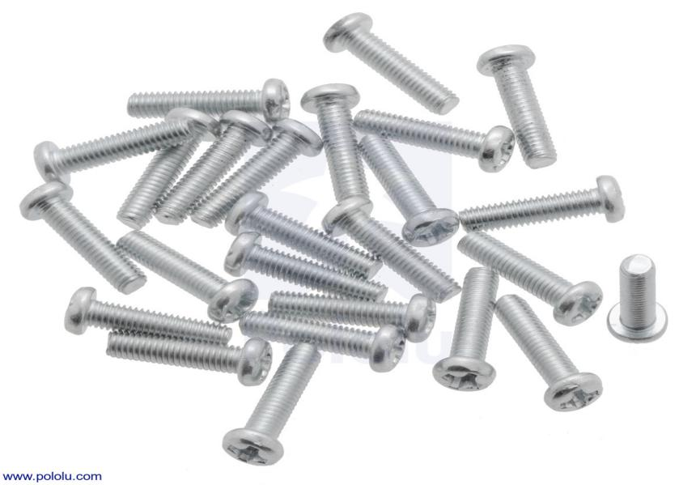

The screws are used to secure any internal drives such as HDDs, SSDs, and optical drives. It is also used to attach fans to the case and keep side panels in place.

PART B – Sketch of a mother board layout
- Sketch manually (using handwriting) a simple diagram of a motherboard layout that consists ALL keywords included in Table 1.0. Label each of the keyword. Diagram 1.0 and 2.0 below are examples of the sketches. Do not copy any of these diagram. Produce your own sketch diagram. Only one sketch diagram of a motherboard layout is required for this assignment.

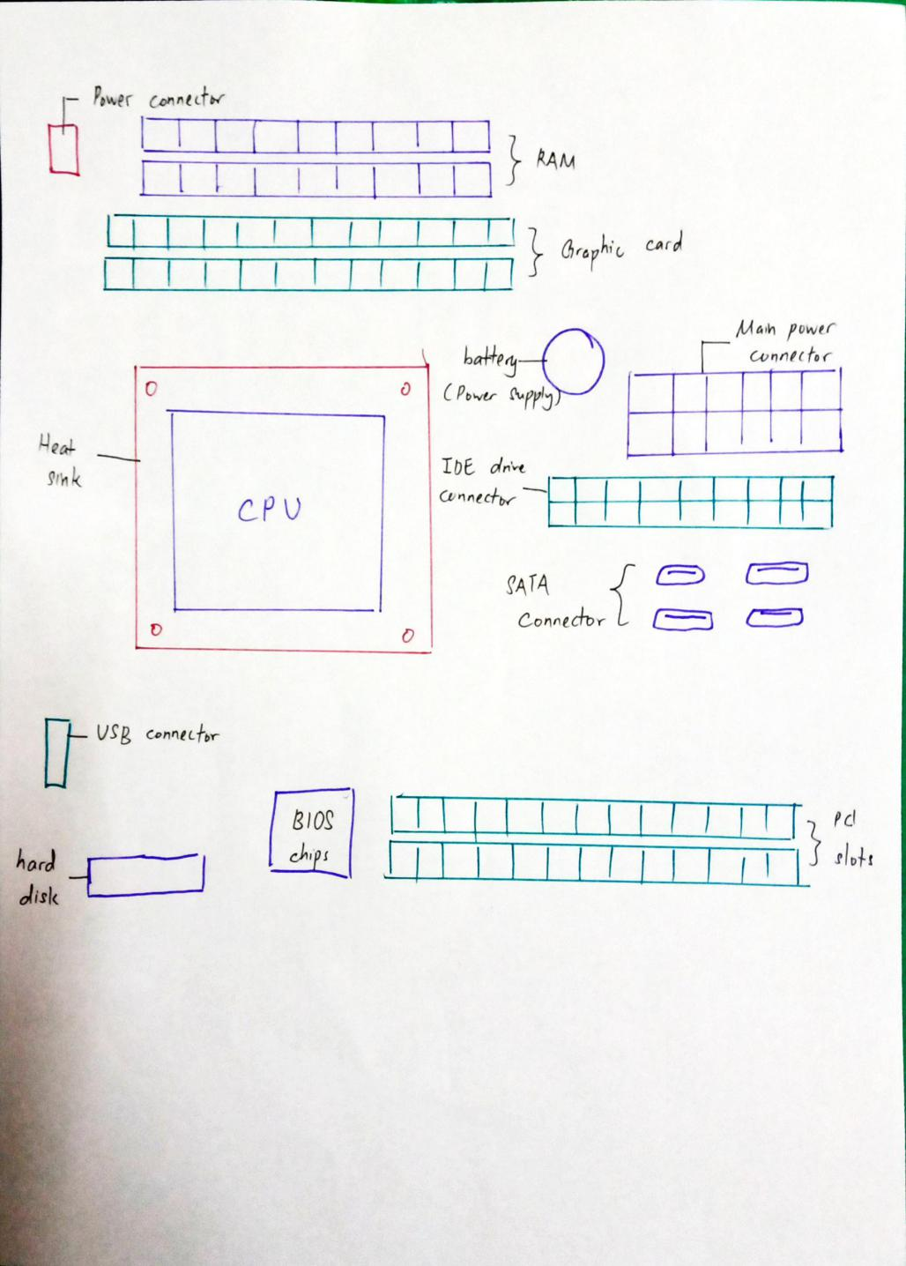

2.0 For each keyword in Table 1.0. Provide picture(s), explanations of its functions and
example of models.

2.1 Graphic card
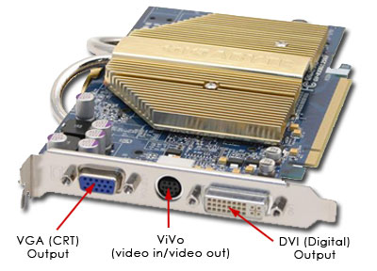
Function:
- An expansion card convert data to useful images on monitor.
- Can be used for AI training.
Example of models:
- Integrated graphic card
- PCI graphic card
- AGP graphic card
- PCI-E graphic card

2.2 USB cable
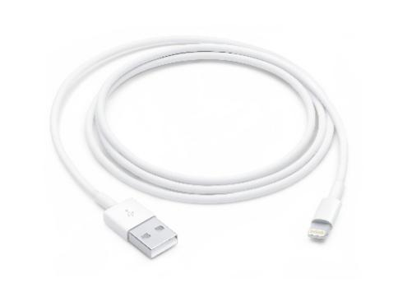
Function:
- Attach computers to peripheral devices such as cameras, camcorders, printers, scanners, and more to peripheral devices.
- Used to charge device such as smartphones, tablets, cameras or laptops.
Example:
- USB Type A
- USB Type B
- Mini-USB
- Micro-USB
- USB-C

2.3 IDE cable (Integrated Drive Electronics /ATA /PATA)
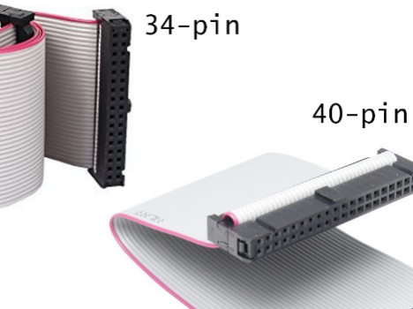
Function:
- Connection for storage devices in computer.
- Used for connecting hard drives and optical drives to the motherboard and to each other.
Example of models:
- 34-pin cable used for floppy drives
- 40-pin hard-disk and optical drive cable

2.4 CPU(Central Processing Unit) /Processor
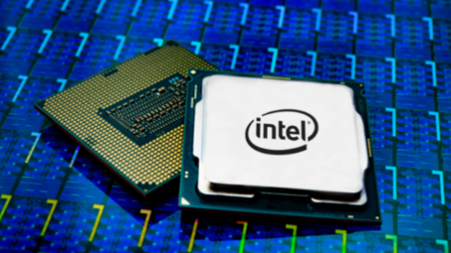
Function:
- Executes instructions that make up a program for the machine.
- Executes the basic operation of arithmetic, logic, control and input/output operations defined by the program instructions.
Example:
- Single-core CPU
- Dual-core CPU
- Quad-core CPU
- Hexa Core processor

2.5 slots PCI
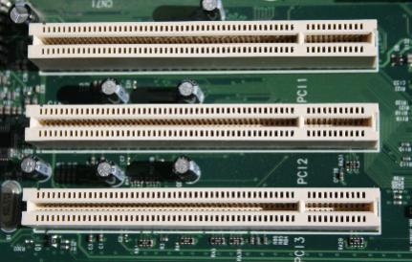
Function:
- High speed serial computer expansion bus
- Allows for the attachment of various hardware components such as network cards, modem, sound cards, disk controller.
Example of models:
- PCI Express
- PCI Express X16
- AGP
2.6 Power supply
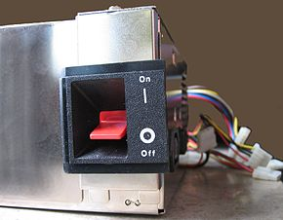
Function:
- Change alternating current from a wall socket of main electricity to low-voltage direct current to operate the processor and peripheral devices
- Provides power signal to the motherboard to indicate when the DC voltages are in spec so that the computer is able to safety power up and boot.
Example of models;
- AT Power Supply Connectors
- ATX Main Power Supply
- ATX Auxiliary Power Connector
- ATX 12V Connector

2.7 Heat sink
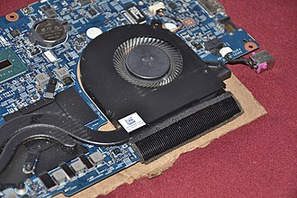
Function:
- Increase the heat flow away from a hot device
Example of model:
- Active Heat Sink
- Passive Heat Sink
- Aluminium Heat Sink
- Copper Heat Sink

2.8 RAM( Random Access Memory )
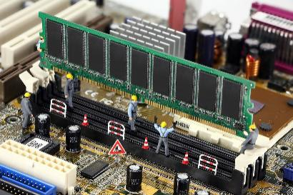
Function:
- Provide short term storage space for data and program code that a computer processor is in the act of using or which it expects to use imminently.
- Provide fast temporary storage and workspace for data and program code.
- Used as a virtual hard disk drive (RAM disk)
Example of model:
- DRAM(Dynamic RAM)
- SPAM(Static RAM)

2.9 hard disk (Hard drive /Fixed disk /HDD)
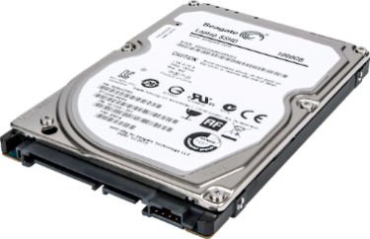
Function:
- A kind of non-volatile storage, except when turned off, preserving stored data.
- An electro-mechanical data storage system which uses magnetic storage to store and retrieve digital data and one or more rigid magnetic material-coated, rapidly rotating plates.
Example of model:
- HDD (Hard disk drives)
- SSD (Solid state drives)

2.10 CD ROM
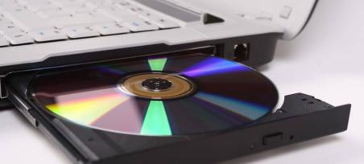
Function:
- Open records such as music files, photographs,word documents on data CDs
- Used as installation discs.
Example:
- CDs
- DVDs
- Blu-ray discs

2.11 SATA cable
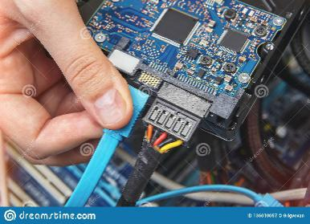
Function:
- Connect an internal hard drive to a computer motherboard.
- Transfer data quickly
Example:
- E-Sata
- Low Profile SATA
- Micro SATA
- SATA Power
- SATA-SATA

PART C - “Step by Step PC Assembly”
STEP 1 – Install CPU processor
First, take out the two hardware CPU and motherboard, as shown in the following figure:
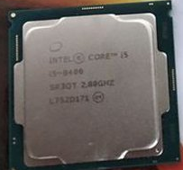 CPU
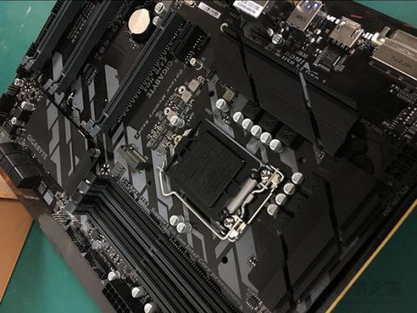 Motherboard
Press down the lever of the motherboard socket firmly and open the cover of the CPU socket, as shown in the figure below:
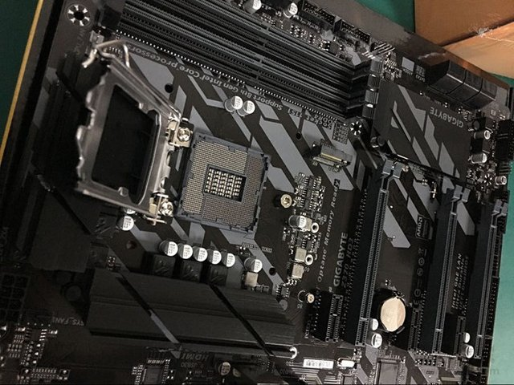
Put the CPU in the CPU socket of the motherboard. Note that there is a gap between the CPU and the motherboard CPU socket. The CPU cannot be put in if it is installed reversely, as shown in the following figure:
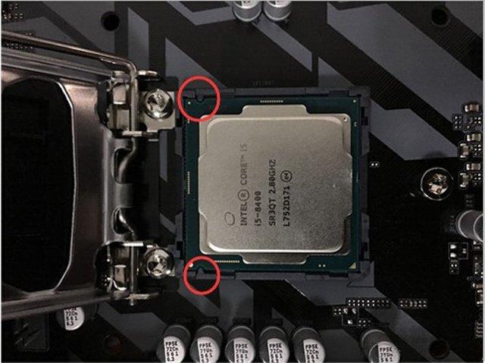
Press the pull rod to restore the pull rod to its previous position to complete the installation of the CPU (installation home), and then the black cover on the top will also be removed, as shown in the following figure:
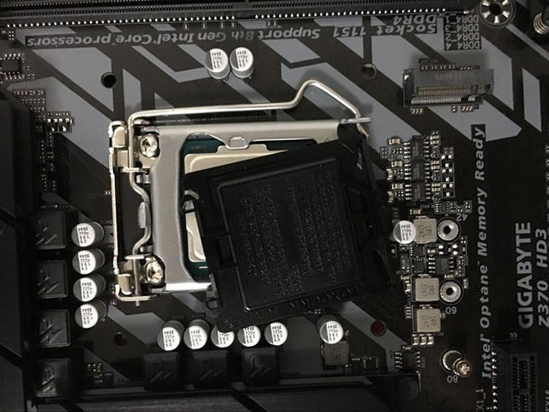
As shown in the figure below, the CPU has been installed, the black cover is useless and can be thrown away, mainly to prevent the pins of the CPU socket from being touched before it is installed.
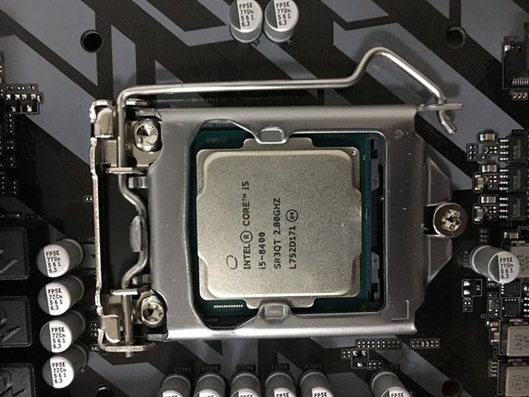
As shown in the figure above, the installation of the CPU and motherboard is completed.

Precautions:
The CPU pins are very fragile. A slight collision may cause the pins to bend and cause abnormal computer functionality.
STEP 2 – Install memory (RAM)
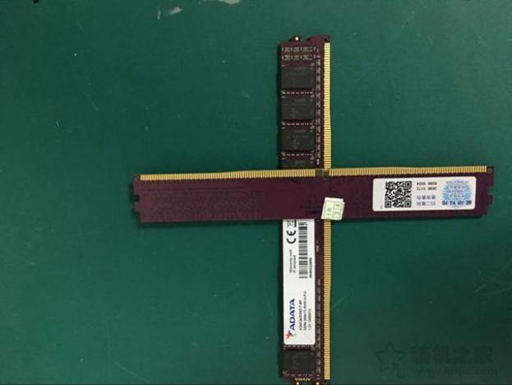 RAM (Random access memory)
Locate the memory slot on the motherboard, and open the buckles on both sides outward. (Some motherboard memory slots may only have one side buckle that can be opened, which does not affect the installation) as shown in the figure below:
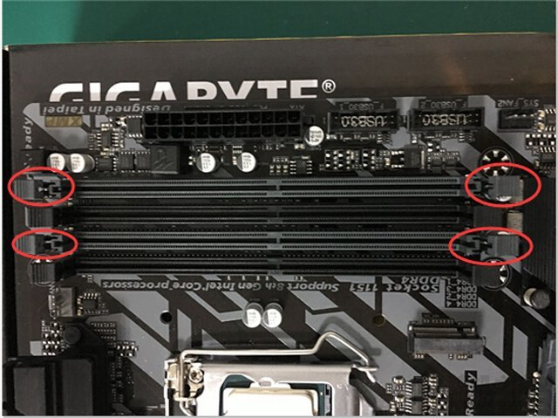
Insert the memory into the motherboard, and the foolproof gap of the main memory corresponds to the foolproof part of the motherboard, as shown in the figure below:
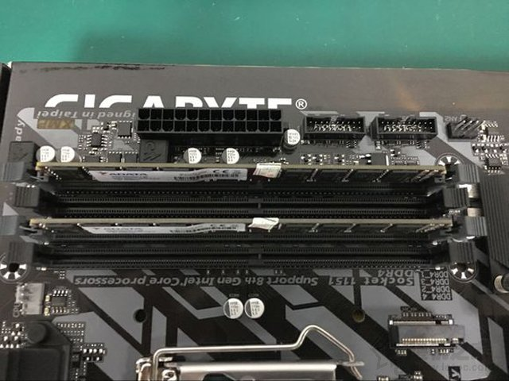
Press down the memory firmly, insert the memory fully into the motherboard memory slot, (installation home) observe that the golden finger part of the memory is fully inserted and the buckles on both sides can be reset, as shown in the figure below.
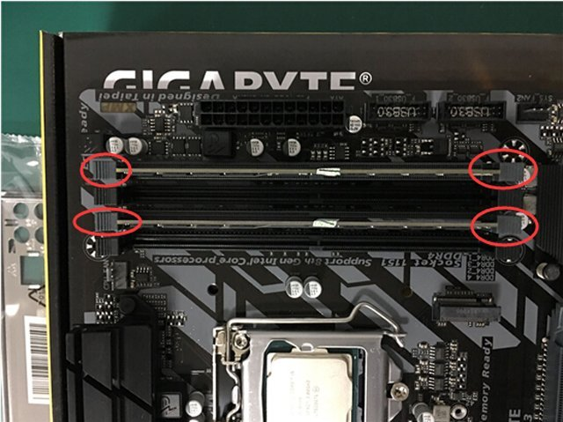
As shown in the figure above, the installation of memory and motherboard is completed.
Precaution:
If there are two memories, if you set up a dual channel of memory, for example, there are four memory slots on the motherboard, such as 1, 2, 3, 4 slots, we can set up a dual channel by inserting in a way, insert 1, 3 Or 2,4 slots.
Tips:
The recommended memory module installation location for each motherboard may not be the same. Take the MSI motherboard as an example, it is recommended to use the first set of slots first.
STEP 3 – Install CPU heat sink
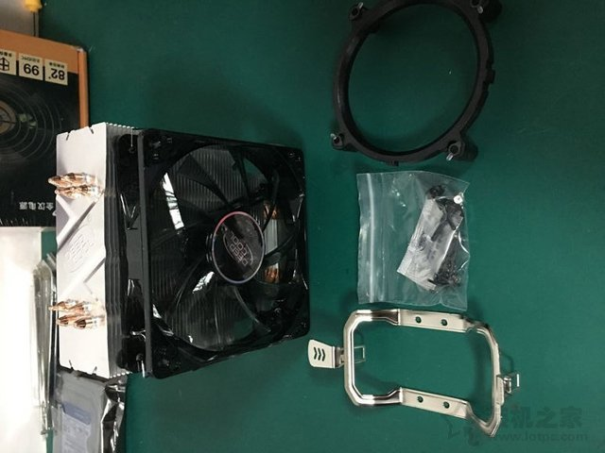 CPU heatsink and some components
Insert the round base of the CPU heat sink into the holes around the motherboard, as shown in the figure below:
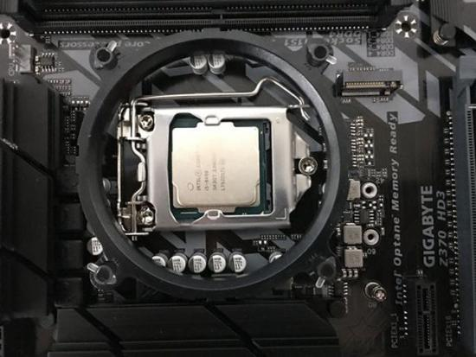
Find the four black plastic nail components, as shown in the figure below:
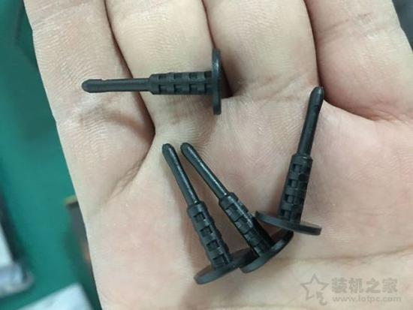
The four black plastic nails are inserted separately for fixation. Note that they need to be inserted completely, as shown in the figure below.
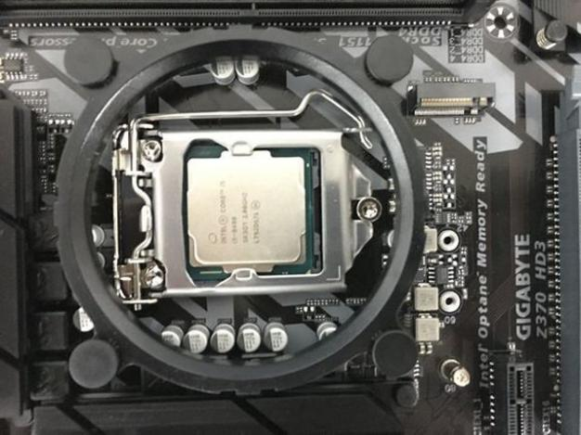
Remove the sticker on the bottom of the CPU cooler, as shown in the figure below.
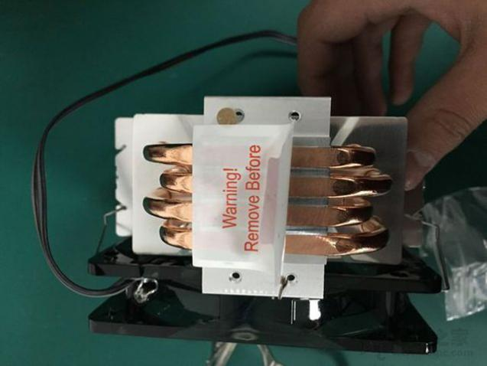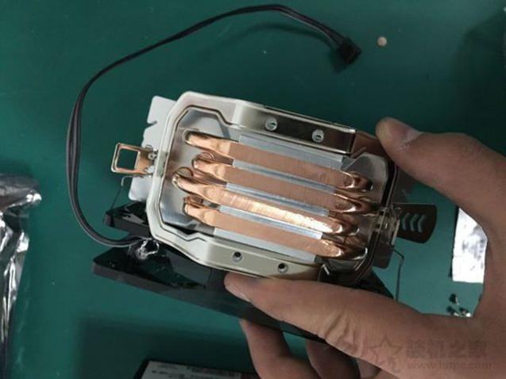
Find the four small screws of the radiator , as shown in the figure below:
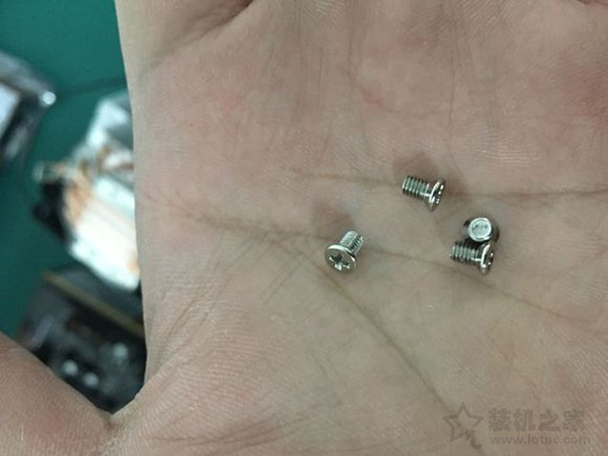
Place the fixing frame on the bottom of the radiator, and use a small cross screwdriver to install the fixing frame, as shown in the figure below:
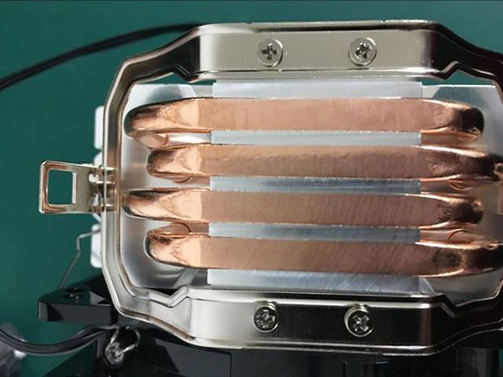

Find the thermal grease, as shown below:
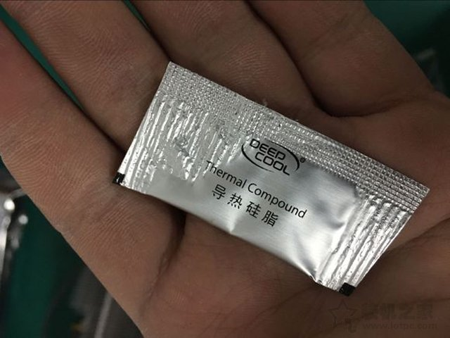
Tear off the thermal grease and apply an appropriate amount to the center of the CPU. The main thing to note is that the thermal grease should not be too much.
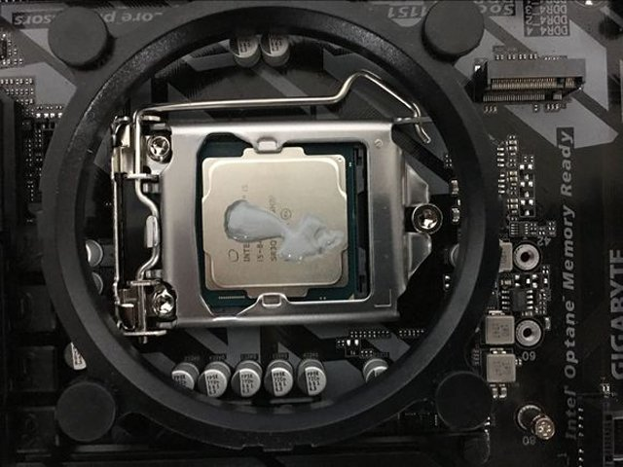
Finally, we plug the power supply interface on the CPU heat sink (installation home) into the corresponding power supply socket of the motherboard. Generally, CPU_FAN will be marked on the motherboard, as shown in the figure below.
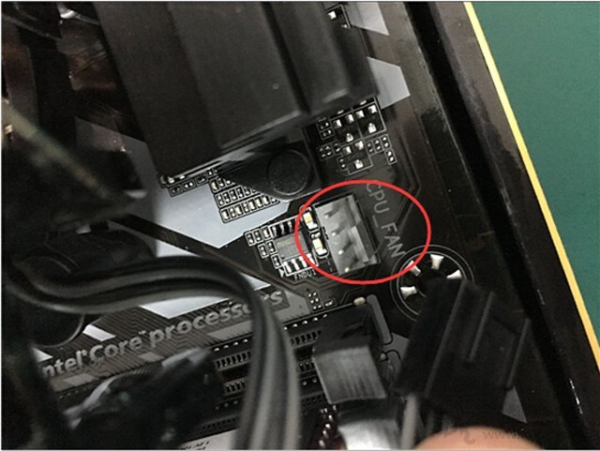 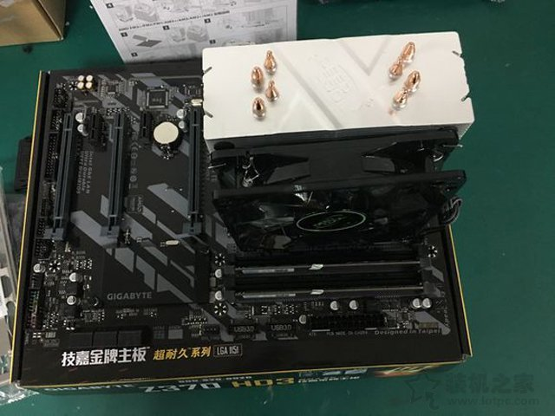 Complete installation of CPU heatsink
Precautions:
Do not over-saturate the thermal grease, too thick or too thin is inappropriate.
When installing the CPU cooler, please make sure that the screws of the cooler are tightened, and try to keep the lock point pressure even, to avoid CPU damage or uneven heat dissipation.
STEP 4 – Install mechanical hard drive
Take out the mechanical hard disk, note that the installation method of the solid state hard disk is similar, and the cable connection method is also the same. If it is an M.2 solid-state hard drive, the method is simpler, no connection cable is needed, and it is directly inserted into the M.2 interface of the motherboard and screwed on.
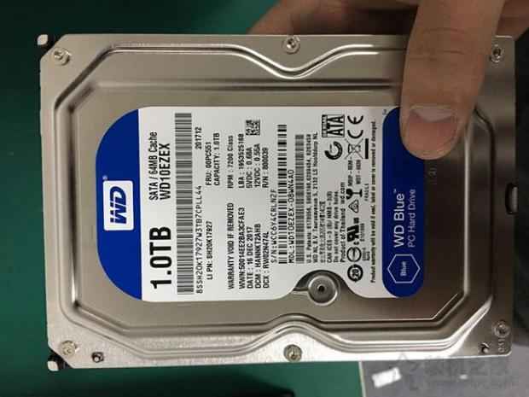 Mechanical Hard Drive
First remove the two side panels of the case, find the position of the mechanical hard disk on the case, which may be different from your case design, just find the hard disk installation position in your case, as shown in the figure below.
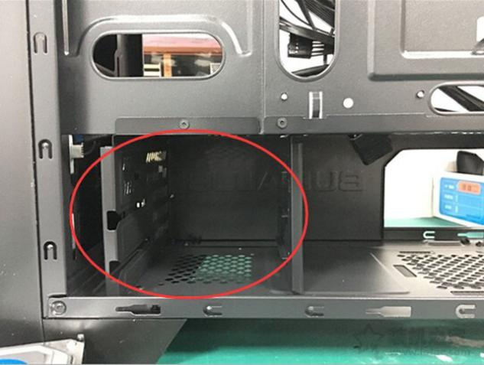
The hard drive screws of different chassis are also different. Here we use thumb screws, as shown in the following figure:
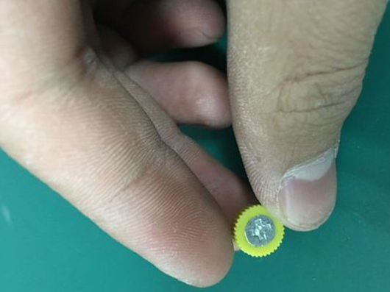
Insert the mechanical hard disk into the hard disk bay of the chassis, and fix the two sides of the mechanical hard disk with thumb screws, as shown in the figure below.
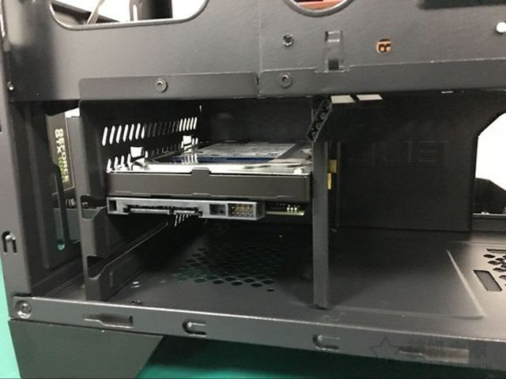
As shown in the figure above, the mechanical hard disk has been installed, waiting to connect the SATA transmission line and SATA power supply line.
STEP 5 – Install power supply
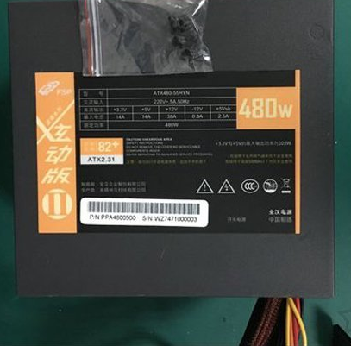 Power supply
Locate the power supply compartment of the chassis, where the chassis is a bottom-mounted power supply design (home of installation), as shown in the figure below.
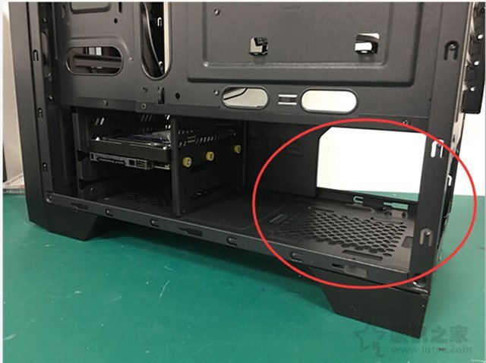
Find the special screw for the power supply, which is the largest one, as shown in the figure below:
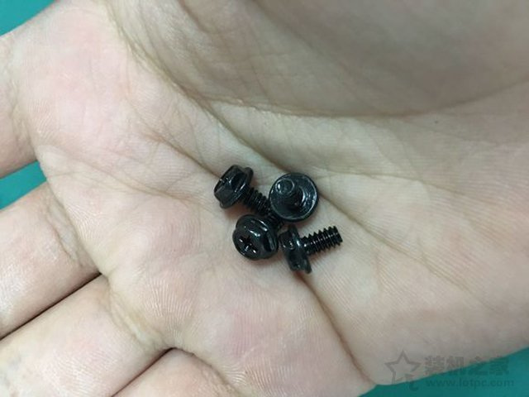
For a chassis with a lower power supply, we put the power supply fan side down and put it in the power supply compartment, then fix it with four large screws, as shown in the following figure:
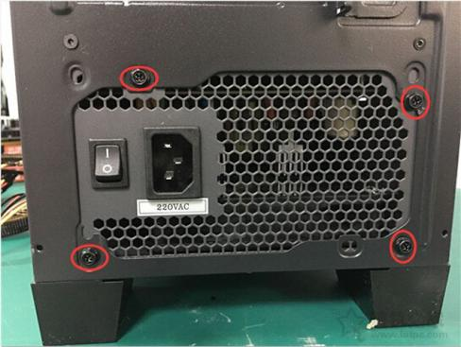
As shown in the figure , the power supply has been successfully installed.
STEP 6 – Install motherboard
First we find the bezel of the motherboard, as shown below:
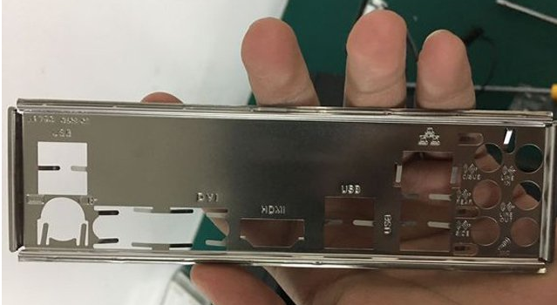
Find the installation position of the motherboard baffle on the chassis, as shown in the following figure:
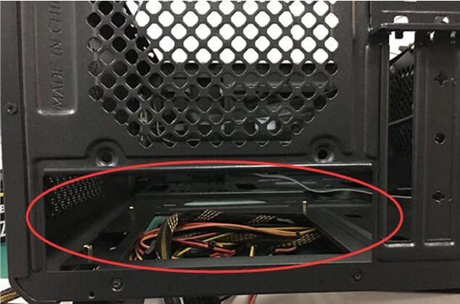
Install the baffle of the main board to the installation position of the baffle, pay attention to the direction of the baffle, and need to correspond to the interface of the main board, as shown in the figure below.
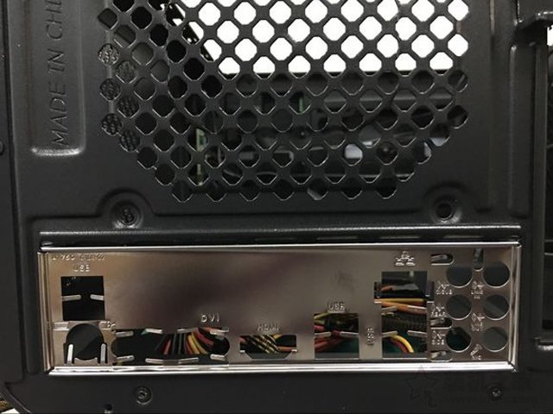
To install the copper studs, it needs to be consistent with the mounting holes of the motherboard, as shown in the figure below:
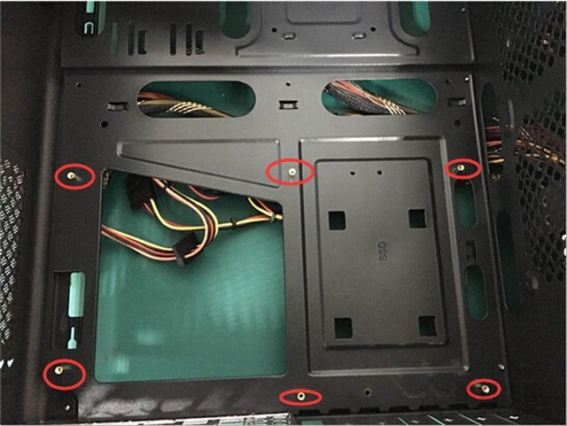
Put the installed CPU, memory, and radiator motherboard into the chassis, corresponding to the position of the copper studs, as shown in the figure below:
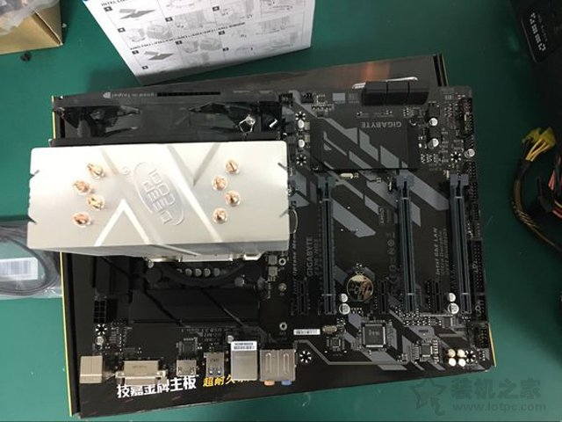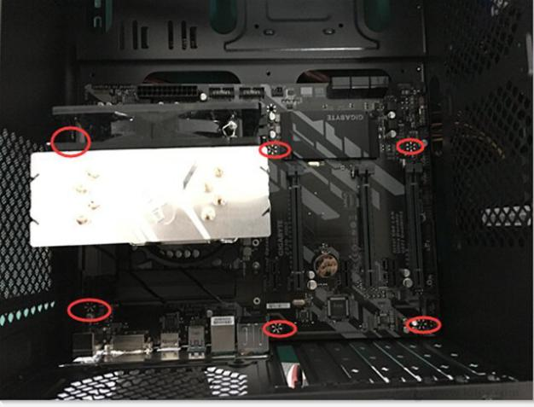
Find the corresponding motherboard screws, as shown in the figure below:
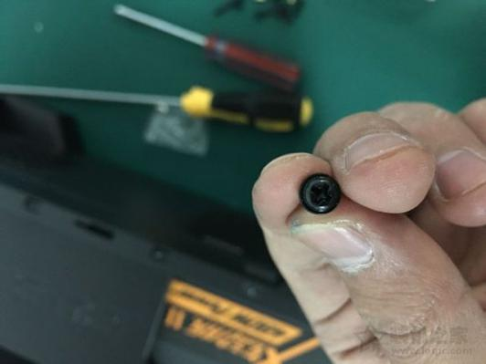
Fix the motherboard on the chassis, as shown in the figure below:
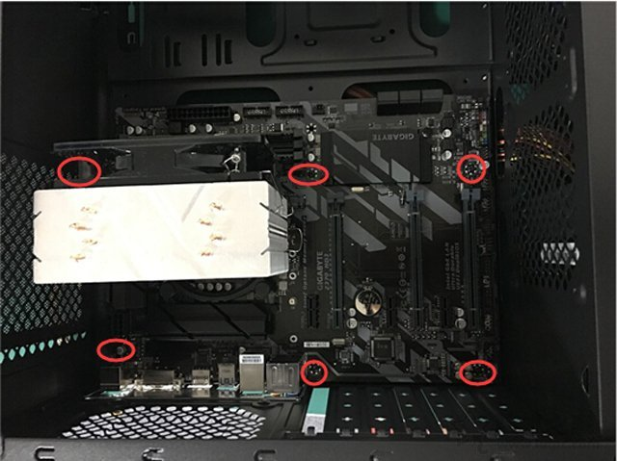
As shown in the figure above, the motherboard has been installed.
STEP 7 – Install SSD(Solid State Driver)
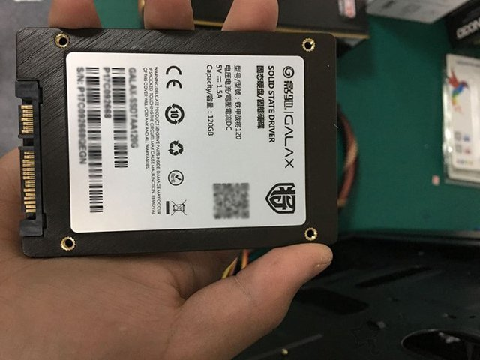 An SSD
Find the holes on the chassis for installing the solid state drive, as shown in the figure below:
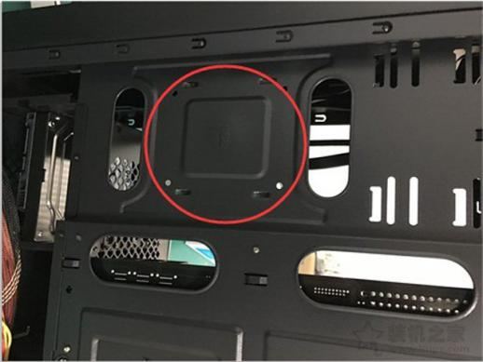
Align the holes on the back of the solid state drive with the four holes on the chassis, and tighten the screws, as shown in the figure below:
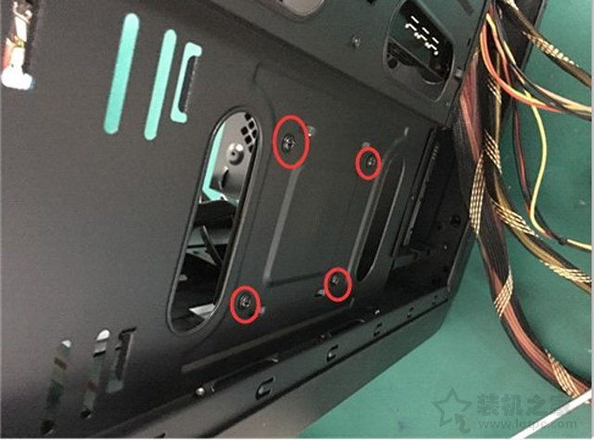
The solid-state drive is installed, as shown in the figure below:
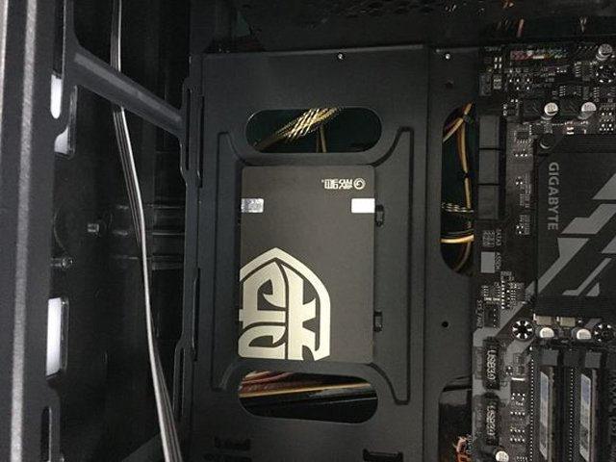
STEP 8 – Install optical drive
Choose the optical drive data cable, generally a serial SATA data cable.
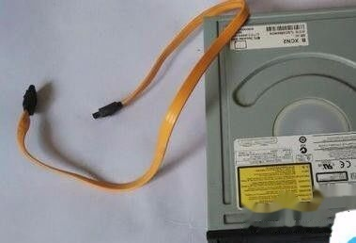

There are two ports on the back of the optical drive. The longer one is the optical drive power cord interface, which is connected to the computer power supply (SATA power supply line) to supply power to the optical drive. The other is the optical drive SATA data line interface. Attention should be paid to the installation of the connection line, and it cannot be forced to prevent damage to its internal interface due to reverse installation. In fact, if the direction of the data cable is wrong, it cannot be plugged in.
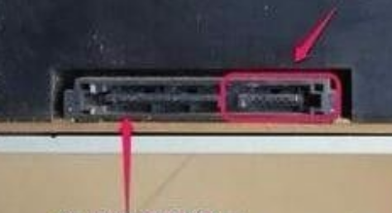
You can see the SATA interface in the motherboard in the figure below. Both interfaces are possible. One is connected to the hard disk and the other is connected to the optical drive. In most cases, SATA1 is connected to hard disk and SATA2 is connected to optical drive.
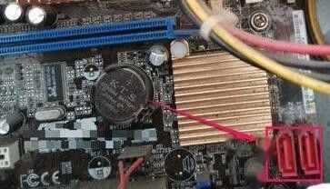
One end of the SATA data cable is inserted into the SATA interface of the motherboard, and the other end is inserted into the SATA interface of the optical drive.

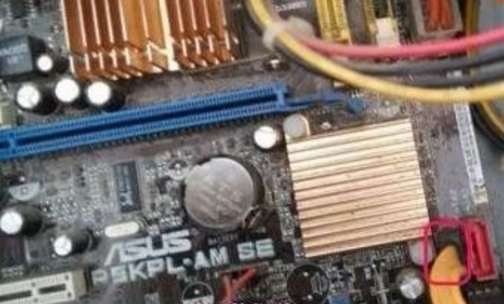
Find the sata power supply interface as shown in the computer power supply. This flat interface is the interface for connecting the optical drive. Just connect the power cord and the optical drive together.
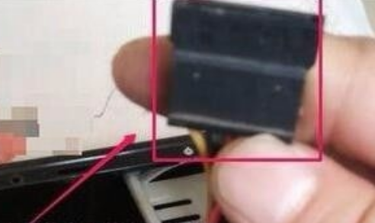
After the connection is complete, you need to remove the plastic baffle on the upper front of the computer case and insert the optical drive into the computer.
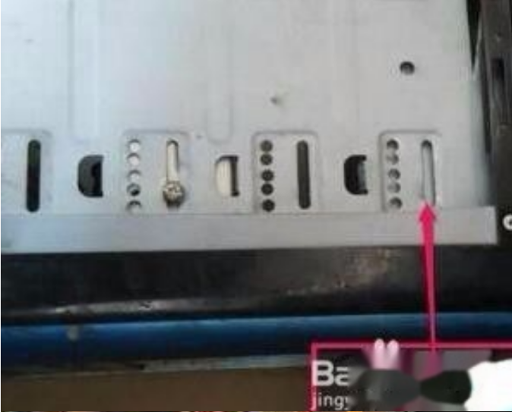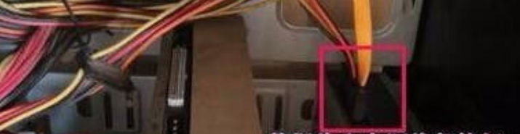

Tips:
- The optical drive is larger than the hard disk. It is marked with CD/DVD-ROM on the front, and there is a door switch in the lower right corner. The tray can be opened by pressing it. The recorder's logo is RW (ReWritable).
- The optical drive is generally installed on the top of the case. The power cable is the same as the IDE hard disk, and the data cable is also the same. The jumper cap at the back is usually on the slave disk .
- The installation of the optical drive is inserted from the front of the chassis, and the screws are fixed on both sides. When removing, remove the screws, unplug the power data cable, or take it out from the front.
STEP 9 – Connecting jumper settings/connection
It is recommended that the chassis use the back line, and the jumper wires of the chassis and the power supply line of the power supply are routed from the back of the chassis to keep the interior of the chassis clean and better for heat dissipation. First find the 24Pin power supply line of the power supply, and insert it into the 24Pin power supply interface of the motherboard. There is a foolproof interface on the interface.
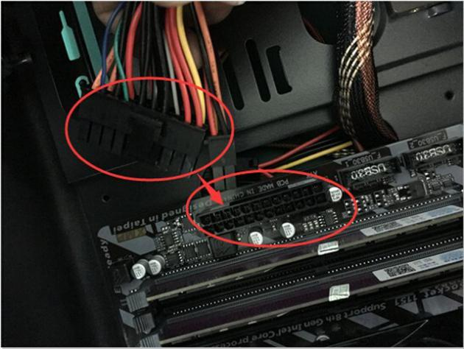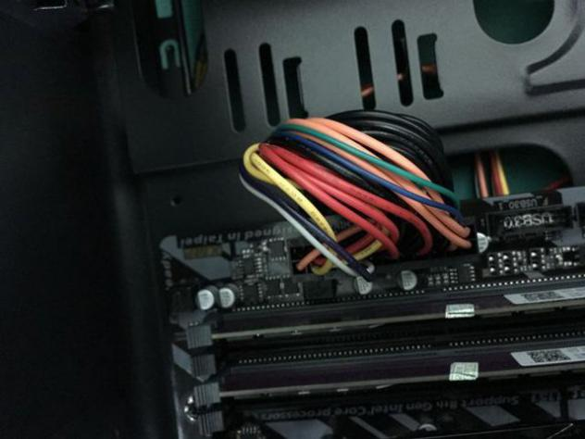
Find the CPU power supply line and insert it into the CPU power supply interface at the upper right corner of the motherboard. Generally, the CPU power supply line will be marked with "CPU". Don't confuse it with the graphics card interface, as shown below
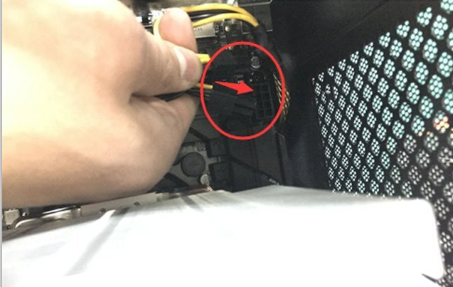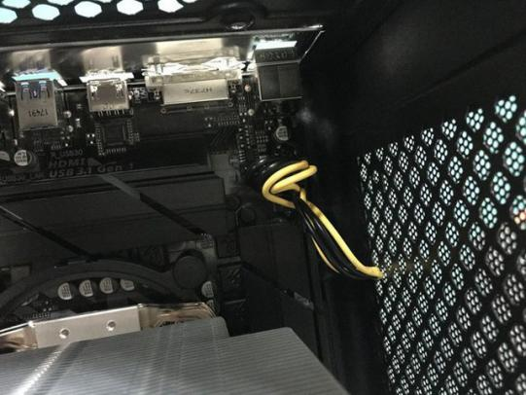
If the chassis supports the USB3.0 interface, the chassis jumper will have a USB.3.0 connection line. We find the corresponding USB3.0 interface on the motherboard. Generally, the motherboard will be marked with USB3.0, as shown in the figure below.
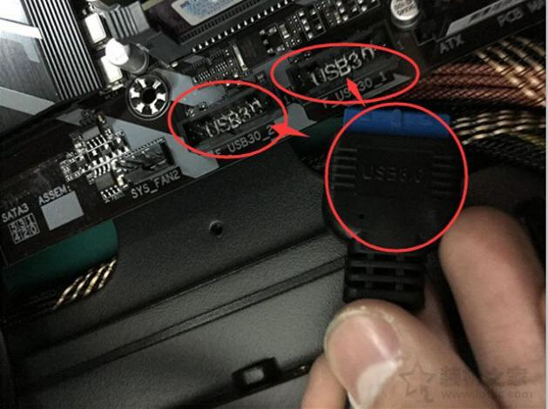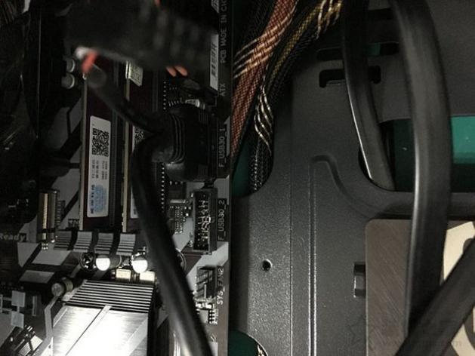
Then find the AUDID audio interface on the chassis, the motherboard and the connection line will have the AUDID mark, (installation home) directly plug in, it will not be plugged in reverse, so do not hard plug it, as shown in the following figure:
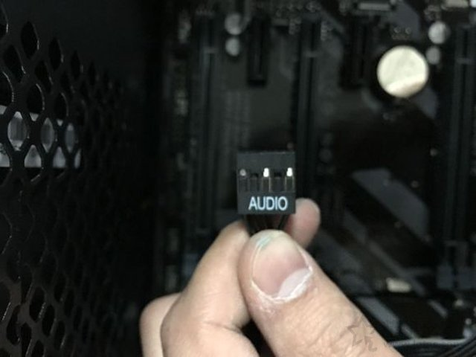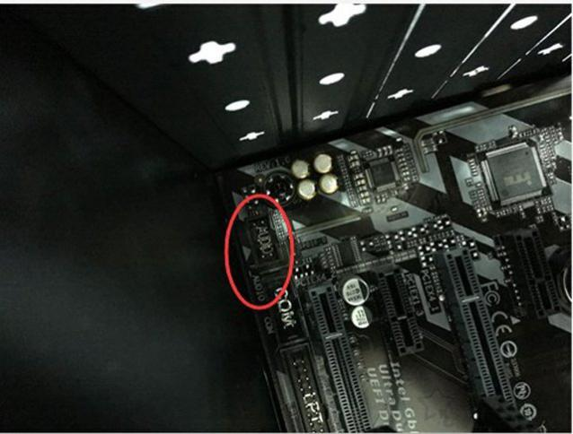
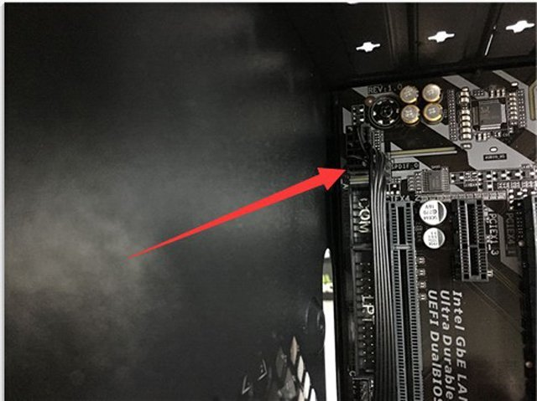
Then find the USB connection line of the chassis jumper, the motherboard and connection line are also marked with USB, and connect to the position of USB_1 first, as shown in the following figure:
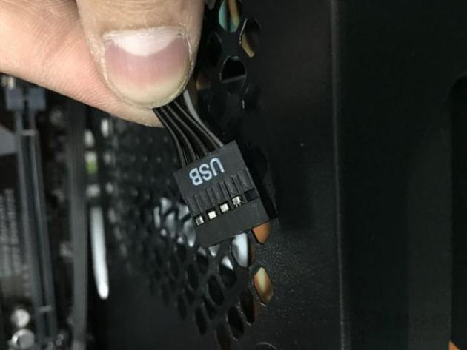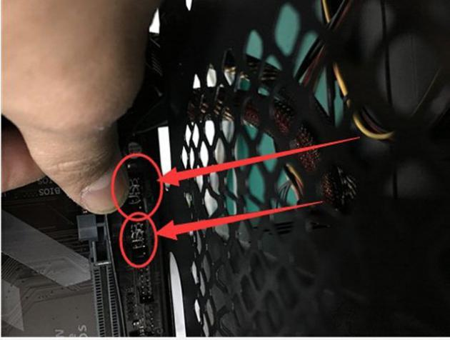
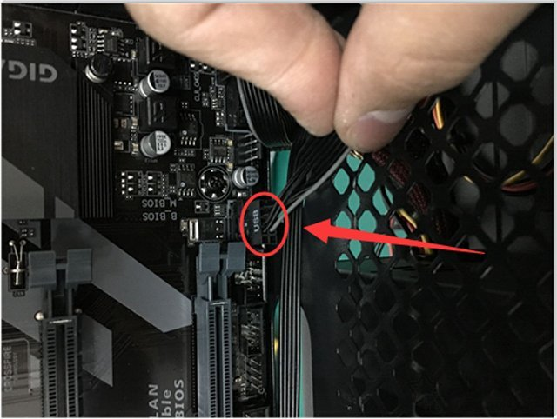
The following are the separate chassis jumpers of H.D.DLED, PPower LED, Power SW, and RESET SW. For many installed users, this step is difficult. In fact, it is not difficult. Let's first understand these chassis jumpers.
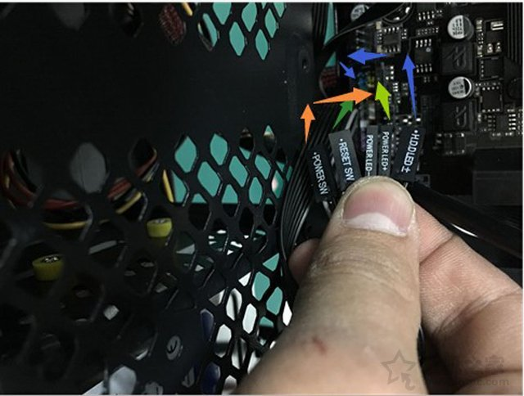
H.D.DLED hard disk indicator, Power LED power indicator, Power SW boot interface, RESET SW restart interface
The motherboard will have the same label as the connection line. The colored line is the positive pole, the white line is the negative pole, and the negative pole is generally on the right. As shown in the figure below, follow the jumper mark on the motherboard and insert it accordingly.
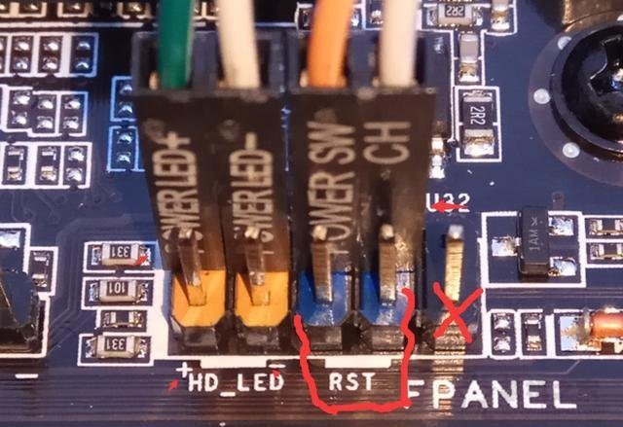

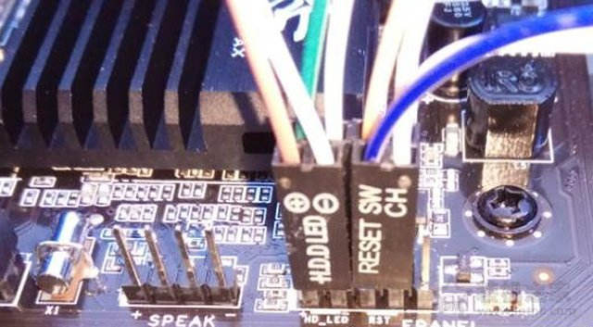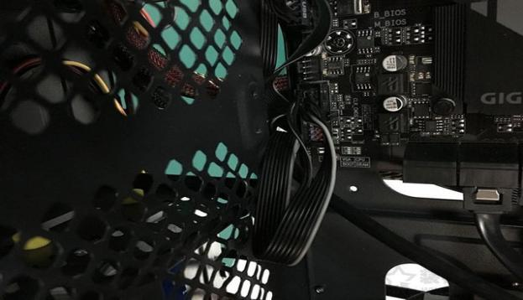
Jumper connection diagram
Note: Due to the different models of each motherboard, the connection method of the jumper will be different. Just connect it according to the label of the motherboard. Pay attention to the positive and negative poles.
Next, let’s connect cables for the mechanical hard disk. The SATA interface mechanical hard disk or solid-state hard disk generally has two wires, one is the SATA data cable, and the other is the SATA power cable. First, we find the SATA power cable on the power supply to connect, as follows As shown in the figure.
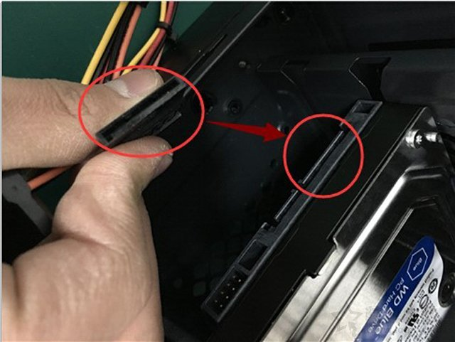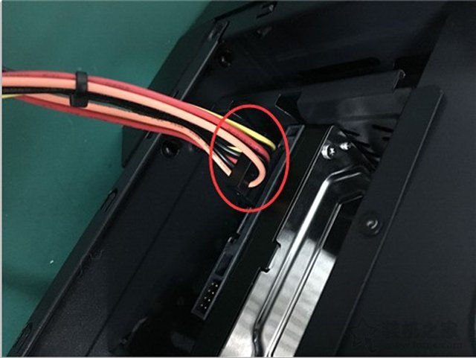
Then take out the SATA cable from the motherboard box, and connect the mechanical hard disk to the SATA cable, as shown in the following figure:
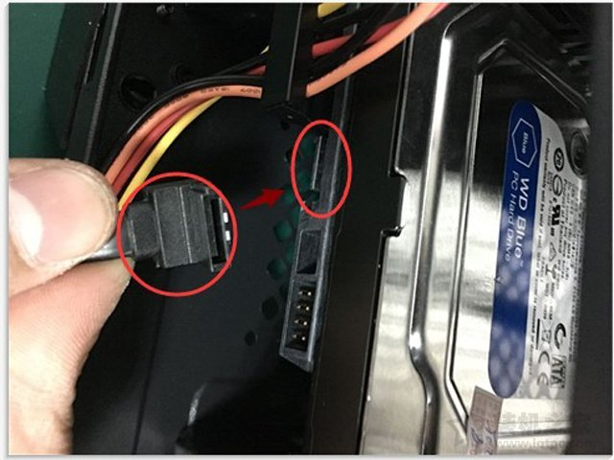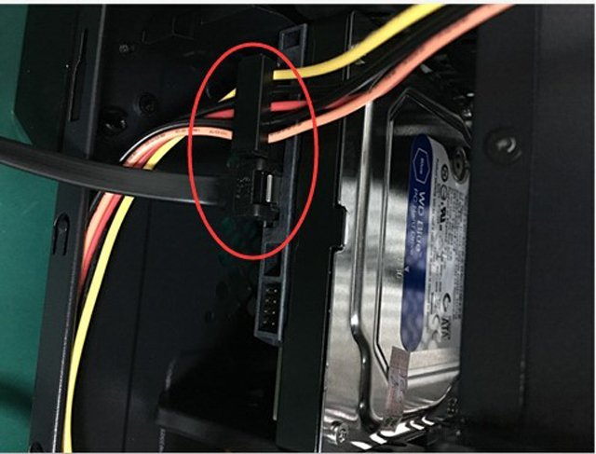
And then connect the other end of the SATA cable to the SATA interface of the motherboard.
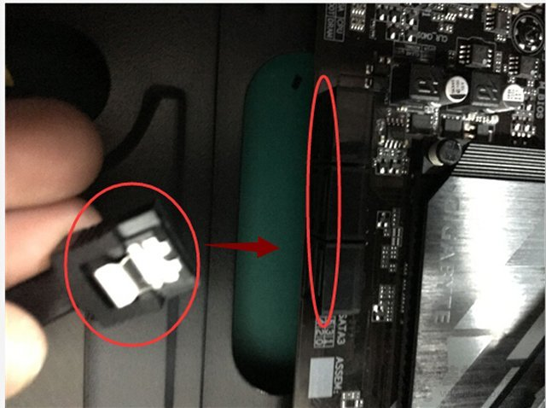
The connection method of the solid state drive of the SATA interface is the same as that of the mechanical hard drive. Please follow the method of connecting the mechanical hard drive. In the case of two hard drives, it is recommended to connect the solid state drive to the SATA0 interface and the mechanical hard drive to the SATA1 interface.
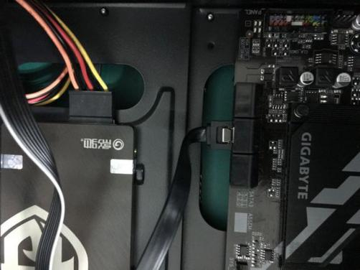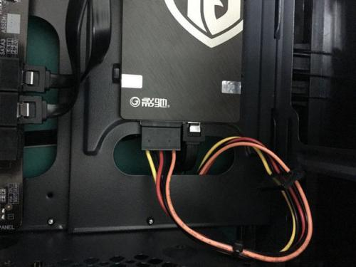
STEP 10 – Install graphic card
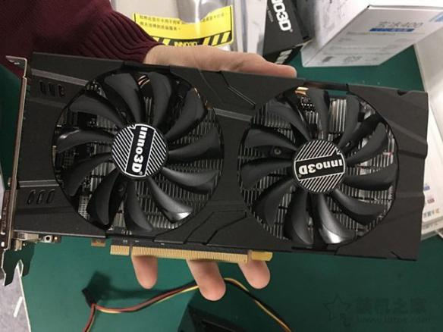
Discrete Graphic Card
Find the PCI-E graphics card slot of the motherboard, as shown in the figure below:
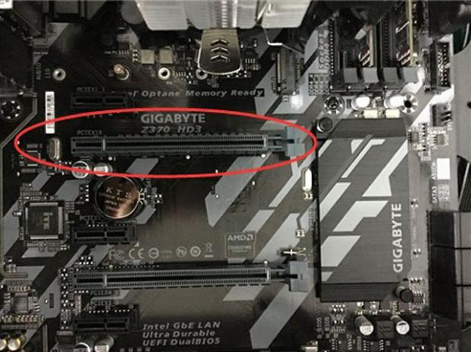
Insert the graphics card into the graphics slot of the motherboard, as shown in the figure below:
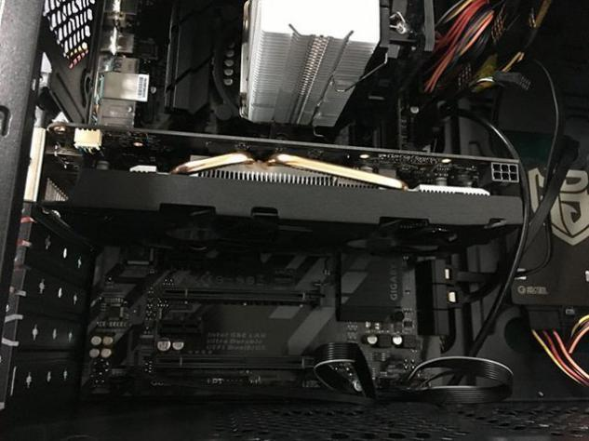
After inserting the “golden finger” of the graphics card into the graphics card slot of the motherboard, find the PCI-E power supply line. Generally, there will be a mark on the interface. In the picture below, the graphics card is powered by 6Pin, we plug in the 6Pin power supply interface, as shown in the following picture.
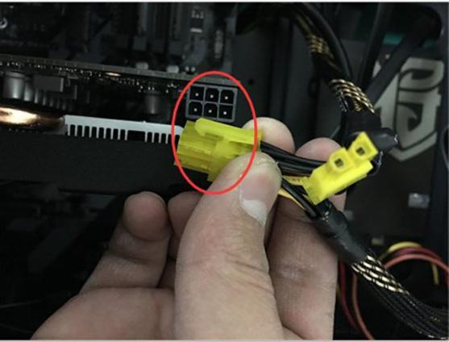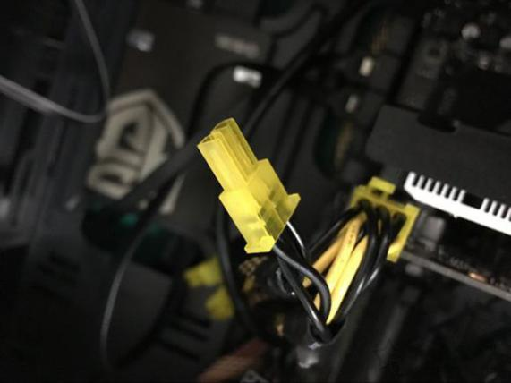
Use large screws to fix the graphics card to the chassis, as shown in the figure below:
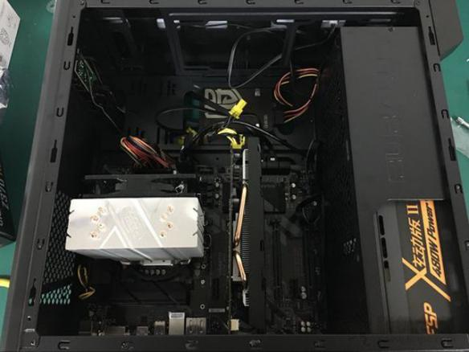
Last STEP - CLOSING THE CASE AND CONNECTING THE PERIPHERALS.
Place the side cover back on and secure the side panels with case screws.
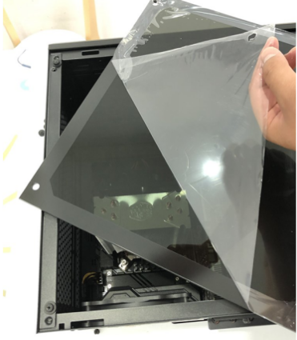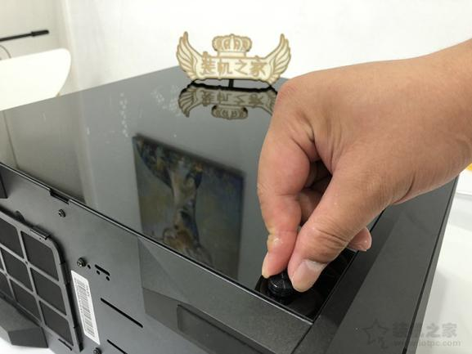
Connect peripheral devices which include keyboard, mouse, wireless network dongle, printer and webcams with your CPU by plugging into USB port.
Then, connect speakers and microphone into 2.5 mm sockets.
Finally connect the CPU with monitor by plugging into display ports
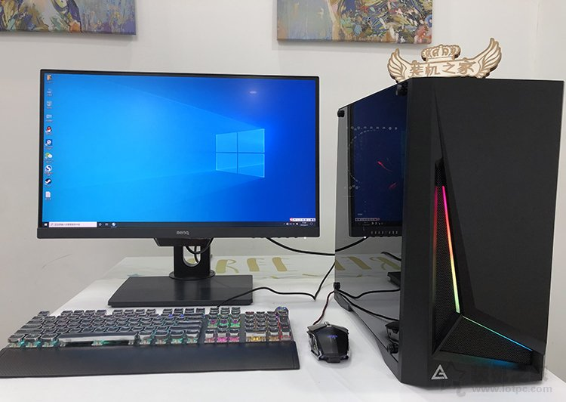
A computer is assembled!

