
SCHOOL OF COMPUTING DEPARTMENT
SECR1013-DIGITAL LOGIC
BACHELOR OF NETWORK AND SECURITY

A MINI PROJECT REPORT
PROGRAMMABLE LOGIC DEVICE (PLD)
PHOTOCOPYING (XEROX) MACHINE

LECTURER’S NAME : | MS. MARINA BT MD. ARSYAD
GROUP NAME : | LUCKY 7
GROUP MATE NAME : | NUR FATEHAH BT HAIROL NIZAM (A20EC0113)  MUQRISYA BT MAT NOOR (A20EC0218)  IRSYAD ROS BIN HISYAM ROS  (A20EC0052)

DEDICATION AND ACKNOWLEDGEMENT

This mini-project has been done successfully with the dedication of our beloved lecturer Miss Marina Binti Md Arshad. We want to thank Miss Marina because she has been teaching throughout the semester with her full will and passion. Despite being busy with her other schedules, she still cares and gives her full attention to us when we need her the most. Without her will and guidance, we would not finish our mini project on time. Although the project keeps rejected and the three of us keep going back and forth, she is still kind to lists out the weaknesses of our project to help us corrected and upgraded our project.
Next, we would like to thank our seniors, Fatima Az Dzikirun Binti Sahrol Nizam and Shakirah Binti Mohd Shukur, who assist us while doing this mini-project by giving a few tips and steps as guidance based on her experience. They are the reasons how we able to revolve and enhance our mini-project.
Finally, we would like to thank our coursemate and other friends who willing to help us to finish this final project. We exchange pieces of information and discuss the project together to make it functional. We also exchange ideas so we could modify our Xerox Machine.

Table of Contents
1.0 THE BACKGROUND 3
2.0 THE PROBLEM 3
3.0 SUGGESTED SOLUTION 3
Figure 1 Block diagram of a complete system of Xerox machine. 4
4.0 REQUIREMENT 5
5.0 SYSTEM IMPLEMENTATION 6
Figure 2 The Drawing Deeds 7
6.0 CONCLUSION 8
7.0 REFERENCES 8

THE BACKGROUND

In this project, we will implement 6 different components on the Xerox machine. These components are 4-bits Synchronous Counter (T flip-flop), 4-bits Comparator, 3-bits Decoder, Subtractor 4-bits Adder, Hexadecimal to Decimal Converter (Custom FSM), and Clock Enabler (And Gate).

THE PROBLEM

After doing Lab 4, we have realized that there are a few problems that arise from the design. First, the user needs to unnecessarily flip the clear switch twice, on and off, every time they want to reset it. Next, the user might not be around all the time to keep watch of their machine thus this allows intruders to use the machine without permission. After that, the maximum amount of papers that can be printed in one time is too small that printing a lot of papers become tedious. Lastly, the counter just counting up can sometimes lead to confusion if the user forgot how much they input so a counter that shows remaining to be printed is needed.

SUGGESTED SOLUTION

The block diagram in Figure 1 shown of components needed in the machine. First and foremost, to avoid from user to flip the switch twice unnecessarily the clear and set are both already set up in HIGH condition. To prevent any intruders to use the machine, a password system has been applied to the circuit. If the password entered is wrong, the LED would not light up and the circuit would not function but if a correct password has entered, the LED will light up and the printing machine is ready to be used.
Maximizing the number of inputs by putting 4-bits input so that the output is not limited only to 1-7 number of copies. Help the users to save the amount of time and energy at once. The 4-bits input number will be compared the number copied inside 4-bits comparator. Then clock enabler will able the clock and start counter from counting and in 4-bits synchronous counter, T flip-flop. The purpose is to determine the number of copies needed to be printed.
Lastly, to show the remaining number of copies so users would not get confused is by adding 4-bit subtractor inside the circuit. Since the 4-bits input in Hexadecimal, a converter is needed to convert it in decimal using custom FSM.

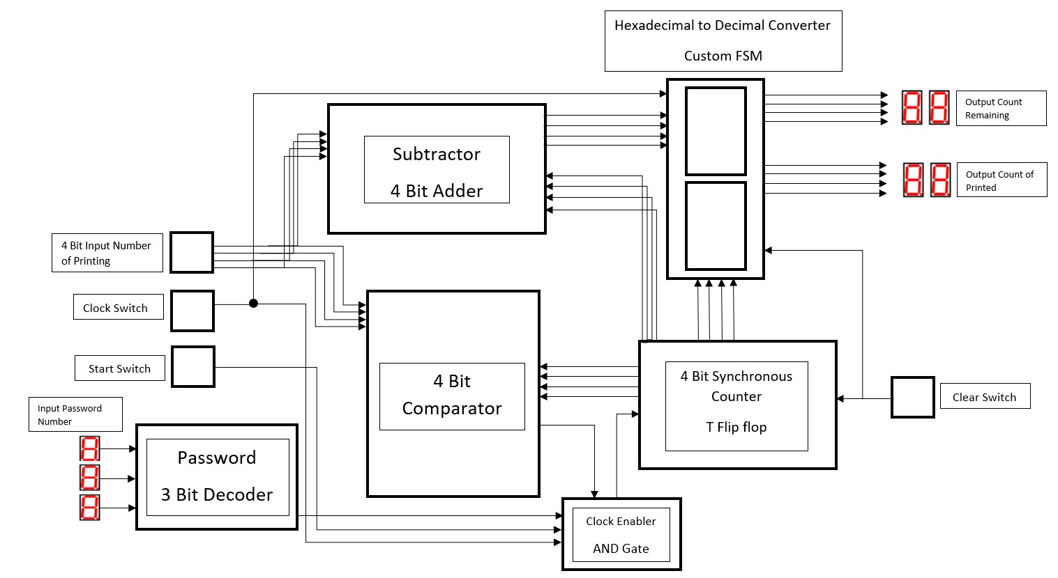

Figure 1 Block diagram of a complete system of Xerox machine.

REQUIREMENT

COMPONENTS | DESCRIPTIONS
3-Bit Decoder | - To ensure the password entered is either correct or not  - A type of security to the machine
Input Switch | - For user to enter how many number of printing they want
Subtractor | - For counting the remaining print available from the total number of printing that user entered
Comparator | - To compare whether the amount of copies required and the amount of printed copies has been met
Clock Switch | - To control the state of the output either 1 or 0  - To allow counter to count if the clock keep on going up and down
Start Button | - To start the operation of printing
Clock Enabler | - To enable the operation for a counter.  - The clock will disable when the comparator give signals to stop the
4-Bit Counter | - To count the amount of copies has been printed
Clear Switch | - To get a reset state
Hexadecimal to Decimal Converter | - Converting hexadecimal such as A, B, C, D, E and F into decimal like 10, 11, 12, 13, 14, 15  - Using two custom FPS to get two digits

SYSTEM IMPLEMENTATION

- Decoder
We use 3-bits decoder to decode the set binary password. The output of decoder is connected to clock enabler AND gate together with lock switch and comparator. So, to make the devices functioning fully, correct passwords need to be entered. After entering the right passwords, the LED light will turn on which is a sign that the printing devices is ready to be used by user.
- 4-bits Comparator
This comparator uses 4 2-input XOR gates to compare value from 2 sources , which are from input and counter. First XOR gates will compare the output of LSB of 2 sources. If the results are same then the output will be 0 and send to NOT gate and convert to 1. It is actually following the XNOR principles. For the second, third and fourth gate XOR will follow the same principle just like before. Then output form all four gates will be send to NAND gate to convert into opposite signal. When all XOR gate received the same input from switch and counter, output 0 will be send to clock enabler and immediately stop the photocopying machine.
- 4-bits count-up Counter
The 4-bits counter that we use is 4-bits T positive edge count-up counter but we are using JK net flip flop . The counter starts to count based on the clock enabler. It will start counting if the J and K input are connected to high input. In this case, the start button is implement as active high input, if password entered is correct and the clock enabler is active. Only stop when the clock pulse is no longer received or reached the number of copies that entered by user.

- Clock Enabler
The clock enabler is set up by 4 input AND gate. The input of AND gate is from the clock , start button , decoder and 4-bits comparator. The enabler can only active when all four inputs are high . It will stop the operation of the counter when the number of printed copies is same the number of copies.

- Subtractor
Subtractor will show remaining number of copies. Input from user is connected to input B of subtractor then the signal went to hexadecimal to decimal converter and produced output of remaining of copies. The remaining copies become 0 if the output of copies is same with input of copies.

- Hexadecimal to Decimal Converter (Custom FMS)
Since the input are in hexadecimal especially input from 9 and above. It help users to understand how many inputs they would like to enter and how many outputs they would get.

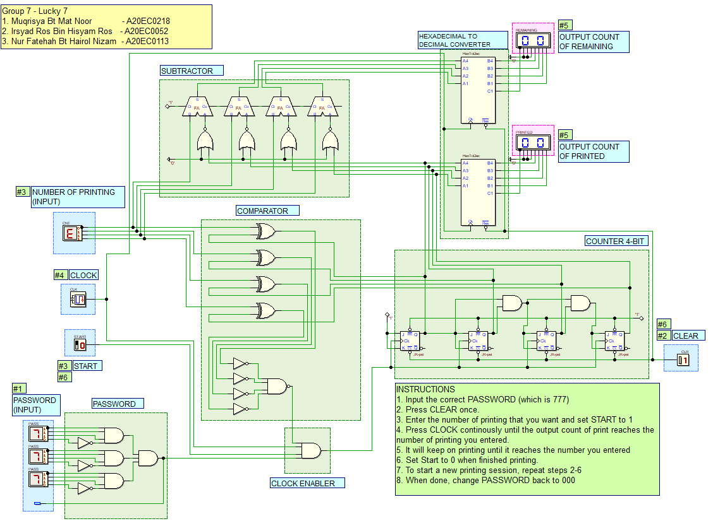

Figure 2 The Drawing Deeds

CONCLUSION

In a nutshell, we successfully completed our project. We able to propose a solution based on the problem we figure out and the circuit can function well. We all know that real xerox machine is more complex circuit design compare to our mini project but with this task it help us to increase our knowledge regarding xerox machine. Now we all know that the main design of xerox machine consist decoder, counter, comparator and clock enabler.
In this mini project, we realise that we are still lacking on knowledge understanding each of components role and how the concept works. We also face the difficulty to draw the block diagram and keep going back and forth for a consultation from Miss Marina. We did redo the block diagram for 5 to 6 times. We did some mistakes while doing the mini project such as connecting the wrong wire on subtractor and comparator, no input for password and did not label properly on the component. The weakness in this project we do not have the idea on how to add multiplexer and demultiplexer in this printing system.
Although we come across some problems, we managed to solve these problems with Miss Marina help. We also gained a lot experience from this project. Due to Covid-19, we could not do it physically in the lab and only use DEEDS to see the simulation and understands how each of the components work in the circuit.
If we manage to add multiplexer and demultiplexer will be betters, it shows that we know how to use these two components. Even the mini project come to an end, we will continue to figure on how to apply multiplexer and demultiplexer component in the circuit.

REFERENCES

- Abd. Bahrim Yusoff, Mazleena Salleh, Mohd Fo'ad Rohani, Ismail Fauzi Isnin. (2018). Digital Logic (Fifth Edition). Johor, Malaysia. Desktop Publisher.

- Eric Coates MA BSc. (2007 – 2019) .Digital electronics. England, LEARN ABOUT ELECTRONICS. Retrieved from
https://learnabout-electronics.org/Digital/dig43.php

APPENDINCES

RECORD ON TASK WE PERFORMED

Name | Task
Irsyad Ros Bin Hisyam Ros | - Giving idea on 4-bit input an converting hexadecimal to decimal  - Doing the circuit  - Help in conducting the meeting
Muqrisya Bt Mat Noor | - Giving idea on remaining number of copies by using subtractor  - Doing the block diagram  - Help in report writing
Nur Fatehah Bt Hairol Nizam | - Giving idea on 3-bit password  - Doing the report writing  - Help in conducting the meeting
Total hours we take to settle the mini project : | 3 days ( 72 hours)

A PICTURE WHILE IN MEETING


