

SEM 1 20202021 : SECTION 01

PROGRAMMING TECHNIQUE 1

ASSIGNMENT 1

Group Num# : 2

Students Information

Name : 1. Hanis Rafiqah Binti Hisham Razuli (A20EC0041)
2. Indira A/P Thangaraj (A20EC0049)
3. Goh Yitian (A20EC0038)
4. Iman Ehsan Bin Hassan (A20EC0048)

Lecturer : Dr. Zuraini Binti Ali Shah

Question 1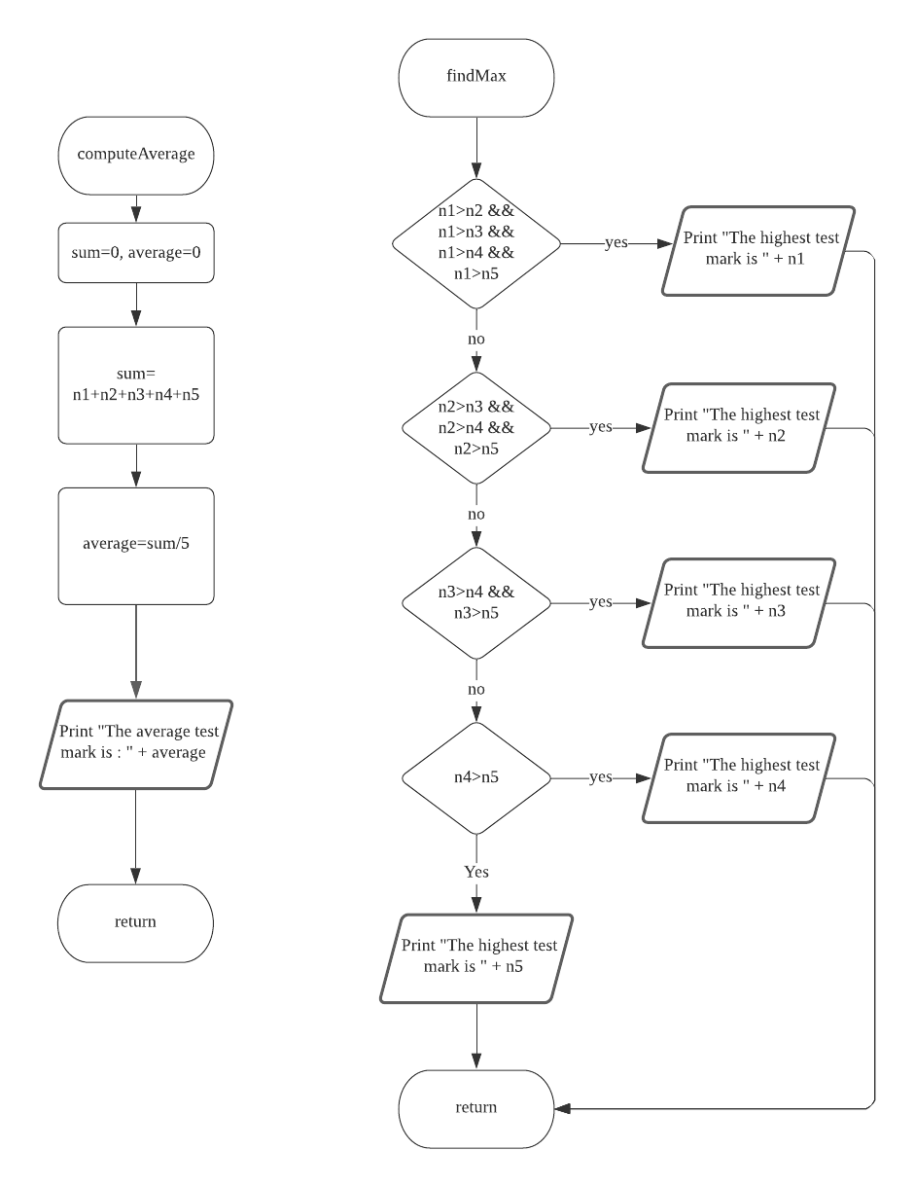

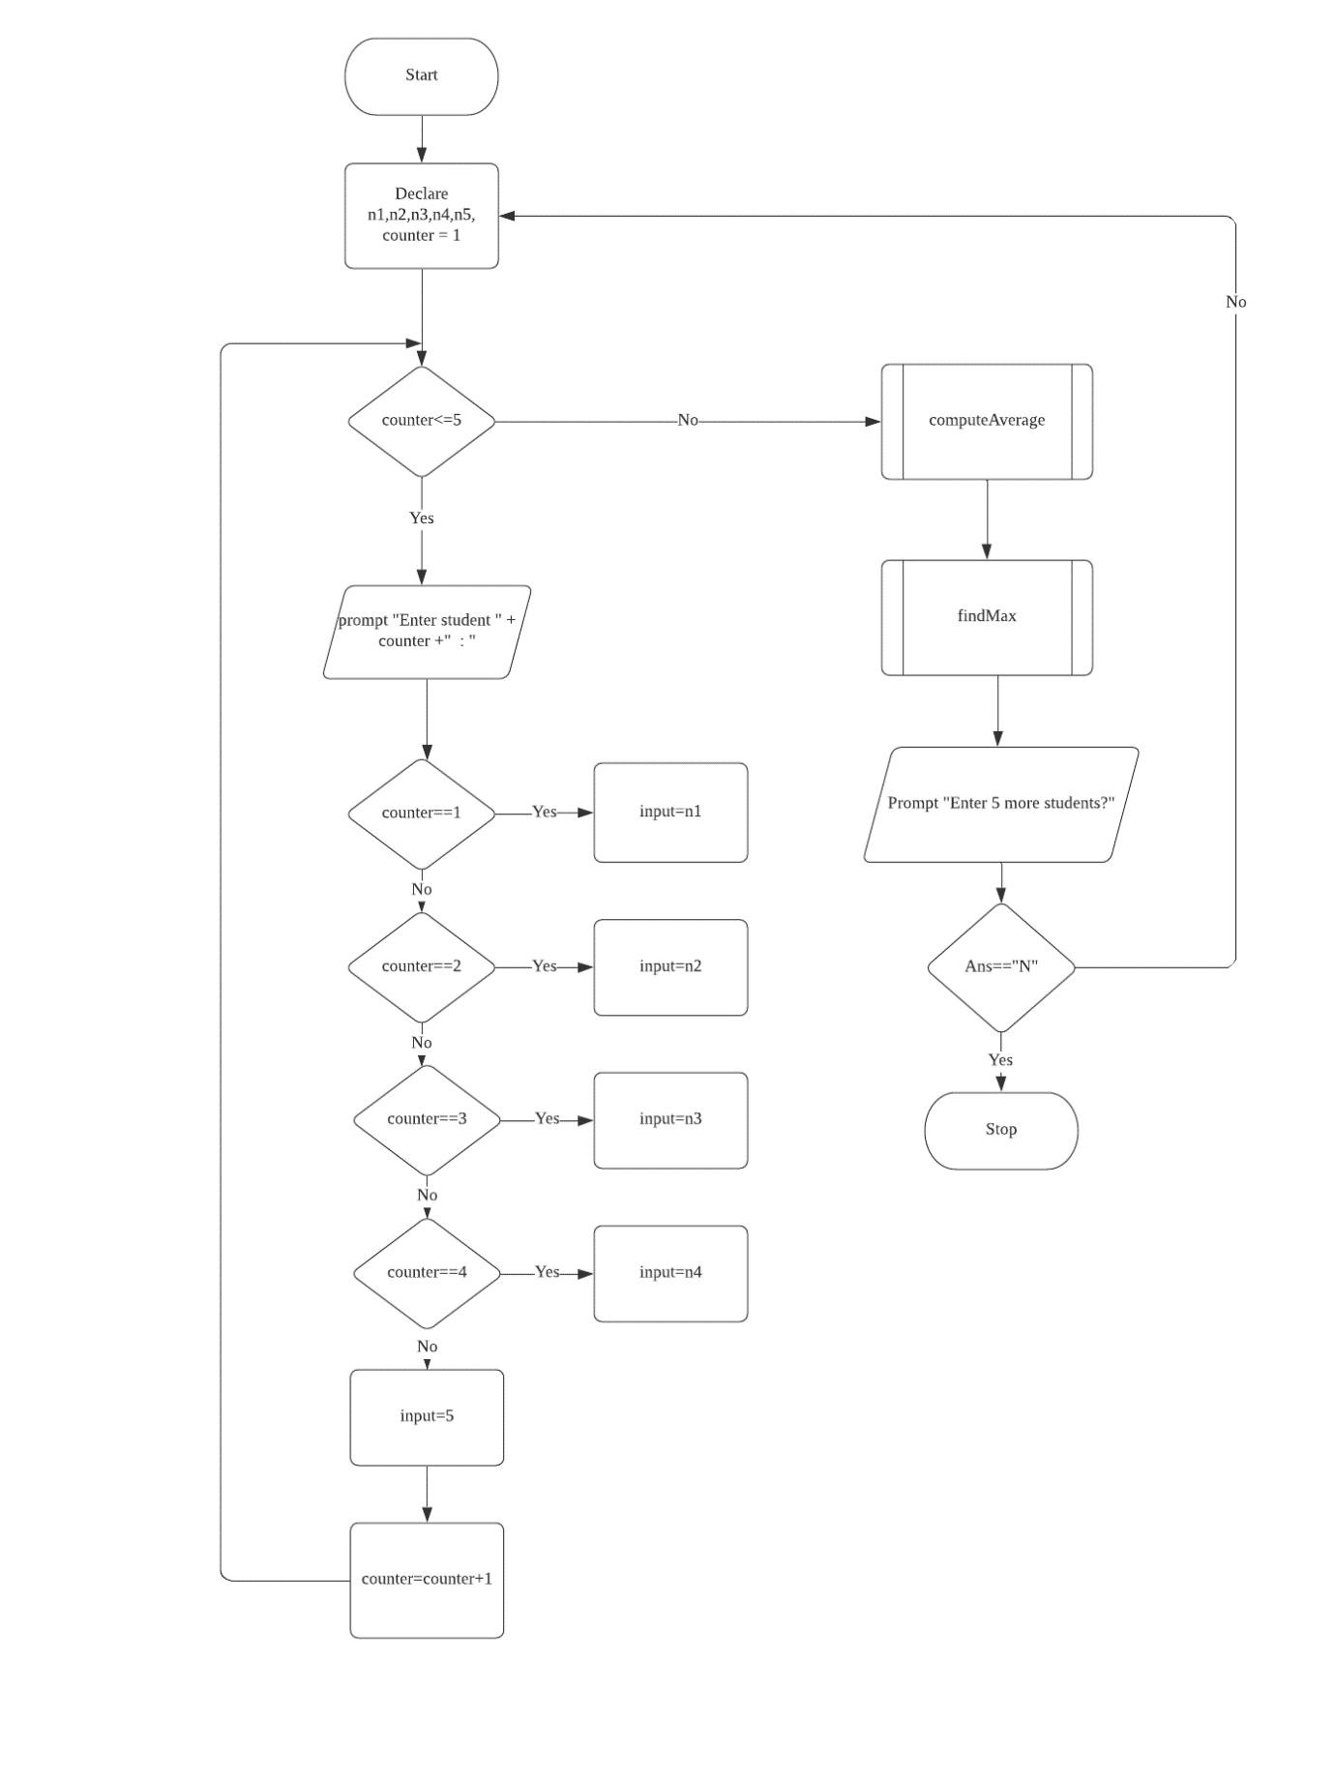

Question 2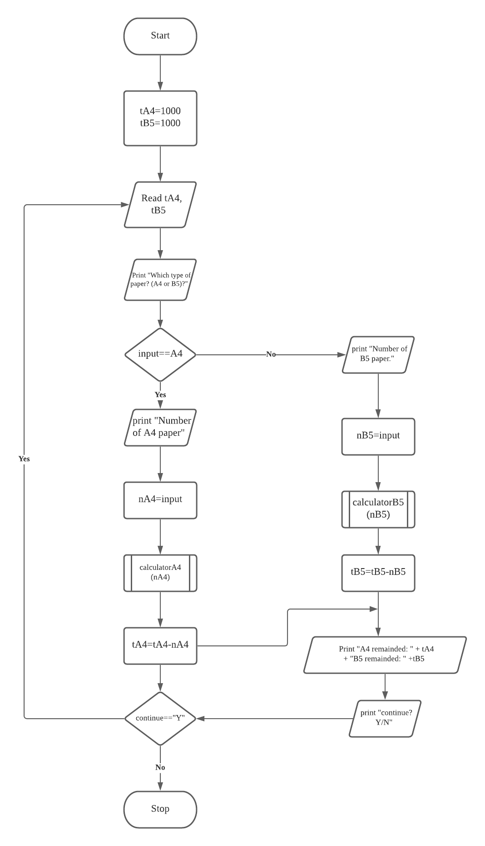

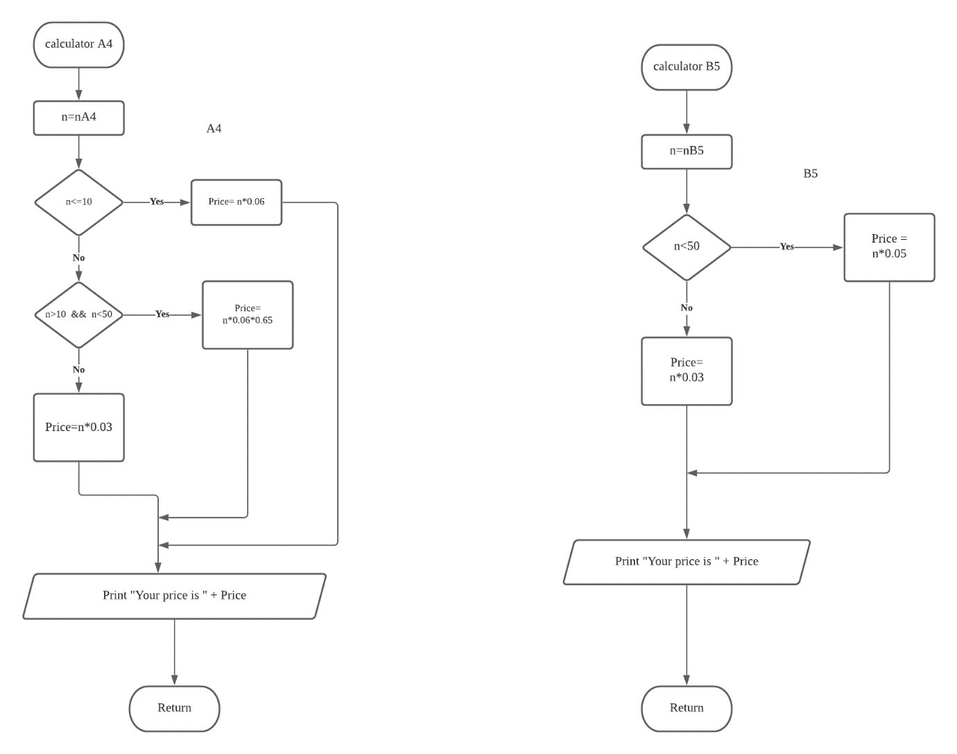

Input: Which type of paper? (A4/B5)
Input: Please enter the number of paper
Output: Your price is RM

Output: A4 remained:
Output: B5 remained:

Input: Continue? Y/N:

