
TECHNOLOGY AND INFORMATION SYSTEM -SECTION 09 (SECP1513-TIS-09)
DESIGN THINKING ASSIGNMENT 1
CHAPTER 3: APPLICATION SOFTWARE
LECTURER: DR. SARINA SULAIMAN

Group members (Group 1):
Members | Matric Number
1. Azni Ain Sabrina Binti Mohamad Nazri | A20EC0019
2. Low Jia Ying | A20EC0070
3. Abraham Loh Tze Lung | A20EC0001

Table of Contents
Chapter 1: Introduction………………………………………………………………………………….1
Chapter 2: Detail Steps and Description in Design Thinking……………………………..2
Chapter 3: Detailed Description…………………………………………………………………………3
Chapter 4: Design Thinking Evidence…………………………………………………………………..5
4.1: Activity Logs for entire assignment …………………………………………………5
4.2: Sample Work to Solve the Design Challenge …………………………………….5
4.3: Details About Each Phases of Design Thinking……………………………………. 6
Chapter 5: Reflection………………………………………………………………………………………………..10
5.1: Goal with Regard to Our Course
5.2: Impact of Design Thinking on Our Goal
5.3: Actions and Improvements for Us to Improve Our Potential in the Industry
Chapter 6: Tasks of Each Members………………………………………………………………………………11

Chapter 1: Introduction

Design Thinking is a generic skill that deemed useful and effective in problem solving in various aspects. The skill mentioned could be applied in business, entrepreneur, social experiment, scientific projects, technologies or even in politics. Design Thinking involves creative and innovative approaches to ranging from get rid of problems to improving the quality of lives of mankind. Products of Design Thinking could be a modification of existing resources or ideas.
“Design Thinking is a methodology applied by project teams for innovation activities focused on satisfying user needs”. Quoted by Tim Brown
Design Thinking may means more than just “thinking outside of the box.” The main purpose is to create innovative, solutions for well-defined problems. An important part of the Design Thinking methodology is that it does not concern itself only with the solutions, but also puts a lot of influences on conceptualizing the problem. This is important for software development, as it allows for a deepened research of user needs and creating best possible user experience.
There are 5 major steps in the working process of Design Thinking:
Empathize
Define
Ideate
Prototype
Test
Figure 1.1: Steps involve in Design Thinking (will be explained in detail in next chapter)

Chapter 2: Detail Steps and Description in Design Thinking
Stage 1 : Empathize (the user)
This stage involves the gathering of the insights of user by observing their needs both directly and indirectly.
Stage 2 : Define (the problem)
This phase is about pondering and discussing the problem which deemed relevant to be solved to give benefit and best experience to the user.
Stage 3 : Ideate (possible solutions)
This stage is about suggesting as many solutions to the problem identified. Our teams had recommended a plenty of solutions and filtering out the less relevant and bettering the selected solution subsequently. We brainstorm multiple ideas.
Stage 4: Prototype (plausible solution)
This stage of Design Thinking is more to “action”. We started turning our ideas into a reality. At this stage, it is more to action rather than thinking by producing a prototype and to be tested subsequently.
Stage 5: Testing (user’s feedback)
The prototype produced is tested against user and we are ready to receive any kind of user’s feedback. This may not be the final stage of Design Thinking. Rather, continuous polishing of idea (jumping back to stage 1) is required to ensure the most benefits experienced by the user.

Chapter 3: Detailed Description
WhatsApps and Telegram are widely-known applications which can both be accessed on computer and on mobile devices. The aforementioned applications are often used for communicating between individuals either privately or in a groups. Both WhatsApps and Telegram have a comparable features in terms of video call, group chats, conferencing, file and folder sharing, photo and video sharing, documents and announcement.
Due to the severity extent of COVID-19 outbreaks, most of our University (UTM) activities were carried out online such as lecturing and co-curriculum meeting. At this moment, both WhatsApps and Telegram are used extensively. Both applications are awesome tools for event announcements and discussing works in relevant groups.
However, various different new groups were created for resorting relevant persons to groups of particular courses. Consequently, there are too many groups out here. Our group members agreed that it is quite frustrated to search a particular group from the main interface. WhatsApps does not possess the feature that Telegram does, that is, pinning couples of relevant groups to a “folder”. The main interface of WhatsApps and Telegram will be depicted in Figure 3.1 and Figure 3.2.

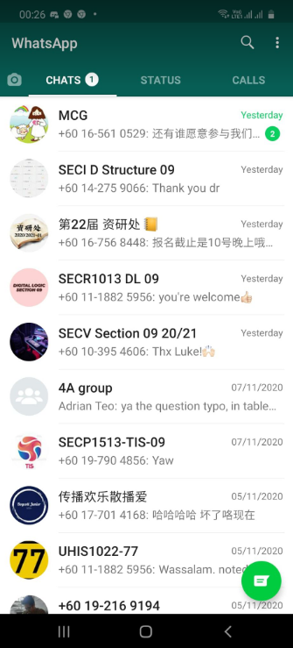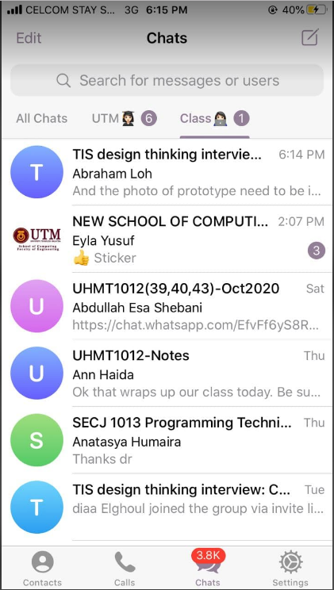
Figure 3.1 Figure 3.2
Main interface of WhatsApps Main interface of Telegram (Relevant class (Mixture of different groups groups were resorted to the folder “class”) which cannot be resorted)

Chapter 4: Design Thinking Evidence
4.1 Activity Logs for entire assignment
Date | Activities
3 November 2020 | Interviewed IT experts via Cisco Webex meeting.
5 November 2020 | Discussing the problems that adjacent users faced.
6 November 2020 | - Contributes points for our group chapter presentation regarding Application Softwares.  - Doing a voiceover by sending our voice recording respectively via Telegram and compile it.
7 November 2020 | Began report writing.
8 November 2020 | Prototype was built.
9 November 2020 | Video about our Design Thinking Project was created.
10 November 2020 | Complete assignment was submitted.

4.2 Sample Work to Solve the Design Challenge
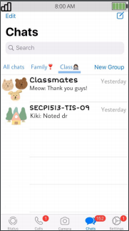 Figure 4.1
How it will be looked like when “Folder” feature is added.

4.3 Details About Each Phases of Design Thinking
Phase 1: Empathize
We carried out an interview against Dr. Mohd Farid and Dr. Murtadha, both are IT experts, regarding Software Application via Cisco Webex Meeting.
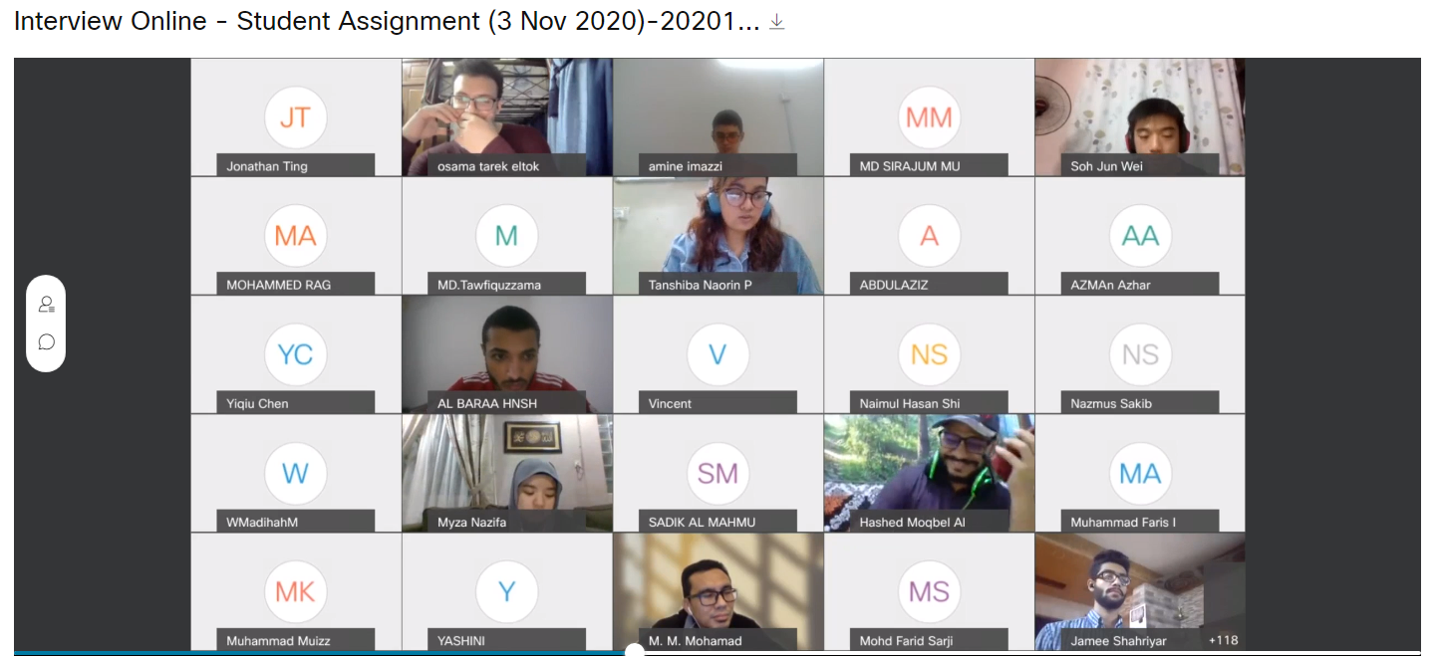
Figure 4.2
- Question 1: What is the difference between application and software?
Interviewee: Dr. Mohd Farid
Answer:
An application can be a program or a group of programs designed for end users whereas a software consists of programs and other operating information used by computer. As a side note, program is a set of instructions that are readable by computer for various function.

- Question 2 : How important is the role of teamwork play in developing a software/application?
Interviewee: Dr. Mohd Farid
Answer:
In Software Development, teams that work together closely over extended period found to be more efficient. Effective teamwork is even more crucial for software developers, who must effectively and efficiently share high-level skills to complete a project on time and within budget.
- Question 3 : Could you list some challenges that will be faced when developing a software? Or Application?
Interviewee : Dr Mohd Farid
Answer:
Well, as you all know, the global world is changing rapidly with technology advancement. Also, there are surging in customer demands. To some extent, a controversy or conflicts may happen among software testing teams. Other challenges are time limitation as well as limited resources and infrastructure.

Phase 2: Define
After the empathize phase, our group members discussed a problem about WhatsApps. We carried out the discussion via Telegram assignment group chat. The recent and extensive increasing in WhatsApps groups were quite messy (i.e. hard to find back a message from the target group). Most of UTM undergraduates agreed that this problem is frustrating.

Phase 3: Ideate
We brainstorm ideas and ended up agreed with the suggestion that the “folder feature” should be added to WhatsApps. The discussion process was done via Telegram Application. Therefore we created a prototype how it will be looked like.

Phase 4: Prototype
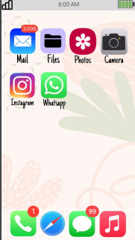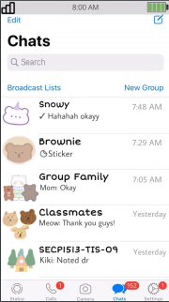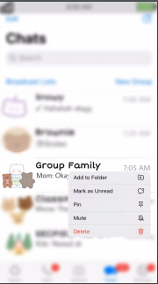
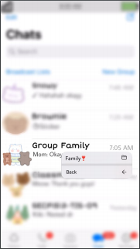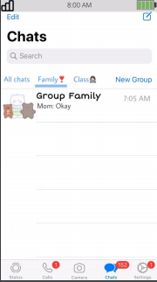
Figure 4.3 : Prototypes of WhatsApps with “Folder” feature

Phase 5: Testing
We created a google submission form with regard to our prototype created. The feedbacks were collected and reflections were made.

Chapter 5: Reflections
The goal with regard to our course Graphics and Multimedia Software is developing solutions to the problem in our life through collaboration, innovation and design.We have a goal to improve our hard skills such as video editing,prototype, report writing.Besides,the second goal is improve the soft skills such as teamworking,time management,communication skill,problem solving,analysis and creativity.Both of the skills can help us to face the challenges in future.

The design thinking impact on our goal regard to this program.We learned how to find out the problem that faced by people in daily life when using social application.We analyzed the problems and discussed the solutions with team members.This help us to improve our skills such as teamworking,problem solving and communication with others.We are given a opportunity to experience how to present our idea by edit the videos,create a prototype or write a report.

To improve our potential in the industry,we need to take part in competition related to this industry.We can get more experience through the competition and we can find out our problems when doing a project.It helps us to prevent and avoid making the same mistake in future career.On the other hand,We should pay attention and follow the latest information and technology so that we always learn new knowledge and techniques.

CHAPTER 6 : Task of Each Members
Name | Divided task received
Azni Ain Sabrina Binti Mohamad Nazri | -Produce chapter video presentation  -Collect and compile voices  -Produce prototype
Abraham Loh Tze Lung | -In charge of report writing  -Record voice for chapter presentation
Low Jia Ying | -Record voice for chapter presentation  -Write the Reflection part of report writing.  -Video presentation about our Design Thinking Assignment.

Video about Design Thinking: https://www.youtube.com/watch?v=l28NZztNu1I&feature=share&fbclid=IwAR2I_YMdi5aPCkmLtCwTpN6MPArHL1eiDNZJ7uBCLQYie0Vdt9amWbnnKPQ
Video about Chapter Presentation (Chapter 3: Application Software):
https://www.youtube.com/watch?v=RsH0QfYI1ko&feature=share&fbclid=IwAR2MkWEQEGqFIVSmahiWg52nJDrP5ifxJ_0bjXKzehkTSsTw3ggpzN6vx3A

