

Semester I 2020/2021

Subject : Technology and Information Systems (SECP1513)

Section : 07

Assignment : Step by step PC Assembly

GROUP NAME / NUMBER : 05

1.

Name : Farhana Tahseen
Matric Number : A20EC4015
Phone Number : 0193272280
E-mail : farhanatahseen98@gmail.com

2.

Name : Md Faridul Islam
Matric Number : A20EC4030
Phone Number : 01128191673
E-mail : mdfaridulislam509@gmail.com

3.

Name : Md Masqurul Hasan
Matric Number : A20EC4031
Phone Number: +601127354746
E-mail : rokie098098@gmail.com

4.

Name : Radin Nazhan Bin Radin Jamzulkomar
Matric Number : A20EC0136
Phone Number : 0193373930
E-mail : radinnazhan@graduate.utm.my

PART A

Electrostatic discharge wrist strap

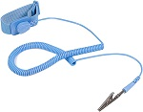

The electrostatic discharge wrist strap will reduce the buildup of charge and reduce the discharge of static electricity on the human body to the computer component by wearing the wristband on the hand or leg and the metal end should be connected to the grounded metal object or any ground socket. Electrostatic discharge can damage electrical components such as hard drives and it is important to use the wristband to prevent any damage on the computer electronics due to electrostatic discharge to ensure there is no error during startup.
Screwdrivers

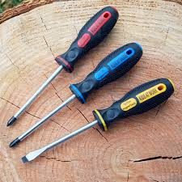

It is impossible to hold together computers without screws. Fortunately, almost every type of screws used in computers is Phillips-head. The most important tool for assembling a PC is a Phillips-head screwdriver. A Phillips-head screwdriver with a big bit is really very useful to avoid stripping the head. While working in tight spaces, a long shaft also helps to keep the handle out of the way. Though flat-bladed screwdrivers are not generally of much use for unscrewing anything, they are really very beneficial for getting extra leverage and prying things apart.

Zip or Twist Ties

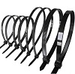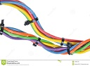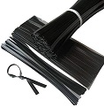

Zip or twist ties are an essential product that can be found in almost anyone’s toolbox. These are ideal products for tying any cables. A zip or a twist tie is a single use product. To build a PC these are essential products because a lot of cables and wires are used to connect all the parts with the mother-board of a pc. These wires can be scattered here and there of the pc which seems messy and also inhibits the air flow. Zip and Twist tie can give the solution. These can be used to tie the cables and keep them in the right place which is why cable management looks orderly and also ensures the lower dust accumulation and higher air-flow.

Pliers

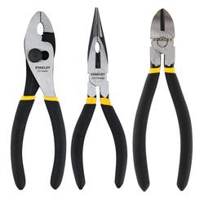

Pliers is one of the basic and fundamental tools for building a PC or any other components. Basically, it’s made by steel alloys with additives, for example “vanadium” to make it stronger and prevent corrosion. Users use it for various purposes. And it is also made in various shapes. Different shapes are used for different purposes. Some are used to harden the wires. Some are used for a combination of tasks with cutting the wire. And by using pliers’ users also can grip something round like a pipe or a mace.

PART B

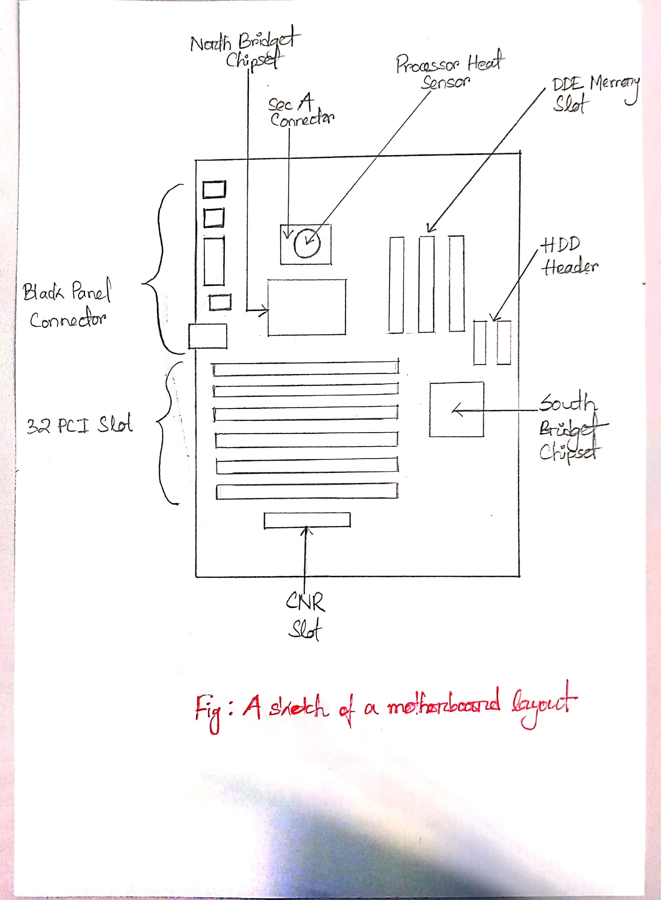
Graphic card

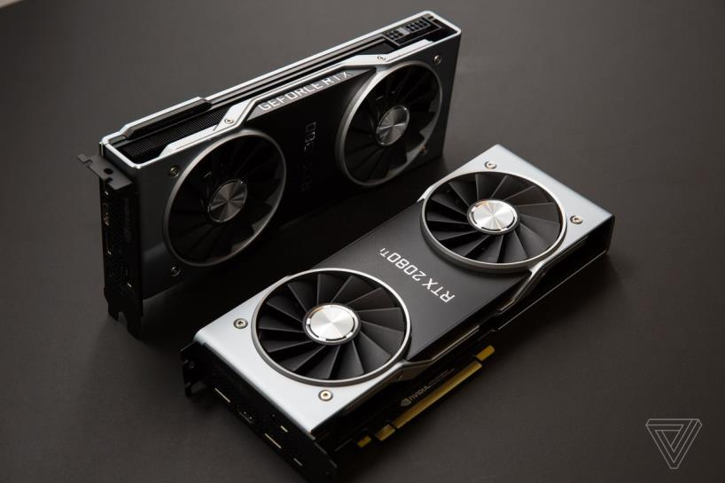

A graphic card is like a smaller version of the entire computer but one dedicated to the task of figuring out how to put an image on the computer scene. For gaming or editing the video it plays a very important role and due to a lot of advantages its popularity is increasing day by day. Example model: Nvidia GeForce RTX 2080 Super, AMD Radeon VII, Nvidia GeForce GTX 1660 Ti, Nvidia Quadro RTX 4000.

USB cable

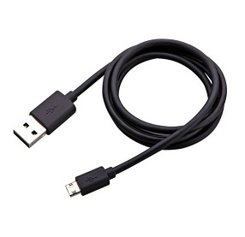

Universal Serial Bus (USB) cable is one of the common hardware that use for connectors or protocols for connection, communication or power supply between one computer to another computer or other peripherals. It is very common and popular hardware. Example model: Anker USB Type C Cable, Anker Thunderbolt 3.0 USB-C Cable, Micro-B 2.0 Cable etc.

IDE cable

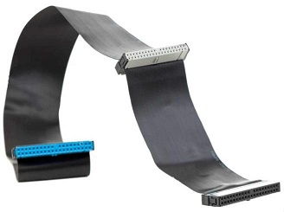

Integrated Drive Electronics (IDE), is the standard type of connection for storage devices in a PC. Generally, IDE alludes to the kinds of cables and ports used to associate some hard drives and optical drives to one another and to the motherboard. Example model: Internal 2-Drop IDE Cable, CableMart 12IN IDE Cable ATA/133, CableMart 12IN ADC Cable etc.

CPU/Processor

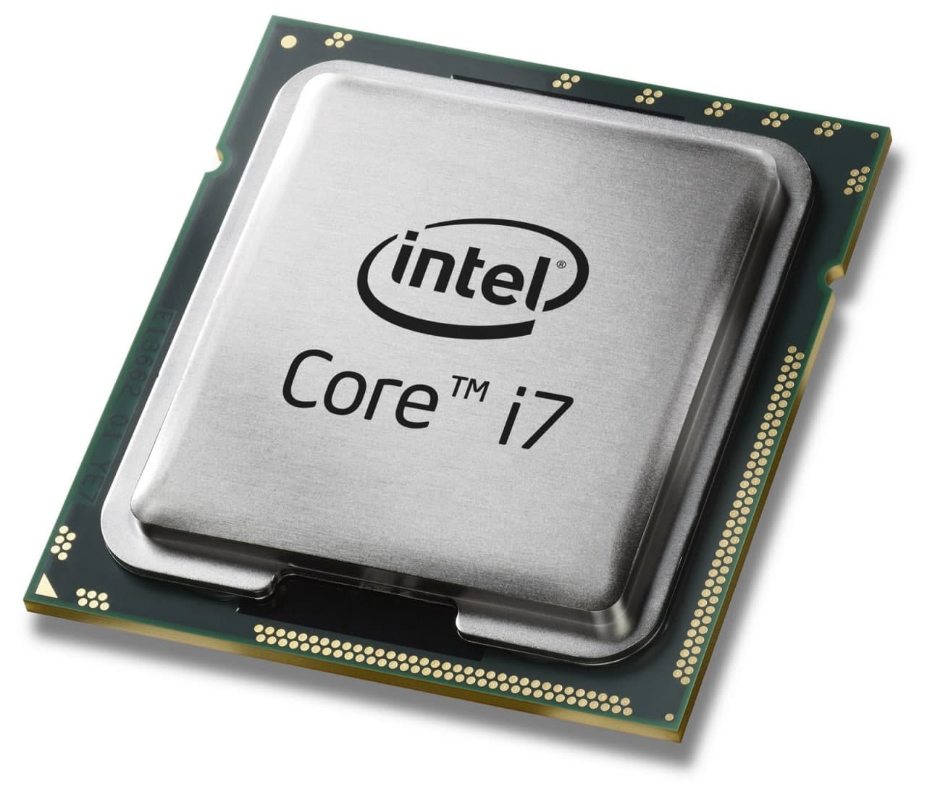

The CPU is the key element in defining a computing device, but it is not the only element - again it is just the brain. It is a chip that sits in a special seat (socket) on the main circuit board (motherboard or mainboard) inside the device. It is separate from memory, where it temporarily stores data. It is also different from a graphics card or graphics chip, which renders all videos and 3D graphics displayed on a screen.
CPUs are made by placing billions of microscopic transistors on a single computer chip. These transistors allow you to create the calculations needed to run programs stored in your system's memory. These effectively have minute gates with switches on or off, which translate what you do with the device into zeroes when translating videos or writing emails. In its core, a CPU takes instructions from a program or application and performs a calculation. This process is divided into three main stages: fetch, decode, and perform. A CPU retrieves the instruction from RAM, decodes what the instruction actually is, and then executes the instruction using the relevant part of the CPU.

SLOTS (IDE, PCI)

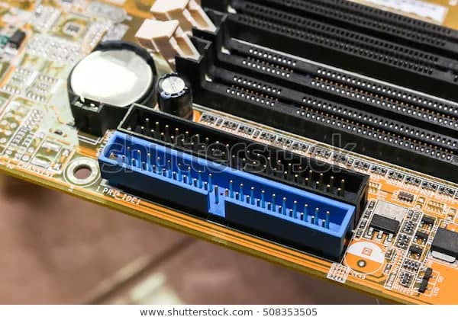

IDE stands for Integrated Drive Electronics. This is a standard electronic interface used between a computer motherboard's data paths or bus and the computer's disk storage devices. Nowadays in computers, the IDE controller is often built into the motherboard.

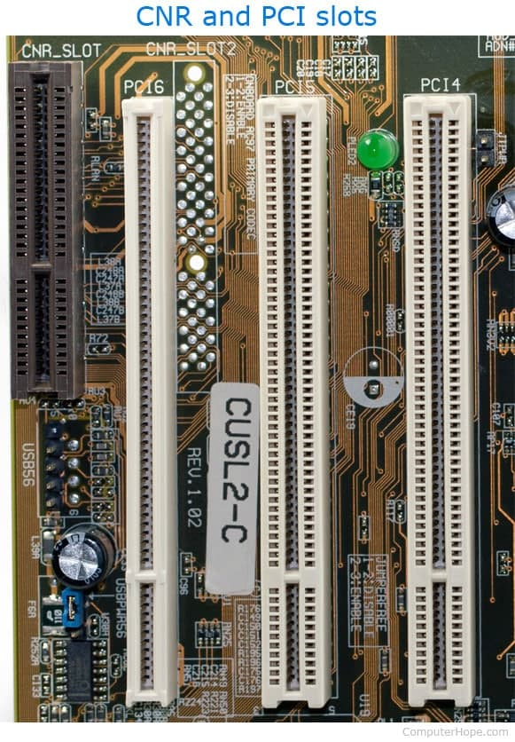

PCI stands for "Peripheral Component Interconnect". PCI is a hardware bus that is used to connect internal components to a desktop computer. For example, a PCI card can be inserted into a PCI slot on the motherboard by providing an additional I / O port on the back of a computer.

There is a large number of peripherals which are put into perfect use owing to PCI slots, some of them are:
• Modem.
• Network card.
• Sound card.
• Graphics card.
• TV tuners.
• Firewire cards.
• Controller card.
• Scanner and so on.

Power Supply

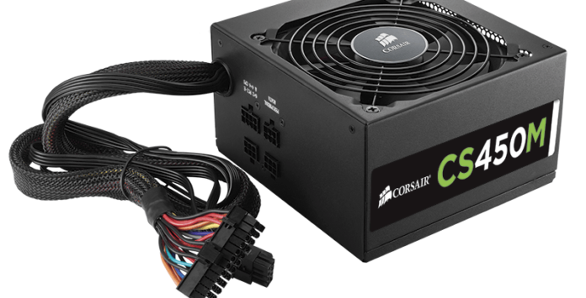

A power supply unit (PSU) converts the main ACT to low voltage-controlled DC power for the computer's internal components. Modern personal computers universally use switched-mode power supplies. The ATM power supply is turned on and off by a signal on the motherboard.

There are three subsets of controlled power supply. These are linear, switched and battery-based. Linear is the least complex of the three basic controlled power supply designs, but has the advantages of switched and battery power.

Heat sink

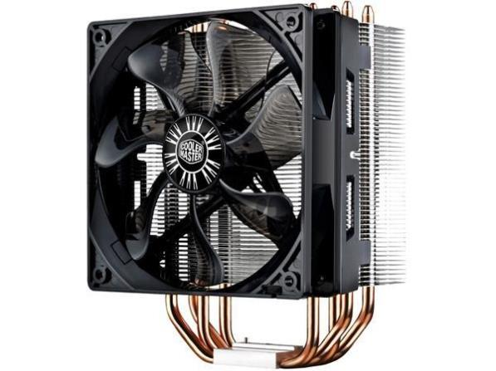

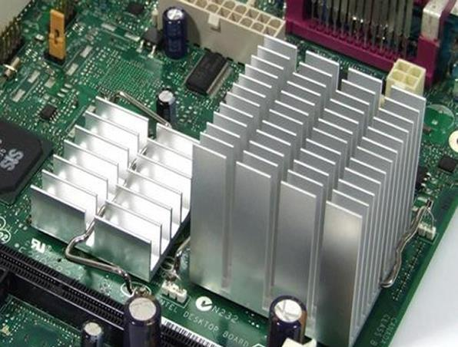

A heat sink is a component that increases the heat flow away from a hot device. It is a heat exchanger that transfers the heat generated by an electronic or a mechanical device to a fluid medium, often air or a liquid coolant, where it is dissipated away from the device, thereby allowing regulation of the device's temperature. It accomplishes this task by increasing the device's working surface area and the amount of low temperature fluid that moves across its enlarged surface area. Example model : Cooler Master Hyper 212 Evo / Motorola Brand Magnesium Az91d Heat Sink Die Casting Heat Sink.

RAM

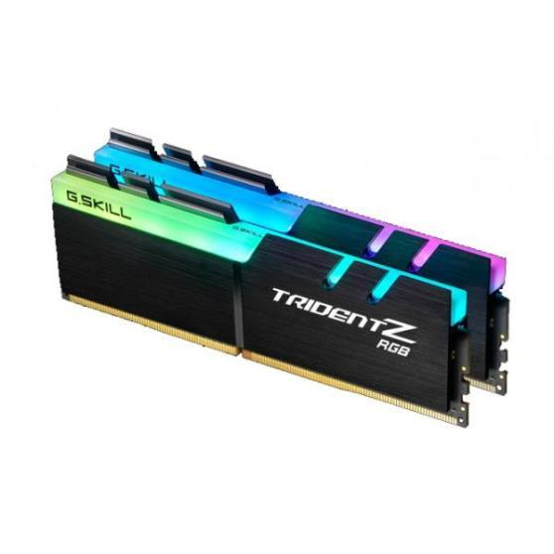

Random access memory (RAM) is a form of computer memory that can be read and changed in any order, typically used to store working data and machine code. It provides short term storage space for data and program code that a computer processor is in the act of using, or which it expects to use imminently. A random-access memory device allows data items to be read or written in almost the same amount of time irrespective of the physical location of data inside the memory. Example model : G.Skill Trident Z RGB.

Hard disk

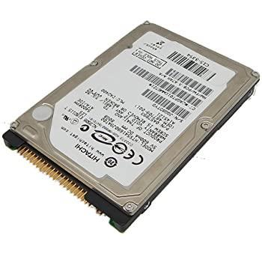

Hard disk is an electro-mechanical data storage device that stores and retrieves digital data using magnetic storage in one or more rigid rapidly rotating platters coated with magnetic material. The platters are paired with magnetic heads, usually arranged on a moving actuator arm, which read and write data to the platter surfaces. Data is accessed in a random-access manner, meaning that individual blocks of data can be stored and retrieved in any order. Example model : Western Digital WD5000AAKB.

CD ROM

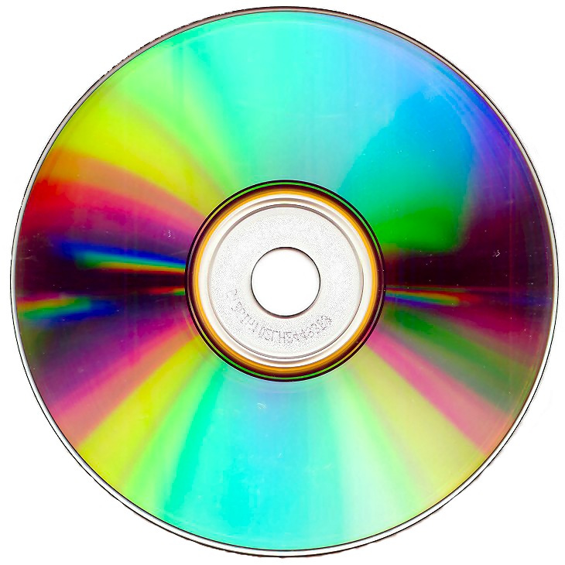

CD ROM drives are used to open on data CDs, for example, music files, pictures, word documents and other files. CDs are really very popular as installation discs.

SATA Cable

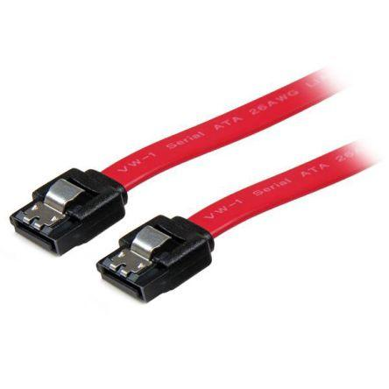

SATA cables are used to transfer data at high rates (1.5 to 6 gbps). Primarily it is used so that a motherboard can be connected to an internal hard drive. Some common types of SATA cables are - MIcro SATA, SATA Bracket, SATA Bridge, SATA Power, SATA SATA, e-SATA and Low Profile SATA.

PART C

It is true that computers are one of the important devices which plays a vital role in our daily life activities. It makes our activity too easy. So, in this report we will discuss the assemble of a PC.

If we build up a CP 1st of all we need some common elements these are given below.

1.Processor /CPU.
2. Heat sink.
3.RAM.
4.Power supplier.
5.Hard disk.
6. CD Rom/ DVD drive.
7. SATA cable.
8. IDE cable.
9.USB port.
10. Graphics card.
11.Slots (IDE, PC)

By using these basic and fundamental elements, step by step we are going to assemble a PC.

1.CPU installation:

1st of all we have to take a motherboard. After taking it, we need to open the CPU slot which is included in the motherboard.

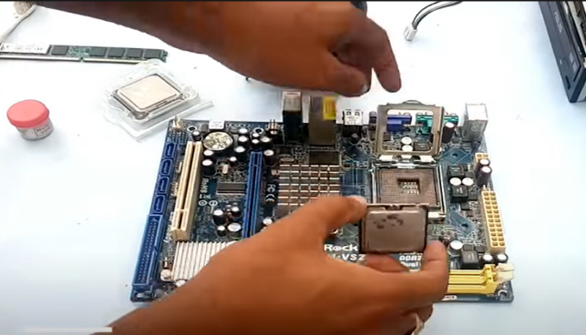
Opening CPU slot

Now we need to install the CPU carefully in the CPU slot. Make sure that all CPU edges match with the slot.

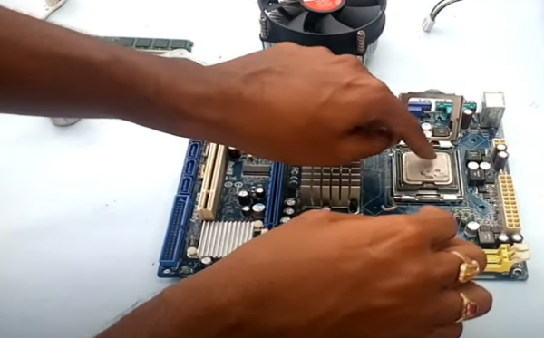
Installing CPU

After installing the CPU perfectly, then we have to close the slot slowly and carefully otherwise it can damage the CPU.

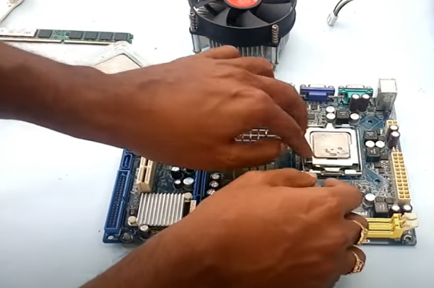

2. Heat sink installation:

Place the CPU heatsink according to the diagram print on the motherboard.

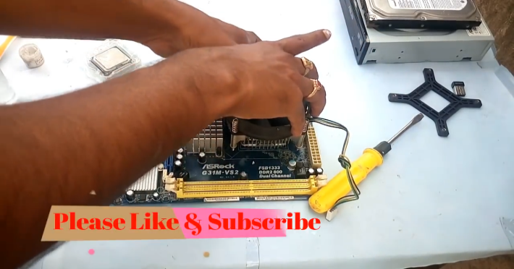
Heat sink installation

After attaching the heatsink, place the mounting ring at the back of the motherboard and align it with the CPU heatsink.

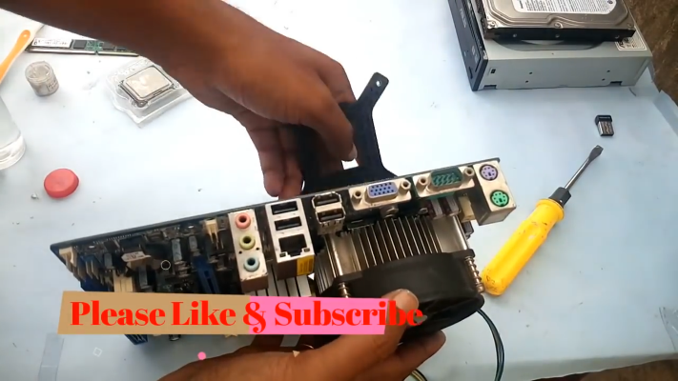
Attach mounting ring

Then we screw the CPU heat sink by following X-formation on the 4 screws. After that we attach the motherboard in the CPU cabinet.

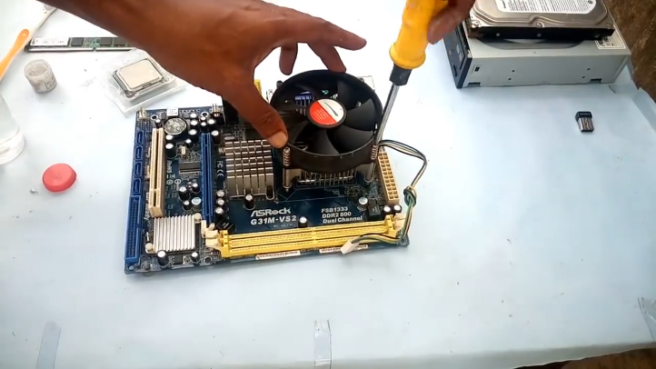
Heat sink attach by using screw

3.RAM installation:

In the next step we open the ram clip at the both side of the RAM slot by slowly pulling it outward before install the RAM.

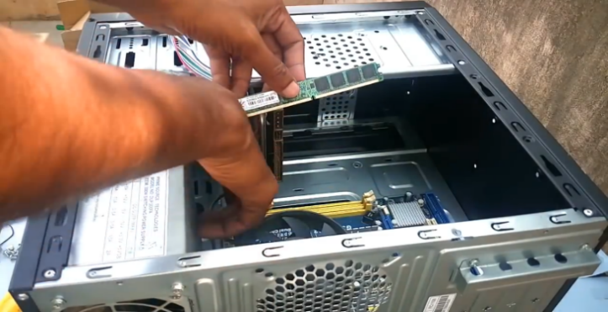
Opening RAM clip

Press the RAM stick into the RAM slot gently until you hear the click sound of the RAM slot clip. We have to ensure the RAM stick position is the same with the RAM slot.

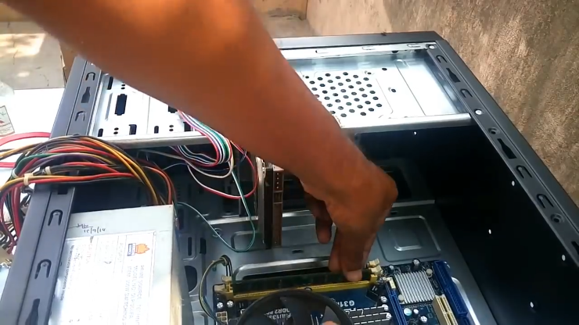
RAM installation
4.Power supply installation: After that install the power supply in the CPU cabinet then attach the power supply with CPU cabinet using screw.

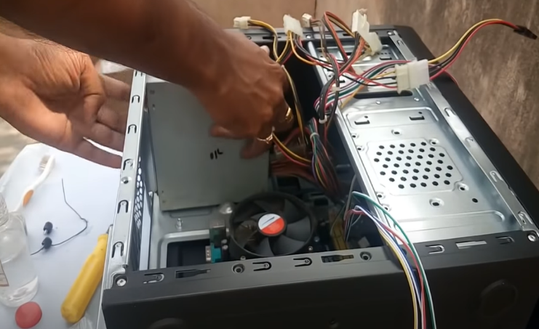
Power supply installation

5.Hard disk installation:

The next step is hard disk installation. Place the hard disk into the CPU cabinet.

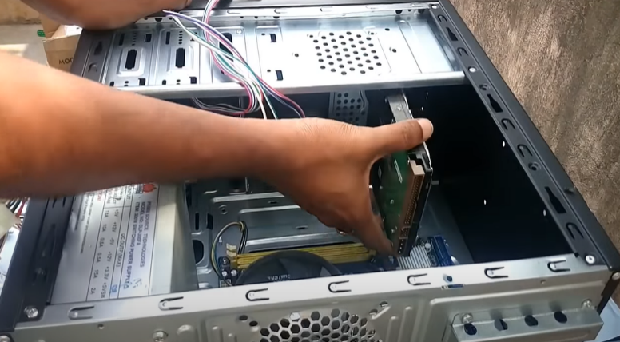

After placing it in the CPU cabinet bay, screw the hard disk tightly. Ensure the hard disk is tightly screwed on the CPU cabinet hard disk bay.

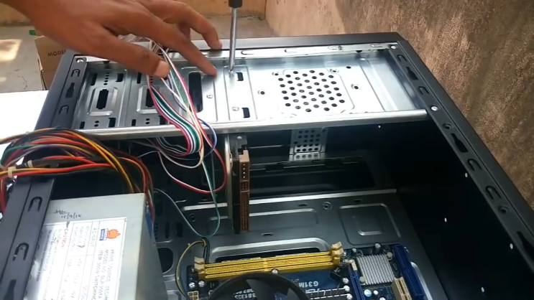
Attach by using screw

If the storage drive is configured as a master, plug in the black IDE cable connector into the IDE connector on the hard disk. If the storage drive is configured as a slave, plug in the grey IDE cable connector into the IDE connector on the hard disk.

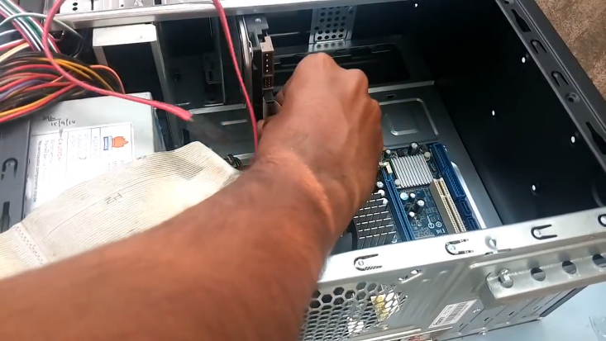
Installing hard disk

Tips: If the system is using ATA-7 and above technology, you can ignore the colour connector in cable installation and “master” and “slave” term.

Plug in the blue IDE cable connector into the IDE slot on the motherboard.

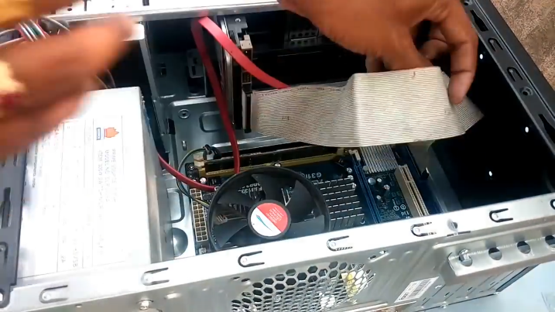

6. CD Rom/ DVD drive installation:

After hard disk installation, place the new drive, DVD drive in the CPU cabinet.

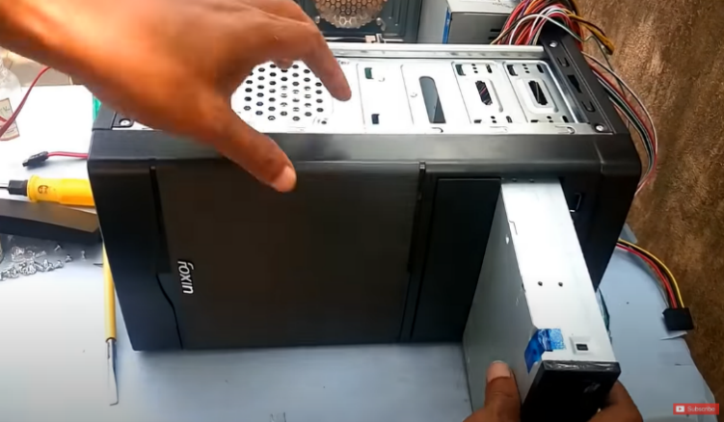
DVD drive installation

Then screw the DVD drive tightly by using the screwdriver. And ensure that the DVD drive is tightly screwed on the CPU cabinet DVD drive bay.

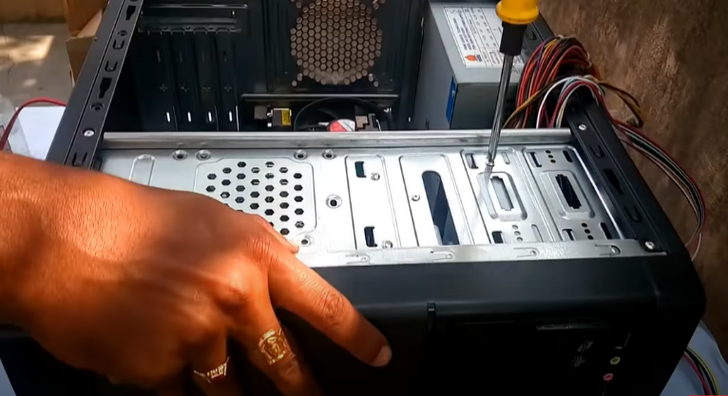
Screw DVD drive

Now we have to connect the CD ROM with the motherboard via SATA Cable. For that 1st we have to take the SATA cable and connect it to the CD ROM and another end of SATA cable will be connected to the SATA port on the motherboard.

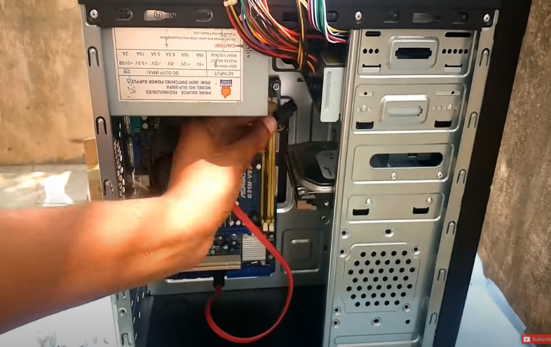

7.USB port installation:

Install the USB port in front of the CPU cabinet by connecting the cable with the motherboard. Carefully do the installation.

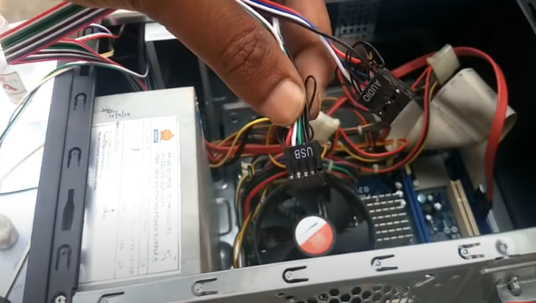
USB port installation

8. Graphics card installation:

For the graphics card section we have to use the PCI express 16x slot. We have to put in the graphics card. Make sure we need to use a PCI express 16x slot for the graphics card installation in order for the graphic card to operate normally.

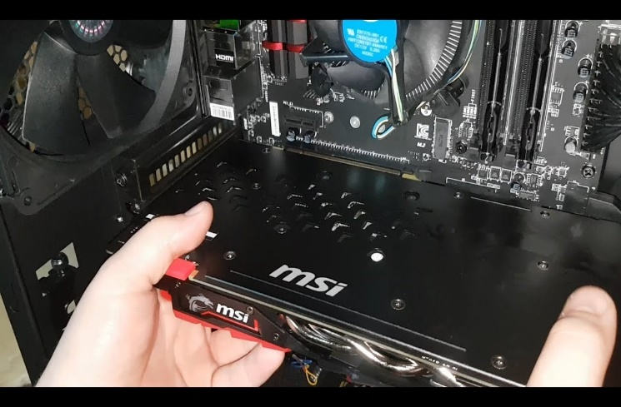

9. Power supply port Connection: Now we need to connect the power supply port with the Motherboard, CD ROM, Hard Drive, and graphics card. For motherboard connection we have to use Power SW, Reset SW, Power LED, H.D.D LED port to connect with motherboard.

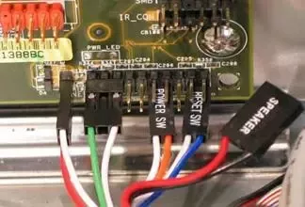
Power supply port

Connect ATX power supply pin to the Hard Drive.

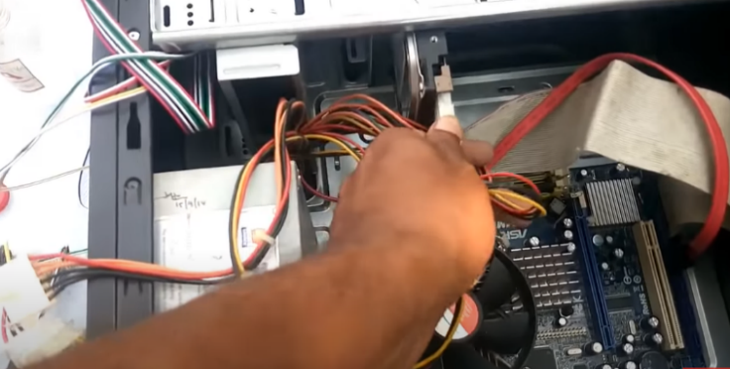
Connecting ATX pin

For graphics card, use via 6 pin F to M port which supplies the power on graphics card.

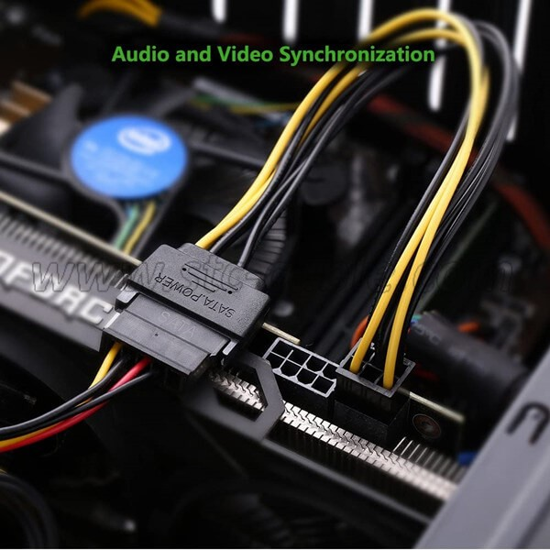
Connect pin with graphics card

Connect 4 pin peripheral ports to the CD ROM.

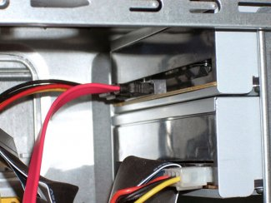
Connect peripheral port

10. Closing the CPU case and connecting the peripherals :

Put the side panel back on and tight it up with the case screws.

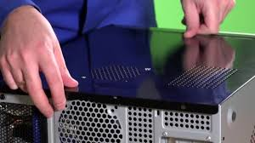

Connect mouse, keyboard, wireless network dongle, printer and webcams to the CPU by plugging into the USB port on the motherboard.

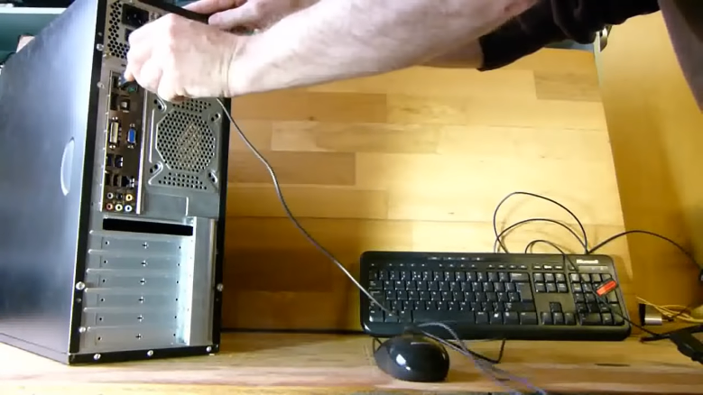

Insert 2.5 mm speaker audio jack into green 2.5 mm sockets and insert 2.5 mm microphone audio jack into the pink 2.5 mm sockets.

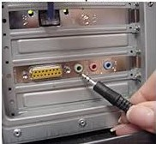

Connect the VGA cable into the monitor VGA ports.

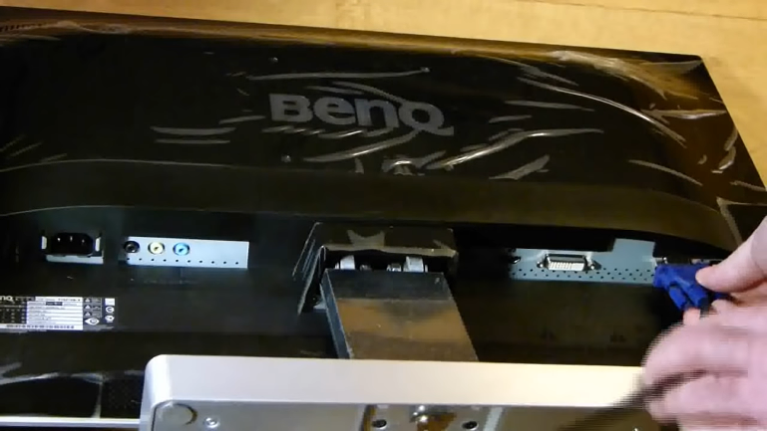

Finally, connect the other end of the VGA cable into the VGA connector on the motherboard.

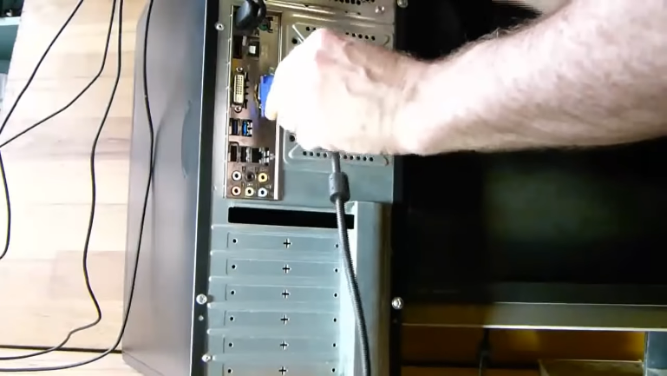

List of references :

https://en.wikipedia.org/wiki/Antistatic_device
https://blog.nzxt.com/tools-need-build-pc/
https://en.wikipedia.org/wiki/Pliers
https://en.wikipedia.org/wiki/Video_card
https://www.l-com.com/frequently-asked-questions/what-is-a-usb-cable
https://www.newegg.com/IDE-Cables/SubCategory/ID-2818
https://www.digitaltrends.com/computing/what-is-a-cpu/
https://en.wikipedia.org/wiki/Peripheral_Component_Interconnect
https://en.wikipedia.org/wiki/Hard_disk_drive#Competition_from_SSDs
https://www.lifewire.com/serial-ata-sata-2626009
https://www.youtube.com/watch?v=m_- G9Cacx2U&ab_channel=TechnologyGuide
https://www.build-computers.com/how-to-assemble-a-pc.html

