

Semester I 2020/2021

Subject : Technology and Information Systems (SECP1513)
Section : 6
Assignment : Step by step PC assembly

GROUP NAME/NUMBER: DIGITAL DOMAIN ( 7 )
1 |  | Name: Muhammad Kasyfi bin Kamarul Hamidi  Matric Number: A20EC0093  Phone Number: 0198338499  Email: kasyfikh@gmail.com
2 |  | Name: Muhammad Aniq Aqil bin Azrai Fahmi  Matric Number: A20EC0083  Phone Number: 0132958152  Email:muhammadaniqaqil@graduate.utm.my
3 |  | Name: Omar Mokhtar bin Yohan  Matric Number: A20EC0128  Phone Number: 0123674977  Email: omarmokhtar@graduate.utm.my
4 |  | Name: Teoh Wei Jian  Matric Number: A20EC0229  Phone Number: 01157512844  Email: weijianteoh2000@graduate.utm.my
5 |  | Name: Rahim Rehnuma Tahsin  Matric Number: A20EC5001  Phone Number: 0177276679  Email: rahimtahsin@graduate.utm.my
6 |  | Name: Afifa Jumana  Matric Number: A20EC4009  Phone Number: +8801799-430915  Email: a.jumana@graduate.utm.my

PART A – List at least FOUR tools needed to assemble a PC. For each tool, provide picture(s), explanations of its functions and its importance.

1.0 Screwdrivers

The number one most important tool for building a PC is a Philips-head screwdriver. Sometimes we need to extend the reach of the screwdriver and simply it just pulls out and it can happen only with high quality screwdriver like hefty screwdriver.
It can be used to secure the motherboard inside a case, installed case fans, tighten up PCle brackets and mount the hard drives to their respective phase. Moreover, we can use magnetic headed screwdriver so that we will not lose the screws in the blackhole!
Torx screwdriver: It is used to loosen or tighten screws that have a star-like depression on the top, a feature that is mainly found on laptop.
.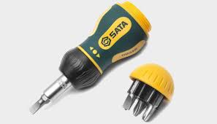
Diagram: Magnetic Screwdriver.


Diagram: Screwdriver set. (Torx screwdriver)

2.0 Anti-Static Equipment

There are many devices that can prevent electro-static discharge, an anti-static mat can be mounted on the workplace ground, allowing unlimited movement, but for a hobbyist designer, they can also be terribly costly. The most cost effective approach is purchasing an electro-static discharge wrist brace and then clipping it to a grounded item or plugging it into any wall outlet’s ground socket.

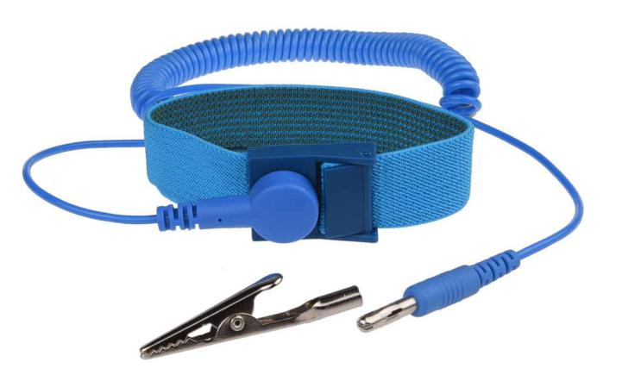
Diagram: anti-static strips.

Wrist straps are essentially a wire that provides the ground with direct skin contact and can be easily found. It is suggested that building on rough, non-insulating surfaces in the absence of an anti-static mat that is not required. The best choice is counter-tops, hardwood floors or a deconstructed cardboard box. This is a big insulator that can build up a static charge that could damage parts of your body.
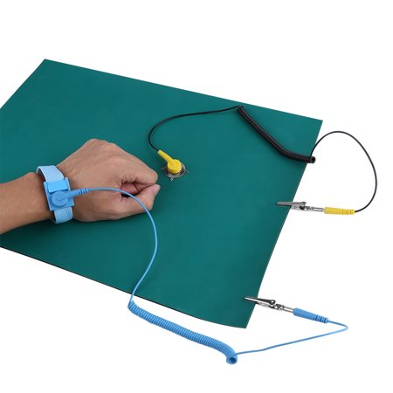
Diagram: Anti-static mat.

3.0 PLIERS

Sometimes when the heads of cheap screws get stripped, the only option is to carefully use a pair of pliers. Needle-nosed pliers have a wide variety of uses, and they often include a wire cutter, which can be used to snip the excess off of cable ties. Small needle-nosed pliers, forceps, or tweezers can be very handy to remove and insert jumpers on motherboards and hard drives as well.
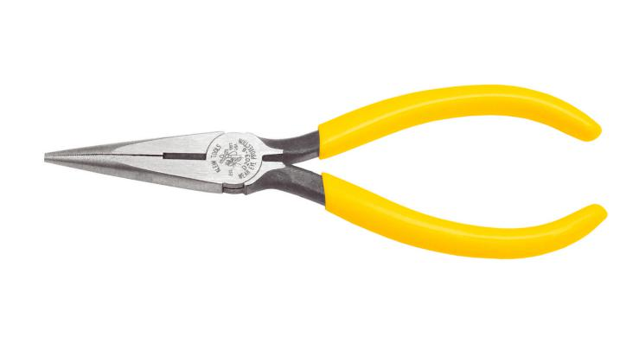
Diagram: Needle Nose Plier.

4.0 ZIP OR TWIST TIES

Cable management is crucial to keep airflow high and dust accumulation low. Moreover, it makes things look nicer and organised. Zip ties are the best way to keep cables in place, but they’re also only good for a single use. These plastic cable ties are useful for neatly bundling cables and wires away from fans and other components inside the computer.
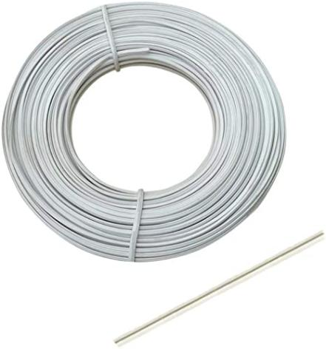
Diagram: A Twist Tie.

5.0 FLASHLIGHT

A flashlight can sometimes come in handy while trying to figure out something on an item that has already been installed. This tool is optional.

Diagram: A Hand Flashlight.

PART B – Sketch of a mother board layout

1.0 Sketch manually (using handwriting) a simple diagram of a motherboard layout that consists ALL keywords included in Table 1.0. Label each of the keyword.

Table 1.0 – Keywords for Part B and C

Graphic card | USB cable | IDE cable
CPU /  Processor | Slots (IDE, PCI) | Power supply
heat sink | RAM | hard disk  (jumper setting  either  master/slave)
CD ROM | SATA cable

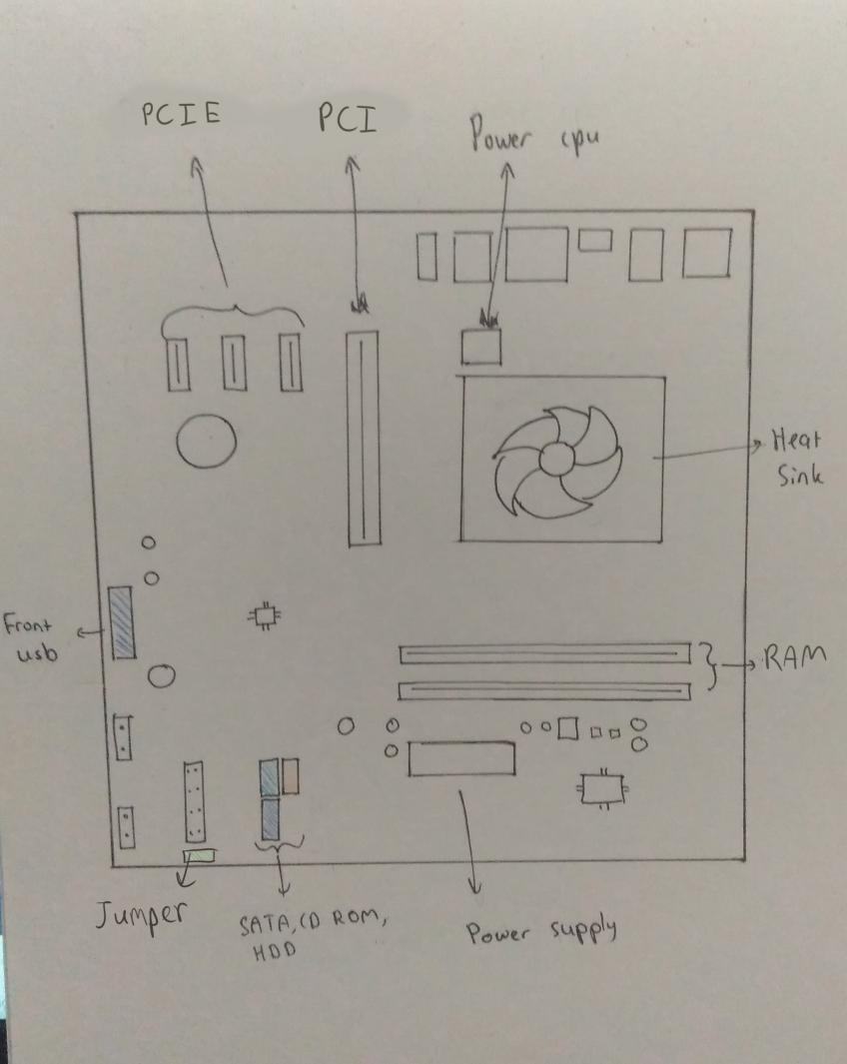
Diagram: Sketch of the Motherboard layout

2.0 For each keyword in Table 1.0. Provide picture(s), explanations of its functions and example of models.
Graphic card
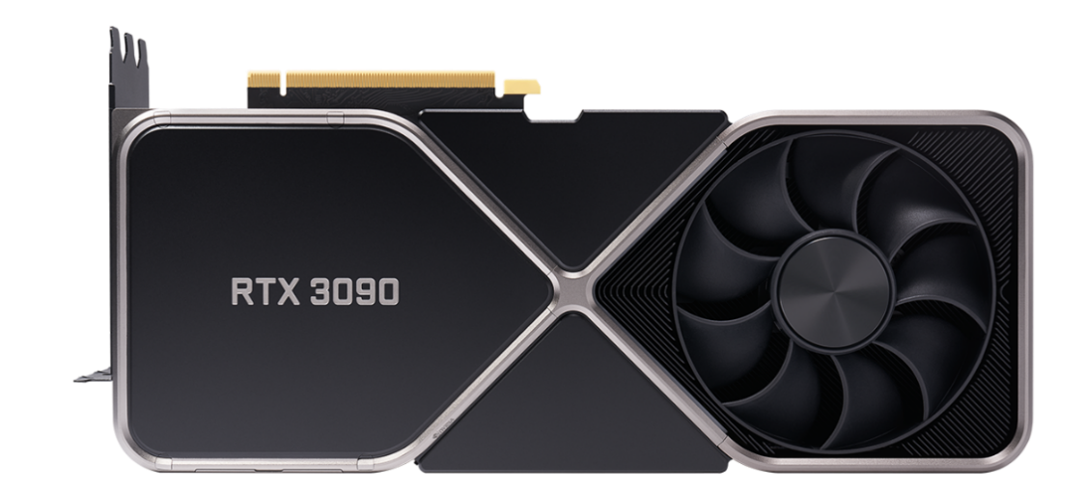
Nvidia GeForce RTX 3090
Graphic card is a computer hardware that allows computer to produce the image or graphic in our monitor more quickly. Graphics card has its own processor called graphical processing unit (GPU). Example of graphic card models such as NVIDIA GeForce RTX 3090, AMD Radeon RX 5700 XT, and NVIDIA GeForce MX150 etc.
USB cable
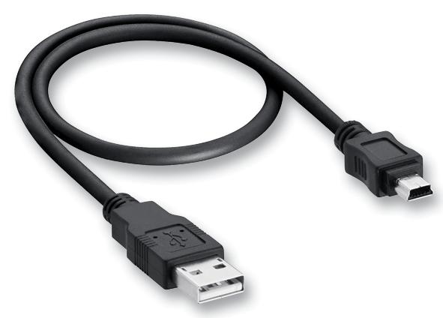
USB Cable, Type A Plug to Mini Type B Plug
USB, Universal Serial Bus is a developed hardware interface that make the peripheral devices such as mouse, keyboards, scanners, digital camera or computer mice can be easily connected to PC. Example of USB cable model is USB Type-A, USB Type-B, Mini-USB, Macro-USB and USB-C.

IDE cable
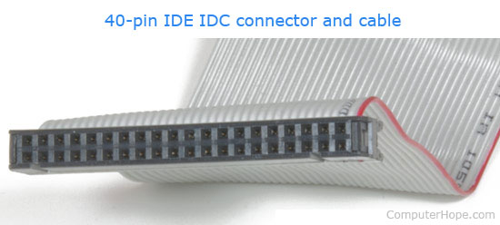
Integrated Drive Electronics, IDE or also known as Advanced Technology Attachment, ATA, is a regulatory cable. It is used as regulator on the motherboard and make it to be able to connect with Disk Drive. Example of IDE cable such as IDE and ATA-1, EIDE and ATA-2, ATAPI.
CPU/Processor
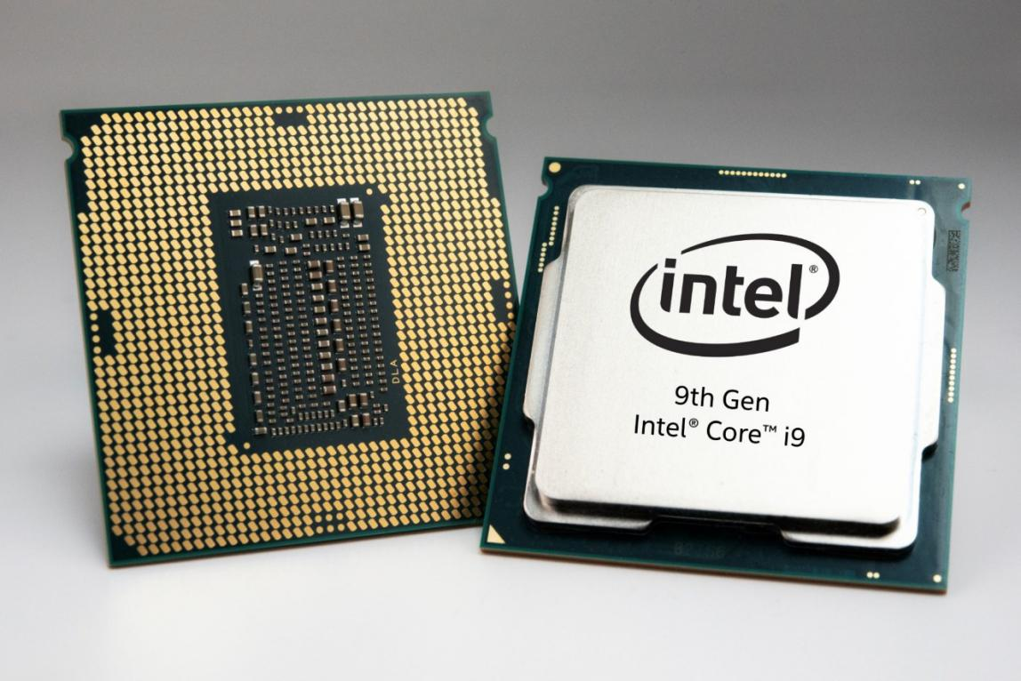
Central Processing Unit, CPU is the electronic circuitry within a computer. CPU will perform basic logic, input/output, controlling, arithmetic operation that specified by the instruction in the program. Example of CPU such as Intel Core i97980XE, Ryzen 3 Pro 1200 and Ryzen Threadripper 1920X.
Slots
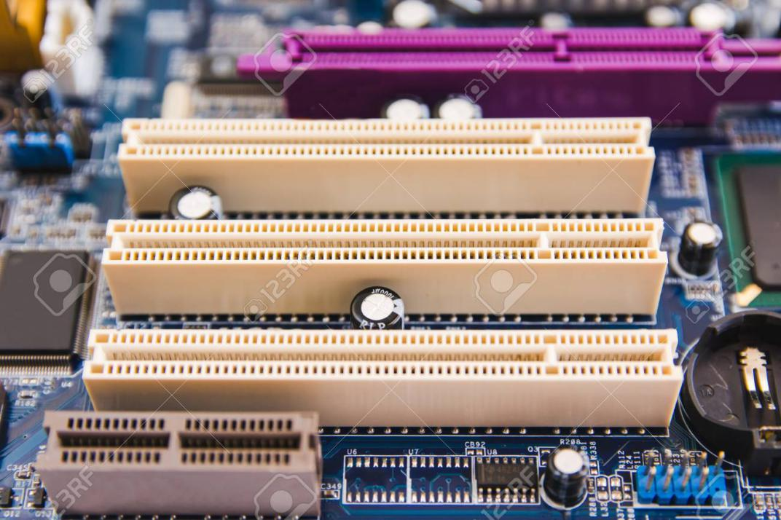
PCI Slot
Slot, alternatively known as expansion slot, expansion port, or bus slot. It provides an installation point for a hardware expansion card to be connected to the motherboard. Example of slot such as CPU slot, RAM slot, PCI slot and PCI express slot.
Power supply
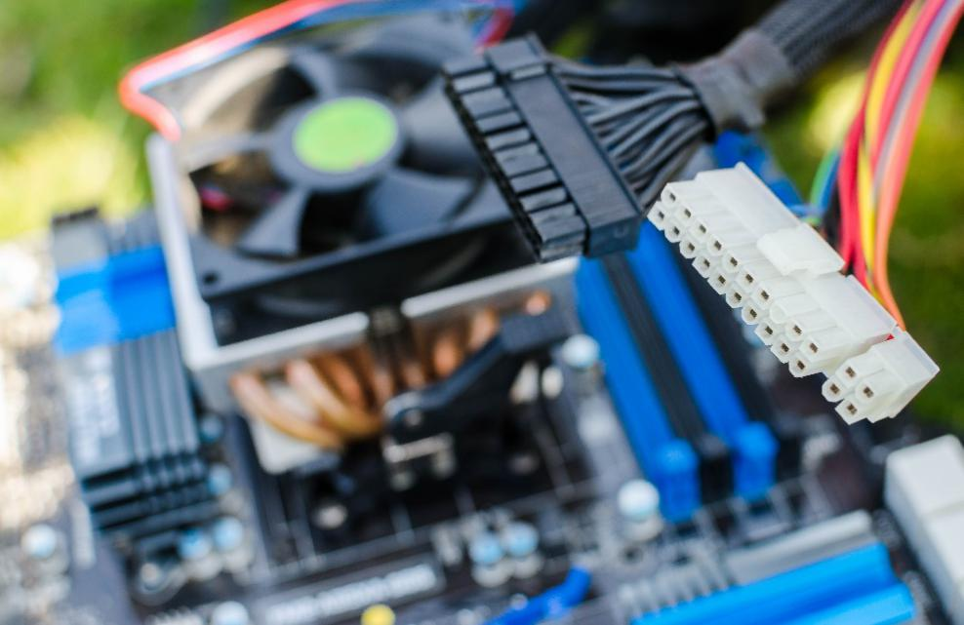
Power supply unit
Power supply unit (PSU) can converts mains main AC voltage to low-voltage which is regulated DC power for the internal components inside the computer. Example of model of power supply unit such as ATX large, CFX12V and TFX12V
Heat sink
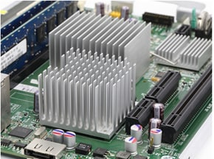
Heat sink
Heat sink is a passive heat exchanger which transfers the heat generated by electronic or mechanical device to a fluid medium like air or liquid coolant in order to regulate the temperature of the device. Example of heat sink model as extruded heat sinks, bonded heat sinks, and CNC machined heat sinks.
RAM
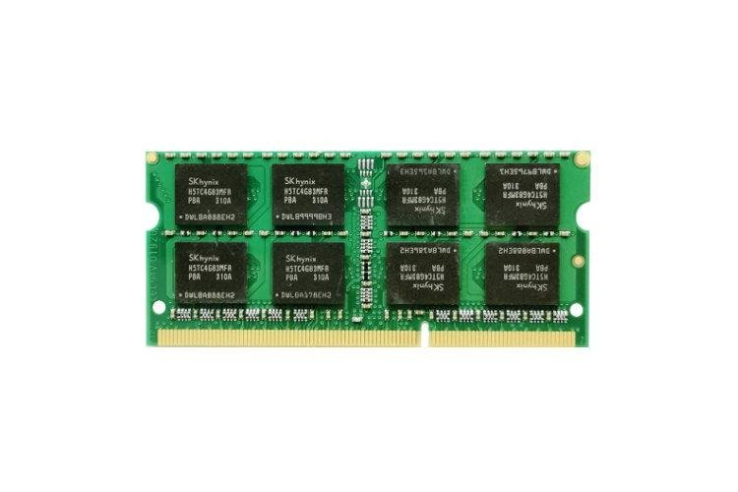
Memory RAM 4gb Acer- Aspire 4253
Random-access memory (RAM) is a form of computer memory that can read and changed in any order. A random-access memory device allows data items to be read or written in almost the same amount of time irrespective of the physical location of data inside the memory. Example of RAM such as DDR SDRAM, DDR2 SDRAM, DDR3 SDRAM and DDR4 SDRAM
Hard disk (jumper setting either master or slave)
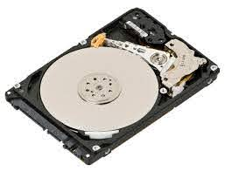
Hard disk drive
Hard disk drive (HDD) or fixed disk is an electro-mechanical data storage device that stores and provides relatively quick access to large amounts of data on an electromagnetically charged surface or set of surfaces. Master and slave settings on IDE hard drive are designed so we can put two drives on a single IDE cable. Example of hard disk model such as Seagate Barracuda, Toshiba X300 and WD VelociRaptor.

CD ROM
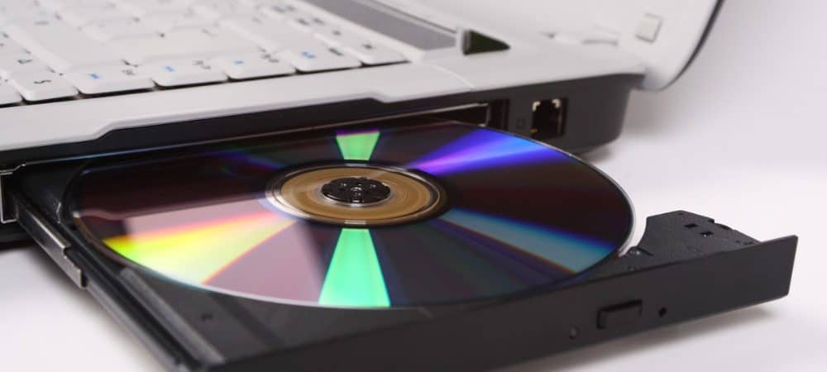
CD ROM
Compact Disc-Read Only Memory (CD ROM) is a type of CD disc that can only be read but cannot record anything. It is used to store data files or programs. A CD ROM have 700 MB storage size only. There are some example of CD other than CD ROM such as CD-DA, CD-RW, VCD and SVCD.
SATA cable
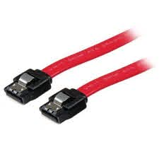
LSATA 12
Serial Advanced Technology Attachment (SATA) is an is an IDE standard for connecting devices like optical drives and hard drives to the motherboard. The data transfer speed of the SATA cable is bases on their won SATA interface. Example of SATA interface is SATA I, SATA II and SATA III. The higher the number of SATA interface that the SATA cable have, the faster the speed of data transfer

PART C - “Step by Step PC Assembly”
Based on the given video and keywords in Table 1.0, prepare a report on “Step by Step PC Assembly” that provide guided instructions on how to Assemble a PC. Assumed that in front of you is an opened computer case (without the side panels). Number of steps should not exceed the number of keywords.

Step 1: Opening the Case

- Remove the case screws.
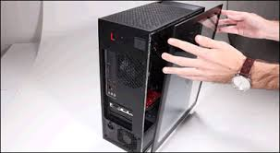
- Take the side cover off.

Step 2: Mounting the Processor (CPU)

- Lift up the latch lever to release and hinge open the CPU socket cover on the motherboard.
- Hold the CPU by its sides, line up any alignment notches or the triangle on the corner of the CPU to the triangle marked on the motherboard to ensure the correct orientation.
- Gently place the CPU straight down into the motherboard socket.
- Lower the CPU socket cover over the CPU and lower the latch lever closed to secure the CPU socket holder closed.
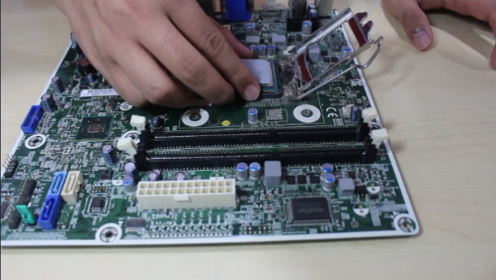
Tip: Do not apply force to seat the CPU. Avoid touching or pressing down on the back of the CPU with your fingers because any residue from your hands can destroy the heat transfer surface for the heat sink.

Step 3: Installing the Heat Sink

- If required apply a small amount of thermal paste to the back of CPU. Some heat sink come with a thermal pad already applied, in which case you can skip this step.
- Place the heat sink and fix it in position.
- Plug the power cable attached to fan of the heat sink into the motherboard connector.
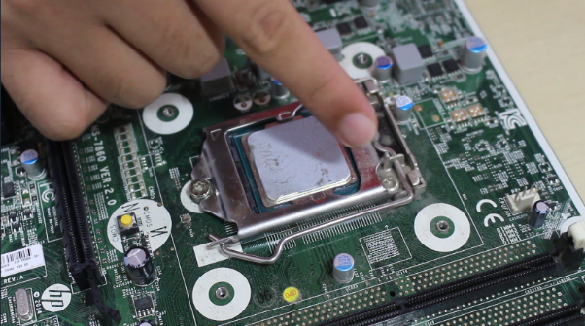
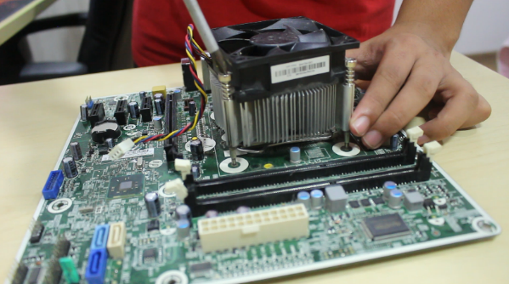

Step 4: Mounting the RAM
- Press to open the clips at both ends of the RAM mounting slots.
- Line up the notch on the RAM stick with the mounting slot.
- Place the RAM onto the slot and press it down firmly down into the slot. The tabs should automatically latch closed as you press the RAM down, securing the RAM in place.
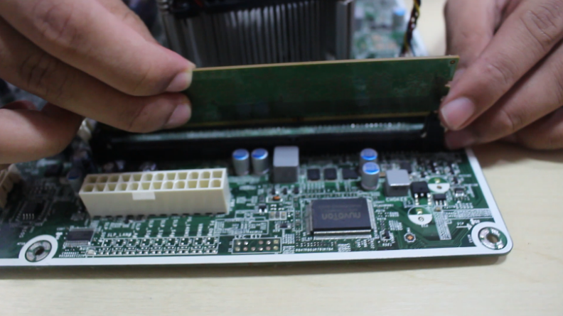
- Repeat the same process to install any other RAM you have.

Step 5: Mounting the Motherboard

- Screw the motherboard standoffs into the case. The motherboard sits on top of the motherboard standoff which screw into the case mounting points. The top of the standoff has a thread for the motherboard mounting screws to screw into.
- Mount the motherboard I/O shield/plate into the case.
- Fasten the motherboard in place on top of the mounting standoffs.

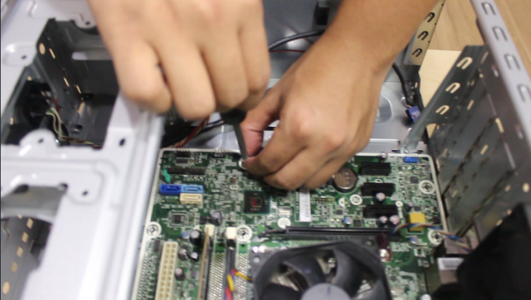
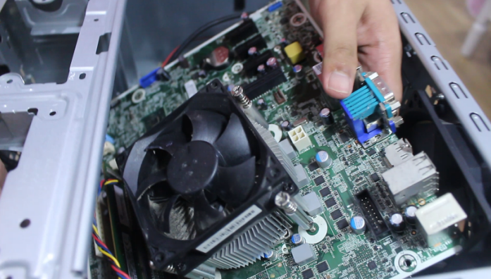
Tip: Install the mounting standoffs in the case positions that match the screw mounting holes on your motherboard.

Step 6: Installing the Power Supply

- Mount the power supply and fasten with screws to the case mounting points.
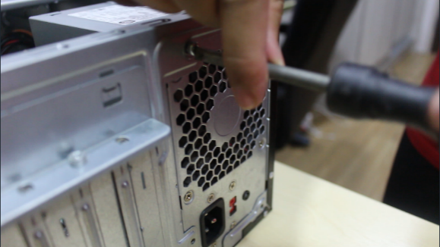
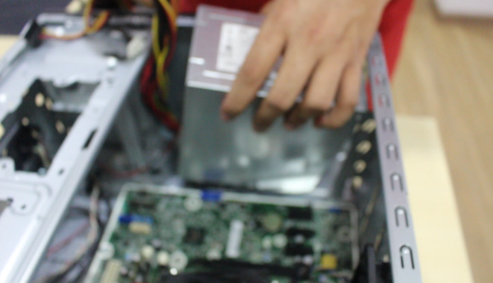
- Plug the largest cabling connector from the power supply cabling into the motherboard power connector.
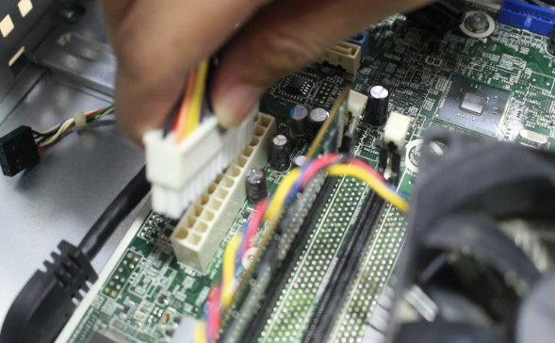
- Plug the 4-pin cabling connector from the power supply cabling into the CPU power connector.

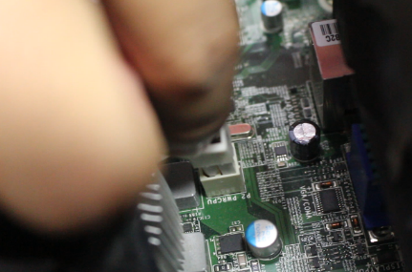

Step 7: Installing the Graphics Card

- The graphics card is slotted into a PCI expansion slot.
- Line the graphics card up and press down firmly to seat the card.
- Screw in the graphics card to hold it in place.
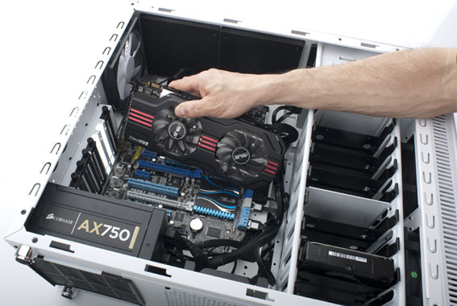
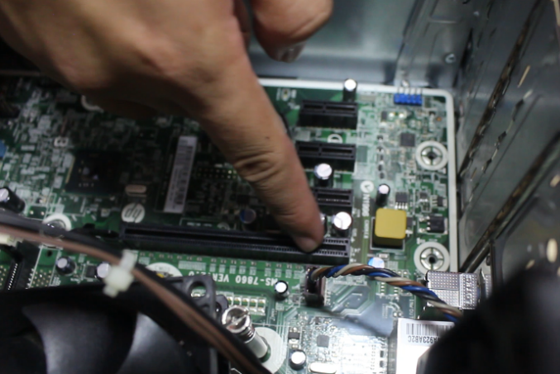
- Plug in the power connector cables from the power supply into the graphics card power connector if it requires external power.

Step 8: Mounting the Storage Drives ( Hard Disk)
- Mount the hard disk drive (HDD) in the case drive bays.
- Screw the hard disk drive in place through the case frame into the case mounting holes located on the hard disk drive.
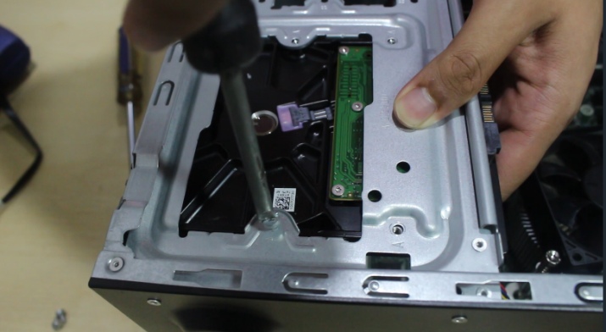
- Connect the hard disk drive to the motherboard using a SATA cable.
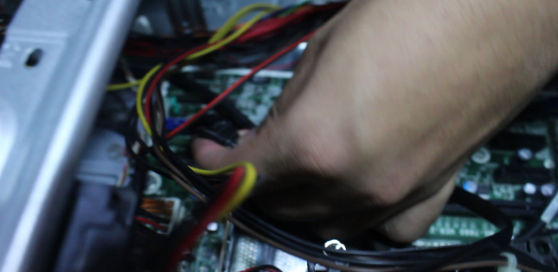
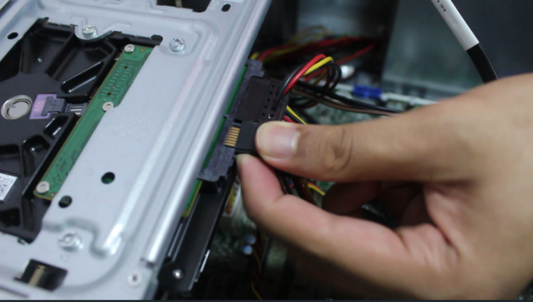
- Plug in power cabling to the storage drive.
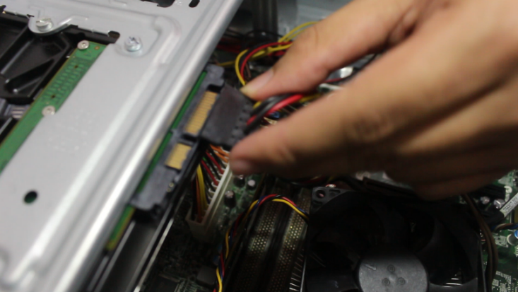

- Repeat the same process to install any other hard disk drive.
- The jumper setting of the hard disk drives can be either master or slave depending on where the jumper is positioned.
Step 9: Mounting the Optical Drive (CD-ROM)

- Remove any front panels from the computer case where the CD-ROM will sit.
- Mount the CD-ROM and screw it in place through the case mounting holes located on the CD-ROM.
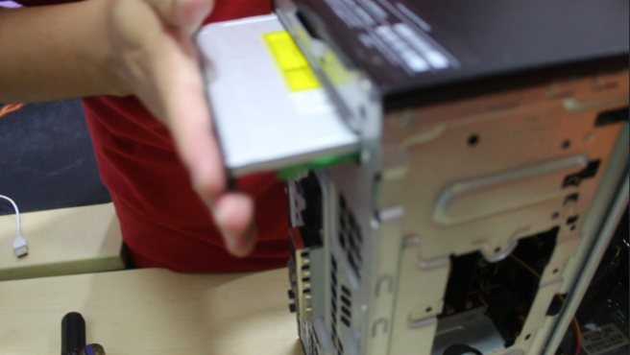
- Connect the CD-ROM to the motherboard using an IDE cable.
- Plug in power cabling from the power supply to the CD-ROM.
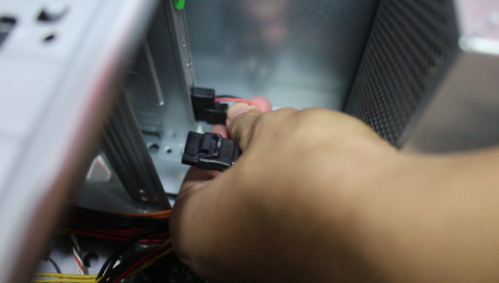
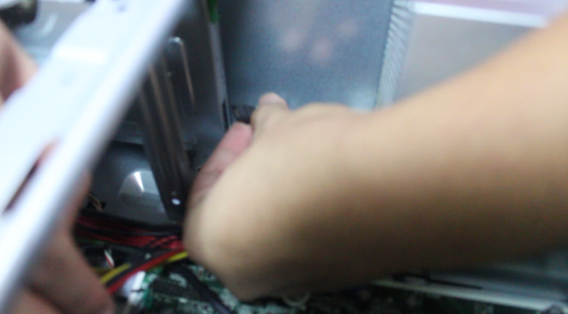

Step 10: Connecting Case Fans and Front Panel Connections

Information: Some computer cases come with case fans already installed. If not you need to mount it on your own or choose not mount any fans on your computer.

- Mount any case fans in the case using screws or clips.
- Connect the case fan power connectors to the multiple fan headers located on the motherboard.
- Identify the cabling from the front panel ports of your computer.
- The front panel connectors is plugged into the motherboard.
- Connect any front panel audio connectors to the motherboard front audio header.
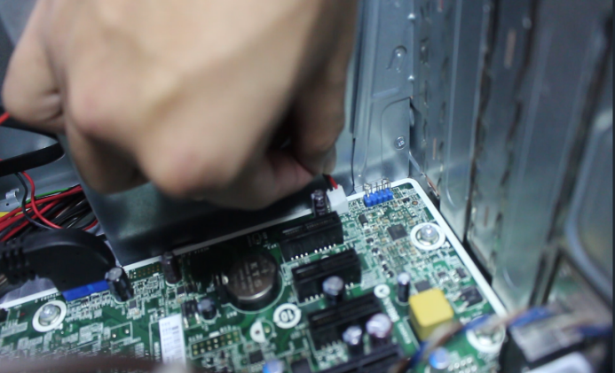
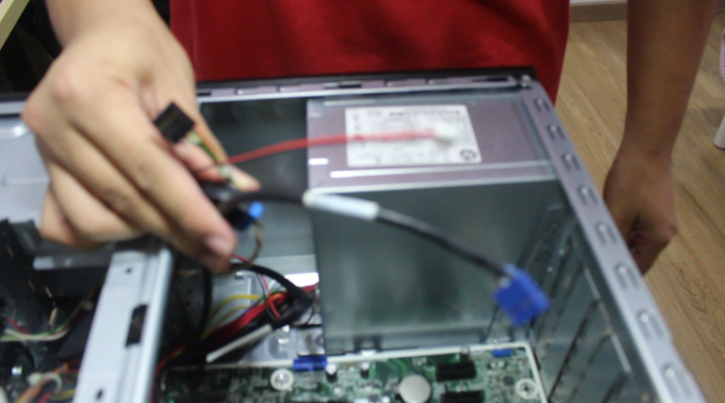

- Connect any front USB connectors to the motherboard USB headers.

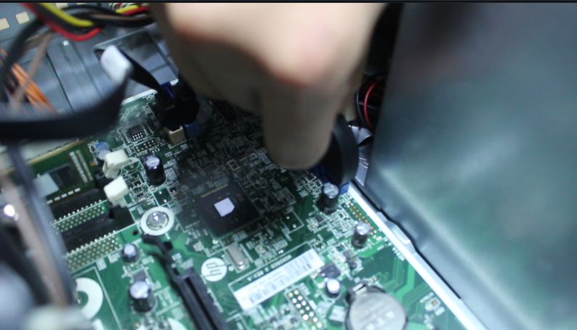

- Connect the front panel case connectors to the motherboard front panel I/O headers.
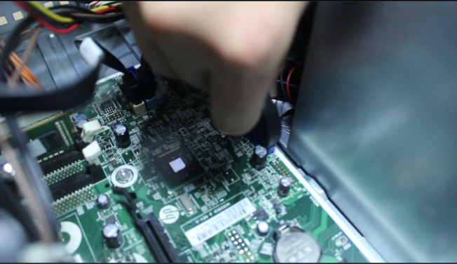

Step 11: Closing the Case and Connecting the Peripherals.

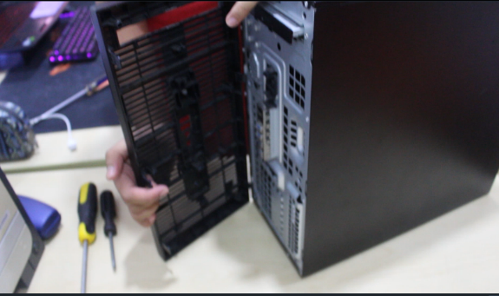
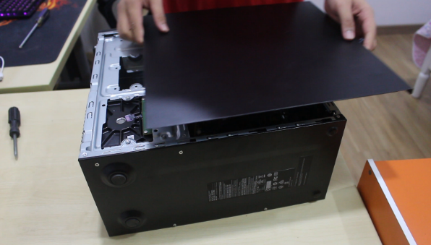
- Place the side cover back on and secure the side panels with case screws.

- Connect peripheral devices which include keyboard, mouse, wireless network dongle, printer and webcams with your CPU by plugging into USB port.
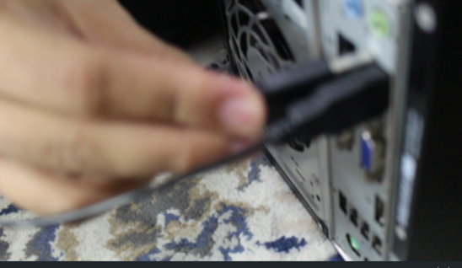
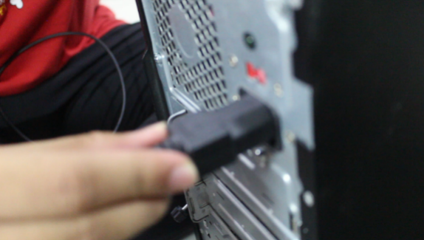

- Then, connect speakers and microphone into 2.5 mm sockets.

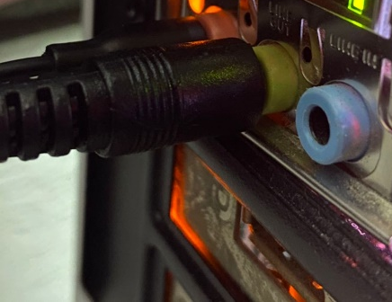

- Finally connect the CPU with monitor by plugging into display ports
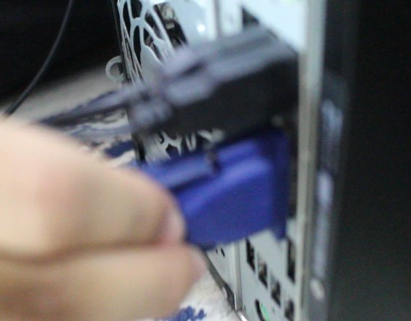

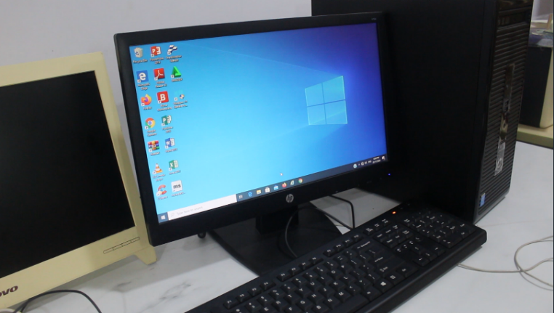
Build completed:
