
SECP1513- TECHNOLOGY & INFORMATION SYSTEM

MULTI-COURT SYSTEM PROJECT REPORT

LECTURER: DR. MUHAMAD RAZIB BIN OTHMAN
Presented by
DESIGN THINKING GROUP DIGITAL DOMAIN
NO. | NAME OF STUDENTS | STUDENT ID
1 | Muhammad Kasyfi bin Kamarul Hamidi | A20EC0093
2 | Muhammad Aniq Aqil bin Azrai Fahmi | A20EC0083
3 | Omar Mokhtar bin Yohan | A20EC0128
4 | Teoh Wei Jian | A20EC0229
5 | Rahim Rehnuma Tahsin | A20EC5001
6 | Afifa Jumana | A20EC4009
SUBMISSION DATE: 15th NOVEMBER 2020
Table of Contents
List of Figures 3
1. INTRODUCTION 5
ACKNOWLEDGEMENT 5
Objectives of the project 6
2.THE DESIGN THINKING PROCESS 7
Empathy 7
Define 9
Ideate 10
Prototype 12
Test 14
4. TASK DIVISION 18
5.REFERENCES 19

List of Figures
Figure 1: Kasyfi (left) Interview Haziq (right) on emphaty part 6
Figure 2: Aniq (left) interview with Harith (right) 7
Figure 3 : Example of a mixed lines Court 8
Figure 4 : Discussion Using Discord 9
Figure 5 : Discussion Using Discord 9
Figure 6 : Design Sketch 10
Figure 7 :Final Sketch 10
Figure 8 :Basketball Court Prototype 11
Figure 9 : Futsal Court Prototype 11
Figure 10 :Tennis Court Prototype 11
Figure 11 : Final Test for the Users 12

1. INTRODUCTION
Design Thinking is an iterative process wherein effort is made to know the user, question assumptions, and reevaluate the problems in order to pinpoint answers that may not be instantly reachable with our initial level of comprehension. The five phases that are essential in the design thinking process is empathy, define, ideate, prototype, test. It is a way of thinking and working as well as a collection of hands-on methods (Rikke & Teo, 2020).

ACKNOWLEDGEMENT
First and foremost, we would like to express our gratitude to our lecturer, Dr. Muhamad Razib Bin Othman , who helped us in making this assignment. Without the guidance from him we cannot accomplish this. This golden opportunity also helped us immerse into more knowledge on design thinking and applying group thinking and discussion to develop a solution to the predetermined problem. Although we encounter various problems, but we managed to handle it and complete this assignment in the time given.

We would also like to express our gratitude to everyone who has helped us directly or indirectly. Moreover, our team members worked hard together to develop our prototype. We hope this prototype can benefit the target user and can be applied in everyday life.

Objectives of the project
This project is carried out to provide a solution for the residents of condominiums and apartment complexes who face the problem which is the limitation of a single court in their building. We have interviewed several residents and gained useful insight which helped us to develop our product into a working prototype. The interview process involved a lot of trial and error and many brainstorm sessions. The end result is a product design which involves the ability to change courts depending on what sports the user wants to play using a controller or screen selection.

2.THE DESIGN THINKING PROCESS

Empathy
We conducted interviews with several condominium residents in order to get more insight of the courts at their respective buildings. The responses that we got were very helpful in order for us to come up with plans for solving the problem.
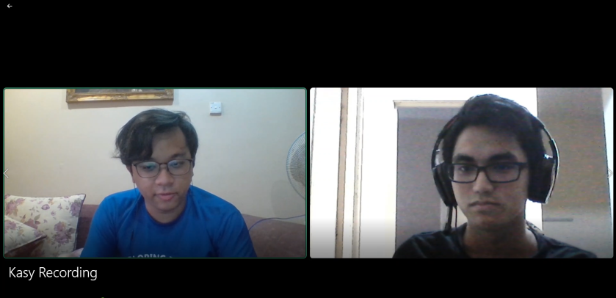
Figure 1: Kasyfi (left) Interview Haziq (right) on emphaty part
The interviewee was a 19 year old college student. The first question asked was about the type of court that is established at their condominium residence. The interviewee replied that there is an indoor hockey court available. The next question asked was whether he plays hockey or not. The response was that the interviewee did not play hockey and prefers playing basketball instead. The last question asked was directed towards his feelings towards the limitation of not being able to play the sport that he wanted to. The interviewee explained that it was upsetting that residents are unable to play the sport that they like.

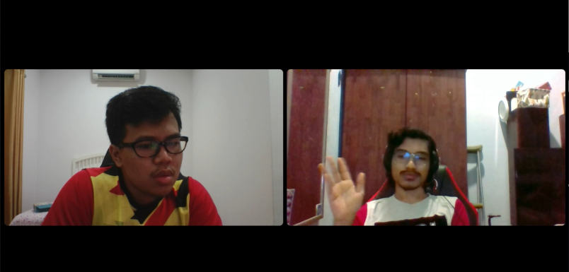
Figure 2: Aniq (left) interview with Harith (right)

The interviewee is a 19 year old college student living in a condominium. The first question asked was about the number of courts that are present in the condominium. The response was that there was only one court which people played multiple types of sports on such as basketball,futsal and badminton. The second question was whether it was confusing for the residents since one court is used to play various different sports. The interviewee replied that it was confusing for both him and the other residents because of the mixed lines on the floor makes it difficult to keep track of the rules when playing a sport.

Define
Based on the response from the interviews conducted, we were able to list down several key problems that needed to be addressed:-
Problem 1- Limitation of single court in the condominium residence
Problem 2- The confusion caused by mixed lines on the court
Problem 3- Users’ desire to play different types of sport

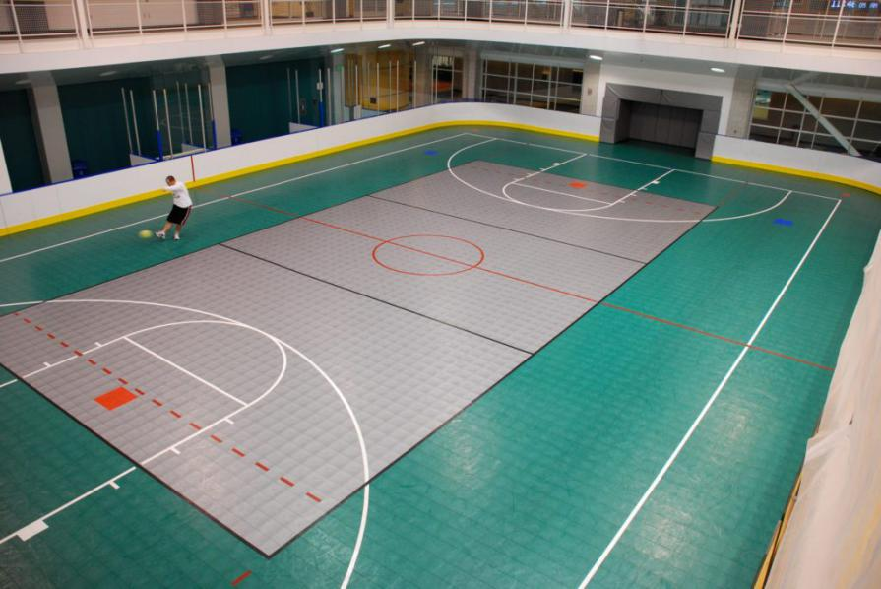

Figure 3 : Example of a mixed lines Court

Ideate
Several sessions were held in order to brainstorm ideas for solutions to the problem addressed. These sessions were held over video call and also through group chat and text messages.
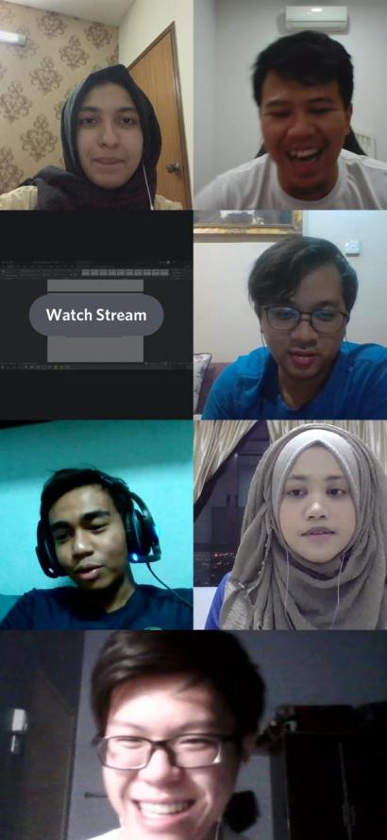
Figure 4 : Discussion Using Discord

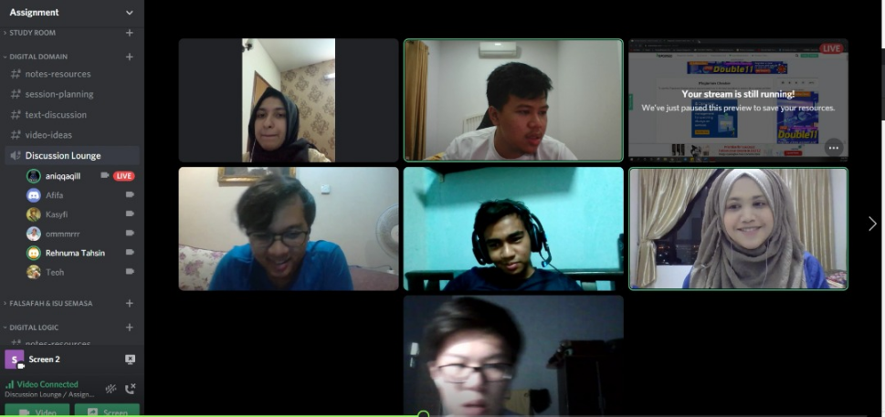
Figure 5 : Discussion Using Discord

A live session was held which we discussed about our findings and potential ideas for the prototype.

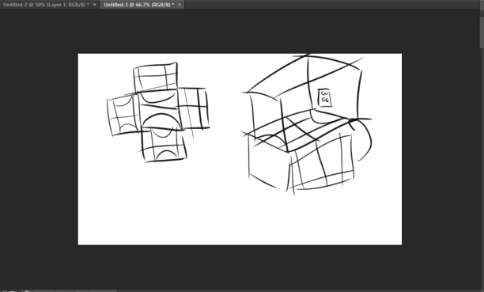
Figure 6 : Design Sketch
An early sketch of the design of the prototype. The idea was to add the ability to rotate the court mats under the floor of the indoor court. The floor would be made of hard, transparent material which allowed the users to see the court mats below, and also prevent any injuries caused by the rotation.

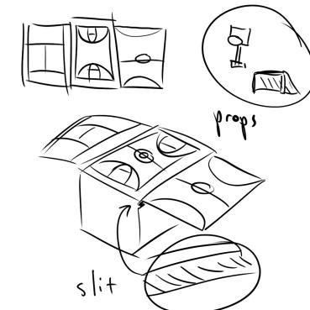
Figure 7 :Final Sketch
The final design of the prototype. The idea is that the court mats are spread in a horizontal line under the floor of the court. By controlling the selection of the court with a device, the courts can be interchanged through a conveyor belt system which uses less space compared to the previous idea, and is also easier to maintain.

Prototype
After deciding on a final product, a prototype was developed in order to test the features of the product idea and as a demonstration to the potential user.

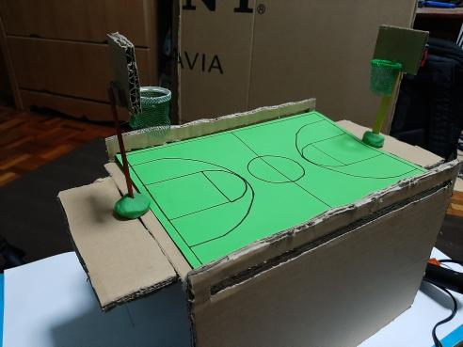
Figure 8 :Basketball Court Prototype
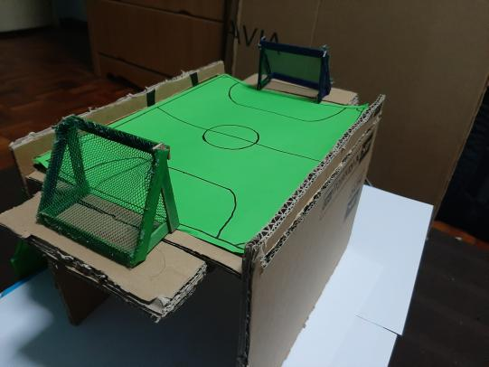
Figure 9 : Futsal Court Prototype

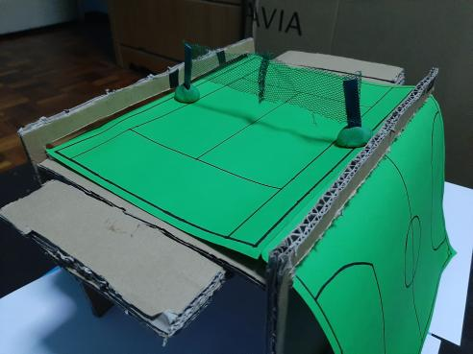
Figure 10 :Tennis Court Prototype

Test
After a working prototype had been finished, testing was needed in order to gauge the users’ reaction towards the product. Unfortunately, due to the COVID-19 pandemic it was difficult to distribute the prototype to the users for testing. In order to curb this problem, we recorded a video demonstration showing off our product to the target user. After the video demonstration, we asked the users for feedback regarding the functionality and overall appeal of the product.

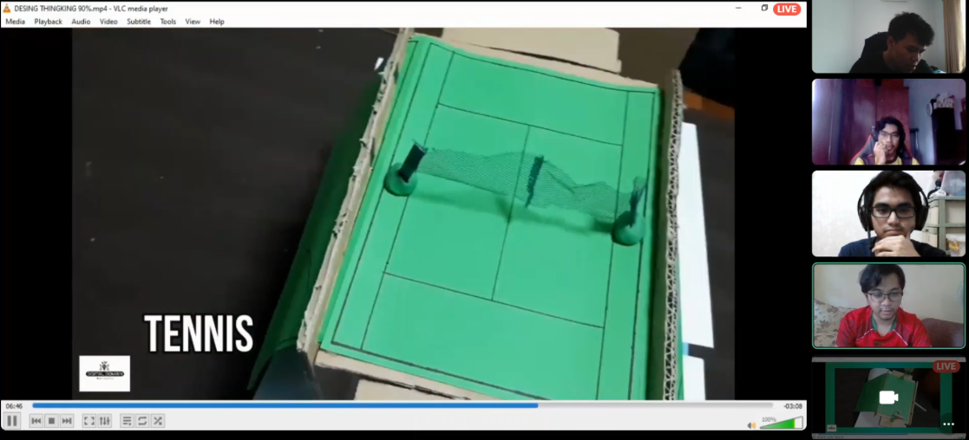
Figure 11 : Final Test for the Users

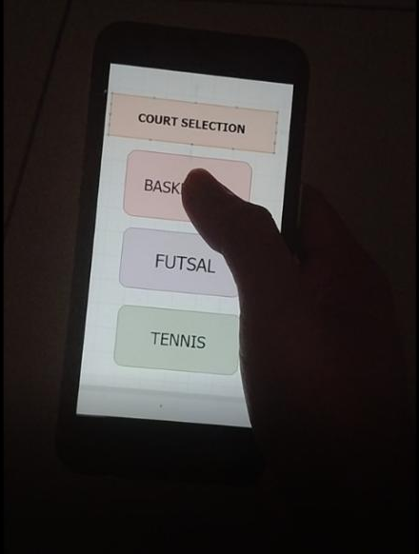
Figure 12: UI for app to control the court system

The overall response was positive. Both respondents felt very satisfied with the product and said that it would be a welcome addition to their residence. Some criticism was given however, regarding how long it would take for the courts to switch and also how other people could not play their sport when someone else is playing a different sport.

REFLECTIONS
Name | What is your goal/dream with regard to your course/program?
Muhammad Kasyfi bin Kamarul Hamidi | I hope that I am able to use the knowledge that I gain in order to pursue my preferred career in programming
Teoh Wei Jian | I hope I can join a team to develop software that will benefit society with the knowledge I learn from this program
Muhammad Aniq Aqil bin Azrai Fahmi | My goals is to expand my knowledge in this course and gain more experience on more about software engineering fundamental and be a programmer that will contribute to the society and country
Omar Mokhtar bin Yohan | I hope I can gain the knowledge and experience necessary for me to succeed in my future career in programming
Rahim Rehnuma Tahsin | My goal is to gain and be able to use my skills and knowledge to contribute and help in improving my society and have the career I desire to have in future.
Afifa Jumana | My goal is to build a software that can make our life more easier and comfortable in order to solving problems of my society and country. I want the proper use of coding and low cost of time or space so that the quality can be modified.

Name | How does this design thinking impact on your goal/dream with regard to your program?
Muhammad Kasyfi bin Kamarul Hamidi | I will be able to apply the same steps taken for this project in order to create my own products in the future
Teoh Wei Jian | Design thinking give me an idea about how to solve the reality problem by using IT, this experience will be helpful for me to develop software in the future
Muhammad Aniq Aqil bin Azrai Fahmi | Design Thinking really helps me to understand the fundamental of innovating something step by step and make me understand how a solution can be found through all the process that we gone through like emphaty ,define ,ideate and prototype building
Omar Mokhtar bin Yohan | I can apply the design thinking process to solve and give solutions to any problems that I may face in the future
Rahim Rehnuma Tahsin | Design thinking is a framework for solving problems that had improved my creative and analytical as well as empathetic skills to be able to solve problems.
Afifa Jumana | Design thinking is a practical way to develop the design concepts.As it is good for problem tackling and brainstorming, so it will help me to become more innovative. So that I can fulfill my goal by prototyping and testing.

Name | What is the action/improvement/plan necessary for you to improve your potential in the industry?
Muhammad Kasyfi bin Kamarul Hamidi | I need to accumulate more experience working in programming related jobs
Teoh Wei Jian | I plan to be more active in joining online talk given by those professional or senior programmer
Muhammad Aniq Aqil bin Azrai Fahmi | My action is to participate in any kind of industrial related programs which I can met a lot of people who can share their knowledge and share their valuable experience to me so that I will be ready to faces the future .
Omar Mokhtar bin Yohan | I must research and study more about this industry so that I can apply my knowledge when I enter this industry
Rahim Rehnuma Tahsin | I need to contribute and engage myself in many exercises to be able to create many programs and improve my programming skills with time. Understanding and improving my personal development skills can help me maximize my potential both personally and professionally.
Afifa Jumana | I’ll try to join more seminars on technology related project. By doing so I can increase my knowledge about related topic and share my experiences as well as know about others.

4. TASK DIVISION
This project was possible with the help of everyone in the group. We divided the tasks between each of us in order to streamline the process and create a more efficient workflow. The task division can be shown in the table below:
Name | Task
Muhammad Kasyfi bin Kamarul Hamidi | Objectives, Ideate, Reflections
Teoh Wei Jian | Test, Ideate, Reflections
Muhammad Aniq Aqil bin Azrai Fahmi | Empathy, Ideate, Reflections
Omar Mokhtar bin Yohan | Protoype, Test, Reflections
Afifa Jumana | Introduction, Acknowledgement, Reflections
Rahim Rehnuma Tahsin | Define, Empathy, Reflections

5.REFERENCES
Futsal Court | Best Sports Flooring Contractor Malaysia, courtesy of Sports Flooring Malaysia, accessed 12 November 2020, https://sportsflooringmalaysia.com/futsal-court/
Rikke & Teo, What is Design Thinking and Why Is It So Popular? https://www.interaction-design.org/literature/article/what-is-design-thinking-and-why-is-it-so-popular, (accessed 11 November 2020)

Rikke & Teo, What is Design Thinking and Why Is It So Popular? https://www.interaction-design.org/literature/article/what-is-design-thinking-and-why-is-it-so-popular, (accessed 11 November 2020)
Futsal Court | Best Sports Flooring Contractor Malaysia, courtesy of Sports Flooring Malaysia, accessed 12 November 2020, https://sportsflooringmalaysia.com/futsal-court/

