

DISCRETE STRUCTURE (SECI 1013)
TUTORIAL 3
DUE DATE: 7 January, 2020

Team members:
- SYAMIMI AMIRAH BINTI ZAMROS (A20EC0226) (Question 1, 3a, 3c& 4)
- ADNAN SHAFI (A20EC0255) (Question-5)
- HASAN ADITTYA (A20EC4023) (Question 2)
- ANIKA RAHMAN ANTU (A19ECO223) (Question 3b)

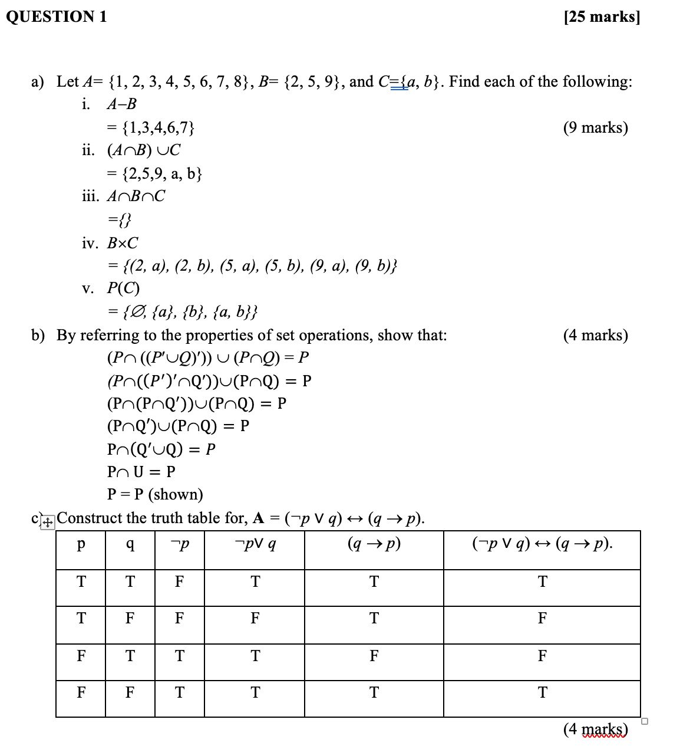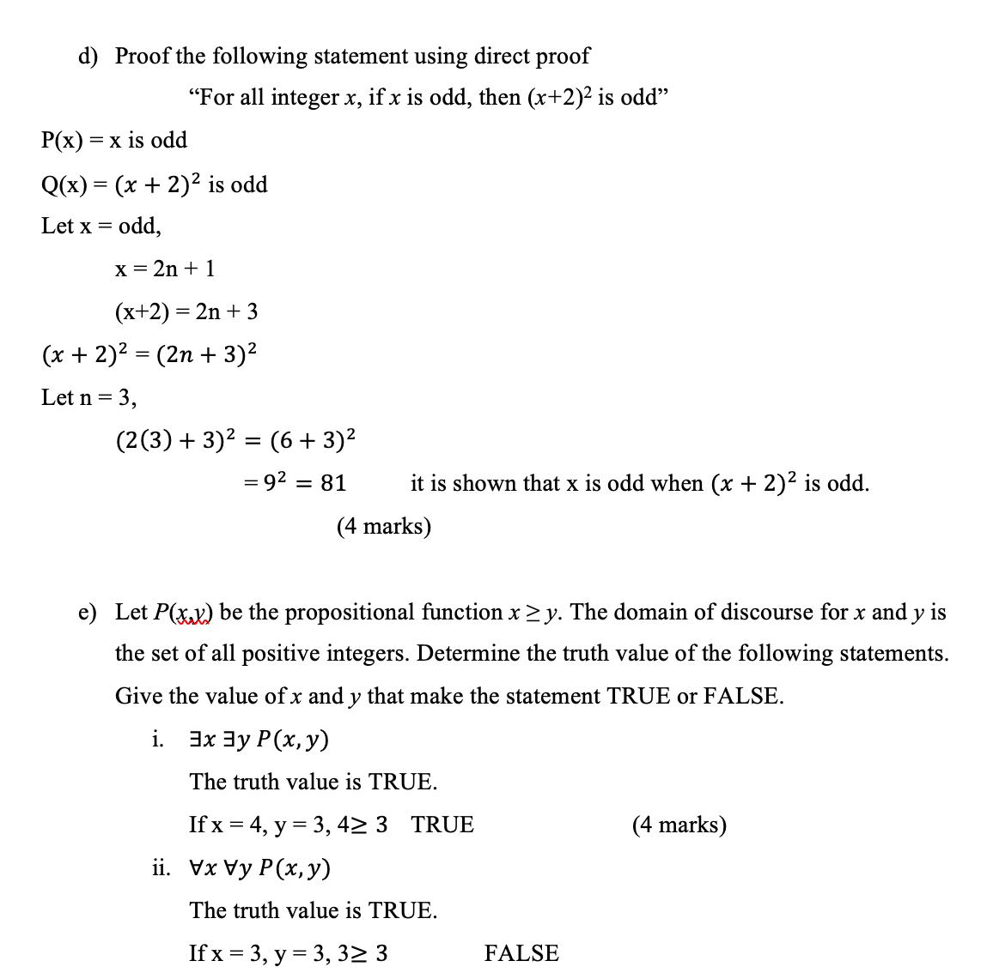
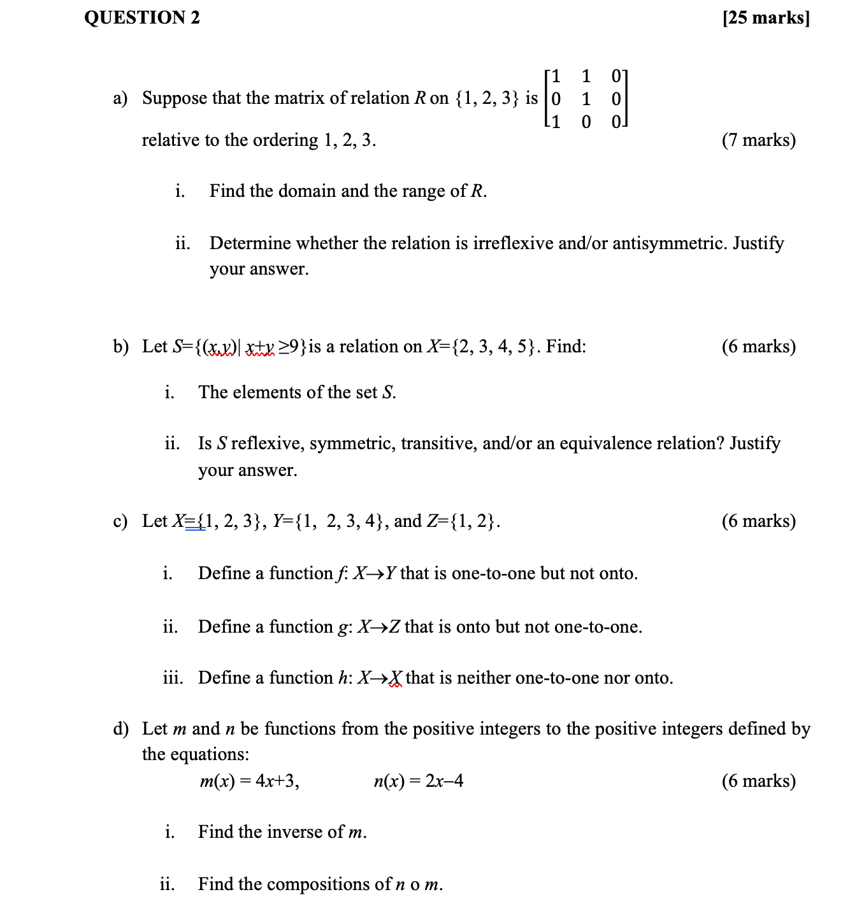
Answer:
a)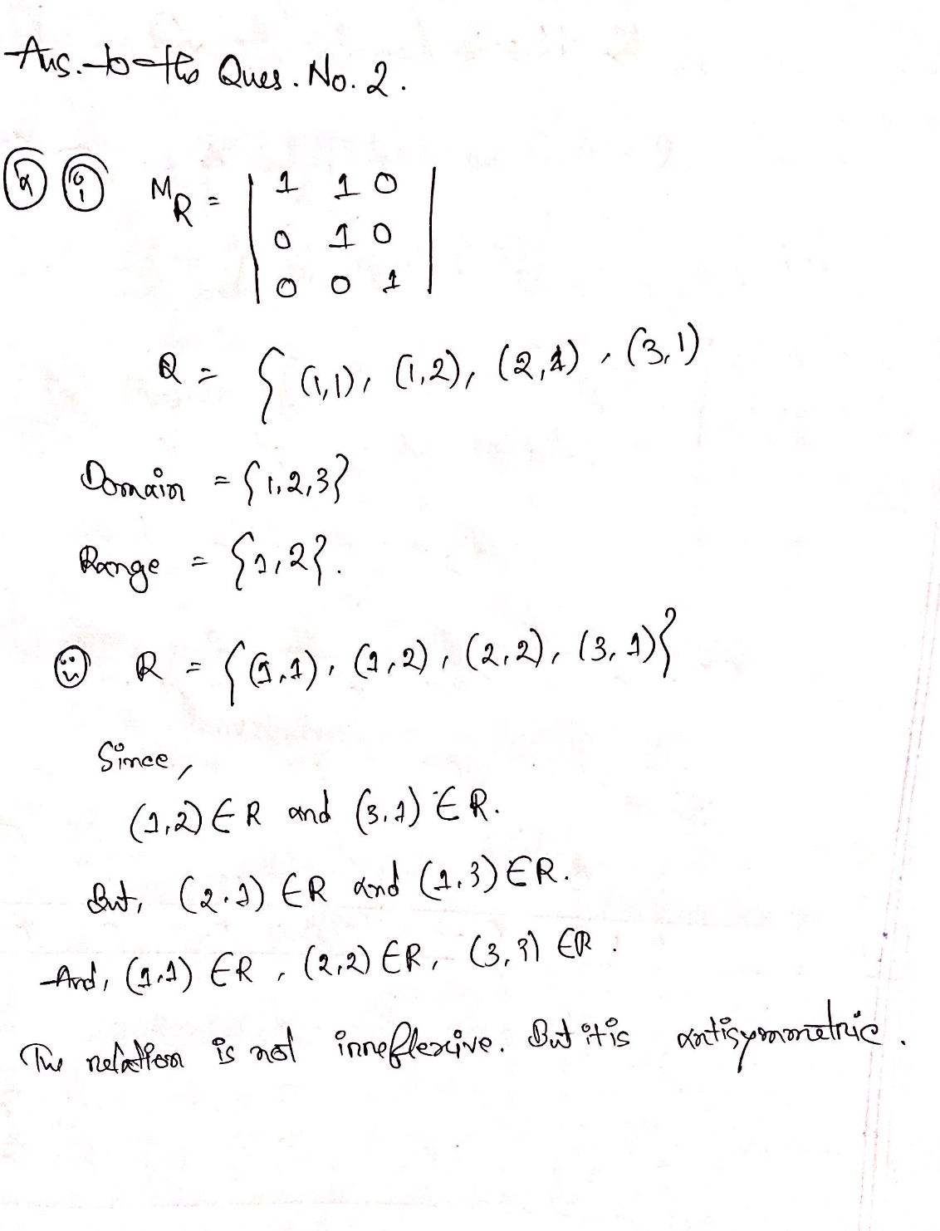
b)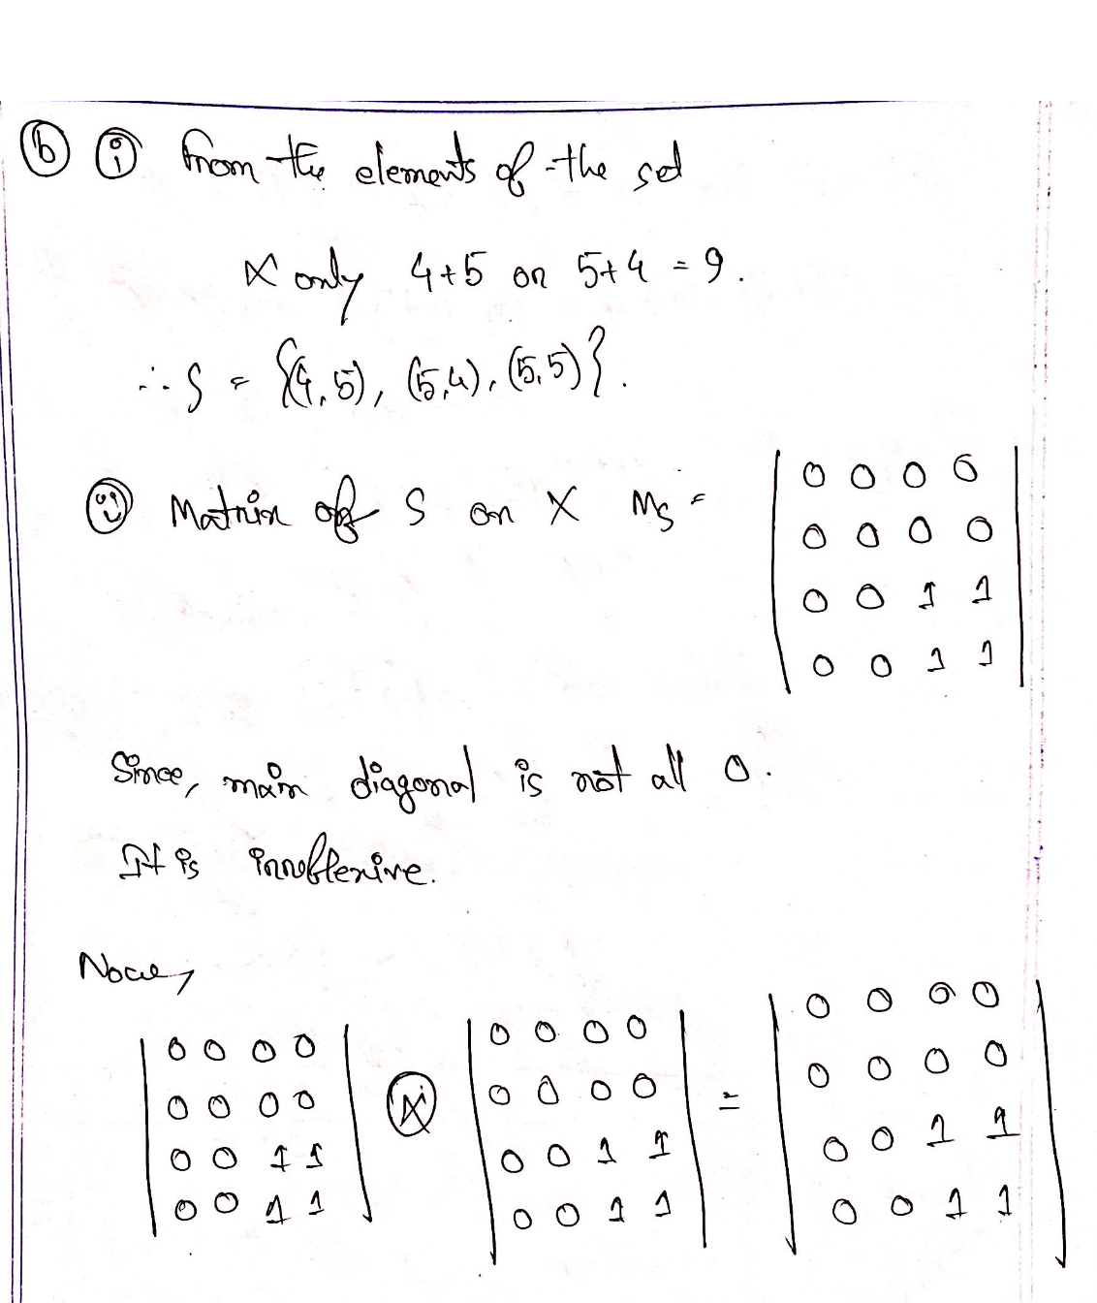
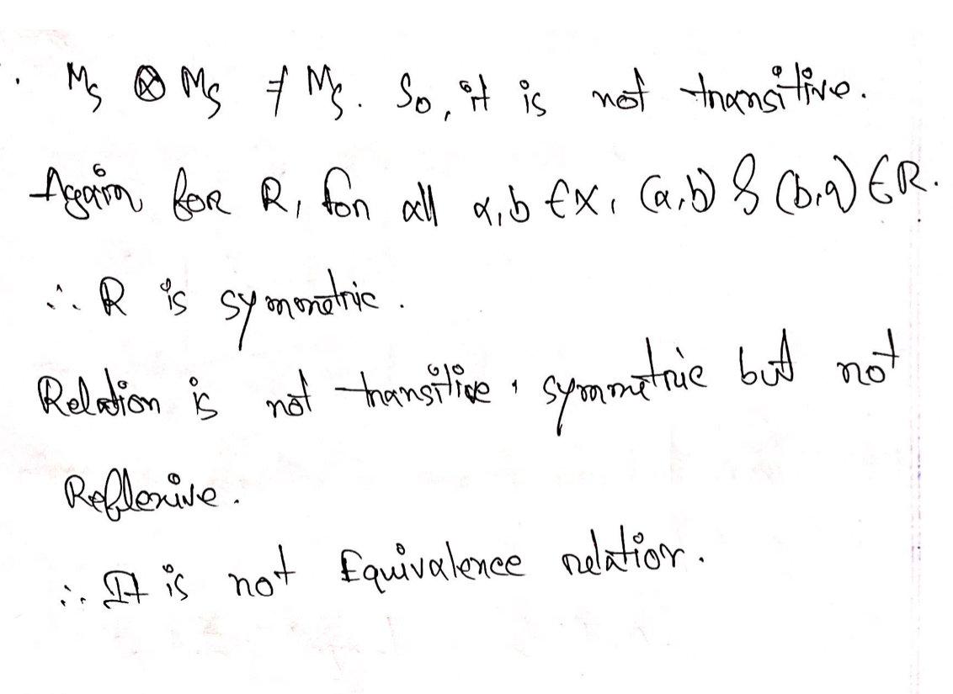
c)
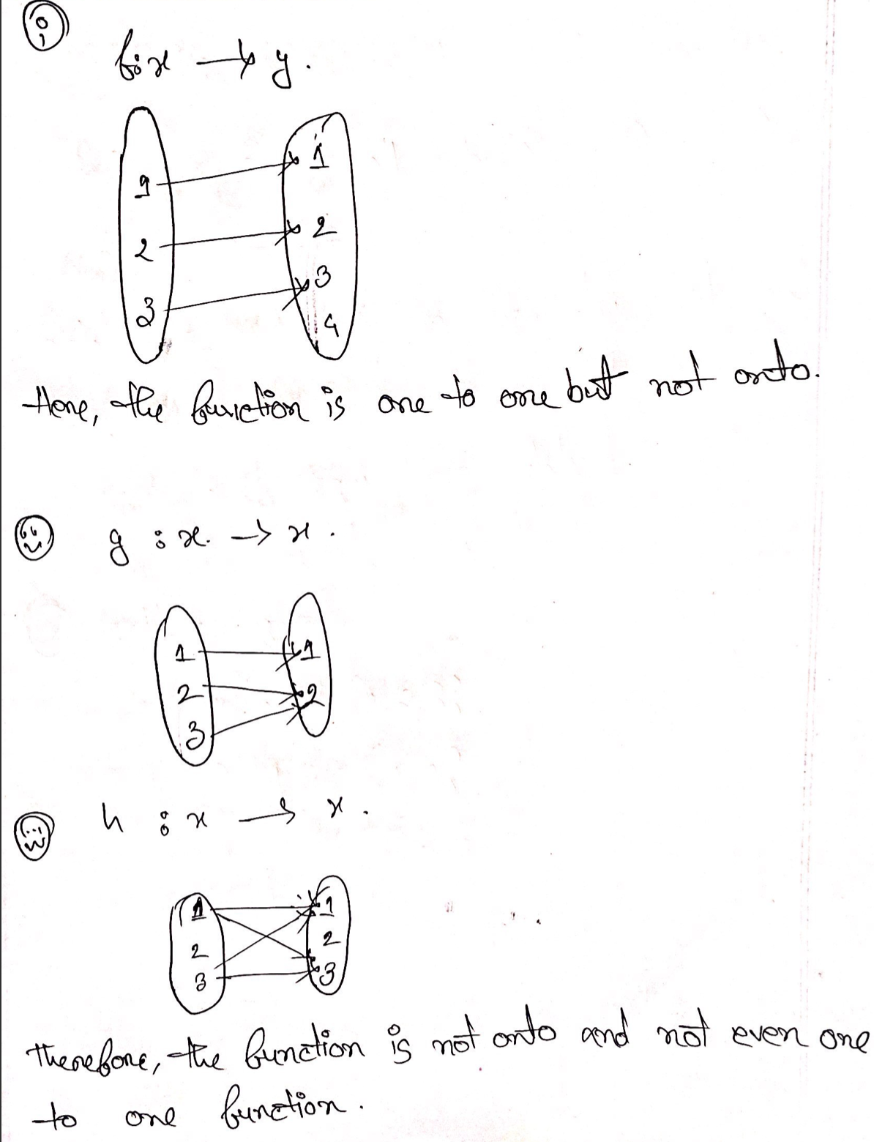
d)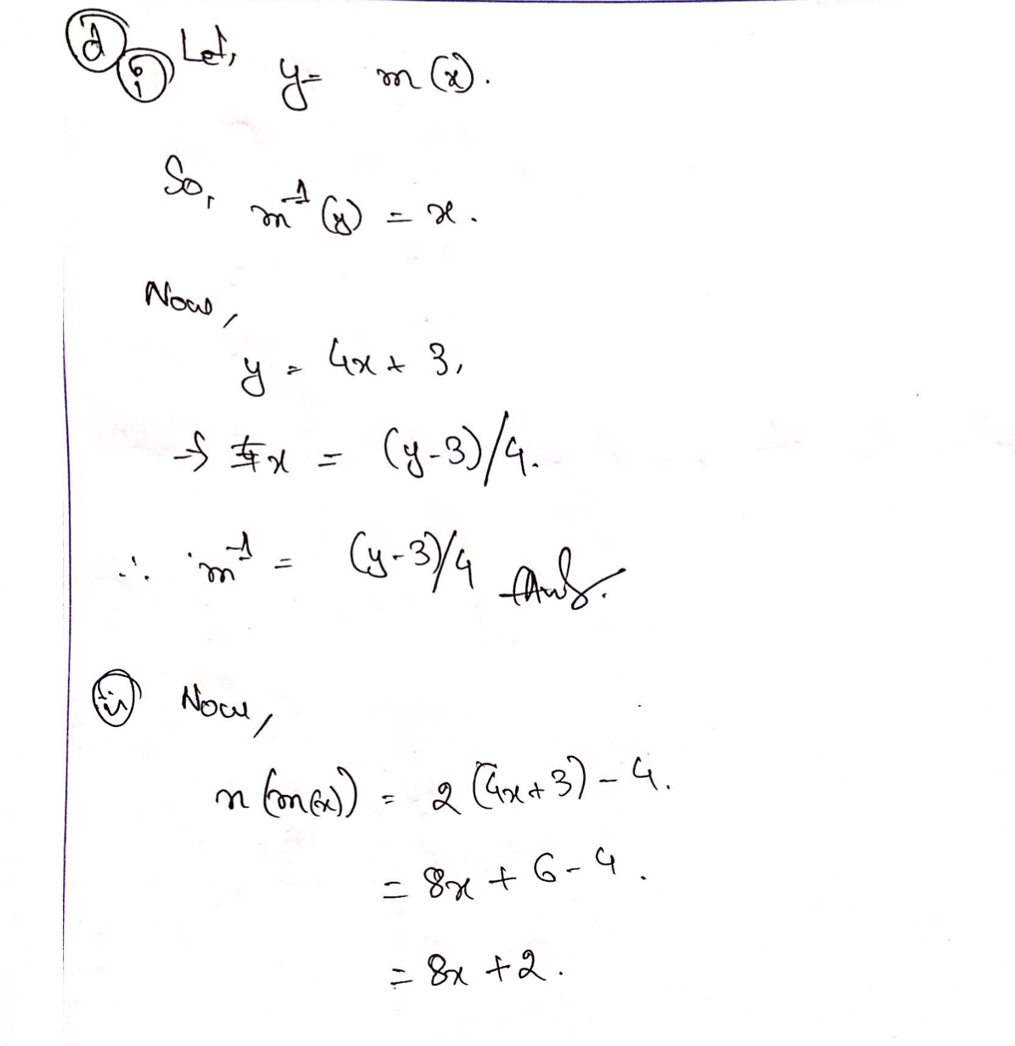
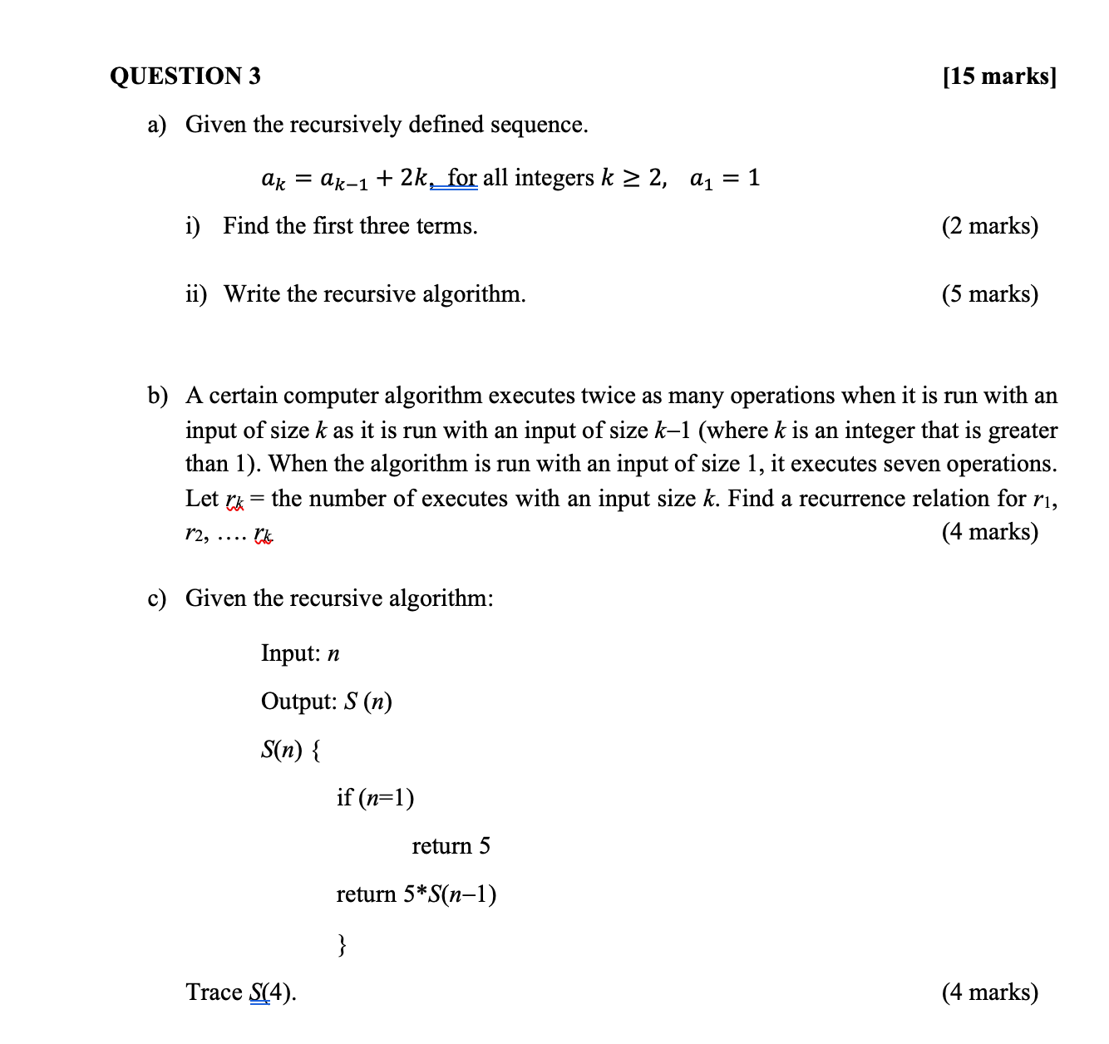
Answers:
a)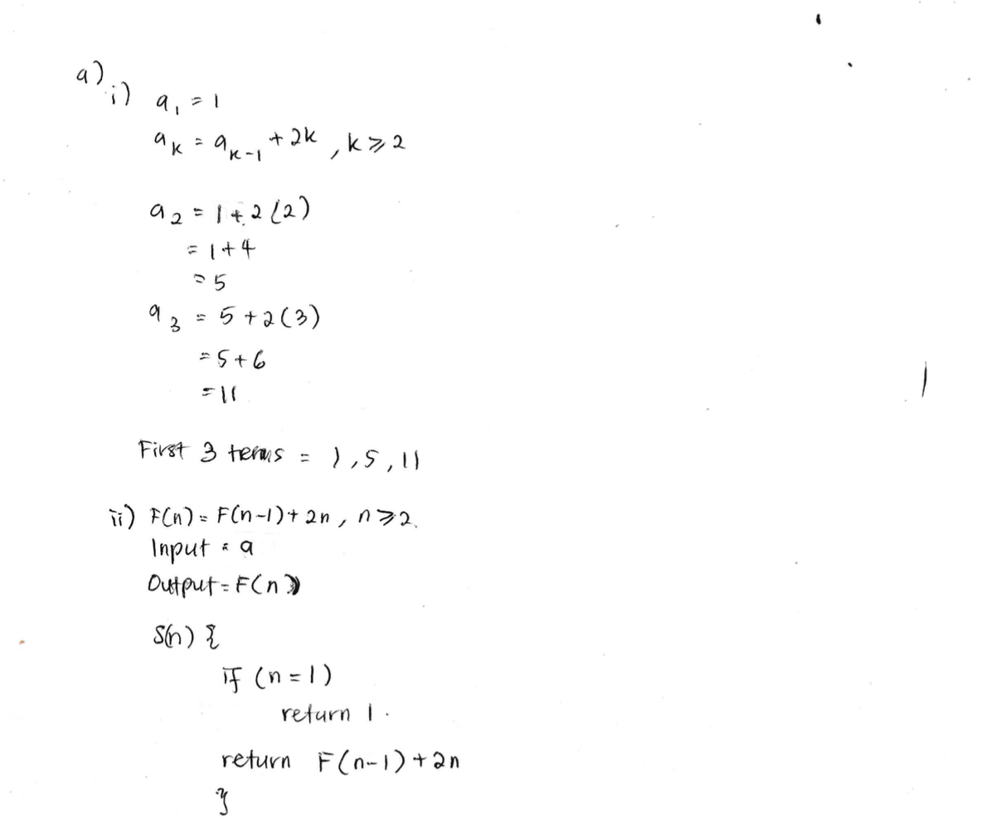
b)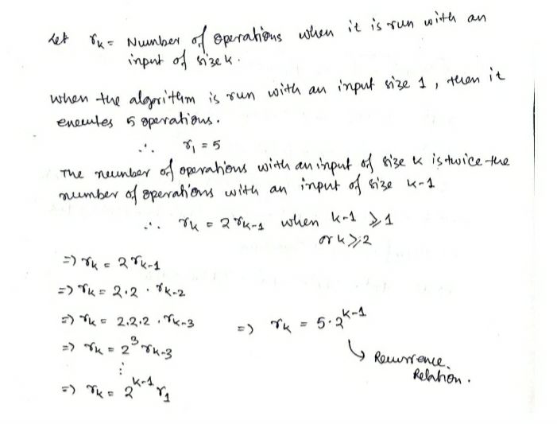
c)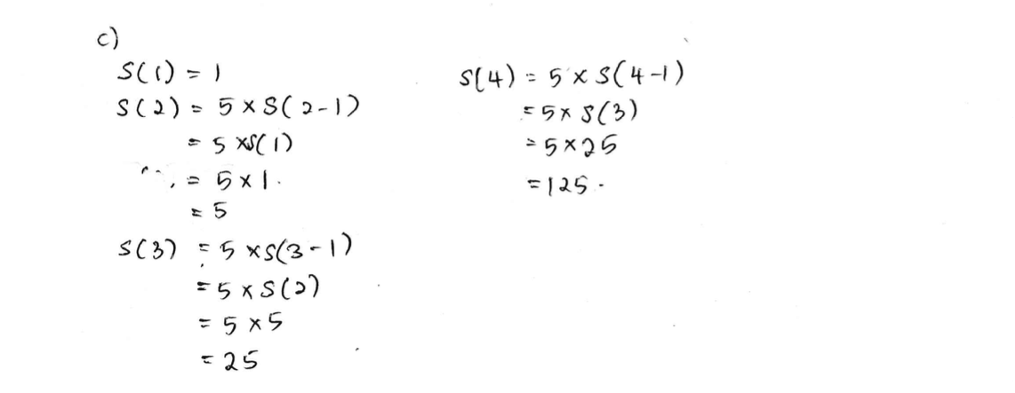

QUESTION 4 [25 marks]

a) Hexadecimal numbers are made using the sixteen digits 0, 1, 2, 3, 4, 5, 6, 7, 8, 9, A, B, C, D, E, F. They are denoted by the subscript 16. How many hexadecimal numbers begin with one of the digits 3 through B, end with one of the digits 5 through F and are 4 digits long?
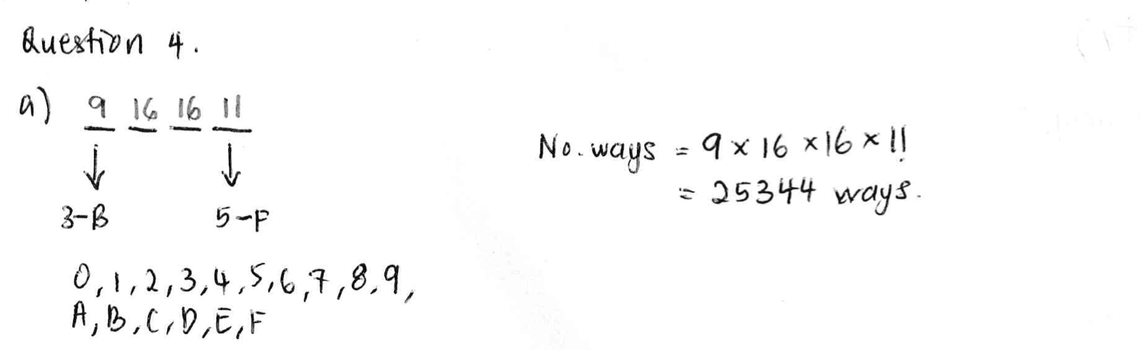
(4 marks)

b) Suppose that in a certain state, all automobile license plates have four letters followed by three digits. How many license plates could begin with A and end in 0?
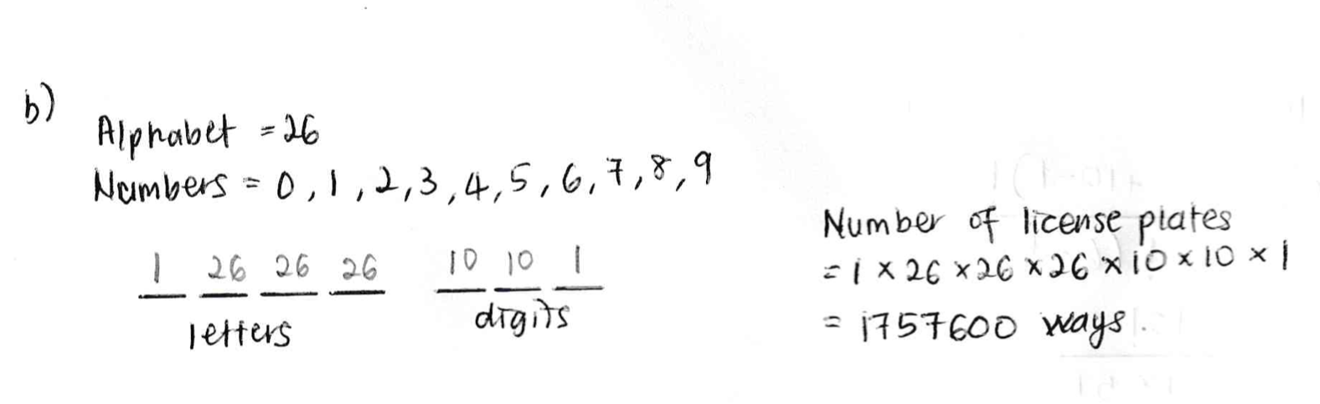
(4 marks)

c) How many arrangements in a row of no more than three letters can be formed using the letters of word COMPUTER (with no repetitions allowed)?
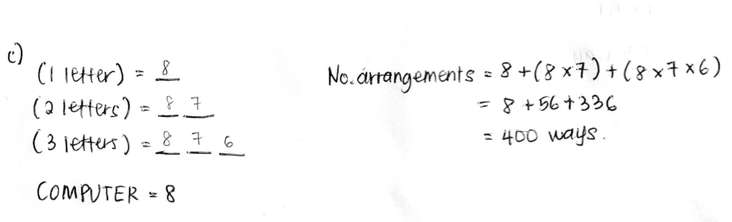
(5 marks)

d) A computer programming team has 13 members. Suppose seven team members are women and six are men. How many groups of seven can be chosen that contain four women and three men?
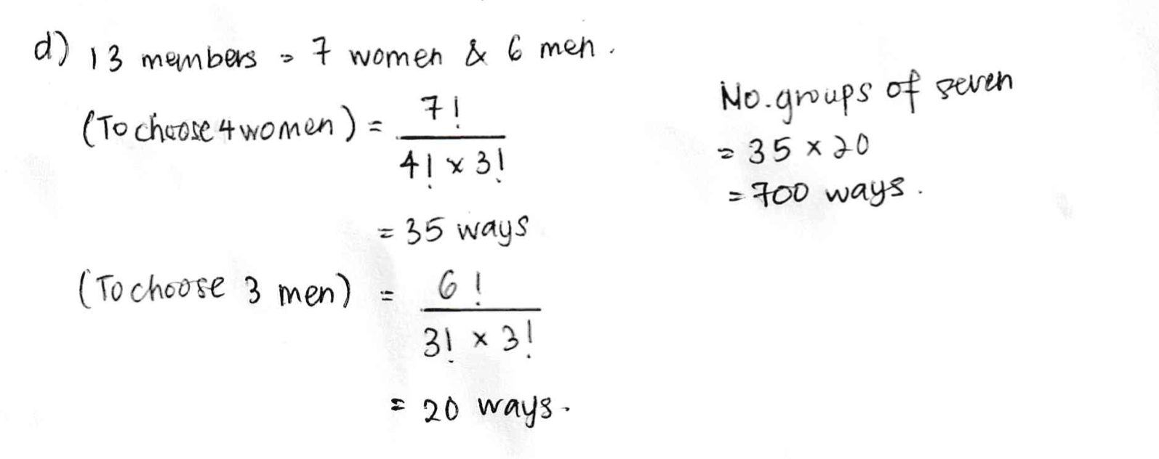
(4 marks)

e) How many distinguishable ways can the letters of the word PROBABILITY be arranged?
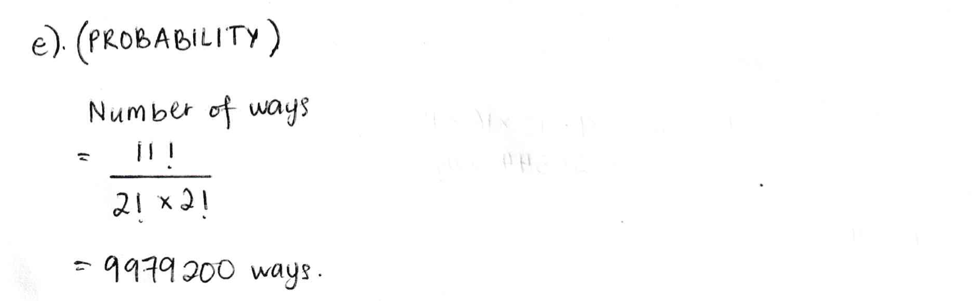
(4 marks)
f) A bakery produces six different kinds of pastry. How many different selections of ten pastries are there?
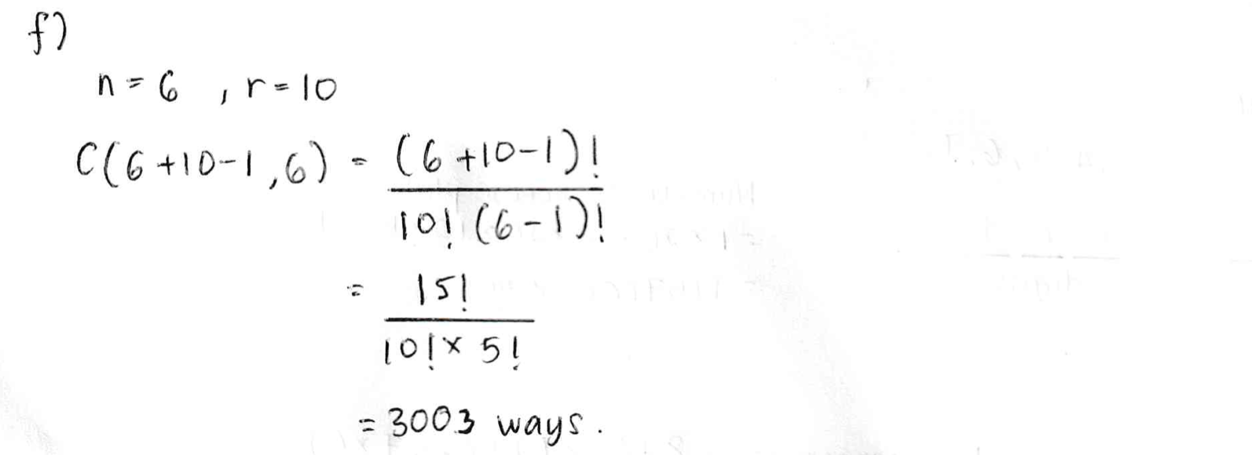

(4 marks)

QUESTION 5 [10 marks]
a) Eighteen persons have first names Ali, Bahar, and Carlie and last names Daud and Elyas. Show that at least three persons have the same first and last names. (4 marks)
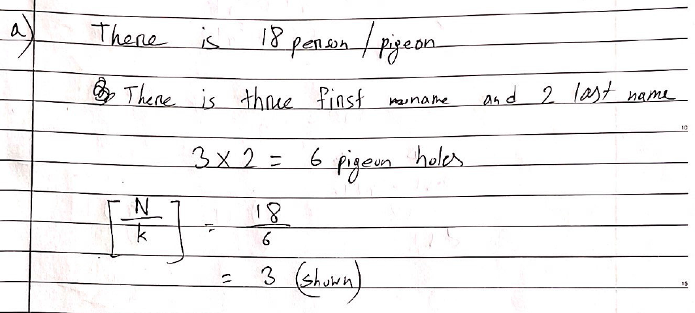
b) How many integers from 1 through 20 must you pick in order to be sure of getting at least one that is odd? (3 marks)
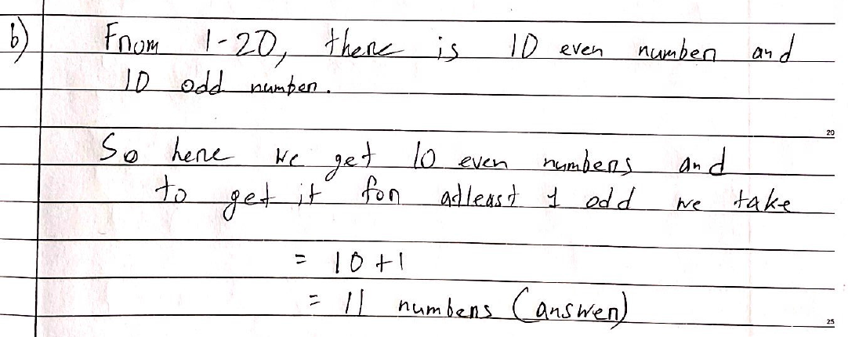
c) How many integers from 1 through 100 must you pick in order to be sure of getting one that is divisible by 5? (3 marks)
