

Tutorial #2
SECI1013 – Discrete Structure
Chapter 3
DUE DATE : 27 DECEMBER, 2020

Team members:
- SYAMIMI AMIRAH BINTI ZAMROS (A20EC0226)
- ADNAN SHAFI (A20EC0255)
- HASAN ADITTYA (A20EC4023)
- ANIKA RAHMAN ANTU (A19ECO223)

1. Consider 3-digit number whose digit are either 2,3, 4, 5, 6 or 7
a. How many numbers are there?
b. How many numbers are there if the digits are distinct?
c. How many numbers between 300 to 700 is only odd digits allow?
Solution:

a) first place can be filled in 6 ways;
2nd place can be filled in 6 ways(numbers will repeat)
3rd place can be filled in 6 ways.
Total: 6 * 6 * 6 = 216;
b) If all the numbers should be distinct;
first place can be filled in 6 ways;
2nd place can be filled in 5 ways;
3rd place can be filled in 4 ways;
Total: 6 * 5 * 4 = 120;
c)
first place can be filled in 4 ways( only 3, 4, 5, 6 allowed)
2nd place can be filled in 6 ways
3rd place can be filled in 3 ways.( only 3, 5, 7 allowed; odd number)
Total: 4 * 6 * 3 = 72;

2. Anita invited 10 of her friends, a couple, four men and four women to her anniversary dinner, how many ways Anita can arrange them around a round dinner table
a. Men insist to sit next to each other
b. The couple insisted to sit next to each other
c. Men and women sit in alternate seat
d. Before her friend left, Anita want to arrange a photoshoot. How many ways can her photographer arrange in a row, if Anita and her husband stand next to each other
Solution:

a) If all men sit together, then we can arrange men in 5! and similarly women can also be arranged in 5!
Total number of ways 5! X 5! = 120 x 120 =14400
b) if couple insists to sit together, then assuming couple a single unit, total number of ways to arrange ( 8+1) people around the table is (9-1)! and the couple can also rearrange themselves in 2 ways
Total number of ways= 8! X 2! = 80640
c) first men can be arranged in (5-1)! ways around the table and then women can arrange themselves in 5! ways between men
Total number of ways=4! X 5! = 2880
d) 10 friends of Anita and 1 couple ( Anita and her husband)
Total number of ways= 10! x 11 x 2 = 79833600

3. In a school sport day, five sprinters are competing in a 100 meter race. How many ways are there for the sprinter to finish
a. If no ties
b. Two sprinters tie
c. Two group of two sprinters tie

Solution:

a. Since , there are a total of 5 sprinters and no ties.
Hence , they can finish in 1st , 2nd , 3rd , 4th , 5th position.
This is same as arranging 5 people for 5 different positions
Hence , the number of ways = 5! = 120

b. Since , there are a total of 5 sprinters and 1 tie.
Hence , they can finish in 1st , 2nd , 3rd , 4th position.
This is the same as arranging 4 people for 4 different positions and choosing which two people will form a tie.
Hence , no of ways = 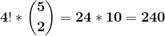

c.
Since , there are a total of 5 sprinters and 2 ties.
Hence , they can finish in 1st , 2nd , 3rd position.
This is the same as arranging 3 people for 3 different positions and choosing which two groups will have which 2 people.
Hence , no of ways = 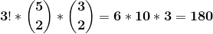

4. A croissant shop has plain croissants, cherry croissants, chocolate croissants, almond croissants, apple croissants, and broccoli croissants. How many ways are there to choose
a. a dozen croissants?
b. two dozen croissants with at least two of each kind?
c. two dozen croissants with at least five chocolate croissants and at least three almond croissants?

Solution :

(a) Types of croissants=6
Here,
n= 6
r= 12
To choose 1 dozen we need,
C (n+r-1, r)
= C (6+12-1, 12)
= C (17,12)
= 6188

(b) Let us first select 2 of each kind, which are 12 croissants in total. Then, we still need to select the remaining 12 croissants.
n= 6
r=12
Repetition of the croissants is allowed
C (6+12-1,12) = C (17,12) = 6188

(c) From 6 types we have to select 2 dozen that is 24.
Here 5 Chocolate croissants and 3 almond croissants are selected. Then, we still need to select the remaining 24-5-3 = 16 Croissants
n= 6
r= 16
Repetition of croissants is allowed
C (n+r-1, r) = C (21,6) = 20,349

5. This procedure is used to break ties in games in the championship round of the World Cup soccer tournament. Each team selects five players in a prescribed order. Each of these players takes a penalty kick, with a player from the first team followed by a player from the second team and so on, following the order of players specified. If the score is still tied at the end of the 10 penalty kicks, this procedure is repeated. If the score is still tied after 20 penalty kicks, a sudden-death shootout occurs, with the first team scoring an unanswered goal victorious.
a. How many different scoring scenarios are possible if the game is settled in the first round of 10 penalty kicks, where the round ends once it is impossible for a team to equal the number of goals scored by the other team?
b. How many different scoring scenarios for the first and second groups of penalty kicks are possible if the game is settled in the second round of 10 penalty kicks?
c. How many scoring scenarios are possible for the full set of penalty kicks if the game is settled with no more than 10 total additional kicks after the two rounds of five kicks for each team?
Solution:
a.) if a team wins 2 games among 4 games we have
C(4,2) = 4C2 = 6
If a team wins 1 game among 3 games we have
C(3,1) = 3C1 = 3

2 wins and 1 ties or wins = C (4,2) X C(3,1) X 2 = 36
1 win and 3 ties or wins = C (3,1) X C(4,3) X 2 X 2 X2 = 96

Since there are 2 teams we multiply it by 2 ;
Scenarios = 2 X (36+96) = 264
b) If 10 penalty kicks are executed we get = = 1024
Unsettled games = 1024 – 264 = 760
So 1st game = 760 ans 2nd game = 264
So total scenarios = 760 = 200640
c) for sudden death shootout we have 3 options
A wins , B win or a tie
So, unsettled games scenarios are
1st round = 760
2nd round = 760
For shootout the game was settled so the scenarios are = 2 = 10
So, final scenario = 10 = 5776000

6. A professor gives a multiple-choice quiz that has ten questions, each with four possible responses, a,b,c,d. What is the minimum number of students that must be in the professor’s class in order to guarantee that at least three answer sheets must be identical?
(Assume that no answers are left blank.)

Solution :
selection for 1 question with selection of 4 C(4,1) = 4
So for 10 questions = 4 = 1048576
Let N = number of students (pigeons)
10 question selection = (pigeon hole)
Using ceiling function from pigeon hole principle = = 3
So, N = 2097153

7. In a secondary examination, 75% of the students have passed in history and 65% in Mathematics, while 50% passed both in history and mathematics. If 35 candidates failed in both the subjects, what is the number of candidates sit for the exam?
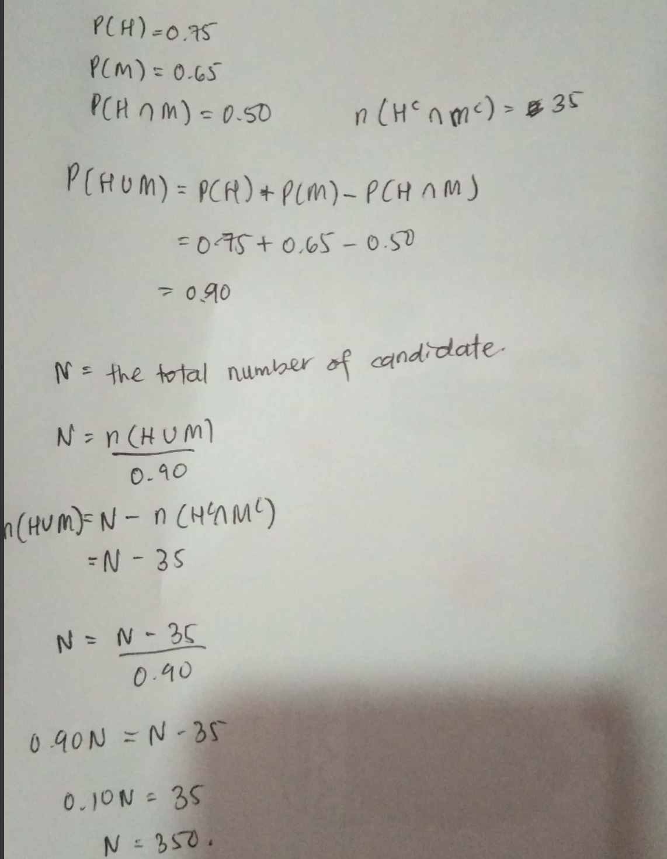

8. An integer from 300 through 780, inclusive is to be chosen at random, find the probability that the number is chosen will have 1 as at least one digit.
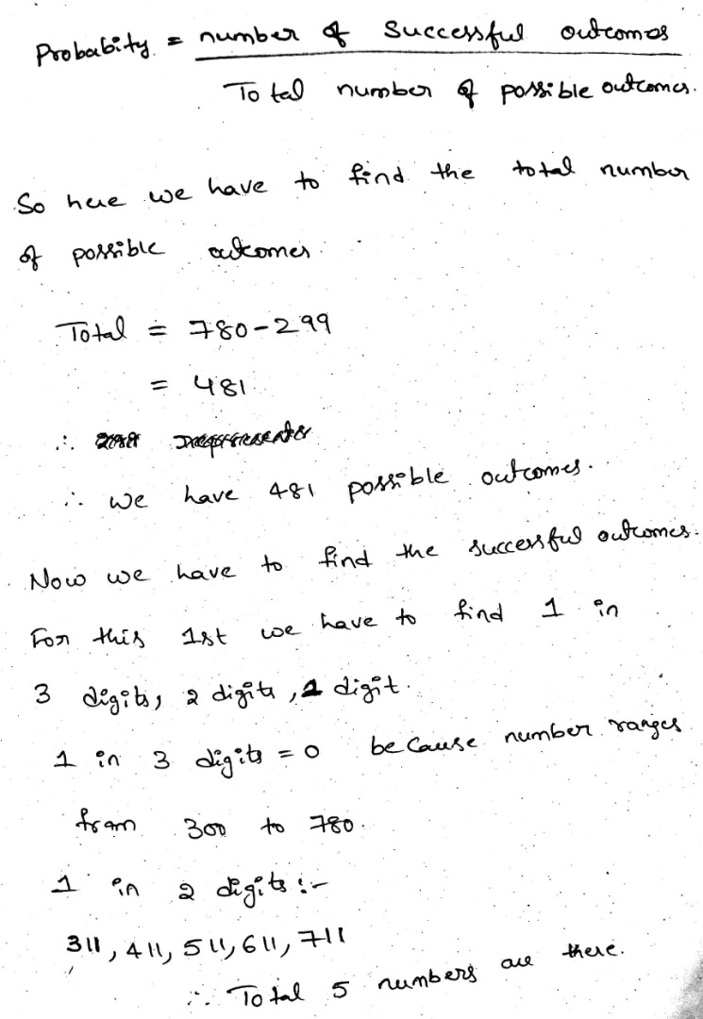

9. Two blue and four yellow cars are to be parked in a row of 10 parking lots. Assume that cars of the same color are not distinguishable, and the parking lots are chosen at random.
- In how many ways can the cars be parked in the parking lots?
- In how many ways can the cars be parked so that the empty lots are next to each one another? Find the probability that the empty lots are next to one another?
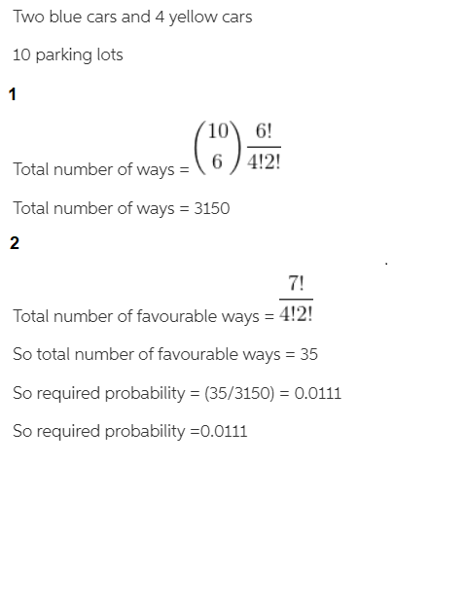

10. A coach wishes to give a message to a trainee. The probabilities that he uses email, letter and handphone are 0.4,0.1 and 0,5 respectively. He uses only one method. The probabilities of the trainee receive the message if the coach uses email, letter or handphone are 0.6,0.8 and 1 respectively
a. Find the probability the trainee receives the message
b. Given that the trainee receives the messages, find the conditional probabilities that he receives it via email
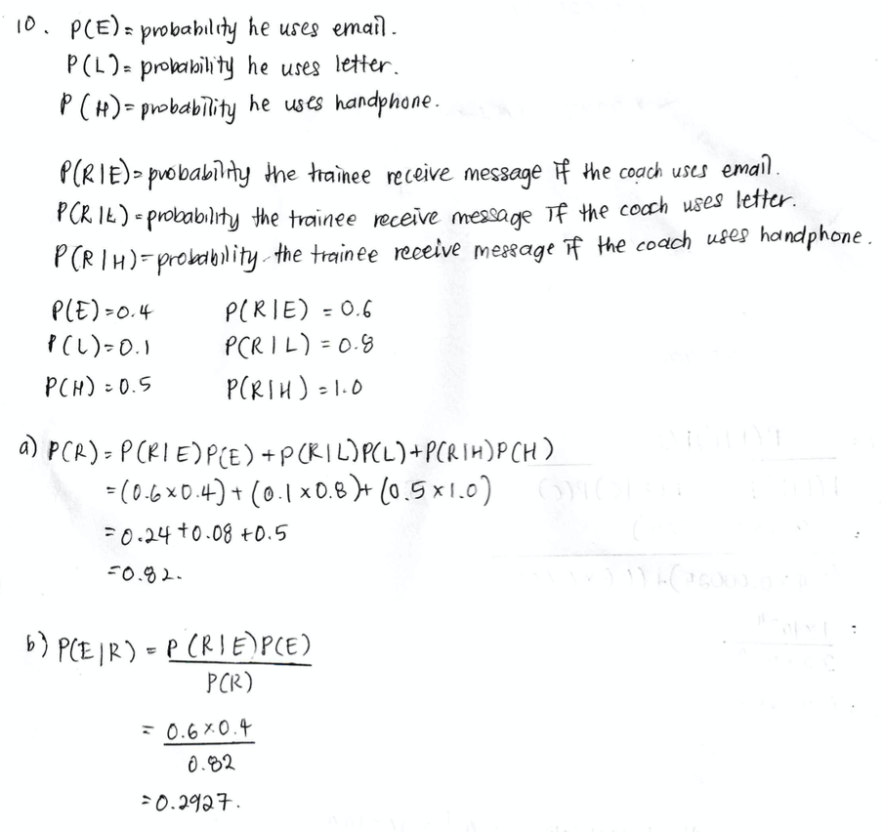

11. In a recent News, it was reported that light trucks, which include SUV’s , pick-up trucks and minivans, accounted for 40% of all personal vehicles on the road in 2012. Assume the rest are cars. Of every 100,000 cars accidents, 20 involve a fatality; of every 100,000 light trucks accidents, 25 involve a fatality. If a fatal accident is chosen at random, what is the probability the accident involved a light truck?
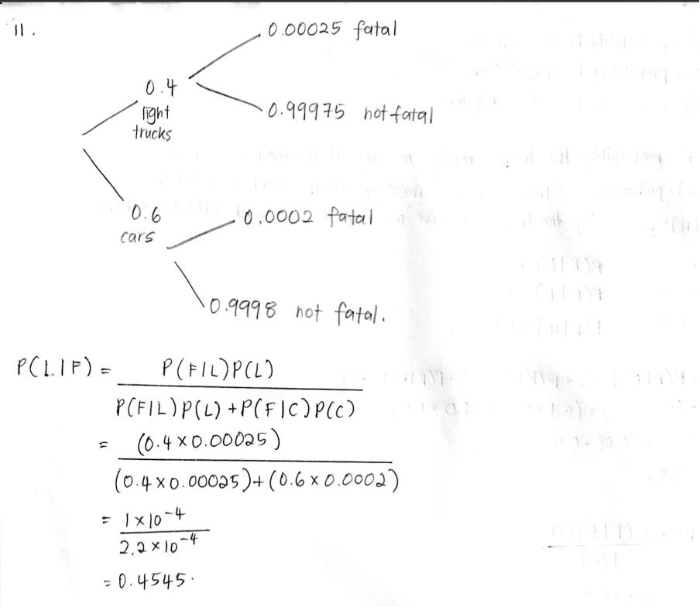

12. There are 9 letters having different colors (red, orange, yellow, green, blue, indigo, velvet) and 4 boxes of different shapes (tetrahedron, cube, polyhedron, dodecahedron). How many ways are there to place these 9 letters into the 4 boxes such that each box contain at least 1 letter?
