

SCSJ 2013-08
DATA STRUCTURE & ALGORITHM

Submitted to: Dr Norsham binti Idris

Submitted by: Meghla Mehnaz Rose A18CS3017
Samiya Hussain Samantha A8CS3030
Khaled Ahmed Sedik Ibrahim A18CS4033
Sarim Ali Ghazi A18CS3031

Team: SSRK

Mini Project

Topic: Car Rental System

Date Submitted: 27.01.2021

Table of Contents
Introduction………………………………………………………………………………….3
Task Allocation………………………………………………………………………………3
Class Diagram………………………………………………………………………………3
Source Code………………………………………………………………………………...4
Explanation of Technique used………………………………..…………………………..18
Output………………………………………………………………………………………...21
Conclusion…………………………………………………………………………………...27

Introduction
Our system is a car rental system, which is mainly used by the customers and the shop-owner. The customer can register or login (if not registered before). Then, he/she can search and select cars for rent. Consequently, making their reservation and paying for it.
The shop-owner maintains car information, views monthly rental information.

Task Allocation
We decided to take a collaborative approach and group programming approach so that we could learn from each other. Hence, all of us did the class diagram together, then divided the classes among us and worked in groups to get the final output. We have collaborated online through Google meet and assisted each other.
It was specially challenging given that all four of us are in different parts of the world and have different time zones. Despite the hardships we are quite satisfied with our output.

Class Diagram
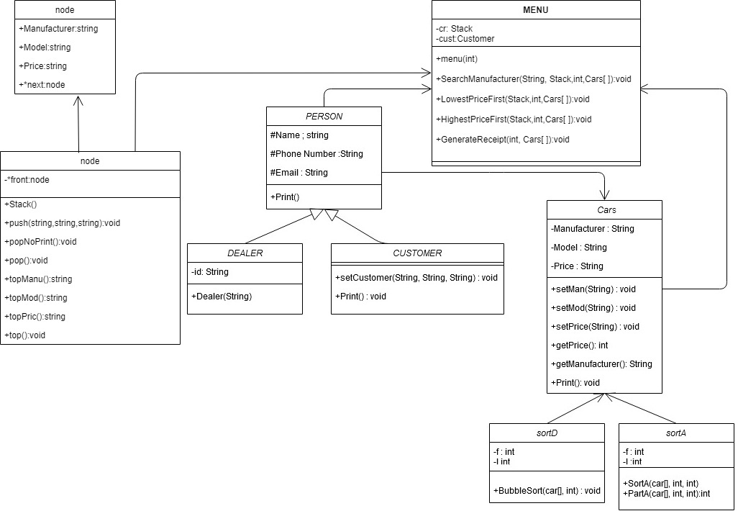

Source Code
#include <iostream>
#include <fstream>
#include <string>
using namespace std;
class node
{
public:
string Manufacturer, Model, Price;
node *next;
};
class Stack
{
node *front;

public:
Stack()
{
front = NULL;
}
void push(string mn, string md, string pr)
{
node *temp;
temp = new node();
temp->Manufacturer = mn;
temp->Model = md;
temp->Price = pr;
if (front == NULL)
{
temp->next = NULL;
}
else
{
temp->next = front;
}
front = temp;
}
void popNoPrint()
{
//if empty stack
if (front == NULL)
{
cout << "STACK EMPTY\n";
}
//delete first element
else
{
node *temp = front;

front = front->next;

delete (temp);
}
}
void pop()
{
//if empty stack
if (front == NULL)
{
cout << "STACK EMPTY\n";
}
//delete first element
else
{
node *temp = front;
cout << "Manufacturer= " << temp->Manufacturer << endl;
cout << "Model= " << temp->Model << endl;
cout << "Price= " << temp->Price << endl;
front = front->next;

delete (temp);
}
}
string topManu()
{
//if empty stack
if (front == NULL)
{
return "STACK EMPTY\n";
}

else
{
node *temp = front;

return temp->Manufacturer;
delete (temp);
}
}
string topMod()
{
//if empty stack
if (front == NULL)
{
return "STACK EMPTY\n";
}

else
{
node *temp = front;

return temp->Model;
delete (temp);
}
}
string topPric()
{
//if empty stack
if (front == NULL)
{
return "STACK EMPTY\n";
}

else
{
node *temp = front;

return temp->Price;
delete (temp);
}
}
void top()
{
cout << "Manufacturer= " << front->Manufacturer << endl;
cout << "Model= " << front->Model << endl;
cout << "Price= " << front->Price << endl;
}
};
class Person
{
protected:
string Name, Email;
string PhoneNumber;

public:
void print();
};

class Dealer : Person
{
private:
string id;

public:
Dealer(string num)
{
string name, email, phone;
char read[100];
ifstream MyFile("dealer.txt");
while (!MyFile.eof())
{
MyFile >> read;
id = read;

MyFile >> read;
Name = read;

MyFile >> read;
PhoneNumber = read;

MyFile >> read;
Email = read;

if (id == num)
{
cout << "dealer id found " << endl;
cout << "Dealer Name :" << Name << endl;
cout << "Dealer Phone Number :" << PhoneNumber << endl;
cout << " Dealer Email :" << Email << endl;
return;
}
}
cout << "id not found";
}
};
class Customer : Person
{
public:
void setCustomer(string n, string p, string e)
{
Name = n;
PhoneNumber = p;
Email = e;
}
void print()
{
cout << "customer Name =>" << Name << endl;
cout << "cutomer Phone =>" << PhoneNumber << endl;
cout << "customer Email =>" << Email << endl;
}
string getName()
{
return Name;
}
string getPhone()
{
return PhoneNumber;
}
string getEmail()
{
return Email;
}
};
class cars
{
private:
string Manufacturer, Model, Price;

public:
void setMan(string s)
{
Manufacturer = s;
}
void setMod(string s)
{
Model = s;
}
void setPrice(string s)
{
Price = s;
}
int getPrice()
{
int x = stoi(Price);

return x;
}
string getManufacturer()
{
return Manufacturer;
}
string getModel()
{
return Model;
}
void print()
{
cout << "Car's Manufacturer =>" << Manufacturer << endl;
cout << "Car's Model =>" << Model << endl;
cout << "Car's Price =>" << Price << "rm" << endl
<< endl;
}
};

class sortA
{ // using QuickSort Algorithm here

int f;
int l;

public:
sortA(cars a[], int f, int l)
{
int cut;
if (f < l)
{
cut = partA(a, f, l);
sortA(a, f, cut);
sortA(a, cut + 1, l);
}
} // end sortA
int partA(cars a[], int f, int l)
{
int pivot;
cars temp;
int loop, cutPoint, bottom, top;
pivot = a[f].getPrice(); // identify pivot
bottom = f;
top = l;
loop = 1; //always TRUE

while (loop)
{

while (a[top].getPrice() > pivot)
{
top--;
}

while (a[bottom].getPrice() < pivot)
{
bottom++;
}

if (bottom < top)
{
// change pivot place
temp = a[bottom];
a[bottom] = a[top];
a[top] = temp;
}
else
{
loop = 0; //loop false cutPoint = top:
cutPoint = top;
}
} // end while
return cutPoint;
} // end partA
};

class SortD
{

int f;
int l;

public:
void BubbleSort(cars a[], int n)
{
cars temp;
bool sorted = false; //false when swaps occur
for (int pass = 1; (pass < n) && !sorted; ++pass)
{
//moves the largest element to the end
sorted = true; //assume sorted
for (int x = 0; x < n - pass; ++x)
{
if (a[x].getPrice() < a[x + 1].getPrice())
{
// exchange items
temp = a[x];
a[x] = a[x + 1];
a[x + 1] = temp;
sorted = false; //signal exchange

} // end if
} //end for
} //end for
}
};

class Menu
{
private:
Stack cr;
Customer cust;

public:
Menu(int x)
{
cars cManu[60];//Temporary Car Array for sorting methods
string mn, md, pr;
char read[50];
int i = 0;
ifstream MyFile("car.txt");
while (!MyFile.eof())
{
MyFile >> read;
mn = read;
MyFile >> read;
md = read;
MyFile >> read;
pr = read;
cr.push(mn, md, pr);
cout << endl
<< i + 1 << ".";
cr.top();
i++;
}
if (x == 1)
{
//customer
string n, em, p;

cout << "Hi could we please know your name" << endl;
cin >> n;
cout << "Hi could we please know your email" << endl;
cin >> em;
cout << "Hi could we please know your Handphone Number" << endl;
cin >> p;
cust.setCustomer(n, p, em);
int choice;
cout << "1. Search for Car via Manufacturer" << endl;
cout << "2. Search for Cars in Ascending price" << endl;
cout << "3.search for Cars in Descending Price" << endl;
cin >> choice;
if (choice == 1)
{

Stack tempcar;
tempcar = cr;
string mans;
int sel = 0;
cout << "What manufacturer are you looking for? !first letter should be capitall" << endl;
cin >> mans;
SearchManufacturer(mans, cr, 60, cManu); //store the search Vehicles in cManu Array

cout << "To Purchase car,enter the number of car on list" << endl;
cout << "To go back, type 0 :";
cin >> sel;
if (sel == 0)
{
cout << "going back" << endl;
}
else
{
GenerateReceipt(sel, cManu);
}
}
else if (choice == 2)
{
Stack tempcar;
tempcar = cr;
LowestPricefirst(cr, 60, cManu);

int choice2;

cout << "To Purchase car,enter the number of car on list" << endl;
cout << "To go back, type 0 :";
cin >> choice2;
if (choice2 == 0)
{
cout << "going back" << endl;
}
else
{
GenerateReceipt(choice2, cManu);
}
//do that shis
}
else if (choice == 3)
{
Stack tempcar;
tempcar = cr;
HighestPricefirst(cr, 60, cManu);
cout << "To Purchase car,enter the number of car on list" << endl;
cout << "To go back, type 0 :";
int choice2 = 0;
cin >> choice2;
if (choice2 == 0)
{
cout << "going back" << endl;
}
else
{
GenerateReceipt(choice2, cManu);
}
}
else
{
cout << "wrong input" << endl;
}
}
else if (x == 2)
{
//dealer
string ID;
cout << "enter id" << endl;
cin >> ID;
Dealer d(ID);
}
else
{
cout << "wrong input";
}
}
void SearchManufacturer(string search_key, Stack car, int array_size, cars newarray[])
{
Stack tempcars = car;
string mans, mods, pric;
int p;
int i = 0;
int index = -1;
//-1 means record is not found
for (p = 0; p < array_size; p++)
for (p = 0; p < array_size; p++)
{
mans = tempcars.topManu();
mods = tempcars.topMod();
pric = tempcars.topPric();
if (search_key == mans)
{

cout << i + 1 << " . ";

newarray[i].setMan(mans);
newarray[i].setMod(mods);
newarray[i].setPrice(pric);
tempcars.pop();
i++;
}
else
{
tempcars.popNoPrint();
}

} //end for

// return location of value
} //end function

void LowestPricefirst(Stack cr, int stackSize, cars array[])
{
Stack tempcars = cr;
string mans, mods, pric;
for (int i = 0; i < stackSize; i++)
{
mans = tempcars.topManu();
mods = tempcars.topMod();
pric = tempcars.topPric();
array[i].setMan(mans);
array[i].setMod(mods);
array[i].setPrice(pric);
tempcars.popNoPrint();
}
sortA sort1(array, 0, 59);
for (int x = 0; x < 60; x++)
{
cout << x + 1 << ".";
array[x].print();
}
}
void HighestPricefirst(Stack cr, int stackSize, cars array[])
{
SortD sort2;
Stack tempcars = cr;
string mans, mods, pric;
for (int i = 0; i < stackSize; i++)
{
mans = tempcars.topManu();
mods = tempcars.topMod();
pric = tempcars.topPric();
array[i].setMan(mans);
array[i].setMod(mods);
array[i].setPrice(pric);
tempcars.popNoPrint();
}
sort2.BubbleSort(array, 60);
for (int x = 0; x < 60; x++)
{
cout << x + 1 << ".";
array[x].print();
}
}
void GenerateReceipt(int x, cars s[])
{
ofstream File("Receipt.txt",ios::app);
File << "Customer Name:" << cust.getName() << endl;
File << "Customer Phone#:" << cust.getPhone() << endl;
File << "Customer Email:" << cust.getEmail() << endl;
File << "Car ManuFacturer:"<<s[x-1].getManufacturer()<<endl;
File << "Car Model:" << s[x - 1].getModel() << endl;
File << "Car Price:" << s[x - 1].getPrice() << endl;
File<<endl;
cust.print();
s[x - 1].print();
cout << "congrats on your new car buddy" << endl;
}
};

int main()
{
int person=0;
string ID;
while(person!=3)
{
cout << "1. for Customer, 2. Dealer, 3. Exit: ";

cin >> person;
if(person!=3)
Menu m1(person);
}
cout<<"Thank You For Using Our System";
int x;
cin >> x;
}

Explanation of Technique Used
Stack is implemented in this mini project. It is used to perform operations, such as add, delete and search. This is because of the following advantages:
- Helps you to manage the data in a Last In First Out(LIFO) method which is not possible with Linked list and array.
- When a function is called the local variables are stored in a stack, and it is automatically destroyed once returned.
- A stack is used when a variable is not used outside that function.
- It allows you to control how memory is allocated and deallocated.
- Stack automatically cleans up the object.
- Not easily corrupted
We use bubble sort for sorting. This is because it is simple to write, easy to understand and it only takes a few lines of code. The data is sorted in place so there is little memory overhead and, once sorted, the data is in memory, ready for processing.

Dataset
Car Dataset
Honda Accord 20000
Tesla Model3 750000
Audi e-Tron 277000
Mercedes E-class 318270
Toyota Camry 196888
Hyundai Kona 143888
Toyota C-HR 145500
Ford Focus 131986
Skoda Octavia 123600
Lexus UX 300000
Hyundai Santa-Fe 170000
Mazda CX-30 130000
Mercedes C-Class 251588
Toyota RAV4 215664
Mazda 6 173659
Lexus LC 1250000
Mercedes S-Class 650112
Ford Fiesta 88388
Volkswagen Golf 156000
Honda Civic 114000
Audi Q8 727900
Hyundai i30 298888
Hyundai Tucson 124000
Volkswagen Polo 77646
Suzuki Swift 102888
Volkswagen Passat 195390
Volvo S60 295888
BMW i8 1508800
BMW i3 279000
Toyota Prius 175000
Ford Mustang 598888
Nissan Leaf 189000
Hyundai i10 52188
Hyundai Ioniq 103888
Honda CR-V 140000
Toyota Land-Cruiser 139888
Volkswagen Tiguan 209575
Audi A5 377900
Mercedes GLC 396869
Tesla Model-S 719888
Mazda MX-5 176800
Nissan Qashqai 134888
Volvo V90 388888
Lexus ES 332888
Mercedes GLE 584720
Ford Mondeo 189086
Audi A7 610000
Volvo XC90 413888
Volkswagen T-Cross 123888
BMW X3 314000
Toyota Supra 568000
BMW X5 441000
Mercedes A-Class 222120
Audi Q5 340000
Bentley Continental-GT 868800
Ford S-Max 221728
Volvo XC60 343888
Toyota Tundra 33675
Jaguar XF 460000
Jaguar I-Pace 1439766

Dealer Dataset
1234 Carlos 01111111111 Carloser@gmail.com
4321 Benjamin 01222222222 benjaminbutton@gmail.com
3412 Greta 0133333333 Gretagurl@gmail.com
2143 Mohito 01444444444 binmohitbun@gmail.com

Receipt Dataset
Customer Name:sar
Customer Phone#:sar
Customer Email:sar
Car ManuFacturer:Jaguar
Car Model:XF
Car Price:460000

Customer Name:sar
Customer Phone#:1111
Customer Email:sar
Car ManuFacturer:Toyota
Car Model:Prius
Car Price:175000

Output
Customer 1
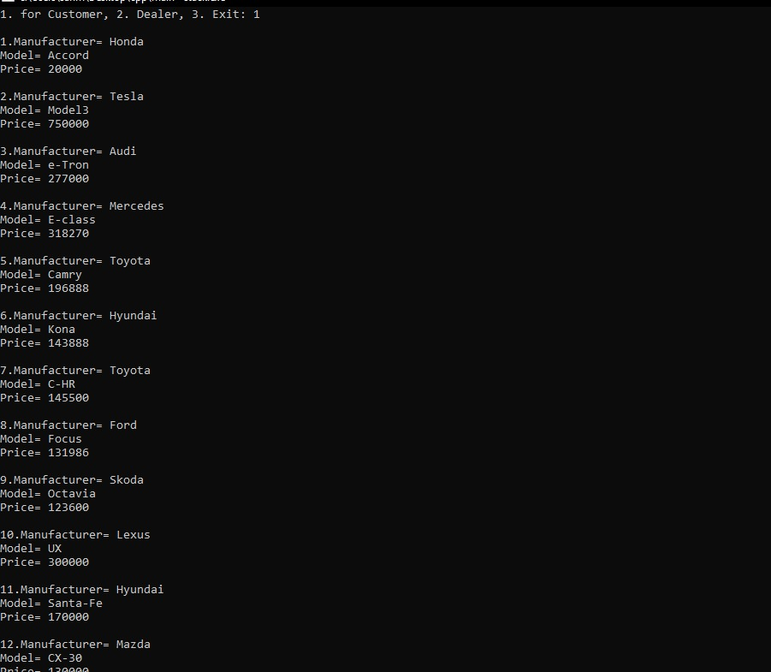

Customer 2
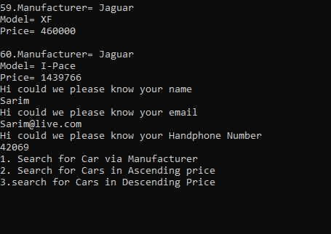

Generates receipt and outputs to txt
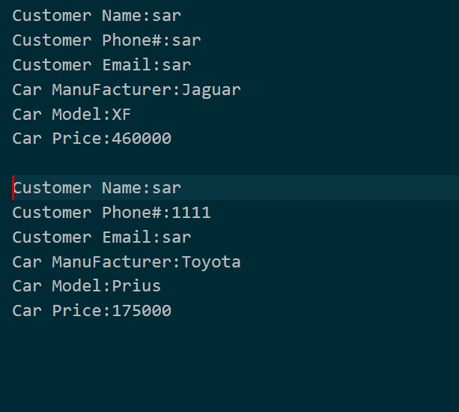
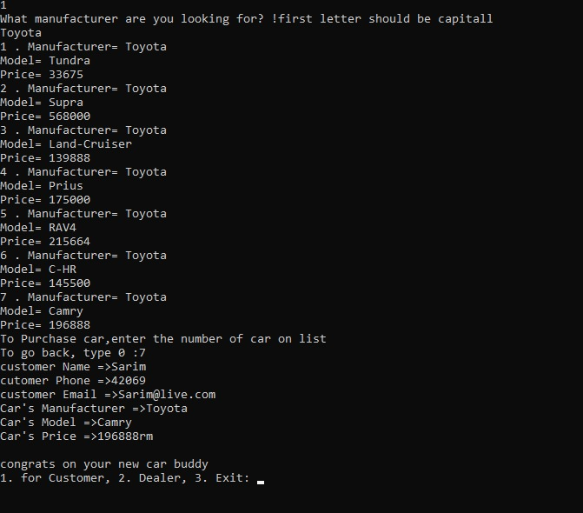

Ascending
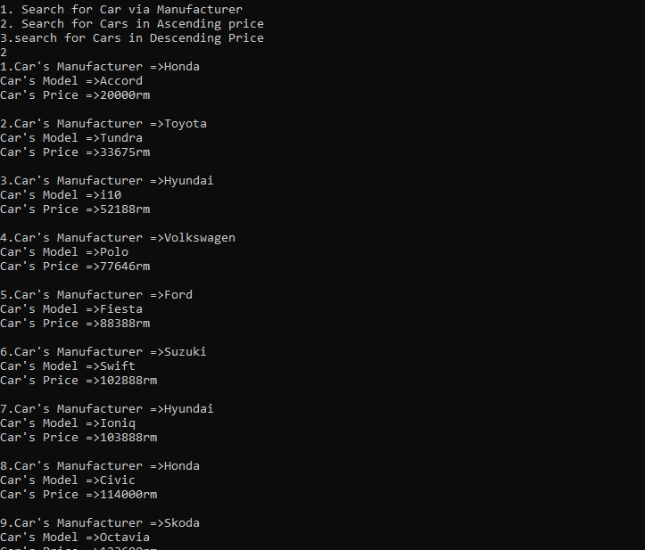

Descending
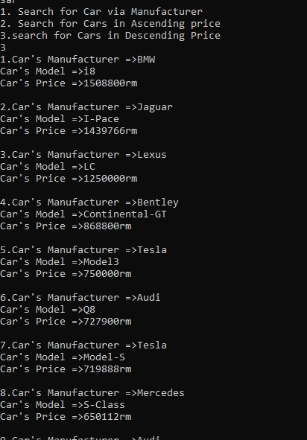
Exit
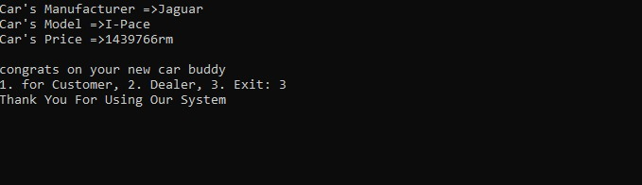

Conclusion
Overall, this project was quite challenging. But, implementing what we learnt in class in real life was very interesting, fun and exciting. Our professor, Dr Norsham Binti Idris has guided us thoroughly and because of her we are actually quite satisfied with the outcome. It has polished our learnings and taught us how we can apply the skills learnt in class in real life.

