

SCHOOL OF COMPUTING
SESSION 2020/2021 SEMESTER 1

SECJ2013 - 08
DATA STRUCTURE AND ALGORTHIMS

Assignment 1

Name:
Khaled Ahmed Sedik (A18CS4033)

Question 1:

- Recursive programs require more space requirements since they need to actively use memory until the base case is reached

- Base case: if (b<=0)

General case: else if(b==1)
else

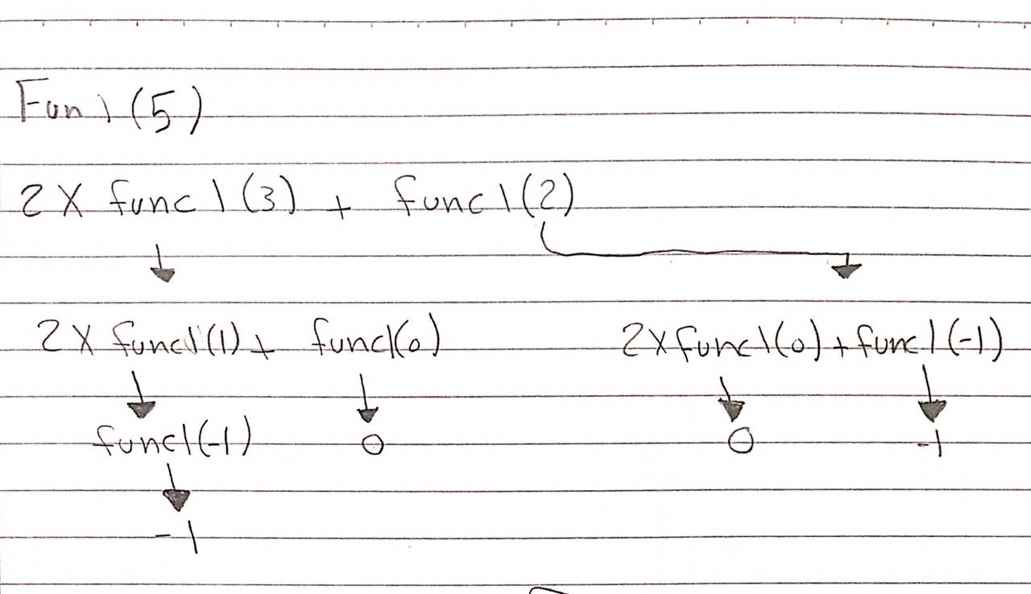

- -5

Question 2:

Statements | Number of steps
for (x=1; x<=n; x=x*2) | Log₂n
{cout << x;} | Log₂n.1
for (y=2; y<n; y++) | n-1
{cout << y; | n-1.1=n-1
for (z=1; z<=n; z++) | n-1.n=n² - n
cout<< z;} | n-1.n = n²-n

- 2log₂n + 2(n-1) +2(n²-n)

- O(n²)

Expressions | Big O Notation
(2n + 2n) ³ | O(n³)
n + 5(2^{n}) + 2 log₂n | O(2^{n})
2 log₂n + 2n + 3n log₂n | O(n log₂n)
Order the efficiencies from the highest to lowest complexity:
Answer: O(2^{n}) > O(n³) > O(n log₂n)

Question 3:

x
x
= sorted
=comparing

- -
11 | 6 | 8 | 13 | 12

6 | 11 | 8 | 13 | 12

6 | 8 | 11 | 13 | 12

6 | 8 | 11 | 13 | 12

6 | 8 | 11 | 12 | 13

- -
11 | 6 | 8 | 13 | 12

11 | 6 | 8 | 12 | 13

6 | 8 | 11 | 12 | 13

unsorted
----------------------------------------------------------------------------

11 | 6 | 8 | 13 | 12

sorted unsorted
--------- --------------------------------------------------------

6 | 11 | 8 | 13 | 12

sorted unsorted
------------------------- ------------------------------------------

6 | 8 | 11 | 13 | 12

sorted unsorted
------------------------------------------ -------------------------

6 | 8 | 11 | 13 | 12

sorted
----------------------------------------------------------------------------

6 | 8 | 11 | 12 | 13

Efficiency | Bubble Sort | Selection Sort | Insertion Sort
Number of comparisons | N(n-1)/2 = 10 | N(n-1)/2 = 10 | N(n-1)/2 = 10

Since this is a worst-case scenario, the algorithm complexity for all three sorts are nearly identical, the only difference is in the number of swaps, which in selection sort will be less than the other two sorts.

Since this is an average case-scenario, we have to go through 2 passes only. The subsequent passes are not continued since the array is already sorted.

After using the improved bubble sort, we can conclude that in average and best case-scenario, both the number of comparisons and sorting time can be minimized.

If (largestIndex != last);
swap(Data[largestIndex],Data[last]);

This improvement is only meant to increase efficiency and prevent the last index being swapped even though it is the largest, however it does not change the number of comparisons in either ArrayA or ArrayB

Question 4:

- Quick sort is more efficient, since it doesn’t need a temporary array to hold sorted data.

