
University of Technology, Malaysia
Faculty of Engineering
School of Computing
Semester 2020/2021-01
(SECJ2013-08)
LAB 1:
LE1A,LE1B
Lecturer:
Dr. Norsham Idris
By:
Khaled Ahmed Sedik (A18CS4033)

LE1A RECURSIVE

6.

- Line 4 and line 5
- 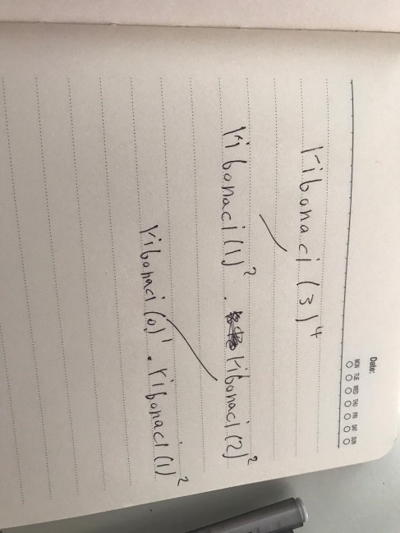
- 4

LE1B
3.
For(int i=1;I<=n;i++)
{
For(int j=1;j<=I;j++)
Cout<<”*”
Cout<<endl;
}
O(n^2)
4.
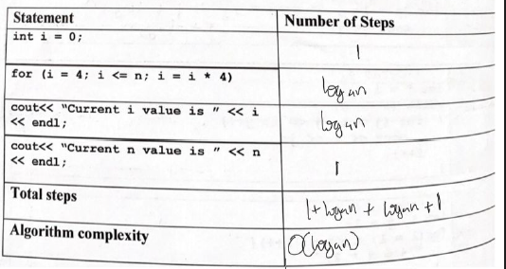

5.
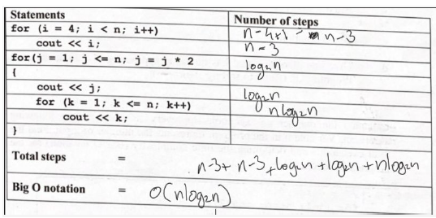

6.

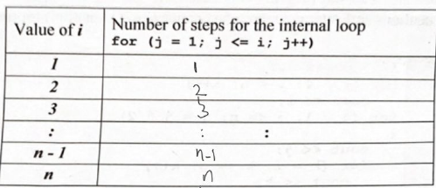

- 1+n+n^2+n^2+n
- O (n^2)

