Lab Exercise 2
Please answer the questions.
1.
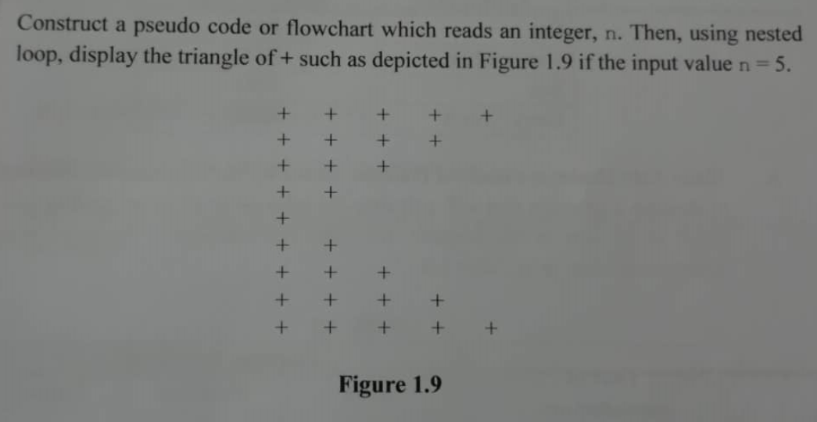
Pseudo code:
1. Start
2. Read n
3. Set counter = n +1
4. While (counter > =2)
4.1. counter = counter -1
4.2. Set amount = 1
4.3. While (amount <= counter)
4.3.1. Display “+ ”
4.3.2. amount = amount + 1
4.4. End_while
4.5. Print “\n”
5. End_while
6. While (counter <= n)
6.1. counter = counter + 1
6.2. Set amount = 1
6.3. While (amount <= counter)
6.3.1. Display “+ ”
6.3.2. amount = amount + 1
6.4. End_while
6.5. Print “\n”
7. End_while
8. End
2.
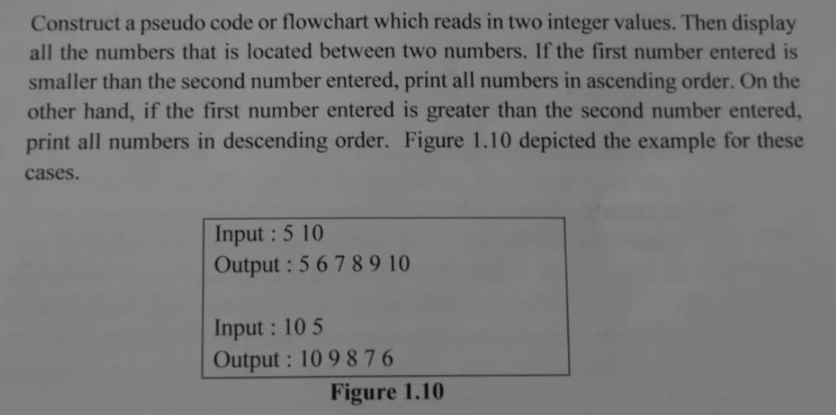
Pseudo code:
1. Start
2. Read num1, num2
3. Calculate difference = num2 - num1
4. If (difference > 0)
4.1. Set output = num1
4.2. While (output <= num2)
4.2.1. Print output
4.2.2. Print “ “
4.2.3. output = output + 1
4.3. End_while
4.4. Go to step 8
5. Else if (difference == 0)
5.1. Print num1
5.2. Go to step 8
6. Else if (difference < 0)
6.1. Set output = num1
6.2. While (output >= num2)
6.2.1. Print output
6.2.2. Print “ “
6.2.3. output = output - 1
6.3. End_while
6.4. Go to step 8
7. End if
8. End

