

Lab Exercise 1
Name: TEOH WEI JIAN
Matric No: A20EC0229
Section: 08

Please answer the questions. Any picture format answer is not accepted
1.
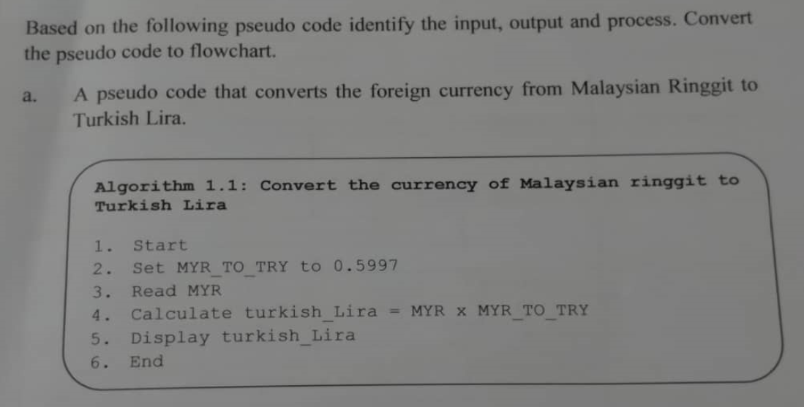
Input: MYR
Process: Set MYR_TO_TRY equal to 0.5997, Calculate turkish_Lira = MYR * MYR_TO_TRY
Output: turkish_Lira
Flowchart:
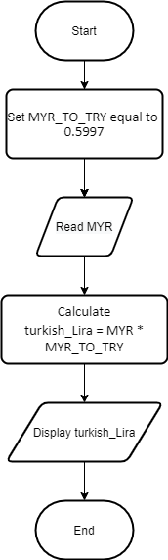

b. 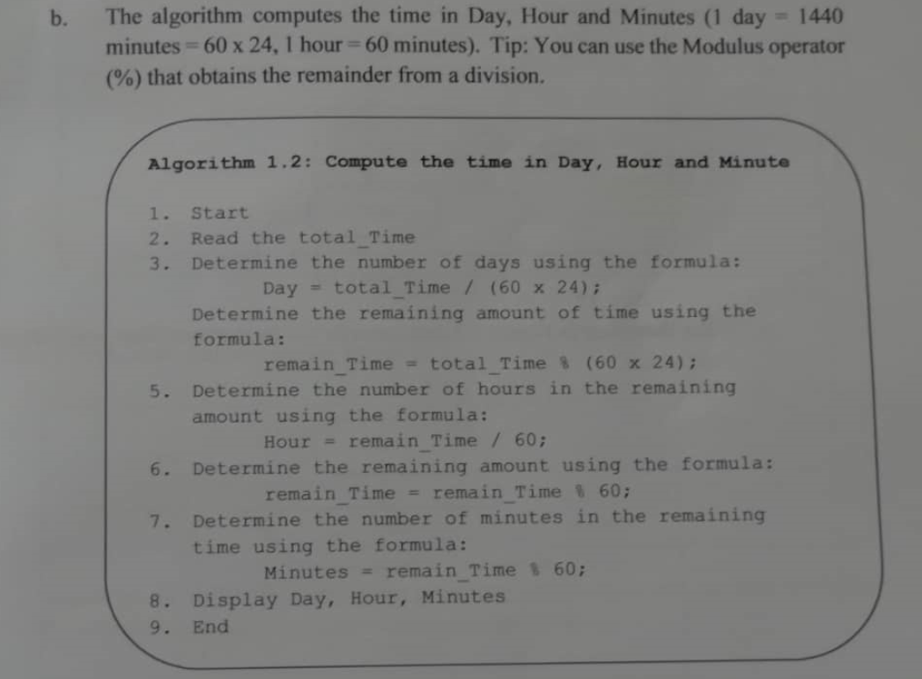
Input: total_Time,
Process: Calculate Day = total_Time / (60 * 24), Calculate remain_Time = total_Time % (60 *24), Calculate Hour = remain_Time / 60, Calculate remain_Time = remain_Time % 60, Calculate Minutes = remain_Time % 60;
Output: Day, Hour, Minutes,
Flowchart:
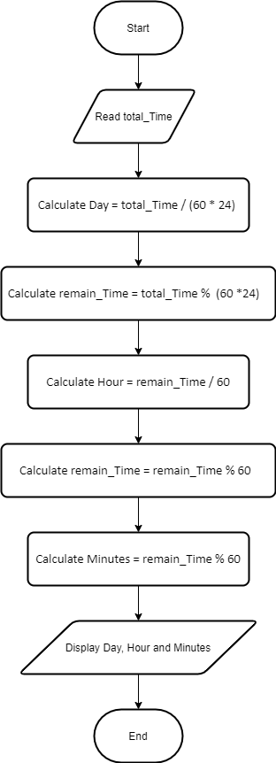
2.
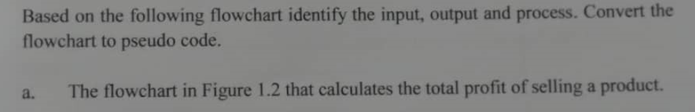

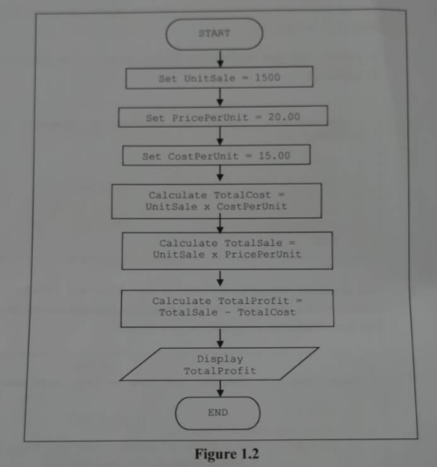
Input: -
Process: Set UnitSale = 1500, Set PricePerUnit = 20.00, Set CostPerUnit = 15.00, Calculate TotalCost = UnitSale * CostPerUnit, Calculate TotalSale = UnitSale * PricePerUnit, Calculate TotalProfit = TotalSale – TotalCost,
Output: TotalProfit,
Pseudo code:
1. Start
2. Set UnitSale = 1500
3. Set PricePerUnit = 20.00
4. Set CostPerUnit = 15.00
5. Calculate TotalCost = UnitSale * CostPerUnit
6. Calculate TotalSale = UnitSale * PricePerUnit
7. Calculate TotalProfit = TotalSale – TotalCost
8. Display TotalProfit
9.End

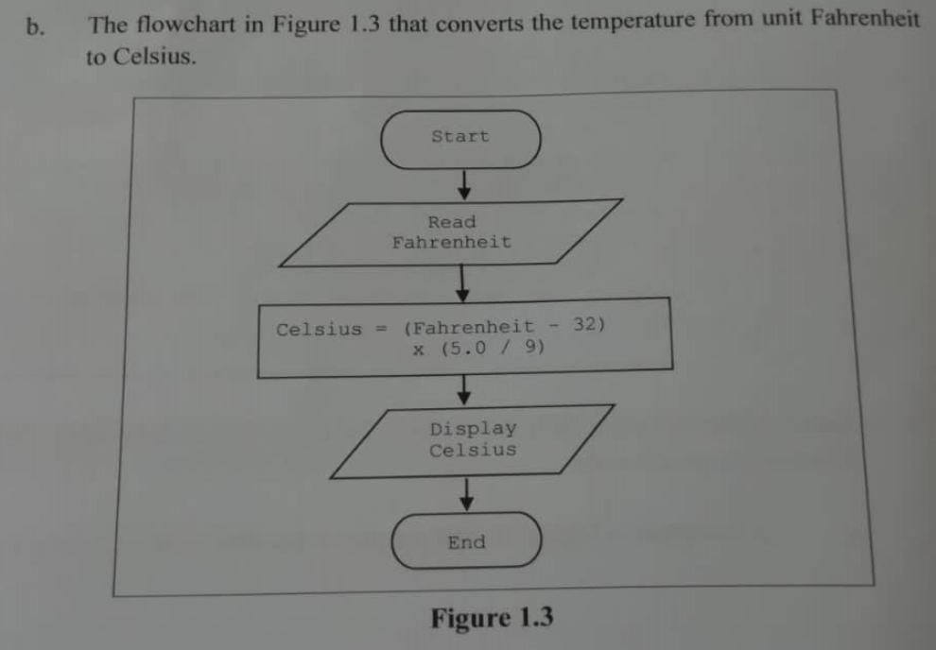
Input: Fahrenheit
Process: Calculate Celsius = (Fahrenheit – 32) * (5.0 / 9)
Output: Celsius
Pseudo code:
1. Start
2. Read Fahrenheit
3. Calculate Celsius = (Fahrenheit – 32) * (5.0 / 9)
4. Display Celsius
5. End

3.
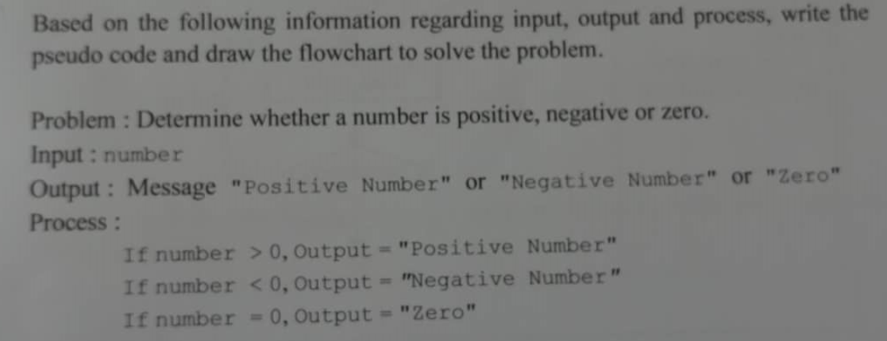
Pseudo code:
1. Start
2. Display “Type in a number”
3. Read number
4. If (number > 0)
4.1 Display “Positive number”
4.2 Go to step 7
5. Else if (number < 0)
5.1 Display “Negative number”
5.2 Go to step 7
6. Else if (number == 0)
6.1 Display “Zero”
7. End if
8. End
Flowchart:
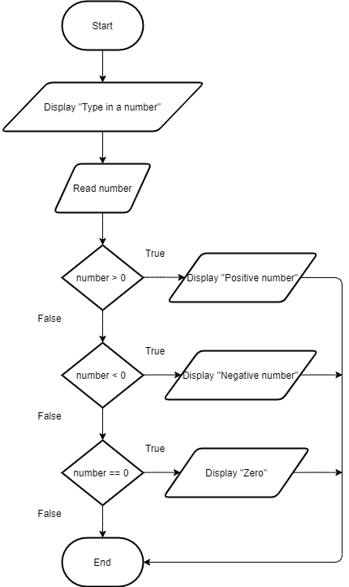
4.
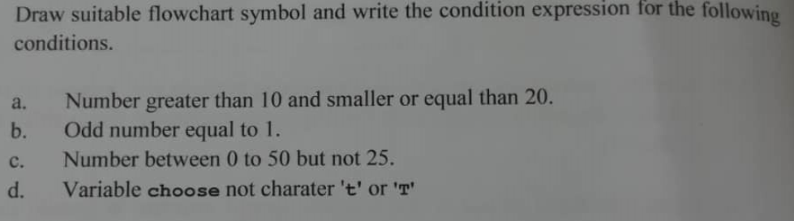
Answer:
a) (num > 10) && (num ≤ 20)
(num > 10) && (num ≤ 20)

b) ((num % 2) == 1) && (num == 1)

((num % 2) == 1) && (num == 1)

C) (num > 0) && (num < 50) && (num != 25)
(num > 0) && (num < 50) && (num != 25)

d) (choose != ‘t’ ) || (choose != ‘T’)

(choose != ‘t’ ) || (choose != ‘T’)

5.
UnitSales | PricePerUnit | CostPerunit | TotalCost | TotalSale | TotalProfit
1500 | 20.00 | 15.00 | 1500 * 15.00  =22500 | 1500*20.00  =30000 | 30000-22500  =7500

6.
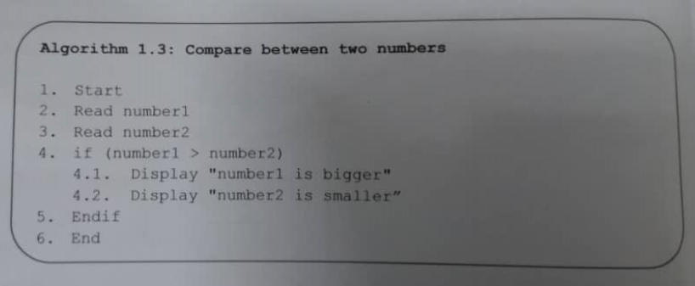
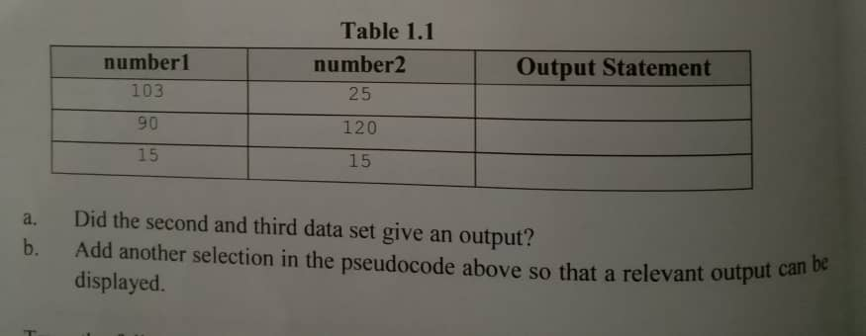
number 1 | number 2 | Output Statement
103 | 25 | Number 1 is bigger number 2 is smaller
90 | 120
15 | 15
Answer:
a) no
b) 5. Else if (number 1 < number 2)
5.1 Display “number 1 is smaller”
5.2 Display “number 2 is bigger”
5.3 Go to step 8
6. Else if (number 1==number 2)
6.1 Display “number 1 is equal to number 2”
7. End if
8. End

