

School of Computing

Faculty of Engineering of Comput

UNIVERSITI TEKNOLOGI MALAYSIA

SUBJECT | : SECR1013 DIGITAL LOGIC
SESSION/SEM | : 2020-2021-1
LAB 3 | : SYNCHRONOUS DIGITAL COUNTER
NAME | : MD MEHEDI HASAN(A20MJ4005)  FURQAN QADRI (A20MJ0158)  MOHAMED ALHADI KHALLEEFAH ABOUJANAH (A20MJ4009)
DATE | : 31/01/2021

Lab #3

Identifying The Properties of a Synchronous Counter

A. Aims
- Expose the student with experience on constructing synchronous counter circuit using Flip-Flop IC, Basic Gate ICs, Breadboard and ETS-5000 Digital Kit.
- Promote critical thinking among students by analyzing the given circuit and identifying the behavior of the digital circuit.

B. Objectives
The objectives of this lab activity are to:
- Implement a synchronous counter circuit into physical circuit using Breadboard, Flip-Flops, Basic Gates and Switches.
- Completing the next-state table of the counter circuit.
- Sketch the state diagram of the counter circuit.
- Identify the properties of the counter.

C. Materials And Equipments

Materials and equipment required for this lab are as follows:

Item Name | Number of Item
1. Breadboard | 1
2. 7408 Quad 2-Input AND | 1
3. 7404 Hex Inverter | 1
4. 7432 Quad 2-input OR | 1
5. 7476 Dual J-K Flip Flop | 1
6. ETS-5000 Digital Kit | 1

D. Preliminary Works

1) Determine the logic level for each input combinations in Table 1 so that the desired result can be realized.

Table 1

Desired Result | PRE | CLR | J | K | CLK | Q
Set initial value Q = 1 | 0 | 1 | X | X | -- | 1
Output Q stays the same | 1 | 1 | 0 | 0 | ⇓ | 1
Output Q become 0, no change in asynchronous input | 1 | 1 | 0 | 1 | ⇓ | 0
Output Q is not the previous Q | 1 | 1 | 1 | 1 | ⇓ | 1
RESET Q | 1 | 1 | 0 | 1 | ⇓ | 0
SET Q | 1 | 1 | 1 | 0 | ⇓ | 1

2) Answer all questions.

- Which state that JK flip-flop has, but not on SR flip-flop.

In SR flip flop, When S=1, R=1, the output is invalid.
In JK flip flop when, J=1 ,K=1, the output toggles (Q_{n}+ = Q̅_{n})
- Toggle state is the state that JK flip flop has, but not SR flipflop.

- Identify whether the JK flip flop in 7476, is a positive-edge triggered or negative-edge triggered flip flop.
IC 7476 has two negative edge triggerd JK flip flops

E. Lab Activities : PART A

1) You are given a counter circuit as shown in Figure 4.

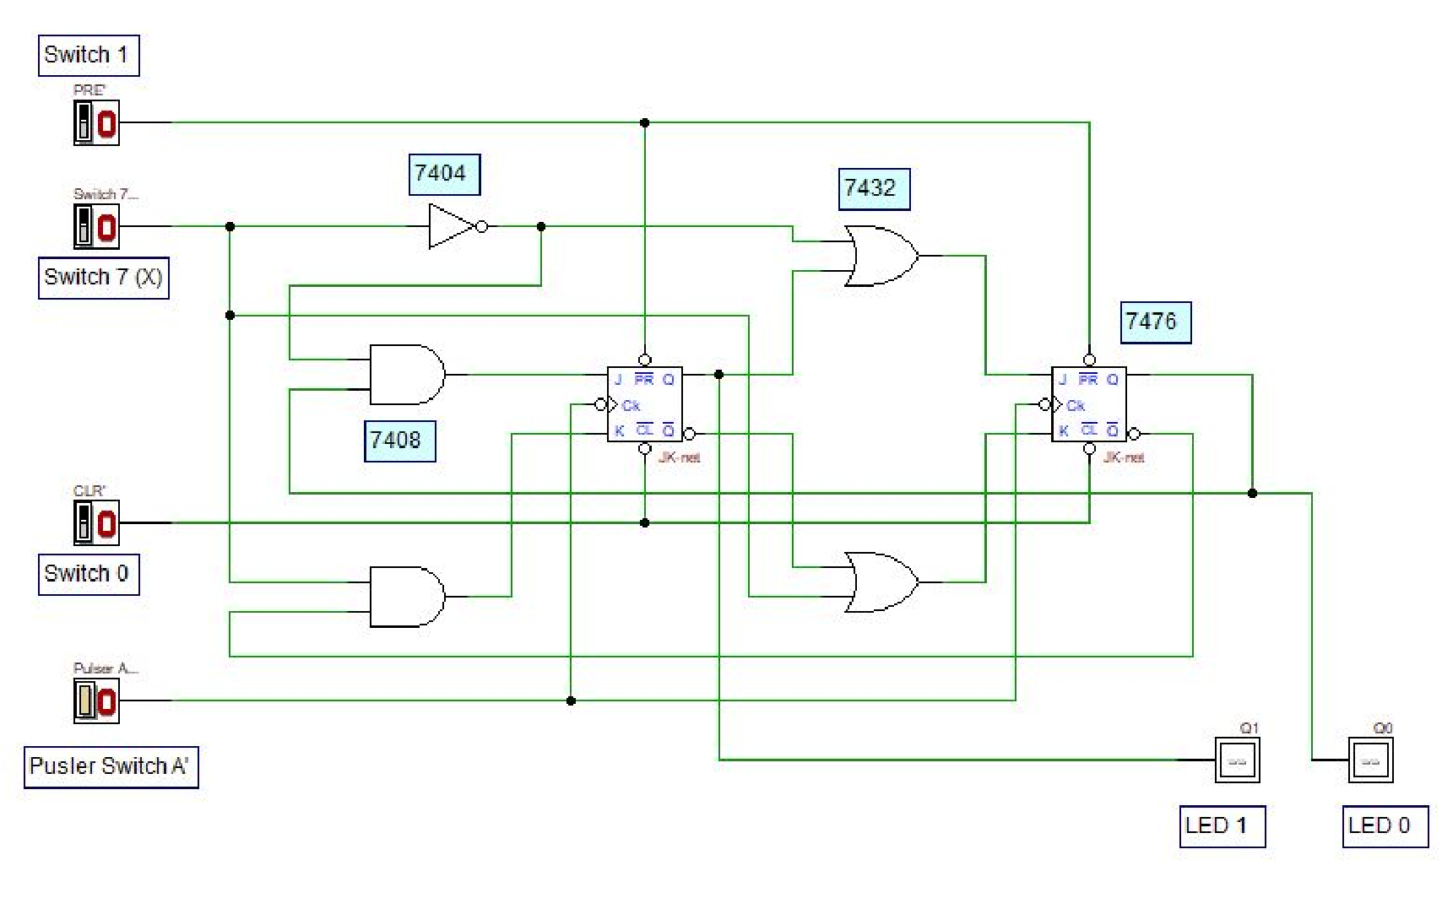 z

Figure 4: A Synchronous Counter Circuit

- By using all materials and equipment’s listed in section C, construct the physical circuit of Figure 4. (Make sure all ICs are connected to Vcc and GND).

- Investigate the behavior of the counter by observing the next state of the counter for all combination of Present State and X values. Complete the NextState table of the counter in Table 2. Ensure the Switch 0 is in HIGH state.
(0=LOW, 1=HIGH)

Table 2

Switch 7 | Present State |  | Next State
X | Q1 LED 1 | Q0 LED 0 | Q1 LED 1 | Q0 LED 0
0 | 0 | 0 | 0 | 1
0 | 0 | 1 | 1 | 0
0 | 1 | 0 | 1 | 1
0 | 1 | 1 | 1 | 1
1 | 0 | 0 | 0 | 0
1 | 0 | 1 | 0 | 0
1 | 1 | 0 | 0 | 1
1 | 1 | 1 | 1 | 0
- By referring to the Next-State in Table 2, sketch the state diagram of the counter.

1
00
0
00

1
0 1

0
11
10

0

1

- By referring to the Next-State in Table 2 and the state diagram in (4), answer all questions.

  - What is the main indicator to decide that the counter is a synchronous counter?

Synchronaus counter:
In the Synchronaus counter at the clock input to the flip flop state are changed.
So, main inclicatior for synchronaus counter is sate should change with reipeat to clock and input only when clock occure.

  - How many states are available for the counter and what are they?

In the avobe counter there is U-state are available which is : 00,01,10,11

  - What is the function of Switch 7 (X) in the circuit?

Switch 7 (x) is controller of counter which decide that counter is up count or down count.

  - What is the function of Switch 0 and Switch 1 in the circuit?

The function of Switch 0 and Switch 1 in the circuit is switch 0 is in HIGH state
And switch 1 is in Low state

  - Is the counter a saturated counter or recycle counter?

It is a saturated counter. Because a saturated counter is counter which count from minimum 00 to maximum value 11.

- Refering to state diagram in 4, draw and built a synchronous counter using D flip-flop.

  - Built the next state and transition table using the header in Table 3

Table 3
Input  X | Present State |  | Next State |  | JK FF Transision
Input  X | Q1 | Q0 | Q1+ | Q0+ | D1 | D0

Input X | Present | state | JK FF | input | Next | State | D FF | Input
 | Q₁ | Q₀ | J₁ K₁ | J₀ K₀ | Q₁⁺ | Q₀⁺ | D₁ | D₀
0  1 | 0  0 | 0  0 | 0 0  0 1 | 1 1  0 1 | 0  0 | 1  0 | 0  0 | 1  0
0  1 | 0  0 | 1  1 | 1 0  0 0 | 1 1  0 1 | 1  0 | 0  0 | 1  0 | 0  1
0  1 | 1  1 | 0  0 | 0 0  0 1 | 1 0  1 1 | 1  0 | 1  1 | 1  0 | 1  1
0  1 | 1  1 | 1  1 | 1 0  0 0 | 1 0  1 1 | 1  1 | 1  0 | 1  1 | 1  0

J K | clk | Q⁺
0 0  0 1  1 0  1 1 |  | Q  0  1  Q̅

D | Q⁺
0  1 | 0  1

(No change)

(Toggle-Change)

  - Get the optimized Boolean expression.

D₁=Ʃm(2,4,6,7)
D₀=Ʃm(0,4,5,6)
By K- map
For D₁: Q₀ X
Q₁
 | 00 | 01 | 11 | 10
0 |  |  |  | 1
1 | 1 |  | 1 | 1

D₁= Q₁Q₀+Q₁X̅+Q₀X̅
D₁= Q1(Q₀+X̅)+Q₀X̅

For D₀: Q₀ X
Q₁
 | 00 | 01 | 11 | 10
0 | 1
1 | 1 | 1 |  | 1

D₀= Q₁Q₀+Q₁X̅+Q₀X̅
D₀= Q1(Q̅₀+X̅)+Q̅₀X̅

  - Draw the complete final circuit design in Deeds.

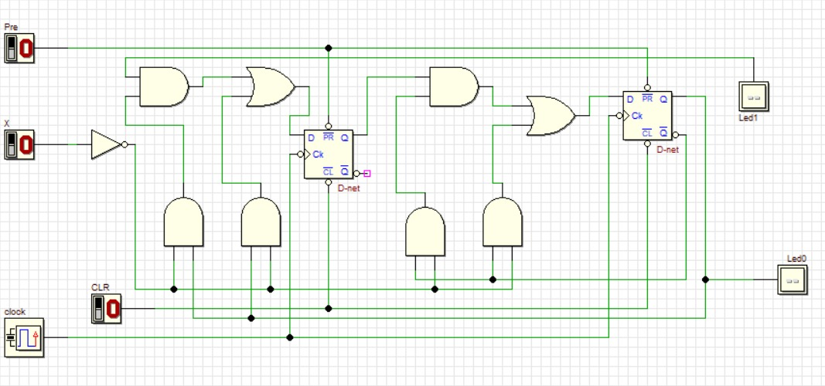

- Repeat steps in Q(6) using T flip-flop.

a) T FF table

Switch 7 | Present State |  | Next State |  | T FF Transition
X | Q1 | Q0 | Q1+ | Q0+ | T1 | T0
0 | 0 | 0 | 0 | 1 | 0 | 1
0 | 0 | 1 | 1 | 0 | 1 | 1
0 | 1 | 0 | 1 | 1 | 0 | 1
0 | 1 | 1 | 1 | 1 | 0 | 0
1 | 0 | 0 | 0 | 0 | 0 | 0
1 | 0 | 1 | 0 | 0 | 0 | 1
1 | 1 | 0 | 0 | 1 | 1 | 1
1 | 1 | 1 | 1 | 0 | 0 | 1

b)
\ Q1Q0 00 01 11 10
0
0

0

0

1

1

T1 = X’Q1’Q0 + XQ1Q0’

X \ Q1Q0 00 01 11 10
1 1 0 1
0

1

1

1

0
1

T0 = XQ1 + X’Q0’ + Q1’Q0

c)
