

Semester 1 2020/2021
Subject: Technology and Information Systems (SECP1513)
Section: 10
Assignment : Step by step PC Assembly

GROUP NAME / NUMBER: LmaoTech (Group 3)

1 |  | Name: Lai Yee Jen  Matric Number: A20EC0061  Phone Number: +60142290938  E-mail: laijen@graduate.utm.my
2 |  | Name: Tham Chuan Yew  Matric Number: A20EC0166  Phone Number: +60168819239  E-mail: thamyew@graduate.utm.my
3 |  | Name: Muhammad Zaki Mufthi  Matric Number: A20EC0325  Phone Number: +62-821-9929-7030  E-mail: mufthi@graduate.utm.my
4 |  | Name: Muhammad Sabiq Ahsan  Matric Number: A20EC0322  Phone Number: +62-822-6710-220  E-mail: ahsan20@graduate.utm.my

PART A – Tools Needed
- Screwdrivers

Screwdriver is used for screwing (installing) and unscrewing (removing) screws.

- Pliers
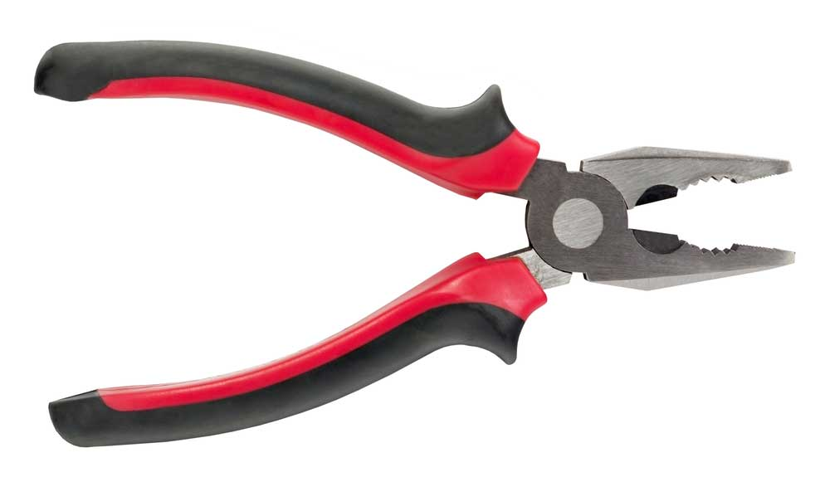
Plier is used to remove and insert jumpers on motherboards and hard drives. It can also be used to cut wires.

- Heat Sink Compounds

Heat Sink Compound is used to eliminate air gaps or spaces (which act as thermal insulation) from the interface area in order to maximize heat transfer and dissipation. It helps to improve the thermal efficiency of heat sinks and improves cooling.

- Cable Ties
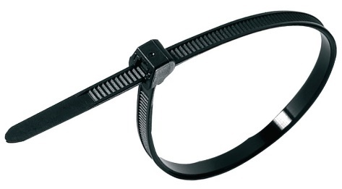
Cable tie is used to bundle the wires neatly and cables away from fans and other components inside the computer.

- Flashlights
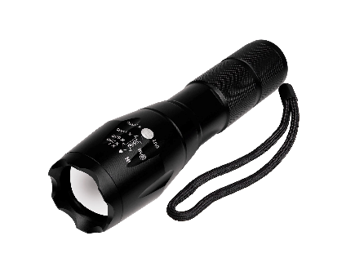
Flashlight is used as a light source to light up the internal of CPU when assembling the components.

6.0 Scissors

Scissors is used to cut the cable tie after bundling the cable. Scissors can also be used to cut wires.

PART B – Sketching the Layout of Motherboard
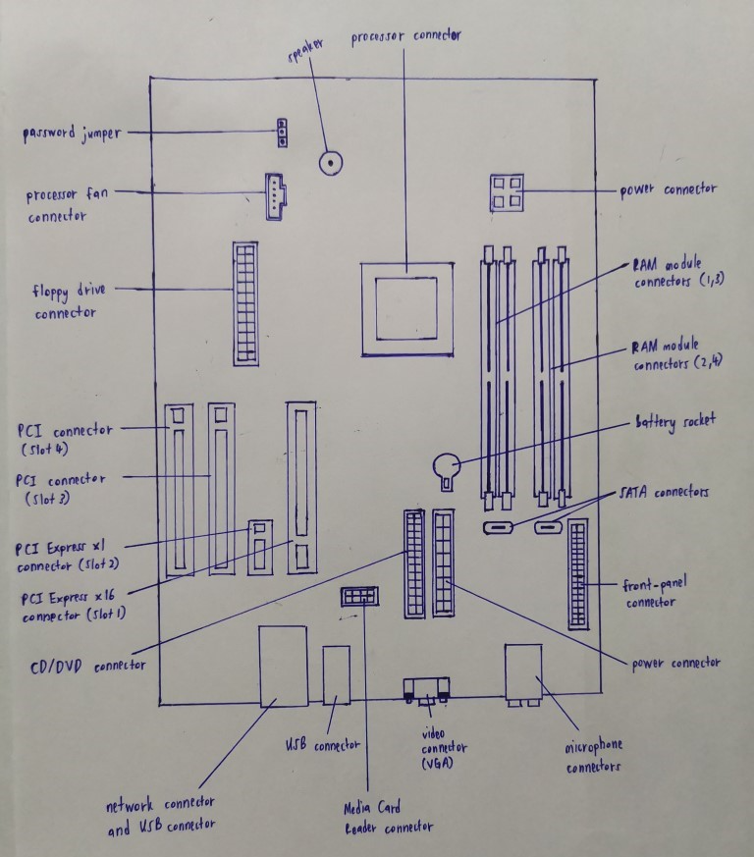
Diagram - A Sketch of a motherboard layout

PART C - “Step by Step PC Assembly”
STEP 1 – INSTALL THE PROCESSOR
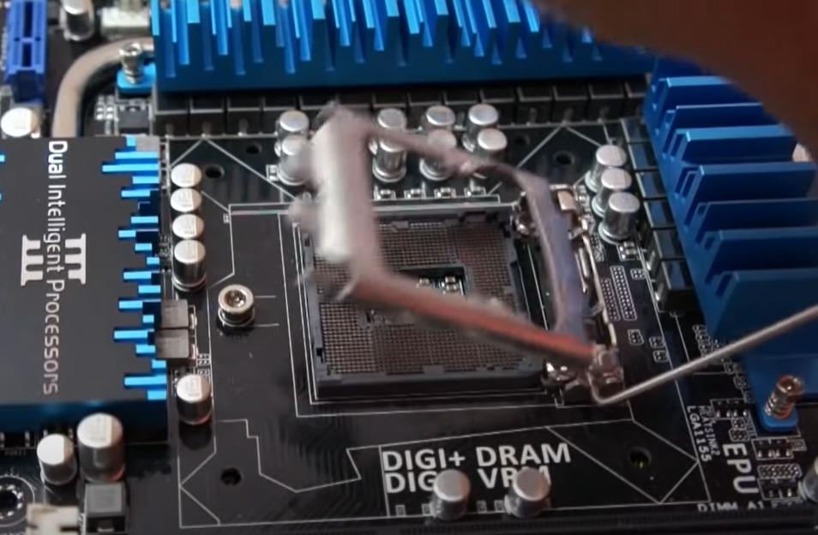
Unlock the Processor Holder Latch Socket Retention Module Mount.

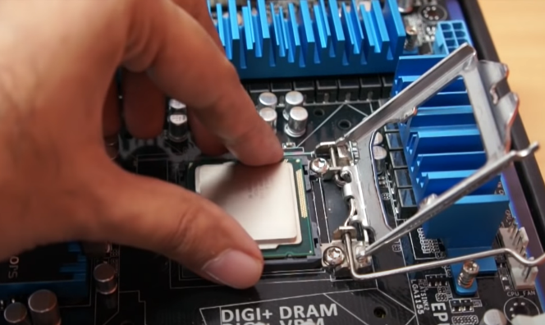
Place the processor chip into the Processor Holder Latch Socket Retention Module Mount.

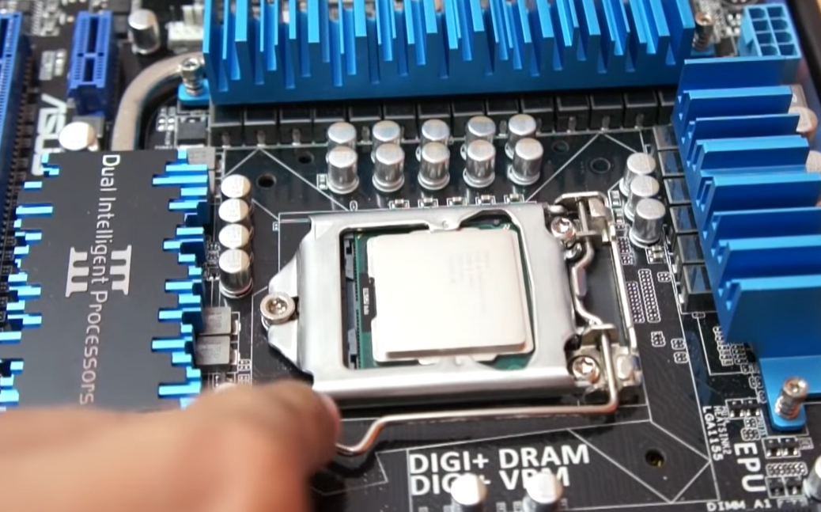
Lock the Processor Holder Latch Socket Retention Module Mount.

STEP 2 – COMPLETE THE HEAT SINK
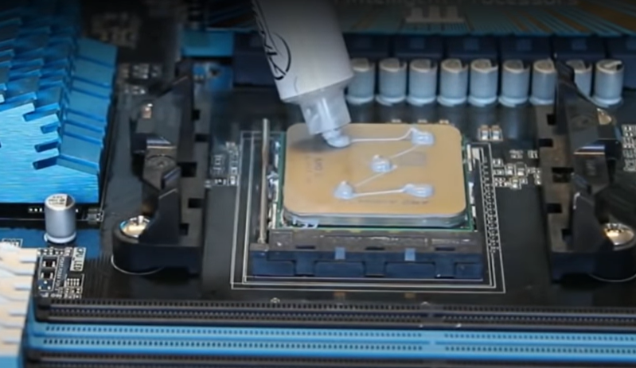
Apply the Heat Sink Compound on the top of the processor chip.

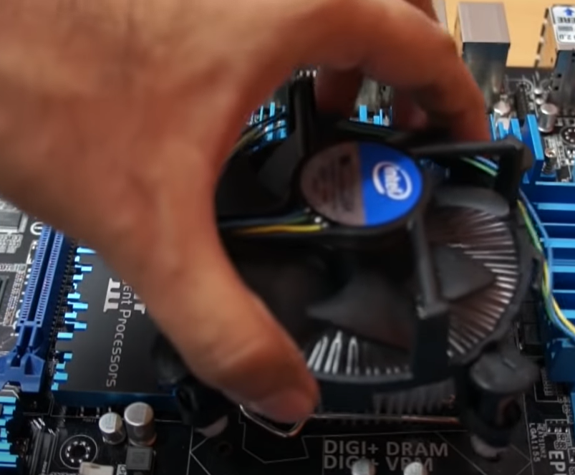
Align the Heat Sink to the processor and the motherboard.

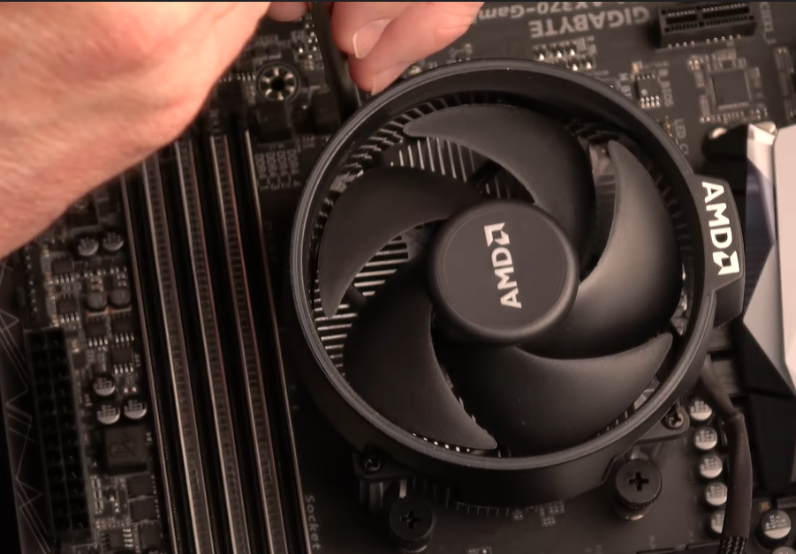
Screw the Heat Sink to the motherboard.

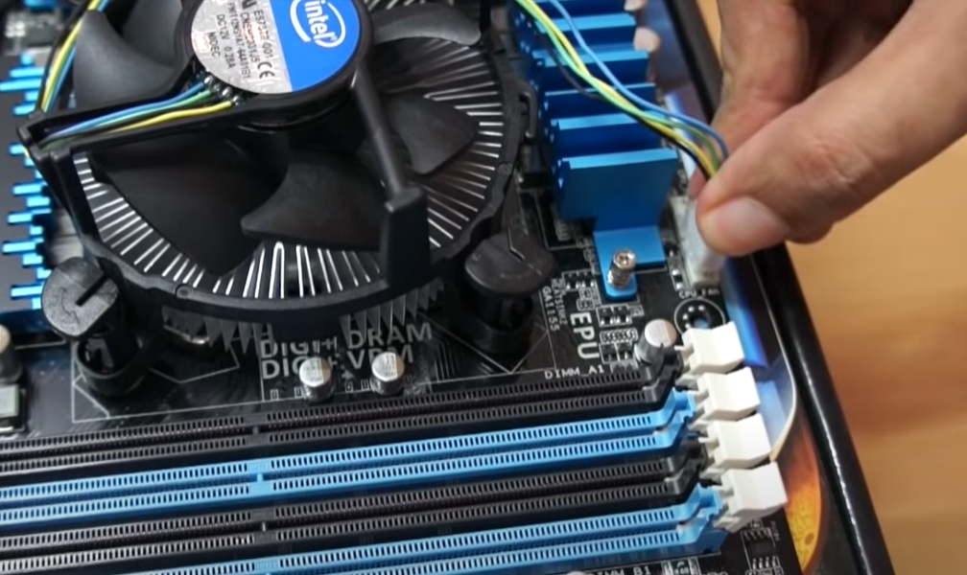
Connect the cable of the Heat Sink to the Processor Fan slot on the motherboard.
STEP 3 – INSTALL THE RAM
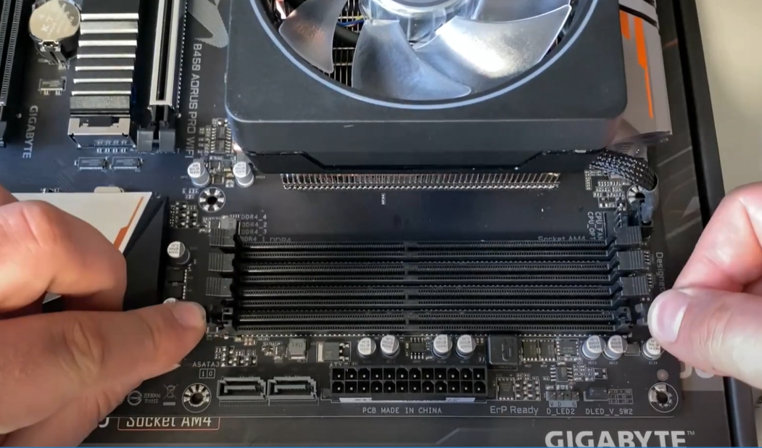
Unlock the RAM holder on the motherboard.
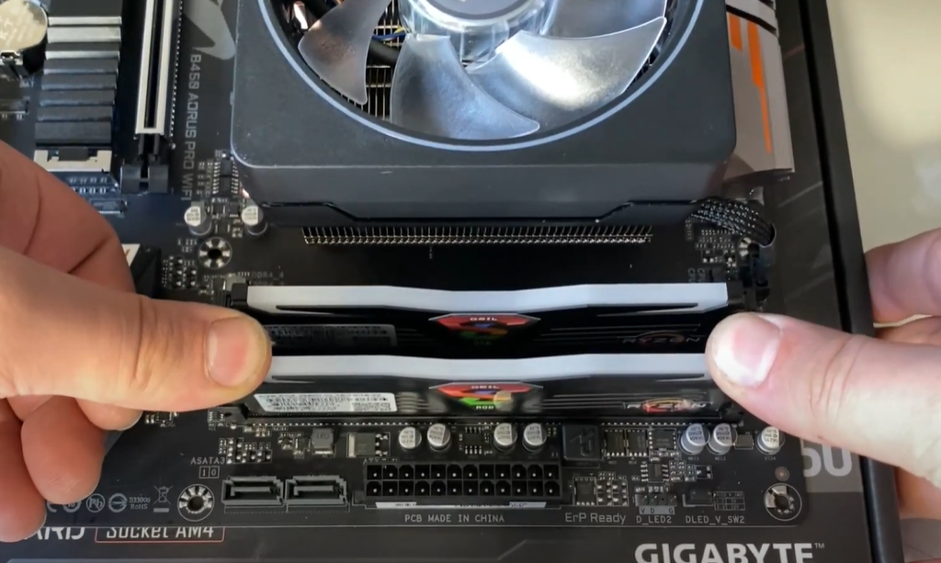
Insert the RAM into the motherboard and lock the RAM holder.

STEP 4 – MOUNT THE POWER SUPPLY
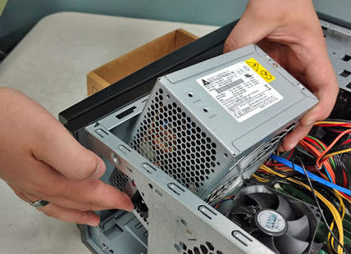
Insert the power supply into the power supply slot in CPU.
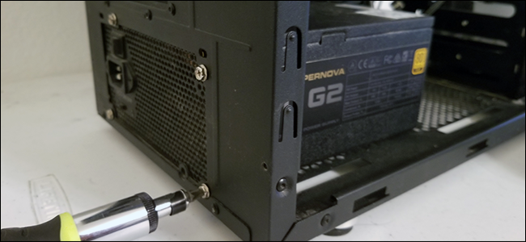
Screw the power supply to the CPU case using the screwdriver.

STEP 5 – INSTALL THE MOTHERBOARD
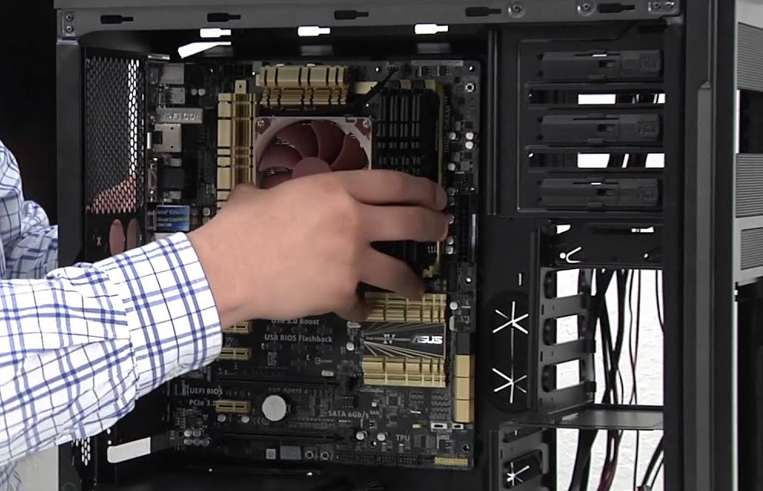
Place the motherboard into the CPU and align to the motherboard slot.
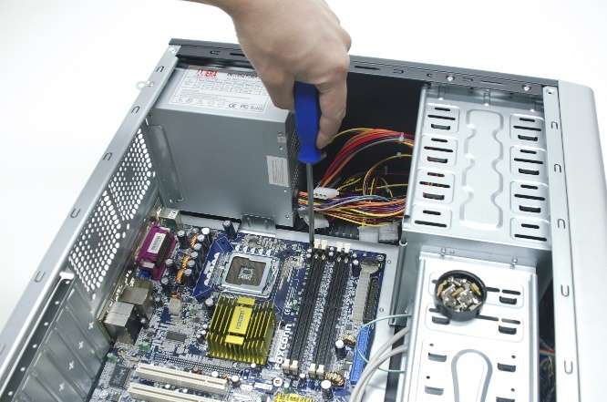
Screw the motherboard to the CPU case using the screwdriver.
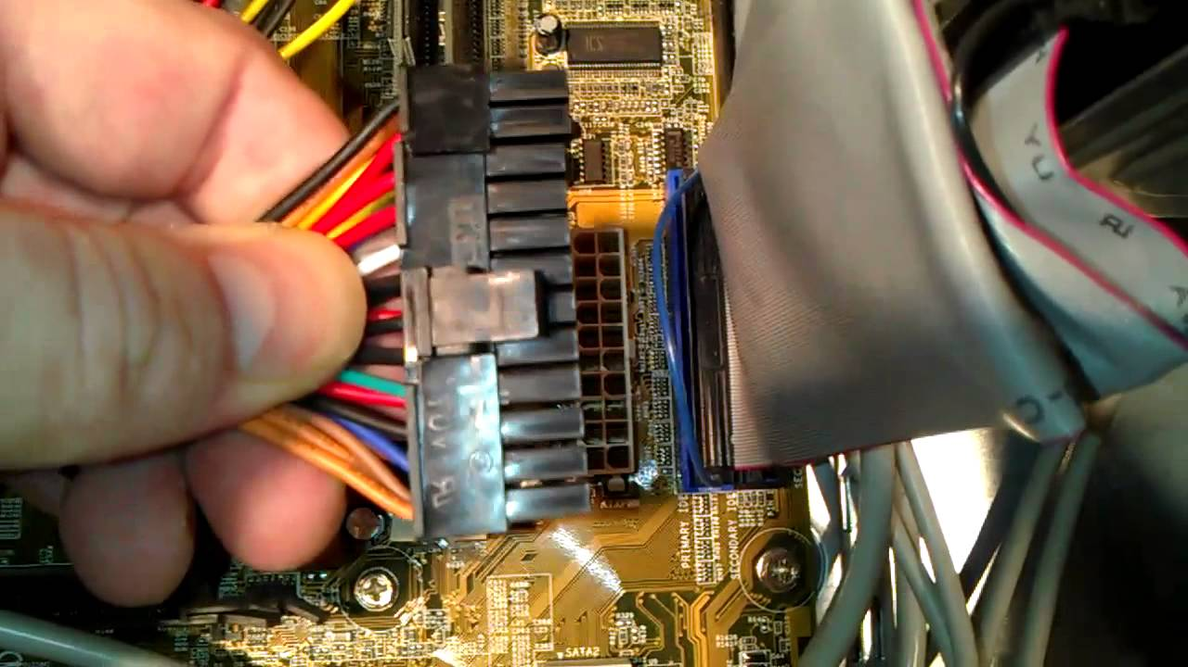
Connect the power supply to the motherboard using 24-Pin Cable or any pin which is suitable.

STEP 6 – INSTALL THE CD ROM DRIVE
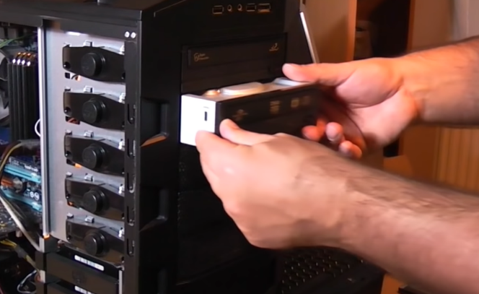
Insert the CD ROM Drive into the CPU.
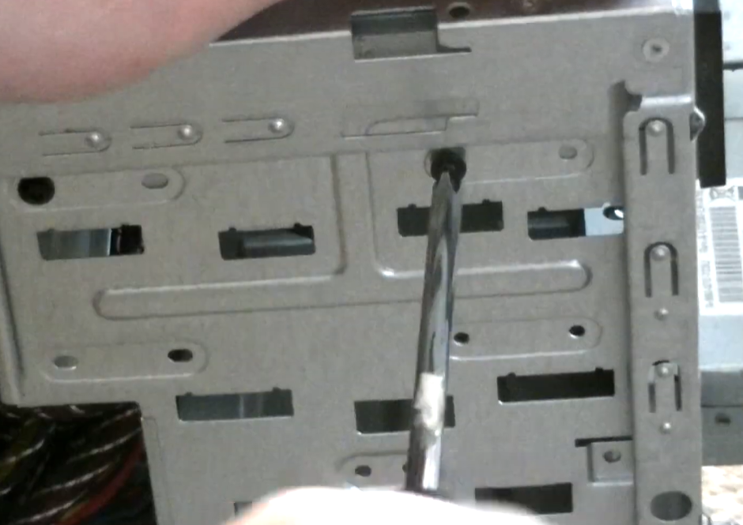
Screw the CD ROM Drive to the CPU case using the screwdriver.
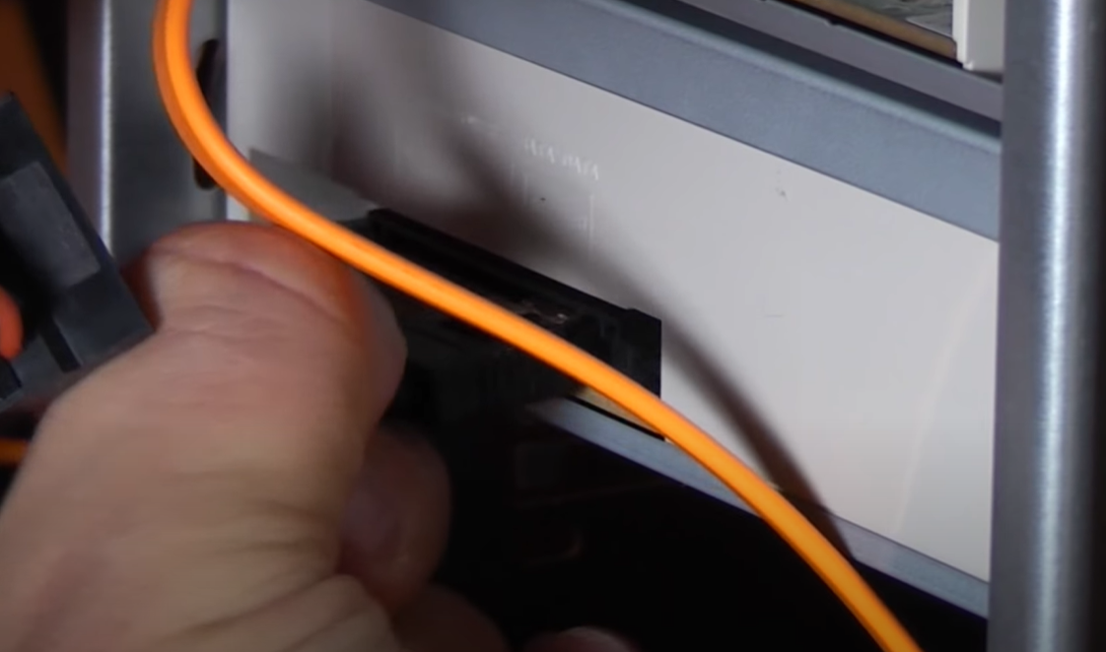
Connect the CD ROM Drive with the motherboard using SATA cable and connect the power supply to the drive using 4-Pin Cable or any pin which is suitable.

STEP 7 – INSTALL THE GRAPHIC CARD
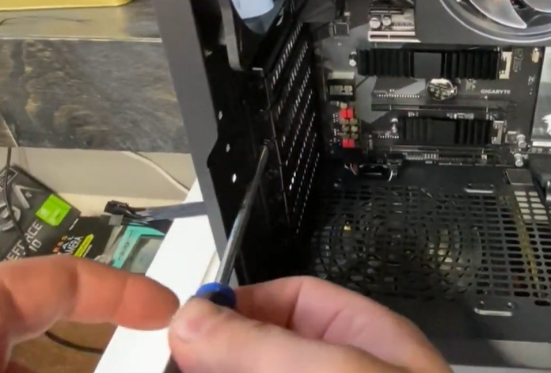
Check how many slots needed for the graphic card and unscrew the slots.
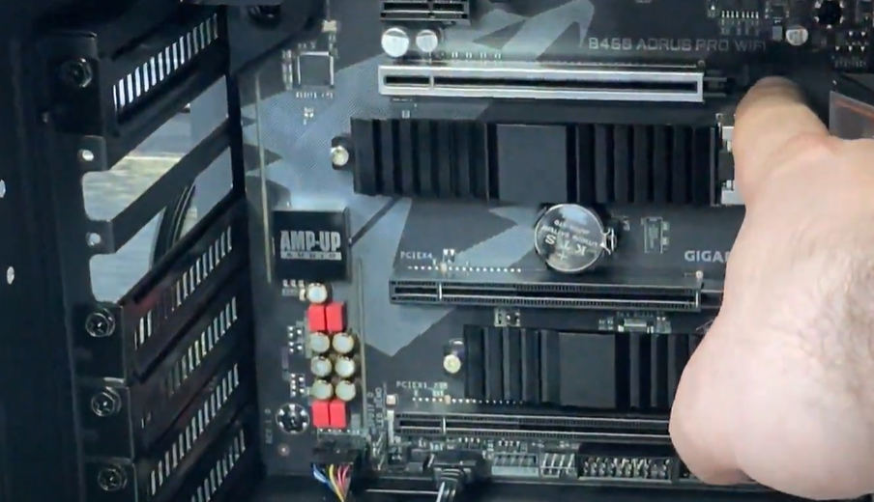
Remove the slots and unlock the holder of the graphic card on the motherboard.
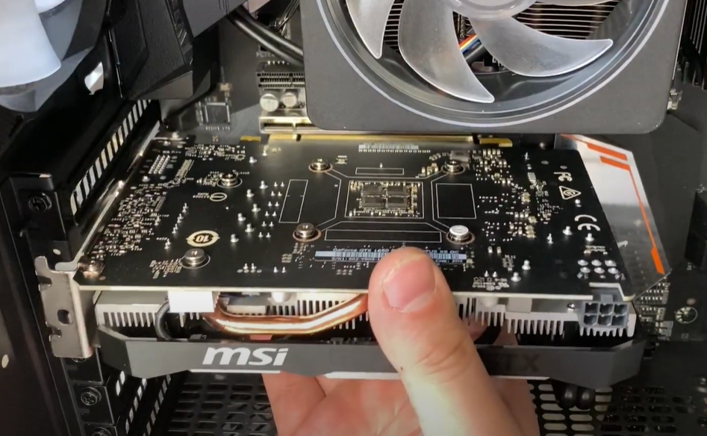
Insert the graphic card into the PCI slot in the motherboard.
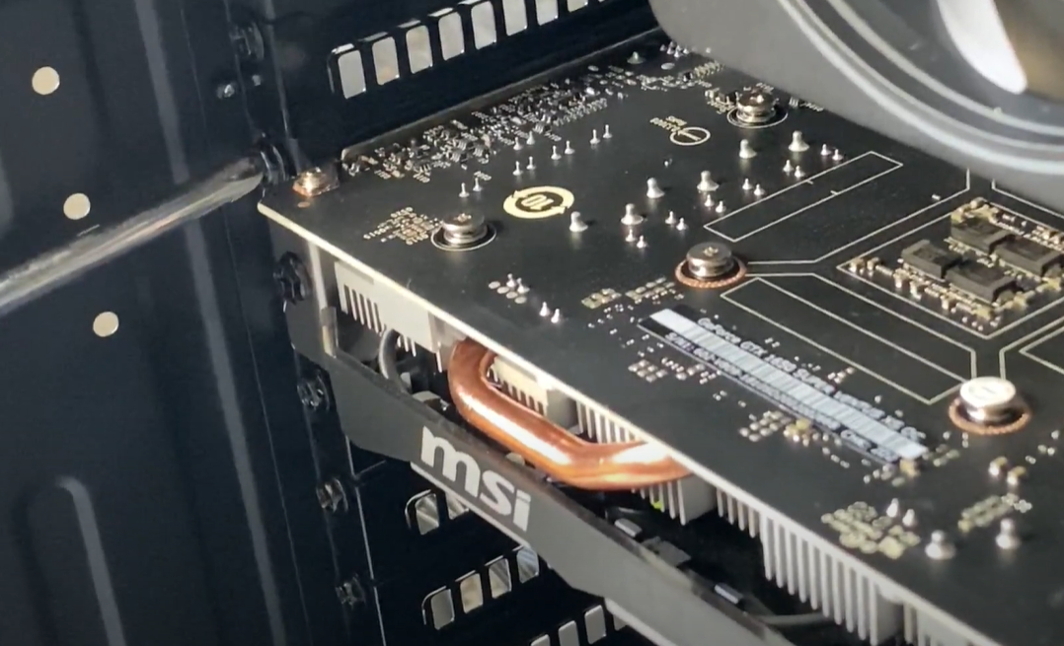
Screw the graphic card to the CPU case using the screwdriver.
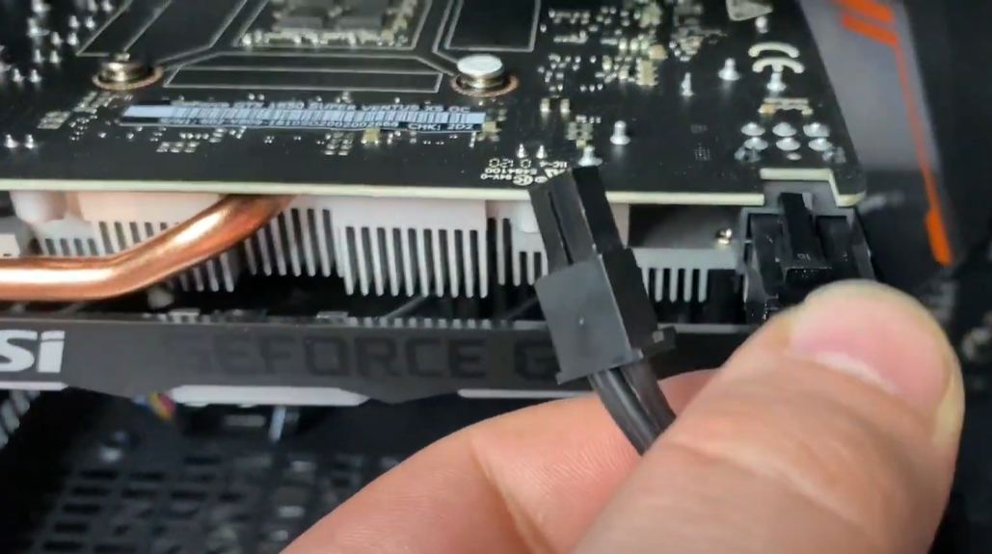
Connect the power supply to the graphic card using 6-Pin PCI-E Cable or any pin which is suitable.

STEP 8 – INSTALL THE HARD DISK
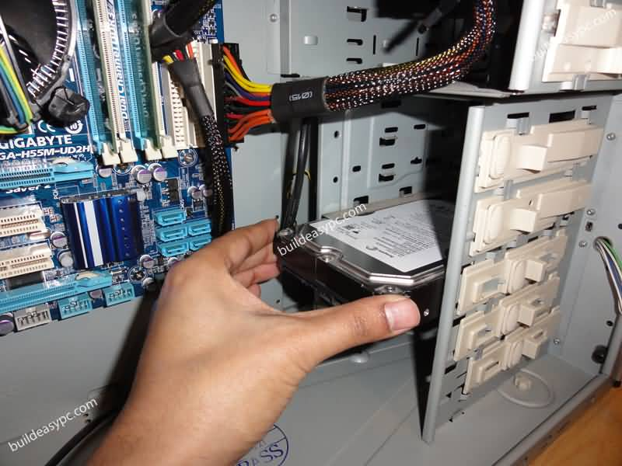
Insert the hard disk into the hard disk slot in the CPU.
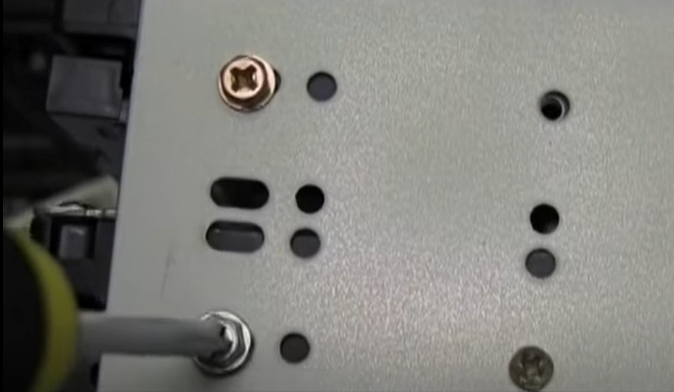
Mount the hard disk to the CPU case using the screwdriver.
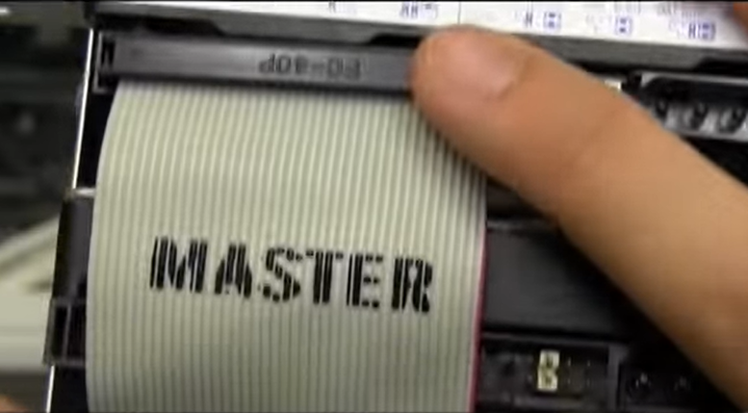
Connect the main hard disk with Master IDE slot and the secondary hard disk with Slave IDE slot then connect the Mainboard IDE slot into the motherboard.
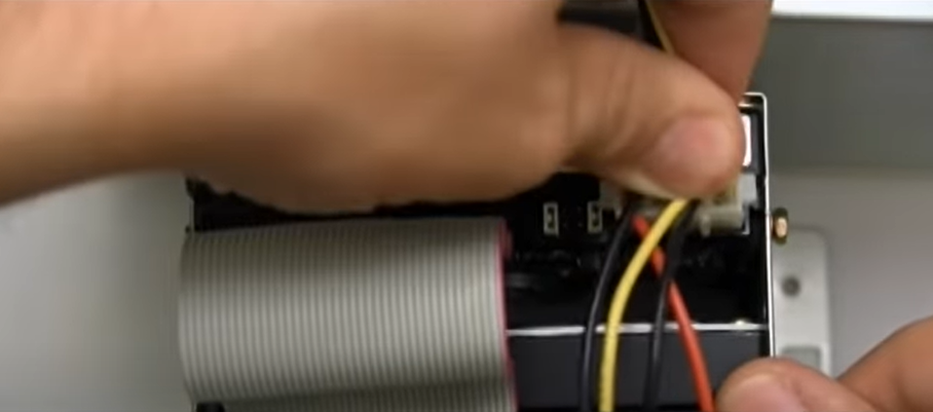
Connect the power supply to the hard disk using the 4-Pin cable or any pin which is suitable.

LAST STEP - CLOSING THE CASE AND CONNECTING THE PERIPHERALS
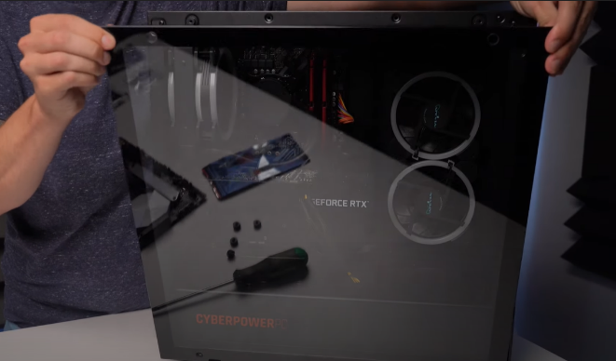  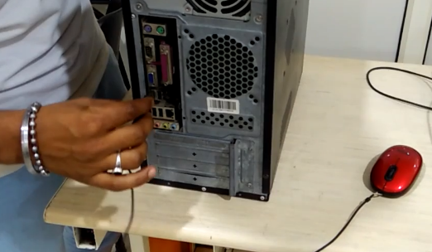 | Place the side cover back on and secure the side panels with case screws.
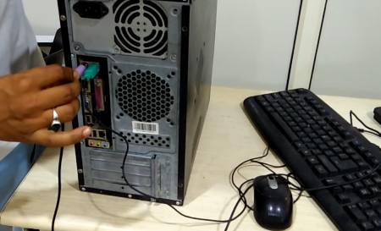 | Connect peripheral devices which include keyboard, mouse, wireless network dongle, printer, and webcams with your CPU by plugging into USB port.
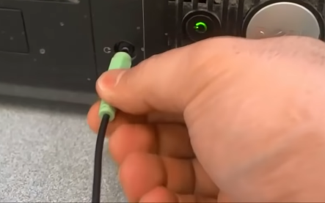  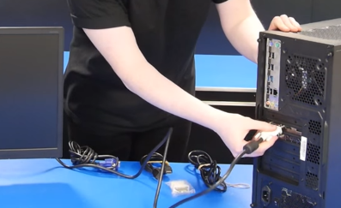 | Then, connect speakers and microphone into 3.5 mm sockets.  Finally connect the CPU with monitor by plugging into display ports.
Thank you!

