
GRADUATE SUCCESS ATTRIBUTE
UHMT 1012 (47)
ASSIGNMENT 2 (15%)
(Group Assignment)
Name | : | Lim Yeu Chen
Matric No | : | A20EC0067
Phone No | : | 01111413342
Program of Study | : | UHMT1012-47 GRADUATE SUCCESS ATTRIBUTES


Name | : | Yu Kok Yong
Matric No | : | A20EC0232
Phone No | : | 01137338263
Program of Study | : | UHMT1012-47 GRADUATE SUCCESS ATTRIBUTES

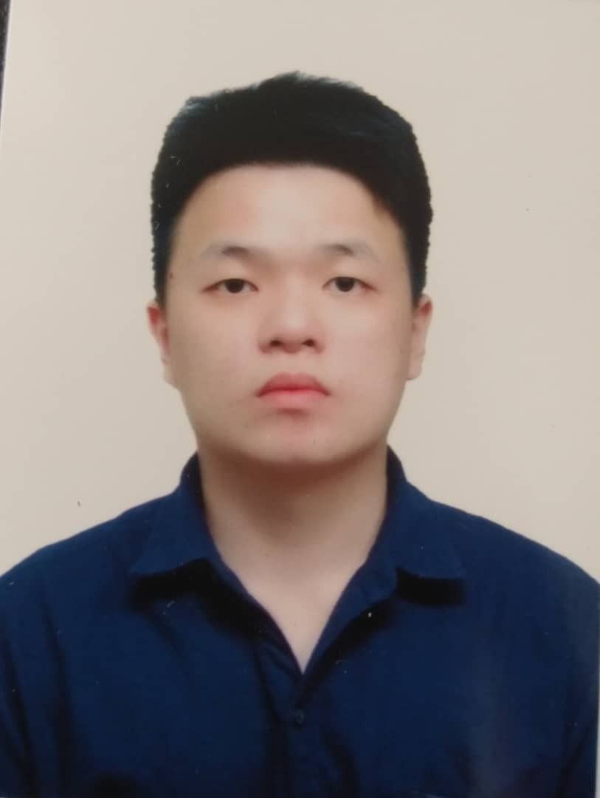

Name | : | Tay Jia Yi
Matric No | : | A20EC0158
Phone No | : | 01110920624
Program of Study | : | UHMT1012-47 GRADUATE SUCCESS ATTRIBUTES



Name | : | Tan Ming Hui
Matric No | : | A20EC0155
Phone No | : | 0126548511
Program of Study | : | UHMT1012-47 GRADUATE SUCCESS ATTRIBUTES
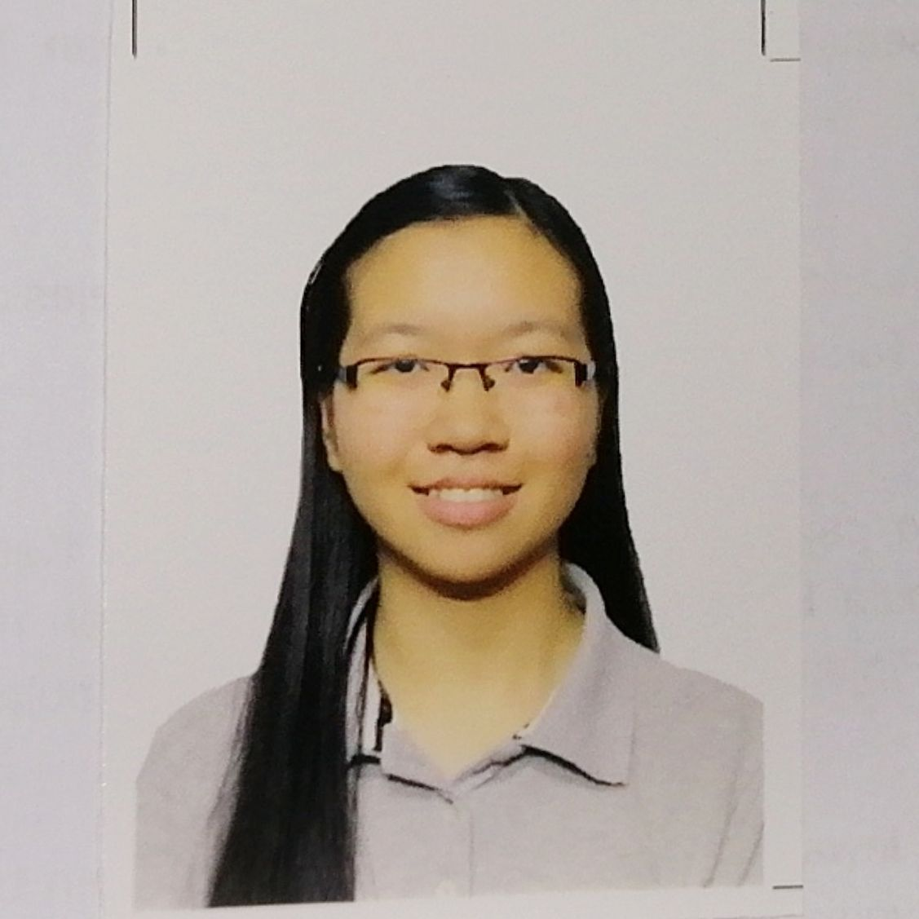

Name | : | Kalaivani A/P Subramaniam
Matric No | : | A20EC0056
Phone No | : | 0137202005
Program of Study | : | UHMT1012-47 GRADUATE SUCCESS ATTRIBUTES


Lecturer’s Name: Dr. Najua Syuhada Ahmad Alhassora

CONTENT

No | Topics | Page
1.0 | Introduction | 1
2.0 | Description of her business | 1-3
3.0 | Target Groups | 3
4.0 | Business History | 3
5.0 | Business Strategies | 4
6.0 | Challenges | 4-5
7.0 | Strength/Weakness | 5-7
8.0 | Interview process/Pictures/Evidence | 8
 | Appendixes | 9-

MS TINA LEE
(ENTREPRENEUR)

- Introduction

The entrepreneur who we had chosen to interview was Ms. Tina Lee. Ms Tina Lee is a
successful entrepreneur in Johor. Her business scope is Educational field. She is a Managing Director of PLMM Tuition Centre Sdn.Bhd. She has been running her business for about 19 years (since 2001). She also has 3 to 4 workers at each branch. One of our team members, Lim Yeu Chen is the one who interviewed Ms. Tina Lee on 4 December 2020 at Ms Tina Lee’s office.

2.0 Description of her business

PLMM Tuition Centre Sdn. Bhd. is an institution that provides services in educational field for students from 6 to 17 years old. The services are mainly promoting the students’ educational levels and results, as well as their attitudes. Services provided comprise the tuition classes, childcare service, transportation service, holiday programs and homework classes. The tuition centre upholds three core values, namely love, caring and patience in educating the students.
Furthermore, it consists of a professional team of tutors. They will be formulating the teaching materials for respective levels’ students on a monthly basis with a view to assisting the students to catch up the syllabus and to pass their examinations with flying colors. During lessons, the tutors will also follow Ms. Tina’s technique to handle the class well – Calm the students down, explain the learning outcomes, go through the notes with students, give them time to complete exercises, mark their works one-by-one, and finally, ask questions to test their understanding as well as giving gifts to those who perform well throughout the lesson. Consequently, the tutors can comprehensively know each student’s level and make personal plans to strengthen their particular weaknesses respectively.
The tuition classes are categorized into two levels, which are primary level and secondary level. For the primary level, the subjects included are Bahasa Malaysia, English, Mandarin and Mathematics. Whilst for the secondary level, the subjects included are Bahasa Malaysia, English, Mandarin, Mathematics, Science, Sejarah and Geography.
Besides, the tuition centre provides the daytime childcare service for elementary and primary students only. The childcare service operates from Monday to Friday. It is divided into two categories as well, there are, morning session and afternoon session. The morning session is for Primary 1, 2 and 3 students who are going to schools in the afternoon.
On the other hand, the afternoon session is for Primary 4, 5 and 6 students who study in the morning. Ms. Tina mentioned that the reason why this service is known as ‘daytime childcare service’ instead of nursing home due to she put the children’s feelings as the first priority. She does not want them to think that they are being left here because they burden their parents, yet they are here to learn new knowledge and make more new friends. To ensure the children can partake healthy food, Ms. Tina has also employed a professionally dietary cooker to prepare balanced, healthy and scrumptious diets for them. Teatime delicacies are prepared for the children too.
Apart from a cooker for the childcare department, there will be a permanent tutor who is responsible on all stuffs related to the childcare service. This tutor must be a fully patient, loving and caring person on all occasions. Ms. Tina believes that their loves to students will unknowingly alter the students’ attitudes, for example, knowing to respect others as well as being enthusiastic in learning. The childcare tutor will supervise the students’ homework. He or she will make sure that they have completed all their homework as well as the spelling or dictation before going to school. Not only the homework, the children’s behaviors are one of the critical importance as well. All the tutors will always correct their inappropriate actions either in childcare or tuition.
In order to ease the parents, the tuition centre also provides transportation for the students. The drivers will be sending the students from their homes to schools, to the tuition centre, or vice versa, therefore the parents can focus on their works without worries. To reinforce the parents’ confidence on their children’s safety, Ms. Tina will employ the drivers after she had strictly penetrated the driver’s background, characteristic. Nevertheless, they will not be sending the morning-class students to school in the morning as their duty hours are starting from 8 a.m. to 7 p.m., same as the centre’s working hours.
In addition, the childcare students will have the opportunities to participate in the centre’s tuition classes and activities as well. They are included in the childcare package. Once Ms. Tina holds any activity in the centre, they can take part in it for free while the tuition class students will have to pay for it. Typically, the activities will be held on Fridays or during the school holidays. The main purpose of the activities is to enable the students to widen their horizon or learning more extra-curricular knowledge and technical skills. Nowadays, the students have been overwhelmed by stress in their educations, thus they can unwind themselves, at the same time, and they can stay away from the electronic gadgets through participating in the activities during school holidays. Making an analogy, the interesting activities consist of cooking, playing games, handcrafting, or so. Whilst during school holidays, the tuition centre will also have some outdoor activities such as visiting farm, culture village and zoo, playing badminton, football and basketball. However, these activities may have some charges.
Moreover, the tuition centre provides homework class too. It emphasizes on assisting the students to accomplish their tasks assigned by the schoolteachers. The tutors will effectively help the students to complete their homework as well as doing revision on the spellings or dictations. In case they finished their works earlier or do not have any homework, they will be given extra exercises on the topics which they may not be very familiar with. Certainly, some students may not be able to finish their homework on time, thus they are encouraged to bring the homework which they do not understand and are unable to do. This will save their precious time and they will be able to do more exercises which they require.

3.0 Target groups

The foremost aim of Ms. Tina’s business is to assist the students on their academic affairs. Meanwhile, the reason why Ms. Tina starts her business is also owing to her determination to benefit the students. Hence, her business’s target groups are prominently the students from kindergarten, primary school and secondary school. For instance, the target groups consist of students from 5 years old to 17 years old. Ms. Tina is persevered to help the students to overcome the obstacles they encounter through consulting and communicating with them as well as inculcating their proper learning attitude and behavior.

4.0 Business history

Before Ms. Tina set up her company, she was actually a part-time tutor in a small-scale tuition centre while she was furthering her studies in local university. She realized that all students had their own potencies and methods to learn. She always upheld a value in teaching the students, that is, ‘No one is stupid, only one who is lazy’. She was deeply loved by her students. After she had graduated in 2001, she persevered to set up her own tuition centre to help more students as well as fostering more tutors who are willing to dedicate for educating the younger generations. In the first ten years, she had been opening three branches in different areas near the local schools. As time flies, she never contradicts her primitive vision of the tuition centre – assisting the students to improve their academic levels, cultivating their proper attitudes and behaviors in learning, leading everyone who comes over the tuition centre towards the success, through communication and consultation fulfilled with love, caring and patience.

5.0 Business strategies

First is service and teaching material. Ms. Tina Lee create and design the tuition centre according to her personal culture and style. She also set the rules and regulations to every student uniformly regardless of the student’s background. She hired a well-trained and experienced teacher to each branch. Next, to promote her business she took photographs of the students and environment for publication. She motivates the students with a view to inspiring their determination to study. In addition, she also helps the students by setting some goals for her students. Her another strategy to motivate her students is by giving them presents who perform well in the examinations.
Second, price. Ms. Tina Lee gives promotion during year-end school holidays (November & December). For example, the students have to pay one-month tuition fee only even though they attend the tuition classes for two months. Furthermore, promotion for tuition class’ students in their transportation fee. For example, a student will have to pay RM12 for one subject per month (two-ways). If the student takes four subjects and above, he or she will have to pay a maximum transportation fee up to RM60 only. Next, students who introduce their friends to enroll in the tuition classes will be given a rebate in their tuition fees.
Third, promotion. Ms. Tina Lee makes conversation with parents and students via Facebook, either personal message or on our official Facebook page timeline. Then, occasionally publicize the centre’s programs, tutors, courses and etcetera through poster, flyer, Facebook post and more.

6.0 Challenges in business

Ms. Tina’s challenges in her business are derived from the institutions nearby in the same scope. There are several tuition centres located nearby which provide the same type of services. Nevertheless, Ms. Tina mentioned that all the competitors have respective pros and cons. So, she has to learn from their pros and overcome her business’s cons in order to improve it.
Her business’s challenges are, first and foremost, it has less tutor who has the teaching experience for more than ten years. Meanwhile, the tutors are mostly short-term workers instead of working as a permanent worker. As an effect, Ms. Tina finds difficulty in effective publication as the tutors will be the most influential way to advertise the tuition centre. Besides, the tuition centre will suffer from the loss of some students. The consumers – the students and parents will be fonder of having a permanent tutor. This is due to a permanent tutor will be more familiar with the students’ weaknesses and how to handle them. This will be beneficial for both the students and parents.
Secondly, Ms. Tina’s business is just a small company. It will be hard to compete with other competitors in the form of enterprise or corporation. It is because the enterprise can expense more on the publication as well as employment of more excellent tutors. Owing to its target groups comprise wider consumer range, that is, students from private or local schools and from primary one to STPM standard. Unknowingly, the public will be more attentive to the popular enterprise rather than a company. The students will also be more prone to study with the professional tutors under the enterprise.
Thirdly, with the advent of technological advancement, Ms. Tina has to cost much in maintaining the communication with the parents via electronic devices. For instance, the maintenance fee of Wi-Fi, computers, smartphones, private system for accounting and students’ data, or so. Some competitors even have their own customized phone applications for tuition fee’s payment, tuition schedule and so on. It may be highly costed to develop such application. Nevertheless, it is of critical importance to communicate with the parents to update them their children’s conditions and problems, therefore the communication system will have a continuous expense on her business.
The challenge in her business is, last but not least, the franchise system. She does have three branches for PLMM Tuition Centre which are located in different areas. So, she will meet a problem to synchronize them in the way of service. At the same time, the consumer groups will be various as well. Thus, she has to train her employees on how to handle different kinds of parent as well as the effective teaching methods for various types of student, however, it still have some uncertainties existed.

7.0 Strength / Weaknesses
In Ms. Tina’s business, it has both strengths and weaknesses in every department that leave either positive or negative impact.

Strength:
Firstly, in childcare department, there will be a hotline specially provided for the childcare students only. Parents can directly communicate with the childcare tutor to update their children’s conditions as well as their special requirements. Besides, the childcare students can enjoy the healthy and scrumptious food prepared by the well-trained cooker carefully. They can also take part in exciting activities held as well as the additional tuition classes for free. In order to ease the childcare tutor, Ms. Tina has also executed a ‘Baby Plan’ – She will assign one student from either Primary 1, 2 or 3 to one student from Primary 4, 5 or 6. The latter will have to take good care of the former such as leading them to wash their hands before eating, keeping their belongings in their respective shelves, or so. Furthermore, the childcare department’s main purpose is to build the students’ good attitude, thought and behavior.
Secondly, in tuition class’s department, the tutors will make a report for each student on a monthly basis with a view to updating to their parents. The cooperation between the tutors and parents matters in the effective improvement of the students in all aspects. The tutors will teach the students with their exclusive notes and exercises in the latest format. Moreover, as the aforementioned description, the tutors will go over the students one-by-one, thus they can completely understand each student’s strength and weakness then update to their parents. During lessons, the tutors will teach in three major languages, that is, Mandarin, English and Malay owing to the students are consisting of three major races in Malaysia. Every month-end, the centre will also hold the examinations to test for their understandings. Of course, they will reward the students as well so the students will be motivated to keep up their efforts. In addition, all the tutors are flexible in their jobs due to their comprehensiveness.
Thirdly, the homework class’s department. Its strength is mostly similar to the childcare department. Parents can contact the tutors via a hotline which is specially provided for the homework class’s students. They have to take part in the month-end examinations and certainly they will be rewarded as well. The tutors will give them the extra exercises once they have completed their homework or spelling’s revision assigned by the schoolteachers. They will not waste any precious time and are able to catch up the school’s learning progress.
Fourthly, in the administration department, the tuition centre has a private system for data storing. It plays an important role in assisting the administrator to provide systematic service. The administrator has to contact the students who are absent to the tuition class as to show the parents that they really emphasize on the students’ attendance. Besides, the administrator will have to arrange the transportation routes and separate them to the drivers. This is attributed to the drivers can pick up the students on-time and safely therefore they will not be late in class. An administrator will be patient in handling every consumer, namely the parents’ and the students’ requirements and issues as well as maintaining the good relationships with them.
Lastly, the tuition centre’s transportation department does possess their own strengths too. This department is Ms. Tina’s strictest concern. It is attributed to she always puts the students’ safety as the first priority. All the drivers in PLMM Tuition Centre have more than 20 years driving experience in transportation service. They are equipped with essential knowledge about the vehicle’s repair and maintenance. Moreover, they are very friendly to the parents and students. Ms. Tina also provides them good-conditioned vans to reduce the possibilities of car breakdown while sending the students. They drive slowly and steadily to make sure that the students’ safety are secured. Hence, they will always start their journeys priorly.

Weakness:
Firstly, in the childcare and homework class’s departments, the provided space is limited, however, the number of students is gradually increasing. It is due to the parents are tougher to work for livings nowadays. Nevertheless, a sufficient space is fundamental for every student as they will not feel depressed. Sometimes, if the students do not have commitment with the childcare tutor, they may hide their homework or spelling or not bringing them to the tuition centre. If the tutor does not realize this behavior and have prior notice to their parents, the parents may receive complaints from the schoolteachers about the uncompleted homework, then the former will blame this responsibility on the childcare tutor. This will overwhelmingly burden the tutors and make them feel stressful and exhausted.
Secondly, as most of the tutors are majorly part-time jobseekers, thus the tuition centre has less permanent tutors. They may work for a few months before they further their studies in master’s degree or so. As a consequence, Ms. Tina has to continuously expense on training the new tutors in the long term. The students have to get used to the changing of teaching styles as well. This will reduce their confidences and enthusiasm in learning. During the vacancy of tutors, the students will be left behind in their academic at school.
Thirdly, for the administrators, they have to be well equipped with the proper and effective communication skills. They have to convince the customers for registration in order to increase the sales. Furthermore, they actually act as a go-between among the departments. They have to coordinate their requirements and tasks, therefore they may lack of time to accomplish their own obligations. In actuality, the incumbent is upon the administrators to create high sales and maintain the customer base. This will cause the decline in the company’s sales.
Lastly, in the transportation department, the most significant weakness is the expenses. For example, the petrol fees, maintenance fees, road taxes and so on. Besides, Ms. Tina cannot predict the drivers’ speed and ensure their compliances with the traffic rules when they are on duty. Sometimes, they may drive recklessly with a view to sending the students on time. All these aforementioned situations may leave a big impact on the tuition centre’s image and reputation. As a result, the parents will worry about their children’s safety and they may lose confidence on the centre in a long run.

8.0 Interview process/Pictures/Evidence

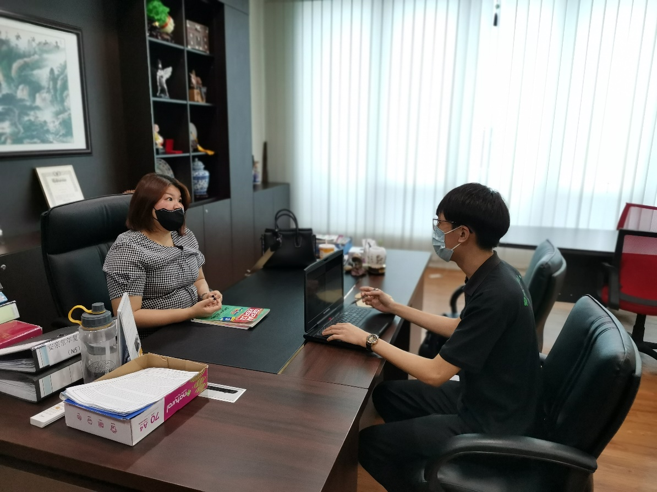

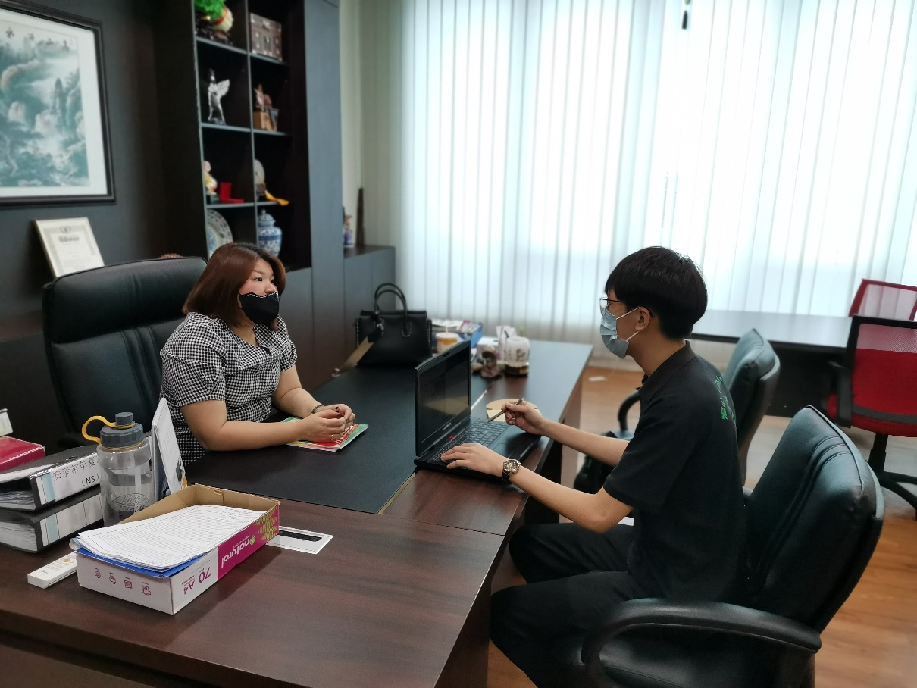

Appendices
Minute Meeting 1 - UHMT 1012 (47) 2020/2021 Sem 1
LEADERSHIP AND TEAMWORK SKILLS
No. | Group Members | Time Arrival with signature | Time Finish with signature | Group Meeting Agenda |  |  |  | Other Remarks e.g. potential problems/ difficulties/ limitations
 |  |  |  | Date: 2020/11/19  Time: 14.00 - 15.00 |  | Who took the notes?  Name: Tan Ming Hui | Who is leading the discussion?  Name: Kalaivani
 |  |  |  | NO. | Agenda items  What are the things discussed in the meeting? | Who is talking/ giving ideas? | What actions need to be taken? What do we need to bring?
1. | Lim Yue Chen | 14.05 | 15.00 | 1. | Choose leader and secretary. | Kalai | Leader: Kalai  Secretary: Tan
2. | Kalaivani | 14.05 | 15.00 | 2. | How we going to interview enterpreneur? | Kalai | Online (Google meet/Webex) / whatsapp
3. | Tan Ming Hui | 14.05 | 15.00 | 3. | Do any of you know someone who running a business? | Kalai
4. | Tay Jia Yi | 14.05 | 15.00 | 4. | Is it tuition centre principal can ? | Lim Yue Chen
5. | Yu Kok Yong | 14.05 | 15.00 | 5. | Can I interview my uncle who is a grab driver ? | Yu Kok Yong
 |  |  |  | 6. | Maybe interview through online is better. | Tay Jia Yi | Screenshoot as the evidences
 |  |  |  | 7. | If the principal cannot online meeting for us to interview, then I just add her into our whatsapp group. | Lim Yue Chen | Ask the permission from the principal first.

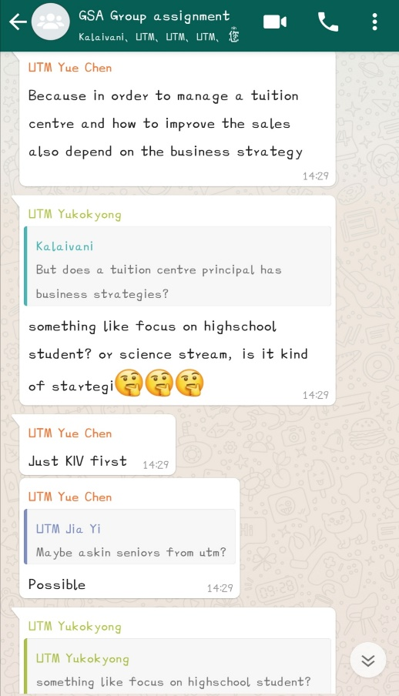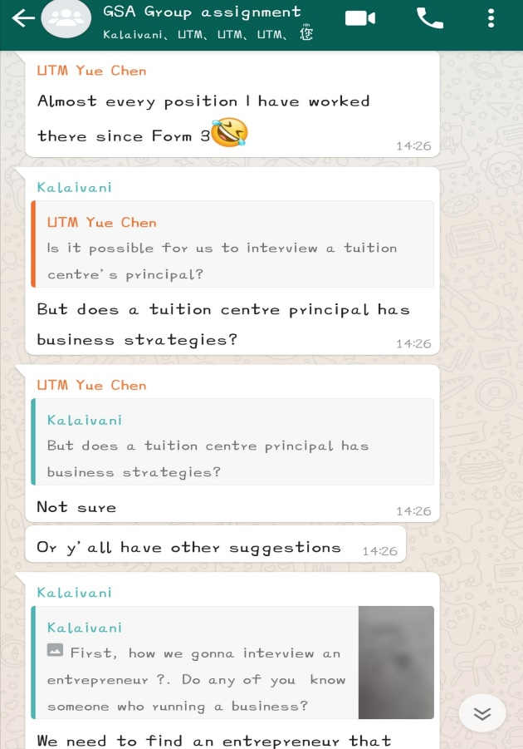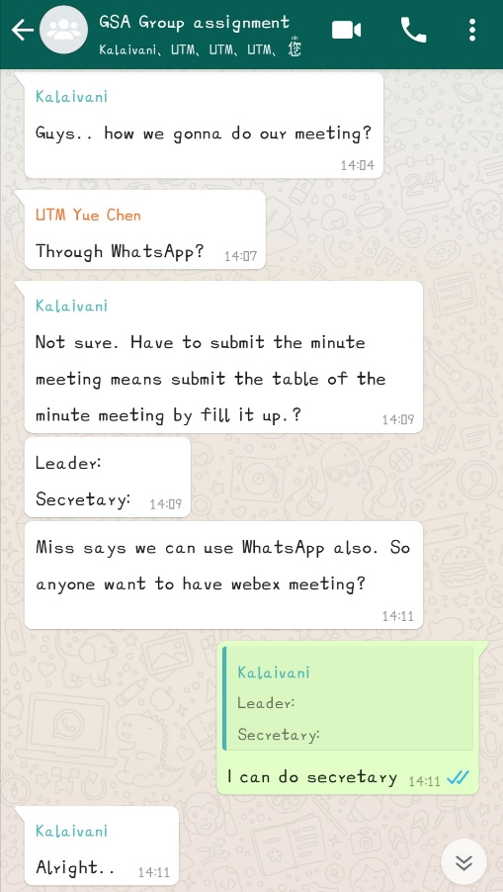

Minute Meeting 2 - UHMT 1012 (47) 2020/2021 Sem 1
LEADERSHIP AND TEAMWORK SKILLS
No. | Group Members | Time Arrival with Signature | Time Finish with Signature | Group Meeting Agenda |  |  |  | Other Remarks  e.g. potential problems/ difficulties/limitations
 |  |  |  | Date: 11/12/2020  Time: 2030-2115 |  | Who took the notes?  Name: Tay Jia Yi | Who is leading the discussion?  Name:Kalaivani
 |  |  |  | No. | Agenda Items  What are the things  discussed at the meeting? | Who is talking/giving ideas? | What action needs to be taken? What do we need to bring?
1. | Lim Yue Chen | 2030 | 2115 | 1 | Proofread the draft. | Everyone
2. | Kalaivani | 2030 | 2115 | 2 | Ways to create video presentations. | Everyone | Using power point and online recording applications.
3. | Tan Ming Hui | 2030 | 2115 | 3 | Read the draft and list out the parts to be presented. | Everyone | Parts were divided into seven portions: introduction, description, target groups, business history, challenges in business, business strategies as well as strength and weakness,
4. | Tay Jia Yi | 2030 | 2115 | 4 | Divide parts from draft to produce video presentation respectively. | Everyone | - Tay was incharge for strength&weakness.  - Tan was incharge for challeneges in business.  - Yu was incharge for business history and business strategies.  - Kalaivani was incharge for target groups and half of the description of business.  - Lim was incharge for intro and another half of business description.
5. | Yu Kok Yong | 2030 | 2115 | 5 | Representative to compile every member’s video. | Everyone | Yu Kok Yong was responsible to compile members’ videos.

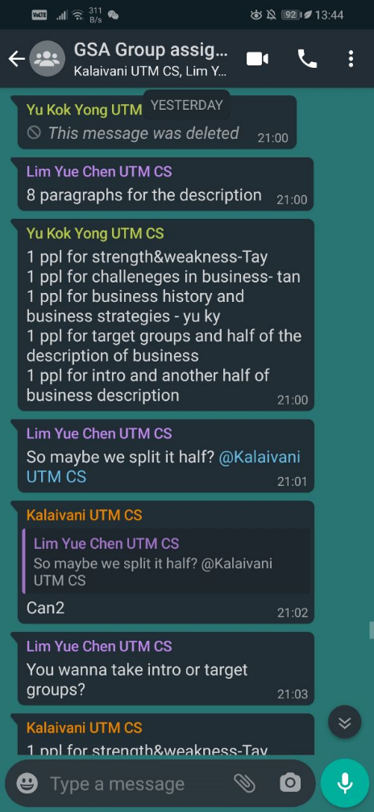
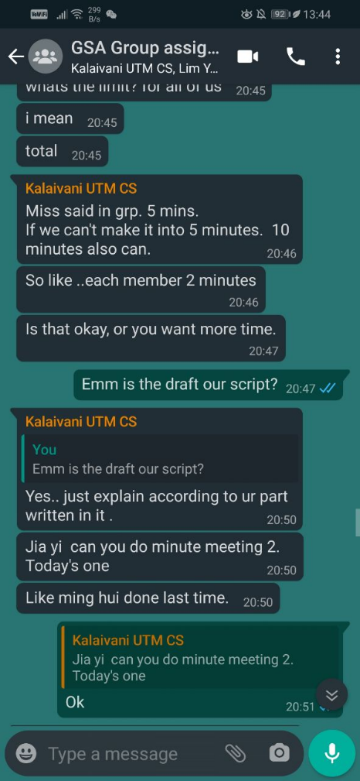
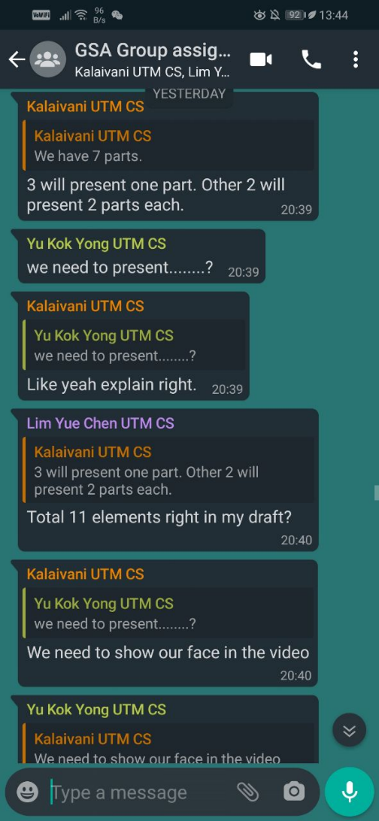
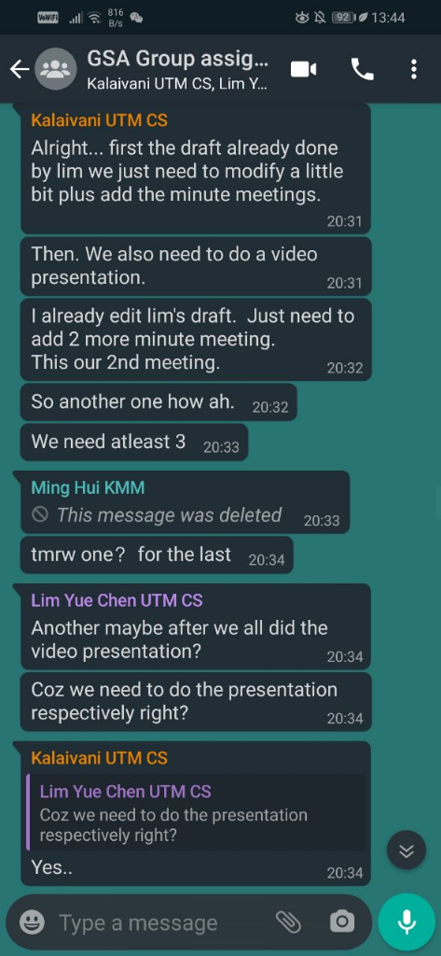

Minute Meeting 3 - UHMT 1012 (47) 2020/2021 Sem 1
LEADERSHIP AND TEAMWORK SKILLS
No. | Group Members | Time Arrival with Signature | Time Finish with Signature | Group Meeting Agenda |  |  |  | Other Remarks  e.g. potential problems/ difficulties/limitations
 |  |  |  | Date: 18/12/2020  Time: 1200-1230 |  | Who took the notes?  Name: Kalaivani | Who is leading the discussion?  Name: Kalaivani
 |  |  |  | No. | Agenda Items  What are the things  discussed at the meeting? | Who is talking/giving ideas? | What action needs to be taken? What do we need to bring?
1. | Lim Yue Chen | 1200 | 1230 | 1 | The format for the report. | Everyone | Follow the report template given by lecturer.
2. | Kalaivani | 1200 | 1230 | 2 | Ask about the video presentation. | Everyone | All members already finish doing their parts and send to Kok Yong via Telegram.
3. | Tan Ming Hui | 1200 | 1230 | 3 | Mention about the video presentation. | Everyone | Already done and send to Kok Yong.
4. | Tay Jia Yi | 1200 | 1230 | 4 | Mention about the video presentation. | Everyone | Already done and send to Kok Yong.
5. | Yu Kok Yong | 1200 | 1230 | 5 | Listed who already send the videos. | Everyone | Yu Kok Yong was responsible to compile members’ video.

