

Department of Computer
Science

School of Computing

UNIVERSITI TEKNOLOGI MALAYSIA

COURSE : SECR1013 DIGITAL LOGIC
SESSION/SEM : 2020/2021 - 1
LAB 2 : COMBINATIONAL LOGIC CIRCUIT DESIGN
SIMULATION
NAME 1 : …TAN MING HUI…………………………………………….

DATE : …21/12/2020………………………………………………….

Lab # 2
Combinational Digital Circuit Design Simulation Using Deeds Simulator

A. Objective

i) To expose student with producing digital logic circuit, generating truth table and Timing Diagram with Deeds Simulator. ii) To expose student with a complete cycle process of a combinatorial circuit design and simulate with Deeds Simulator.

B. Material

Deeds Software for Windows.

C. Introduction

Deeds Simulator

The Digital Circuit Simulator d-DcS appears to the user as a graphical schematic editor, with a library of simplified logic components, specialized toward pedagogical needs and not describing specific commercial products. As described before, the schematic editor allows building a simple digital networks composed of gates, flip-flops, pre-defined combinational and sequential circuits and custom-defined components (defined as Finite state machine).

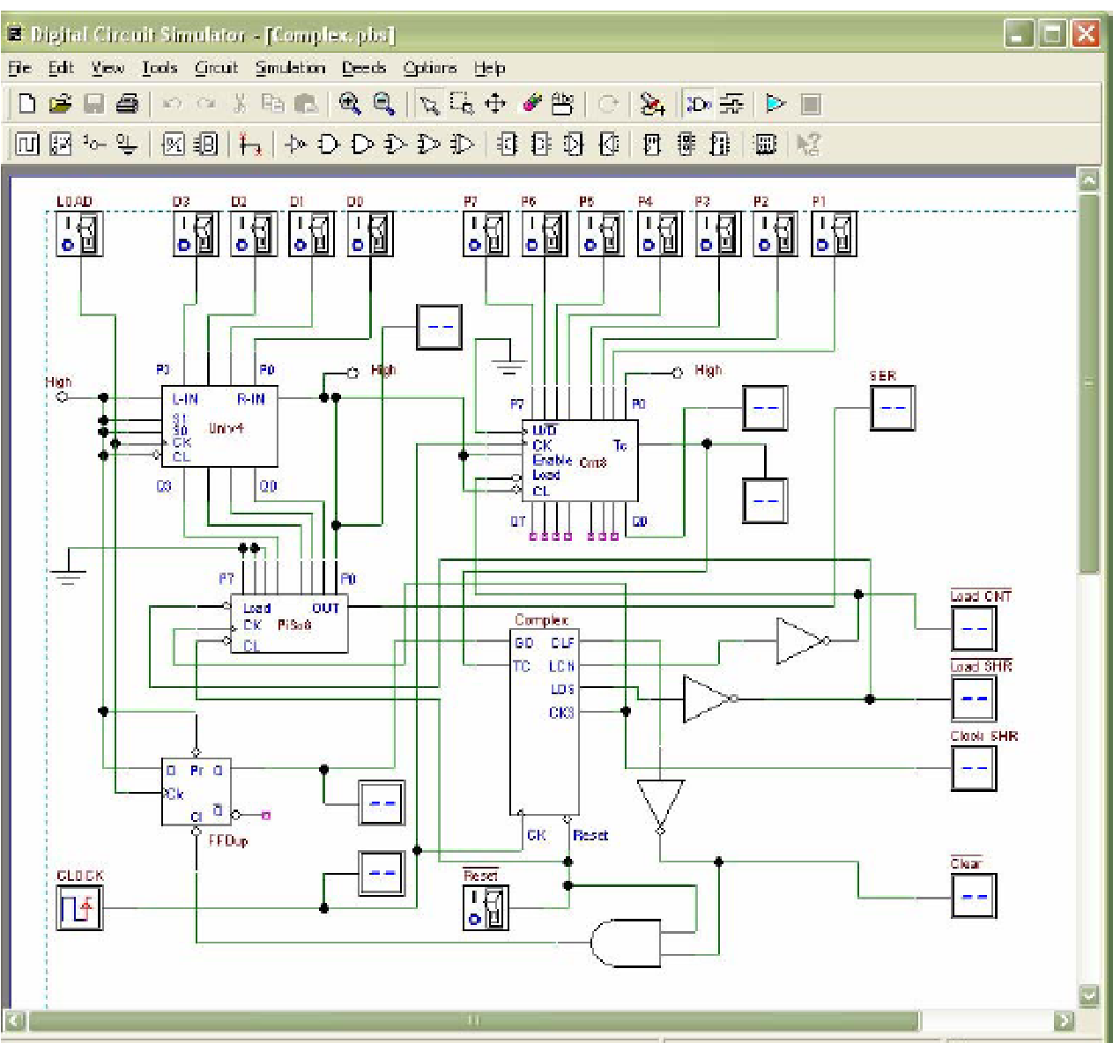

Figure 1 Circuit Editor of Digital Circuit Simulator (d-DcS)
Simulation can be interactive or in timing-mode. In interactive mode, the student can "animate" the digital system in the editor, controlling its inputs and observing the results. This is the simplest mode to examine a digital network, and this way of operation can be useful for the beginners. In timing mode, the behavior of the circuit can be analyzed by a timing diagram window, in which the user can define graphically an input signal sequence and observe the simulation results.

Digital Circuit Simulator (d-DcS): A Simple Example

In the following screen shots (Figure 2a, 2b, and 2c), student can see the circuit during the drawing and then simulate it by animation with following simple steps:

- student picks-up components from the Component Tool Bar.
- connects them using Wires.
- student activates the animation.

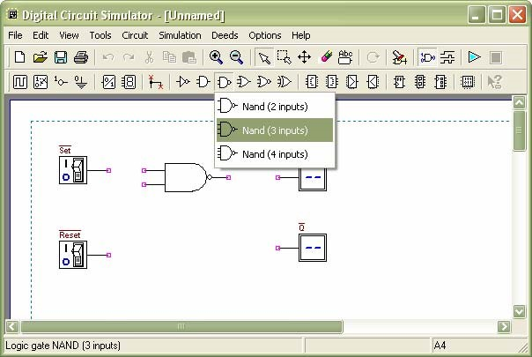
Figure 2a Drawing Phase of the Digital Circuit Editor: Insertion of Components

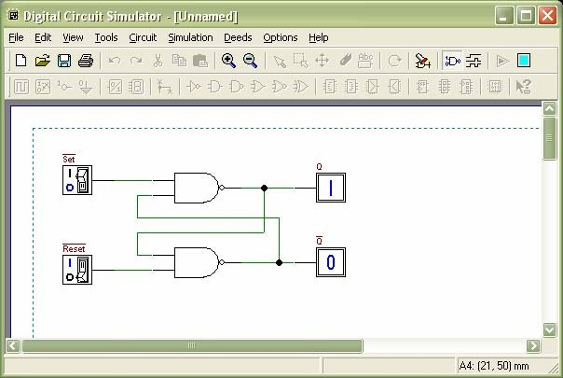
Figure 2b Next Phase of the Work: Connection of Components using Wires

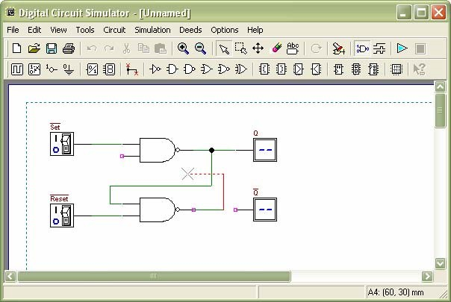

Figure 2c Animation: User Switches Inputs and the Circuit Shows Changes on Outputs

To exit the animation, it is necessary to click on the square Stop button. Instead, if the timing simulation is to be performed, student should click on the Timing Simulation button. This will show the Timing Diagram simulation window (Figure 3).

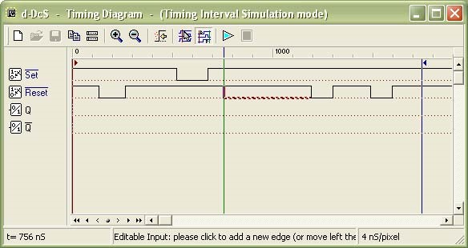

Figure 3 Timing Diagram Simulation Window

In this window, first student should define the timing of the input signals, drawing them on the diagram with the mouse. A vertical line cursor permits to define the ‘end time’ of the simulation. When student clicks on the triangular play button on the toolbar, the simulation is executed, and its results are displayed in the same window (Figure 4).

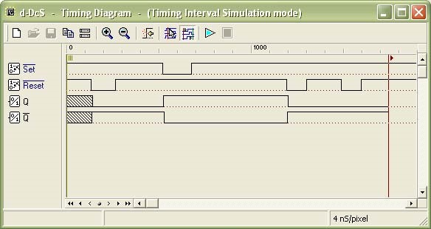

Figure 4 Timing Simulation Results, Displayed in Timing Diagram Window

Student can verify the correct behavior of the digital circuit, comparing simulation results with reasoning and theory concepts.

D. Lab Activities

Part 1 (submitted in pdf file)
Simulating logic circuit, construct truth table and timing diagram with Deeds.

Given Boolean expression as follow:

Y=AB+BC+AC

- Convert the non-standard Boolean expression into standard form.
Y= AB(C+ C’) + BC (A+A’) + AC( B+B’)
= ABC + ABC’ + ABC + A’BC + ABC + AB’C
= ABC + A’BC + AB’C + ABC’

- Based on standard form expression, complete the following truth table.

 | INPUT |  | OUTPUT
A | B | C | Y
0 | 0 | 0 | 0
0 | 0 | 1 | 0
0 | 1 | 0 | 0
0 | 1 | 1 | 1
1 | 0 | 0 | 0
1 | 0 | 1 | 1
1 | 1 | 0 | 1
1 | 1 | 1 | 1
- Using Deeds Simulator, draw the following circuits and cut & paste your circuit below:

- Circuit (i) for non-standard form (based on the given expression).

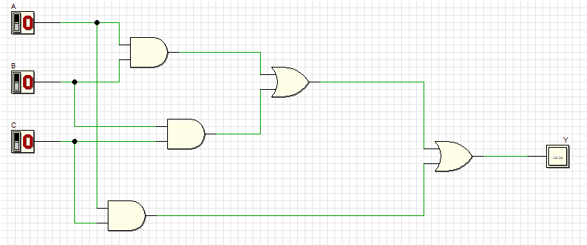

- Circuit (ii) for standard form (from your answer in question (1)).

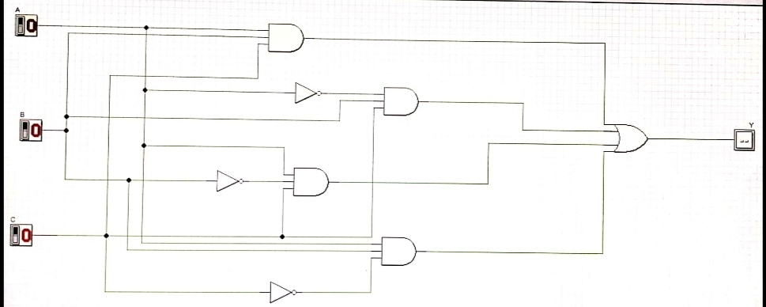

- Simulate these two circuits in step (3) and complete their truth table.
- Compare the simulation result for these two truth tables. What is your conclusion?
Circuit (i) Circuit (ii)

INPUT |  |  | OUTPUT |  | INPUT |  |  | OUTPUT
A | B | C | Y |  | A | B | C | Y
0 | 0 | 0 | 0 |  | 0 | 0 | 0 | 0
0 | 0 | 1 | 0 |  | 0 | 0 | 1 | 0
0 | 1 | 0 | 0 |  | 0 | 1 | 0 | 0
0 | 1 | 1 | 1 |  | 0 | 1 | 1 | 1
1 | 0 | 0 | 0 |  | 1 | 0 | 0 | 0
1 | 0 | 1 | 1 |  | 1 | 0 | 1 | 1
1 | 1 | 0 | 1 |  | 1 | 1 | 0 | 1
1 | 1 | 1 | 1 |  | 1 | 1 | 1 | 1

- What conclusion can you make?
Tips: Write down your observation first. What did you see? Then,you make your conclusion. What can you deduce based on the observation?

Output Y for Circuit (i) and Circuit (ii) are the same. Thus, the equation in Y=AB+BC+AC is equal to the equation Y = ABC + A’BC + AB’C + ABC’ (in standard form). The standard form make us to be more easier and spend shorter period to directly know which are the input that produce 1 in the output.

- Simulate output of circuit (ii) with Timing Diagram. Illustrate some examples of different inputs and output. Cut & Paste the timing diagram here.

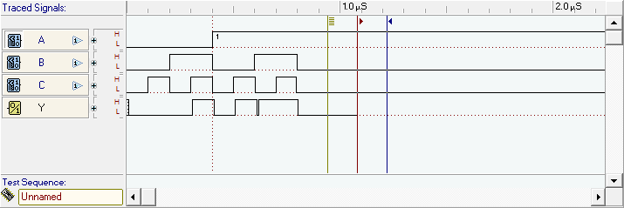

Part 2 (video file less than 50MB)
Combinational circuit design process and simulate with Deeds Simulator.

Design Process
- Determine Parameter Input / Output and their relations.
- Construct Truth Table.
- Using K-Map, get the SOP optimized form of all Boolean equation outputs.
- Draw the circuit and use duality symbol; convert AND-OR circuit to NAND gates ONLY.
- Simulate the design using Deeds Simulator. Check the results according to Truth Table and Timing Diagram Operation.

Problem Situation

A new digital fault diagnoses circuit is requested to be designed for analysing four bit 2’s complement input binary number from sensors A, B, C, and D. Sensor A represents input MSB and sensor D represents input LSB. As shown in the following Figure 5, bit pattern analysis from input sensors A, B, C, and D will trigger four different output errors (active HIGH) of type E1, E2, E3, and E4.
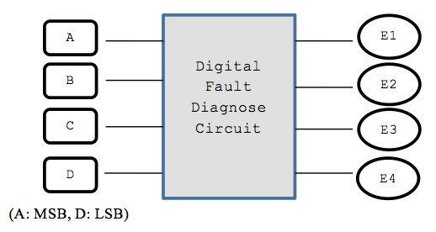

Figure 5

The following rules are used to activate the error’s signal type:
RULE 1: | E1 is activated if the input number is positive odd and the majority of the bits is ‘0’.
RULE 2: | E2 is activated if the input number is positive even and the majority of the bits is ‘0’.
RULE 3: | E3 is activated if the input number is negative odd and the majority of the bits is ‘1’.
RULE 4: | E4 is activated if the input number is negative even and the majority of the bits is ‘1’.
RULE 5: | The output of error signal is invalid if the input has equal bit ‘0’ and bit ‘1’

NOTE: Positive odd is positive numbers that are odd
Negative even is negative numbers that are even.

Experimental Steps

1. Complete Truth Table 1 for Digital Fault Diagnose Circuit. Use variables A, B, C and D as inputs; E1, E2, E3 and E4 as outputs.

Truth Table 1

 | INPUTS |  |  |  | OUTPUTS
A | B | C | D | E1 | E2 | E3 | E4
0 | 0 | 0 | 0 | 0 | 1 | 0 | 0  0  1  2  3  4  5  6  7  -8  -7  -6  -5  -4  -3  -2  -1  Msb start with 0 is positive  Msb start with 1 is negative
0 | 0 | 0 | 1 | 1 | 0 | 0 | 0
0 | 0 | 1 | 0 | 0 | 1 | 0 | 0
0 | 0 | 1 | 1 | x | x | x | x
0 | 1 | 0 | 0 | 0 | 1 | 0 | 0
0 | 1 | 0 | 1 | x | x | x | x
0 | 1 | 1 | 0 | x | x | x | x
0 | 1 | 1 | 1 | 0 | 0 | 0 | 0
1 | 0 | 0 | 0 | 0 | 0 | 0 | 0
1 | 0 | 0 | 1 | x | x | x | x
1 | 0 | 1 | 0 | x | x | x | x
1 | 0 | 1 | 1 | 0 | 0 | 1 | 0
1 | 1 | 0 | 0 | x | x | x | x
1 | 1 | 0 | 1 | 0 | 0 | 1 | 0
1 | 1 | 1 | 0 | 0 | 0 | 0 | 1
1 | 1 | 1 | 1 | 0 | 0 | 1 | 0

- Using K-MAP, get minimized SOP Boolean expressions for E1, E2, E3 and E4 circuits.
E1 E2
CD  AB | 00 | 01 | 11 | 10
00 | 0 | 1 | x | 0
01 | 0 | x | 0 | x
11 | x | 0 | 0 | 0
10 | 0 | x | 0 | x

CD  AB | 00 | 01 | 11 | 10
00 | 1 | 0 | X | 1
01 | 1 | X | 0 | X
11 | X | 0 | 0 | 0
10 | 0 | X | 0 | X

E1
0001
0011
=00 1
=A’B’D
E2
0000
0100
0010
0100
=0 0
=A’D’

E3
1101
1111
1001
1011
=1 1
=AD

E4
0110
1110
= 110
=BCD’

E3 E4

CD  AB | 00 | 01 | 11 | 10
00 | 0 | 0 | X | 0
01 | 0 | X | 0 | X
11 | X | 0 | 0 | 1
10 | 0 | X | 0 | X

CD  AB | 00 | 01 | 11 | 10
00 | 0 | 0 | X | 0
01 | 0 | X | 0 | X
11 | X | 1 | 1 | 0
10 | 0 | X | 1 | X

- From the Boolean expression in the step (2), draw your final E1, E2, E3 and E4 circuits using 2 input basic gates (AND, OR, NOT). Use Deeds Simulator.

E1=A’B’D
E2=A’D’
E3=AD
E4=BCD’
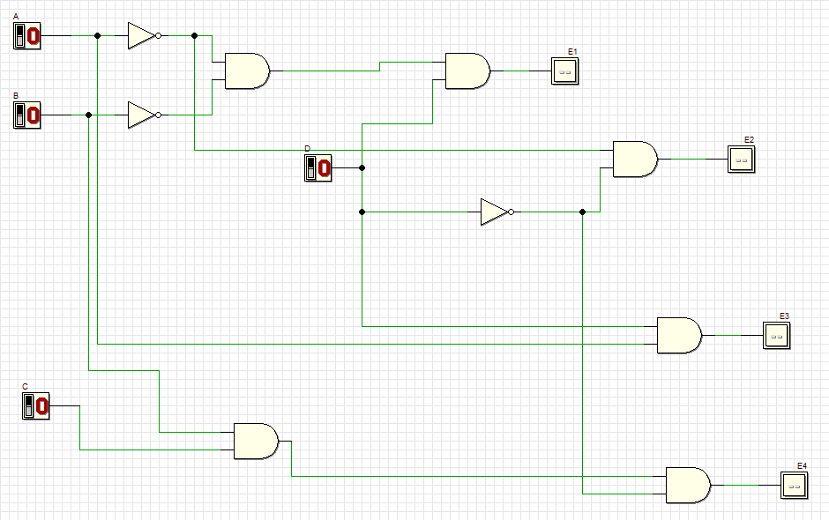

- Simulate the Deeds circuit in step (3):

a) Update Truth Table 2 based on the simulation result.

Truth Table 2
 | INPUTS |  |  |  | OUTPUTS
A | B | C | D | E1 | E2 | E3 | E4
0 | 0 | 0 | 0 | 0 | 1 | 0 | 0
0 | 0 | 0 | 1 | 1 | 0 | 0 | 0
0 | 0 | 1 | 0 | 0 | 1 | 0 | 0
0 | 0 | 1 | 1 | 1 | 0 | 0 | 0
0 | 1 | 0 | 0 | 0 | 1 | 0 | 0
0 | 1 | 0 | 1 | 0 | 0 | 0 | 0
0 | 1 | 1 | 0 | 0 | 1 | 0 | 1
0 | 1 | 1 | 1 | 0 | 0 | 0 | 0
1 | 0 | 0 | 0 | 0 | 0 | 0 | 0
1 | 0 | 0 | 1 | 0 | 0 | 1 | 0
1 | 0 | 1 | 0 | 0 | 0 | 0 | 0
1 | 0 | 1 | 1 | 0 | 0 | 1 | 0
1 | 1 | 0 | 0 | 0 | 0 | 0 | 0
1 | 1 | 0 | 1 | 0 | 0 | 1 | 0
1 | 1 | 1 | 0 | 0 | 0 | 0 | 1
1 | 1 | 1 | 1 | 0 | 0 | 1 | 0

- Compare the output results in Truth Table 2 with Truth Table 1. What is your conclusion?
Output result 2 majority is same as output result 1. There only have 6 different outputs in Table 2 compare to Table 1, which are all don’t care output (x) in Table 1.
Conclusion : don’t care (x) term can be assigned either 1 or 0, it doesn’t matter as it will never occur.

c) Produce the Timing Diagram (you can create your own signals)

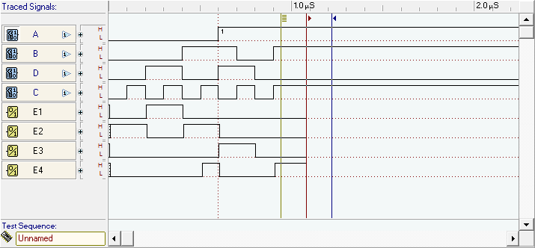

d) Explain some analysis values based on your timing diagram:

- Using dual symbol concept, convert your circuit in step (3) to NAND gates only. Use Deeds Simulator.

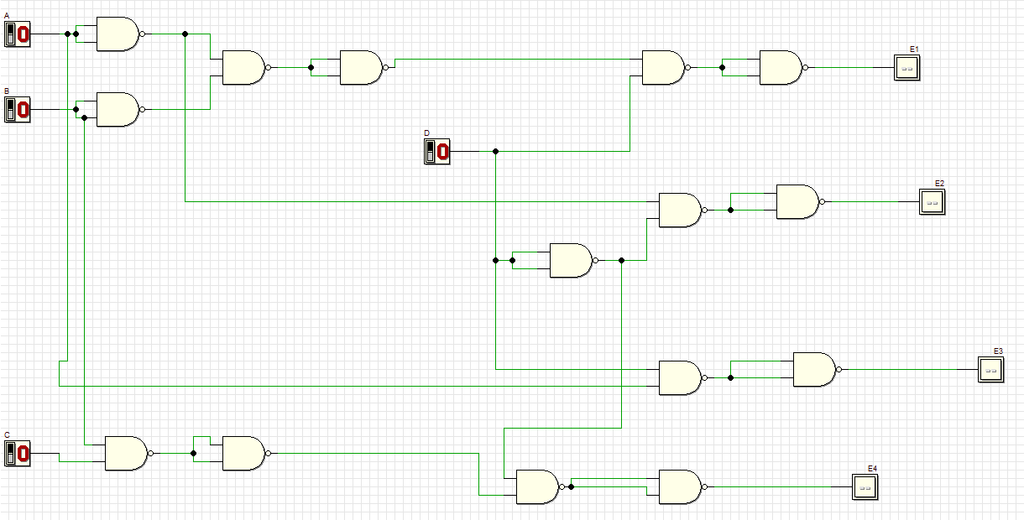

- Simulate the Deeds circuit in step (5):

a) Update Truth Table 3 based on the simulation result.

Truth Table 3
 | INPUTS |  |  |  | OUTPUTS
A | B | C | D | E1 | E2 | E3 | E4
0 | 0 | 0 | 0 | 0 | 1 | 0 | 0
0 | 0 | 0 | 1 | 1 | 0 | 0 | 0
0 | 0 | 1 | 0 | 0 | 1 | 0 | 0
0 | 0 | 1 | 1 | 1 | 0 | 0 | 0
0 | 1 | 0 | 0 | 0 | 1 | 0 | 0
0 | 1 | 0 | 1 | 0 | 0 | 0 | 0
0 | 1 | 1 | 0 | 0 | 1 | 0 | 1
0 | 1 | 1 | 1 | 0 | 0 | 0 | 0
1 | 0 | 0 | 0 | 0 | 0 | 0 | 0
1 | 0 | 0 | 1 | 0 | 0 | 1 | 0
1 | 0 | 1 | 0 | 0 | 0 | 0 | 0
1 | 0 | 1 | 1 | 0 | 0 | 1 | 0
1 | 1 | 0 | 0 | 0 | 0 | 0 | 0
1 | 1 | 0 | 1 | 0 | 0 | 1 | 0
1 | 1 | 1 | 0 | 0 | 0 | 0 | 1
1 | 1 | 1 | 1 | 0 | 0 | 1 | 0
b) Compare the output results in Truth Table 3 with Truth Table 2. What is your conclusion?
Output result 3 is same as output result 2. The gate used is different in both circuit to produce otput. For the result 3, the gate used is all universal gate which is NAND gate while for result 2, the gate used is basic gate (NOT, AND, OR gate).
Conclusion: Universal gate can function as basic gate with different number of themselves.

- Produce the Timing Diagram (you can create your own signals)

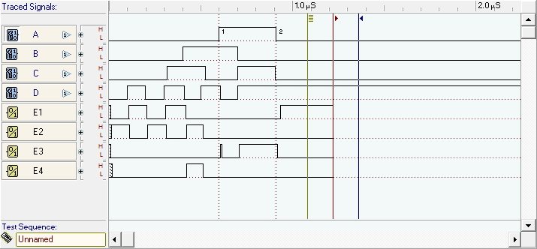

- Explain some analysis values based on your timing diagram:

