

School of Computing

Faculty of Engineering of Comput

UNIVERSITI TEKNOLOGI MALAYSIA

SUBJECT | : SECR1013 DIGITAL LOGIC
SESSION/SEM | : …2021/1……………………………………………………………….
LAB 3 | : SYNCHRONOUS DIGITAL COUNTER
NAME | : ………Tan Ming Hui………………………………………………………….
DATE | : ……………2021/01/18…………………………………………………….

Lab #3

Identifying the Properties of a Synchronous Counter

A. Aims
- Expose the student with experience on constructing synchronous counter circuit using Flip-Flop IC, Basic Gate ICs, Breadboard and ETS-5000 Digital Kit.
- Promote critical thinking among students by analysing the given circuit and identifying the behaviour of the digital circuit.

B. Objectives
The objectives of this lab activity are to:
- Implement a synchronous counter circuit into physical circuit using Breadboard, Flip-Flops, Basic Gates and Switches.
- Completing the next-state table of the counter circuit.
- Sketch the state diagram of the counter circuit.
- Identify the properties of the counter.

C. Materials And Equipment

Materials and equipment required for this lab are as follows:

Item Name | Number of Item
1. Breadboard | 1
2. 7408 Quad 2-Input AND | 1
3. 7404 Hex Inverter | 1
4. 7432 Quad 2-input OR | 1
5. 7476 Dual J-K Flip Flop | 1
6. ETS-5000 Digital Kit | 1

D. Preliminary Works

1) Determine the logic level for each input combinations in Table 1 so that the desired result can be realized.

Table 1
Desired Result | PRE | CLR | J | K | CLK | Q
Set initial value Q = 1 | 0 | 1 | X | X | -- | 1
Output Q stays the same | 1 | 1 | 0 | 0 | ⇓ | 1
Output Q become 0, no change in asynchronous input | 1 | 1 | 0 | 1 | ⇓ | 0
Output Q is not the previous Q | 1 | 1 | 1 | 1 | ⇓ | 1
RESET Q | 1 | 1 | 0 | 1 | ⇓ | 0
SET Q | 1 | 1 | 1 | 0 | ⇓ | 1

2) Answer all questions.

- Which state that JK flip-flop has, but not on SR flip-flop.

When J and K both are in the state of High (1), JK flip-flop have the output of toggle. However, when S and R both are in the state of High (1), SR flip-flop is invalid.

- Identify whether the JK flip flop in 7476, is a positive-edge triggered or negative-edge triggered flip flop.
negative-edge triggered flip flop because the arrow shown is to downward

E. Lab Activities

1) You are given a counter circuit as shown in Figure 4.

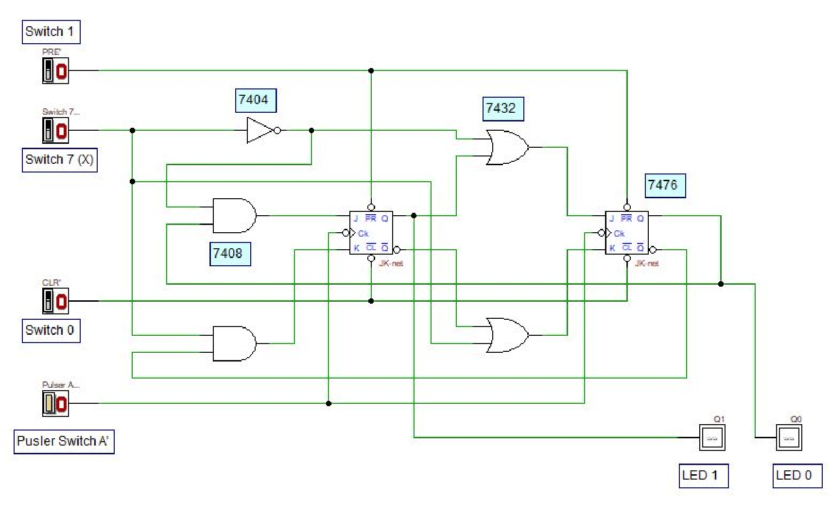

Figure 4: A Synchronous Counter Circuit

- By using all materials and equipment’s listed in section C, construct the physical circuit of Figure 4. (Make sure all ICs are connected to Vcc and GND).

- Investigate the behaviour of the counter by observing the next state of the counter for all combination of Present State and X values. Complete the NextState table of the counter in Table 2. Ensure the Switch 0 is in HIGH state.
(0=LOW, 1=HIGH)

Table 2
Switch 7 | Present State |  | Next State
X | Q1 LED 1 | Q0 LED 0 | Q1 LED 1 | Q0 LED 0
0 | 0 | 0 | 0 | 1
0 | 0 | 1 | 1 | 0
0 | 1 | 0 | 1 | 1
0 | 1 | 1 | 1 | 1
1 | 0 | 0 | 0 | 0
1 | 0 | 1 | 0 | 0
1 | 1 | 0 | 0 | 1
1 | 1 | 1 | 1 | 0
- By referring to the Next-State in Table 2, sketch the state diagram of the counter.
1
00
01
10
11
0
0
0
0
1
1
1

- By referring to the Next-State in Table 2 and the state diagram in (4), answer all questions.

  - What is the main indicator to decide that the counter is a synchronous counter?
The clock are from the same source (Pulser Switch A’).

  - How many states are available for the counter and what are they?
4 stage which are 00,01,10,11

  - What is the function of Switch 7 (X) in the circuit?

Switch 7(X) is to control the JK flip-flop, to make the counter wheter is count-up, or count-down, or count-up and down.

  - What is the function of Switch 0 and Switch 1 in the circuit?

Switch 0 is CLR that have the function to reset the output while switch 1 is Preset that have the functon of set the output.

  - Is the counter a saturated counter or recycle counter?

Saturated counter because 00, and 11 are continue to itself when count down and count-up respectively.

- Referring to state diagram in 4, draw and built a synchronous counter using D flip-flop.

  - Built the next state and transition table using the header in Table 3

Table 3
Input  X | Present State |  | Next State |  | D FF Transition
Input  X | Q1 | Q0 | Q1+ | Q0+ | D1 | D0
0 | 0 | 0 | 0 | 1 | 0 | 1
0 | 0 | 1 | 1 | 0 | 1 | 0
0 | 1 | 0 | 1 | 1 | 1 | 1
0 | 1 | 1 | 1 | 1 | 1 | 1
1 | 0 | 0 | 0 | 0 | 0 | 0
1 | 0 | 1 | 0 | 0 | 0 | 0
1 | 1 | 0 | 0 | 1 | 0 | 1
1 | 1 | 1 | 1 | 0 | 1 | 0

  - Get the optimized Boolean expression.

D0 D1
Q1Q0  X | 00 | 01 | 11 | 10
0 | 1 | 0 | 1 | 1
1 | 0 | 0 | 0 | 1
Q1Q0  x | 00 | 01 | 11 | 10
0 | 0 | 1 | 1 | 1
1 | 0 | 0 | 0 | 1

000 011 010 001 011 010
010 010 110 011 010 110
0 0 01 10 0 1 01 10
X’ Q0’ x’Q1 Q1Q0’ x’Q0 x’Q1 Q1Q0

D0 = X’ Q0’ + X’Q1 + Q1Q0’ D1 = X’Q0 + X’Q1 + Q1Q0

  - Draw the complete final circuit design in Deeds.

*In the file of submition name (TanMingHui_04_Q6.pbs)

- Repeat steps in Q(6) using T flip-flop.
- table

Input  X | Present State |  | Next State |  | T FF Transition
Input  X | Q1 | Q0 | Q1+ | Q0+ | T1 | T0
0 | 0 | 0 | 0 | 1 | 0 | 1
0 | 0 | 1 | 1 | 0 | 1 | 1
0 | 1 | 0 | 1 | 1 | 0 | 1
0 | 1 | 1 | 1 | 1 | 0 | 0
1 | 0 | 0 | 0 | 0 | 0 | 0
1 | 0 | 1 | 0 | 0 | 0 | 1
1 | 1 | 0 | 0 | 1 | 1 | 1
1 | 1 | 1 | 1 | 0 | 0 | 1

b) boolean expression

T0 T1
Q1Q0  X | 00 | 01 | 11 | 10
0 | 1 | 1 | 0 | 1
1 | 0 | 1 | 1 | 1
Q1Q0  X | 00 | 01 | 11 | 10
0 | 0 | 1 | 0 | 0
1 | 0 | 0 | 0 | 1

011= X+Q1’+Q0’ 001 = X’Q1’Q0
100 = X’ + Q1 + Q0 110 = XQ1Q0’

T0=(X+Q1’+Q0’) (X’ + Q1 + Q0) T1= (X’Q1’Q0) + ( XQ1Q0’ )

c) circuit
* In the file of submition name (TanMingHui_04_Q7.pbs)

