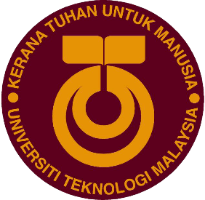
SECP ASSIGNMENT 1
DESIGN THINKING: SOFTWARE SYSTEM

Tham Chuan Yew (A20EC0166)
Muhammad Zaki Mufthi (A20EC0325)
Muhammad Sabiq Ahsan (A20EC0322)
Lai Yee Jen (A20EC0061)

Nowadays in the 21st Century, many modern innovators use a method called Design Thinking to improve their business to heights they never thought of reaching before. For example, some of the world leading brands such as Samsung, Google, Apple, and much more have adopted this method and look at their business now, it has skyrocketed so high that people are making rivalries out of them, like which one is better than the other. This proves that Design Thinking is a valuable method to improve businesses around the world. So, what is this method that we call Design Thinking? Design thinking is a process of critical thinking used to develop solutions to problems through collaboration, innovation, and design. Design thinking consists of skills such as teamwork, problem solving, communication, analysis, creativity, and the ability to influence others. Design thinking is used to understand users, challenge assumptions, redefine problems and create innovative solutions to real world-problems.
Our group was assigned to carry out a research on Design Thinking regarding Software System. After asking the users for feedback, we evaluated the results and collaborated with other people to find an alternative solution that can bring out 100% of the user experience. Design Thinking resolves around how the user experience the product so we can always improve it to be a better product. With the success rate of the Design Thinking method, many institutes nowadays teach Design Thinking in their syllabus and curriculum, UTM is also included. Design Thinking involves 5 phases, which are Empathy, Define, Ideate, Prototype, and Test.

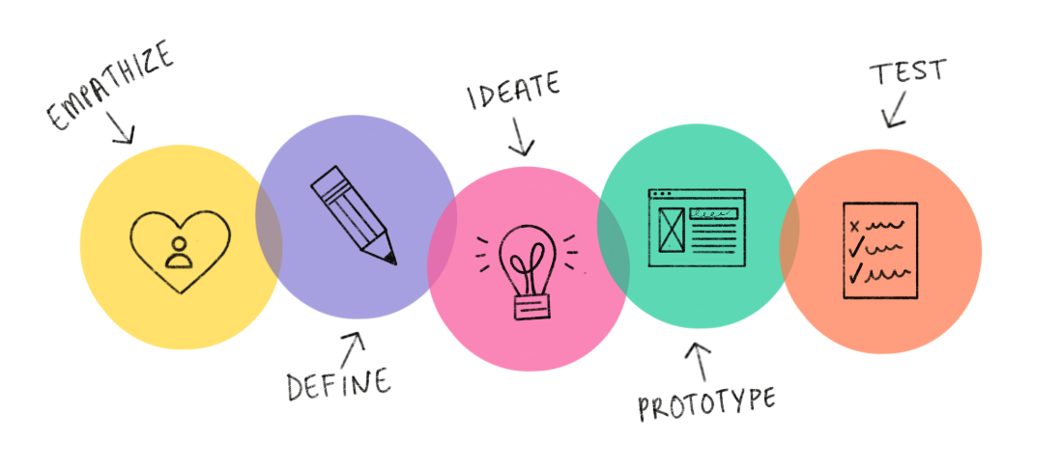

In our case, we interviewed Dr. Mohammad Murtadha bin Mohamad who is a staff at UTM Digital Care, about OS which is related to the system software topic. The questions that we asked are all related to the pros and cons about the OS that he is using right now and what he needs to enhance his experience.

This is the result of our interview:

Questions:
1. What operating system are you currently using?
2. Do you face any problem with the menu interface of the operating system? Do you find it messy and complicated? How long does it take to get used to it?
3. On a scale of 1-5, how much would you rate the security of the OS? Can you give a little elaboration?
5. Can you briefly describe your user experience with this OS? What would you expect from a perfect OS?

Answers:
- MacOS
- So far since I used MacOS from 2007, I swear that I do not want to switch to any operating system other than Mac because it is very user friendly. Even though people say that when you use MacOS you will face a lot of problem with running other applications, but for me that is not a big problem.
- Five. I feel that so far my experience with the security of MacOS, I do not face any kind of trouble with the security of the OS because first the update is routine. Second is you can have a direct support from the support team of the Apple Company. Lastly, the forum for reporting and solving the problems are always up to date. There will always be someone responding to the customer’s problem.
- Actually, for me it depends on the usage of the laptop or the computer. For me, before when I purchased Microsoft products, they did not support MacOS. But now, almost every application always provides the MacOS version of it. My expectations are so that every application provide the version for other OS, such as a version for the MacOS.

After we interviewed Dr. Mohammad Murtadha bin Mohamad, we concluded that he’s satisfied with the OS he’s currently using. According to Dr. Mohammad Murtadha bin Mohamad statement, MacOS is quite easy to be understood and to be used. The security of this operating system can be rated highly. For Dr. Mohammad Murtadha bin Mohamad, MacOS security system better than other operating systems. One thing that make MacOS considered more is the service they provide. When users are confused or having any problem, their customer service will be answering the report quickly.
So far there is no problem that annoyed Dr. Mohammad Murtadha bin Mohamad as a user in terms of comfort, security, or features provided by MacOS. However, all these statements are returned to the opinions of each user. We suggest it is better to choose the operating system that you think is the most comfortable and easy to use, because convenience in use is in the opinion of each user.

Define
Following an extensive research, we found out that each operating system has its own advantages and disadvantages. Windows, MacOS, and even Linux has its own pros and cons. Especially windows, people often say that Windows is the best, but in some scenario, its better using MacOS or even Linux. Because of that, we discussed among ourselves and listed out the major drawbacks of currently available operating systems. Below are our findings:
- Messy home screen/Unpleasant home screen/difficult to navigate
- Unorganized and laggy start-up menu
- Poor security/Third-party antivirus software needed
- Limited games support/Lack of high-end gaming technology
- Hard to learn/High learning curve
- Poor technical support/Lack of technical expert
- Inflexible hardware upgrades/Expensive hardware/Lack of support for normal hardware
- Closed-source/Limited modifications or customization

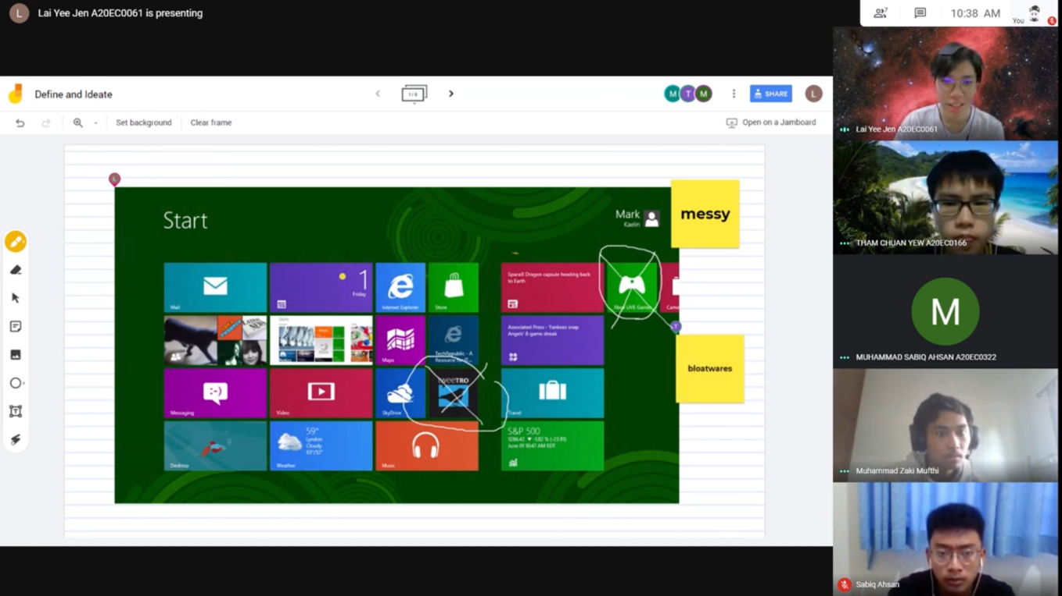
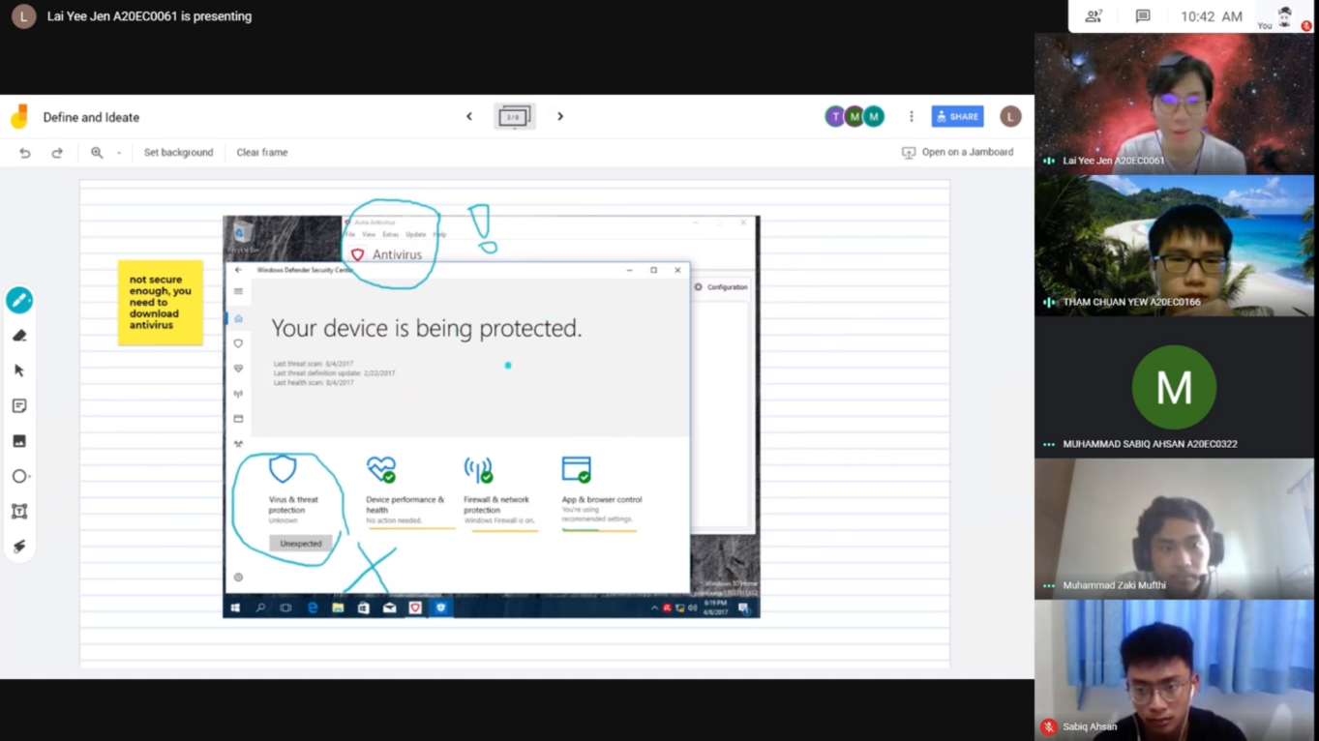
Team Meating (Define)

Ideate
With the problems identified, we instantly got to work and mapped the problems out. We went to great lengths and explored all the possibilities with out-of-the-box thinking to find the perfect solution for each problem. Below are our solutions:
- Messy home screen → Organized home screen
- Unorganized and laggy start-up menu → Organized and smoother start-up menu
- Poor security → Top-tier security preloaded
- Limited games support → Huge library of games supported at highest graphics
- High learning curve → Step-by-step usage guide
- Poor technical support → Excellent technical support available 24/7
- Inflexible hardware upgrades → Allows users to upgrade to any hardware available
- Closed-source → Making it open-source for user’s modifications

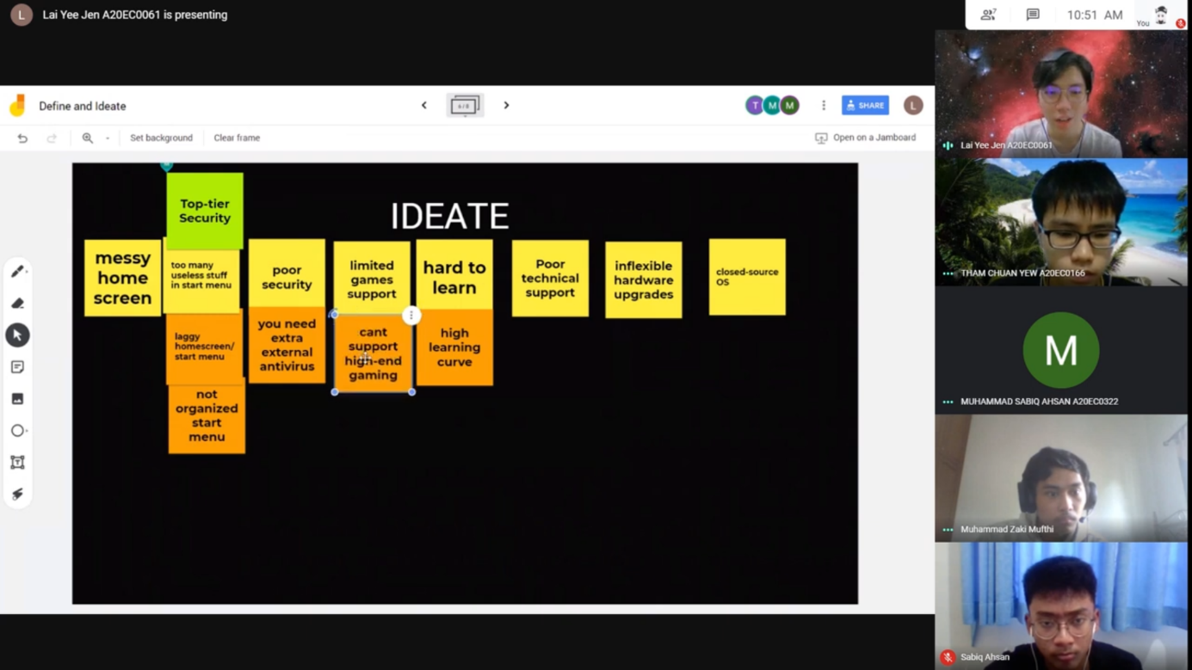
Team Meeting (Ideate)
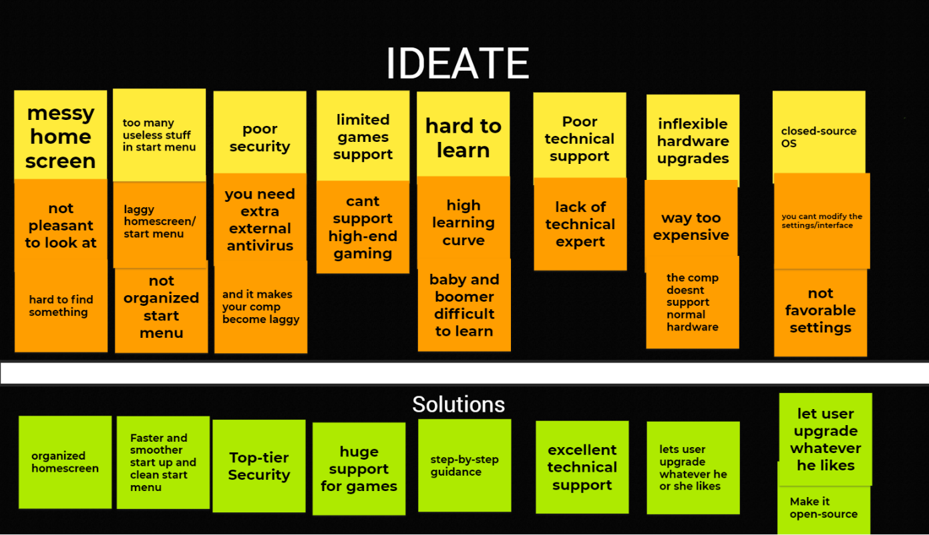

Prototype
Now that we have the solutions for each of the drawbacks of the operating systems, we move on designing the prototype for our operating system, CandyOS, which promises to give you a hassle-free and enjoyable user experience. CandyOS is a simple yet powerful operating system which solves all the problems you are having on your current operating system.
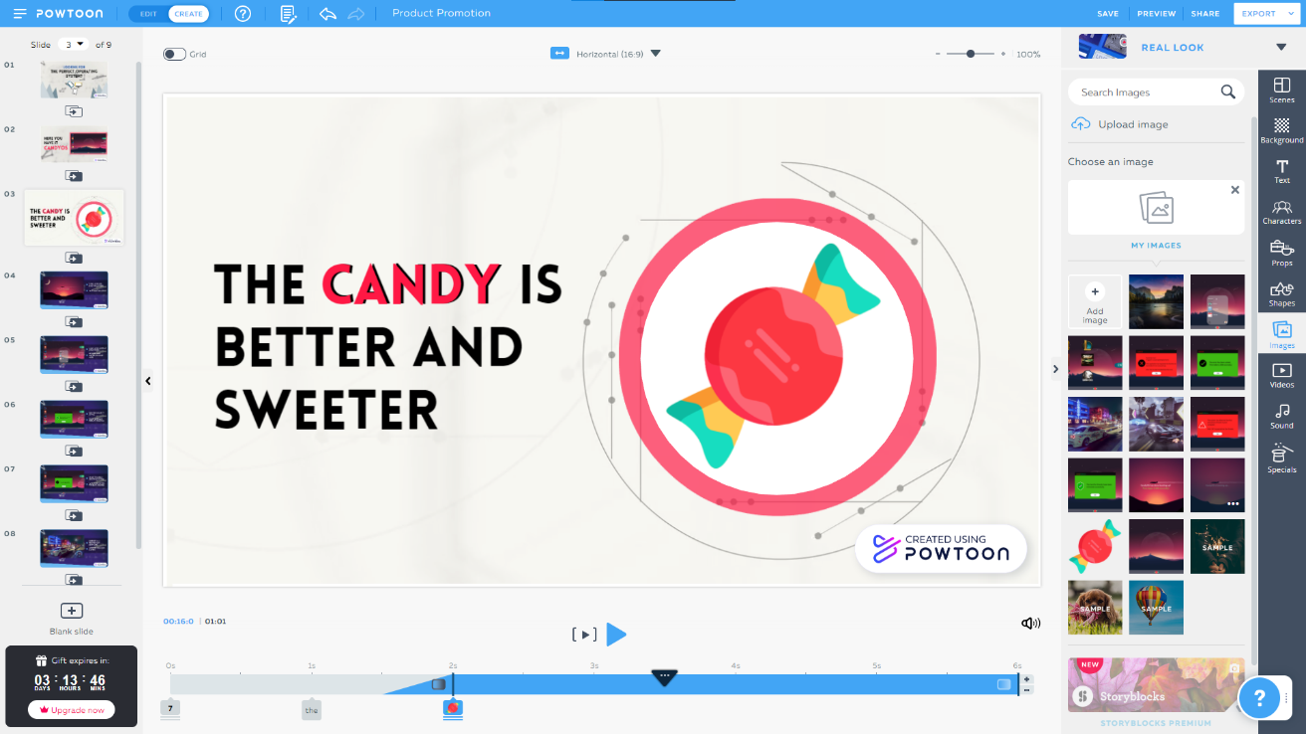
Making of Prototype
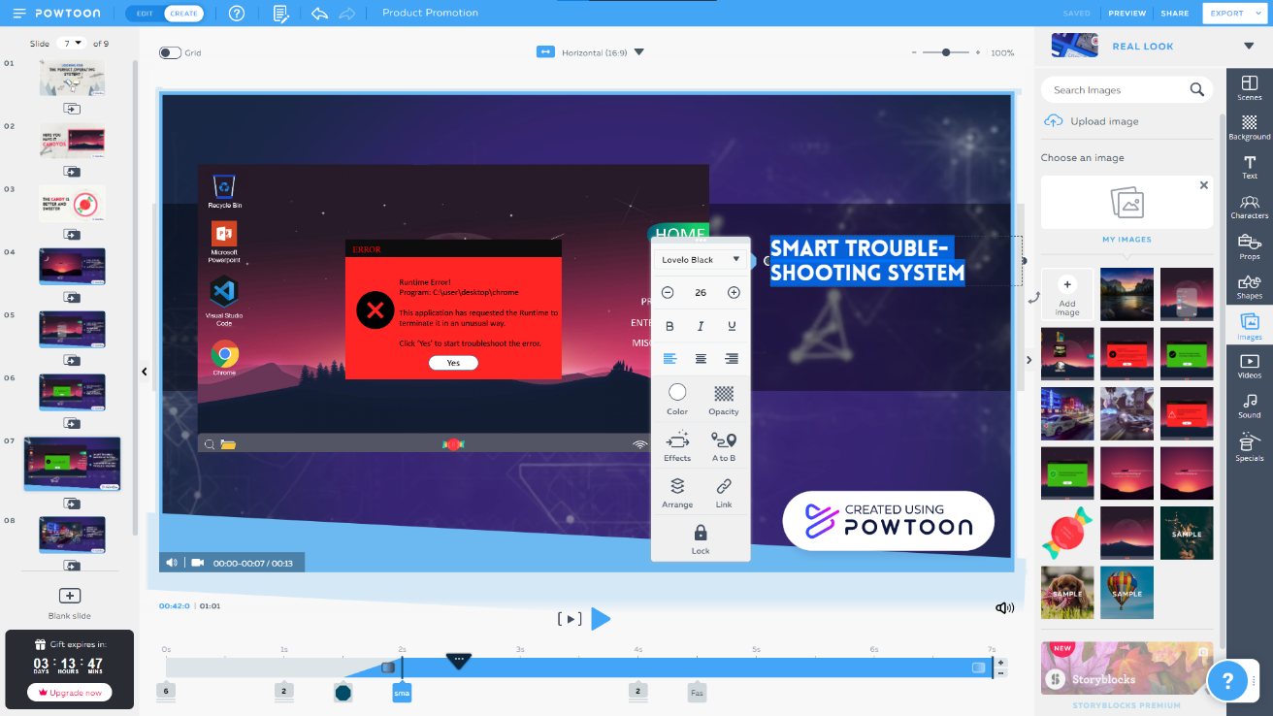
Reflections:
For the following part, we have written out our goal regarding our program, how design thinking impacts our goal about our program and the necessary action to improve our potential in the industry.
We all agree that Technology and Information System is an interesting course and, on the surface this course looks like it does not correlate with computer science. However, we have already learned a lot by doing this assignment, including teamwork, effective communication, and project management. Furthermore, we learned about how to improve someone's business to unprecedented heights through Design Thinking. However, Design Thinking is not always about business, for example in governing a system or a place, you can ask your citizens whether they are satisfied with the rules or system you are currently using. And you can expand your system from that alone and elevate it to be a better place for all. For us, our goal is to be able to excel in assignments and group works given by to us.
Design Thinking impacts our goal by making us think and approach each problem differently. We learn how to communicate effectively, analyze the problem, and use our creativity to tackle this problem. With this approach, we can solve a problem more efficiently and effectively. This is especially useful when doing our assignments and organizing activities. Design Thinking will definitely play an important role in determining our performance in university, both academically and non-academically.
The necessary action for us to improve our potential in the industry include improving our communication skills, analytical skills and being influential. These are all becoming increasingly important in the industry. Therefore, we must hone our Design Thinking skills because it comprises all the skills mentioned beforehand.

Tasks that we did:
Lai Yee Jen | Question for the interview, Presentation Slide, Design CandyOS Prototype, Video DT Editing, Presentation Video Editing, Report
Tham Chuan Yew | Question for the interview, Presentation Slide, Design CandyOS Prototype, Report
Muhammad Zaki Mufthi | Question for the interview, Report
Muhammad Sabiq Ahsan | Report

Thank you.

Yours sincerely,
LmaoTech (Group 3)

