
Semester I 2020/2021
Subject: Technology and Information Systems (SECP1513)
Section: 02
Assignment: Step by Step PC Assembly

Group 9
1 |  | Name: Vincent Boo Ee Khai  Matric Number: A20EC0231  Phone Number: 0195583800  E-mail: vincentboo7733@gmail.com
2 |  | Name: Ong Han Wah  Matric Number: A20EC0129  Phone Number: 0177679868  E-mail: hanwah0924@gmail
3 |  | Name: Madihah binti Che Zabri  Matric Number: A20EC0074  Phone Number: 0196407973  E-mail: madihah01@graduate.utm.my
4 |  | Name: Qaisara binti Rohzan  Matric Number: A20EC0133  Phone Number: 0122542549  E-mail: qaisara@graduate.utm.my
5 |  | Name: Rishma Fathima binti Basher  Matric Number: A20EC0137  Phone Number: 0165942331  E-mail: rishmafathima31@gmail.com

PART A
1.0 Screwdrivers
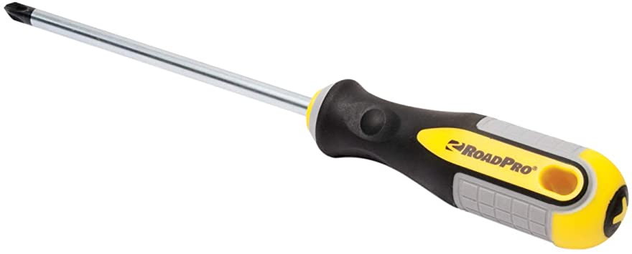

Screwdrivers are one of the most crucial tools used in assembling the PC. Therefore, the function of screwdrivers is to tighten and untighten screws from the PC. The importance of this tool is to making sure that the parts and the components are attached firmly to one another. Without the screwdrivers, the process of assembling the PC would have been extremely hard.

2.0 Anti-static device
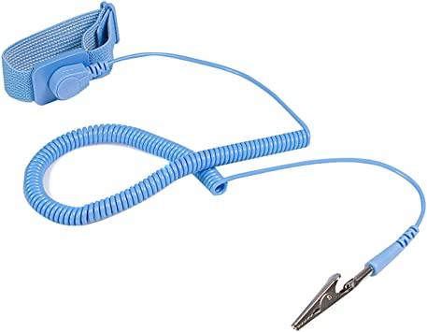

The next tool needed is the anti-static device. This tool is used to reduce and restrain electrostatic discharge. It is extremely important to have this tool, moreover in handling electronic devices and components. This is because, anti-static devices allows the build-up static electricity in us to be eliminated from our body. Without this tool, electrical components can easily be damaged and in other cases set fire to flammable liquids.

3.0 Zip Ties

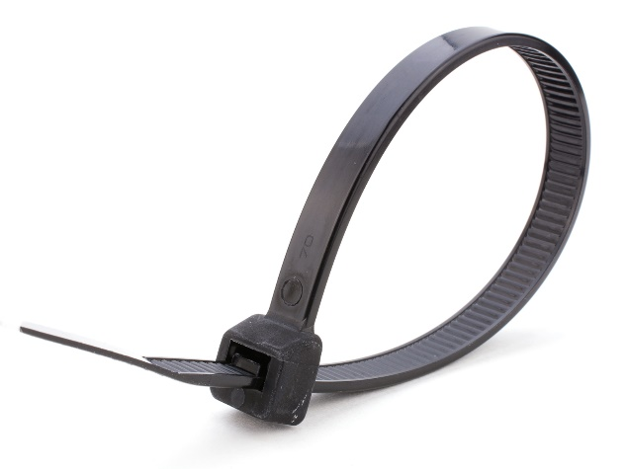

Zip ties or known as cable ties are functioned to properly secure any loose cables. By this way, the finished build PC would look neat. The importance of having this cable tie is that it allows better airflow and also it helps people to find damaged cables easily.
4.0 Light Source
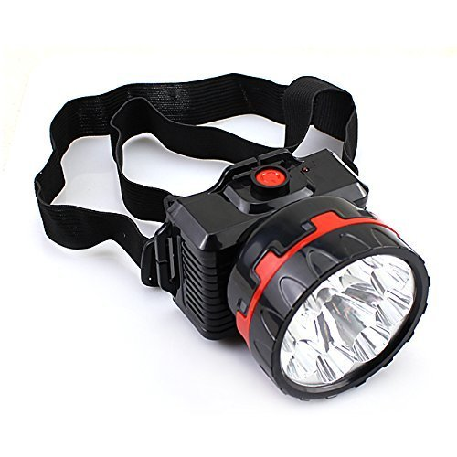
Flashlight or lamps are extremely important tools needed to assemble a PC. Any kind of light source would be a great help. The function of having a good light source is to help the person assembling to focus with what they are doing. In some unique cases, having a flashlight on your head can bring the importance of lighting your work place well in places that are not fully lit well.
PART B
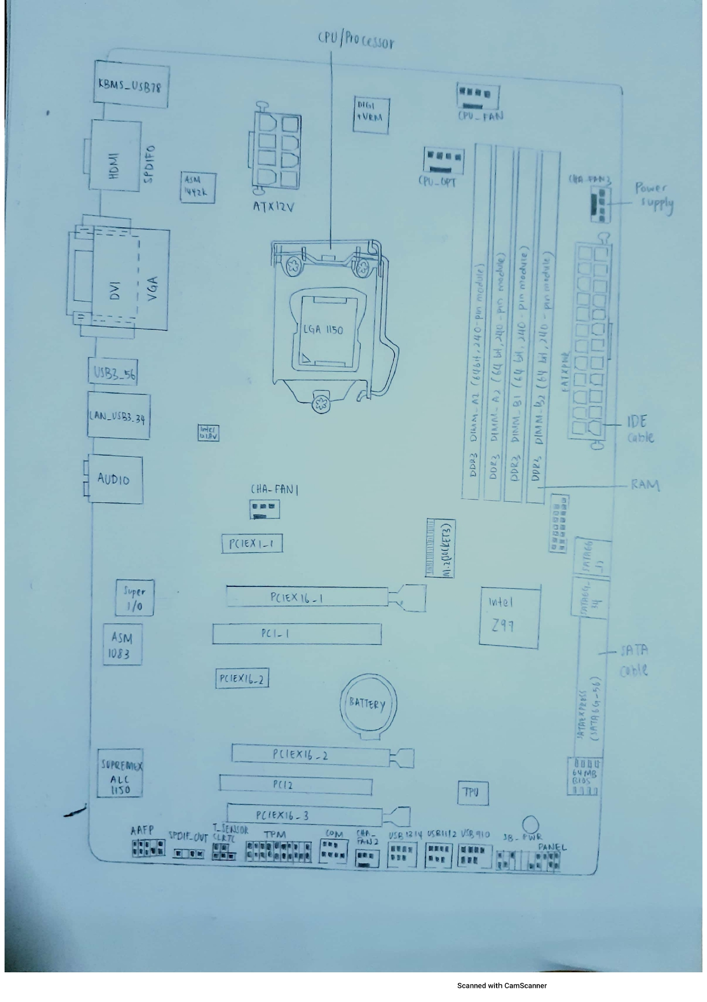

- Graphic card

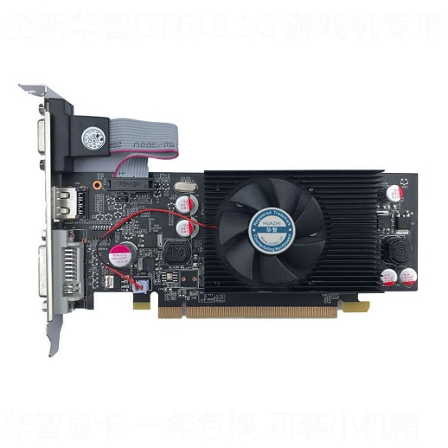
Although this component might be small, it brings a big functionality to a PC which is to produce images you see on the monitor. This component is important in converting plenty of data’s into signals that only monitors understand.

- USB Cable
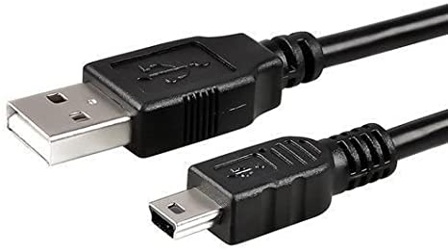
USB stands for Universal Serial Bus. USB cable assemblies are some of the most popular cable types available, used mostly to connect computers to peripheral devices such as cameras, camcorders, printers, scanners, and more. USB portson the other hand allow USB devices to be connected to each other with and transfer digital data over USB cables. They can also supply electric power across the cable to devices that need it.

- IDE Cable
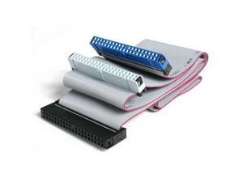
IDE, an acronym for Integrated Drive Electronics. This component works as a standard type of connection for storage devices in a computer. Generally, IDE refers to the types of cables and ports used to connect some hard drives and optical drives to each other and to the motherboard

- CPU/Processor

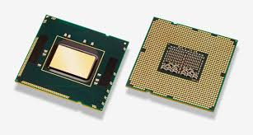
The processor or known as the central processing unit, CPU works as the brain of the computer. It controls and provides instructions for the computer to work and execute programs.

- Slots for IDE, PC
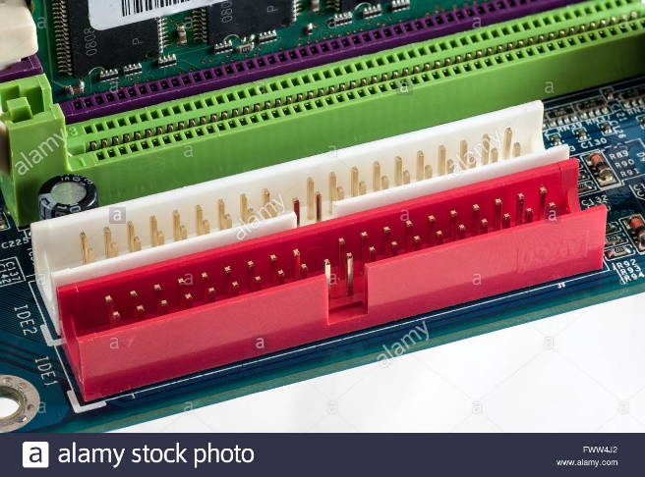

Integrated Drive Electronics (IDE) is a standard interface for connecting a motherboard to storage devices such as hard drives and CD-ROM/DVD drives. In most older motherboards, there used to be 2 IDE channels where drives were connected via a ribbon cable. The speed of an IDE-connected device depends not only on its own capabilities but also on the cable being used. For example, if you plug a slow cable into a fast hard drive, the drive will operate only as fast as the cable allows it to.

- Power supply
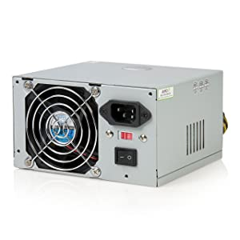
The main function is to convert AC current into DC current which is then converted into power or energy needed by components on a computer such as a motherboard, Room CD, Hard drive, and other components. ATX power supplies are turned on and off by a signal from the motherboard. They also provide a signal to the motherboard to indicate when the DC voltages are in spec, so that the computer is able to safely power up and boot.

- Heat Sink
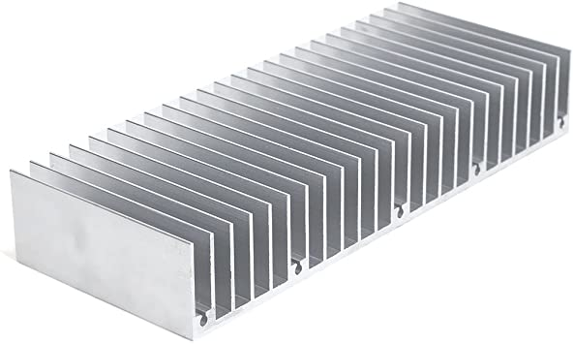
A heat sink is a component that increases the heat flow away from a hot device. It accomplishes this task by increasing the device's working surface area and the amount of low-temperature fluid that moves across its enlarged surface area.A motherboard heatsink is a cooling device used on certain chips found on system boards. The main chip or computer processing unit (CPU) requires a heatsink, and chipsets also use heatsinks. The size and design of these devices varies, as do materials and method of attachment.

- RAM
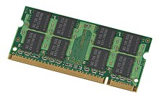
Random Access Memory (RAM) is used to store temporary storage and it is volatile. Thus, we can accessed the data and information quickly. Examples of temporary storage

- Hard Disk
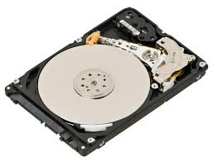
The hard disk drive is probably the most important component to your computer. Without it your computer would never be able to save any files, you would not be able to boot up your operating system, and could never play a game or download a file. A hard disk drive (sometimes abbreviated as a hard drive, HD, or HDD) is a non-volatile data storage device. It is usually installed internally in a computer, attached directly to the disk controller of the computer's motherboard. It contains one or more platters, housed inside of an air-sealed casing

- CD ROM
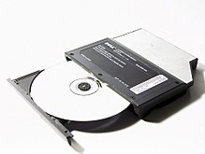

CD-ROM can be read by an optical drive and ROM means that it just can be read but cannot be altered, erased or edited. It stores non-volatile storage. Compact Disc Read Only Memory (CD-ROM) is used as a compact disc to store data of audio, graphics and text.

- SATA Cable
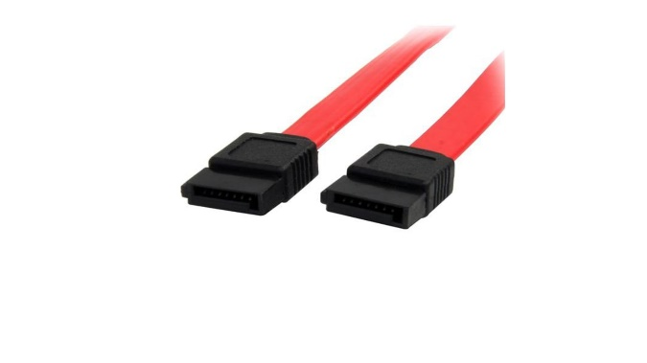
This component stands for "Serial Advanced Technology Attachment," or "Serial ATA." It is an interface used to connect ATA hard drives to a computer's motherboard. SATA transfer rates start at 150MBps, which is significantly faster than even the fastest 100MBps ATA/100 drives. SATA is a connection type used by computers and computer-like devices to connect peripheral storage components like optical drives and hard drives to the device. SATA replaced the parallel ATA standard
PART C
STEP 1 - INSTALLING CPU TO THE MOTHERBOARD
Before handling the motherboard and other components in every step, make sure to ground yourself to remove build-up static electricity from the body by wearing an anti-static strap or touching a metal surface that is grounded. Place the motherboard on a flat surface such as the top of the motherboard box or a wooden desk. When handling the motherboard, hold the motherboard by its edges and avoid touching any exposed circuit on the board.
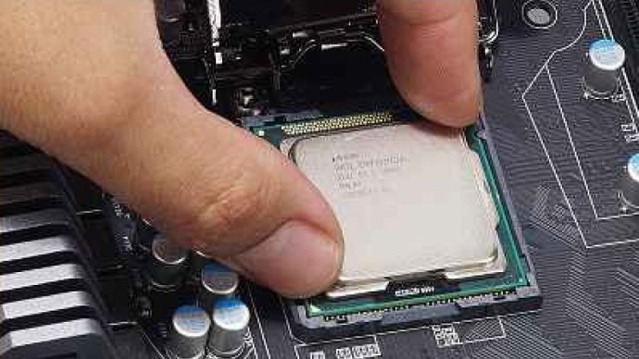
To open the CPU socket, you need to release the tension lever first by pushing down on the lever and pull it out from its side. Lift the lever up until the socket cover flips open. Pick up the CPU by holding it from its edges and do not touch the bottom of the processor. When you look closely, there is a triangle or arrow mark on the CPU and the socket. There is only one correct orientation to install the CPU into the socket, which is by placing it so that the arrow on the CPU matches the arrow on the socket. Gently lower the CPU into the socket by grabbing it by the edges and do not apply any force onto the CPU, it will naturally fall right in place. After making sure the CPU is correctly in place, lower the socket cover and the lever to lock the CPU in place. The CPU socket cover should pop off automatically if there is one, after the lever is tighten.

STEP 2 - MOUNTING HEATSINK ON MOTHERBOARD
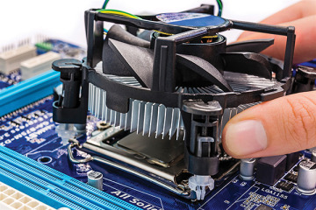
After the CPU is installed, it’s time to install the CPU cooler or heatsink. Some CPU cooler has thermal paste pre-applied. If it does not come pre-applied, you just have to apply a half pea-sized amount of thermal paste onto the centre of CPU, then use a clean tool like a card to spread the paste evenly cover all the top of the CPU. Then, you can mount your cooler onto the CPU. You just need to align the four pins of the cooler to the holes on the motherboard. But before you mount it, you will need to make sure that the cable is long enough to reach the power connector on the motherboard by orientating the cooler to find the perfect position. Gently lower the cooler on the CPU and make sure the four pins of the cooler are aligned with the four holes on the motherboard. Lock the cooler by tightening the spring-screws or pushing down on each four pins one by one diagonally until a clicking sound is heard depending on the type of cooler. Gently lift the cooler to check whether it is nicely secured in place. After making sure the cooler is fully locked on the board, connect the fan cable to the motherboard header labelled as “CPU_FAN” or similar label. Take note to keep the cable away from the fan blades.

STEP 3 - INSTALLING MEMORY TO MOTHERBOARD
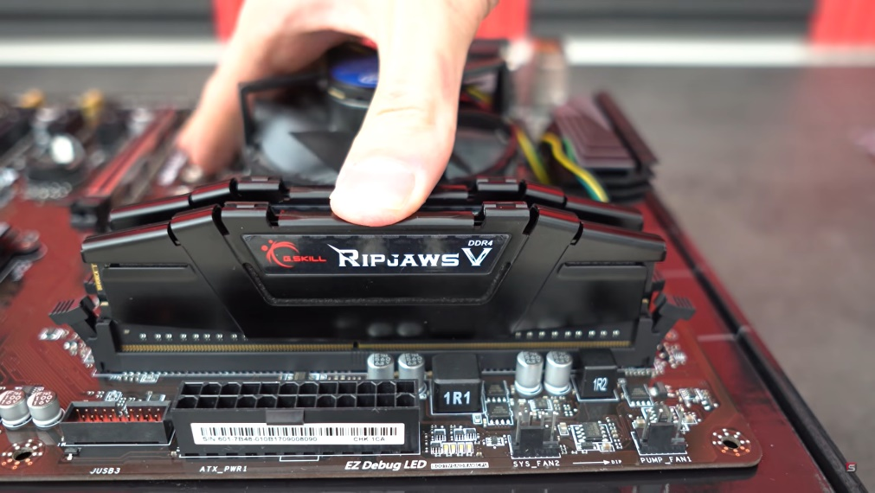
Locate the slot on the motherboard where you install RAM modules which is called Dual In-line Memory Module or DIMM slots. For single memory module, check the labelling printed on the motherboard to locate slot 1 and insert the RAM stick into it. If you are installing dual channel RAM, for example installing two RAM modules among four memory slots, just refer to the printing on motherboard that will indicate which slots should be occupied first before the others. To insert RAM stick into the slot, first unlock the latches on both sides of the slot by pushing them outwards. Only hold the RAM stick by its edges and do not touch the sides where the circuit is exposed. There is only one correct way to install a RAM module into a slot. Make sure the notch at the bottom of the RAM module matches the bump in the memory slot, rotate the RAM module 180° if it is not aligned. Gently lower the RAM stick down evenly and push down until it snaps into the slot. Do not apply too much force to prevent damage. Once the RAM stick is settled in place, the clips on the sides will lock into place themselves.

STEP 4 - INSTALLING MOTHERBOARD
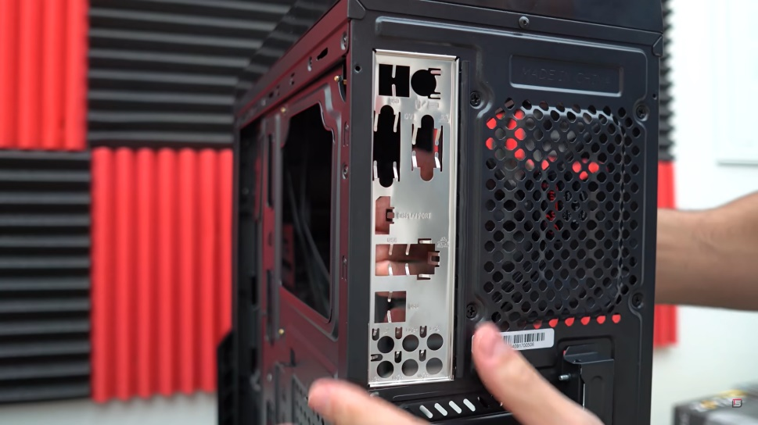
The first step is to install the IO shield. Before installing, make sure the it is right-side up by align the IO shield with the motherboard ports. Once you are confirmed, fit the IO shield in the back of the case from the inside. Apply pressure on all four corners of the IO shield evenly until it snaps in place. Do not apply force on the centre of the IO shield to avoid dent. Be careful not to hurt yourself by the sharp edges of IO shield. After completing, slightly push the IO shield from the outside of the case to make sure it is firm and securely in place. Next move is to install the standoffs. You can figure out which holes are to be installed standoffs by gently lower the motherboard inside the case and align the holes on the motherboard to that on the case. Then, you can determine where to install the standoffs.
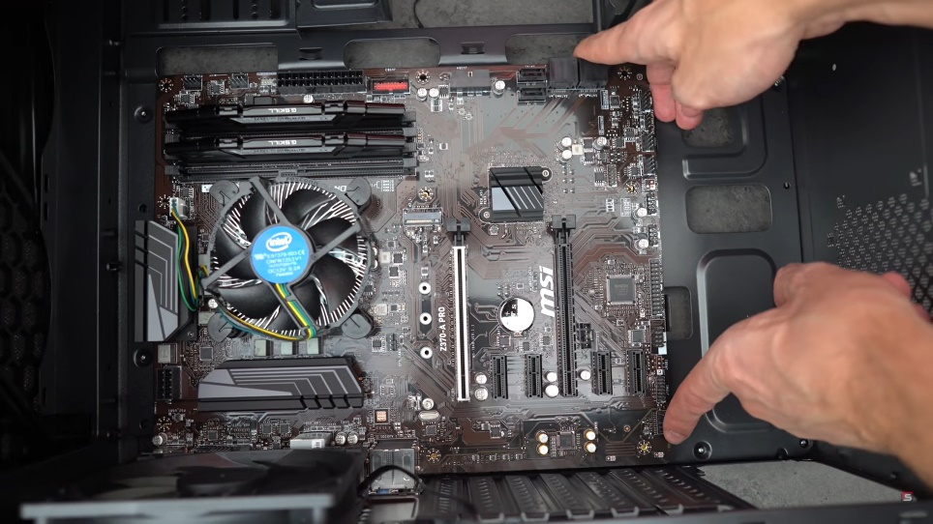
After you successfully install IO shield and standoffs, you can install the motherboard in the case. Carefully lower the motherboard in the case, align the ports with the IO shield and fit the holes to the standoffs at the same time. Install the screws on the standoffs and tighten it one by one by using screwdriver but do not over-tighten them.
STEP 5 - INSTALLING POWER SUPPLY
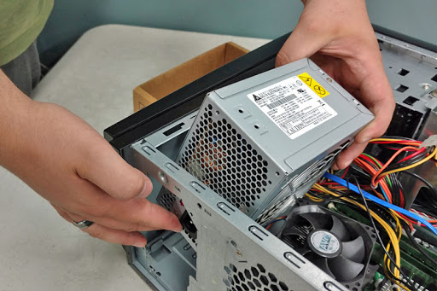
Locate the area to mount the power supply unit in the case where there is a rectangular cut-out and make sure to ground yourself before installing it. Fit the power supply unit inside the case and align the four screws holes on the power supply unit to the holes on the case. Screw all the four holes to hold the power supply in place but do not over-tighten. Then, connect the 24-pin cable from the power supply to the 24-pin socket on the motherboard

STEP 6 - INSTALLING HARD DRIVE
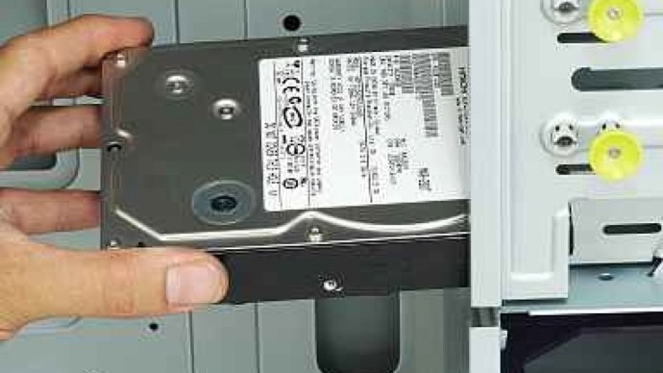
Before installing the hard drive, ground yourself to prevent damaging to the other components inside the case. Locate the hard drive bay inside the case and slide the hard drive into the bay with its connection facing inward the case. Match the screw holes on the hard drive with the holes on the drive bay and screw it using corresponding screws to secure the hard drive in place. Do not over-tighten the screws to avoid damage to the hard drive. After the hard drive is secured in place, connect the hard drive to the motherboard using the SATA data cable provided. The SATA data cable should connect the hard drive to an available SATA port on the motherboard referring to each motherboard manual. Next, connect the SATA power connector from the power supply to the hard drive. If the power supply only has Molex connector, just use a Molex to SATA adapter. Note that there is only one correct way to fit in the connectors.

STEP 7 - INSTALLING OPTICAL DRIVE
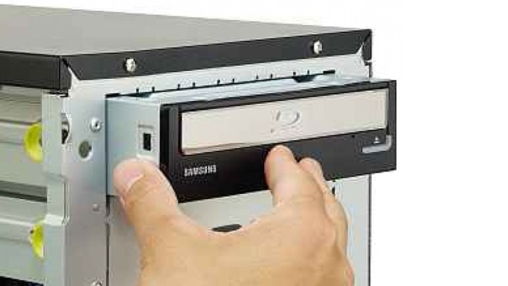
Locate the optical drive bay and remove the cover. Undo the screws to remove the cover if the cover is screwed in place. Insert the optical drive from the outside of the case and carefully slide it into the drive bay until it is fully inserted. Align the holes on the optical drive to that on the drive bay and screw them to secure the optical drive in place. After the optical drive is securely in place, plug the SATA data cable into the back of the optical drive and connect the other end to an available SATA port on the motherboard. Next, connect the SATA power cable from the power supply to the back of the optical drive.

STEP 8 - INSTALLING GRAPHIC CARD
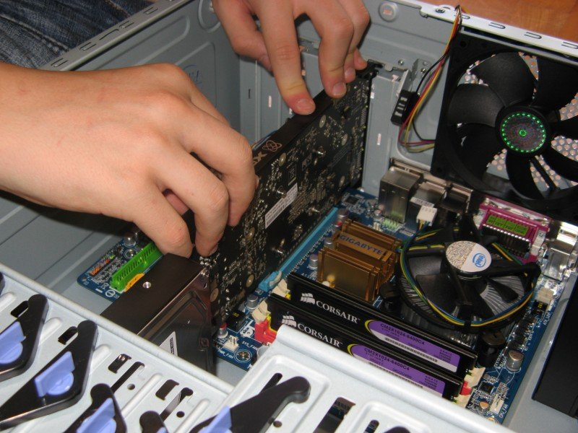
First, identify the PCIe slot to install the graphic card or GPU which typically is full-sized and at the topmost or closest to the CPU if there are more than one slots. Next, you need to remove the expansion brackets by unscrewing them depending on the size and position of the graphic card to be installed. You can determine which expansion brackets are to be removed by simply align the GPU to the PCIe slot identified. When handling with GPU, make sure to ground yourself and avoid touching any exposed circuit on the GPU. You can lay the case down for easier installation of GPU. Before installing the GPU, unlock the latch on the PCIe slot. Gently bring the GPU closer to the PCIe slot and line up the GPU ports properly to the cut-outs of the case. Fit the bottom of the GPU to the PCIe slot and exert some force until you feel it snaps in place, then lock the latch. Screw the GPU in place using the same screws from the expansion bracket.

STEP 9 - CONNECTING THE CABLES
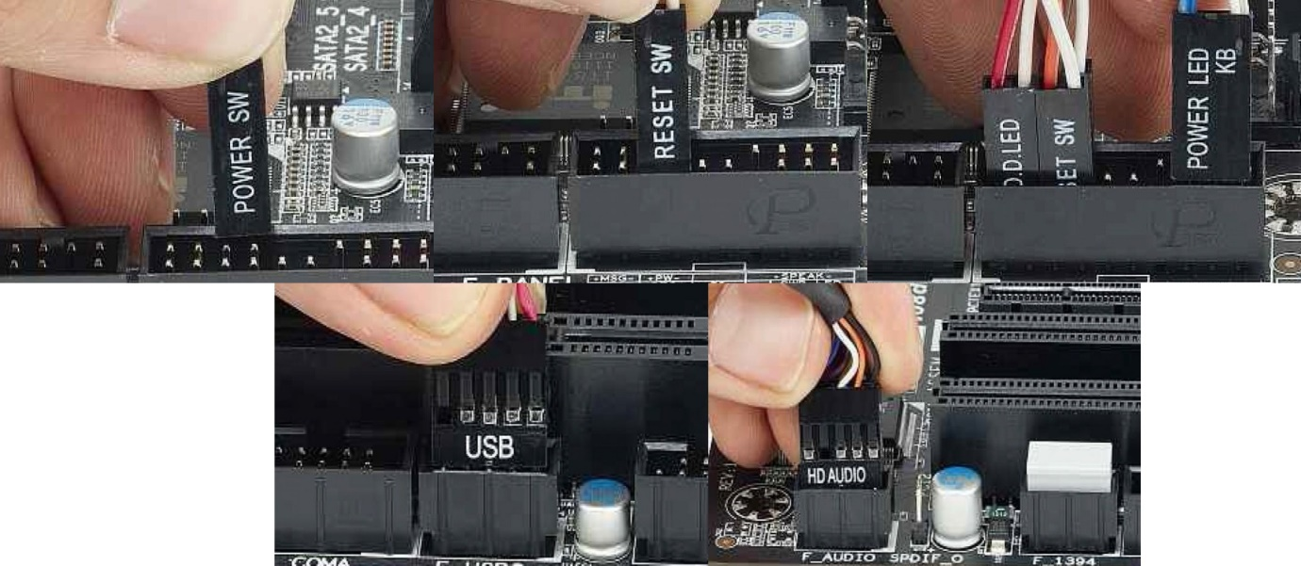
You can refer to the motherboard manual to find the corresponding connector. Connect the 8-pin power supply cable to the 8-pin header on the motherboard labelled “CPU_PWR1” or similar. Plug the audio cable to the pins on the motherboard labelled as “AUDIO” or similar. Connect the USB connector to the USB header marked “USB” on the motherboard. Next, connect the reset switch, power switch, power and HDD LEDs. Ensure all the connections are firm and there is only one correct way to insert each connector. Tidy up the cables for a neat look and better airflow.

STEP 10 - CLOSING THE CASE AND CONNECTING THE PERIPHERALS
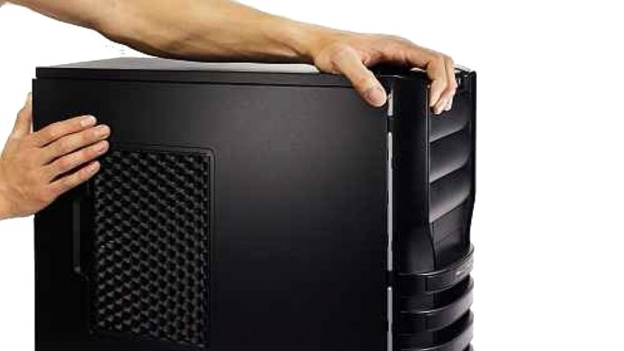
After all the work is done, put the side cover of the case back and secure it in place with screws.
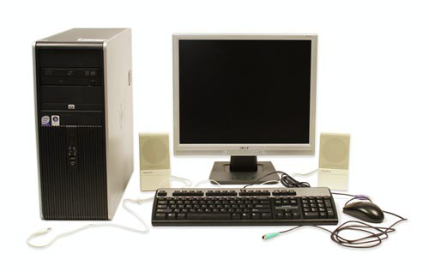
Connect peripheral devices such as keyboard, mouse, wireless network dongle, printer and webcams with CPU through USB ports. Then, connect speakers and microphone into 2.5 mm sockets. Finally, connect the CPU with monitor by plugging into display port.

