

Technology and Information System
PC Assembly - Group 7

Group Members
1. |  | Name : Amirul Shafiq Bin Amirrullah  Matric Number : A20EC0013  Phone Number : 0182674250  E-mail : amirulshafiq@graduate.utm.my
2. |  | Name : Natasya Nadhira Binti Ahmad Nazrain  Matric Number : A20EC0103  Phone Number : 018-9190293  E-mail : natasyanadhira@graduate.utm.my
3. |  | Name : Hafiz Surya Nugraha  Matric Number : A20EC0304  Phone Number : 082176208948  E-mail : hafiznugraha@graduate.utm.my

Lecturer : Dr Sarina Binti Sulaiman
School : Computing
Faculty : Engineering
Subject : Technology and Information System
Subject Code : SECP1513 – 09

Table of Content
Table of Content 1
Introduction 2
PART A : Tools Needed 3
1.0 - Screwdrivers 3
2.0 - Needle Nose Pliers 3
3.0 - Head mounted lamp 4
4.0 - Thermal paste 4
5.0 - Multimeter 4
PART B : Sketch of a Motherboard Layout 5
1.0 - Motherboard Layout Sketch 5
2.0 - Computer parts and their function 6
PART C : Step by Step PC Assembly 9
Step 1 : Processor 9
Step 2 : Installing RAM into motherboard 10
Step 3 : Installing motherboard into PC case 11
Step 4 : Mounting the power supply into PC 12
Step 5 : Installing CD-ROM 13
Step 6 : Installing the right cables 13
Step 7 : Mounting a storage drive 15
Step 8 : Installing a Graphics Card 16
Step 9 : Closing the case and connecting the peripherals 18

Introduction

Building a computer from scratch gives us the perfect machine for our own needs and requirements, but it can be daunting the first time around. To begin building or assembling a computer, one must know the computer hardware basics.

Preparing the required tools for pc assembling is a great way to start. Although a single phillips screwdriver is all we need to construct a PC, it is wise to have a few more things on hand just in case. For example, needle nose pliers or a head mounted head may come in handy to place screws into tight places or retrieve them. The most important part before beginning pc assembling, we must make sure that we acquire the fundamental knowledge of the motherboard component part and make sure we take safety precautions such as removing any electrostatic charge and installing the right cable at the right connection. After this, we are prepared to do a practical pc assembling step-by-step.

PART A : Tools Needed

1.0 - Screwdrivers
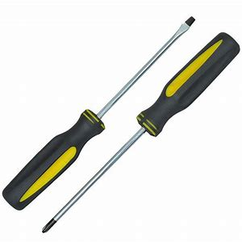
The screwdrivers serves to rotate the screws used as fasteners and looseners of various components. Screwdrivers in general there are only two types of screwdrivers + and screwdrivers - , both distinguished from the tip of the screwdriver. Screwdriver is very important in assembling the pc to tighten the components of the pc so that the pc can run properly and nothing shakes or loose.

2.0 - Needle Nose Pliers
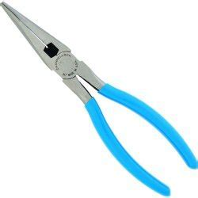
Needle nosed pliers serve to wire or clamp wires and work objects that are blocked or hard to reach.because their long shape, they are very useful for assembling a pc because if you want to reach to a small area where the cable or other material has become jammed or can not be reached by finger or other means.

3.0 - Head mounted lamp
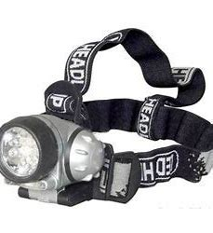
Head mounted lamp It serves to illuminate the dark part of the surrounding area.A good head-mounted lamp or adjustable clip-on lamp is very useful when building a pc. Many parts have black or dark interiors, which can make it difficult to see small screws and other components unless you work in a perfectly lit room.

4.0 - Thermal paste
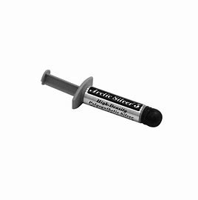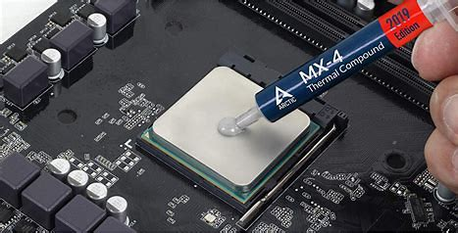
Thermal paste is a very high heat conductive paste used between two objects (usually heatsink and CPU/GPU) serves to get better heat conduction.This tool is important for keeping your CPU temperature low during use. Most CPU coolers come with already applied thermal paste, which means you don't need any extras.

5.0 - Multimeter
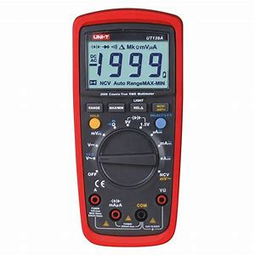
Multimeter serves to troubleshoot problems when tracking electrical or cable related problems. If you have this device, it only takes a few seconds to ensure that your power supply is in good working order, the voltage is being output correctly with the multimeter.

PART B : Sketch of a Motherboard Layout

1.0 - Motherboard Layout Sketch
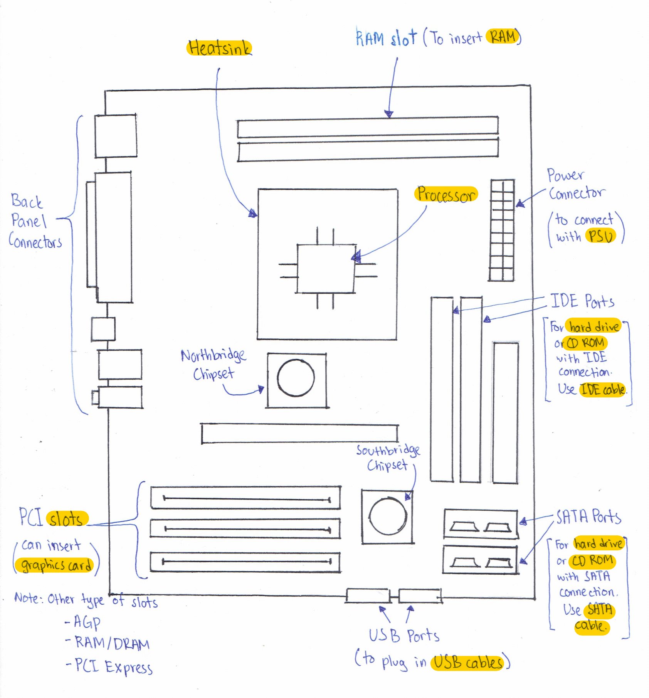
Figure 1 - A sketch of an ATX motherboard layout
(Note: Highlighted words are keywords)

2.0 - Computer parts and their function

Computer parts | Function and example of model
Graphics Card  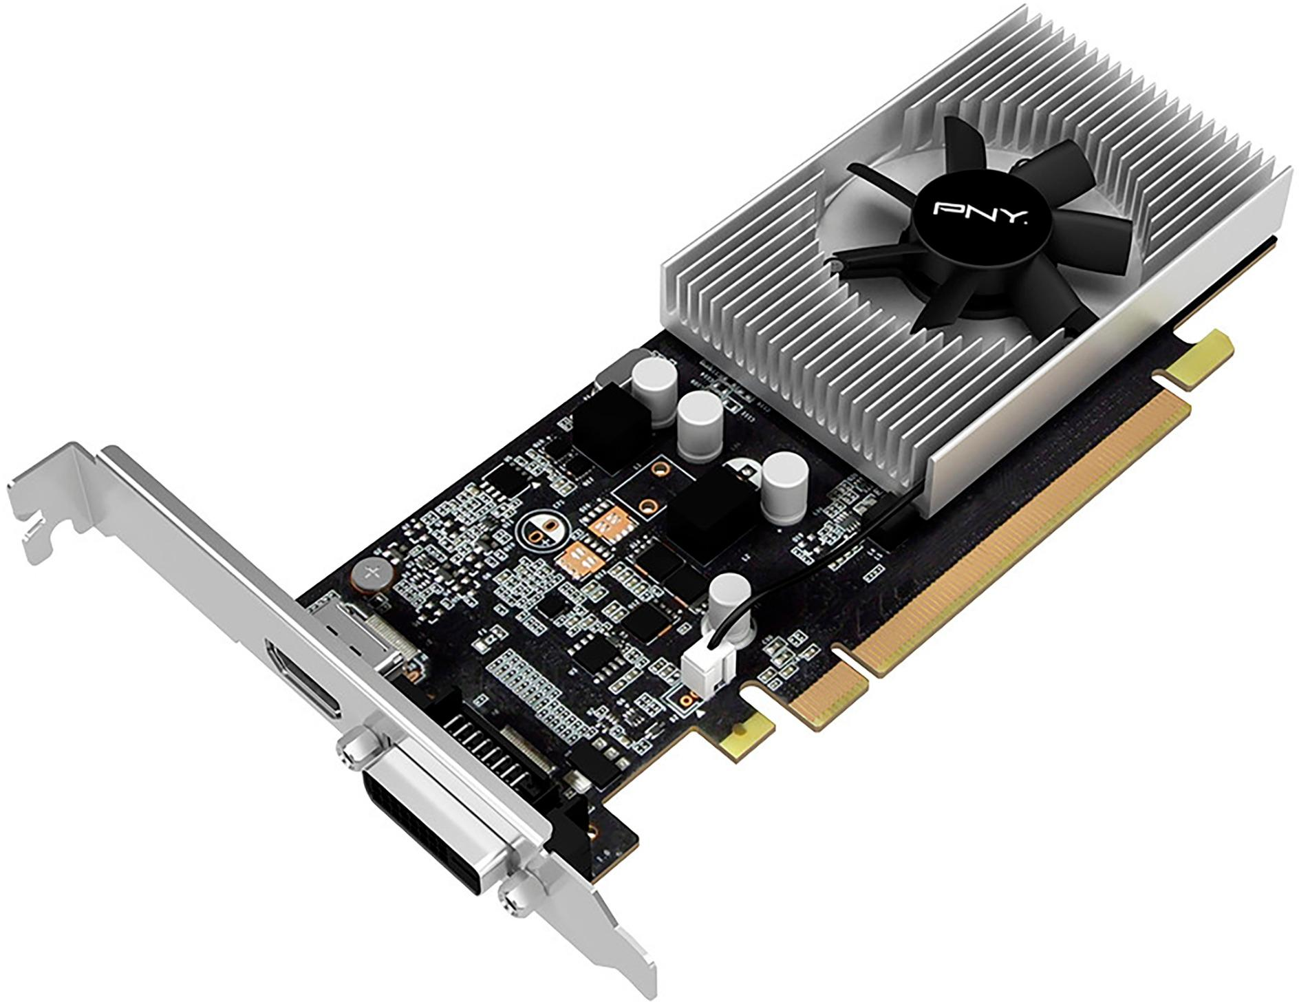 | Function:  Graphics cards allow computers to produce graphics and images more quickly. A graphics card has its own processor, a GPU or graphical processing unit. Graphics cards are also referred to as video cards.  Example of model:  NVIDIA GeForce GT1030
Processor / Central Processing Unit (CPU)  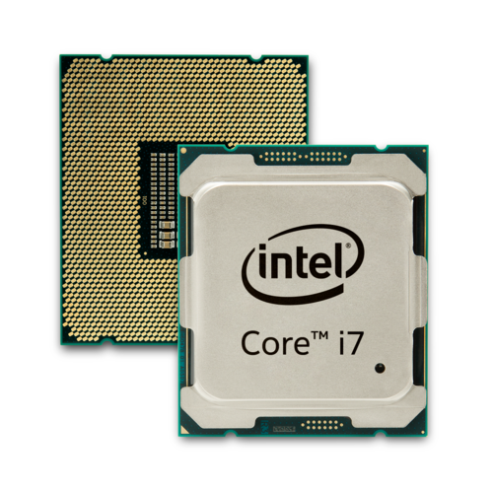 | Function:  The CPU is considered as the brain of the computer. CPU performs all types of data processing operations. It stores data, intermediate results, and instructions (program). It controls the operation of all parts of the computer.  Example of model:  Intel core i7
Heat Sink  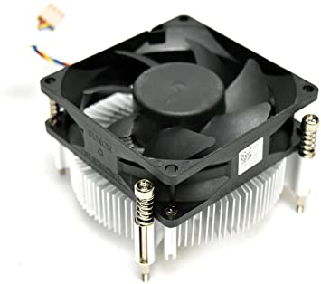 | Function:  Heat sink is a component designed to lower the temperature of an electronic device by dissipating heat into surrounding air. A heat sink without a fan is called a passive heat sink. A heat sink with a fan is called an active heat sink.  Example of model:  XG27M Inspiron 3650 (Active Heat Sink)
CD ROM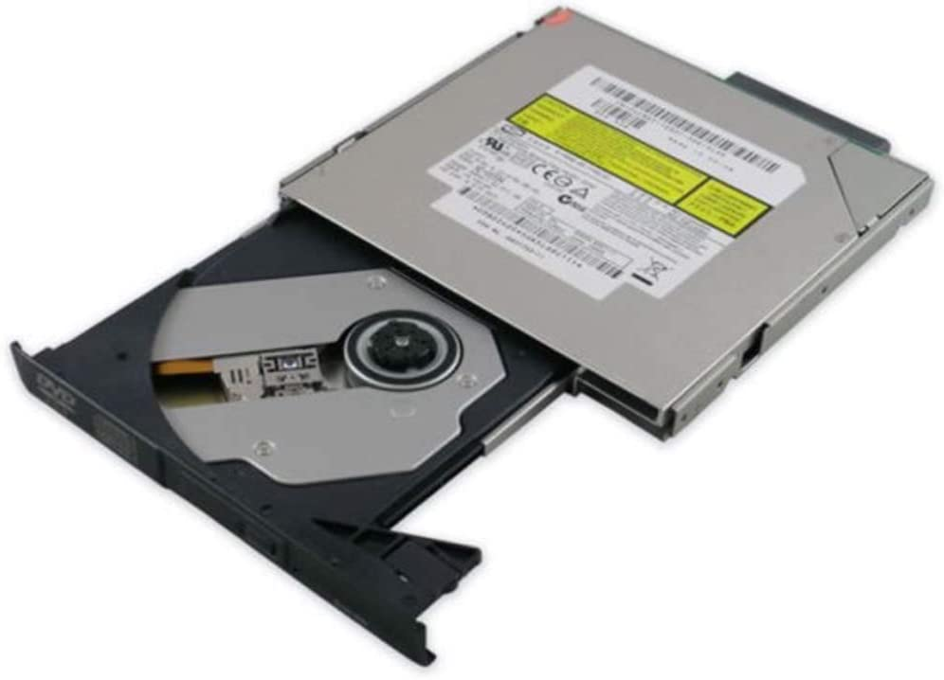 | Function:  CD-ROM is a device that uses photodiodes to detect reflecting lights on optic discs and uses a laser to read or write data.  Example of model:  CD-ROM Drive for HP COMPAQ
USB cable  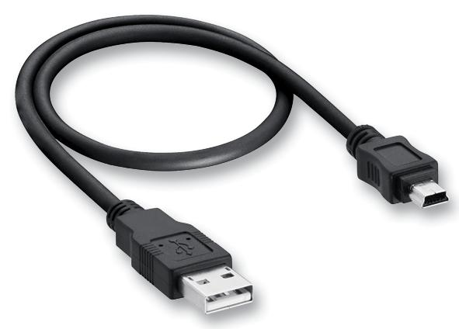 | Function:  Universal Serial Bus (USB) cables carry power as well as signals (data). USB cables are designed with several distinct connector types and USB 3.0 has a faster rate of transferring data compared to USB 2.0.  Example of model:  USB 2.0 Type A to Mini Type B (Male to Male)
Slots (PCI)  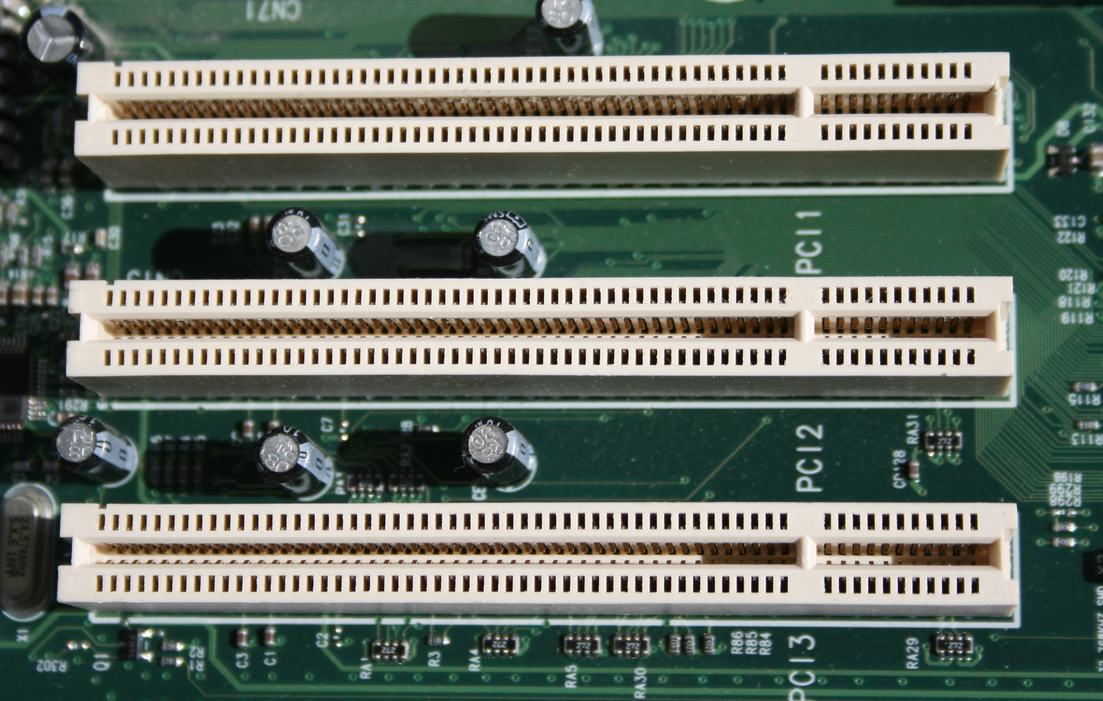 | Function:  Slots are a connection or port located inside a computer on the motherboard or riser board that allows a computer hardware expansion card to be connected. For PCI slots, it can expand Network card, SCSI, Sound card, Video card. There are a few types of slots on the motherboard that serve different purposes. Some of the slot types are CPU slot, RAM/DRAM slot, AGP slot, PCI slot and PCI Express slot.  Example of model:  PCI Slots
Random Access Memory (RAM)  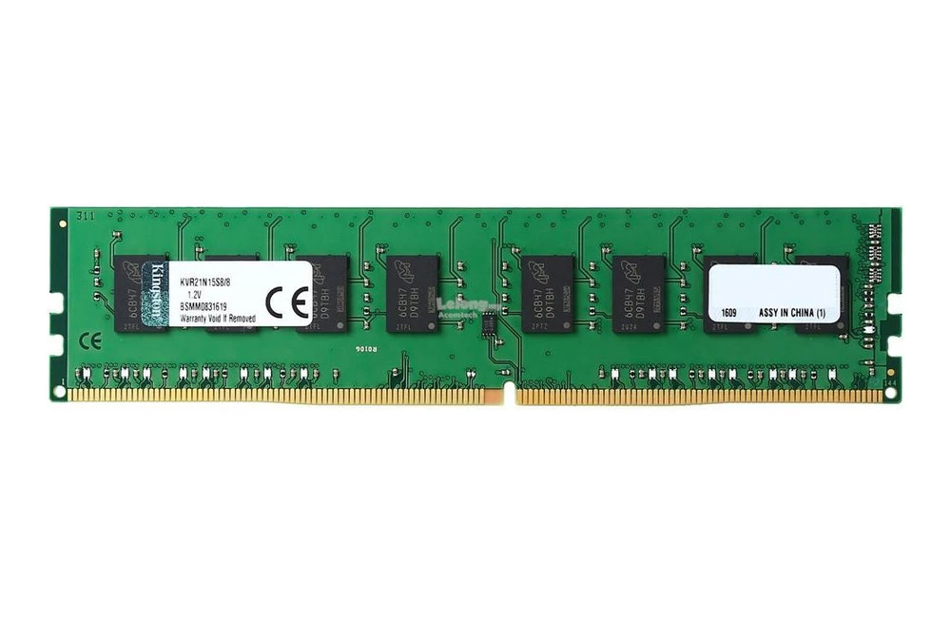 | Function:  Memory or RAM is a computer hardware that serves as a temporary data storage. RAM gives applications a place to store and access data on a short-term basis. It stores the information your computer is actively using so that it can be accessed quickly.  Example of model:  Kingston 8GB DDR4 2400Mhz Desktop
SATA cable  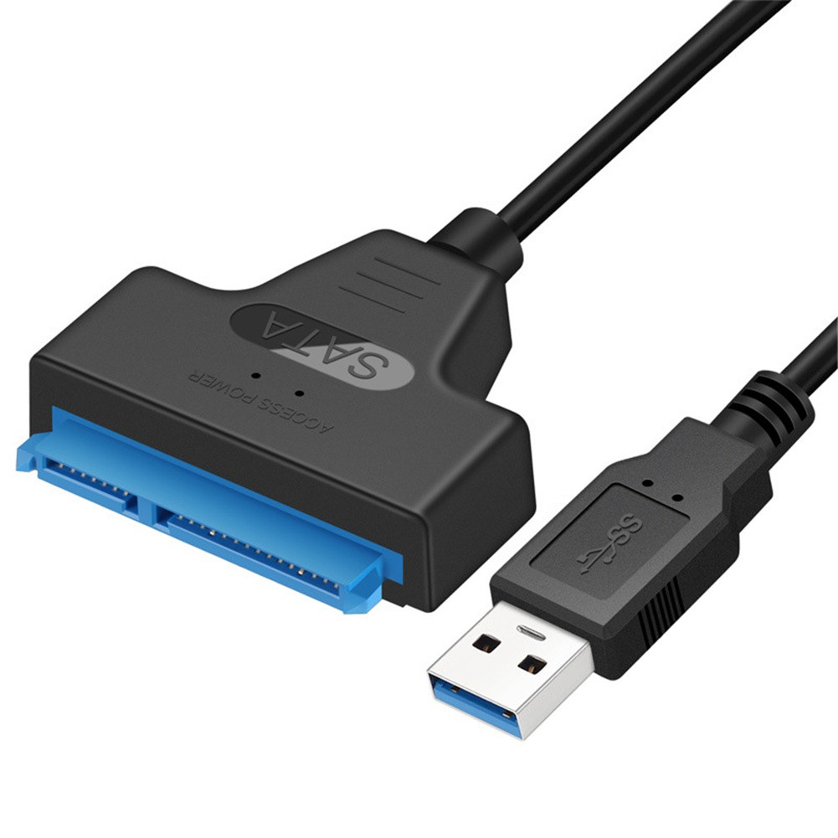 | Function:  The primary use for the SATA cable is to connect an internal hard drive to a computer motherboard. This ability of the SATA cable to transfer data quickly makes these cables the desired device to connect these devices.  Example of model:  SATA cable 3.0
IDE cable  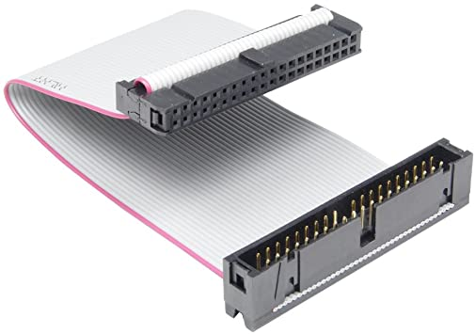 | Function:  IDE Cables connect from the motherboard of a computer to the hard drive, cd drive or floppy drive.  Example of model:  IDE cable 40-Pin
Power Supply (PSU)  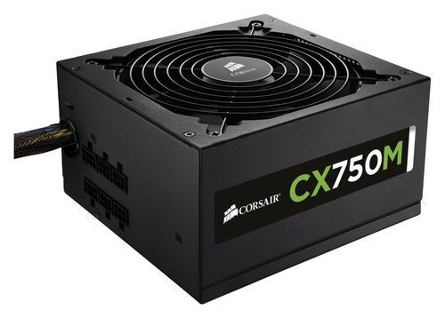 | Function:  Power supply is an electronic device that supplies electric energy to an electric load. The primary function of a power supply is to convert one form of electrical energy to another and, as a result, power supplies are sometimes referred to as electrical power converters.  Example of model:  Corsair CX Series Modular CX750M 750W
Hard Disk 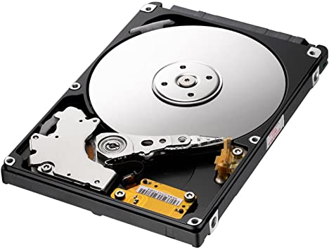 | Function:  A hard disk is an electro-mechanical data storage device that stores and retrieves digital data using magnetic storage and one or more rigid rapidly rotating platters coated with magnetic material.Slave drives are mostly used for storing data to protect it in the event of a system crash. Master drives usually contain the operating system to run the computer.  Example of model:  SATA Hard Disk (slave jumper setting)

PART C : Step by Step PC Assembly

Before assembling a PC, make sure to discharge any static buildups and to yourself from any electrostatic charges for example, touching metal objects to discharge the statics or purchase an anti-static wrist strap as touching any PC parts with statics can cause electric charges to yourself and maybe can damage the certain part of the PC parts.

Step 1 : Processor
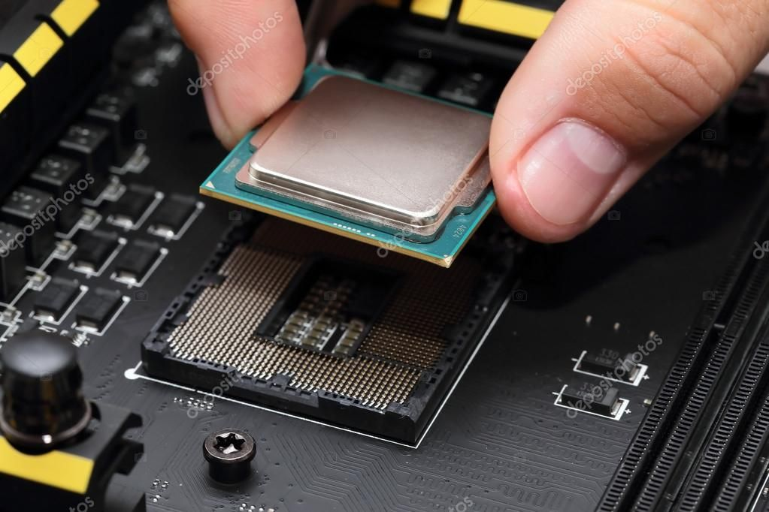

Processor is like a brain inside a computer. A computer cannot run without it. In order to install the processor, make sure that the processor is compatible with the socket type of the motherboard. AMD and Intel have different types of sockets. Intel processors will not fit into AMD motherboards and vice versa. After unboxing a CPU box, make sure to only hold the edge of the processor, as shown in this picture. Never touch the golden pins under the processor under any circumstances as it can damage the pins. Open the socket near the CPU slot and then carefully insert the processor into the processor slot and close the socket gently after that.

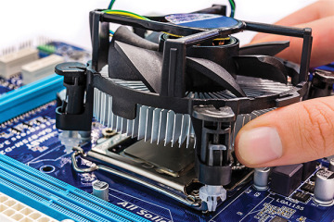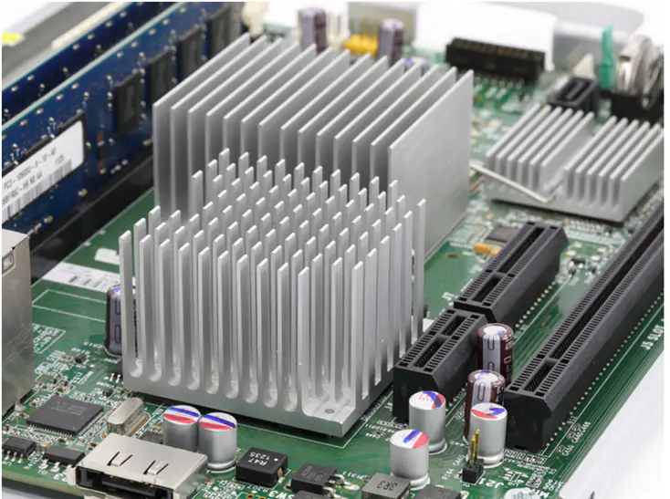

Secondly, install the CPU cooler. Take out the metal strap covering the fan slots by removing the screws by using a Phillips screwdriver. And then, mount the cooler fan on the CPU, some cooler fan can be mounted easily by just clicking on the corner until it snaps. Some cooler fans will have to be screwed to get it tight on the CPU. Locate where the cooler cable will go in the motherboard. Look at a motherboard port called “CPU_FAN” or equivalent and insert the cable associated with the cooler fan and insert it to the port. Heat sink is also useful and common in increasing the heat conductivity and heat flow away as well as from the PC.

Step 2 : Installing RAM into motherboard
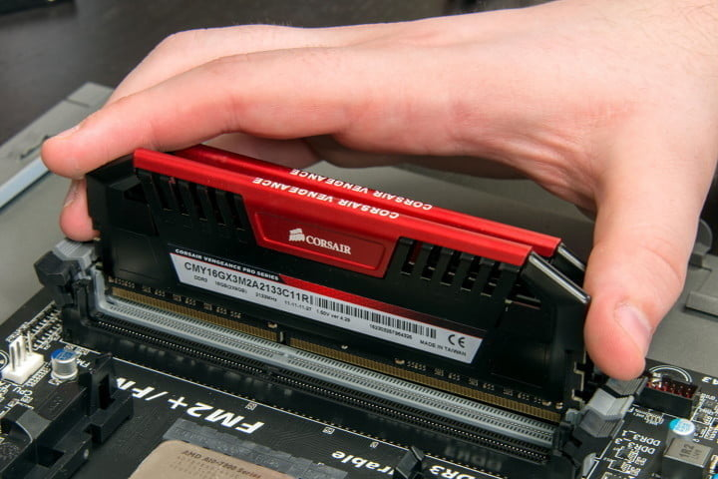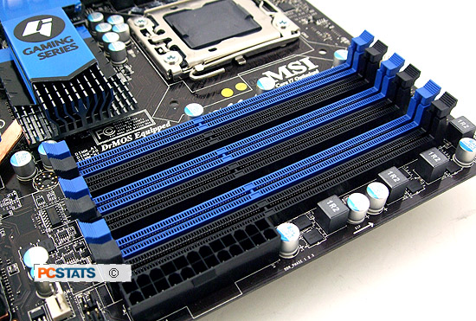

Install the RAM from the box into the memory slot in the motherboard. Do not touch the pins under the RAM. Open the memory holder. And then, align the pins on the RAM into the memory slot before putting it in. Apply a little pressure of inserting the RAM until the “snap” sound is heard. When it snaps, it means that the RAM is properly installed.

Step 3 : Installing motherboard into PC case

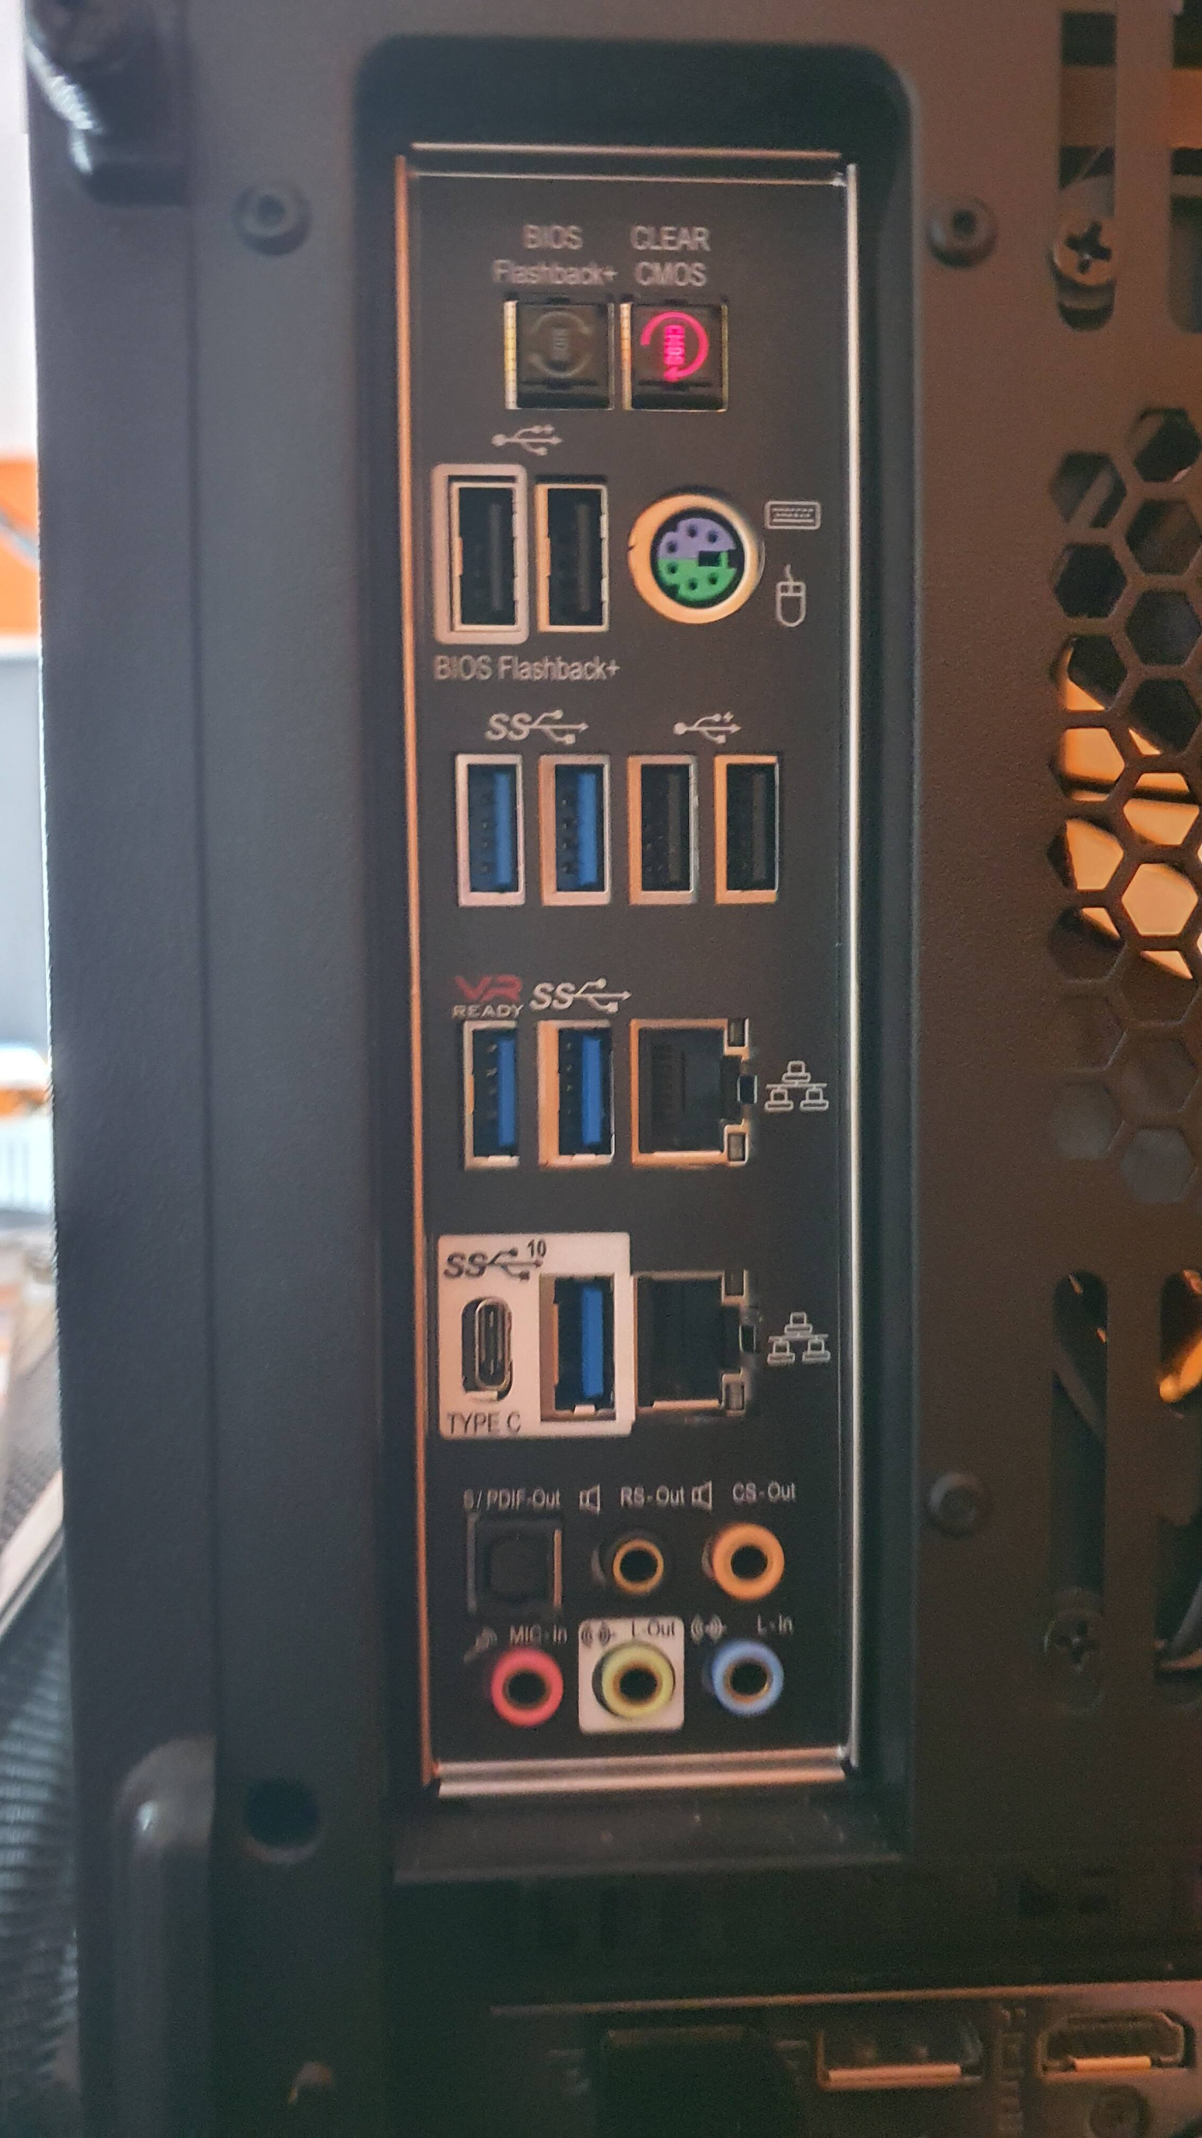

Before installing the motherboard inside a PC, an IO shield have to be installed first, where we can connect the peripherals through there such as USB devices, audio devices, ethernet ports and others. IO shield is usually included inside the motherboard box. To insert the IO shield into the PC, apply pressure towards the corners of the panel until it snaps.

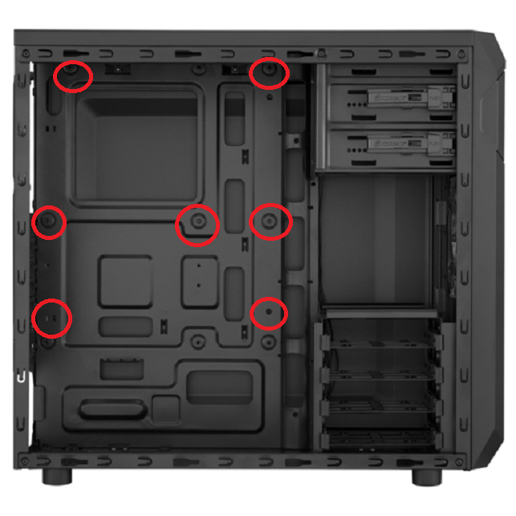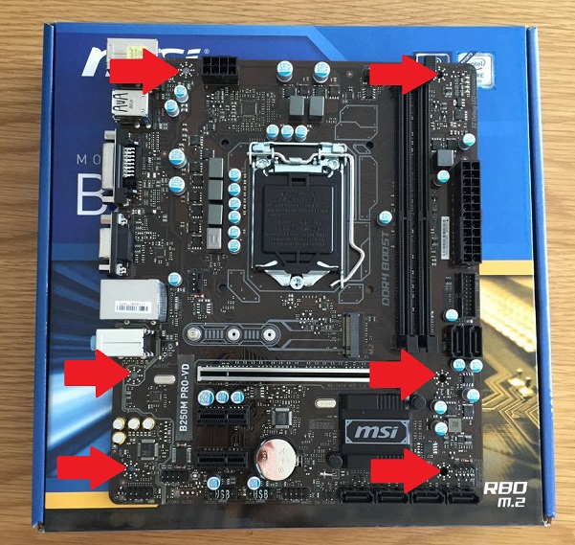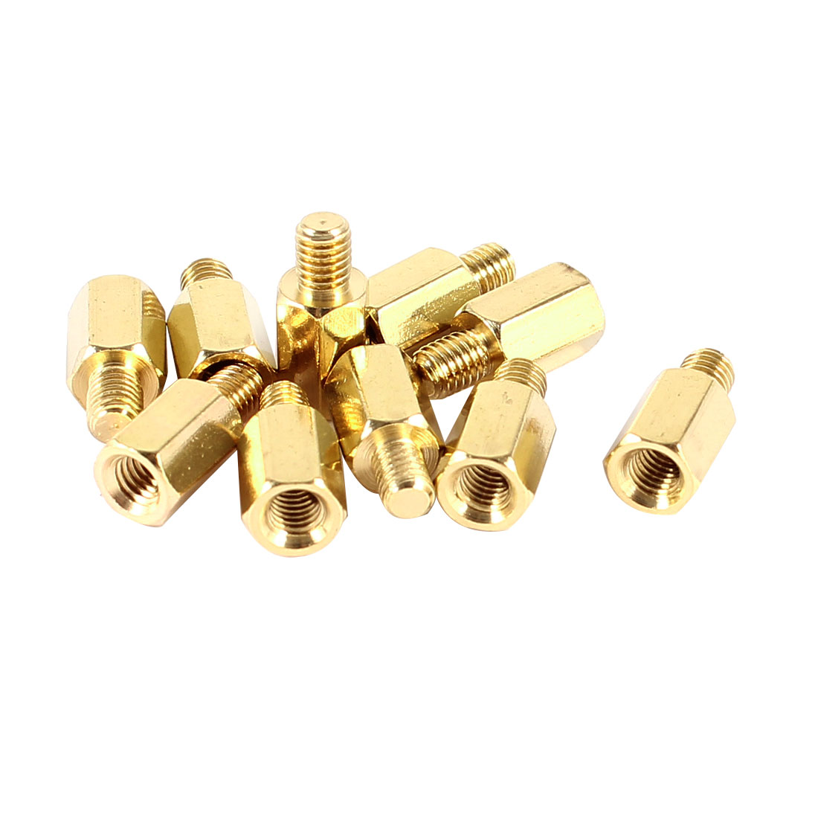
Locate the standoffs of the PC. If the PC only has 6 standoffs while the motherboard has 9 holes in it, then install the other 3 standoffs that are included in the PC case by screwing them in place. Then, place and screw the motherboard by Phillips screwdriver into the allocated standoffs in the PC by cross pattern tactics to apply even pressure to the motherboard. Do not overtighten the screws.

Step 4 : Mounting the power supply into PC
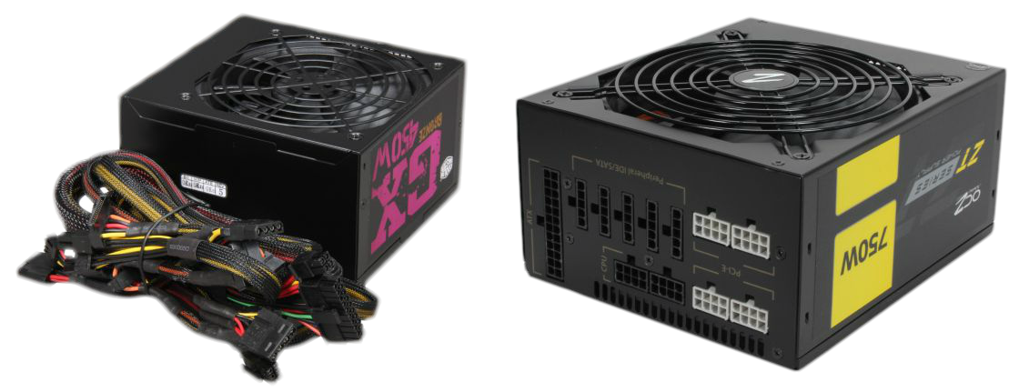

There are 2 types of power supply which is non modular and modular power supply. Non modular power supply is included with the wires (right) while modular power supply has ejectable wire ports on it (left) in which we have to buy the cables separately. Insert the power supply in the allocated power supply location inside the PC (usually at the corner) and mount it by screwing the corner of the power supply slots by screw. And then, attach the power supply 24-pin IDE cable into the motherboard.

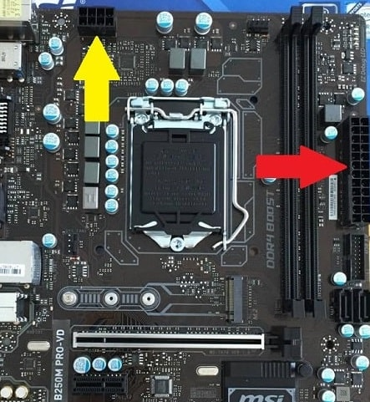

Then, attach the 24-pin and 8-pin (sometimes 4-pin depending on the power supply) IDE cable from the power supply into the motherboard with the ports shown as above. This is crucial because the PC will not turn on without installing either one of them. After that, attach the 3-pin big wire cable from the main plug into the power supply to turn on the power.

Step 5 : Installing CD-ROM
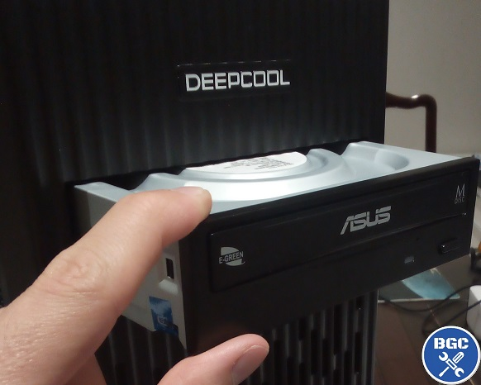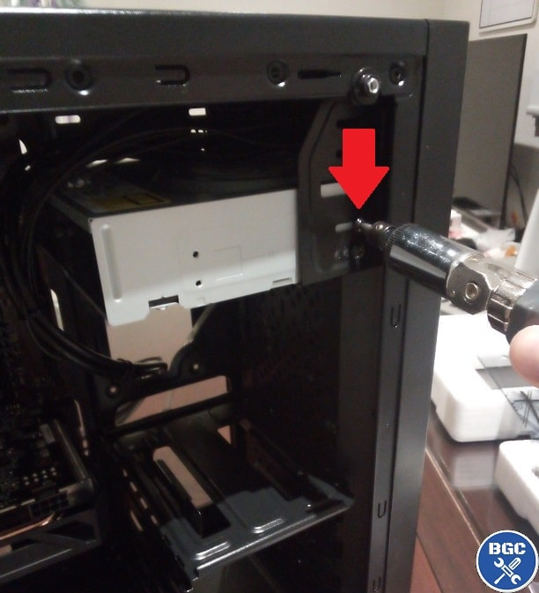

Nowadays, most recently created PCs do not include the location of the optical drive. If that is so, this step can be skipped. Slide the optical drive into the optical drive location allocated space in the PC. Then, line up the holes in the PC with the holes in the optical drive and screw in the optical drive aligned with the PC.

Step 6 : Installing the right cables
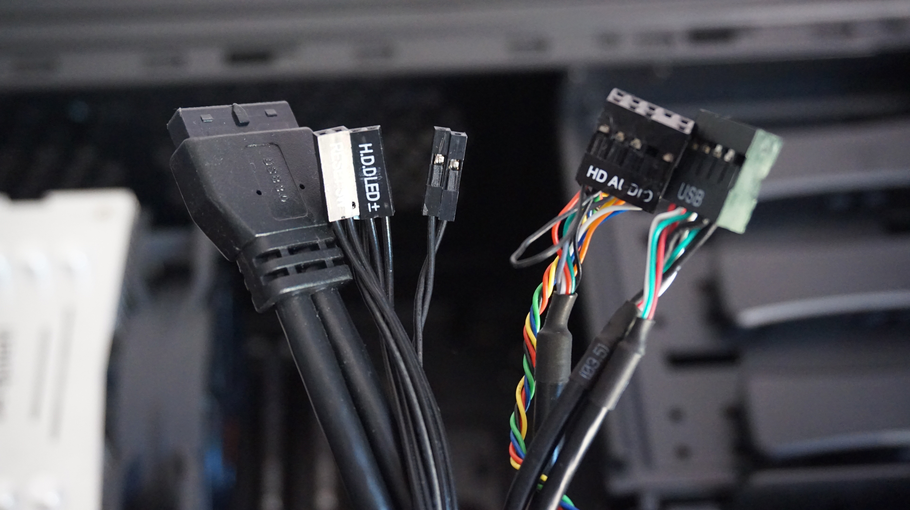
The cables mentioned are mostly cables from power supply such as 24-pin CPU, (4+4) pin CPU, MOLEX, SATA and floppy connectors and 8-pin PCI-E. There are also front cable connectors from the PC case such as 3.0 USB cable adapter, HD Audio, USB, Power Switch, Reset Switch, HDD LED & power LED +-. These cables need to be inserted properly into the motherboard.

As mentioned before, both 24-pin and (4+4) pin cable has to be inserted into the motherboard ports shown before. So, firstly, the locations of the front panel ports need to be identified first, before putting the cables in the motherboard.
Plug in the 3.0 USB cable adapter and HD Audio cable into the allocated ports inside the motherboard.
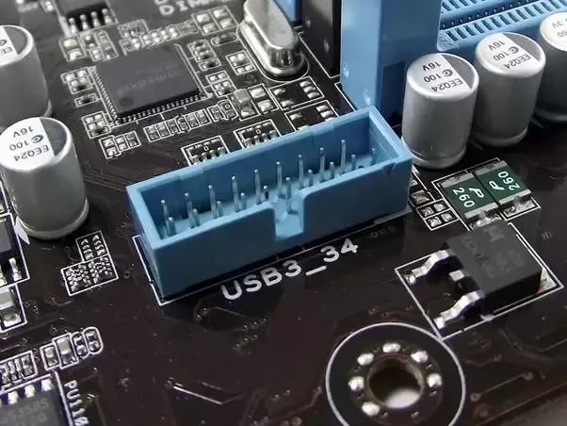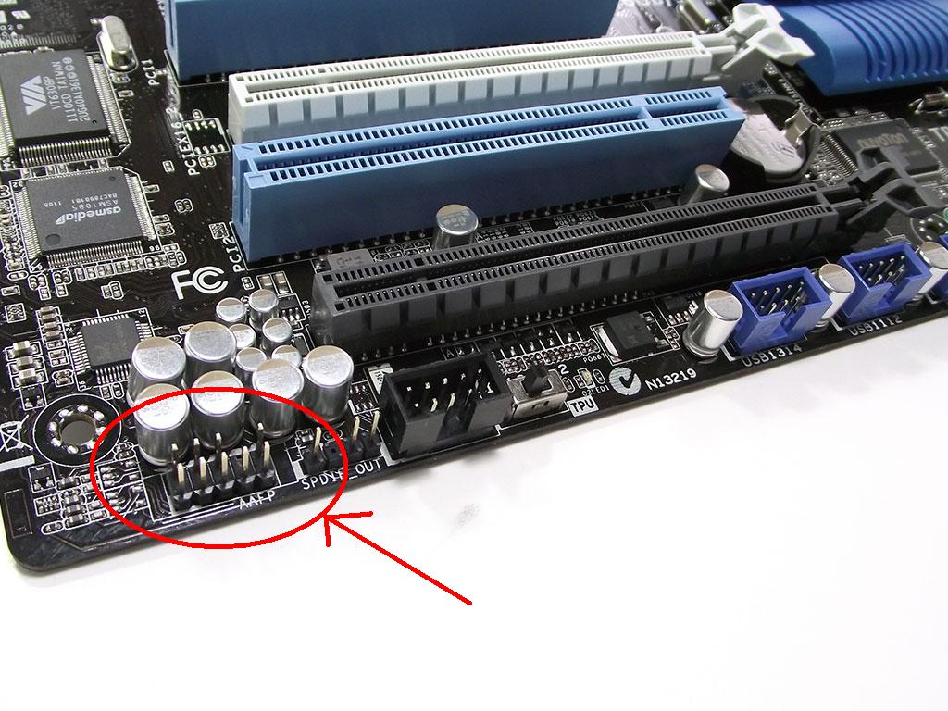
3.0 USB Port HD Audio Port

Plug in USB cable from the PC case into the motherboard (one of them in USB1, USB2,...)
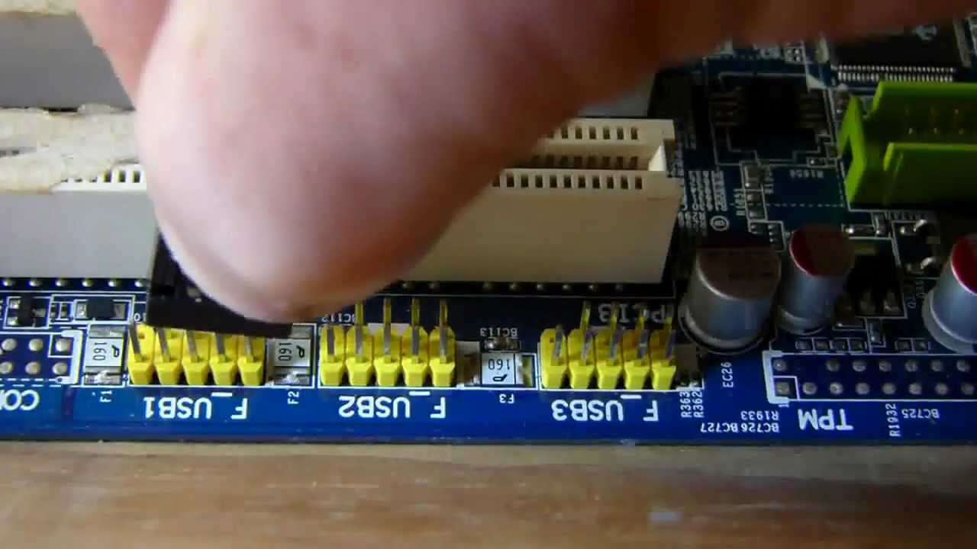

For HDD LED, Reset Switch Power Switch, Power LED, those things need to be installed into the correct location of its ports which is usually found at the bottom or top right of the motherboard, otherwise the PC will not turn on.
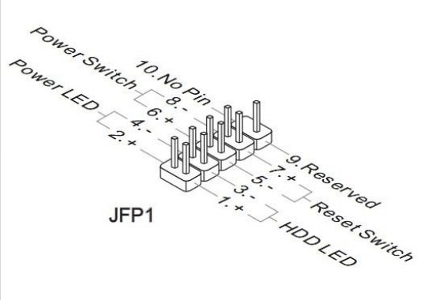

Step 7 : Mounting a storage drive
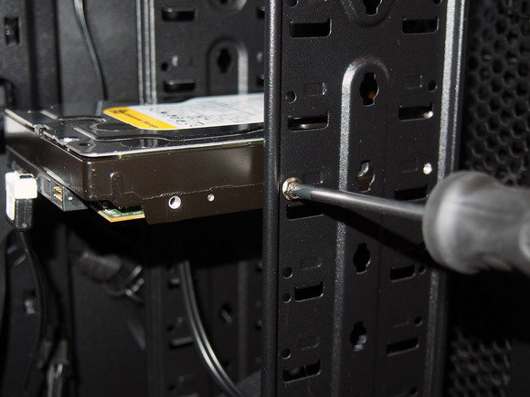

Internal 3.5 inch hard disk is usually mounted in a drive bay, provided by the PC case. Just align the holes in the PC towards the HDD/SSD holes and screw it. And then, attach the SATA/IDE power cable from the power supply and from the SATA/IDE separate cable to be plugged in inside the storage drives. The SATA/IDE separate cable is then plugged in inside a port inside the motherboard For HDD, make sure that the orientation is always vertical or horizontal, not at a certain angle as it can slow down the data flow in HDD. As for Solid State Drive (SSD), it is safe to install it everywhere in the PC as the SSD is a type of vibration-resistance device in which the HDD is not.

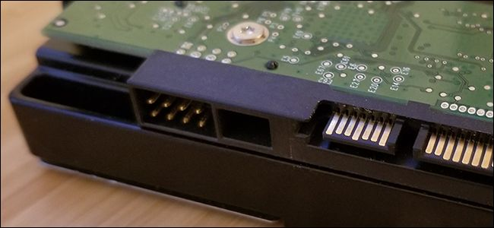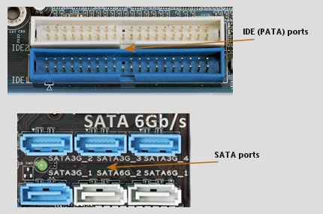

HDD ports consist of (from left) IDE or PATA power port , SATA data ports and SATA power ports.
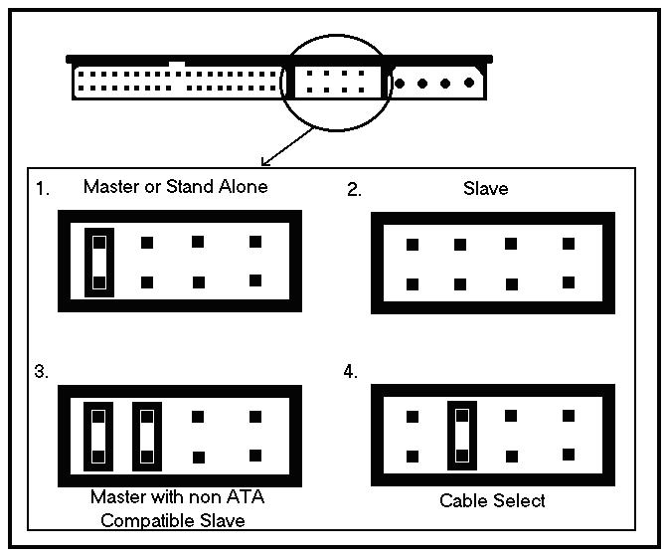
Note that the jumper settings that can be plugged only by IDE cable in the HDD ports may vary depending on the type of the HDD.

Step 8 : Installing a Graphics Card
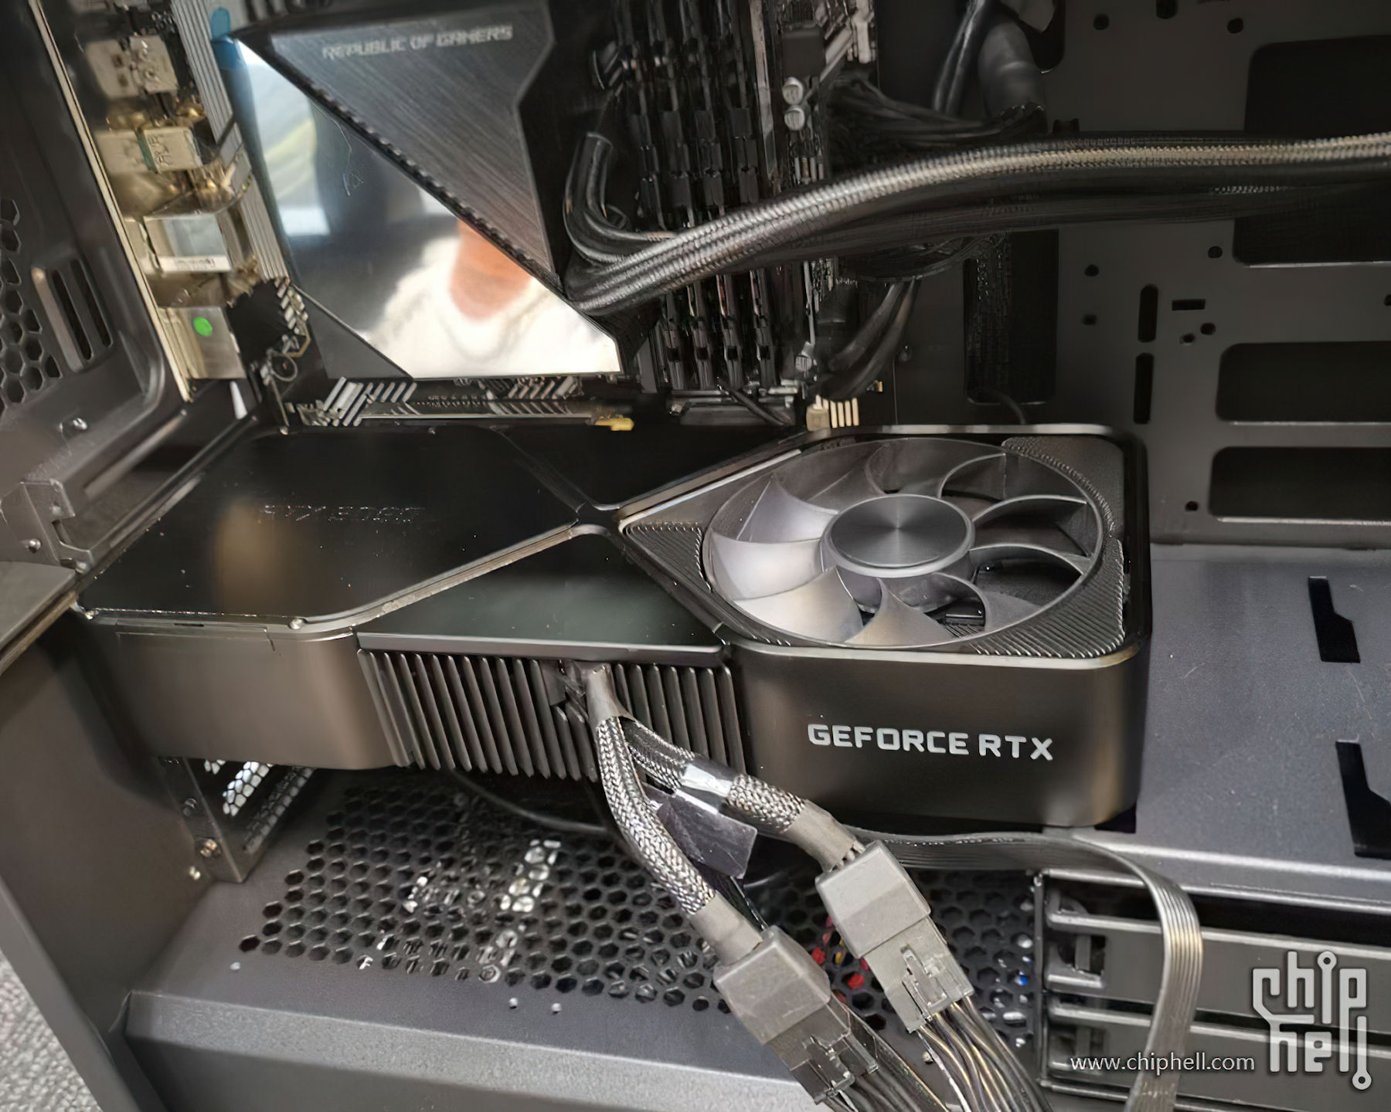

Some processors already have their integrated graphics card included for the PC. For example, Intel Core i5 2500 with its integrated graphics card of Intel HD graphics. In this case, this step can be skipped, unless if the motherboard has 2 or more graphics card slots then it is up to the user whether to install another or not.. In order to install the graphics card, put out the side panel of the PC by unscrewing them, removing the screws. Then, open the pin cover under the graphic card in order to install the golden pins into the motherboard.

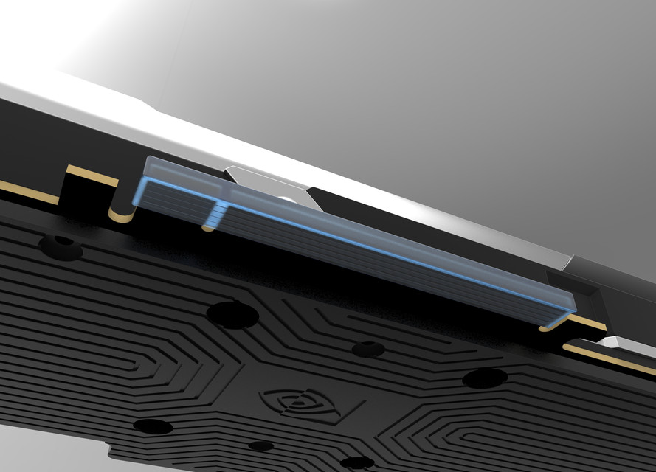
pin cover of the graphics card

Align the pins from the graphics card into the PCI slot from the motherboard and apply some pressure to insert it correctly. If the”snap” sound is present, then the graphics card is properly installed. Next, screw the side panel inside by using the Phillips screwdriver at the top and bottom of the panel. Attach the 8-pin PCI-E cable from the power supply into that one graphics card port. When the power supply is turned on, sometimes the graphics card has a light indicator which shows white light if the graphics card is installed correctly and red light if it is not.

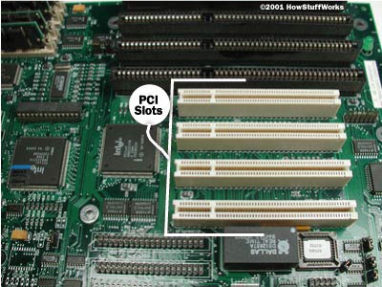

Step 9 : Closing the case and connecting the peripherals
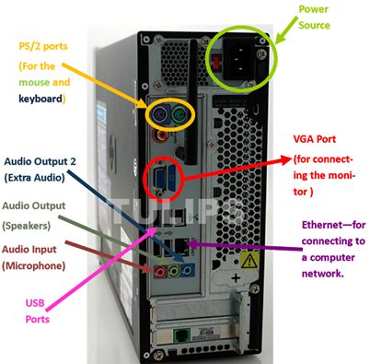
Peripherals is a collection of parts of hardware that is needed to complete a computer setup. These parts consist of monitor, printer, mouse, speaker, router, headphones and many more. Nowadays, there are HDMI ports that can be connected into HDMI port monitors which perform better in terms of resolution, data flow and so on than those of VGA ports.

Basically, just plug in the cables into its position and the PC is completed and can be assembled. For instance, plugging the mouse cable, speakers, monitor cable, keyboard cable and also the ethernet port into the port shown in above. For those who preferred Wifi over Ethernet, the Wifi USB adapter can be bought on the market. Just insert the USB on one of the USB ports and then the PC is connected to the Internet.

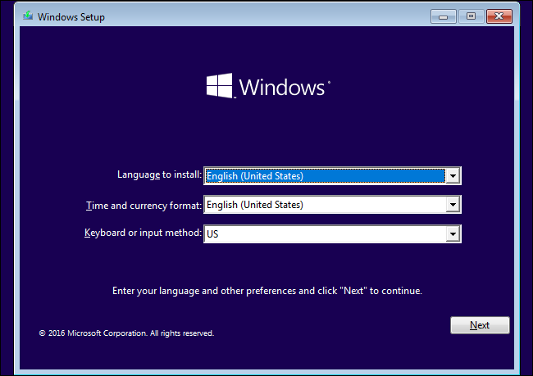

After all of the peripherals have been connected, install the Windows Operating Software and purchase the license key from the market or buy it online. Usually, assembling a PC takes around a few minutes by a professional and maybe a few hours for those who want to try something new, depending on the skills. But building and assembling PCs really gives experience a whole new different level.

