
Semester I 2020/2021

Subject : Technology and Information System (SECP1513)
Section : ___________09_______________
Assignment : Step by step PC Assembly

GROUP NAME / NUMBER: _____09_____

1 | 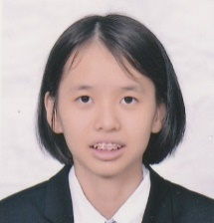 | Name: ANG WAN XIN  Matric Number: A20EC0015  Phone Number：017-5844078  E-mail: angxin@graduate.utm.my
2 |  | Name: HENRY MESHACK OKINYI ODONGO  Matric Number: A20EC0268  Phone Number：+639772934057  E-mail: henryokinyi@graduate.utm.my
3 |  | Name: NUR DINIE SAJEEDA BINTI AZMAN  Matric Number: A20EC0112  Phone Number: 011-10862706  E-mail: nudiniesajeeda@graduate.utm.my

PART A – Tools needed
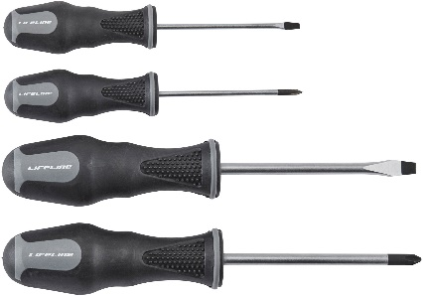
- Screwdriver

The screwdriver is the main tool that needed to screw the components in CPU especially Philips Head. They are important for screwing and unscrewing screws and they also tighten or loosen screws that can prevent the components in the CPU from falling apart.

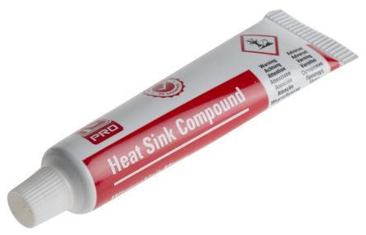
- Thermal Paste

The thermal paste is applied to a processor before installing a cooling solution. It allows for an efficient transfer of heat from the IHS of the processor to the base plate.

- Screw
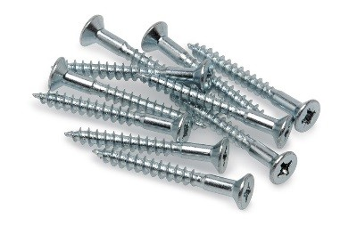
The screws are usually small and slender metal pins with slotted heads. They are used to join things together by being rotated so that they pierce a material with another material. It is also important to keep the components inside the panel in the right place to prevent failure function. This also ensures that the two materials are tightly held in place. There are a wide variety of screws that come in different sizes.

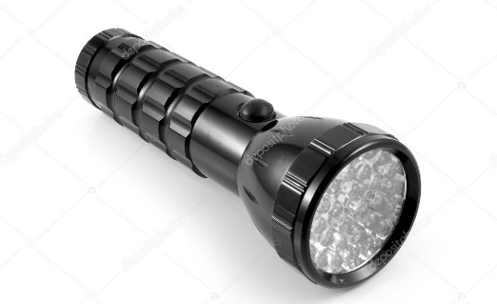
- Torchlight

Torch light is used for direct illumination. PC cases are full of shadows and screws love to roll into the darkest corners. We may screw the components in the wrong place if inside the PC is not well lit. The torch light can also be used to check that the wirings inside the PC are done properly and if all components are aligned precisely.

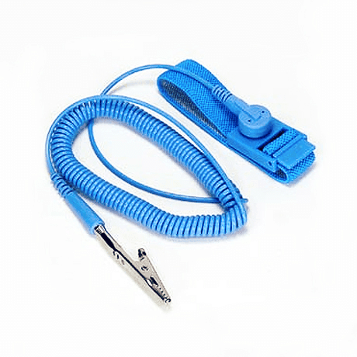
- Antistatic wrist strap

The antistatic wrist strap prevents static electricity from building up. The antistatic wrist strap should always be worn and the alligator clip should attach to the non-painted metal surface of computer case. This is important as static electricity can electronically destroy the delicate components inside the computer.

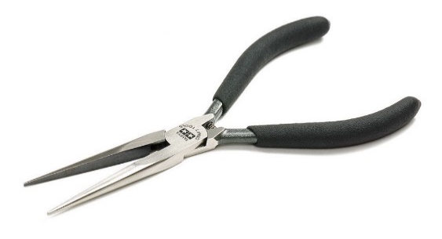
6.0 Needle-nose Pliers

Needle-nose pliers are pliers that allow cutting and holding functionalities. They are useful especially because of their long-pointed needle-like tip which help if a nut, screw or an element has become stuck in an unreachable area inside an electrical component. They also help in picking up and installing various bits and pieces of small electrical components. For wires, it can assist in the bending, re-positioning and snipping of a wire.
PART B – Sketch of a mother board layout

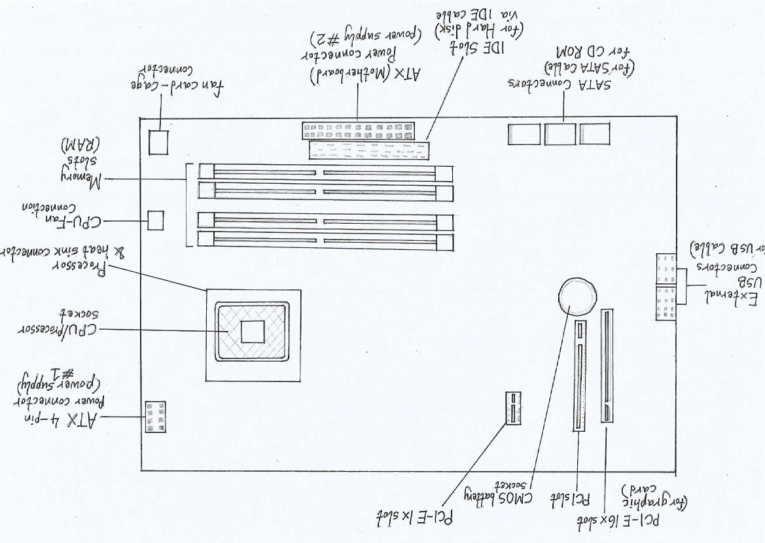
Figure 1 sketch of motherboard layout
Components | Function | Example of models
Graphic card  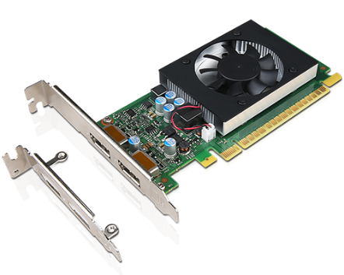 | -produces the image to see on a monitor.  -it's a piece of hardware inside your computer that processes images and video.  -Connects to the motherboard and the monitor.  -This allows the card to accept information from the CPU and send output to the monitor. | - Nvidia GeForce RTX 3070  - Nvidia GeForce RTX 3080  - Nvidia GeForce RTX 3090  - AMD Radeon RX 5600 XT  - Nvidia GeForce RTX 2070 Super  - AMD Radeon RX 5700
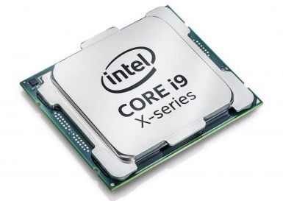  CPU/Processor | -logic circuitry that responds to and processes the basic instructions that drive a computer. | - 10th-generation Intel Core i5 – i7  - Apple M1  - 11th Generation Intel Core i7-1165G7  - Intel Core i7-1065G7  - AMD Ryzen 7 4800HS  - Intel Pentium – Core m7
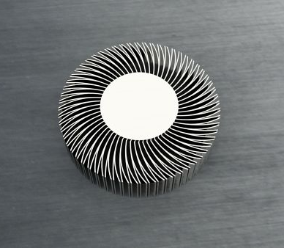  Heat sink | -a passive heat exchanger that transfers the heat generated by device to a fluid medium, often air or a liquid coolant, where it is dissipated away from the device, thereby allowing regulation of the device's temperature. | - HTS191-P=25MM HS ASSY PPA CLIP  - XFP. MSA HEATSINK 10mm TALL  - XFP HEAT SINK CLIP, PLATED  - SFP HEATSINK 13.5MM TALL
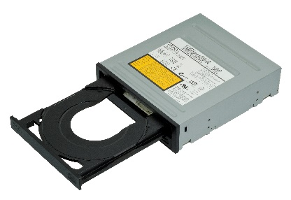  CD ROM | -pre-pressed optical compact disc that contains data.  -Computers can read but not write to or erase CD-ROMs. | - ASUS Black SATA DVD-ROM Drive Model DVD-E818AAT (DVD-E818AAT/BLK/B/GE)  - NEW Dell BD-ROM DVD+RW Combo Drive DH-6E2S18B - 3TD2H
For each keyword in Table 1.0. Provide picture(s), explanations of its functions and example of models.

USB cable  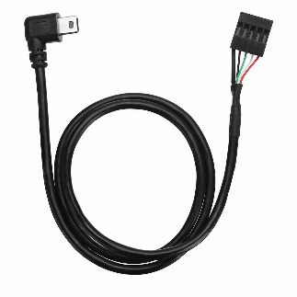 | -is a plug and play interface that allows a computer to communicate with peripheral and other devices.  - may also be used to send power to certain devices, such as smartphones and tablets and also to charge their batteries. | - Mini-USB  - Micro-USB  - USB Type-A  - USB Type-B  - USB Type-C
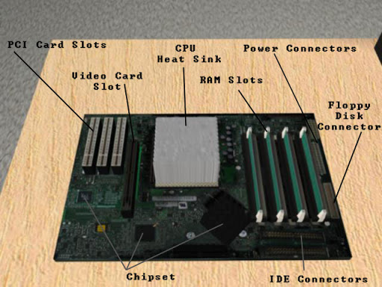  Slots (IDE, PCI) | -allows IDE cables to connect to the motherboard  -allows the connection of the motherboard to storage devices such as hard drives and CD-ROM/DVD drives. | - hard drive and CD-ROM connections  - motherboard connectors  - standardized power connector
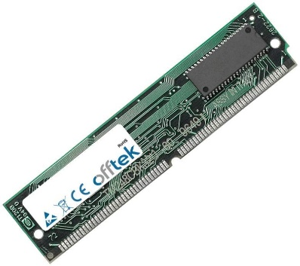  RAM | -a form of computer memory that can be read and changed in any order, typically used to store working data and machine code.  -allows data items to be read or written in almost the same amount time irrespective of the physical location of data inside the memory. | Lenovo 8GB PC4-21300 DDR4 2666MHz SoDIMM Ram Memory Module 01AG843  4GB Samsung DIMM 2RX8 DDR4/DDR3/DDR2
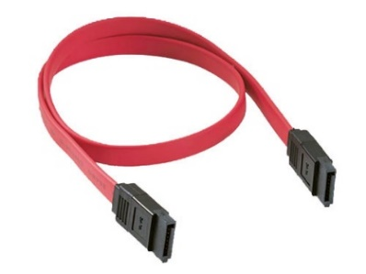  SATA cable | -computer bus interface that connects host bus adapters to mass storage devices such as hard disk drives, optical drives, and solid-state drives. | - E-Sata  - Low Profile SATA  - Micro SATA  - SATA Bracket

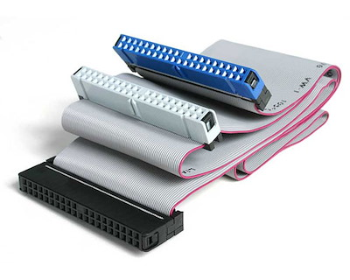  IDE cable | -Integrated Drive Electronics  -used to connect some hard drives and optical drives to each other and to the motherboard. | - Gaetooely 2-inch 44-pin  - Adanse 2-inch 44-pin  - IDE 40-Pin Male to Female  - UCTRONICS Male to Female GPIO Ribbon Cable
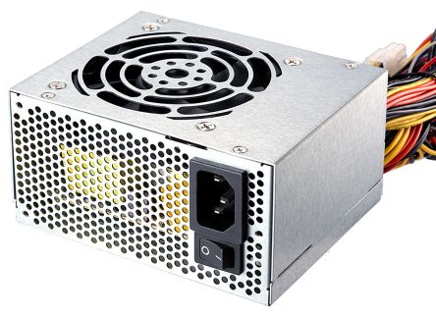  Power supply | -converts the alternate current (AC) from the power outlets in your home to the direct current (DC) your PC uses.  -provides power to the various components of the computer, such as hard drives, fans and optical drives. | - Antec NeoECO Zen 700W  - Corsair CV550  - ASUS ROG Strix  - Cooler Master MWE  - Kolink Classic Power
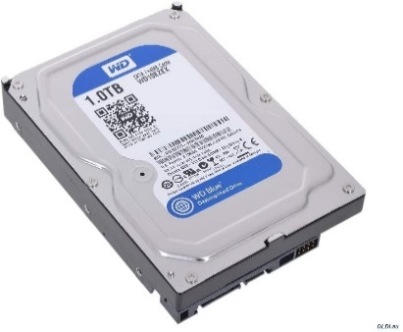  Hard disk | -is a non-volatile data storage device.  -needed to store nearly everything that it needs to operate, including all of its programs and data. | - Toshiba X300  - Seagate BarraCuda  - WD Purple1TB Surveillance  - 500GB SATA  - Toshiba MK3276GSX 320GB SATA

PART C : Steps to assemble computer system

STEP 1 – PLACING THE PROCESSOR ON THE MOTHERBOARD
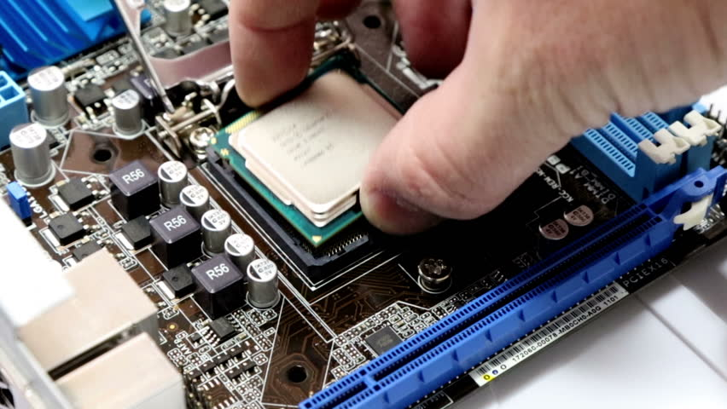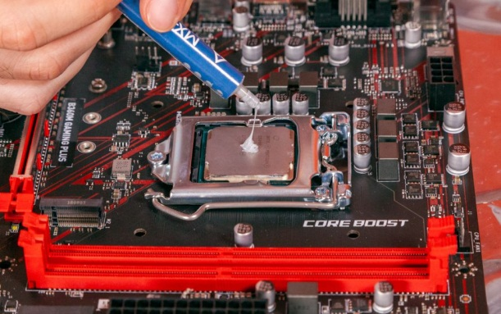
Place the processor in its socket on the motherboard and put some thermal paste on the processor. Make sure to not put too much thermal paste or it will be squirting onto the socket.
STEP 2 – PLACING THE HEAT SINK ON TOP OF THE PROCESSOR
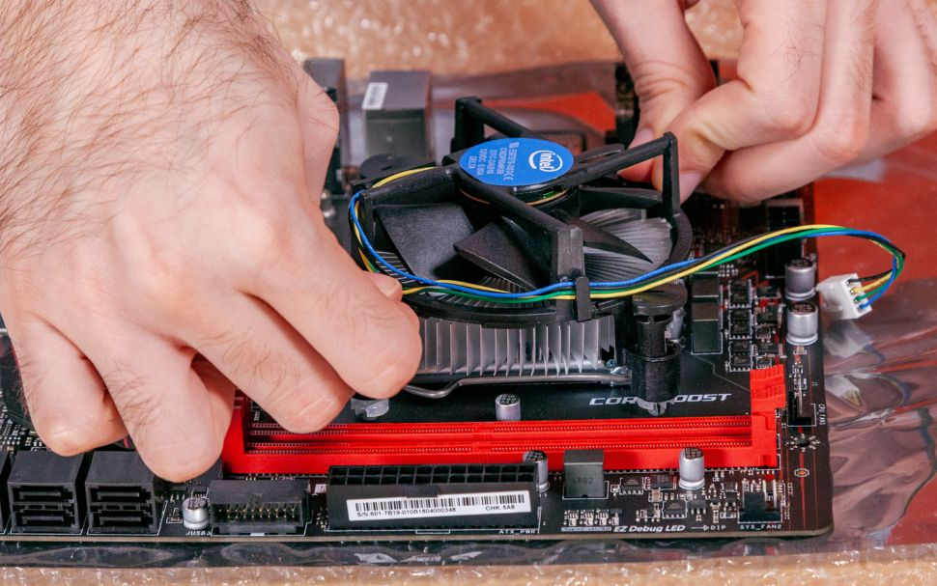
Place the heat sink on top of the processor and make sure it is stuck firmly.
- Tip: The thermal paste ensures that heat is efficiently transferred from the processor to the heat sink.

STEP 3 – INSTALLING THE RAM
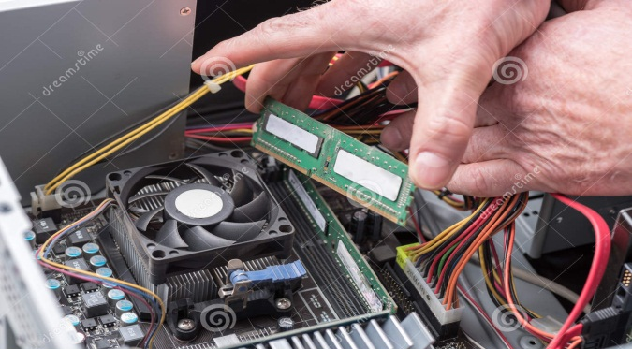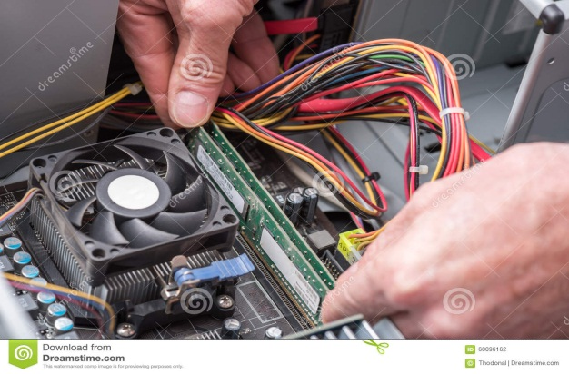
Place the RAM into RAM slot. Make sure the latches of the RAM slot are open and put the RAM tightly into the slot.
- CAUTION: Pressing the boards in when the tab is not aligned could cause damage to the RAM boards as well as the motherboard.
- Tip: Be careful and gentle when trying to align the RAM boards.

STEP 4 – INSTALLING THE POWER SUPPLY
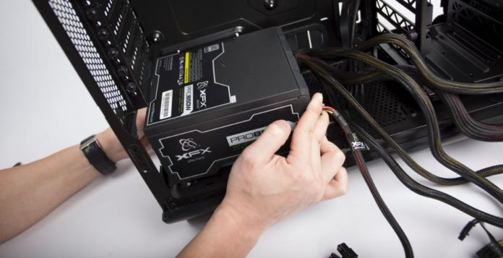
Place the power supply into the computer case. Screw the power supply using screws and a screwdriver.
- Tip: Make sure the screws are tight to keep the power supply in place.

STEP 5 – PLACING THE MOTHERBOARD INSIDE THE CASE
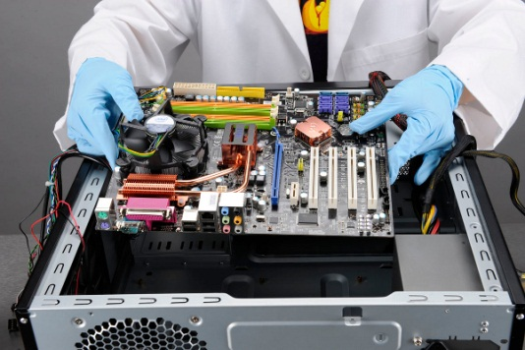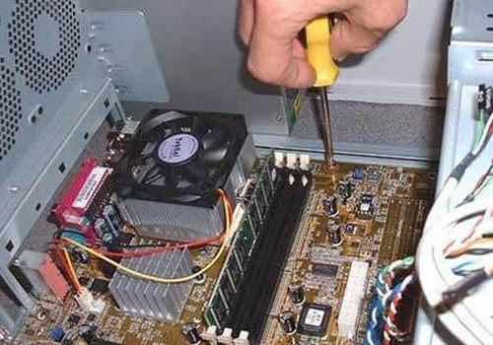
Place the motherboard into the case and screw it tightly.
STEP 6 – INSTALLING THE GRAPHIC CARD
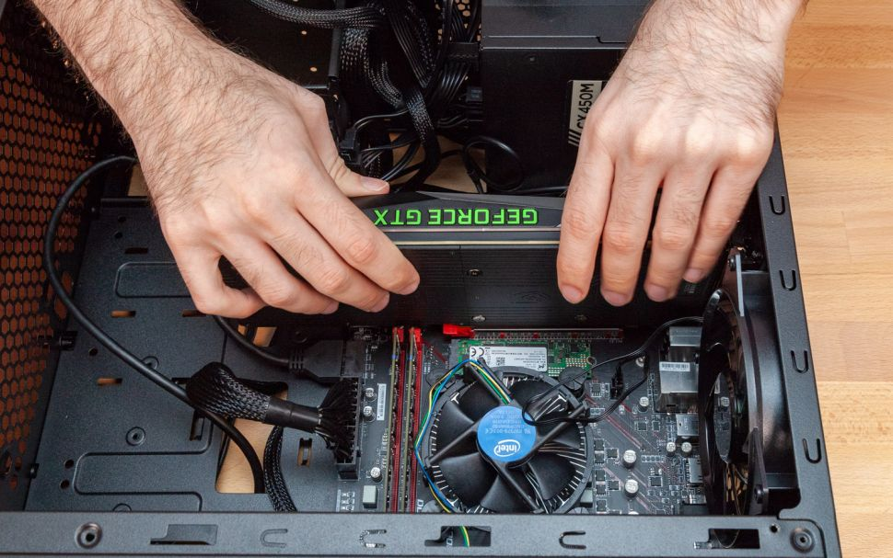
Install the graphic card into PCIe slot on the motherboard and screw it tightly so that it will not easily come off.

STEP 7 – INSTALLING THE CD ROM & HARD DRIVE
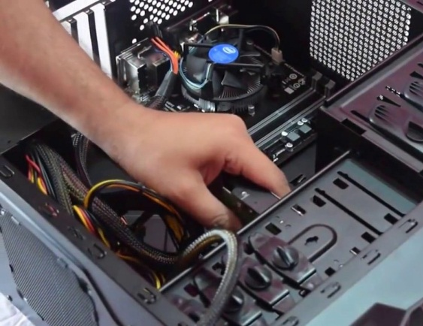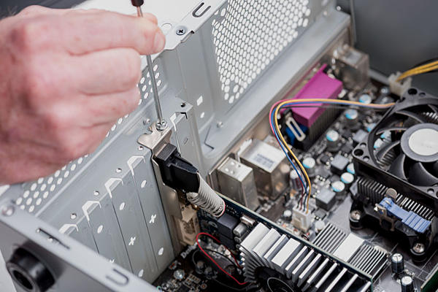
Place the CD ROM and hard drive inside the case and screw them tightly. Make sure to put them in safely and correctly so that they will not get damaged.
STEP 8 – CONNECTING THE IDE CABLE & SATA CABLE
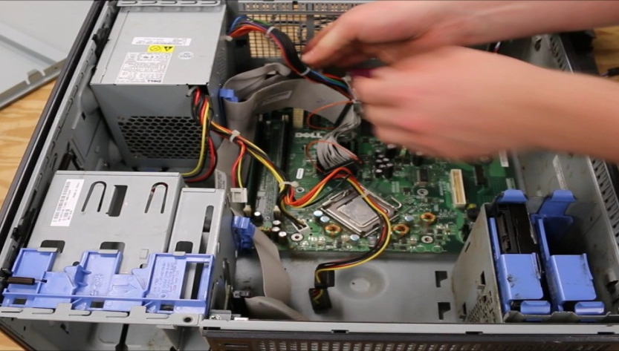
Connect the IDE cable from the CD ROM into the IDE slot on the motherboard. Next, connect the SATA cable from the hard disk (with jumper setting either master/slave) to the motherboard.
- Tip: Avoid incorrect connections as they can damage components and cause bodily injury.

STEP 9 – CONNECTING ALL DRIVES TO THE POWER SUPPLY
. 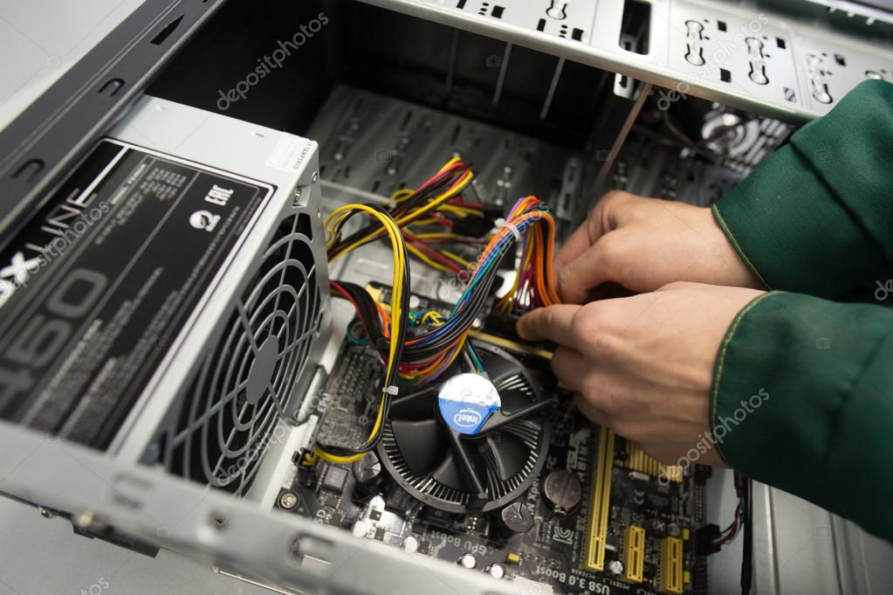
Connect the power supply to all the drives (Hard disk & CD ROM). Then, organize all the cables so that we can save more space and reduce heat accumulation in the case.
STEP 10 – CONNECTING THE FRONT PANEL USB & AUDIO
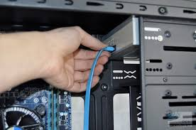
Connect the switch wire to the motherboard and then to the front panel USB and audio. Next, connect the USB cable for front panel and audio. Refer to the guideline for correct connection. Handle the cable carefully and use pliers for the cable if needed.

STEP 11 – CLOSING THE CASE, CONNECTING THE PERIPHERAL DEVICES
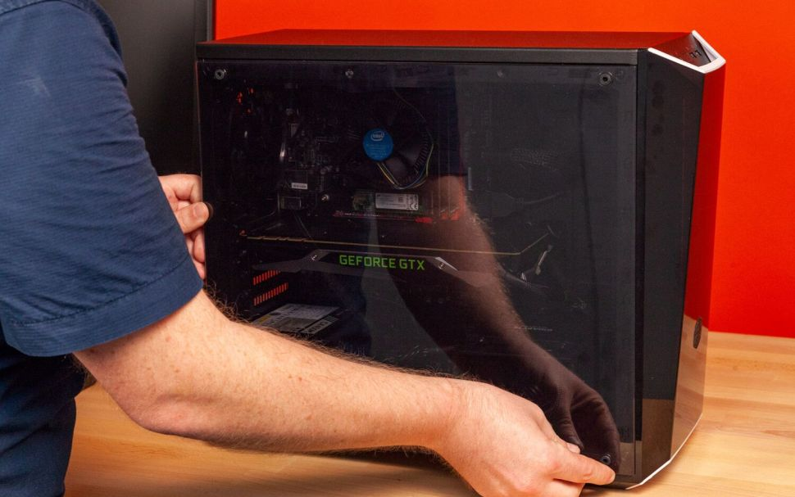
Place the case cover and screw it tightly to prevent dust from accumulating inside the case. Then connect all the peripheral devices with your CPU by plugging them into the USB ports. The peripheral devices include: keyboard, mouse, wireless network dongle, printer and webcams.
STEP 8 – TESTING
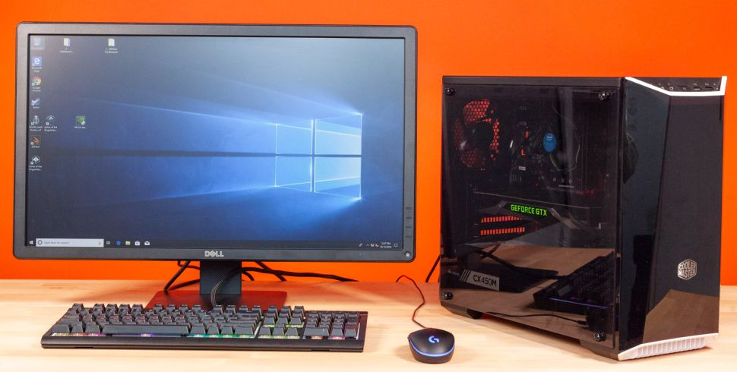
Test the system by connecting the CPU to the power supply and monitor. Turn on the monitor and if the screen of the monitor is functioning, then the installation is correct.

REFERENCE
- https://www.youtube.com/watch?v=ctK58A71DTs
- https://www.youtube.com/watch?v=m_-G9Cacx2U
- http://www.mysuperpc.com/build/pc_connect_front_panel_usb_audio.shtml
- https://www.build-your-own-computer.net/motherboard-diagram.html
- https://www.tomshardware.com/reviews/how-to-build-a-pc,5867.html
- https://www.instructables.com/How-To-Assemble-A-Basic-Desktop-PC/
- https://www.pccasegear.com/category/15_535/power-supplies/all-models
- https://www.houkconsulting.com/2018/11/understanding-usb-cables-ports/
- https://html.com/blog/100-computer-building-tools-resources/
- https://www.diffen.com/difference/IDE_vs_SATA
- https://www.techradar.com/news/computing-components/graphics-cards/best-graphics-cards-1291458
- https://www.techradar.com/news/mobile-computing/laptops/best-laptops-1304361
- https://www.te.com/usa-en/plp/heat-sinks/Y30gx.html
- https://www.newegg.ca/CD-DVD-Drives/SubCategory/ID-55
- https://customcablesbrett.wordpress.com/2015/08/12/what-is-sata-cable-types-of-sata-cables-and-input/
- https://www.google.com/search?q=ram+model&bih=722&biw=1536&hl=zh-CN&sxsrf=ALeKk01Sq9I4AU-f3UqV3n6ha2KdoONBtg:1606387082715&source=univ&tbm=shop&tbo=u&sa=X&ved=2ahUKEwj7jb-bgqDtAhXA4HMBHSliBQoQ1TV6BAgQEGQ

