LAB 1

E Laboratory Work

1.Construct Circuit 1 on the breadboard. Connect all input(A,B) to a switches and output F to LED.

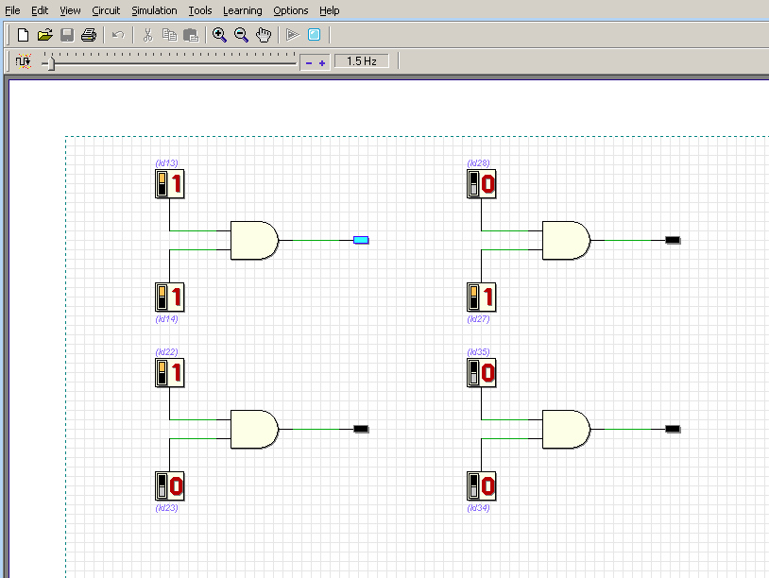

2. Test Circuit and fill in truth table 5 for the circuit response to all possible input combination. The truth table 5 should match the truth table 1 prepare in the preliminary work.

Input | Input | Output
A | B | F
1 | 1 | 1
1 | 0 | 0
0 | 1 | 0
0 | 0 | 0

Part 2

3.Construct Circuit 2 on the breadboard. Connect all input (A,B) to a swithes and the output C and F to LED.

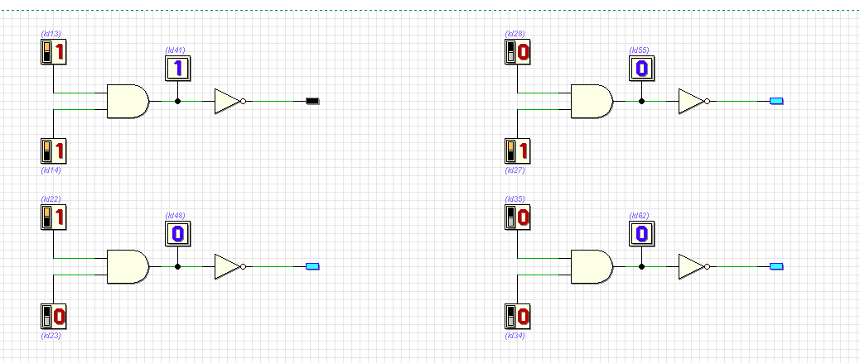

4. Test Circuit 2. Fill in Truth Table 6 for the circuit response to all possible input combination.

A | B | C | F
1 | 1 | 1 | 0
1 | 0 | 0 | 1
0 | 1 | 0 | 1
0 | 0 | 0 | 1

5.Compare Truth table 6 to truth table 2. What conclusion can you make?

Truth table 2 show the output of and gate which only all input in active state can make the output in active state also but in truth table 6 show when inventer put it can make complementation which change the end of the output of any gate to the opposite .

Part 3

6. Construct circuit 3 on the breadboard. Connect all input (A,B) to a switches and output C,D and F to LED

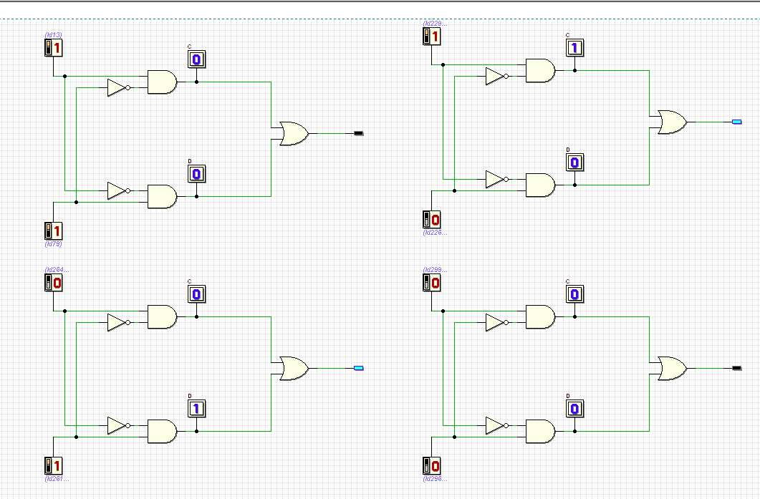

7 Test Circuit 3, Fill in truth table 7 for the circuit output (C,D and F) for all possible input combination.

A | B | C | D | F
1 | 1 | 0 | 0 | 0
1 | 0 | 1 | 0 | 1
0 | 1 | 0 | 1 | 1
0 | 0 | 0 | 0 | 0

8. What single gate does circuit 3 represent?
XOR gate

