

SECP 1513
TECHNOLOGY AND INFORMATION SYSTEM

DESIGN THINKING:
SECURECA

LECTURER:
DR AZURAH ABD SAMAH

SUBMITTED BY:
HANIS RAFIQAH BT. HISHAM RAZULI(A20EC0041)
IMAN EHSAN BIN HASSAN(A20EC0048)
INDIRA A/P THANGARAJ(A20EC0049)
GOH YITIAN(A20EC0038)

SEMESTER 1 2020/2021
SECURECA
Team members’ name: Hanis Rafiqah binti Hisham Razuli, Iman Ehsan bin Hassan, Indira A/P Thangaraj, Goh Yitian
School of Computing, Faculty of Engineering
Universiti Teknologi Malaysia, 81300, Skudai,
Johor Bahru, Malaysia

ABSTACT
This paper describes a mobile application “SECURECA” designed to protect our data and credentials from identity theft. This application provide solutions regarding to the problems faced by the users to keep their personal information safe. The main idea of this application is to aid users who are not familiar with network security. Background of users and users feedback on the prototype of application are discussed to give a better understanding on what users think. Business analysis using SWOT had been done to know the strengths, weaknesses, opportunities and threats of the application.

1.0 INTRODUCTION
Nowadays, the Internet had become the most important thing in human life and most of us cannot live without it. People can access the Internet through a lot of gadgets such as smartphones, computers, tablets, and so on.
For convenience, most people tend to save their personal information and data on the phone or laptop. This gives chance to some person to commit an online crime. There are a lot of crimes that commit online are because they stole the identity and information of the victim.
Identity theft is known as an unauthorized party take your personal information and uses it for criminal purposes. There are many types of identity thieves such as financial identity thief, medical identity thief, criminal identity thief, mail identity thief, and so on.

2.0 PROBLEM BACKGROUND
There are a lot of ways of how identity theft can occur. By hacking into the phone or laptop, the identity theft may obtain the personal information and data of the owners. Besides, identity theft also can collect the information from users that are connected to the public Wi-fi or hotspot as public wireless access points are easily for them to attacks.
In our project, we are targeting to protecting users from financial fraud. This kind of identity theft includes credit card, bank, computer, etc. In fact, credit card fraud has occurred most frequently. Although financial identity theft is the most common, it is certainly not the only type. However, other types of identity theft usually also involve financial factors. (ANN, n.d.)
Besides, password cracking activities frequently occur around the world. In fact, social media are the most common victims. Many hackers try to steal the credentials of users and login to their accounts for malicious purposes. For example, many Facebook users' accounts have been hacked. Then, the hacker tries to send some malicious messages in the name of others.
As a result, we know that most of the users are lack awareness or knowledge of protecting themselves from the cyber-criminal.

3.0 METHODOLOGY
3.1 THE DESIGN THINKING PROCESS
Empathize Mode
Observation
Based on our observation, many people still fail to protect their digital identity. For example, they may use the same password for many different accounts, access the unauthorized website or wi-fi, and so on. This gives chances to the identity thief to steal personal information of the users.
Engage
Interviews had been conducted to let us more understanding of the users’ problems and requirements. Generally, most interviewees show that they have no ideas about what is happening behind the network and hows is their credential been leaked. For example, they always use the same password for many accounts and like to connect to public wi-fi in the public areas.
Immerse
To have a better understanding on how is the experience of identity theft victims, we read real experience and stories about identity theft victims. We also watched videos made by victims via YouTube. It is really overwhelming to know the emotional suffering they went through after the theft. Identity theft is often a bigger crime that can trigger a host of emotional reactions in the victim. We can understand that, they experience loss of time and money, damaged credit and tax debt. Most of the identity theft happened due to giving less important to data protection.

Define Mode
Our group of four had undergone analysis, research, and discussion in order to develop a deep understanding of our users and the design. We have come up with a problem statement for the project. Based on the analysis, we found out that we can notify users away from becoming a victim of identity theft. Since the user is not familiar with security knowledge, we decided to build an application that can aid them in protecting themselves from the internet. We are aimed to protect their social media account, credit card information, personal information, and email account. The most important criterion to make this application to be a success is the ability to detecting identity theft. So, the process of analyzing and verifying personal data to identity theft is necessary to support our idea.

Ideate Mode
In this phase, all of our group members are brainstorming ideas about the design of our application. We have decided on the main features and sub-features of the Secureca application and managed to come up with some workable ideas. Four of us had sketched the design of the application interface. After that, we have voted the design based on the features such as the personal favourite, the function and the chance of succeeding in idea selection phase. The idea with most votes had been chosen in the final step.
Regarding the research about artificial intelligence, the subsets of it such as machine learning and deep learning can increase the accuracy of the process, verification, and identities authentication (Larson, 2018). We are decided to focus on credit card fraud regarding the analysis we made. The application should have the ability to detect identity theft and give a warning while it is detected. Referring to the research, we found out that Machine Learning Algorithm is able to do so. Through ML algorithms, crucial identity documents can be scanned and cross-verified against secure databases in real-time. This ensures identity theft and consequent frauds do not go undetected (How Machine Learning is Changing Identity Theft Detection, 2020). With the ML algorithm, the application will be able to detect whether the password is begin leaking or not.

Prototype Mode
In prototype mode, we made our logical design to physical design. We have using Proto.io to design our prototypes of application. The prototype was inexpensive to allow us to modify and investigate other possibilities. After the prototype is designed, our team tested it out virtually and try to find out the solutions for the problems identified in the first three steps. We keep enhancing and solving the problem until a satisfactory version of the prototype is produced.

Test Mode
In this phase, we have explained our application to the users so can get the responses and feedback from them on how they think and feel. This enables us to identify the problems that we are not considered before. We doing this by conducting a survey through Google form. In this way, we can collect the suggestion from the users and establish a better and more comprehensive way to solve the problem.

3.2 TASK ASSIGNMENT
Each members of the group had been assigned the specific task. Hanis is assigned to design the interface of the application and proposed solution, Iman and Indira make the video, SWOT and google form and Yitian assigned to write the report. We have discussed the ideas about the project through Whatsapp and Telegram group. Also, we have conducted our meeting via Google meet.

4.0THE PROPOSED SOLUTION

4.1 ACKNOWLEDGEMENT OF SIMILAR PRODUCT
From our study, we found that there is a lot of applications existing to protect the users’ data, for example, the LifeLock app. We have made references from this application and generate some new ideas when designed our own application. However, we found that a lot of security apps need to pay monthly or annually. In this case, we had designed our application to be free and easy to use for everyone.

4.2 FEATURES OF PROPOSED SOLUTION
From the information that we gathered, we have concluded to create an application called “SECURECA”. This application is designed to protect our data from identity theft. For the first page of the application, we have the home page. This page is for when the user wanted to know the alerts, notification, wanted to do the overview or scanning, check their identity list, and identify. The second page is alerts. This page is where users get alerts if anything happens. As an example, when someone's password was leaked. Other than that, we have alerts for when the user’s email address was monitored. Alerts when the application did the credit report and also track the user’s NRIC.
The third page is for notification. It is for when the application block some fake websites, threat, and credit card block when the limit was changed out of sudden. The fourth page is an overview. It is to show the user when was the last time they checked. It will also show what the user has checked. Like if they checked their mail password, social media, and credit card. The fifth page was for scanning. This page was related to the previous page. This is where you can scan the user’s item. Such as user’s device, social media and credit card. After user scanned, the icon of the item scanned will be moved to an overview. The sixth page is the activity. This page shows all the activity for when any transaction was done on user’s credit card. The seventh page is to identify. It shows the number of activities checked on the item. The last page is to show accounts at risk. It shows if something happened and there is a fixed button right under the features.
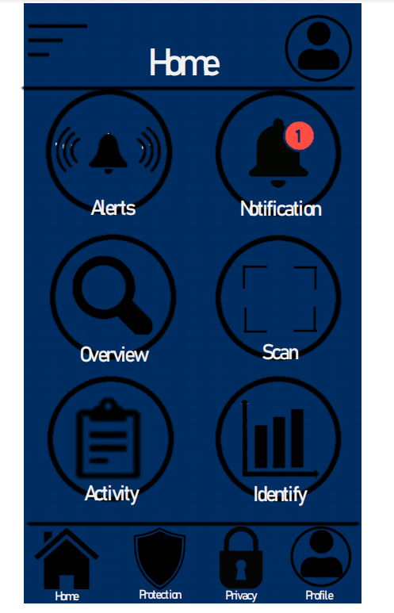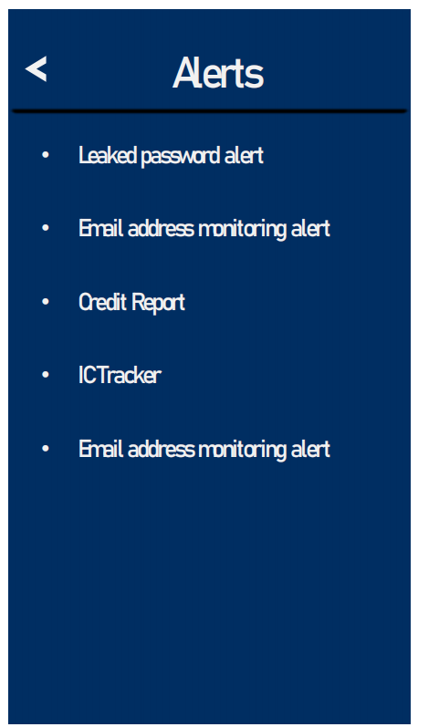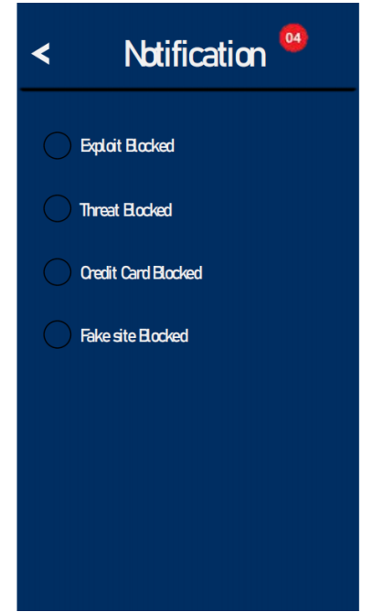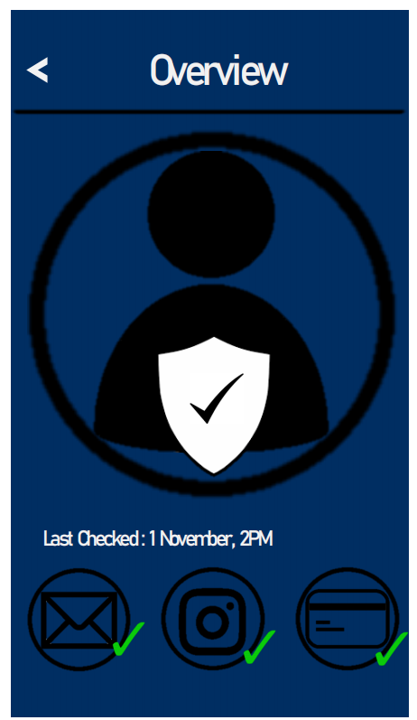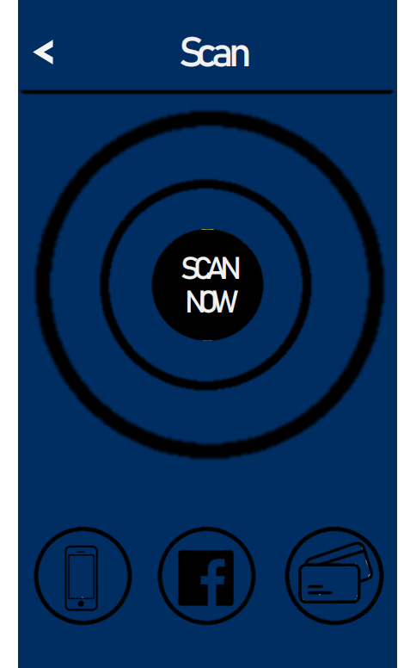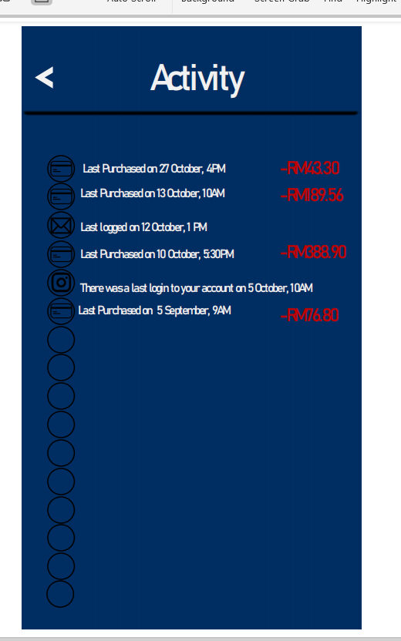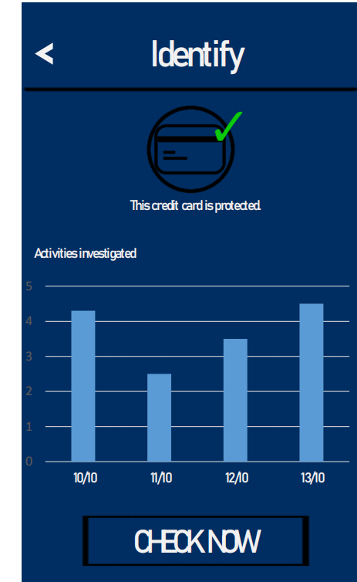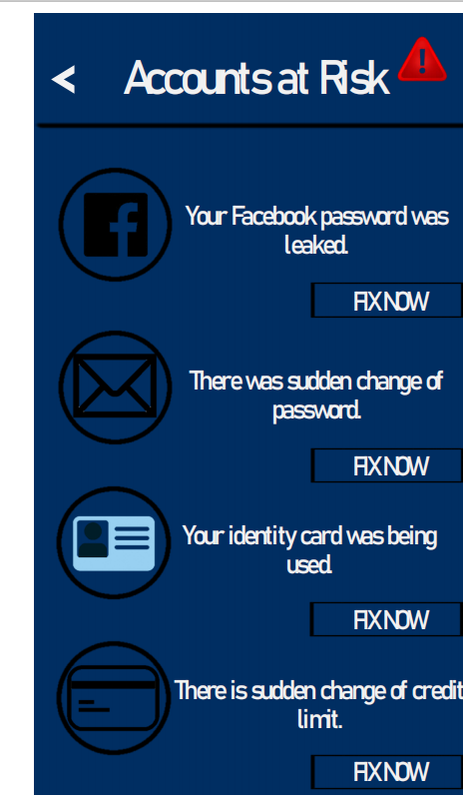

4.3 USERS FEEDBACK
We had conducted a survey through Google form to get user feedback. The interviewee can be divided into 2 groups which the major are students from Bioinformatics and some from the public (office workers). Based on the survey, most of the interviewees agree that our application “Secureca” can protect their personal data efficiently. They are mostly satisfied with the features of the prototype app. There is also some feedback that we should enhance our app’s user interface as the colour of the app may be too dark. Besides that, some interviewees suggested that we should have more details on every function.

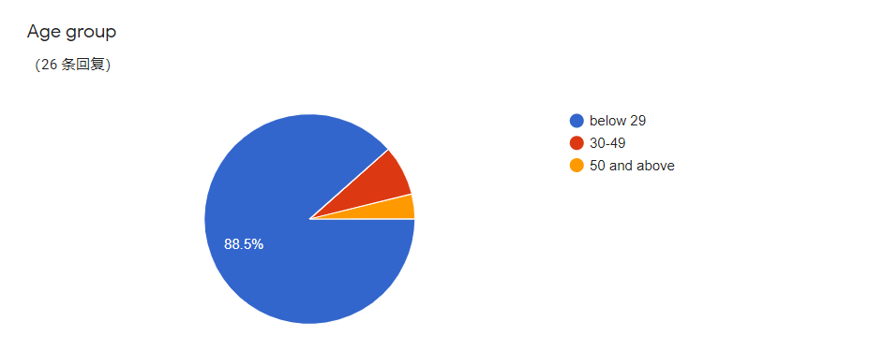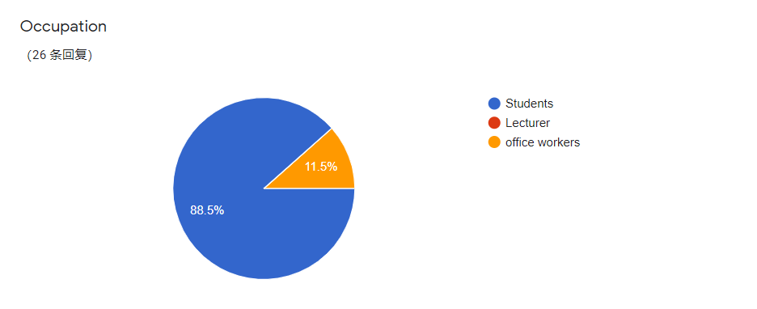

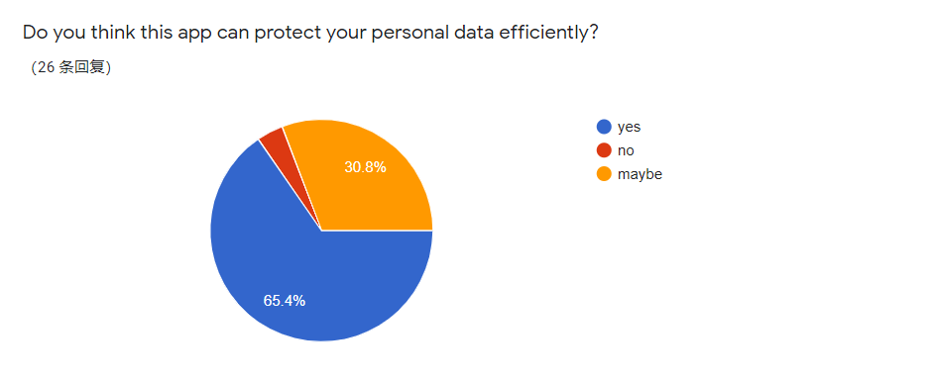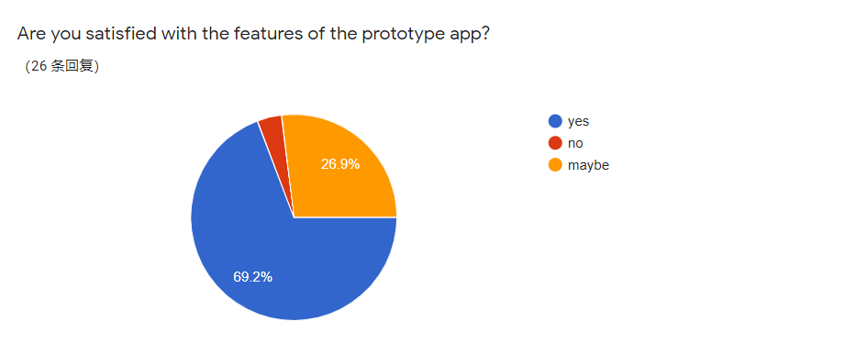
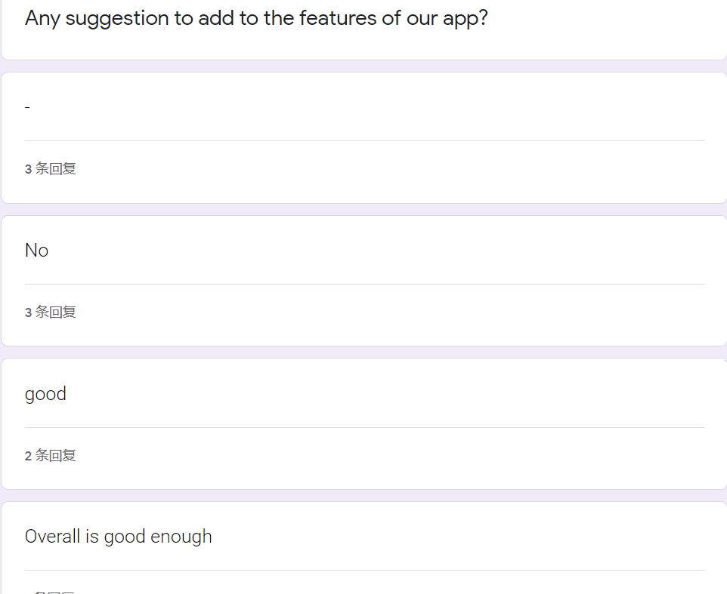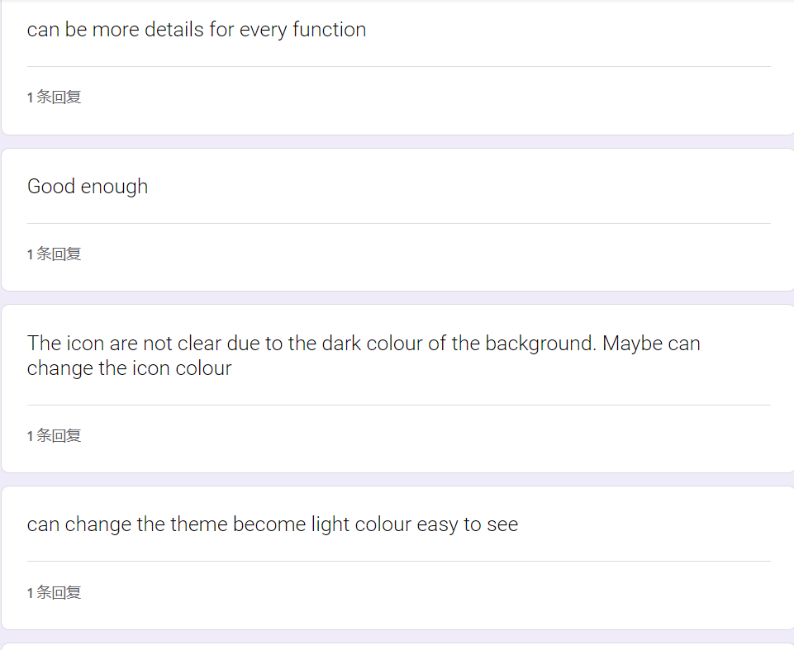
4.4 BUSINESS ANALYSIS USING SWOT
We had undergone the business analysis of Secureca using SWOT ( strengths, weaknesses, opportunities and threats).
Strengths | Weakness
- Allow users to monitor threats to their identity.  - Alert users by sending message when their credit limit is changed. | - Competition from other well established applications.  - Not available online.
Opportunities | Threat
- App is created due the increasing number of identity theft.  - Meet demands of users in ensuring their privacy and security. | - Development of new techniques in hacking and phishing attack.

4.5 FUTURE WORKS/ IMPROVEMENT
The Improvement we would do is to have a personal interview with the staff to get some ideas. If we were given the chance to do this project again face to face, I think it would be much more amazing since we can more easily to cooperate between each other, can get a lot of user’s feedback, solutions and many more.
5.0 REFLECTION AND CONCLUSION
Our goals with regards to this course is to learn about how the software or application in computer work. This design thinking project provide us a chance to touch on the initial face of developing an application. We will improve our soft skills and hard skills such as communication with teammates and technique of design thinking in order to improve our potential in the industry.
In this project, we had faced a lot of problems. The biggest problem is we cannot discussed the ideas face-to-face due to the pandemic of covid-19. This is a big challenge to us as we can only discuss the problems online. The meeting online may be interrupt by a lot of issues such as the internet problem and environment problem.
In conclusion, we notice about the importance of security and learn how to protect our data and information. The identity theft is very dangerous as it can occur everywhere when a vulnerability is exposed. Also, we have better understanding on design thinking process after conducted this project.
Reference
- ANN, L., n.d. How Identity Theft Works. [online] HowStuffWorks. Available at: <https://money.howstuffworks.com/identity-theft.htm> [Accessed 6 November 2020].
- Larson, G., 2018. How To Use AI To Fight Identity Fraud | Techbeacon. [online] TechBeacon. Available at: <https://techbeacon.com/security/how-use-ai-fight-identity-fraud> [Accessed 6 November 2020].
- GreatLearning. 2020. How Machine Learning Is Changing Identity Theft Detection. [online] Available at: <https://www.mygreatlearning.com/blog/how-machine-learning-is-changing-identity-theft-detection/> [Accessed 6 November 2020].

Appendix
- Here is the link of 'Someone Had Taken Over My Life': An Identity Theft Victim's Story <
https://www.forbes.com/sites/laurashin/2014/11/18/someone-had-taken-over-my-life-an-identity-theft-victims-story/?sh=37ff531125be
>

- Meeting via Google meet.

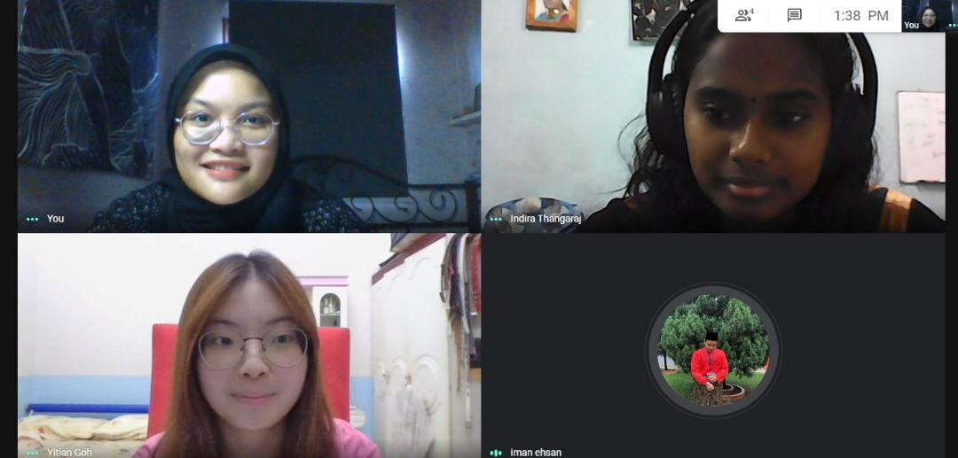

- Google form survey

