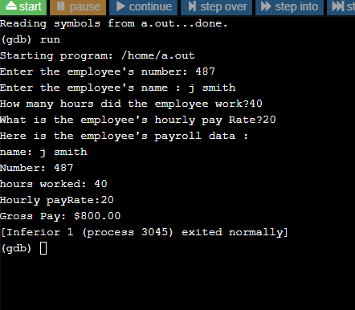
Program 11-1
#include <iostream>
#include <iomanip>
using namespace std;

const int SIZE = 25;

struct PayRoll
{
int empNumber;
char name [SIZE];
double hours;
double payRate;
double grossPay;
};
int main()
{
PayRoll employee;

cout << "Enter the employee's number: ";
cin >> employee.empNumber;

cout << "Enter the employee's name : ";
cin.ignore();
cin.getline(employee.name, SIZE);

cout << "How many hours did the employee work?";
cin >> employee.hours;

cout << "What is the employee's hourly pay Rate?";
cin>>employee.payRate;

employee.grossPay = employee.hours * employee.payRate;

cout << "Here is the employee's payroll data :\n";
cout << "name: "<< employee.name << endl;
cout<< "Number: "<< employee.empNumber << endl;
cout << "hours worked: " <<employee.hours<< endl;
cout << "Hourly payRate:" << employee.payRate << endl;
cout << fixed << showpoint << setprecision (2);
cout << "Gross Pay: $" << employee.grossPay << endl;
return 0;
}

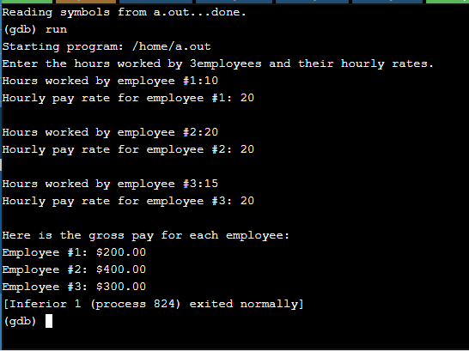
Program 11-5
#include <iostream>
#include <iomanip>

using namespace std;

struct PayInfo
{
int hours;
double payRate;
};
int main()
{
const int NUM_WORKERS =3;
PayInfo workers[ NUM_WORKERS];
int index;

cout<< "Enter the hours worked by " << NUM_WORKERS << "employees and their hourly rates.\n";

for (index = 0; index < NUM_WORKERS; index++)
{
cout << "Hours worked by employee #" << (index + 1);
cout <<":" ;
cin >> workers [index].hours;

cout << "Hourly pay rate for employee #";
cout << (index + 1) << ": " ;
cin >> workers [index].payRate;
cout<< endl;
}

cout<<"Here is the gross pay for each employee:\n";
cout<<fixed<<showpoint<<setprecision(2);
for (index=0; index < NUM_WORKERS; index++)
{
double gross;
gross = workers [index].hours * workers[index].payRate;
cout<<"Employee #" << (index + 1);
cout << ": $" << gross << endl;
}
return 0;
}

Program 11-8
#include <iostream>
#include <iomanip>
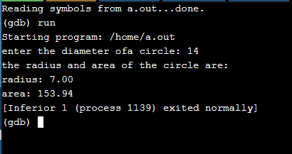
#include <cmath>
using namespace std;

const double PI=3.14159;

struct Circle
{
double radius;
double diameter;
double area;
};

Circle getInfo();
int main()
{
Circle c;
c = getInfo();
c.area = PI * pow(c.radius, 2.0);

cout<<"the radius and area of the circle are:\n";
cout<< fixed << setprecision(2);
cout<<"radius: "<<c.radius<<endl;
cout<<"area: "<<c.area<<endl;
return 0;
}

Circle getInfo()
{
Circle tempCircle;

cout<<"enter the diameter ofa circle: ";
cin>> tempCircle.diameter;
tempCircle.radius = tempCircle.diameter/2.0;

return tempCircle;
}

