During the Covid-19 pandemic that hit the world without end. Many people have to face certain challenges such as financial insecurity and most importantly is job loss. In research from Malay Mail (2020) Malaysia's unemployment rate rose by 0.1 percentage point month-on-month to 4.7 percent in October 2020, said the Department of Statistics Malaysia (DOSM). . On 29th December 2020, the School of Computing, University

Technology and Information System (SECP1513) School of Computing, UTM
7 January 2021

INSPIRING WORK EXPERIENCE AND COVID 19 PANDEMIC CHALLENGE

Micron Semiconductor Asia. The main purpose of this webinar is to let the speakers share tips for students to get a higher chance to hire during the Covid-19 pandemic. This webinar also shares about their experience during internship and how to improve students’ soft skills. This talk is targeted at all year one students so that they do not waste their time in university.
Teknologi Malaysia (UTM) conducted a webinar which topic Inspiring Work experience & Covid-19 Pandemic Challenge session with alumni Dr. Johanna Ahmad, senior lecturer School of Computing UTM. The alumni speaker involved in this webinar is Miss Qistina Batrisyia Binti Azman Shah, the social media data analyst from TM One, Mr. Mohamad Zamarul Akmal bin Mohd Hussin, the data engineer from PPG Coating(M) and Mr. Tan Yong Keong, the data Science engineer from
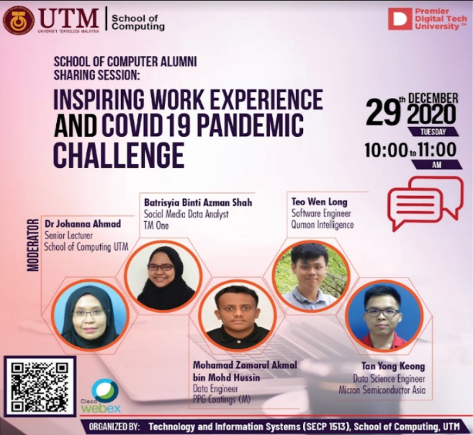

CONTENT: ~
help
In the way to secure job in Covid-19 pandemic, Mr. Tan has come out his opinion to encourage the students in participate in varies competition in university. He thinks participate in competition is very important as it helps the students to gain professional skill and presentation skill. These prove when the students need to present their project to the judges and equip more knowledge to win the competition.
He said that result is not really important but the effort to do the best in competition is more important as you can learn a lot through the competition. When the students lose the competition, they win in the aspect of experience and professional skill from the winner. Otherwise, the students can get a freelancer job to gain more experience regarding to their studies. Mr. Mohamad Zamarul, one of the speakers who get permanent job in his internship company,

 | encourage the students to be proactive in university life. Based on his experience, he exposes himself to give idea and opinion during his internship, and these make his supervisor give more attention to him. When participate in group project, he discusses with the group members to learn
practice and think it easy in our mind. Mr. Zamarul suggests the students to attend the online class and improve the soft skill as the good communication skill can help to discuss easily with others in the teamwork. Miss Qistina encourage the student to keep asking and mingle around the people to learn something new. She said that asking questions before someone teach you is a good habit. . They suggest the students to participate in competition and volunteer to speak out their idea and opinion so that they can train to be confident. |  | Confidence is important for students when they need to attend an interview for their future job. Mr. Zamarul advise the students try to minimize the chance of getting mistakes from now since if getting mistake in their job, they will get negative impact in their future. He also asks students to discuss with supervisor if overwork during internship period. Some students ask for CGPA, but they said it is not really important compare to the attitude, technical skill, and soft skill. CGPA is one of the criteria to filter the candidates, but to be safe, the CGPA must above 3.0.
SUMMARY: ~
Mr. Tan who graduated with flying colours in UTM advise all the students to involve themselves in competition as he gained many experiences and confidence through this method. He also keeps himself motivated by setting a mindset that what he does can help
the world and contribute to the community. Mr. Zamarul stressed on two points that students should have which is technical skills and soft skills such as teamwork. To stay motivated with daily basis, he said that he appreciates the chance he gets because he
can learn new knowledges and he was excited with it. Miss Qistina thinks that the most important to maintain our daily basis is to love what you do and stay proactive for every project you do. When we show good attitude towards the job, we will get good results on it.
more technical skills from the senior colleague. During working, we must be confident and keep asking when face problem, said Miss Qistina Batrisyia. She said that this action can help to gain a lot of knowledge other than her job scope. . Besides, they also ask students to learn about the technical skill such as Python for programming. Mr. Tan share his learning tips which understand the concept when learn something new especially the programming language. To score in programming, he suggests making a lot of



Mek Zhi Qing
Rohaizaazira binti Mohd Zawawi
Zereen Teo Huey Huey
Prepared by:
TIS sec01 Group 05

Reference: Malay Mail. (2020, December 11). Malaysia’s unemployment rate at 4.7pc in Oct 2020, data shows. Malaysia | Malay Mail. https://www.malaymail.com/news/malaysia/2020/12/11/malaysias-unemployment-rate-at-4.7pc-in-oct-2020-data-shows/1931012
REFLECTION: ~
Throughout this webinar, we can learn further about the working environment after graduate and get some experience from our seniors since they are success to secure their job in this period. Great competition with others
will be faced by a fresh graduate student to get hire in the future. The webinar did not share too much about their working experience, but we can learn a lot knowledge to prepare for our future and become more competitive.
We should be proactive and effective during our internship to get an offer of job from the company. As an idea, we think that we need to invite the webinars from varies fields so that we can learn some experience in different situation.

