

Assignment 3
Group 10
Group member:
Name | Matric number
Tan Ming Hui | A20EC0155
Mohamad Hilmi Azfar Bin Rosli | B19EC3007
Tahmedur Rahman | A19EC4059

Subject: DISCRETE STRUCTURE (SECI 1013)
Section: 04

Lecturer: Haswadi Bin Hasan
Mark:
DISCRETE STRUCTURE (SECI 1013)
TUTORIAL 3
DUE DATE: 7 January, 2020

QUESTION 1 [25 marks]

- Let A={1, 2, 3, 4, 5, 6, 7, 8}, B={2, 5, 9}, and C={a, b}. Find each of the following:
(9 marks)
- A−B
- (A∩B) ∪C
- A∩B∩C
- B×C
- P(C)
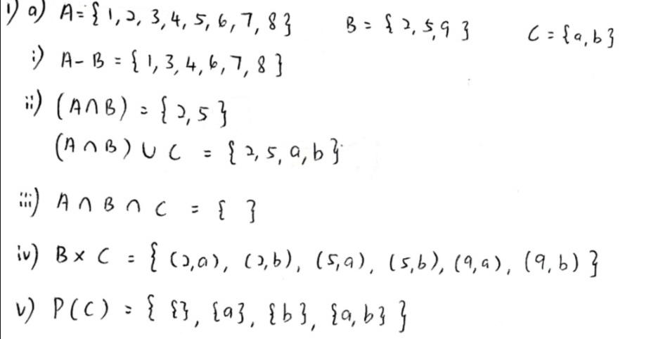

- By referring to the properties of set operations, show that: (4 marks)
(P∩ ((P′∪Q)′)) ∪ (P∩Q) = P
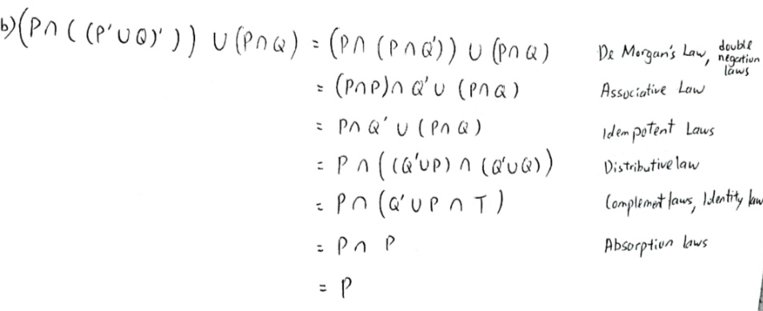
- Construct the truth table for, A = (¬p ∨ q) ↔ (q → p). (4 marks)
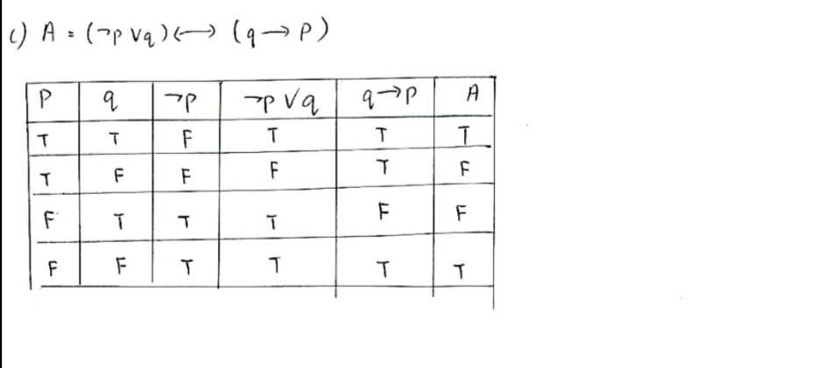
- Proof the following statement using direct proof
“For all integer x, if x is odd, then (x+2)² is odd” (4 marks)
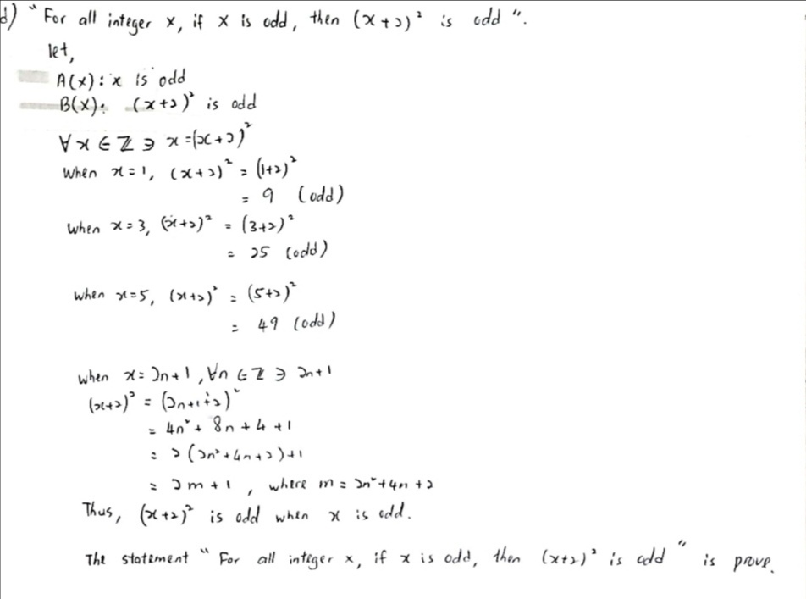
- Let P(x,y) be the propositional function x ≥ y. The domain of discourse for x and y is the set of all positive integers. Determine the truth value of the following statements. Give the value of x and y that make the statement TRUE or FALSE. (4 marks)
  - 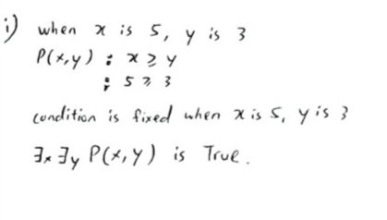
  - 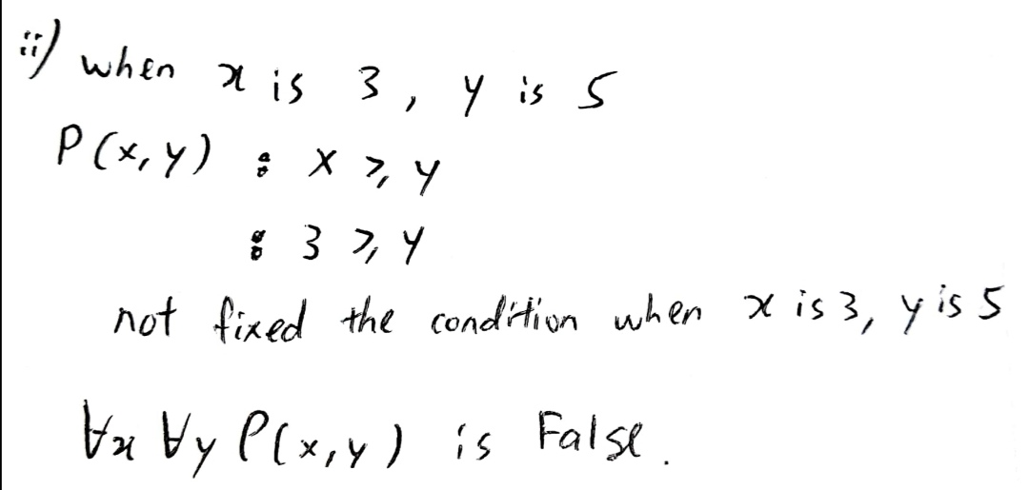

QUESTION 2 [25 marks]

- Suppose that the matrix of relation R on {1, 2, 3} is
relative to the ordering 1, 2, 3. (7 marks)

- Find the domain and the range of R.

- Determine whether the relation is irreflexive and/or antisymmetric. Justify your answer.

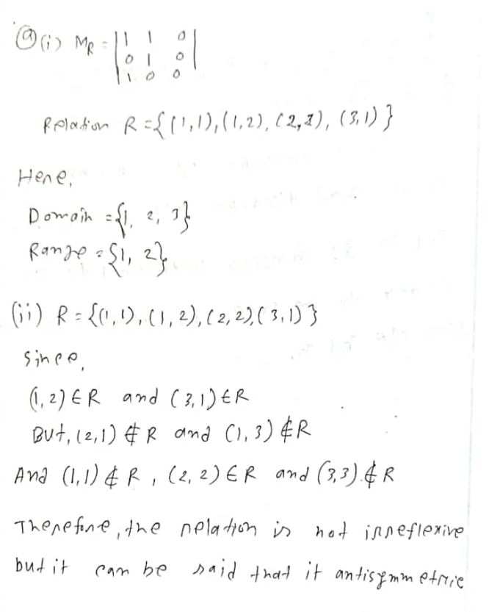

- Let S={(x,y)| x+y ≥9}is a relation on X={2, 3, 4, 5}. Find: (6 marks)

- The elements of the set S.

- Is S reflexive, symmetric, transitive, and/or an equivalence relation? Justify your answer.

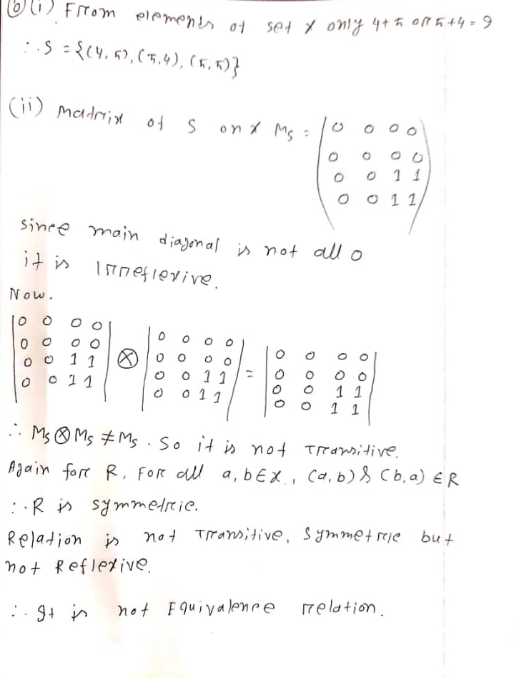

- Let X={1, 2, 3}, Y={1, 2, 3, 4}, and Z={1, 2}. (6 marks)

- Define a function f: X→Y that is one-to-one but not onto.

- Define a function g: X→Z that is onto but not one-to-one.

- Define a function h: X→X that is neither one-to-one nor onto.

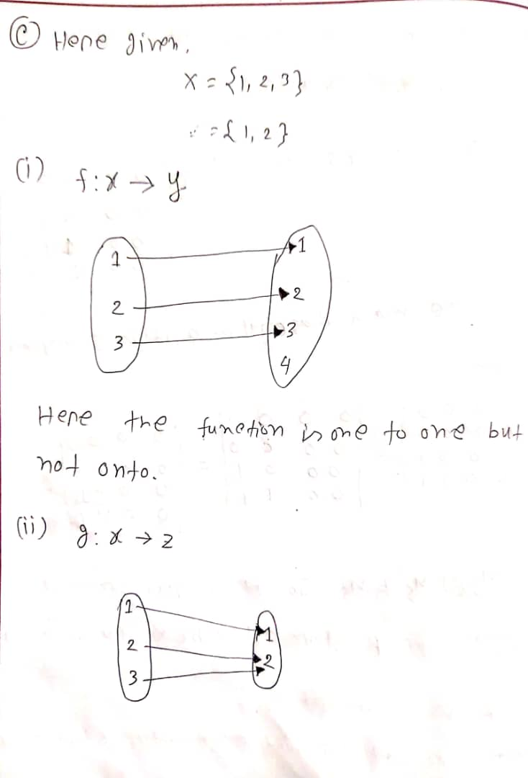
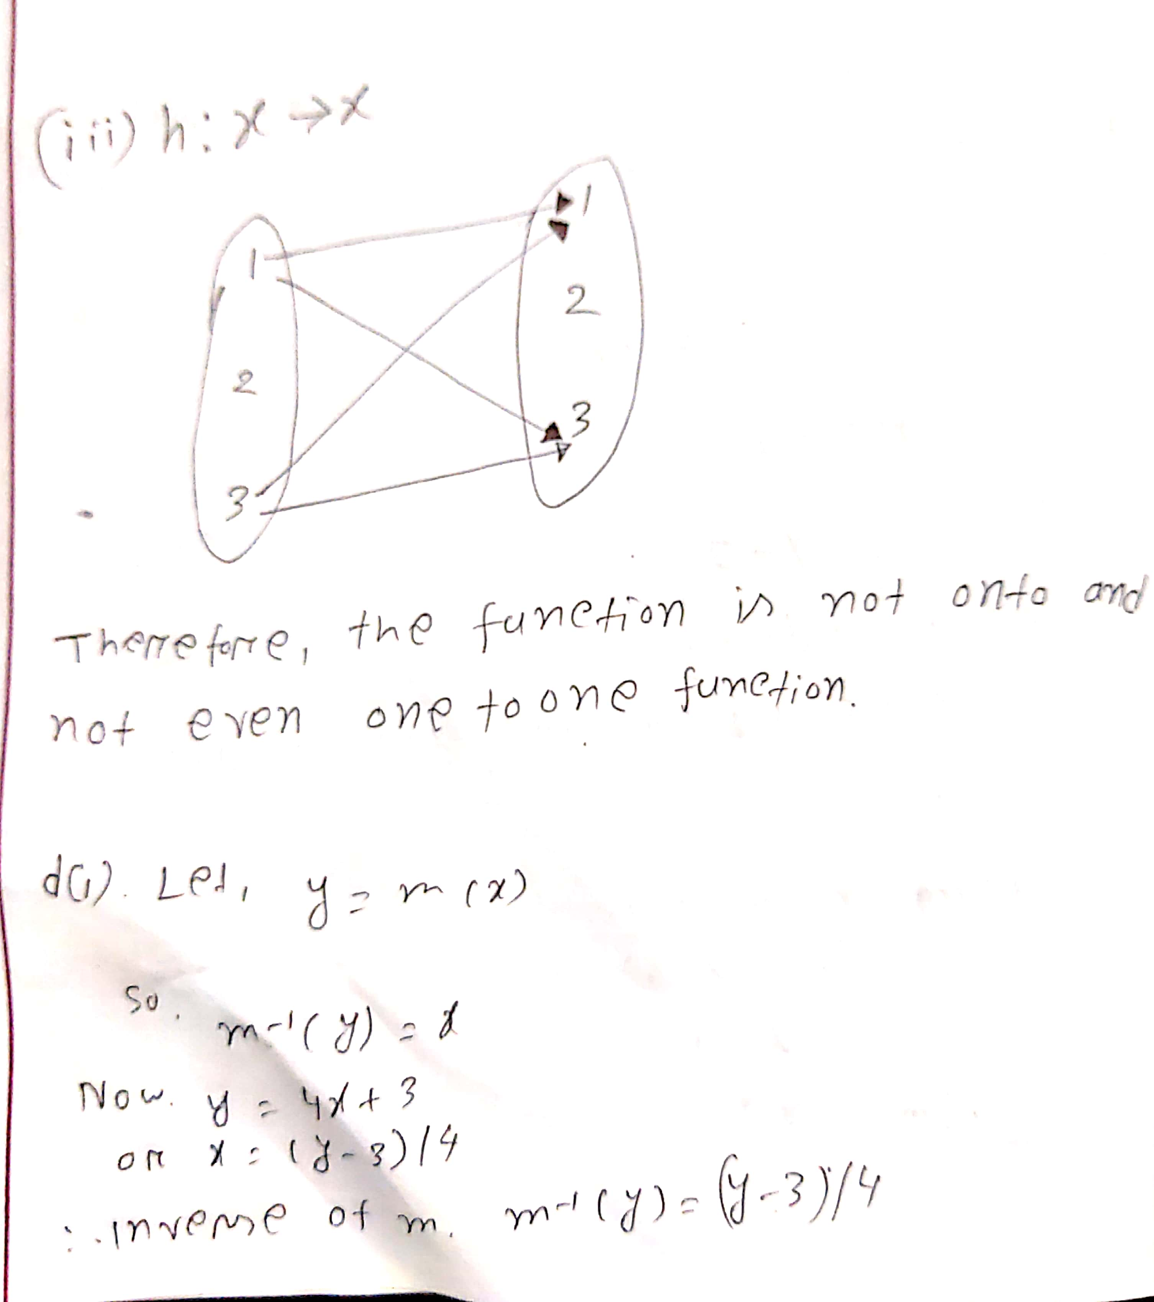

- Let m and n be functions from the positive integers to the positive integers defined by the equations:
m(x) = 4x+3, n(x) = 2x−4 (6 marks)

- Find the inverse of m.

- Find the compositions of n o m.

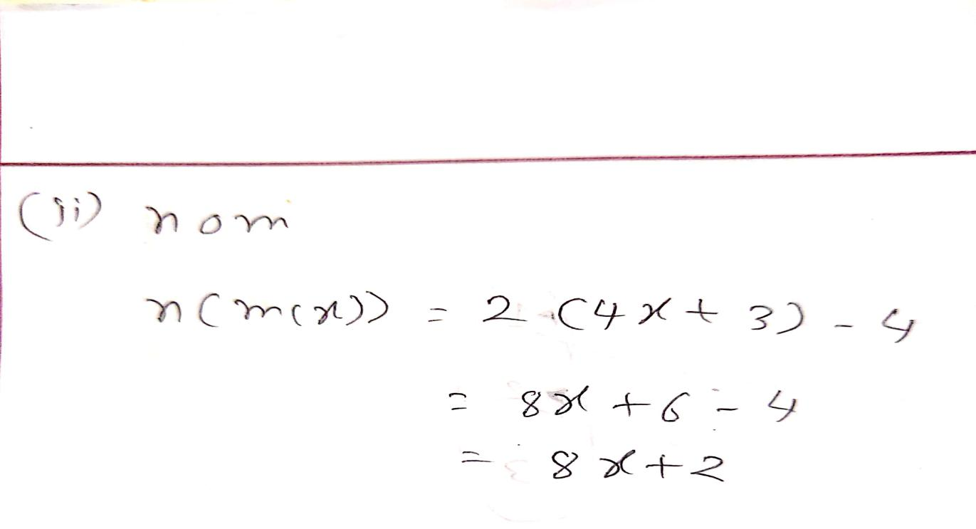

QUESTION 3 [15 marks]
- Given the recursively defined sequence.
, for all integers
- Find the first three terms. (2 marks)

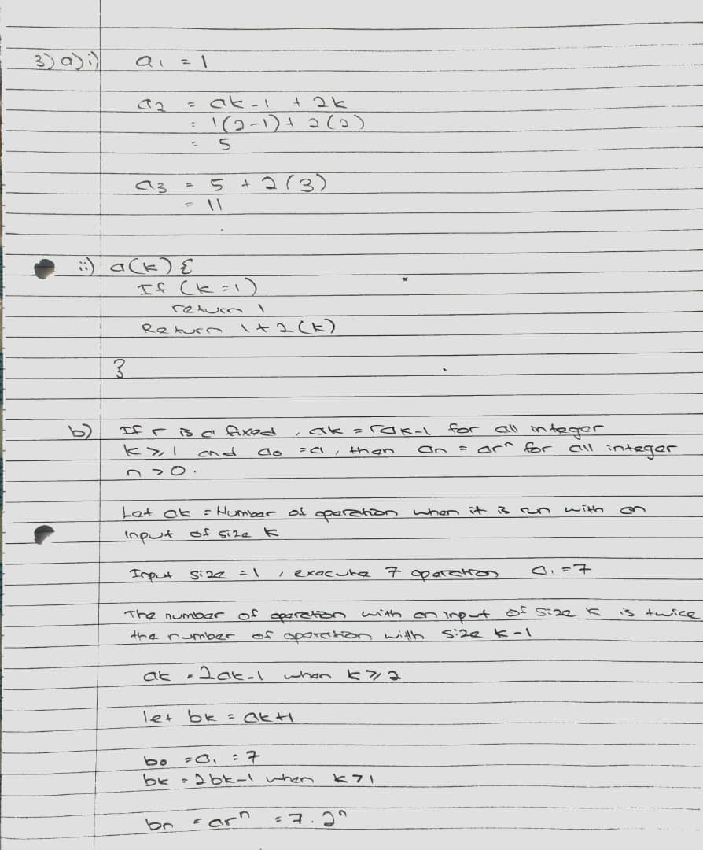

- Write the recursive algorithm. (5 marks)

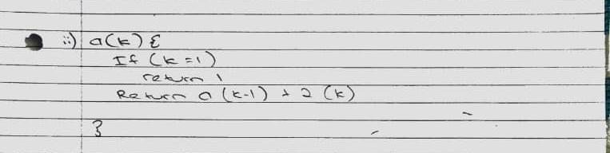

- A certain computer algorithm executes twice as many operations when it is run with an input of size k as it is run with an input of size k−1 (where k is an integer that is greater than 1). When the algorithm is run with an input of size 1, it executes seven operations. Let r_{k} = the number of executes with an input size k. Find a recurrence relation for r₁, r₂, …. r_{k.} (4 marks)

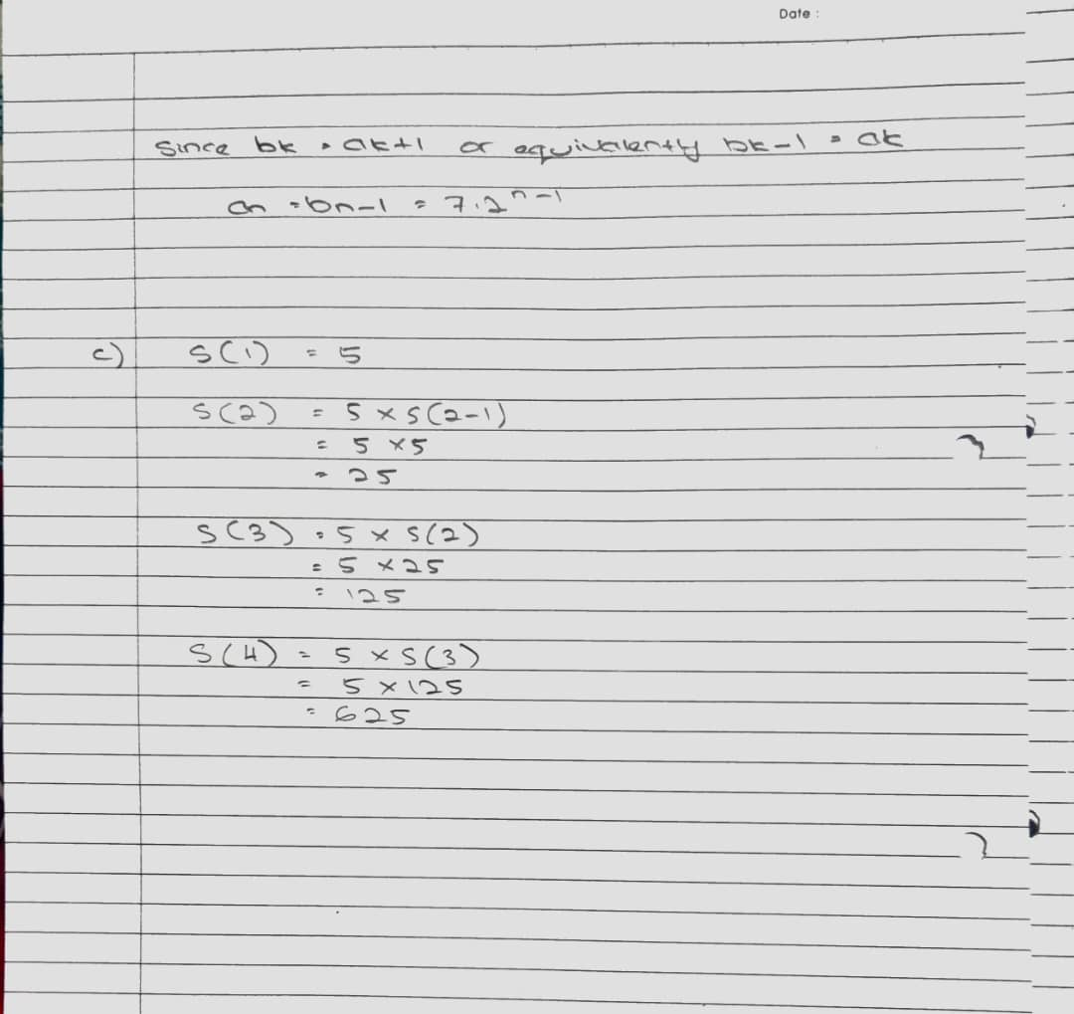

- Given the recursive algorithm:
Input: n
Output: S (n)
S(n) {
if (n=1)
return 5
return 5*S(n−1)
}
Trace S(4). (4 marks)

QUESTION 4 [25 marks]

- Hexadecimal numbers are made using the sixteen digits 0, 1, 2, 3, 4, 5, 6, 7, 8, 9, A, B, C, D, E, F. They are denoted by the subscript 16. How many hexadecimal numbers begin with one of the digits 3 through B, end with one of the digits 5 through F and are 4 digits long? (4 marks)
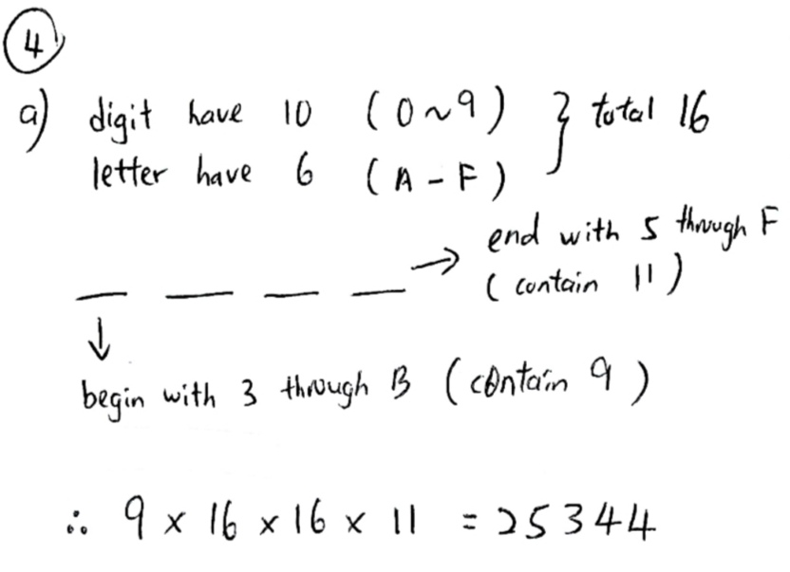

- Suppose that in a certain state, all automobile license plates have four letters followed by three digits. How many license plates could begin with A and end in 0? (4 marks)
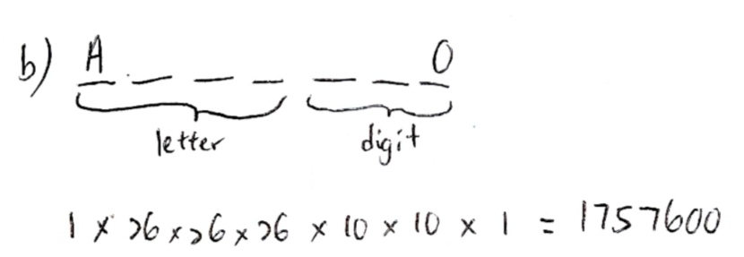
- How many arrangements in a row of no more than three letters can be formed using the letters of word COMPUTER (with no repetitions allowed)? (5 marks)

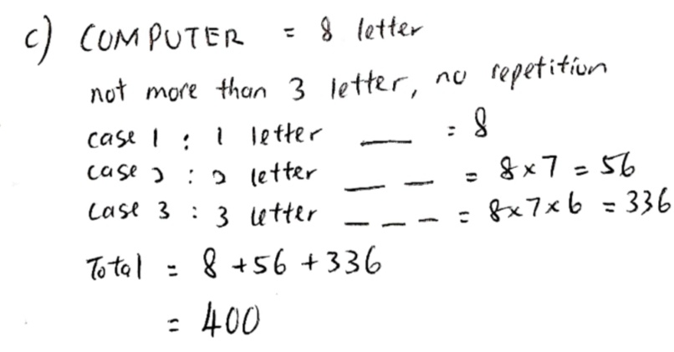

- A computer programming team has 13 members. Suppose seven team members are women and six are men. How many groups of seven can be chosen that contain four women and three men? (4 marks)

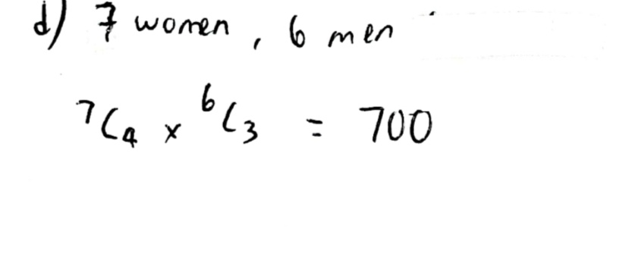

- How many distinguishable ways can the letters of the word PROBABILITY be arranged? (4 marks)

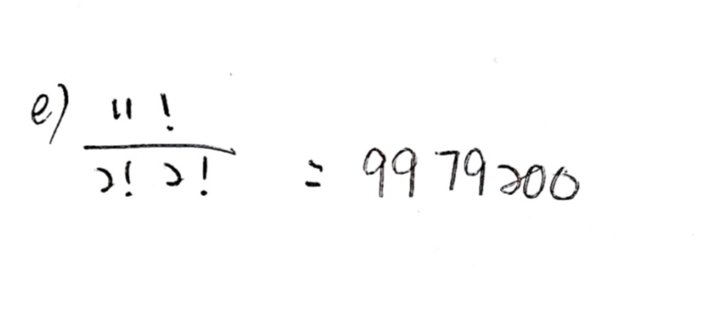

- A bakery produces six different kinds of pastry. How many different selections of ten pastries are there? (4 marks)
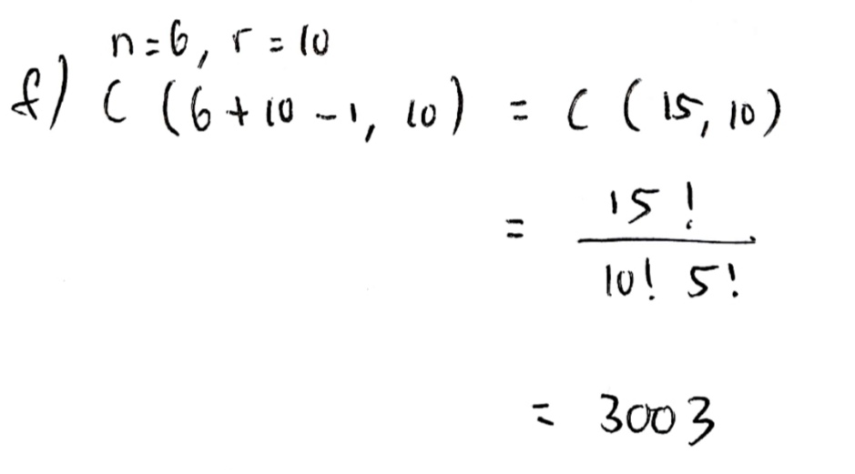

QUESTION 5 [10 marks]

- Eighteen persons have first names Ali, Bahar, and Carlie and last names Daud and Elyas. Show that at least three persons have the same first and last names.
(4 marks)
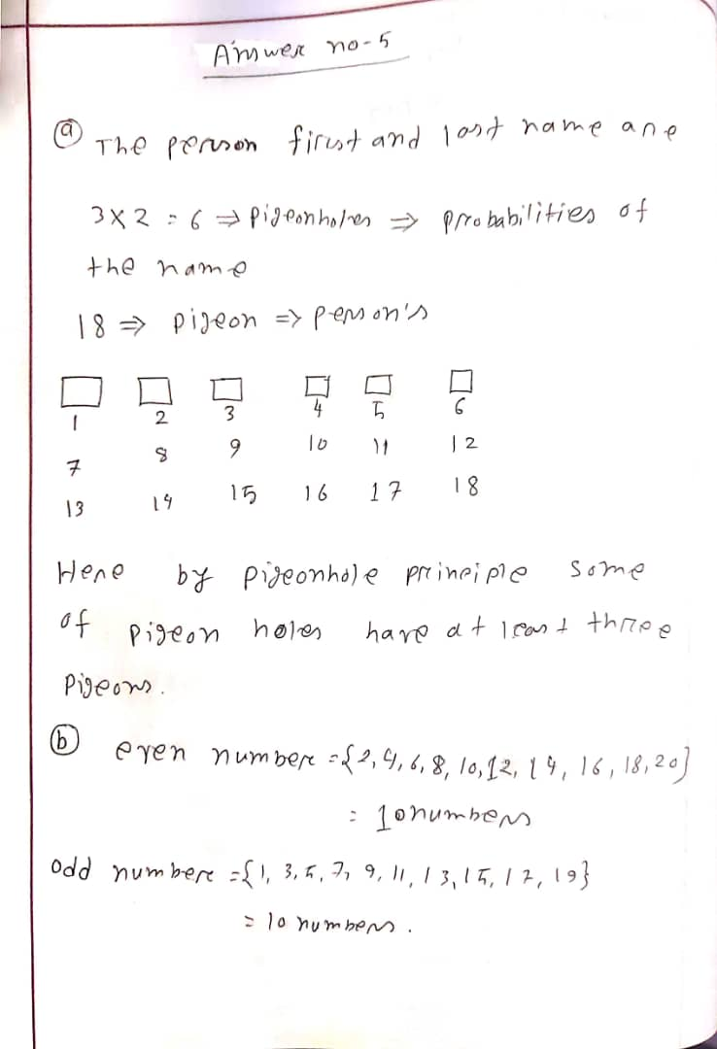

- How many integers from 1 through 20 must you pick in order to be sure of getting at least one that is odd?
(3 marks)
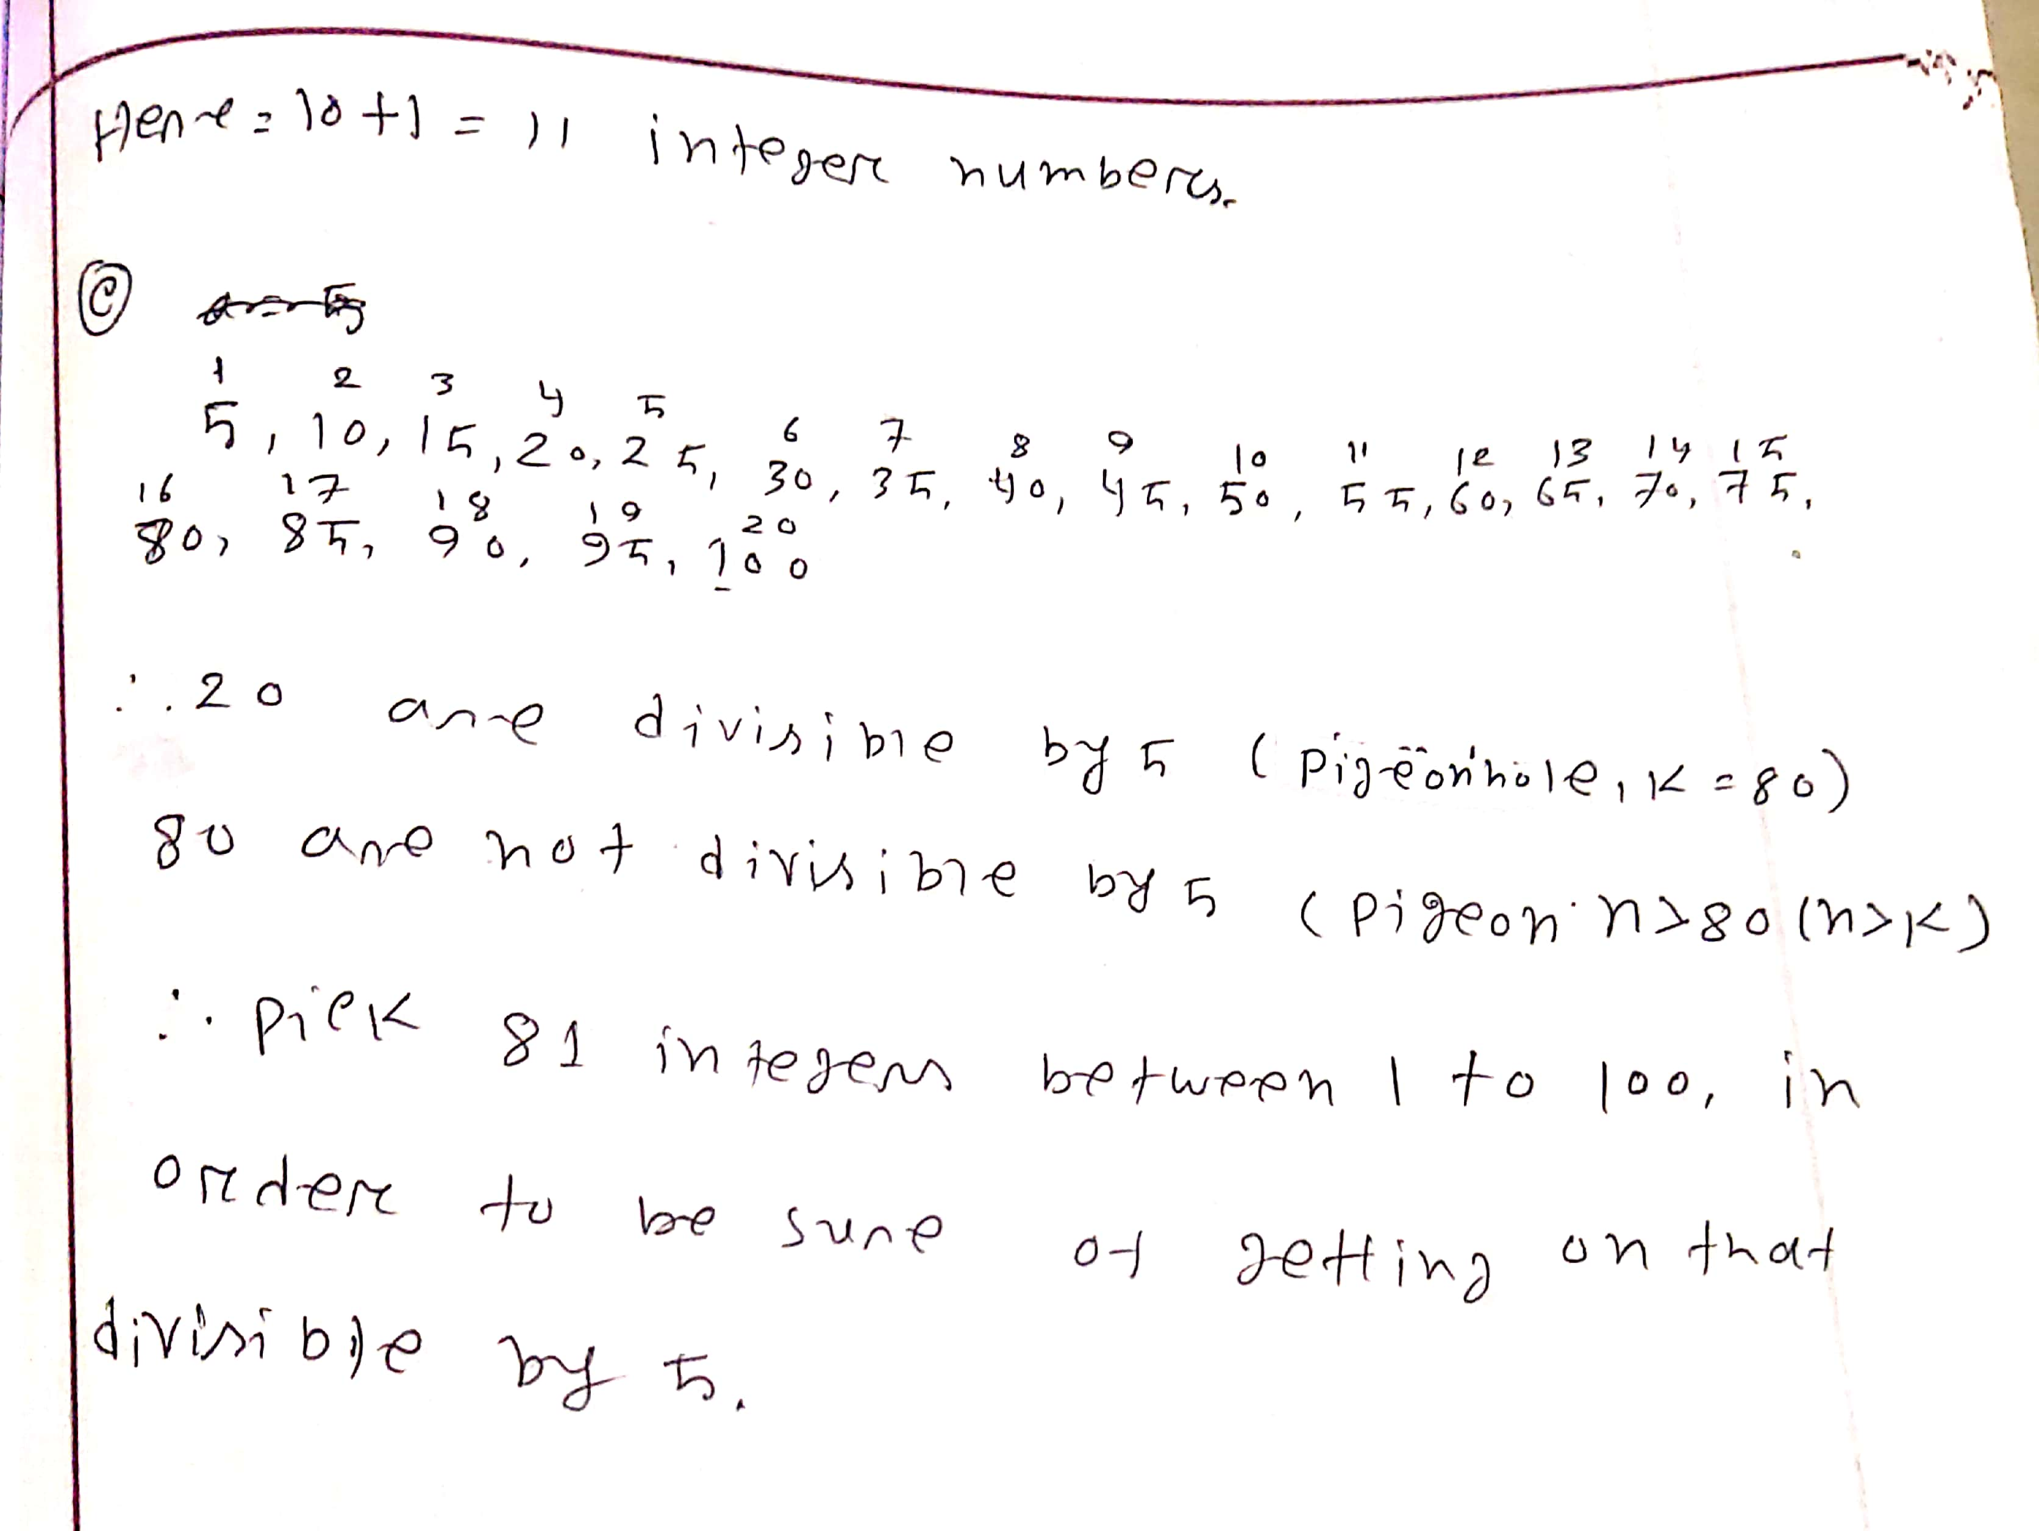
- How many integers from 1 through 100 must you pick in order to be sure of getting one that is divisible by 5?
(3 marks)

