LAB2 – Muhammad Amiruddin Bin Zulkifli - A20EC0208
Amirul Iman bin Ahmad Keflee - A20EC0183

Part 1

1.
Y=AB+BC+AC
AB(C+C’)+BC(A+A’)+AC(B+B’)
ABC +ABC’+ABC+A’BC+ABC+AB’C
Y=ABC+ABC’+A’BC+AB’C

2.

 | INPUT |  | OUTPUT
A | B | C | Y
0 | 0 | 0 | 0
0 | 0 | 1 | 0
0 | 1 | 0 | 0
0 | 1 | 1 | 1
1 | 0 | 0 | 0
1 | 0 | 1 | 1
1 | 1 | 0 | 1
1 | 1 | 1 | 1

3. a)
.
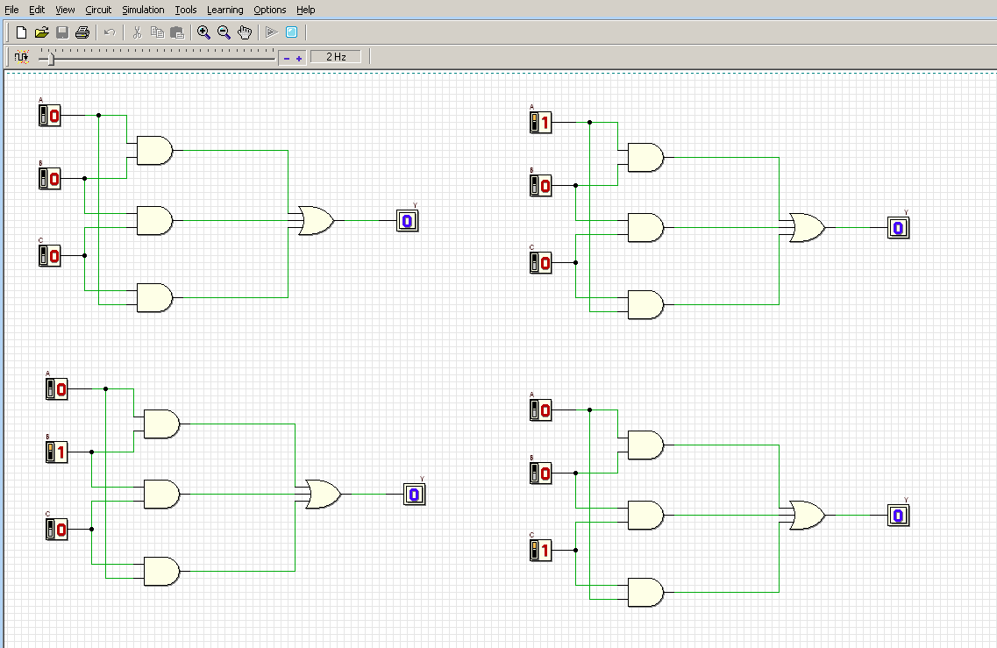

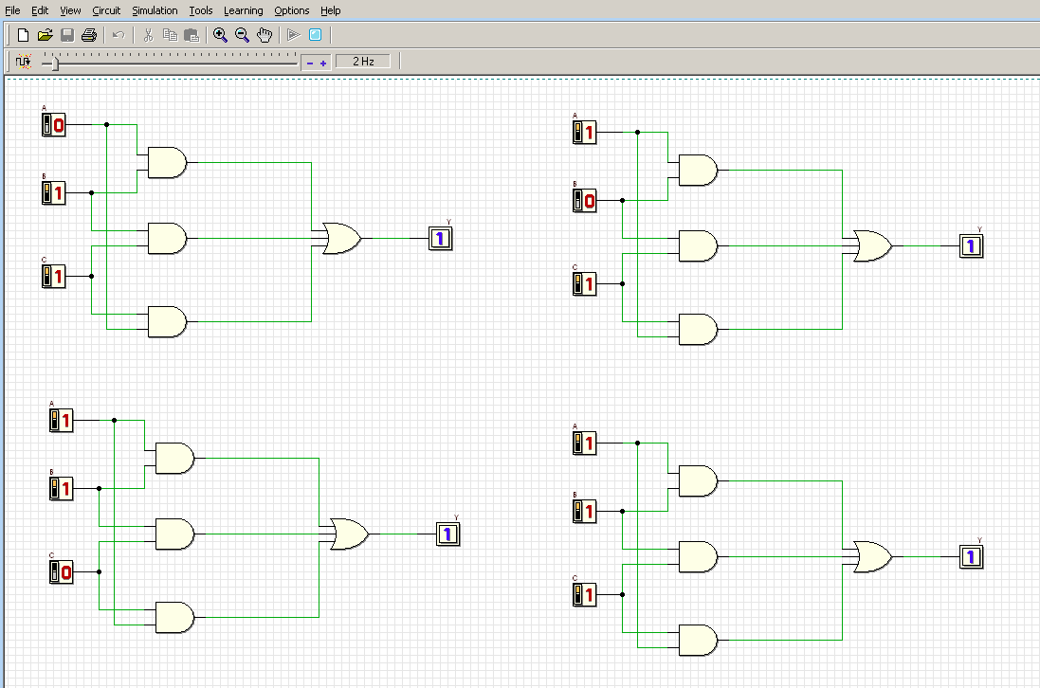
circuit (i)

b)

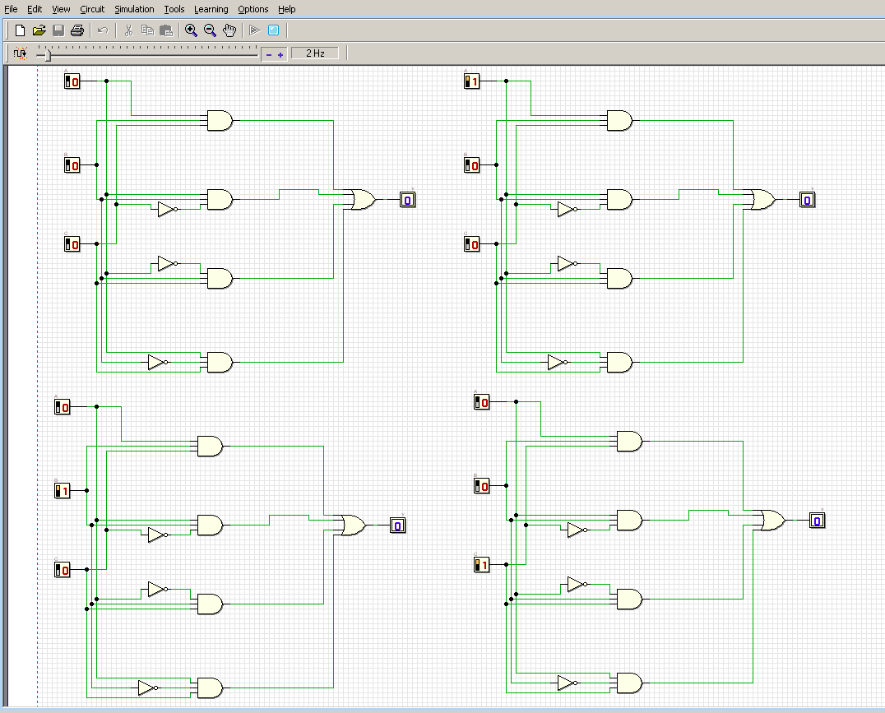

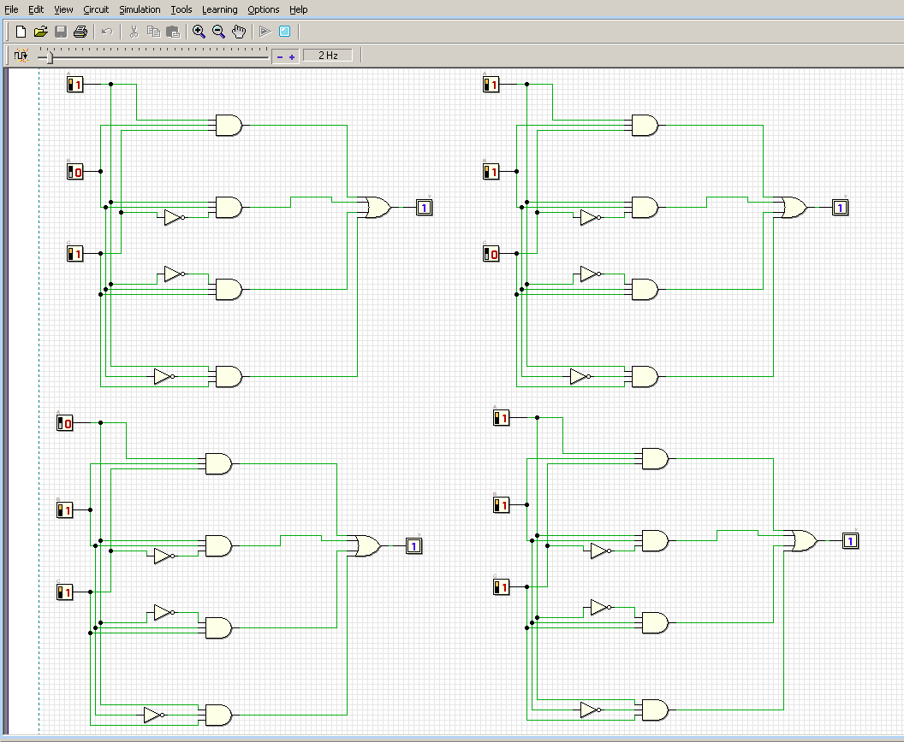
Circuit(ii)

4.
Circuit (i)
 | INPUT |  | OUTPUT
A | B | C | Y
0 | 0 | 0 | 0
0 | 0 | 1 | 0
0 | 1 | 0 | 0
0 | 1 | 1 | 1
1 | 0 | 0 | 0
1 | 0 | 1 | 1
1 | 1 | 0 | 1
1 | 1 | 1 | 1

Circuit(ii)

 | INPUT |  | OUTPUT
A | B | C | Y
0 | 0 | 0 | 0
0 | 0 | 1 | 0
0 | 1 | 0 | 0
0 | 1 | 1 | 1
1 | 0 | 0 | 0
1 | 0 | 1 | 1
1 | 1 | 0 | 1
1 | 1 | 1 | 1

Conclusion
The non-standard will also have the same output for truth table with the standard form of Boolean algebra.

5.

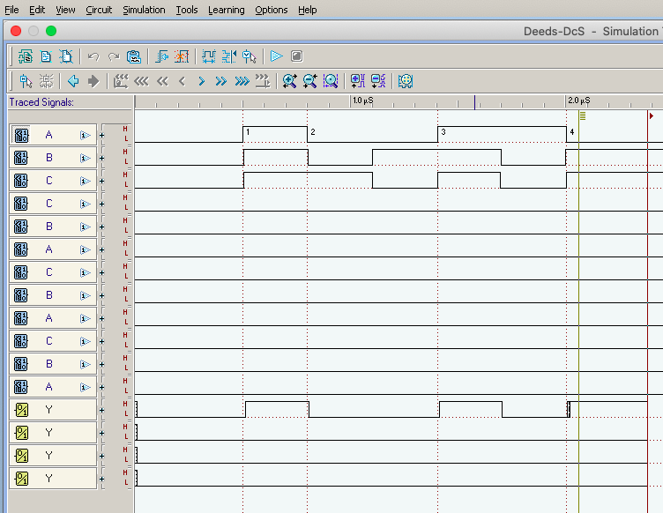

Part 2
Experimental Steps
- Truth Table 1
 | INPUTS |  |  |  | OUTPUTS
A | B | C | D | E1 | E2 | E3 | E4
0 | 0 | 0 | 0 | 0 | 1 | 0 | 0
0 | 0 | 0 | 1 | 1 | 0 | 0 | 0
0 | 0 | 1 | 0 | 0 | 1 | 0 | 0
0 | 0 | 1 | 1 | X | X | X | X
0 | 1 | 0 | 0 | 0 | 1 | 0 | 0
0 | 1 | 0 | 1 | X | X | X | X
0 | 1 | 1 | 0 | X | X | X | X
0 | 1 | 1 | 1 | 0 | 0 | 0 | 0
1 | 0 | 0 | 0 | 0 | 0 | 0 | 0
1 | 0 | 0 | 1 | X | X | X | X
1 | 0 | 1 | 0 | X | X | X | X
1 | 0 | 1 | 1 | 0 | 0 | 1 | 0
1 | 1 | 0 | 0 | X | X | X | X
1 | 1 | 0 | 1 | 0 | 0 | 1 | 0
1 | 1 | 1 | 0 | 0 | 0 | 0 | 1
1 | 1 | 1 | 1 | 0 | 0 | 1 | 0

- Minimized SOP Boolean Expression

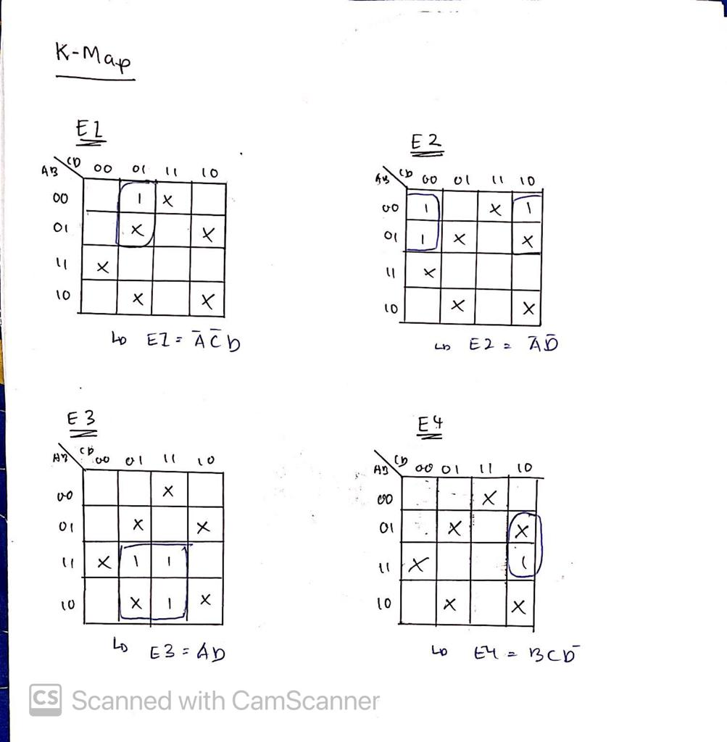
- Final Circuits
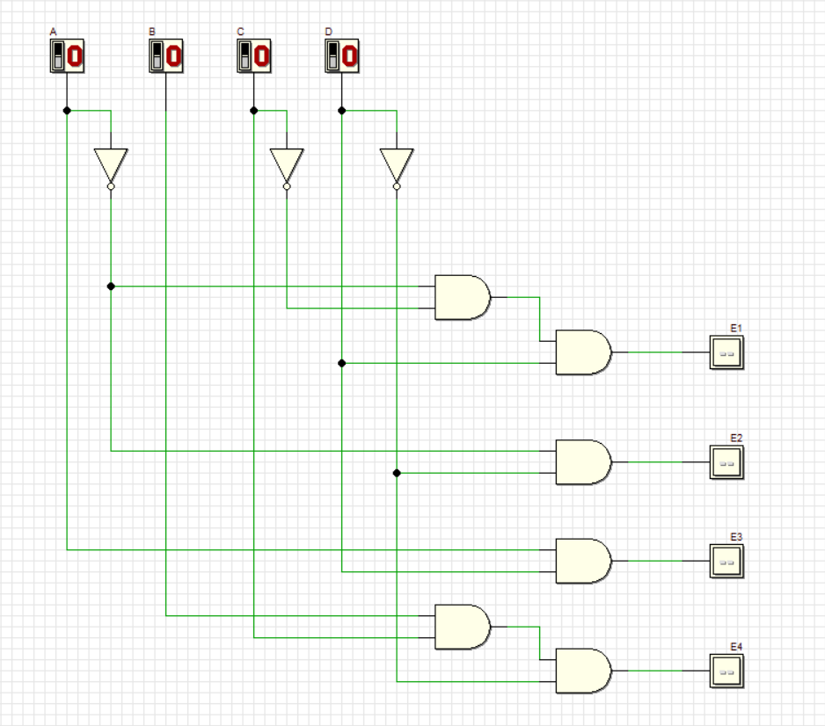

A) Truth Table 2

 | INPUTS |  |  |  | OUTPUTS
A | B | C | D | E1 | E2 | E3 | E4
0 | 0 | 0 | 0 | 0 | 1 | 0 | 0
0 | 0 | 0 | 1 | 1 | 0 | 0 | 0
0 | 0 | 1 | 0 | 0 | 1 | 0 | 0
0 | 0 | 1 | 1 | X(value deeds) | X(value deeds) | X(value deeds) | X(value deeds)
0 | 1 | 0 | 0 | 0 | 1 | 0 | 0
0 | 1 | 0 | 1 | X(value deeds) | X(value deeds) | X(value deeds) | X(value deeds)
0 | 1 | 1 | 0 | X(value deeds) | X(value deeds) | X(value deeds) | X(value deeds)
0 | 1 | 1 | 1 | 0 | 0 | 0 | 0
1 | 0 | 0 | 0 | 0 | 0 | 0 | 0
1 | 0 | 0 | 1 | X(value deeds) | X(value deeds) | X(value deeds) | X(value deeds)
1 | 0 | 1 | 0 | X(value deeds) | X(value deeds) | X(value deeds) | X(value deeds)
1 | 0 | 1 | 1 | 0 | 0 | 1 | 0
1 | 1 | 0 | 0 | X(value deeds) | X(value deeds) | X(value deeds) | X(value deeds)
1 | 1 | 0 | 1 | 0 | 0 | 1 | 0
1 | 1 | 1 | 0 | 0 | 0 | 0 | 1
1 | 1 | 1 | 1 | 0 | 0 | 1 | 0

- Both truth table 1 and truth table 2 produced the same output results. X in the table resulting from Deeds Value which is Rule 5 where the output of error signal is Invalid when the input has equal bit of 0 and 1.
B) Timing Diagram
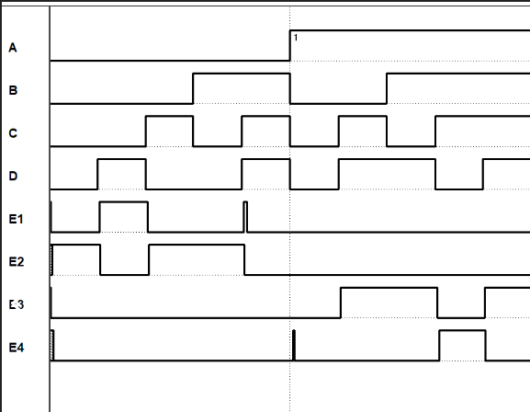

- Timing Diagram Analysis
From the timing diagram, we can see input A was constantly Low first and then went High, compared to output B,C and D that went Low and High across the timing diagram especially D that shows rollercoaster pattern. Fot the ouputs, we can see only 1 output is high/activated for each input.

- NAND Gates Circuit

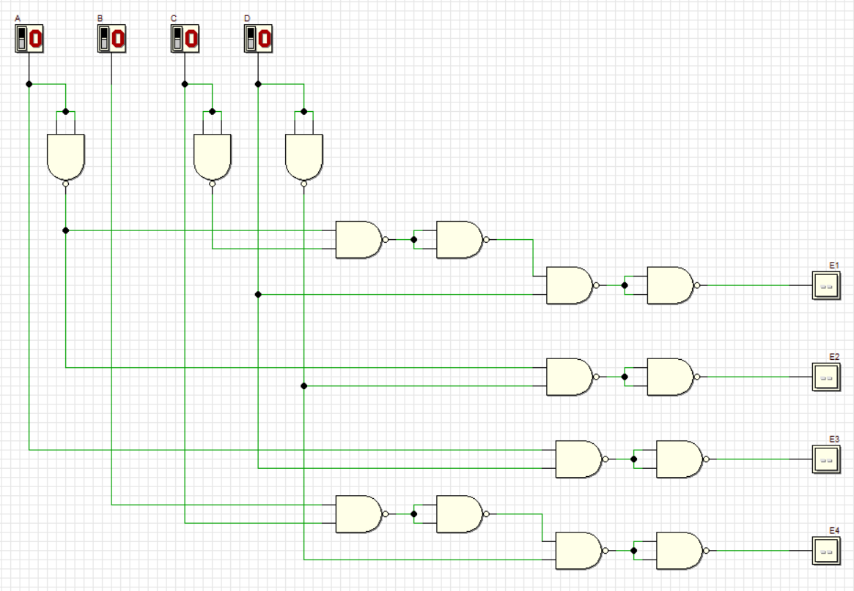

A) Truth Table 3

 | INPUTS |  |  |  | OUTPUTS
A | B | C | D | E1 | E2 | E3 | E4
0 | 0 | 0 | 0 | 0 | 1 | 0 | 0
0 | 0 | 0 | 1 | 1 | 0 | 0 | 0
0 | 0 | 1 | 0 | 0 | 1 | 0 | 0
0 | 0 | 1 | 1 | X(value deeds) | X(value deeds) | X(value deeds) | X(value deeds)
0 | 1 | 0 | 0 | 0 | 1 | 0 | 0
0 | 1 | 0 | 1 | X(value deeds) | X(value deeds) | X(value deeds) | X(value deeds)
0 | 1 | 1 | 0 | X(value deeds) | X(value deeds) | X(value deeds) | X(value deeds)
0 | 1 | 1 | 1 | 0 | 0 | 0 | 0
1 | 0 | 0 | 0 | 0 | 0 | 0 | 0
1 | 0 | 0 | 1 | X(value deeds) | X(value deeds) | X(value deeds) | X(value deeds)
1 | 0 | 1 | 0 | X(value deeds) | X(value deeds) | X(value deeds) | X(value deeds)
1 | 0 | 1 | 1 | 0 | 0 | 1 | 0
1 | 1 | 0 | 0 | X(value deeds) | X(value deeds) | X(value deeds) | X(value deeds)
1 | 1 | 0 | 1 | 0 | 0 | 1 | 0
1 | 1 | 1 | 0 | 0 | 0 | 0 | 1
1 | 1 | 1 | 1 | 0 | 0 | 1 | 0

- Both truth table 2 and truth table 3 still produced the same output results. X in the table resulting from Deeds Value which is Rule 5 where the output of error signal is Invalid when the input has equal bit of 0 and 1.
B) Timing Diagram 2

- Timing Diagram Analysis
From the timing diagram, we can see input A was constantly Low first and then went High, compared to output B,C and D that went Low and High across the timing diagram especially D that shows rollercoaster pattern. Fot the ouputs, we can see only 1 output is high/activated for each input.

