
SEM 1 20202021 : SECTION 01

PROGRAMMING TECHNIQUE 1

ASSIGNMENT 1

Group Num# : 08

Students Information

Name : Felicia Chin Hui Fen (A20EC0037)
Erica Desirae Mauritius (A20EC0032)
Lue Guo Ming (A20EC0073)
Mohd Firdaus Bin Zamri (A20EC0080)

Lecturer : Dr Zuraini Binti Ali Shah

Question 1

This question requires the use of modular flowcharts as described in Chapter 1 – Programming Problem Solving. In the main flowchart, input data will be accepted which is the Test mark for SECP1513 course. For testing part, you as a designer just input/enter 5 marks. This flowchart will stop when user enter N. As long as user not entered N, the flowchart will be repeated to accept another 5 marks.
Two modular flowcharts computeAverage and findMax requires to be created that will accept the input and return the result. Main flowchart will call function computeAverage. Function computeAverage will send the input and calculate the average for 5 student marks. Next, computeAverage will return the average to the main flowchart. Main flowchart will display the average together with maxima mark that will be returned by findMax function. Main flowchart will call function findMax. Function (module) findMax will accept the input and find the highest marks among five (5) marks. Last, findMax will return the highest mark to the main flowchart.

Flowchart input and output specification :
Sample input (input in BOLD) :
Enter student 1 : 65
Enter student 2 : 90
Enter student 3 : 83
Enter student 4 : 75
Enter student 5 : 68
The variables need to be named as n1, n2, n3, n4 and n5.
The red counter needs to be displayed (auto) when user repeat the input process for 5 students.
The output for the flowchart (output in BOLD) :
The average test mark is: 76.2
The highest test mark is: 90

Enter 5 more students? Y

Enter student 1 : 70
Enter student 2 : 95
Enter student 3 : 45
Enter student 4 : 86
Enter student 5 : 78

The average mark is: 74.8
The highest test mark is: 95
Enter 5 more student? N
------THE FLOWCHART STOP------

Question 2

Answers:
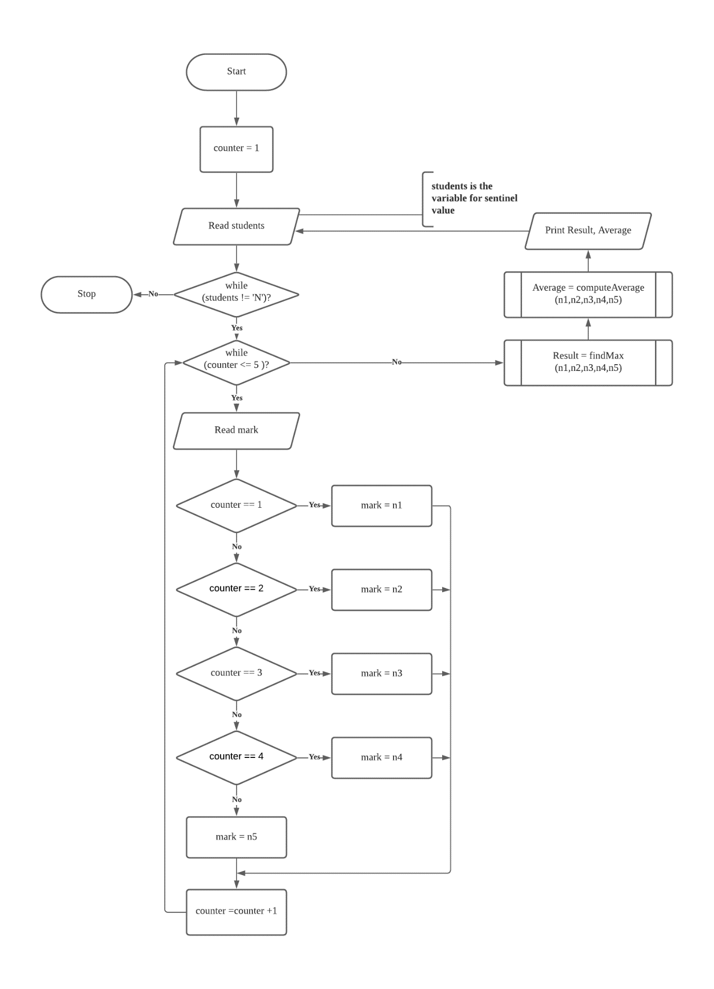
1.

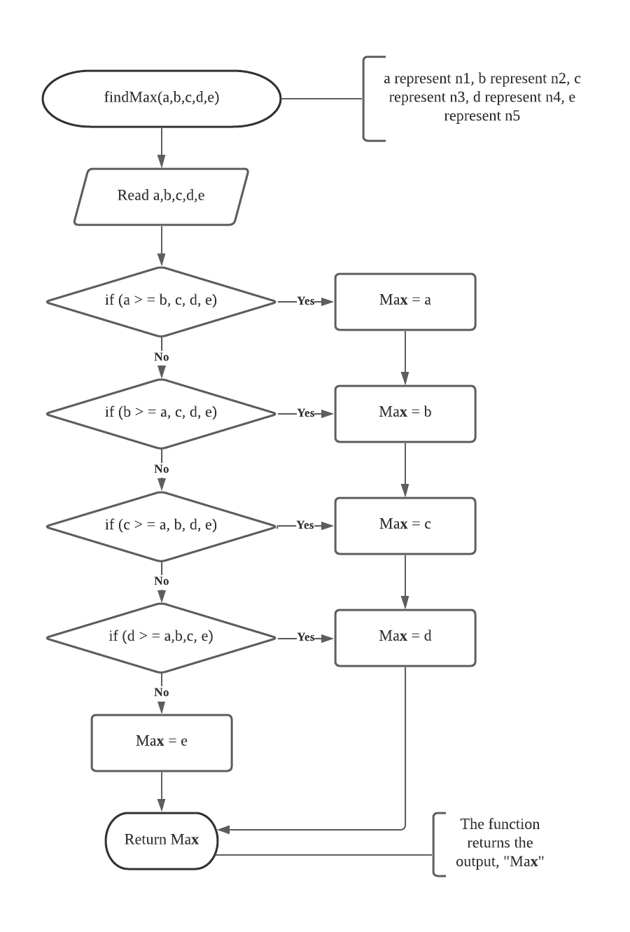

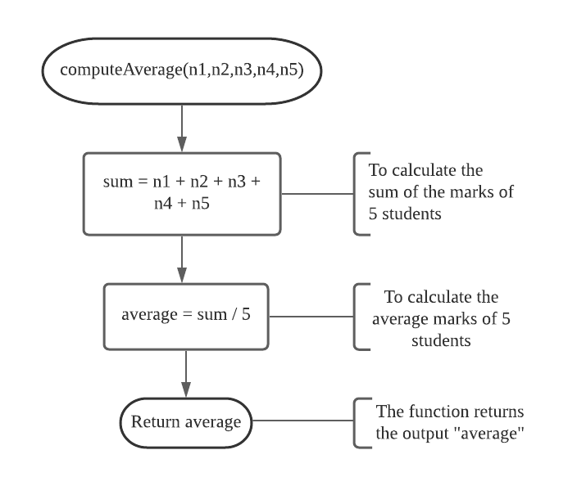

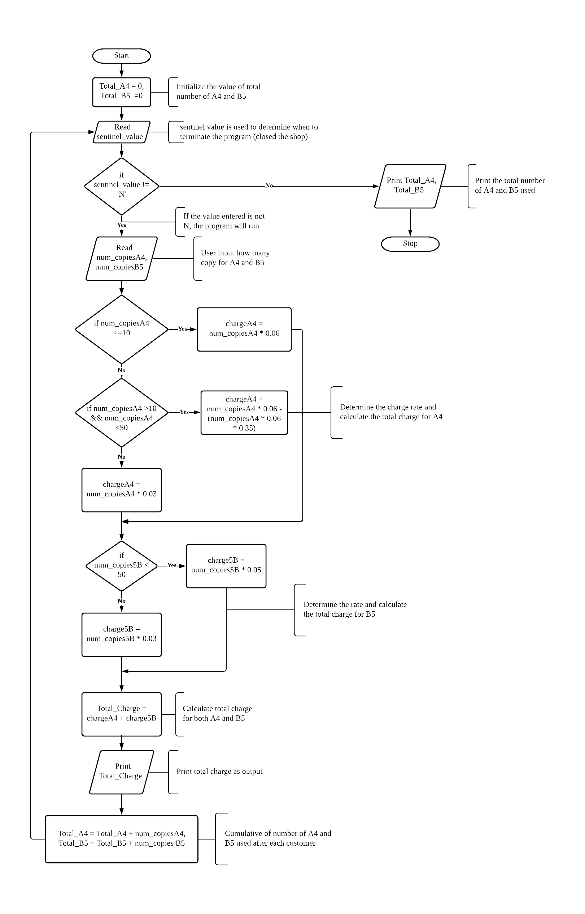
2.

