Thursday,  7 Jan,  2021 | NEWS TODAY  Latest news and bulletin updates |  |  |  |  |  |  | Group 6
Ieskandar Zulkarnain, Aiman Na’im, Hibban, Syaza Syaurah, Lai Kin Yong  General information  On 29th December 2020, the alumni sharing session titled “Inspiring Work Experience and COVID-19 19 Pandemic Challenge” had been held which is organized by the Technology and Information Systems Department, School of Computing, UTM from 10 A.M. to 11 A.M.  Dr. Johanna Ahmad, the senior lecturer in the School of Computing is invited as the moderator to this talk. Mrs. Batrisyia as a social media data analyst in TM One, Mr. Teo as a software engineer in Qumon Intelligence, Mr. Zamarul as a data engineer in PPG Coatings (M), Mr. Tan as a data science engineer in Micron Semiconductor Asia had been invited as the speaker to share their experience during this session.  Purpose of the talk  The aim of the talk was to share their experiences with the speakers about how they became good in their careers. Therefore, they expressed how they managed to follow their vision and get a safe job. As for the new UTM student crowd, speakers also share their tips about how to balance their time between research and curriculum.  In addition, they also discuss how they continue to gain inspiration to concentrate on their careers. So, this talk was very important to all the students who lost their inspiration to learn during this pandemic period. The other goal of the talk was also to inspire the student's spirit to concentrate on their studies to protect their futures and follow their dream jobs in the future. |  |  | 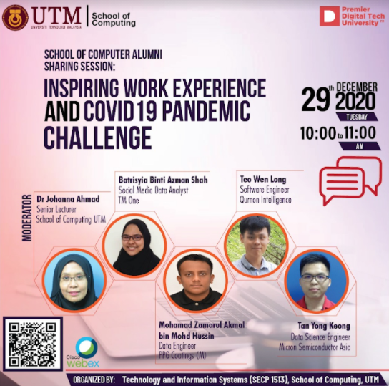
 |  |  | A memorable poster by School of Computer which organized by Technology and Information Systems Department, School of Computing, UTM
 |  |  | How did you get employed by your current company?
 |  |  | During Tan’s university life, frequent participation in the competition had benefited him as he managed to earn the achievements, professional skills, presentation skills and even a chance to attend the interview of the company named Micron in he is working under now. Tan stated that since the fresh graduates who attended the interview were generally lack of working experience, the interviewer would focus on the projects and competition they joined throughout university life. He later mentioned that learning a new programming language was almost inevitable during the internship.  Zamarul who was employed by his industrial training company told that his personality of being proactive had contributed a lot to his employment. During his internship, Zamarul always tried to expose himself by giving constructive ideas. |  |  |  | For example, he suggested replacing the manual data-monitoring tool with a monitoring dashboard that could keep track of all data at once. Then, this proposal had become his internship project and helped him to draw the attention of his supervisor. As the consequence, he managed to remain as a permanent staff in that company after his internship ended.  As for Batrisyia, she is working as a social media data analyst in the TM One company. She remained in this position since she was an intern and she showed a lot of effort to join the social media dashboard project during her internship. The aim of this project was to gather all of the social media data, interpret them and integrated them into the dashboard. Then, the client management department would use the organised data in the dashboard to improve the company branding for marketing purposes.
Useful Tips For Job Application During Pandemic
Qistina:  It was recommended to possess skills like Excel, Python, and SQL as they helped in drawing in good attention from the interviewers. The candidates who were accepted as interns should show their quality of being proactive and independent to deliver a good impression. |  |  |  |  | Zamarul:  There was nothing better than skills to help a person in getting a job. Mastering the soft skills could help a person to communicate more efficiently, build good teamwork with others and voice out his opinion in any discussion. Certainly, effort should also be spent in improving technical skills like programming skills via self-learning lessons on an online platform.
 |  |  |  | Page 1

Thursday, 7 Jan, 2021 | NEWS TODAY |  |  |  |  | Group 6
Innovation, the fuel of programming |  |  |  |  | Group Reflection  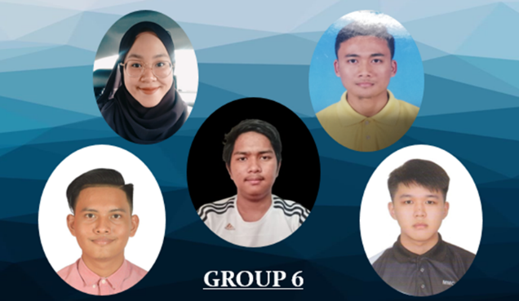  The discussion offered a valuable insight into how to develop, especially during the University, so that we could find a better job. They speak about being diligent and engaging in various events to develop the soft skills that help us get a career. The speaker can even chat with the student when they are now beginners and can share a little about them after graduation. The weakness, though, is that the talk probably has pupils who have employment after they graduate. Listening to the side of good students may be a little unilateral because we cannot learn how if we don't get a job right after graduation. Lack of clarification is often something weak because the speakers have not explained their interactions during the internship and work in depth.
As a matter of the fact that some undergraduate students were offered the software engineering course by UPU which was not their first choice, they struggled to find the motivation in improving their programming skills which were essential in software engineering courses. In this case, Tan encouraged those people with less interest in programming to have a new perception of programming. Tan urged them to consider programming as an ability to create innovation, such as an application or software that could tackle real-world problems. Nevertheless, he thought that the key factor to improve programming skills was to keep practicing programming skills as he quoted “Practice makes perfect”. Being a caring senior, Tan also did not forget to recommend several websites that provided free programming skills exercises and tests like Leadcode.com.
Skill or CGPA?  Which one was more important for employment?  According to Dr. Johanna’s experience, a private company typically prioritised technical skills compared to CGPA as her programming skills were tested on spot during the interview. On the other hand, both CGPA and skills would be taken into account if a person was applying for job from a government agency. Meanwhile, Batrisyia, Zamarul, and Tan who are working in the private sector agreed with Dr. Johanna. However, Tan stated that CGPA was still an important criteria that the private companies would not consider any candidate with a CGPA less than 3.0.  Motivation for daily basis  Qistina :  “My love for the job always motivates me to do better.”  Tan :  “I always try my best to create something in my project so I could dedicated myself to contribute for the others  Zamarul :  “Telling myself to always be grateful for having this chance to possess the current daily basis”  Love what you do,  do what you love  During the internship, you are not tied with anything, as if you get work was which not related with your studies, you can choose either to proceed or ask the supervisor to change it to your related course. But if you proceed, it will be a new knowledge and experience for you to try it on. |  | Success is a journey,  not a destination  As being emphasized by all of the speakers, joining a competition was never about winning or losing but rather the experience gained from the process of the competition. Therefore, the speakers greatly encouraged the audience to give a shot in any kind of competition to earn new experience.  Treatment received by an intern  In Zamarul’s experience, he never felt like being treated as a slave in the company. They treated him the same as other staff and friends. He didn’t get a low wage but he can be considered that he got the highest pay among others. He can also demand payment. So, if you get a low payment, you can directly discuss it with your supervisor in university. To have overwork experience is less for him as he works in his studied field. In his opinion, the internship is the phase where he really gets to know his studied field. Going for an intern makes you have more experience with working and it is not really to have overwork experience. But if you have some overwork, you can always tell your supervisor. As for example, you need to do other work that does not relate with your studied and you have no fundamental of knowledge about it, so you can discuss with the university and they will manage themselves.
Individual Reflection
(Hibban)
The point from this talk in my opinion is you must always spirit for every challenge even during pandemic or not. Because chances is not coming 2 times or more, even the chances coming more than 1 time the atmosphere will be different. Don’t forget to practice what you learn, because without practicing is nothing. Practice will make you have a new skill and upgrade your basic skill. Find partner and work in team will you learn something from them. Talk with other will help you to find solution. I really appreciate to alumni for sharing his experience to us. I learn many things from this talk. Because now I still young must develop my own skill to prepare myself to get a work experience. But I can’t hear clearly because of my internet not good at that time. Greetings and Thank you!
 |  |  | Page 2

