

SEM 1 20202021 : SECTION 01

PROGRAMMING TECHNIQUE 1

ASSIGNMENT 1

Group Num# : 7

Students Information

Name : Shahril Bin Saiful Bahri (A20EC0144)
Gui Yu Xuan (A20EC0039)
Phang Cheng Yi (A20EC0131)
Nurzarifah Binti Azizan (A20EC0127)

Lecturer : Dr Zuraini Binti Ali Shah

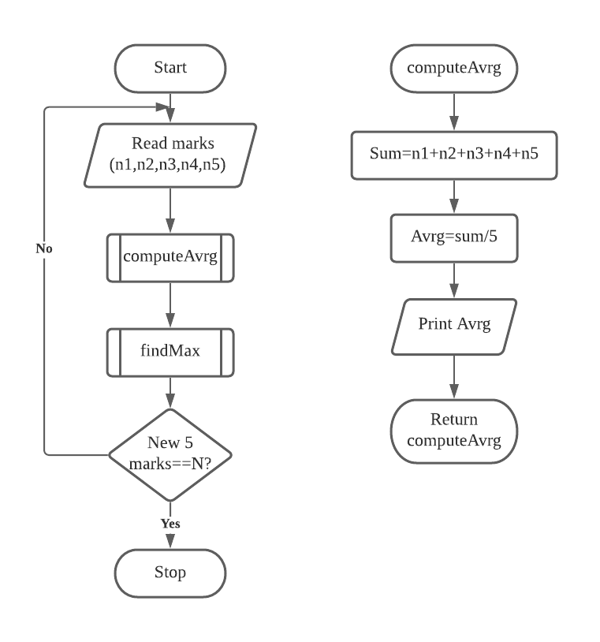
Question 1

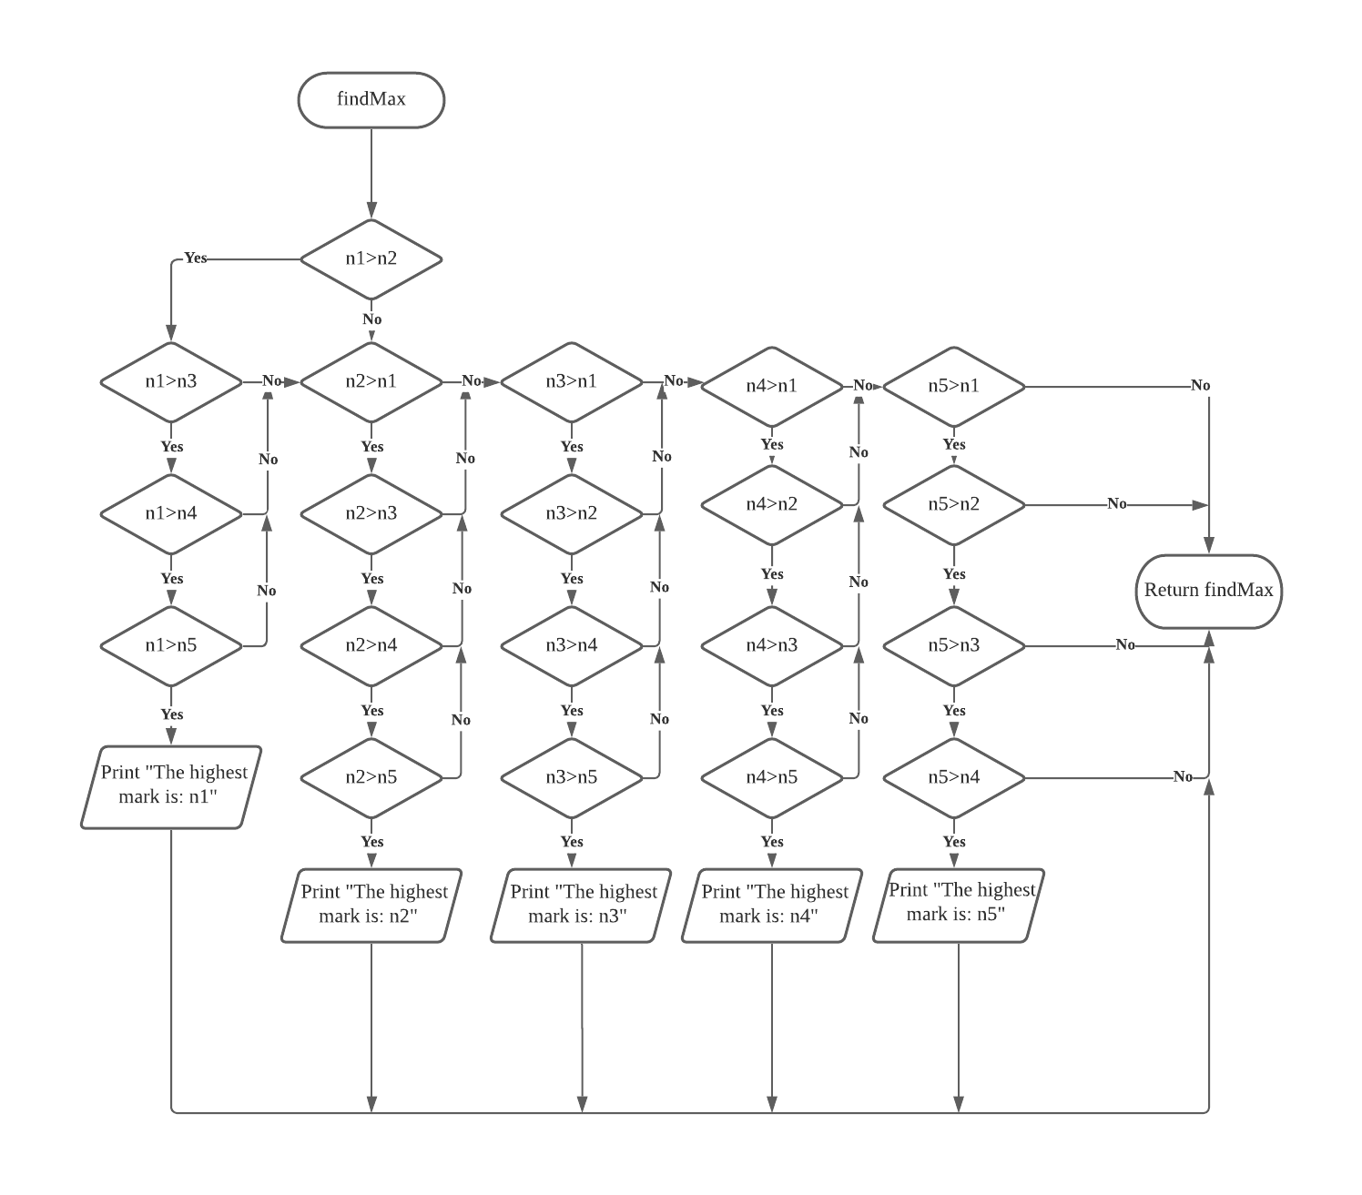

Question 2

